COMPREHENSIVE SEISMIC EVALUATION OF EXISTING BUILDINGS USING ASCE 41-17 STANDARDS | 

Anis Rosyidah^{1*}, Tree Irma Dinda¹, Jonathan Saputra¹, I Ketut Sucita¹
¹ Department of Civil Engineering Politeknik Negeri Jakarta

Abstract  This study investigates the seismic performance of a 35-year-old existing building in Jakarta using ASCE 41-17 standards, applying Tier 1, Tier 2, and Tier 3 evaluations. The building, categorized as Risk Category II, was analyzed under the BSE-2E seismic hazard level with a Collapse Prevention (CP) performance objective, based on as-built drawings and material tests showing a concrete strength of 21 MPa. The Tier 1 assessment of the building’s configuration identified 5 out of 14 items as non-compliant, including issues with soft story and overturning stability. Tier 2, using Demand-to-Capacity Ratios (DCR), found that most structural elements, particularly beams and columns, had DCR values greater than 4, indicating a high demand for ductility. Tier 3 pushover analysis revealed that despite considering elastic design, the capacities of the columns and beams were insufficient to resist extreme seismic loads, risking significant deformation and threatening CP performance. The inter-story drift analysis showed the highest drift on the first floor, with 2.321% in the X direction and 2.319% in the Y direction, surpassing the 2% limit for Life Safety (LS) performance. These findings suggest that the building, especially at lower levels, operates between LS and CP performance levels, necessitating reinforcement of structural elements per ASCE 41-17.  This is an open access article under the CC BY-SA license   | Keywords:  Seismic Evaluation  Existing Buildings,  Seismic Performance,  Collapse Prevention  Article History:  Received: May 2, 2019  Revised: May 29, 2019  Accepted: June 2, 2019  Published: June 2, 2019  Corresponding Author:  Anis.rosyidah@sipil.pnj.ac.id

INTRODUCTION
Indonesia experienced 10,789 earthquakes in 2023, significantly higher than the annual average of 7,000 events [1]. Although 861 of these were felt, and 24 caused damage, no fatalities were reported. Jakarta, being a densely populated city with over 3,400 buildings, is not exempt from seismic threats, as seen from several notable earthquakes, including a magnitude 6.7 quake in January 2022 [2][3]. Buildings in densely populated areas must be designed to withstand earthquakes to minimize casualties [4]. Indonesia’s seismic regulations have evolved, with the latest standard being SNI 1726:2019, which addresses the increasing seismic intensity. However, many older buildings designed with outdated codes remain vulnerable to future quakes[5]. Seismic assessments, following international standards such as ASCE/SEI 41-17, are essential for analyzing and strengthening these existing structures[6].
Numerous techniques, including non-destructive testing, dynamic analysis, and static analysis, can be used to carry out seismic assessments [7]. Dynamic analysis provides insights into a building’s response under seismic conditions by modeling interactions with real-time ground motion, capturing complex behaviors of mass and stiffness. Conversely, static analysis evaluates the structural response using static equivalent forces that approximate seismic effects, making it suitable for initial assessments and simpler structures. When combined, these methods offer a comprehensive framework for understanding and ensuring structural resilience in earthquake-prone regions [8]. Testing that isn't harmful evaluates the structural and material conditions without causing harm. Existing structures are frequently susceptible to deterioration brought on by elements including age, poor soil, air pollution, and earthquakes, especially those in seismically active places like Jakarta [9][10]. Comprehensive seismic evaluations and possible retrofitting are necessary because of the increased danger of catastrophic damage caused by these elements as well as by subpar structural design or out-of-date construction standards [11].
ASCE 41-17, published by the American Society of Civil Engineers, offers a structured framework for assessing and retrofitting existing buildings to improve their seismic resilience, using a tiered methodology [12]. The tiered methodology for seismic assessment is critical for evaluating the resilience of existing structures against seismic hazards. In Tier 1, an initial evaluation is conducted through visual inspections and basic calculations to establish performance objectives aligned with the Basic Performance Objective for Existing Buildings (BPOE). This stage is essential for classifying seismic hazards such as BSE-1E and BSE-2E while also delineating structural categories and material properties relevant to the assessment [13].
Tier 2 involves a more comprehensive evaluation, addressing deficiencies identified in the first tier. This assessment utilizes linear static or dynamic methods, where linear static analysis applies under specific conditions, while dynamic linear analysis incorporates factors like elastic stiffness and viscous damping, thereby enhancing the understanding of the building's response to seismic forces.
If any issues persist post-assessment in Tier 2, the process progresses to Tier 3, employing advanced non-linear analyses such as pushover or time-history analyses. This tier provides a thorough evaluation of the impact of structural reinforcements and the overall performance of the building, ensuring that all potential vulnerabilities are effectively addressed.
This systematic approach is essential for developing targeted retrofitting strategies that enhance the resilience of structures located in seismically active regions, ultimately contributing to improved safety and performance.
.
METHOD
The methodology employed in this study focuses on the assessment of seismic performance for an existing office building, referred to as the Existing Building, following the guidelines established by ASCE 41-17. A detailed three-dimensional model of the structure is developed using software software, which serves as the basis for a comprehensive, multi-tiered evaluation process. Data collection encompasses both primary and secondary sources, which include building surveys, material testing, and analysis of as-built drawings.
The seismic assessment is conducted sequentially, progressing from Tier 1, which involves screening, to Tier 2, where linear modeling techniques are applied, and ultimately to Tier 3, which employs nonlinear analysis to thoroughly address any deficiencies identified in the previous phases. This evaluation process is systematically guided by applicable codes and standards, including SNI and ASCE, ensuring that the assessment meets the necessary safety and performance criteria.
This structured approach facilitates a robust understanding of the building's seismic resilience and informs potential retrofitting strategies to enhance structural performance in the face of seismic events.

RESULTS AND DISCUSSION
Tier 1 Evaluation
The Tier 1 process begins by benchmarking the existing building through the development of a checklist tailored to the specific structure type under assessment (Table 1). This checklist acts as a fundamental tool to evaluate various components and conditions of the building, ensuring that critical factors pertinent to seismic performance are systematically addressed. The results derived from this checklist categorize the building's status into several outcomes, such as compliant, non-compliant, not applicable, and unknown.
These classifications are instrumental in identifying the areas that require further scrutiny and intervention. For instance, a "compliant" status indicates that the building meets the necessary seismic performance criteria, while a "non-compliant" status highlights deficiencies that need to be addressed in subsequent tiers of analysis. The "not applicable" status may pertain to elements of the building that are irrelevant to the seismic assessment, whereas "unknown" indicates areas where data is insufficient or unclear​.
This systematic evaluation process not only aids in determining the building's initial seismic resilience but also informs subsequent assessments necessary for retrofitting and enhancing overall structural performance.

Table 1
Benchmark for Existing Building Tier 1
Category | Details
Building Risk Categories | Risk Category II
Performance Levels | BSE-2E, Collapse Prevention (CP)
Seismicity Levels | Ss = 0.8032g and Sd1 = 0.3894g, High Seismicity
Checklist Selection | Basic Configuration Checklist, Structural Checklist for Collapse Prevention Performance
Source: Author

Table 2
Basic Configuration Checklist
No | Item Evaluated | Status
1 | Load Path | C
2 | Adjacent Buildings | C
3 | Mezzanine | C
4 | Weak Story | C
5 | Soft Story | NC
6 | Vertical Irregularity | NC
7 | Geometry | NC
8 | Mass | NC
9 | Torsion | C
10 | Liquefaction | C
11 | Slope Failure | C
12 | Surface Fault Rupture | U
13 | Racking | NC
14 | Foundation Tie-down | C
Source: Author

Table 3
Collapse Prevention Structural Checklist for Concrete Frame (C1)
No | Item Evaluated | Status
1 | Redundancy | C
2 | Column Axial Stress | NC
3 | Concrete Columns | C
4 | Infill Walls | C
5 | Column Shear Stress | NC
6 | Flat Plate Frame | C
7 | Pre-tensioned Frame Elements | C
8 | Floating Columns | C
9 | Shear Failure | NC
10 | Strong Column - Weak Beam | NC
11 | Beam Reinforcement | C
12 | Column Reinforcement Splice | C
13 | Beam Reinforcement Splice | C
14 | Column Tie Spacing | NC
15 | Beam Tie Spacing | C
16 | Deflection Compatibility | C
17 | Flat Plate | C
18 | Diaphragm Continuity | C
19 | Uplift Resistance in Poer/Pile Cap | C
Source: Author

Table 4
Collapse Prevention Structural Checklist for Shearwall Frame (C2)
No | Item Evaluated | Status
1 | Shear Stress Check | C
3 | Shear Wall Anchors | N/A
4 | Load Transfer to Shear Wall | C
5 | Coupling Beams | N/A
6 | Diaphragm Continuity | C
7 | Openings in Shear Walls | N/A
8 | Uplift Pile Cap | U
Source: Author

The Tier 1 assessment of the Collapse Prevention (CP) performance under BPOE BSE-2E classification for the Existing Building reveals significant non-compliance with ASCE 41-17 standards. Based on Table 2, Out of 14 configuration checklist items evaluated, 5 items were non-compliant (NC), including soft story, vertical irregularity, geometry, mass, and racking, while one item, surface fault rupture, was classified as unknown (U). The remaining 8 items were compliant (C), such as load path, adjacent buildings, mezzanine, torsion, liquefaction, slope failure, and foundation ties. These findings indicate that the building requires further evaluation through a Tier 2 assessment.
Based on Table 3, The evaluation of the Existing Building CP performance for C1 (Moment Frames) under ASCE 41-17 revealed 5 out of 19 items as non-compliant (NC). Non-compliance was primarily due to lower-than-expected material strength and inadequate column detailing, resulting in columns being unable to resist shear stresses from seismic loads. The output highlights that improper stirrup placement could lead to column failure. Similarly, Table 3 shows several components failing to meet shear capacity due to improper detailing at beam-column joints and inadequate stirrup placement.
For C2 on Table 4 (Shear Walls), 3 out of 7 items were compliant (C), with one item classified as unknown (U) due to missing uplift pile cap details, and 3 items deemed not applicable (N/A). These results suggest that while most shear wall components meet CP standards, further attention is required for unknown or non-relevant items to ensure optimal seismic performance.

Tier 2 Evaluation
In the Tier 2 assessment, seismic force scaling is applied using modification factors following the ASCE 41-17 standards. These factors help identify the demand and force conditions acting on structural elements, including beams, columns, joints, and shear walls, as detailed in Table 6. This approach ensures that the evaluation accurately reflects the seismic performance and resilience of the structure under expected seismic load [14].
Table 5
Seismic Force Calculation Tier 2
Direction | Spectrum Response
X | 16077.77
Y | 15118.16
Source: Author

Table 5 displays the seismic force calculations obtained during the Tier 2 evaluation, showing spectral response values of 16,077.77 in the X direction and 15,118.16 in the Y direction. These values are derived from the short-period spectral response (Ss) and the 1-second spectral response (Sd1), scaled according to the site-specific seismic characteristics using Response Spectrum Analysis (RSA). This analysis is essential for estimating the lateral forces that the structure must withstand during seismic events, ensuring adequate design for safety and stability [15].

Table 6
Classification of Structural Component Actions (ASCE 41-17 Section C7.5)
Komponen | Deformation-Controlled Action | Force-Controlled Action
Momen Frame
• Beam | Moment (M) | (V)
• Column | — | P, V
• Joints |  | V
Shear Wall | M, V | P
Bracing Frame
• Bracing | P | —
• Beam | — | P
• Column | — | P
• Shear link | V | P, M
Connections | P, V, Mb | P, V, M
Diaphragms | M, Vc | P, V, M
Source: ASCE 41-17

The capacity of structural elements is analyzed using m-factors based on the type of component action. Beams, which use Deformation-Controlled Action, require m-factors that vary according to the ratio of ρ−ρ′/ρbal and transverse reinforcement. Columns and joints, that use Force-Controlled Action, do not require m-factors. For shear walls, also using Deformation-Controlled Action, m-factors are determined based on confine boundary and component type, with different values for IO, LS, and CP conditions. All references are based on ASCE 41-17[16].
Table 7
Relationship Between DCR Value and Ductility Requirements
Maximum DCR or Displacement Ductility | Description
< 2 | Low ductility requirements
2- 4 | Medium ductility requirements
> 4 | High ductility requirements
Source: ASCE 41-17
Table 7 presents the correlation between the Demand-Capacity Ratio (DCR) values and the ductility requirements specified in the ASCE 41-17 guidelines. The DCR is a fundamental measure used to evaluate the seismic performance of structures, reflecting their ability to sustain deformations without significant damage.
- DCR < 2: This category indicates low ductility requirements, suggesting that structures are designed to resist seismic loads with minimal deformation. Such structures are typically more rigid and may be suitable for regions with lower seismic hazards.
- DCR 2-4: In this range, structures have medium ductility requirements. This implies that they are expected to accommodate moderate levels of deformation while still maintaining structural integrity. This level of ductility is often deemed appropriate for areas with moderate seismic risk, where some damage may occur, but collapse is not anticipated.
- DCR > 4: A DCR exceeding 4 signifies high ductility requirements. Structures in this category are engineered to endure substantial deformations during seismic events, allowing them to dissipate energy effectively and prevent catastrophic failure. This design approach is critical for buildings situated in seismically active zones, where the potential for significant ground movement exists [16].

Table 8
Beam Ductility Requirements Categories
Beam Type | Ductility Requirements | DCR
B 20x40 | High ductility requirements | 9,35799
B 30x40 | High ductility requirements | 7,241566
B 30x50 | High ductility requirements | 9,459187
B 90x1000 | High ductility requirements | 7,640804
B 40x60 | Medium ductility requirements | 3,51804
B 40x70 | Medium ductility requirements | 2,605844
B 25x40 | Low ductility requirements | 1,026568
Source: Author

Table 9
Column Ductility Requirements Categories
Column Type | Ductility Requirements | DCR
C 50 x 110 | High ductility requirements | 5.894574
C 90 | High ductility requirements | 4.909338
C 50 x 75 | Medium ductility requirements | 2.515219
C 40 x 40 | Medium ductility requirements | 2.34233
C 26 x 50 | Medium ductility requirements | 3.400475
C 70 | Low ductility requirements | 0.950266
C 30 x 30 | Low ductility requirements | 0.298015
Source: Author

Table 10
Joint Ductility Requirements Categories
Joint | Ductility Requirements | Nilai DCR
C 50 x 110 | Low ductility requirements | 1,6201
C 90 | Low ductility requirements | 1,0927
C 70 | Low ductility requirements | 0,8887
C 50 x 75 | Low ductility requirements | 0,9264
C 40 x 40 | Low ductility requirements | 0,6437
C 26 x 50 | Low ductility requirements | 1,1330
C 30 x 30 | Low ductility requirements | 0,8417
Source: Author

Table 11
Shear Wall Ductility Requirements Categories
Shear Wall | Ductility Requirements | DCR
W1=W3=W4=W6 | Low ductility requirements | 1,402
W2=W5 | Low ductility requirements | 1,125
Source: Author

The Tier 2 assessment results indicate that several structural elements of the building require special attention, particularly those with high ductility demands. Beams, columns, joints, and shear walls with high Demand Capacity Ratios (DCR) are at significant risk of failure during an earthquake. Therefore, additional reinforcement is necessary to increase ductility capacity and reduce the risk of collapse [17].
Beams (Table 8) such as B 20x40, B 30x40, B 30x50, and B 90x1000, which have high ductility demands, require immediate intervention to ensure structural safety. Columns with high DCR values, such as C 50x110 and C 90 (Table 9), also need reinforcement to maintain the overall stability of the structure.
Furthermore, joints with low ductility demands (Table 10), such as C 50x110 and C 26x50, may become weak points in the structure if not reinforced. Shear walls (Table 11) in the low ductility category also require further evaluation and reinforcement to ensure their ability to withstand significant lateral forces during an earthquake [18].
Tier 3 Evaluation
In Tier 3, a nonlinear analysis, specifically a pushover analysis, was conducted. The pushover curve represents the relationship between base shear force (V) and displacement at a reference point (δ) [19]. The analysis was performed in each orthogonal direction of the Existing Building, using the following displacement control parameters:
Magnitude = 742 mm (2% of the total building height, which is 37,100 mm), meeting 150% of the displacement target.
Joint = Topmost node at the end of the concrete structure (Top Floor).
The moment-curvature curve of the beam is derived from the analysis results of the section designer in software, which is simplified to align with the available moment-curvature column in the program. Meanwhile, the plastic shear hinge utilizes Shear V2. The pushover analysis results in Figure 1.

Figure 1
Story Displacement Base Shear
Source: Author

Displacement tends to increase from the lower floors to the top floor, with the highest value recorded at the R. MEP roof. In the X direction, the maximum displacement is 59.104 mm at the R. MEP roof, while in the Y direction, the highest value is 59.297 mm at the same level. This increase in displacement indicates the accumulation of loads and forces acting more significantly on the upper floors [20]. The difference in values between the X and Y directions reflects variations in the structure's response to lateral loads [21].

Figure 2
Story Displacement Ratio
Source: Author

According to ASCE 41-17, the target displacements for structures should align with the limits specified in FEMA 356 [22]. These limits dictate that the maximum displacement for the Immediate Occupancy (IO) performance level is 1%, Life Safety (LS) is 2%, and Collapse Prevention (CP) is 4%. The largest inter-story drift recorded is 2.321% in the X direction and 2.319% in the Y direction on the first floor (Figure 2). These values exceed the 2% maximum limit set for the Life Safety (LS) performance level, indicating that the building is nearing the Collapse Prevention (CP) threshold at this level. This suggests that the building, particularly on the lower floors, is operating between the Life Safety (LS) and Collapse Prevention (CP) performance levels. While the structure still meets the Life Safety standards and prevents total collapse, the increased deformation at the lower floors indicates that special attention is needed to ensure safety and stability under more extreme loading conditions.
Based on the output running, there is one element that first reached the yielding condition (B-C) at step 1. As the steps progress, the number of elements reaching yielding conditions increases. By the final step, step 36, 413 elements have experienced yielding (Figure 3). In the pushover analysis in the Y direction, 11 steps are observed, with 6 elements yielding first at step 1 and 528 elements reaching yielding conditions by step 11 (Figure 4).
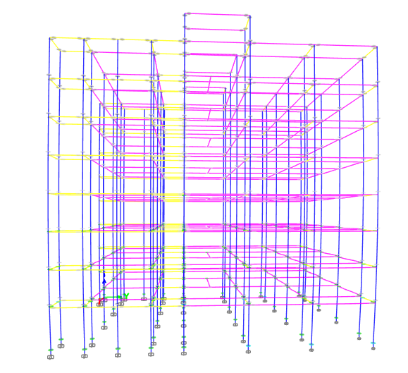
Figure 3
Location of Plastic Hinges in the X Direction (yellow lines)
Source: Author

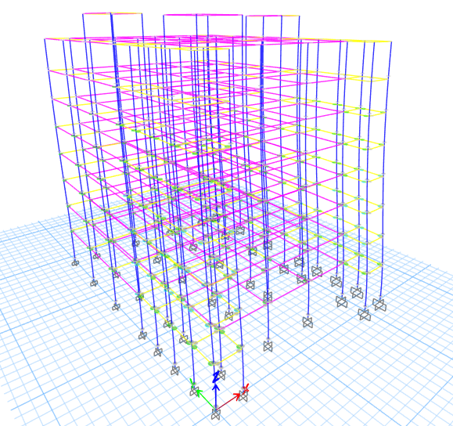
Figure 4
Location of Plastic Hinges in the Y Direction (yellow lines)
Source: Author

The "strong column-weak beam" requirement for a building structure is satisfied if plastic hinges form first in the beams [23]. According to Figures 3 and 4, the most critical elements in this study are located in the columns with Life Safety (LS) performance in both X and Y directions. This condition leads to the loss of the building's ability to maintain a "continuity strong mechanism," which involves the formation of plastic hinges in the columns at both the top and bottom of the vertical structure [24] In this study, plastic hinges in the columns occur due to the suboptimal design of 900 mm columns, which are inadequate to support the load. Therefore, the design of beams and columns should ensure sufficient dimensions to effectively support the loads.

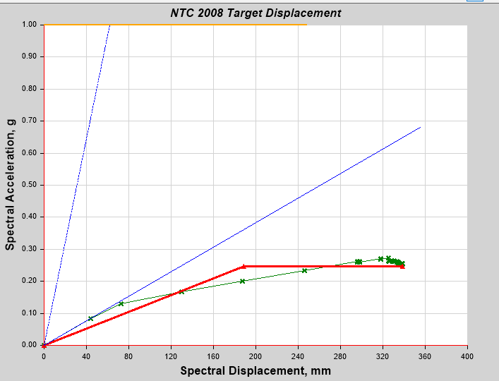
Figure 5
Structural Performance According to ATC-40 Push X
Source: Author

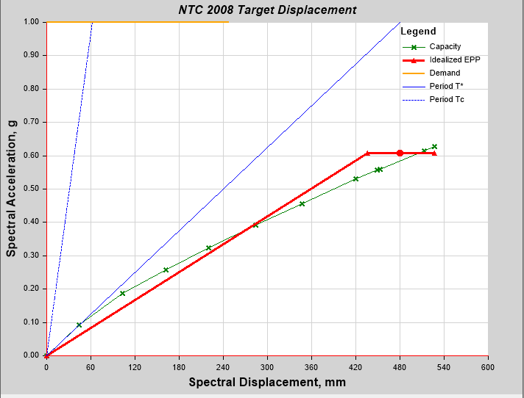
Figure 6
Structural Performance According to ATC-40 Push X
Source: Author

Table 12
Structural Performance Levels
Direction | Displacement (mm) | Maximum Total Drift | Performance Level
X | 523,22 | 0,0141 | Damage Control
Y | 631,462 | 0,0170 | Damage Control
Source: Author

According to the ATC-40 method, the structure is categorized within the Damage Control (DC) performance level for both the X and Y directions, as presented in Table 12, Figure 5, and 6. This classification signifies that the building can effectively withstand seismic forces during an earthquake while posing minimal risk to human life. The Damage Control level indicates that although the structure can endure seismic activity, it may sustain some damage that could impair its functionality.
It is advisable to implement reinforcing measures even when the structure meets the Damage Control requirements. Such reinforcements are crucial for ensuring long-term stability and safety, especially in seismically active regions. The significance of retrofitting is underscored in numerous seismic assessment frameworks, which advocate for proactive enhancements to structural integrity to mitigate risks associated with future seismic events. By adopting these measures, building owners can significantly reduce the likelihood of severe damage, thereby improving the overall resilience of the structure[25].
Pushover analysis reveals that the Existing Building is at risk of not achieving the Collapse Prevention (CP) performance level, even if the overall drift is within the Damage Control (DC) limits. This concern is particularly relevant for structural components that may undergo significant deformation in the later stages of analysis, potentially jeopardizing the building's seismic performance. Addressing these vulnerabilities through appropriate retrofitting strategies is essential for enhancing overall safety and resilience against seismic events[26].
For several reasons, the Existing Building fails to meet the Collapse Prevention (CP) performance criteria. Although the building's elastic design aims to minimize structural damage and ensure the safety of its occupants, this approach does not suffice to achieve the CP performance target. While the elastic design allows the building to endure deformation without incurring significant permanent damage, it may lack the necessary rigidity to conform to the minimal deformation requirements established by CP performance standards.
Research highlights that reliance on elastic design strategies alone can lead to insufficient structural response during severe seismic events, potentially exposing the building to risks of failure or excessive damage [27]. Effective seismic design must prioritize both the ability to withstand deformation and the necessity for rigidity to meet stringent performance objectives, particularly in seismically active regions [28]. Thus, enhancing structural integrity through retrofitting or adopting more resilient design principles becomes imperative to ensure compliance with performance criteria in future seismic assessments [29].
To cut expenses and material waste, relatively small structural element sizes were chosen [30]. But this also has an impact on the rigidity and strength of the structure. Smaller components typically have lower lateral load resistance, which makes it harder for the building to achieve the Collapse Prevention (CP) performance target [31]. Additionally, the lack of lateral stiffness affects the building's overall performance in meeting the Collapse Prevention (CP) requirement, even though columns offer significant structural support and have an average height on each floor [32]. Variations in structural element capacity can also be caused by differences in reinforcement and dimension rounding between the original design and field execution [33]. These differences may cause structural components to be less capable of withstanding earthquake loads, failing to
To optimize cost and minimize material waste, structural elements were designed with relatively small dimensions, as noted by prior studies [34]. However, this choice compromises both the stiffness and strength of the overall structure. Typically, smaller components exhibit reduced lateral load resistance, posing challenges for the building to meet the Collapse Prevention (CP) performance criteria [35]. Insufficient lateral stiffness adversely affects the building's ability to satisfy the CP requirement, despite the columns providing considerable structural support with a standard height across each floor level [31]. Furthermore, disparities in the structural capacity of elements may arise due to variations in reinforcement placement and dimensional adjustments made during field implementation, as opposed to the initial design specifications [36]. Such discrepancies can reduce the structural elements' resilience against seismic forces, potentially compromising their earthquake-resistant capacity.
Taking all factors into account, the Existing Building does not satisfy the Collapse Prevention (CP) standards outlined in ASCE 41-17. To enhance its resilience under severe seismic forces, a more rigorous approach is required during the design and construction phases. Assessments from Tier 1 to Tier 3 reveal that critical structural components, primarily columns and beams, are inadequate in meeting CP criteria. Strengthening these elements with Fiber-Reinforced Polymer (FRP) is recommended to improve their capacity and performance in resisting seismic loads.
The ASCE 41-17 standard endorses the utilization of Fiber-Reinforced Polymer (FRP) strengthening as an effective strategy to enhance the shear and flexural capacities of structural elements, such as beams and columns, while keeping the additional dead load to a minimum. Applying FRP to these surfaces significantly improves their ductility, mitigates the risk of cracking or failure under seismic loading, and increases lateral strength. This approach is crucial for enhancing the resilience and overall performance of structures in seismic-prone areas, ensuring compliance with modern engineering safety standards [37].
Applying Fiber-Reinforced Polymer (FRP) to columns enhances their axial and shear capacities, effectively preventing collapse due to localized high stresses. This strengthening technique improves the columns' overall structural integrity, enabling them to withstand greater loads and resist failure during seismic events. By reinforcing these critical components, engineers can significantly enhance the resilience of structures in seismic-prone regions, ensuring they meet safety standards and performance requirements. [38]. The integration of Fiber-Reinforced Polymer (FRP) materials into structural components significantly enhances their performance under various loading conditions. When applied to columns, FRP improves both axial and shear capacities, mitigating the risk of collapse due to concentrated stresses. This enhancement is particularly crucial in ensuring the structural integrity of columns subjected to high loads and dynamic forces, such as those experienced during seismic events [39]
Similarly, the application of FRP in beams improves their flexural and shear capabilities, allowing these elements to undergo greater deformations without incurring substantial damage. This capacity for increased deformation is vital in improving the overall resilience of structures during seismic activities, effectively reducing the likelihood of structural failure. Research has demonstrated that strengthening reinforced concrete (RC) beams with FRP can significantly enhance their load-bearing capacity and cracking resistance, providing a durable and lightweight alternative to traditional reinforcement methods [40].
To enhance the performance of columns during seismic events, the use of stirrups is recommended to improve lateral confinement. This approach increases the columns' capacity to withstand seismic stresses without incurring significant damage. Additionally, reinforcing beam-column joints is critical, as these areas often become vulnerable during earthquakes. By providing extra reinforcement at these junctions, the flexural and shear capacities can be significantly improved [41]. Furthermore, to ensure better lateral stress distribution to shear walls or other vertical structural elements, it is essential to strengthen and stiffen the floor diaphragm. This can be achieved by adding a reinforced concrete topping slab or applying an FRP layer on the diaphragm's surface. Such modifications not only enhance the structural integrity but also help in meeting the Collapse Prevention (CP) criteria set forth by ASCE 41-17 [42]. Lastly, better lateral stress distribution to shear walls or other vertical elements can be ensured by strengthening and stiffening the floor diaphragm, for example, by installing a reinforced concrete topping slab or FRP layer on the diaphragm surface [43]. Through the implementation of these strengthening measures, the Existing Building is expected to achieve greater structural safety and stability during seismic events, ultimately enhancing its resilience and compliance with established performance standards.​

CONCLUSION
Upon conducting a comprehensive evaluation, the existing building was determined to be non-compliant with the Collapse Prevention (CP) performance criteria outlined in ASCE 41-17 across all three evaluation tiers: Tier 1, Tier 2, and Tier 3. Specifically, the Tier 1 assessment revealed significant deficiencies within the moment frame structure and essential structural elements, predominantly attributed to substandard materials and inadequate design practices. The Tier 2 evaluation indicated that numerous structural components, such as beams, columns, and joints, exhibited elevated Demand-Capacity Ratio (DCR) values, signaling a substantial ductility demand. Furthermore, the Tier 3 analysis confirmed that even the implementation of an elastic design does not enable the building to achieve the CP performance targets, thereby highlighting the imperative for additional reinforcement measures.
In light of the findings from this investigation, several avenues for future research are recommended. Subsequent studies need to incorporate the substructure into their assessments to enhance the precision of the results. Additionally, future research initiatives could focus on developing effective strengthening methodologies aimed at improving the seismic resilience of critical elements such as columns, beams, and shear walls, thereby addressing the deficiencies identified through the DCR analyses.
.
ACKNOWLEDGMENT
The authors disclosed receipt of the following financial support for the research, authorship, and/or publication of this article: This work was supported by the Politeknik Negeri Jakarta.

REFERENCES
[1] Humas Universitas Indonesia, “Strategi Efektif Bangunan Sederhana Tahan Gempa.” Accessed: Feb. 01, 2024. [Online]. Available: https://www.ui.ac.id/strategi-efektif-bangunan-sederhana-tahan-gempa/
[2] CNN, “BMKG: Indonesia Diguncang 10.789 Gempa Sepanjang 2023,” CNN Indonesia,” 2023.
[3] M. Mavrouli, S. Mavroulis, E. Lekkas, and A. Tsakris, “The Impact of Earthquakes on Public Health: A Narrative Review of Infectious Diseases in the Post-Disaster Period Aiming to Disaster Risk Reduction,” Microorganisms. 2023. doi: 10.3390/microorganisms11020419.
[4] B. Yildizlar, C. Akcay, and N. K. Öztorun, “A rapid analysis method for determining current status of existing buildings: A conceptual framework,” Rev. la Constr., vol. 17, no. 2, pp. 267–278, 2018, doi: 10.7764/RDLC.17.2.267.
[5] D. A. Pohoryles, D. A. Bournas, F. Da Porto, A. Caprino, G. Santarsiero, and T. Triantafillou, “Integrated seismic and energy retrofitting of existing buildings: A state-of-the-art review,” Journal of Building Engineering. 2022. doi: 10.1016/j.jobe.2022.105274.
[6] ASCE, ASCE standard, ASCE/SEI, 41-17, seismic evaluation and retrofit of existing buildings. 2017.
[7] M. Dilena, M. Fedele Dell’Oste, A. Gubana, A. Morassi, and E. Puntel, “Dynamic Testing in Support of the Seismic Assessment of a Century Old Masonry Building Complex,” Buildings, 2022, doi: 10.3390/buildings12060805.
[8] M. M. Khan, M. F. A. Khan, K. K. Karinuddin, and K. S. Charan, “Comparative Study of Linear Static and Linear Dynamic Method of Seismic Analysis of RCC Multistoried Building Using ETABS,” Int. J. Res. Appl. Sci. Eng. Technol., 2022, doi: 10.22214/ijraset.2022.42322.
[9] P. Kot, M. Muradov, M. Gkantou, G. S. Kamaris, K. Hashim, and D. Yeboah, “Recent advancements in non-destructive testing techniques for structural health monitoring,” Applied Sciences (Switzerland). 2021. doi: 10.3390/app11062750.
[10] A. Keshmiry, S. Hassani, M. Mousavi, and U. Dackermann, “Effects of Environmental and Operational Conditions on Structural Health Monitoring and Non-Destructive Testing: A Systematic Review,” Buildings. 2023. doi: 10.3390/buildings13040918.
[11] W. W. Carofilis Gallo, N. Clemett, G. Gabbianelli, G. O’reilly, and R. Monteiro, “Seismic Resilience Assessment in Optimally Integrated Retrofitting of Existing School Buildings in Italy,” Buildings, 2022, doi: 10.3390/buildings12060845.
[12] American Society of Civil Engineers, ASCE standard, ASCE/SEI, 41-17, seismic evaluation and retrofit of existing buildings. 2017.
[13] J. A. Jarrett, J. P. Judd, and F. A. Charney, “Comparative evaluation of innovative and traditional seismic-resisting systems using the FEMA P-58 procedure,” J. Constr. Steel Res., 2015, doi: 10.1016/j.jcsr.2014.10.001.
[14] S. Prasanth, G. Ghosh, P. K. Gupta, V. Kumar, P. Paramasivam, and S. Dhanasekaran, “Selection of Response Reduction Factor Considering Resilience Aspect,” Buildings, 2023, doi: 10.3390/buildings13030626.
[15] Badan Standarisasi Nasional, “SNI 1726:2019,” Tata Cara Perenc. Ketahanan Gempa Untuk Strukt. Bangunan Gedung dan Non Gedung, 2019.
[16] ASCE/SEI 41-2017, Seismic Evaluation and Retrofit of Existing Buildings. 2017. doi: 10.1061/9780784416112.
[17] M. V. Requena-Garcia-Cruz, A. Morales-Esteban, and P. Durand-Neyra, “Optimal ductility enhancement of RC framed buildings considering different non-invasive retrofitting techniques,” Eng. Struct., 2021, doi: 10.1016/j.engstruct.2021.112572.
[18] N. Gharaei-Moghaddam, M. Meghdadian, and M. Ghalehnovi, “Innovations and advancements in concrete-encased steel shear walls: A comprehensive review,” Results in Engineering. 2023. doi: 10.1016/j.rineng.2023.101351.
[19] R. R. Arima, R. Sani Saputra, and R. Kurniawaran, “Pushover Analysis of 6-Floors Irregular Building Structure (Case Study: Fave Hotel Building-Padang City, West Sumatra),” Riwayat Educ. J. Hist. Humanit., vol. 6, no. 3, pp. 859–871, 2023, [Online]. Available: https://doi.org/10.24815/jr.v6i1.33793
[20] M. Vinay, P. Kodanda Rama Rao, S. Dey, A. H. L. Swaroop, A. Sreenivasulu, and K. Venkateswara Rao, “Evaluation of progressive collapse behavior in reinforced concrete buildings,” Structures, 2022, doi: 10.1016/j.istruc.2022.10.001.
[21] H. S. Aji, A. Rosyidah, and J. Saputra, “The effect of variation of shear walls placement on the response of building structure using the Direct Displacement-Based Design method,” SINERGI, 2022, doi: 10.22441/sinergi.2022.2.009.
[22] FEMA, “FEMA 356 - Prestandard and commentary for the seismic rehabilitation of buildings , FEDERAL EMERGENCY MANAGEMENT AGENCY,” Rep. FEMA-356, Washington, DC, 2000.
[23] M. M. Shamszadeh and S. Maleki, “Evaluation of strong column-weak beam criterion in spliced columns of steel moment frames,” Results Eng., 2022, doi: 10.1016/j.rineng.2022.100453.
[24] H. Jiang, C. Jin, L. Yan, Q. N. Li, and W. Lu, “Design method for the relocation of plastic hinges in prefabricated steel beams with corrugated webs,” PLoS One, 2021, doi: 10.1371/journal.pone.0246439.
[25] “Seismic Risk Analysis of Government Buildings in the City of Tembilahan using FEMA P-58,” Rekayasa Sipil, 2024, doi: 10.21776/ub.rekayasasipil.2024.018.01.6.
[26] M. M. Kassem, F. Mohamed Nazri, and E. Noroozinejad Farsangi, “On the quantification of collapse margin of a retrofitted university building in Beirut using a probabilistic approach,” Eng. Sci. Technol. an Int. J., 2020, doi: 10.1016/j.jestch.2019.05.003.
[27] F. Freddi et al., “Innovations in earthquake risk reduction for resilience: Recent advances and challenges,” Int. J. Disaster Risk Reduct., 2021, doi: 10.1016/j.ijdrr.2021.102267.
[28] W. Hua, J. Ye, and J. Ye, “Resilience assessment and seismic risk assessment of reticulated shell structures considering multiple uncertainties,” Structures, 2023, doi: 10.1016/j.istruc.2023.06.129.
[29] J.-H. Kim, C. J. Hessek, Y. J. Kim, and H.-G. Park, “Seismic analysis, design, and retrofit of built-environments: a procedural review of current practices and case studies,” J. Infrastruct. Preserv. Resil., vol. 3, no. 1, p. 11, Sep. 2022, doi: 10.1186/s43065-022-00056-3.
[30] I. M. Pertiwi, F. S. Herlambang, and W. S. Kristinayanti, “ANALISIS WASTE MATERIAL KONSTRUKSI PADA PROYEK GEDUNG (STUDI KASUS PADA PROYEK GEDUNG DI KABUPATEN BADUNG),” J. SIMETRIK, 2019, doi: 10.31959/js.v9i1.204.
[31] N. Elkady, L. Augusthus Nelson, L. Weekes, N. Makoond, and M. Buitrago, “Progressive collapse: Past, present, future and beyond,” Structures, 2024, doi: 10.1016/j.istruc.2024.106131.
[32] Nurul Hidayati, Hariyadi, and Mukhta Riqi Sab’it Tibaq, “Analisa ketidakberaturan horizontal dan vertikal pada struktur gedung beton bertulang,” Padur. J. Tek. Sipil Univ. Warmadewa, 2023, doi: 10.22225/pd.12.2.7653.235-243.
[33] F. S. Yoresta, “Perbedaan Desain Tulangan Elemen Struktur Beton Bertulang Berdasarkan Jenis Tanah Pada SNI-1726-2002,” J. Rekayasa Sipil, 2017, doi: 10.25077/jrs.13.1.23-28.2017.
[34] L. Mei and Q. Wang, “Structural optimization in civil engineering: A literature review,” Buildings. 2021. doi: 10.3390/buildings11020066.
[35] M. Ebadi-Jamkhaneh, D. P. N. Kontoni, and A. Homaioon Ebrahimi, “Assessment of Different Methods for Enhancing Progressive Collapse Resistance of Irregular Reinforced Concrete Buildings Using Pushdown Analysis,” Arab. J. Sci. Eng., 2024, doi: 10.1007/s13369-024-08847-4.
[36] K. M. Aishwarya, N. V Anand, and N. C. Balaji, “An experimental study on structural performance of reinforced concrete beams strengthened for combined flexure and shear by using NSM-GFRP strips,” IOP Conf. Ser. Mater. Sci. Eng., 2023, doi: 10.1088/1757-899x/1282/1/012006.
[37] M. Chellapandian and S. S. Prakash, “Axial compression-flexure interaction behavior of hybrid fiber-reinforced polymer-strengthened columns,” ACI Struct. J., 2019, doi: 10.14359/51710877.
[38] Y. Yardim, S. Yilmaz, M. Corradi, and W. A. Thanoon, “Strengthening of Reinforced Concrete Non-Circular Columns with FRP,” Materials (Basel)., 2023, doi: 10.3390/ma16216973.
[39] A. Jahami and C. A. Issa, “An Updated Review on the Effect of CFRP on Flexural Performance of Reinforced Concrete Beams,” International Journal of Concrete Structures and Materials. 2024. doi: 10.1186/s40069-023-00651-y.
[40] A. Arafa, “Seismic Response of Concrete Components and Systems Reinforced with Fiber Reinforced Polymer (FRP) Bars: Trend and Challenges,” Curr. Trends Civ. Struct. Eng., 2019, doi: 10.33552/ctcse.2019.03.000567.
[41] W. Zheng, W. Chang, and M. Hao, “Estimation of lateral stress of stirrups at peak stress and residual stress of confined concrete at stirrups fractured in confined concrete under axial compression,” Mater. Today Commun., 2023, doi: 10.1016/j.mtcomm.2023.106260.
[42] M. K. Askar, A. F. Hassan, and Y. S. S. Al-Kamaki, “Flexural and shear strengthening of reinforced concrete beams using FRP composites: A state of the art,” Case Stud. Constr. Mater., 2022, doi: 10.1016/j.cscm.2022.e01189.
[43] M. A. El-Mandouh, M. S. Omar, and A. S. Abd El-Maula, “Behaviour of RC flat slabs with openings strengthened with CFRP,” Case Studies in Construction Materials. 2021. doi: 10.1016/j.cscm.2021.e00587.

