 | SINERGI Vol. xx, No. x, February 20xx: xxx-xxx http://publikasi.mercubuana.ac.id/index.php/sinergi http://doi.org/10.22441/sinergi.xxxx.x.xxx | 

Improving the Implementation of Indonesian Halal Logistics: A Statistical Approach | 

Dwi Agustina Kurniawati¹, Dwi Kristanto², Suhaiza Zailani³, Muhammad Arief Rochman¹, Cindy Caroline¹

¹Department of Industrial Engineering, Universitas Islam Negeri Sunan Kalijaga, Indonesia
²Department of Industrial Engineering, Universitas Gadjah Mada, Indonesia
³Faculty of Business and Economics, University of Malaya, Malaysia

Abstract  In Indonesia, only a limited number of logistics providers have obtained halal certification, even though halal logistics plays a crucial role in preserving product integrity and preventing cross-contamination. This study analyzes the implementation of halal logistics by identifying key variables that influence the availability of halal products in the Indonesian market. Using a quantitative research approach, data were collected through surveys of 108 companies, including 35 logistics service providers and 73 halal-certified MSMEs, as well as semi-structured interviews with logistics service providers and MSME business actors in the food sector. The data were analyzed using multiple regression analysis to determine the most influential factors affecting halal product availability. The findings indicate that halal product information availability, consistent worker training, and corporate environmental responsibility are the primary variables influencing halal product availability. These insights provide a foundation for policymakers to develop regulations that strengthen halal logistics while enabling logistics providers and MSMEs to allocate resources more effectively to maintain halal product availability in the market. As one of the few studies examining halal logistics in Indonesia’s food sector, this research contributes to the broader discourse on halal supply chain management and policy development.  This is an open access article under the CC BY-SA license   | Keywords:  Halal Logistics, Multi Regression, Availability, Logistics Service Companies, MSME.  Article History:  Corresponding Author:  Dwi Agustina Kurniawati  Industrial Engineering Department, Universitas Islam Negeri Sunan Kalijaga, Indonesia  Email: dwi.kurniawati@uin-suka.ac.id

INTRODUCTION
The halal industry has its roots in Islamic dietary laws and principles that have been practiced for centuries. However, its modern economic significance began to grow in the late 20th century, driven by globalization, increased consumer awareness, and government regulations supporting halal certification [1]. The expansion of halal certification beyond food products, including cosmetics, pharmaceuticals, and logistics, has played a crucial role in shaping the contemporary halal economy [2]. In recent times, the halal industry has emerged as a substantial market, expanding beyond Muslim-majority nations to include non-Muslim countries [3]. The sector is experiencing notable growth, presenting promising opportunities.
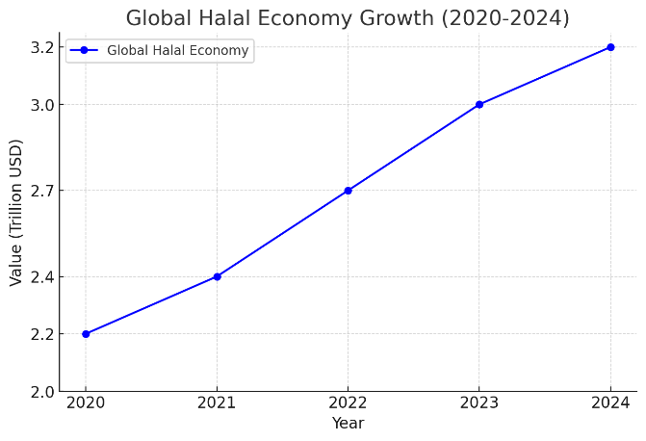
Figure 1. Global Halal Economy Growth Chart (2020-2024)

Figure 1 illustrates the growth of the global halal economy from 2020 to 2024, showing a significant upward trend. The market value increased from $2.2 trillion in 2020 to a projected $3.2 trillion in 2024, highlighting the rising demand for halal products and services worldwide. According to the Halal Guidebook's second edition, experts predict the global halal economy will reach $3.2 trillion by 2024, with the food and beverage sector leading the way [4]. For Muslims, it's crucial that food adheres not only to halal standards prescribed by Islamic law but also meets the criterion of tayyib, ensuring it is wholesome and fit for consumption [5]. Cross-contamination poses a significant risk, potentially transforming halal products into non-halal ones, highlighting a unique challenge in the industry [6].
Nugroho et al. [7] calls this characteristic of halal products cross-contamination with non-halal products. Cross-contamination occurs due to the discovery of pig DNA, pork, and others in halal products. Similarly, in 2014, Malaysia authority discovered non-halal ingredients in Cadbury Malaysia's halal chocolate products [8]. Research on the distribution of halal products is essential to consider the risk of cross-contamination between halal and non-halal products. The risk is to address the possibility of cross-contamination, where halal products may turn into non-halal products [9]. Consequently, research into the distribution of halal products becomes crucial to mitigate the risk between halal and non-halal items, aiming to prevent halal products from inadvertently becoming non-halal [2].
Kurniawati and Savitry [10] discovered that Muslim consumers exhibit a high awareness of halal products. Consequently, inadequate management of halal product distribution can result in issues such as scarcity, overstocking, and product damage due to contamination with non-halal items [11]. Damaged products contribute significantly to waste within the supply chain, underscoring the need for strategies to manage the impact of waste resulting from product damage [12]. The implementation of a halal supply chain and effective logistics is essential to ensure efficiency and effectiveness in halal product distribution.
Halal supply chain represents a relatively new area in supply chain research, warranting further investigation [13]. Given this context, there is a pressing need for a study that examines the adoption of halal standards by logistics providers in Indonesia. Currently, only a small number of logistics providers in Indonesia have obtained halal certification [14]. However, given the critical role of halal logistics in maintaining the integrity of halal products, it is imperative to conduct comprehensive research and analysis to assess the extent to which logistics providers in Indonesia adhere to halal standards [15]. This study would shed light on the implementation challenges and successes in integrating halal requirements into logistics practices within the Indonesian context.
As noted earlier, there has been an increasing demand for implementing halal supply chains (HSC) and halal logistics to ensure the integrity of halal products [7]. Soon et al. [16] have proposed frameworks and models for maintaining HSC integrity. There is several determinants crucial for the success of HSC, including government support, transportation planning, information technology, human resources, collaborative relationships, halal certification, and halal traceability [2]. The need for a supply chain approach to guaranteeing halal integrity, while investigating barriers to managing HSC effectively. Therefore, halal logistics plays a crucial role in ensuring the halal status of food products [7].
Halal logistics encompasses all activities involved in product distribution, contamination prevention processes, and adherence to Shariah principles [16]. According to Saidah et al. [1], transportation, warehousing, material handling, and procurement activities must comply strictly with halal requirements. Implementing halal storage and transportation practices significantly impacts a company's financial performance [1]. The necessity of segregating halal and non-halal products during warehousing and transportation to prevent contamination [17]. Key Halal Compliance Points for processed products emphasize the importance of closely monitoring critical aspects like storage, warehousing, transportation, and product handling to maintain adherence to halal standards [18]. Manufacturers are responsible for ensuring products are produced in accordance with halal standards and that there is no cross-contamination with non-halal materials [19]. To authenticate halal meat products, the implementation of halal supply chains and verification methods is crucial. These measures ensure that products meet halal requirements from production through to distribution and consumption.
Several barriers hinder the widespread adoption of halal logistics certification in Indonesia. Regulatory challenges, including the complexity of obtaining halal certification and the lack of standardized enforcement mechanisms, have contributed to slow adoption rates [20]. Additionally, logistical costs associated with maintaining halal compliance, such as dedicated storage, transportation segregation, and certification fees, create financial burdens for logistics providers, particularly small and medium enterprises [21]. Furthermore, awareness among logistics companies regarding the importance of halal compliance remains relatively low, resulting in inconsistent implementation of halal logistics practices [20].
Furthermore, it is essential for all logistics companies to use materials derived from halal sources when packaging halal products. Talib et al. [22] conducted a study focusing on halal practices within the poultry processing industry, revealing that the use of halal animal feed, adherence to proper sharia-compliant slaughter methods, and appropriate post-slaughter processes (including handling, packaging, transportation, and storage of poultry products) are crucial factors determining halal integrity in this sector [23].
The capabilities of halal logistics play a critical role in maintaining halal integrity throughout the supply chain, from farm to consumer [1]. Therefore, ensuring complete separation of halal and non-halal products during logistics operations is necessary to guarantee the halal status of a product [24]. This practice shields halal products from contamination with non-halal items or substances until they are delivered to the consumer [25]. In conclusion, the implementation of halal logistics is pivotal in assuring the integrity of halal products. This involves rigorous adherence to halal standards and practices throughout the logistics process to uphold the sanctity of halal products from production through distribution and consumption.
By conducting a study to analyze the implementation level of logistics providers, it will enable an assessment of how well halal standards are implemented by logistics providers in Indonesia. This study aims to derive valuable insights and lessons learned that can inform the formulation of policy proposals for halal logistics in the country. The research will contribute by examining and analyzing the current state of halal logistics implementation in Indonesia, thereby providing a basis for developing policy recommendations to enhance adherence to halal standards within the logistics sector. This study aims to bridge this gap by analyzing halal logistics implementation and identifying key factors influencing halal product availability in the Indonesian market.

METHODOLOGY
This study employs a quantitative approach to examine logistics service providers and MSMEs in Indonesia. The research utilizes a random sampling method to ensure representativeness in data collection. The selected samples include business operators from the logistics sector and MSME-level business actors from the food sector in Indonesia. The sample data are collected through randomization.
In this study, the population consists of logistics service providers in Indonesia. At the same time, the selected samples comprise business operators in the logistics service sector and MSME-level business actors in the food sector in Indonesia. The sample was drawn using a random sampling method to ensure each entity has an equal chance of being selected, so that the results of the study can be considered representative of the wider population. This research sampled a total of 108 companies, consisting of 35 logistics service companies and 73 MSME-level that have obtained halal certification. This study relies on primary data obtained directly through questionnaire-based assessments by the researchers and secondary data that includes R-table information, halal logistics elements, and questionnaires related to halal logistics.
Data collection in this study used observation, interviews, and questionnaires. The observation was conducted by directly examining the company's production flow and overall condition. This approach allowed the researchers to understand the flow of the company's supply chain. The research process was conducted in three main phases. The data collection phase, carried out from January to March 2024, involved conducting observations, interviews, and distributing questionnaires to logistics service providers and MSMEs. This was followed by the data analysis phase, which took place from April to June 2024, where responses were processed, statistical tests were performed, and a multi-regression analysis was conducted to identify key influencing factors. Finally, the results interpretation and report writing phase, conducted from July to August 2024, focused on analyzing findings, drawing conclusions, and preparing the final research documentation.
Interviews were conducted with five company owners from the logistics sector and seven MSME representatives who had obtained halal certification. Each interview lasted 30–45 minutes and focused on four key topics: procurement processes, production flow, distribution methods, and product return management. The interview questions covered procurement, production, distribution, and product returns. The insights gained from these interviews were later used to design the questionnaires.
The questionnaire method involved distributing a list of questions to be completed by respondents. The questionnaires used a Likert scale ranging from 1 to 5, where 1 represents "strongly disagree," 2 means "disagree," 3 means "neutral," 4 means "agree," and 5 represents "strongly agree.".

Validity Test
Validity refers to the extent to which a measuring instrument accurately measures what it is intended to measure. A valid instrument effectively demonstrates this by reliably assessing the desired constructs or variables. In conducting a validity test, researchers typically perform a data sufficiency test at a 5% significance level (α) and a 95% confidence level, resulting in a critical Z-value of 1.96. The error rate (e) is set at 10%. The assumption is that the population probability of being sampled is 0.5. This test determines whether the collected data is adequate for further analysis and interpretation, utilizing formulas such as those described, particularly relevant in contexts where the number of small and medium enterprises is dynamic.
Moreover, Pearson's product-moment correlation analysis is commonly employed to assess the relationship between individual item scores and the total score. This analysis aids in determining whether the questions effectively measure the underlying constructs. Firdaus [18] suggests using the Pearson product-moment formula to evaluate validity, where if the calculated correlation coefficient (r) is greater than the critical value (r table), the variable is deemed valid; otherwise, it is considered invalid. In summary, validity testing ensures that the instrument used accurately measures the intended variables or constructs, employing statistical methods to validate the instrument's effectiveness and reliability in research studies.

Reliability Test
A reliability test shows how the measurement results remain consistent when carried out twice or more on the same symptoms [2]. Use a measuring tool with the Cronbach Alpha technique in this reliability test. If a variable is worth measured r => 0.60, it is said to be reliable. Meanwhile, if a variable is worth a count <0.60, it is said to be unreliable.
The normality test determines whether data distribution follows or approaches a normal distribution. The Kolmogorov- Smirnov test is one of several tools that can be used to test for normality [26].
The Likert scale is a scale used to measure the attitudes, opinions and perceptions of a person or group of people about social phenomena [2].
Multi regression analysis is a statistical method used to analyze the relationship between one dependent variable (Y) and two or more independent variables (X₁, X₂, ..., X_{n}). Multi-regression analysis was selected because it allows for identifying significant relationships between multiple independent variables and the availability of halal-certified logistics services. Given the complexity of logistics operations, this method is suitable for examining how different factors collectively influence logistics efficiency and service availability.
The first step in multi-regression analysis is to collect data that meets the classical assumptions of linear regression. These assumptions include linearity, independent variables, homoscedasticity, error distribution normality, and the absence of multicollinearity. Next, a regression model is built with the equation Y = β₀ + β₁X₁ + β₂X₂ + ... + β_{n}X_{n} + e. Hypothesis testing determines the statistical significance of the regression coefficients. Researchers conduct residual analysis to ensure that classical assumptions are met. Interpretation of the multi-regression analysis results focuses on the regression coefficient and the coefficient of determination (R₂). The regression coefficient explains the relationship between the independent and dependent variables, while R₂ measures the model's power in explaining variations in the dependent variable. The steps in this research are depicted in the flow diagram in Figure 1.
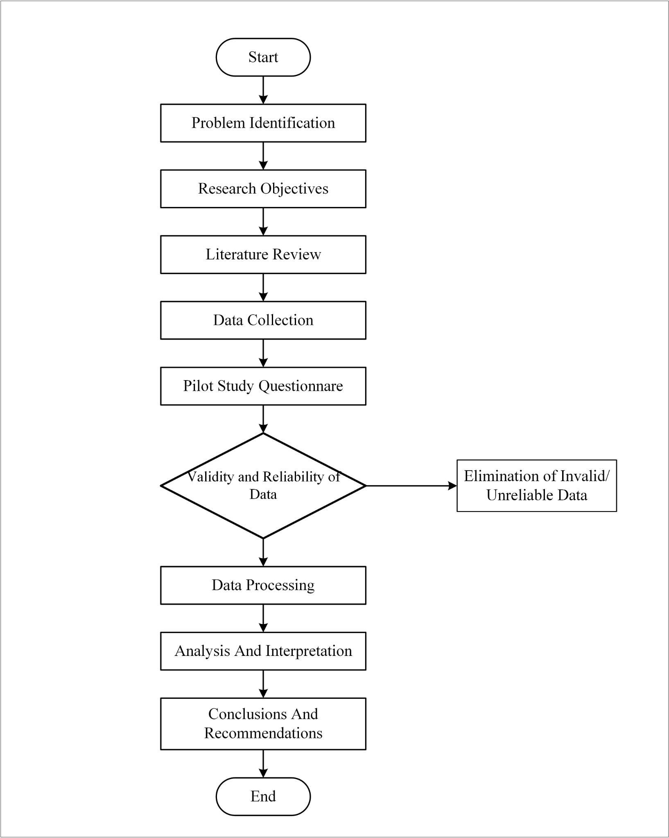
Figure 1. Research flow diagram

This study aims to address the following research questions: (1) What are the key factors influencing the successful implementation of halal logistics in Indonesia? (2) What are the main challenges logistics providers face in obtaining halal certification? (3) How does the implementation of halal logistics impact the efficiency and integrity of halal product distribution? However, this study has some limitations. First, the sample size, although representative, may not fully capture regional variations in logistics operations. The remainder of this paper is structured as follows: Section 2 provides a review of the existing literature on halal logistics and supply chain management. Section 3 discusses the research methodology used in this study. Section 4 presents the findings and analysis of halal logistics implementation in Indonesia. Finally, Section 5 concludes the study with key insights, implications, and recommendations for policymakers and industry stakeholders.

RESULT AND DISCUSSION
Researchers conducted a pilot study before distributing the questionnaire to all respondents, during which they distributed questionnaires to 108 respondents to assess the validity and reliability of the questions provided. The process of evaluating the research instrument will be carried out with consideration after filling out the questionnaire, as well as the relevance of the answers obtained.
The survey was divided into 2 sections. The first section includes respondent biodata, which consists of 3 questions. The second section contains research questions containing 32 variables containing respondents' perceptions of implementing Halal Logistics in Indonesia. Thirty-two variables were obtained from distributing questionnaires. By filling in the data, respondents were asked to rate on a scale of 0 - 5, where 0 means "Disagree" and 5 means "Strongly agree". The total number of respondents in this study was 108 respondents. An explanation of the 32 variables can be seen in Table 1.

Table 1. Variable of Halal Logistics Implementation
Dimensions | Sub Dimension | Variables | Description | Reference
Implemen-tation of halal logistics | Availability of Halal Products | Halal products are always available according to market demand | Y | [27]
Organization | Social | Information about halal products is always available and transparent | X₁ | [28]
Organization | Social | The image of the halal product delivery company greatly influences consumer confidence in the product. | X₂ | [29]
Organization | Social | Workers who handle halal products are highly competent and trustworthy | X₃ | [30]
Organization | Social | Workers who handle halal products receive training in a planned and consistent manner. | X₄ | [30]
Organization | Social | Workers have sufficient knowledge of Islamic law when handling halal products. | X₅ | [30]
Organization | Stakeholders | Informed data on halal products is harmonized between producers, logistics service providers, and consumers. | X₆ | [5]
Organization | Stakeholders | Manufacturers and logistics service providers do an excellent job planning and evaluating halal product business strategies. | X₇ | [27]
Organization | Stakeholders | Halal product business performance indicators are aligned between producers and logistics service providers. | X₈ | [27]
Organization | Stakeholders | The objectives and focus between producers, logistics service providers, and consumers of halal products are aligned to avoid conflicts. | X₉ | [30]
Finance | Financing | Good management of halal products affects company revenue | X₁₀ | [13]
Finance | Financing | There is growing investment in the halal product business | X₁₁ | [31]
Finance | Financing | Halal product consumers experience significant growth | X₁₂ | [12]
Finance | Financing | There are developments in the marketing strategy of halal products | X₁₃ | [31]
Finance | Financing | Special treatment of halal products affects corporate financing | X₁₄ | [27]
Finance | Financing | Halal product transportation costs following the quality of service provided | X₁₅ | [22]
Transporta-tion | Reliability | The number of products delivered is in accordance with consumer orders | X₁₆ | [32]
Transporta-tion | Reliability | Products are distributed with good quality and following the description provided | X₁₇ | [2]
Transporta-tion | Reliability | During distribution, halal products remain hygienic and are not mixed with non-halal goods. | X₁₈ | [30]
Transporta-tion | Reliability | Halal product temperature is always well maintained during the shipping process. | X₁₉ | [30]
Transporta-tion | Electability | Shipping companies can adapt well to halal policies | X₂₀ | [30]
Transporta-tion | Electability | Shipping companies can cope with fluctuations in demand for halal products. | X₂₁ | [30]
Transporta-tion | Asset manage-ment | Halal product deliveries can always be made at a Predetermined time | X₂₂ | [30]
Transporta-tion | Asset manage-ment | Halal product delivery can be done with the expected frequency | X₂₃ | [33]
Transporta-tion | Asset manage-ment | Halal product delivery mileage varies widely | X₂₄ | [33]
Transporta-tion | Asset manage-ment | During the distribution process, there is excessive stock of halal products | X₂₅ | [30]
Transporta-tion | Security | There are many significant threats during the halal product delivery process | X₂₆ | [27]
Transporta-tion | Security | Shipping halal products uses separate containers or vehicles with non-halal products. | X₂₇ | [27]
Sustaina-bility | Carbon Emissions | The company has a target to reduce CO2 emissions from year to year | X₂₈ | [15]
Sustaina-bility | Route Optimization | Average mileage per shipment of halal products by company planning | X₂₉ | [15]
Sustaina-bility | Route Optimization | Average travel time in shipping halal products according to company planning | X₃₀ | [15]
Sustaina-bility | Regulatory Compliance | The company complies with environmental regulations when shipping halal products | X₃₁ | [7]
Sustaina-bility | Impacts to Air and Water Quality | The company is responsible for monitoring and reducing air and water pollution generated during the production and delivery of halal products. | X₃₂ | [27]

Researchers conducted the pilot study to evaluate and improve the developed survey instrument. The sampling technique used in the pilot study was convenient sampling, according to the researcher's wishes. It is commonly used for explanatory research or questionnaire testing and is limited. The pilot study was conducted in two stages, namely qualitative and quantitative stages. The qualitative pilot study was used to validate the content and format of the research instrument. The first stage, or qualitative pilot study results, was then used as a table of questions for 10 pilot study questions or assessment tools, and the second stage was for the quantitative pilot study. The quantitative pilot study data is used to test the research instrument's validity and reliability.
The research questionnaire was validated by 4 people, consisting of 3 directors of logistics service providers and 1 academic. The qualitative pilot study was conducted for 4 iterations, and no comments were found from the fourth respondent, so researchers can use the instrument to collect data. The results of the first stage or qualitative pilot study are then used as a questionnaire or research instrument that has been improved and used for the second or quantitative pilot study.
At this stage, the research instrument underwent evaluation to determine any necessary modifications or enhancements to the questionnaire developed in the previous phase. This evaluation involved testing the validity and reliability of data collected from an initial sample of 30 respondents. A questionnaire is considered valid if its statements or questions effectively measure the intended variables. Meanwhile, reliability refers to the consistency or stability of a measuring instrument over time [2].
The results of the validity and reliability tests ensure that the data obtained are both valid and reliable. Should improvements be identified, the researcher adjusts the instrument based on feedback gathered during this evaluation phase. Conversely, if the survey instrument proves suitable with no further modifications required, it proceeds to the data collection phase.
In this study, the validity test utilized the Spearman correlation test due to the abnormality of the data. The validity was assessed by comparing the correlation coefficient (r count) of each statement with the critical correlation coefficient value (r table) at α = 0.05, set at 0.361. Statements were deemed valid if their correlation coefficient (r count) exceeded 0.361, meeting the requirements outlined in Table 2.
Reliability was tested using Cronbach's alpha (α), where a higher coefficient indicates greater reliability. A questionnaire achieves reliability if it achieves a Cronbach's alpha value above 0.6 [34]. Overall, the reliability test results indicated that all dimensions were reliable. Table 2 presents detailed outcomes of the validity and reliability tests for each dimension.

Table 2. Validity and reliability test
Variables | Dimensions | Validity | Reliability | Interpretation
 |  | Spearman test | Cronbach's Alpha
Organiza-tion | Social | 0.873 | 0.876 | Valid and Reliable
Organiza-tion | Stakeholders | 0.874 | 0.871 | Valid and Reliable
Finance | Financing | 0.878 | 0.874 | Valid and Reliable
Transpor-tation | Reliability | 0.883 | 0.874 | Valid and Reliable
Transpor-tation | Flexibility | 0.872 | 0.874 | Valid and Reliable
Transpor-tation | Asset Management | 0.879 | 0.871 | Valid and Reliable
Transpor-tation | Security | 0.873 | 0.875 | Valid and Reliable
Sustaina-bility | Carbon Emissions | 0.871 | 0.87 | Valid and Reliable
Sustaina-bility | Route Optimization | 0.873 | 0.876 | Valid and Reliable
Sustaina-bility | Regulatory Compliance | 0.879 | 0.881 | Valid and Reliable
Sustaina-bility | Impacts to Air and Water Quality | 0.884 | 0.879 | Valid and Reliable

This research sampled a total of 108 companies, consisting of 35 logistics service companies and 73 MSME-level business actors from the food sector in Indonesia. Based on the processing of the analyzed data, it shows that the amount of valid data on all variables is (n = 108), while the amount of missing data on these variables is 0, which means that this data is valid and there is no missing data. Ho: Significance value p > 0.05, then the data is not normally distributed. H₁: Significance value p <= 0.05, then the data is normally distributed. Analysis of data normality measured using the Shapiro-Wilk test indicates that all variables analyzed follow a normal distribution characterized by a p-value < .050, which means that there is a rejection of Ho in this hypothesis test.
At this stage, an assumption test is used for the variables involved in the multiple regression to determine whether the data meets the data assumptions for linearity, normality, Homoscedasticity and independence of error. Assumption testing uses histograms to determine data normality, residual graphs with predicted values to determine the independence of error and residuals vs predicted values graphs to test Homoscedasticity and linearity.
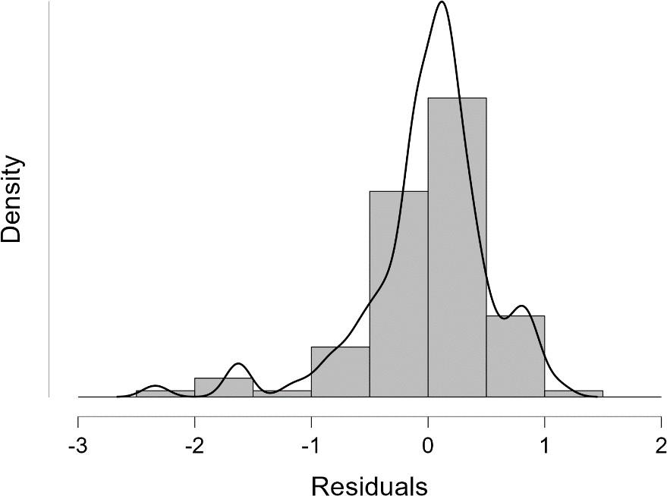
Figure 2 Normality Test Density vs. Residual
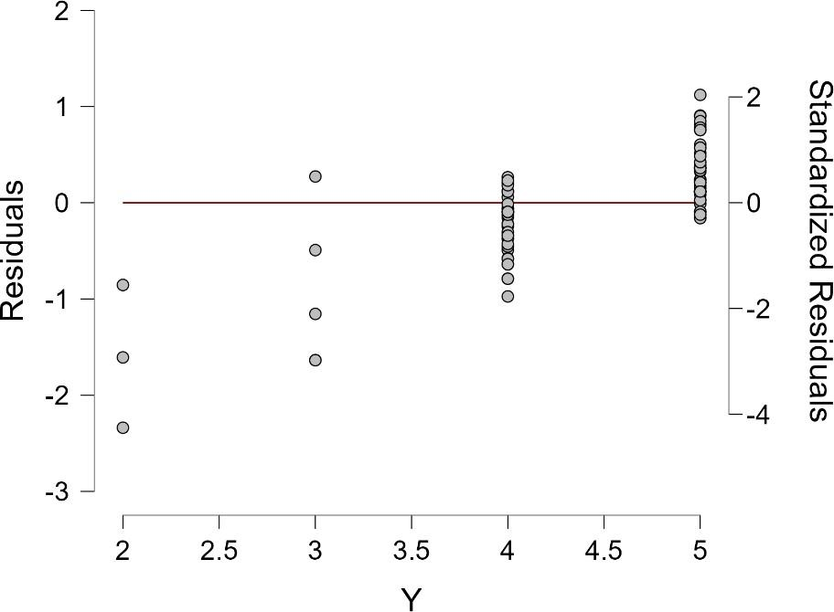
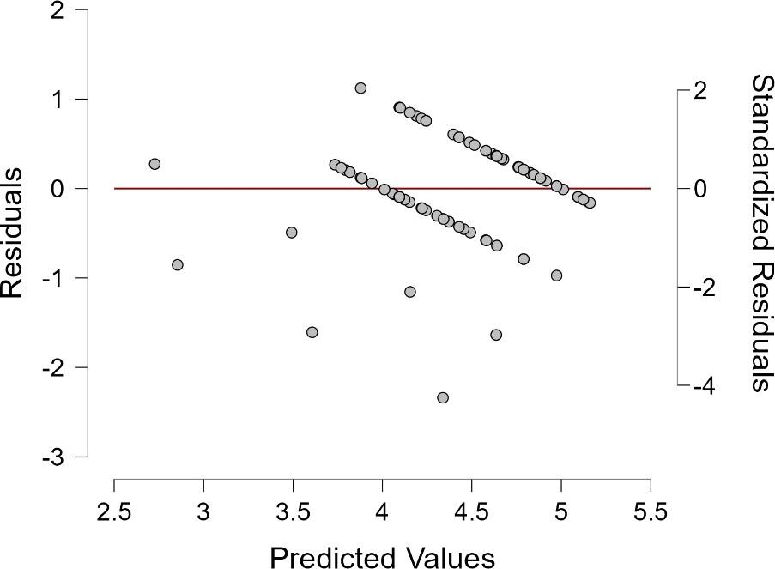
Figure 3 Linearity Test Residuals vs. Dependent
Figure 4 Independence of Error Test
Residuals vs. Predicted

Based on Figure 2, the graph shows that the data is normally distributed because the peaked curve is right in the middle of the data distribution, and the skewness of the data is right in the middle.

Correlation Analysis
From the correlation value, it is found that there is a positive correlation between the dependent variable and other independent variables. The most significant correlation is between the dependent variable and variable X₁ r (108) = .547, p < .001. as well as other dependent variables. Multicollinearity assessment occurs in several predictors, where between the dependent variable X₁₂ and X₁₃ r (108) = .675, p < .001. and the dependent variable X₁₂ and X₁₄ r (108) = .450, p < .001, which must be further analyzed using a multicollinearity check. Linearity testing can be done by analyzing the residuals of the regression model formed. Figure 3 above shows that the data distribution is evenly distributed or does not form a particular pattern, indicating that the data has a linear relationship.
Testing for unequal variance is called the heteroscedasticity test. Alternatively, testing for the same data variance is called homoscedasticity. Figure 3 shows the data variance that does not form a funnel/triangle and/or diamond pattern, so the data is in the homoscedasticity category.
Regression assumes that each predicted value is independent, which means that the predicted value does not depend on the other values. If the residuals are independent, the data distribution pattern appears random and similar to the null plot, as shown in Figure 4, which indicates that the data is independent of error.
The coefficient table obtained for the beta coefficients value above shows that the highest Beta value is X₁, which is 0.513, which means that variable X₁ can cause changes in variable Y by 51.3%, followed by variable X₁₇ by 25.7%. So, in this regression equation, the X₁ value dominates the dependent variable (Y). In addition, from the beta coefficient value, which independent variable has the most dominant influence is also known. The Standardized Coefficient Beta Test compares each variable's Standardized Coefficient Beta value. For example, in the case above, the Coefficient Beta value for X₁ > X₁₇ means that Information Regarding Halal Products is Always Available and Transparent (X₁) contributes dominantly to the implementation of halal logistics compared to other variables. So it can be concluded, in this regression model, the most dominant variables affecting the dependent variable in order are X₁ (Information about halal products is always available and transparent), X₁₇ (Products are distributed with good quality and following the description given), X₁₃ (There are developments in the marketing strategy of halal products), X₄ (The workforce handling halal products receives planned and consistent training), X₃₂ (The company is responsible for monitoring and reducing air and water pollution generated during the production and delivery of halal products) and X₁₂ (Consumers of halal products have experienced significant growth). When viewed in the coefficient table above, it can be concluded that each independent variable does not exhibit symptoms of multicollinearity in the regression model because all the variables' Tolerance values are > 0.1 and VIF values < 10.
Multicollinearity checking by building an MLR model on one dependent variable and six independent variables to be predicted. Next is to conduct a collinearity diagnostic analysis by looking at the tolerance value and partial correlation, where multicollinearity is indicated if the tolerance value is low (< 1 - R₂). In this case, the value of R₂ = 0.411 so that (1 - R₂ = 0.589) shows that the tolerance value is low on X₁₂ and X₁₃ with tolerances <0.589. Furthermore, to see multicollinearity is done by looking at the collinearity diagnostics table where if there are two variables with the maximum value in the same dimension, it is considered to have high multicollinearity; in this case, it occurs in variables X₁₂ and X₁₃, where this assumption is reinforced by the substantial correlation value of the two variables. So, the elimination of variable X₁₃ still results in the appropriate analysis.
Variable selection uses the Backward Method, where all predictors were initially included in the model and their respective contributions were calculated. Predictors with insignificant contribution rates (b<0.1) were removed from the model/equation. This process repeated until all predictors were statistically significant. After 27 iterations, the following is the best result: the variable with the most influence on the dependent variable. The following is a summary table of the backward method with JASP.
The order of variables using the backward value is determined gradually by the JASP application by looking at the correlation value between variables. The greater the Pearson's r value of the independent variable on the dependent variable, the greater the level of correlation. As for the independent variables, the smaller the R square value, the smaller the level of correlation between the independent variables. This is the basis for decision-making in variable selection.
In general, the above model's R-value is the best, with an R-value of 0.639 after deducting variables that are considered to have not affect the dependent variable. The variables selected after 27 iterations with an explanation of each variable are as shown in Table 3.

Table 3. Key Variable and Description in Halal Product Managaent
Variables | Description
Halal products are always available according to market demand | Y
Information about halal products is always available and transparent | X₁
Workers who handle halal products receive training in a planned and consistent manner. | X₄
Halal product consumers experience significant growth | X₁₂
There are developments in the marketing strategy of halal products | X₁₃
Products are distributed with good quality and following the description provided | X₁₇
The company is responsible for monitoring and reducing air and water pollution generated during the production and delivery of halal products. | X₃₂

H₀: Significance value p> 0.05, then there is no effect of the independent variable (X_{n}) on the dependent variable (Y)
H₁: Significance value p <= 0.05, then there is an influence of the independent variable (X_{n}) on the dependent variable (Y)

Table 4. Coefficient
Model | Unstandardized |  | Standard Error | Standar-dized | t | p
H₀ | (Intercept) | 4.463 | 0.069 |  | 64.779 | < .001
H₁ | (Intercept) | 1.303 | 0.543 |  | 2.37 | 0.018
 | X₁ | 0.534 | 0.094 | 0.503 | 5.700 | < .001
 | X₄ | 0.172 | 0.086 | 0.175 | 1.989 | 0.049
 | X₁₂ | -0.151 | 0.091 | -0.146 | -1.658 | 0.100
 | X₁₇ | 0.349 | 0.126 | 0.269 | 2.765 | 0.007
 | X₃₂ | -0.201 | 0.093 | -0.195 | -2.165 | 0.033

After seeing the regression model with the variable selection in Table 4, recalculation using the same regression model and the R square value for this model, and the value is obtained are as shown in Table 5.

Table 5. Model Summary - Y
Model | R | R² | Adjusted R² | RMSE
H₀ | 0.000 | 0.000 | 0.000 | 0.716
H₁ | 0.625 | 0.390 | 0.360 | 0.573

By using 6 variables to predict the value of the dependent variable, researchers obtained an r-square value of 0.625. This r square value is good enough because the closer to one number, the better the model issued by the regression will be. As for the value of the latest regression model, it is shown in the table below. Based on this table, the newest regression model results are as Y = 1,303 + 0.534X₁ + 0.172X₄ - 0.15x₁₂ + 0.349X₁₇ - 0.201X₃₂.
The results of retesting the regression model using JASP software show the final regression equation or model for the combination of variable Y and 6 X variables (X₁, X₄, X₁₂, X₁₇, X₃₂). The equation is Y = 1.303 + 0.534X₁ + 0.172X₄ - 0.151X₁₂ + 0.349X₁₇ - 0.201X₃₂.
The results of making this new model are not too different from the previous one, which shows that the built model is good enough. In the model above, this intercept value is only meaningful or predicts logically if X₁, X₄, X₁₂, X₁₇ and X₃₂ are not equal to 0. In each regression coefficient, each addition, for example, 1 value of X₄ will increase by 0.172. This means that the variable of labor handling halal products and receiving training in a planned and consistent manner contributes 0.175 for an additional value of 1 in predicting that halal products are always available according to market demand. The exciting thing is that the value of X₃₂ is negative, indicating an opposite effect between variables X₃₂ and Y. The implication of this finding is the importance of finding a balance between green practices and operational efficiency. Companies should consider innovations and technologies that can reduce environmental impact without compromising the overall performance of halal logistics. In this context, if small and medium-scale companies are given more responsibility for sustainability, their performance in providing halal products will be reduced by market needs. This is relevant because small and medium-scale companies face the main challenge of limited resources.
When viewed from the beta coefficient value in regression modelling, the variables that have the most influence on the dependent variable are X₁ (Information about halal products is always available and transparent), X₄ (Workers who handle halal products receive training in a planned and consistent manner), X₁₂ (Consumers of halal products experience significant growth), X₁₇ (Products are distributed with good quality and following the description provided), and X₃₂ (The company is responsible for monitoring and reducing air and water pollution generated during the production and delivery of halal products). So, the focus of this research in implementing halal logistics should be to increase information on the transparency of halal products and the distribution of halal products following the rules.
The relationship between increased transparency of information about halal products (X₁) not only has a direct impact on consumer confidence, but can also strengthen worker performance through effective training (X₄). Thus, companies should focus on developing these two aspects simultaneously to improve the implementation of halal logistics. The synergy between information transparency and worker capability development is crucial in creating a strong and reliable halal supply chain.
In addition, continuing to improve the marketing strategy for halal products and conducting training for the workforce in handling halal products is also essential. Another thing that affects the dependent variable is how the company is responsible for reducing air and water pollution during the production and delivery of halal products, so it is expected that consumers of halal products will experience significant growth.
The contribution of the six variables that most significantly affect the performance of halal implementation, in general, is how halal product transparency information both from the product handling process during production and during product distribution, where all elements involved are expected to know halal standards so that training is needed for the relevant workforce in carrying out halal implementation. In addition, no less important is how the company responds to the role of reducing negative impacts on the environment while handling and distributing halal products.
However, the six selected variables indicated to be very significant influencing the dependent variable are variables that already have good performance in improving the implementation of halal logistics. So, the variables not included in the regression model must be considered. Researchers/companies must continue to enhance or improve the performance of variables not included in the model to improve the implementation of halal logistics. One example is variable X₁₀: good halal product management affects company revenue. If this performance is improved, the implementation of halal logistics will be better, as with other variables.
Improvements that can be made gradually by the company are to maintain the performance of the fifth variable X₁ (Information about halal products is always available and transparent), X₄ (Workers who handle halal products receive training in a planned and consistent manner), X₁₂ (Consumers of halal products experience significant growth), X₁₇ (Products are distributed with good quality and following the description provided), and X₃₂ (The company is responsible for monitoring and reducing air and water pollution generated during the production and delivery of halal products). In addition, improving the performance of variables not included in other models, such as improving the image of a halal product delivery company, significantly affects consumer confidence in these products (X₂). The workforce that handles halal products is very competent and trustworthy (X₃). The data about halal products is harmonized between producers, logistics service providers, and consumers (X₅).
This study highlights key factors influencing halal product availability, aligning with existing literature on the need for information transparency and employee training in halal logistics. Findings indicate these factors impact consumer trust and have significant implications for policymakers and operational practices in the logistics and food sectors, emphasizing the need for integrated strategies. However, limitations such as potential data collection bias and methodological constraints must be acknowledged to enhance credibility. Future research should explore the role of technology in transparency and external factors shaping policies to contribute to a broader discourse in this field.

CONCLUSION
Based on the beta coefficient value in regression modelling, the variables that have the most influence on the dependent variable are X₁ (Information about halal products is always available and transparent), X₄ (Workers who handle halal products receive training in a planned and consistent manner), X₁₂ (Consumers of halal products experience significant growth), X₁₇ (Products are distributed with good quality and following the description provided), and X₃₂ (The company is responsible for monitoring and reducing air and water pollution generated during the production and delivery of halal products). These findings align with the research objective of identifying key factors influencing the effectiveness of halal logistics implementation.
This research has a limited scope of respondents in SMEs and certain logistics companies. Of the 108 respondents, 75% stated that the availability of information on halal products is a major factor affecting consumer confidence, while 85% agreed that consistent training for workers contributes to improved product quality. In addition, 70% of respondents noted that a company's responsibility towards environmentally friendly practices also plays an important role in attracting consumers.
To enhance halal logistics, SMEs should prioritize product transparency and worker training. Key strategies include clear halal standards, transparent product tracking, and regular employee training. These measures can help maintain halal integrity and strengthen consumer trust. Policymakers can support this by providing incentives and developing infrastructure, such as training centers and integrated distribution systems, to promote broader adoption of halal logistics and strengthen Indonesia's halal industry.
In general, improving the performance of halal logistics implementation is categorized into several aspects, namely enhancing performance during the production and distribution process following Islamic law, employee training to provide a thorough understanding of halal handling standards, transparency of information regarding the process and distribution of halal products so that there is no bias in defining halal products or contamination of halal products, how the logistics distribution performance of halal products in terms of time and distance in delivery and finally focus on how the logistics of halal products can affect the impact on the environment. Future research could explore a broader sample, including multinational companies, to examine whether the findings hold true in different operational scales and regions.

ACKNOWLEDGEMENT
The authors acknowledge the full financial support from Lembaga Penelitian dan Pengabdian
Kepada Masyarakat (LPPM), Universitas Islam Negeri Sunan Kalijaga, Indonesia for the grant awarded for this research under scheme Penelitian Kolaborasi Antar Perguruan Tinggi - Research Grant Year 2023, which has made the research and presentation of this paper possible.
REFERENCE
[1] F. Saidah and Y. D. Lestari, “Halal Logistics Practices: Logistics Service Provider Cases in Indonesia,” Int. J. Nusant. Islam, vol. 9, no. 1, pp. 1–17, 2021, doi: 10.15575/ijni.v9i1.10784.
[2] R. A. F. Tumiwa et al., “Investigating halal food Supply chain management, halal certification and traceability on SMEs performance,” Uncertain Supply Chain Manag., vol. 11, no. 4, pp. 1889–1896, 2023, doi: 10.5267/j.uscm.2023.6.003.
[3] H. Ahmad and A. Shabudin, “Potencies and Opportunities of Halal Market in Global Industry : An Empirical Analysis of Malaysia and Indonesia .,” Halal Rev., vol. 3, no. 1, pp. 1–24, 2023, doi: 10.55265/halalreviews.v3i1.14.
[4] D. Agustina and A. Cakravastia, “A review of halal supply chain research : Sustainability and operations research perspective,” Clean. Logist. Supply Chain, vol. 6, no. January, pp. 96–108, 2023, doi: 10.1016/j.clscn.2023.100096.
[5] A. Rahman, N. Izyana, and B. Abd, “Diverse Halal Standards in Malaysia , Indonesia , and Brunei : Their Effect on Regional Halal Food Trade Industry Development,” Int. J. Acad. Res. Bussiness Soc. Sci., vol. 14, no. 7, pp. 2036–2043, 2024, doi: 10.6007/IJARBSS/v14-i7/22141.
[6] S. N. Izaty and F. Ilman, “Evolution Of The Concept Of ’Halal And Tayyib ’ In The Era Of Sustainable Investment: Implications And Opportunities For The Global Halal Industry,” Int. Conf. Islam. Econ. 2024, vol. 1, no. 1, pp. 253–266, 2024.
[7] A. A. Nugroho, S. Sumiyati, and H. Hamsani, “Integrity and Legitimacy of Halal Products: The Urgency of Halal Supply Chain Management Technology Adoption in Halal Product Authentication Traceability Evidence from Indonesia,” South East Asian J. Manag., vol. 18, no. 1, pp. 54–80, 2024, doi: 10.21002/seam.v18i1.1485.
[8] C. Yu and T. Chan, “Cadbury Malaysia Porcine DNA Case : Lessons from Crisis Management and Cultural Perspectives Background of Company Malaysia and Islam Crisis that Cadbury have gone through,” Malaysian J. Soc. Sci. Humanit., vol. 5, no. 8, pp. 33–38, 2020.
[9] S. Khan, A. Haleem, and M. I. Khan, “Risk assessment model for halal supply chain using an integrated approach of IFN and D number,” Arab Gulf J. Sci. Res., vol. 41, no. 3, pp. 338–358, 2023, doi: 10.1108/AGJSR-09-2022-0160.
[10] D. A. Kurniawati and H. Savitri, “Awareness level analysis of Indonesian consumers toward halal products,” J. Islam. Mark., vol. 11, no. 2, pp. 522–546, 2019, doi: 10.1108/JIMA-10-2017-0104.
[11] V. Sarasi and N. D. Satmoko, “Evaluation of halal supply chain management ’ s performance in culinary enterprises culinary enterprises,” Cogent Bus. Manag., vol. 12, no. 1, p., 2025, doi: 10.1080/23311975.2024.2440128.
[12] E. Karyani, I. Geraldina, M. G. Haque, and A. Zahir, “Intention to adopt a blockchain-based halal certification: Indonesia consumers and regulatory perspective,” J. Islam. Mark., vol. 15, no. 7, pp. 1766–1782, 2024, doi: 10.1108/JIMA-03-2023-0069.
[13] L. Yani, “Halal Supply Chain Management Based on Maqasid Syariah to Improve Business Performance of Curry Minang Restaurant Ciputat,” Int. J. Appl. Manag. Bus., vol. 3, no. 2, pp. 125–139, 2024.
[14] R. Andespa, Y. Yurni, A. Aldiyanto, and G. Efendi, “Challenges and Strategies in Halal Supply Chain Management for MSEs in West Sumatra: A Participatory Action Research Study,” Int. J. Saf. Secur. Eng., vol. 14, no. 3, pp. 907–921, 2024.
[15] S. Marjudi, R. Setik, R. M. T. R. L. Ahmad, W. A. W. Hassan, and A. A. M. Kassim, “Utilization of Business Analytics by SMEs in Halal Supply Chain Management Transactions,” Int. J. Informatics Vis., vol. 7, no. 2, pp. 407–415, 2023, doi: 10.30630/joiv.7.2.1308.
[16] J. M. Soon and J. Mac Regenstein, “Halal integrity in the food supply chain,” Br. Food J., vol. 119, no. 1, pp. 39–51, 2017, doi: 10.1108/BFJ-04-2016-0150.
[17] A. Haleem and M. I. Khan, “Understanding the Adoption of Halal Logistics through Critical Success Factors and Stakeholder Objectives,” Logistics, vol. 5, no. 38, pp. 1–15, 2021.
[18] N. N. Ferdaus, “Navigating Halal Certification : Key Factors Influencing Lombok SMEs ’ Commitment to Compliance,” vol. 6, no. 2, 2024.
[19] N. M. Noor, N. Azrini, N. Azmi, N. A. Hanifah, and Z. Zamarudin, “Navigating the Halal Food Ingredients Industry : Exploring the Present Landscape,” Halalsphere, vol. 3, no. 2, pp. 32–43, 2023, doi: 10.31436/hs.v3i2.80.
[20] A. Susanty, N. B. Puspitasari, A. D. Caterina, and S. Jati, “Mapping the barriers for implementing halal logistics in Indonesian food, beverage and ingredient companies,” J. Islam. Mark., vol. 12, no. 4, pp. 649–669, 2020, doi: 10.1108/JIMA-11-2019-0244.
[21] D. Abid Haleem et al., “Assessing Barriers to Adopting and Implementing Halal Practices in Logistics Operations,” IOP Conf. Ser. Mater. Sci. Eng., vol. 404, no. 1, 2018, doi: 10.1088/1757-899X/404/1/012012.
[22] M. S. A. Talib, A. B. A. Hamid, M. H. Zulfakar, and A. S. Jeeva, “Fundamentals of Halal Transportation,” Sch. Bus. Manag. Univ. Utara Malaysia, vol. 1, no. 2012, pp. 100–105, 2020.
[23] I. Vanany, J. M. Soon-Sinclair, and N. A. Rahkmawati, “Assessment of halal blockchain in the Indonesian food industry,” J. Islam. Mark., vol. 15, no. 6, pp. 1498–1518, 2024, doi: 10.1108/JIMA-05-2022-0122.
[24] M. S. E. Azam and M. A. Abdullah, “HALAL STANDARDS GLOBALLY : A COMPARATIVE STUDY OF UNITIES AND DIVERSITIES AMONG THE MOST POPULAR HALAL STANDARDS GLOBALLY,” Halalsphere, vol. 1, no. 1, pp. 11–31, 2021.
[25] L. I. Hakim, N. M. Nur, S. M. Tahir, and E. B. Ibitoye, “Effect of halal and non-halal slaughtering methods on bacterial contamination of poultry meat,” Sains Malaysiana, vol. 49, no. 8, pp. 1947–1950, 2020, doi: 10.17576/jsm-2020-4908-16.
[26] S. B. Hasiloglu and M. Hasiloglu-Ciftciler, “What should be the measure of conformity to normal distribution (normality) test in Likert type digital and face-to-face survey data?,” J. Internet Appl. Manag., vol. 14, no. 2, 2023.
[27] M. I. Khan, E. Studies, A. Haleem, and S. Khan, “Examining the link between Halal supply chain management and sustainability,” Int. J. Product. Perform. Manag., vol. 1, no. April, pp. 8–36, 2021, doi: 10.1108/IJPPM-07-2019-0354.
[28] A. Rejeb, K. Rejeb, S. Zailani, and Y. Kayikci, “Knowledge diffusion of halal food research: a main path analysis,” J. Islam. Mark., vol. 14, no. 7, pp. 1715–1743, 2023, doi: 10.1108/JIMA-07-2021-0229.
[29] R. N. Hamidah, “HYPERPLANES THEOREM FOR SAFETY DELIVERY OF HALAL,” Pros. Konf. Integr. Interkoneksi Islam dan Sains, vol. 4, no. 13, pp. 87–90, 2022.
[30] D. Kristanto and D. A. Kurniawati, “Development of halal supply chain risk management framework for frozen food industries,” J. Islam. Mark., vol. 14, no. 12, pp. 3033–3052, 2023, doi: 10.1108/JIMA-04-2022-0112.
[31] Y. Fernando, R. Saedan, M. S. Shaharudin, and A. Mohamed, “Integrity in Halal Food Supply Chain Towards the Society 5.0,” J. Gov. Integr., vol. 4, no. 2, pp. 103–114, 2021, doi: 10.15282/jgi.4.2.2021.5948.
[32] H. Aslan, “The influence of halal awareness, halal certificate, subjective norms, perceived behavioral control, attitude and trust on purchase intention of culinary products among Muslim costumers in Turkey,” Int. J. Gastron. Food Sci., vol. 32, no. March, p. 100726, 2023, doi: 10.1016/j.ijgfs.2023.100726.
[33] I. Osman, E. N. Omar, R. T. Ratnasari, C. Furqon, and M. A. Sultan, “Perceived service quality and risks towards satisfaction of online halal food delivery system : from the Malaysian perspectives,” J. Islam. Mark., vol. 12, no. 9, pp. 2198–2228, 2023, doi: 10.1108/JIMA-06-2023-0176.
[34] I. Kennedy, “Sample Size Determination in Test-Retest and Cronbach Alpha Reliability Estimates,” Br. J. Contemp. Educ., vol. 2, no. 1, pp. 17–29, 2022, doi: 10.52589/BJCE-FY266HK9.

