Lean Manufacturing in Food Industry: Determining Appropriate Quality System (Qs) Position And Implementation Strategy | 

Budianto ¹, Zefki Okta Feri², Qomarotun Nurlaila³, Helena Sitorus⁴, Tina Hernawati Suryatman⁵, Fitra⁶

¹ Chemical Engineering, Institute Sains & Teknologi Al-Kamal, Jakarta, Indonesia
² Universitas Negeri Yogyakarta, Yogyakarta, Indonesia
³ Industrial engineering Dept. Universitas Riau Kepulauan
⁴ Industrial engineering Dept. Universitas Bhayangkara Jakarta Raya
⁵Industrial engineering Dept. Universitas Muhammadiyah Tangerang
⁶Industrial engineering Dept. Sekolah Tinggi Teknologi Dumai
Abstract  The placement of the Quality System (QS) within the Lean Manufacturing (LM) framework in the food industry has not yet reached a consensus among researchers. The purpose of this research is to compare QS placement and LM implementation strategies in the food industry. This study employed a comparative approach with literature analysis and empirical data to compare the implementation of Lean Manufacturing (LM) in food companies in Indonesia. Two approaches to LM implementation were analyzed: phased implementation with a separate QS (Companies A and B) and simultaneous implementation with QS integrated (Companies C and D). To optimize LM performance, Response Surface Methodology (RSM) with Box-Behnken design was used, based on optimization theory. Principal Component Analysis (PCA) was applied to identify key variables, based on multivariate analysis theory, to map the factors contributing to the success of LM implementation. The study found that Company A achieved the highest performance with 5S (88%) and JIT (85%), followed by Company B with 80% for JIT and 75% for 5S. In contrast, Companies C and D showed lower performance. PCA results showed that PC1 (80.40%) focused on on-time delivery and sales growth, while PC2 (14.47%) highlighted rejection factors. Companies A and B excel in PC1, while Companies C and D were dominant in PC2. Gradual application of LM tools proved to be more effective than using all LM tools simultaneously.  This is an open access article under the CC BY-SA license   | Keywords:  Evolution Lean Manufacturing; Comparative study; system integration; Industry optimization, Performance Evaluation  Article History:  Received: May 2, 2019  Revised: May 29, 2019  Accepted: June 2, 2019  Published: June 2, 2019  Corresponding Author:  Budianto_delta@yahoo.com ; budianto@ista.ac.id

INTRODUCTION
The implementation strategy of Lean Manufacturing (LM) has not been fully understood by food companies, and this condition is further complicated by differing perceptions among previous researchers. Some studies suggest that the gradual implementation of LM facilitates the selection and evaluation of appropriate LM tools [1]. On the other hand, other research indicates that simultaneous application of LM tools can save processing time [2], [3]. These differing views highlight the lack of clarity regarding the best LM implementation strategy in the food sector.
Meanwhile, although the LM concept has been widely applied in various industries, its effectiveness in the food processing sector remains uncertain [4]. Food products face unique challenges such as limited shelf life, susceptibility to spoilage, and dependence on seasonal raw materials[5], making LM implementation more complex [6]. Therefore, it is crucial to evaluate whether the LM concept introduced by Krafcik [7], initially applied in the automotive industry, can also be effectively implemented in the food industry.
Comparative efforts between literature and empirical data on LM implementation have been widely conducted in non-processing industries. However, the relationship between LM and QS has only been studied by Manoj Dora [8], [9]. Manoj Dora et al. [8] compared literature with surveys in three countries, while in 2016, he conducted direct observations in four food processing companies. The findings showed that although LM can improve efficiency, challenges like strict QS requirements and food industry-specific factors hinder its effective implementation.
Manoj Dora's [9] research has not fully optimized the use of advanced statistical methods such as RSM and PCA, even though these methods are important for identifying and grouping the dominant factors that influence the implementation of LM in the food industry. RSM helps optimize important variables, while PCA provides a more comprehensive analysis of the factors affecting operational performance and product quality. The application of these two methods is expected to fill the gap in previous research, offering a deeper understanding of the challenges and opportunities in LM implementation in the food industry.
To carry out an in-depth and valid analysis of the actual situation, multiple case studies are used. The case study method is the most suitable method that focuses on the exploratory nature of research [10], where qualitative and quantitative data are used [11] Cases that have occurred will provide in-depth information about the process for testing hypotheses and explaining cause and effect relationships [12]. This method is very helpful in making conclusions regarding causal relationships [13]. This method is also suitable for use in analyzing certain phenomena that focus on events [14].
This study offers an advanced novel approach by comparing literature and empirical data related to the implementation of LM in the food industry. The uniqueness of this research lies in the use of advanced statistical methods, namely RSM and PCA, which have not been applied in previous studies. These methods are expected to fill existing research gaps and enrich the understanding of the evolution of the LM concept.
The aim of this study is to analyze the implementation of LM in the food industry through a comparison of literature and empirical data, as well as to identify the appropriate QS positioning and LM implementation strategy. This research also optimizes the use of advanced analysis methods such as RSM and PCA to uncover the dominant factors influencing the effectiveness of LM implementation in the food industry.

METHODS

Material
To meet the research objectives, the research design was carried out through: (a) A comprehensive literature review regarding LM, operations management, food processing, and product characteristics. (b) Comparison of the effectiveness of LM implementation in four food companies. Companies with different characteristics were deliberately involved to show the relationship between LM and QS based on company perceptions about LM implementation [15].
The choice of LM tool in this research was determined by the company which was then used as a reference for comparative studies. These LM tools were: Just In Time and the kanban system [16]; 5S [17]; TQM [18] and TPM [19].
The application of LM was the authority and strategy used by the company to obtain optimal results. There are two options, namely: a) a gradual LM process, where the implementation of QS was followed by the gradual implementation of lean practices [1]. b) application of LM together with QS [2].
The performance of the four companies was compared to find out whether the strategies used by these companies were running effectively and optimally within a period of 2 years (2021-2023). This causal relationship can be the basis for proposing recommendations for better LM implementation and confirming conformity with previous literature. This research design was illustrated in Fig.1.
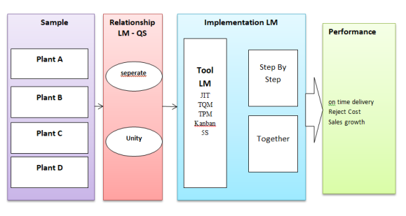
Figure 1. Design of the Study

Methods
We mapped research on LM in the food industry from 2010-2023. The data were from Scopus and Web of Science collected using Harzing's Publish or Perish (Window GUI Edition) 7.31.3306.7768 and visualization using VOSviewer version 1.6.16.
The comparative study was conducted over two years (August 2021-2023), involving four different companies. Researchers had access to be directly involved in observation, documentation and data collection. Interviews, document reviews, and field observations before and after LM implementation were conducted in this research [20]. The combination of complementary data was called triangulation [21]. In addition, several strategies that ensure the reliability of research, as recommended by Powell et al [22], include detailed documentation, consistency of respondents' statements and the evidence used. A general description of the company as a comparative study can be seen in Table 1.

Table 1. General Overview of Companies
Plant | Location |  | Product | Expire | Revenue/ year  Billion IDR | Certification
A | Surabaya |  | Bread | < 1 month | 64 | HACCP
B | Bandung |  | Chocolate | >1 year | 114 | ISO, HACCP
C | Tangerang |  | Wafer Cream | >1 year | 146 | ISO, HACCP
D | Medan |  | Cake | <1 month | 78 | HACCP

Implementation
The implementation stage was divided into: (i) LM relationship with QS, (ii) LM implementation and (iii) performance analysis. The results of these factors were used as a reference for the application of LM in the food industry.
The LM-QS relationship explains the relationship between two variables (LM-QS) in the four companies. The relationship was defined as follows.
Separate: QS was not a part/tool of LM. QS was seen as a quality system whose position was parallel to LM and QS's position is more prioritized than LM.
Converge: QS was a set of LM tools, while LM was the company's main priority.
All four companies selected and used LM tools. Use of LM tools depends on company policy. At this stage, the comparative study focuses on implementation: (a) Step by Step; selecting an LM tool through stages (choosing one tool to be applied with QS. If successful, you may add another LM tool. (b) Simultaneously, where QS was part of an LM tool that was used together with other LM tools. Sometimes, five LM tools (JIT, TQM, TPM, Kanban, 5S) were used simultaneously. The selection of LM-QS relationships and their application are presented in Table 2.

Table 2. Lean Manufacturing Implementation
Plant | Relationship  LM-QS | LM Tool | Method | Implementation
A | separate | 5S 1t^{h}; JIT 2th | Gradual (Step by Step) | LM tools adjust to the characteristics of QS. In the first year, the implementation of QS was along with 5S and added with JIT implementation.
B | Separate | JIT 1th; 5S 2th | Gradual (Step by Step) | LM tools adjust to the characteristics of QS. The JIT was implemented simultaneously with QS, in the first year while 5S was implemented in the second year.
C | Converge | JIT, TQM, TPM, 5S, Kanban | Together | QS (TQM) was a LM tool. All LM tools were simultaneously applied.
D | Converge | TQM, 5S, JIT, Kanban | Together | QS (TQM) was LM tool, the four LM tools were implemented simultaneously.

In the final stage, performance analysis was carried out based on the following indicators: a) on-time delivery (%) which shows the timeliness of delivery, b) Reject Cost (%) which refers to costs incurred due to product defects and expiration. c) Sales Growth (%) within 6 months compared to the highest achievement in 2023.

Statistics
The application of Response Surface Methodology and Box-Behnken Design was to optimize the performance of the LM tool. Performance was measured based on achieving standards set by the company internally. Variable measurement is based on a 1-5 Likert scale. Where 1= very bad; 2= poor; 3= balanced (neutral); 4= good; and 5= very good. We involved 20 respondents who were experts in the field of LM, namely sustainable manufacturing consultants in Indonesian companies.
Plant A: performance optimization was measured using three (3) variable factors, namely implementation time, JIT, and 5S.
Plant B: performance optimization is measured using three (3) variable factors, namely implementation time, JIT, and 5S.
Plant C: performance optimization was measured using six (6) variable factors, namely implementation time, JIT, 5S, TQM, TPM, and Kanban.
Plant D: performance optimization was measured using five (5) variable factors, namely implementation time, JIT, 5S, TQM, and Kanban.
To evaluate the performance of the four companies, Principal Component Analysis (PCA) was conducted based on three main variables: percentage of rejects, sales growth, and on-time delivery. Company performance data was obtained from the 2021-2023 period. This PCA analysis aims to identify the principal components that contribute most to the variation in company performance and to simplify the complexity of the data into a few significant principal components.

RESULTS AND DISCUSSION

Based on the mapping results of previous researchers in 2010 - 2023, the role of QS (TQM) which was forced to become an LM indicator caused the crucial role of QS in the food industry to be reduced by the LM strategy. So many companies separate QS from LM. However, on the other hand, QS becomes an LM tool (if referring to the initial concept of LM formation). Fig.2 helps in mapping QS placement and research hypotheses. Referring to Figure 2a, we map the papers based on research objectives: (i) placement of QS in LM implementation (ii) how to implement LM.
Fig. 2b provides an understanding of the LM evolution process. LM development was dominated by non-processing companies such as: textiles, electronics, automotive, furniture, etc. Developments in processing industries such as food, pharmaceuticals and chemicals had not seen their dominance. LM continues to develop in terms of paradigm, philosophy and implementation to gain efficiency and productivity. LM was a derivative of sustainable manufacturing so its evolution must follow developments. In 2018 until now, LM has been collaborated with the nature of Agile manufacturing to gain agility in responding to customer desires.

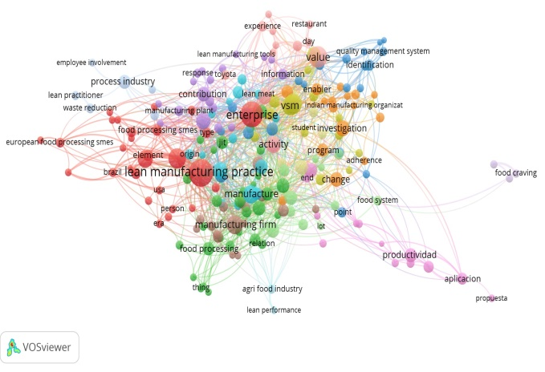a | 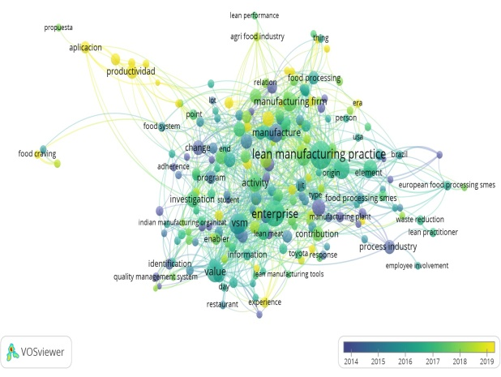b
Figure. 2. Mapping of previous research for the period 2010-2023 using VosViewer. Mapping of research based on correlation between variables (a). Mapping based on LM development from the period 2010-2023 (b).

The placement of QS separately from LM turned out to be higher (41%) compared to the placement of QS as an indicator of LM (30%). Implementing LM gradually (step by step) also showed greater results (39%) than simultaneous implementation (0.16% + 2% = 18%). We show the complete results in table 3

Table 3. The research mapping of the application of LM in the food industry for the period 2010- 2023
Number | Description | Quantity
Number | Description | paper | %
1 | Number of papers | 1000 | 100%
1 | Scopus indexed papers | 650 | 65%
1 | papers indexed by Web of Science | 350 | 35%
2 | QS variable was separate from LM | 410 | 41%
2 | LM implementation (step by step) | 390 | 39%
2 | LM implementation (simultaneously) | 20 | 2%
3 | QS variable becomes LM tool | 300 | 30%
3 | LM implementation (simultaneously) | 158 | 16%
3 | Does not explain the implementation | 142 | 14%
4. | Others | 290 | 29%
Note: % based on total number of papers (1000 papers)

This study reveals that in the food industry, QS is more frequently separated from LM (41%) rather than being used as an LM tool (30%), due to QS's crucial role in maintaining product quality and safety. A step-by-step LM approach (39%) is also proven to be more effective than simultaneous implementation (18%), avoiding confusion between QS and LM. These findings support previous studies in non-food sectors [23], [24], [25], [26] but challenge the assumption that the relationship between QS and LM can be directly applied to the food industry [27]. This research provides significant contributions to understanding a more contextual integration strategy for QS and LM in the food sector.
The placement of QS into an LM tool and the relationship between the two have been researched previously. Collaboration in manufacturing fields such as automotive, electronics, textiles, furniture, etc. provides strong evidence that these two concepts support each other and can be used simultaneously [9 ,11]. The application of LM in the food industry has produced different conditions. The food industry has tried to implement LM simultaneously with QS, confusion has occurred in implementing the LM. An in-depth study of the literature review also shows results that are not much different [8], [29], [30].
We prove the results of this literature mapping with an in-depth case study in a food company with high researcher involvement. Recommendations for the application of LM in food companies are proposed based on comparative studies. Data regarding performance analysis was presented first to determine the effectiveness of the various strategies implemented by the company which supports the performance analysis of this study (Fig. 3).
Fig. 3 shows the performance of the four companies in terms of on time delivery, reject costs and sales growth. On time delivery at company B showed an improvement and its achievement in the 24th month was almost perfect (close to 100%), followed by company A and the reverse condition was seen in companies C and D (Fig 3a).

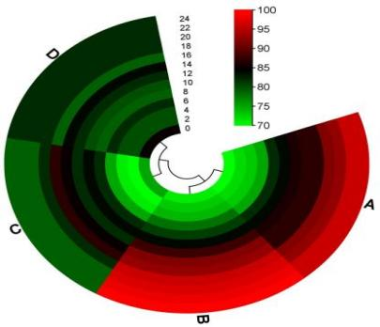  a | 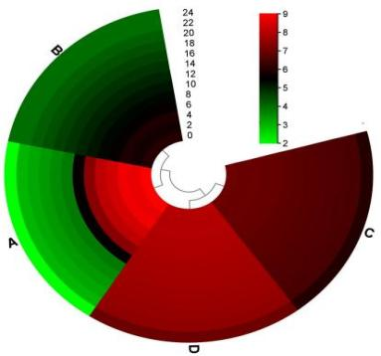  b | 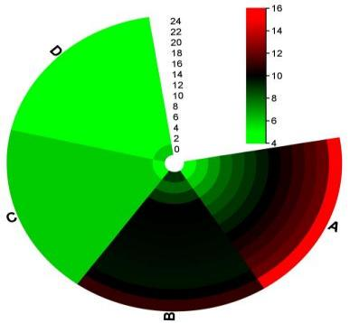  c
Figure 3. The Performance of LM Implementation. Percentage (%) on time delivery (a). performance based on % reject (b), and performance based on sales growth (c).

The results of interviews with factory managers and supervisors at factory B show: a) the implementation of JIT supports distribution effectiveness, b) the selection of an LM tool was intended to be more focused in dealing with obstacles c) the implementation of JIT was intended to meet market demand with guaranteed quality. In this performance analysis, the implementation of factory B strategy was found to be more effective.
The "Reject Cost" performance indicator shows that success can be seen from the reduction in costs caused by product defects and product returns (Fig 3b). Plant A succeeded in reducing reject costs gradually from 9% to 3% through implementing one tool (5S) in the first year and JIT in the second year. Factory B succeeded in reducing reject costs from 6% to 3.9%. In contrast, Factories C and D never succeeded in reducing their reject costs. Factory A implements a more effective strategy in reducing rejection costs. Factory managers and supervisors admit that: a) 5S LM tools which were synonymous with sanitation really help QS in avoiding product contamination. b) The product's lifespan was quite short, and must be supported by strong quality to anticipate damage due to processing and contamination by microorganisms. c) after successful implementation of 5S, JIT is implemented in stages.
The performance indicator "Sales Growth" shows an increase in the number of sales compared to 2020. Factory A was more effective as shown by a continuous increase in sales percentage. Factory B experienced a decline in sales growth after 5S was implemented. Meanwhile, factory C and factory D experienced different conditions (Fig.3c). Factory manager A admitted that this happened because a) the use of JIT tools was implemented when 5S had been firmly embedded in the company. b) the implementation of JIT had to be carried out because the product life was relatively short.
Interviews conducted with factory managers C and D yielded similar findings: a) the company experienced confusion as to whether the LM tool should be implemented simultaneously or the quality system should be seen as part of the LM tool. b) Overlapping priorities of LM tools cause companies to be unable to focus on main problems. c) Confusion continues to the evaluation and problem solving stage.
This study highlights the importance of a phased strategy in implementing Lean Manufacturing (LM) to improve efficiency and performance, particularly in industries with short product shelf lives, such as the food industry. Factory A successfully reduced rejection costs and significantly increased sales by first implementing 5S, which focuses on sanitation to prevent contamination, before proceeding with Just-In-Time (JIT) to optimize distribution efficiency. In contrast, other factories that did not adopt a phased approach showed suboptimal performance, with some even experiencing a decline in sales growth. These findings reinforce the importance of flexibility in LM implementation tailored to the specific challenges of the industry [31], [32] while challenging previous research claims that simultaneous LM implementation is universally effective across all sectors [33]. This study contributes by emphasizing that the success of LM depends on system readiness and structured strategies[34].
Company A implemented LM using 5S followed by JIT. The implementation of JIT had a performance impact of 85% in months 13 - 18. However, there was a significant decrease in performance (p<0.05) in months 22 - 24. The lowest performance < 60% is seen in months 7-9 (Fig 4b). The implementation of 5S was not much different from JIT. 5S provided the highest performance impact of 88% in months 12-19. It decreased periodically until the 24th month (<72%). The lowest performance was shown in the 1st month at <72%. Complete results can be seen in Fig. 4a.

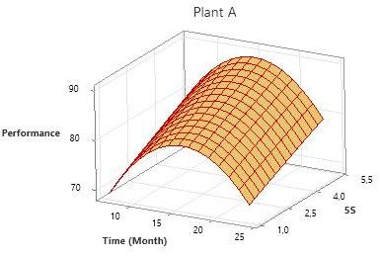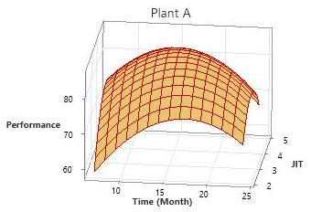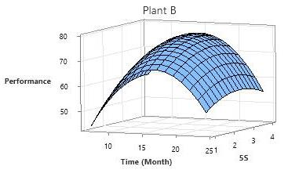
a b c
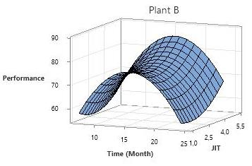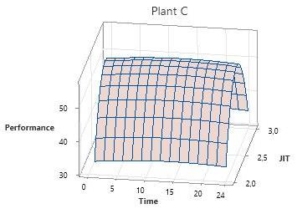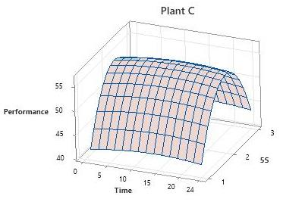
d e f
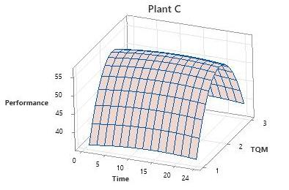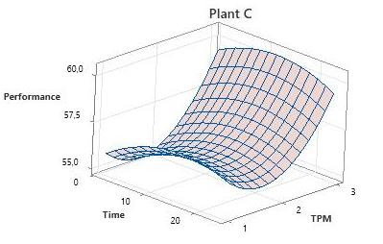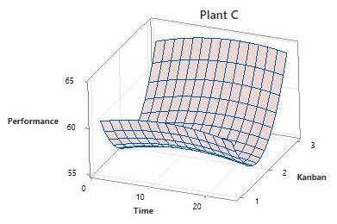
g h i
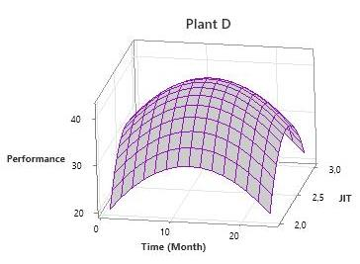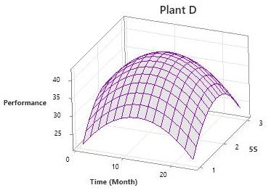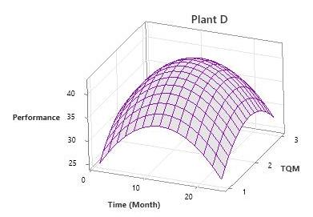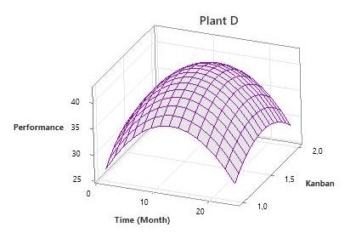
j k l m
Figure 4. Response Surface Methodology and Box-Behnken Design for LM performance optimization. Surface plot of performance vs 5S (a), JIT in company A (b), 5S in company B (c), JIT in company B (d), JIT in 5S in company C (e), 5S in company C (f), TQM in company C (g), TPM 5S in company C (h), Kanban in company C (i), JIT in company D (j), 5S JIT in company D (k), TQM JIT in company D (l), and Kanban JIT in company D (m).

Implementation of JIT in company B provided the highest performance of 80% in the 10-20th month. However, there was a gradual decline in the following months, the decline continued until month 24 (70%). JIT implementation was very bad at the beginning of the month (month 1-2) (Fig.4d). The implementation of 5S had an impact on increasing performance (75%) in the 12-18th month, although there was a consistent decline until the 24th month (55%). The lowest performance is shown by 5S activities in months 1-3. We show the complete results in Fig.4c
The implementation of JIT, 5S, TQM, TPM, and Kanban in Company C was carried out simultaneously. Overall, it was only able to have an impact on performance of 60%. JIT consistently provides performance (55%) from the beginning to the 24th month (Fig.4e). The same phenomenon also occurs in the implementation of 5S (Fig.4f) and TQM (Fig.4g). The best implementation of TPM occurs in the 10-15th month which had an impact on performance of 50% in the 12-15th month (Fig.4h). A different phenomenon was shown by kanban which experienced a decline in performance reaching <54% in the 12-15th month (Fig.4i). The sequence of LM tool effects that have the largest impact on performance was JIT, TQM, 5S, TPM and the lowest was the Kanban system.
Simultaneous implementation of JIT, 5S, TQM, and Kanban in company D was only able to produce performance of 54%. JIT only had an effect on performance of 40% in months 8-16, then there was a decline of up to 20% in month 24 (Fig.4j). Results that were not much different are shown by 5S activities (Fig.4k). The effect of TQM on performance reached its peak in months 8-18 at 40%, but the decline in TQM reached 30% in month 24 (Fig.4l). The kanban system reached its peak influence on performance (42%) in months 11-13, then there was a drastic decline ( 27%) in the 24th month (Fig.4j). The LM activities that have the greatest influence were JIT, 5S, TQM, and the lowest was the kanban system.
This study shows that Company A, which implemented LM gradually with 5S followed by JIT, achieved optimal performance, especially between the 12th and 19th months, although there was a performance decline after the 22nd month. Company B also showed good performance improvement with the implementation of JIT and 5S, but the decline occurred more quickly by the 24th month. Meanwhile, Companies C and D, which implemented LM simultaneously, including JIT, 5S, TQM, TPM, and Kanban, only reached performance levels of around 60-54%, with a sharp decline observed in Kanban. These findings support previous research indicating that the gradual implementation of LM, with a clear focus and tailored tools, is more effective [9] than simultaneous implementation [35] , which tends to be confusing and difficult to sustain.

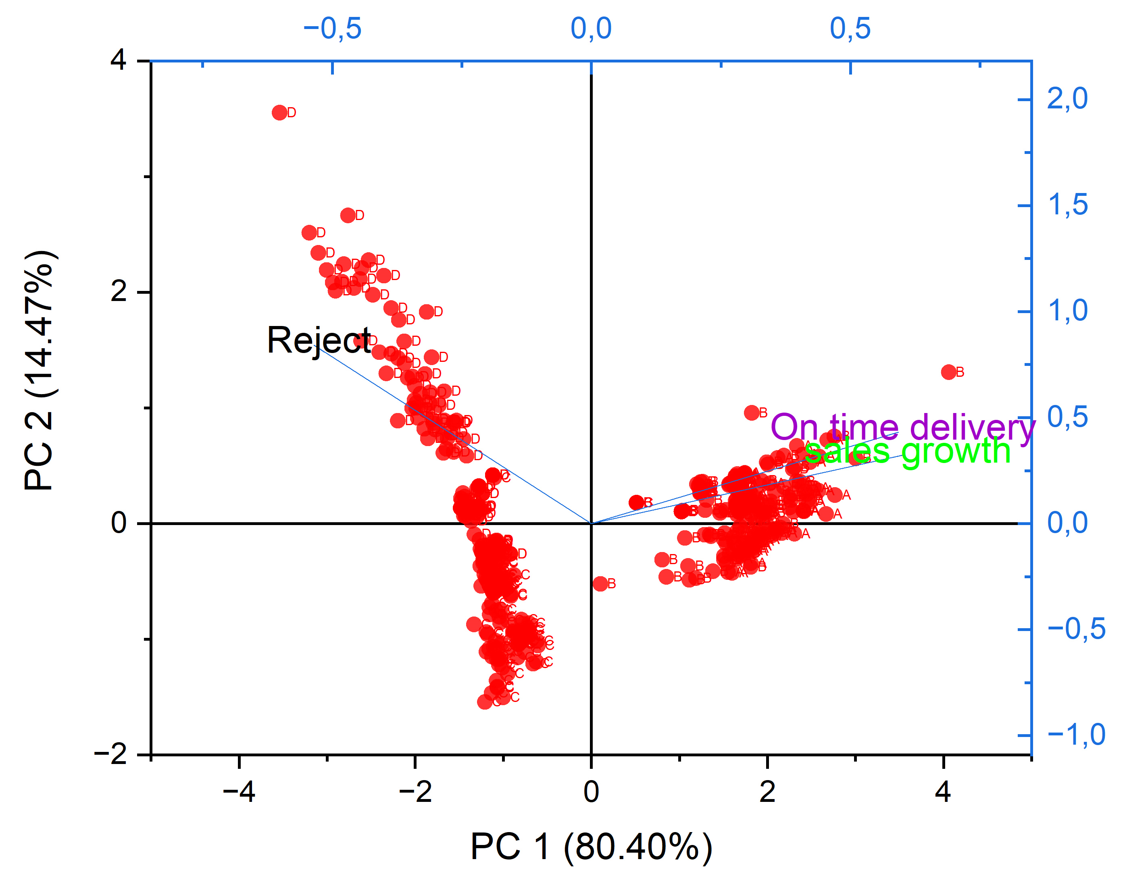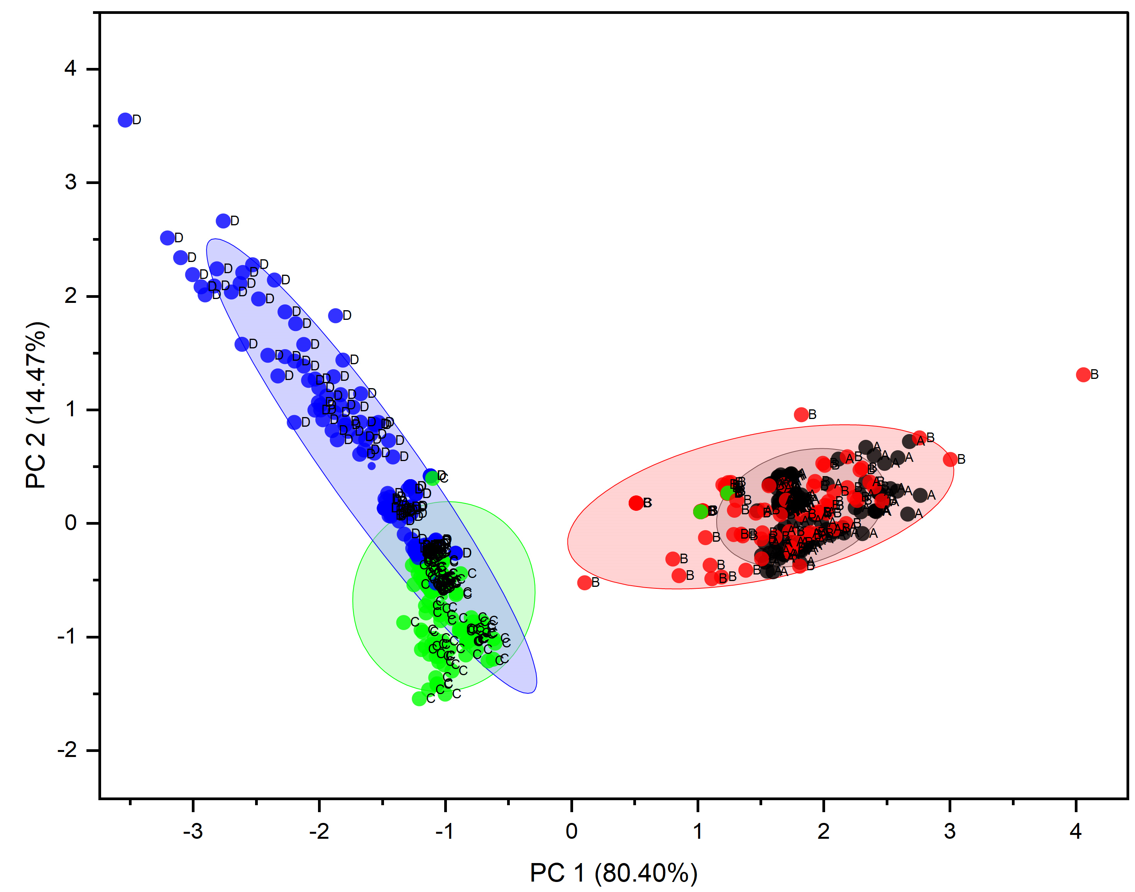
a b
Figure 5. Results of Principal Component Analysis, Biplot (a) and Cluster Plot with Confidence Interval (b).

According to the PCA results (Fig 5a, 5b), the most significant component was the first one (PC1), which had an eigenvalue of 2.41198 and explained 80.40% of the variation in the whole. With an eigenvalue of 0.43404, the second component (PC2) contributed 14.47% more to the variance's explanation, for a cumulative total of 94.87%. The remaining 5.13% was supplied by the third component (PC3), which has an eigenvalue of 0.15398. The biggest positive contributions for PC1 were from sales growth (0.6014) and on-time delivery (0.5929), whereas reject (-0.53553) had a negative influence. Reject (0.84178) was the main element in PC2.

Companies A and B demonstrated exceptional proficiency in implementing Lean Manufacturing (LM) methods, as determined by the findings of the PCA (Fig.5a). Their dominance in on-time delivery and sales growth was demonstrated by their locations in the upper right quadrant of the biplot, where their PC1 values were high at 80.40%. Conversely, firms C and D demonstrated inferior performance, especially with regard to high reject rates, as seen by the negative values in PC2 (14.47%). Their places, distant from the biplot's center, showed serious problems with quality that affected how well they performed as a whole. In summary, firms A and B outperformed in critical LM areas, but companies C and D needed to improve especially in lowering reject rates to increase the efficacy of their LM implementation.
Based on PC1 and PC2, the two primary components of the data structure, the cluster plot with confidence analysis offered crucial insights (Fig 5b). With an eigenvalue of 2.41198, the first principal component (PC1) could account for 80.40% of the variation in the data. The results showed that PC1 was the most important dimension for differentiating the data features, especially those that were affected by factors like sales growth and on-time delivery, which had strong positive coefficients on this component (0.6014 and 0.5929, respectively). Companies A and B were positioned along PC1, indicating that their profiles were comparable with respect to the features that this dimension described. With an eigenvalue of 0.43404, the second principal component (PC2) was able to account for 14.47% of the variation in the data. Despite having a lesser impact than PC1, PC2 was still significant since it improved comprehension of the variations in the data. Affects like reject, which had a positive coefficient on PC2 (0.84178) and a negative coefficient on PC1 (-0.53553), were evident in the dominating companies C and D on PC2. This showed that, in contrast to Companies A and B, Companies C and D had unique qualities, with refuse serving as a major differentiator.
The results from PCA highlight the key factors influencing the performance of Lean Manufacturing (LM) implementation across companies. PCA identified that Companies A and B excelled in on-time delivery and sales growth, with their positions on PC1, which accounts for 80.40% of the data variation. This shows how PCA effectively highlights the relationship between LM tools and performance outcomes. In contrast, Companies C and D, marked by high reject rates, were positioned negatively on PC2. PCA thus provides valuable insights into the effectiveness of LM strategies, emphasizing the importance of focusing on specific performance drivers for optimal results.[36]
The separation of QS from the LM concept is a crucial step in the evolution of LM, which is currently considered more suitable for application in the food industry. This research shows that separating QS from LM can be an effective solution to address various failures experienced by food companies in implementing LM. This emphasizes that LM needs to be applied with a flexible approach, tailored to the characteristics and readiness of each industrial sector [37]. By separating QS from LM, companies can focus on improving process efficiency without being hindered by the difficulties of integrating both concepts, leading to more sustainable long-term improvements in performance and quality [38]
Simultaneous application of LM (plants C and D) apparently brings confusion when applied in the food industry. Optimal results were actually obtained by separating QS from LM as proven by plants A and B. In this case, these findings are at odds with research conducted by Djekic et al [2]. Failures in implementing the LM concept must be overcome so that it can be applied simultaneously, namely: a) Selecting the right LM tool to pair with QS [39]. b) Define QS and LM in detail to avoid overlapping concepts [40].
Practically, this research provides recommendations for implementing LM so that it does not overlap with the role of QS. Company managers are expected to be able to choose the right LM tool related to the characteristics of food products (product age, raw materials, risk of contamination/damage, etc.). In the short term, managers can implement recommendations from research, namely: selection of LM tools, implementation process, and placement of QS separately from LM. If it does not provide optimal results, continuous analysis can be carried out while still separating QS from LM activities.

CONCLUSION
The comparison results of the literature review with comparative studies of LM implementation in the food industry show the same results, QS is not a barrier to implementing the LM concept. Food companies must be able to position QS separately from the LM concept which is widely known. Implementing LM in stages will help companies evaluate appropriate LM tools that can be optimized in company conditions.
Company A performed best in terms of 5S (88%) and JIT (85%), with Company B coming in second with 80% for JIT and 75% for 5S. Companies C and D, on the other hand, showed worse performance levels. The findings of the Principal Component Analysis (PCA) showed that PC1 (80.40%) was mostly linked to sales growth and on-time delivery, whereas PC2 (14.47%) focused on rejection criteria. While Companies C and D were more noticeable in PC2, Companies A and B fared better in PC1.
The results indicate that adopting all of the Lean Manufacturing (LM) tools at once was not as beneficial as using them gradually. Better control over performance factors and customization to particular operational requirements were made possible by this method.
Suggestions for further research are to increase the number of research samples, then analyze using the Structural Equation Model Partial Least Square (SEM-PLS) test to emphasize the influence of the LM variable (f²) and the predictive value of LM on QS (Q²)

REFERENCES

[1] A. P. and J. H. Ian Kennedy, “a consept lean manufacturing model,” Springer International Publishing. 2013, DOI: 10.1007/978-3-319-00557-7_127.
[2] I. Djekic, D. Zivanovic, S. Dragojlovic, and R. Dragovic, “Lean Manufacturing Effects in a Serbian Confectionery Company – Case Study,” Organizacija, vol. 47, no. 3, pp. 143–152, 2014, DOI: 10.2478/orga-2014-0013.
[3] R. B. Lopes, F. Freitas, and I. Sousa, “Application of lean manufacturing tools in the food and beverage industries,” J. Technol. Manag. Innov., vol. 10, no. 3, pp. 120–130, 2015, DOI: 10.4067/s0718-27242015000300013.
[4] S. D. Rico Lugo, K. Kimita, and N. Nishino, “Characteristics of decision process towards circular food economy: A review,” Clean. Logist. Supply Chain, vol. 7, no. October 2022, p. 100104, 2023, DOI: 10.1016/j.clscn.2023.100104.
[5] J. García-Díez, C. Gonçalves, L. Grispoldi, B. Cenci-Goga, and C. Saraiva, “Determining food stability to achieve food security,” Sustain., vol. 13, no. 13, pp. 1–13, 2021, DOI: 10.3390/su13137222.
[6] A. Kowalska, S. Lingham, D. Maye, and L. Manning, “Food Insecurity: Is Leagility a Potential Remedy?,” Foods, vol. 12, no. 16, pp. 1–18, 2023, DOI: 10.3390/foods12163138.
[7] J. F. Krafcik, “Triumph of the lean production system,” Sloan Manage. Rev., 1988, DOI: 10.1108/01443570911005992.
[8] M. Dora, M. Kumar, D. Van Goubergen, A. Molnar, and X. Gellynck, “Operational performance and critical success factors of lean manufacturing in European food processing SMEs,” Trends Food Sci. Technol., vol. 31, no. 2, pp. 156–164, 2013, DOI: 10.1016/j.tifs.2013.03.002.
[9] M. Dora, M. Kumar, and X. Gellynck, “Determinants and barriers to lean implementation in food-processing SMEs - A multiple case analysis,” Prod. Plan. Control, vol. 27, no. 1, pp. 1–23, 2016, DOI: 10.1080/09537287.2015.1050477.
[10] M. Casula, N. Rangarajan, and P. Shields, “The potential of working hypotheses for deductive exploratory research,” Qual. Quant., vol. 55, no. 5, pp. 1703–1725, 2021.
[11] M. Choshin and A. Ghaffari, “An investigation of the impact of effective factors on the success of e-commerce in small-and medium-sized companies,” Comput. Human Behav., vol. 66, pp. 67–74, 2017.
[12] A. . Miles, M.B & Huberman, An expanded sourcebook: Qualitative data analysis (2nd Edition). 1994. DOI: 10.1016/0149-7189(96)88232-2.
[13] A. L. George, “Case Studies and Theory Development: The Method of Structured, Focused Comparison BT - Alexander L. George: A Pioneer in Political and Social Sciences: With a Foreword by Dan Caldwell,” D. Caldwell, Ed., Cham: Springer International Publishing, 2019, pp. 191–214. DOI: 10.1007/978-3-319-90772-7_10.
[14] J. Buchner and M. Kerres, “Media comparison studies dominate comparative research on augmented reality in education,” Comput. Educ., vol. 195, p. 104711, 2023, DOI: https://doi.org/10.1016/j.compedu.2022.104711.
[15] B. Budianto, Z. O. Feri, Q. Nurlaila, H. Sitorus, and T. H. Suryatman, “Quality system as a mediating variable of the relationship between lean manufacturing and operational performance in the food industry,” SINERGI, vol. 27, no. 2, pp. 201–210, 2023, DOI: 10.22441/sinergi.2023.2.008.
[16] B. G. Aadithya, P. Asokan, and S. Vinodh, “Lean manufacturing in fabrication industry: literature review and framework proposal,” Int. J. Qual. Reliab. Manag., vol. 40, no. 6, pp. 1485–1517, Jan. 2023, DOI: 10.1108/IJQRM-03-2021-0084.
[17] M. Helmold, “5S Concept in Quality Management BT - Virtual and Innovative Quality Management Across the Value Chain: Industry Insights, Case Studies and Best Practices,” M. Helmold, Ed., Cham: Springer International Publishing, 2023, pp. 113–126. DOI: 10.1007/978-3-031-30089-9_10.
[18] V. Kumar, A. Mittal, P. Verma, and J. Antony, “Mapping the TQM implementation approaches and their impact on realizing leadership in Indian tyre manufacturing industry,” TQM J., vol. ahead-of-p, no. ahead-of-print, Jan. 2023, DOI: 10.1108/TQM-08-2022-0258.
[19] M. T. Gelaw, D. K. Azene, and E. Berhan, “Assessment of critical success factors, barriers and initiatives of total productive maintenance (TPM) in selected Ethiopian manufacturing industries,” J. Qual. Maint. Eng., vol. 30, no. 1, pp. 51–80, Jan. 2024, doi: 10.1108/JQME-11-2022-0073.
[20] A. Shokri, J. Antony, J. A. Garza-Reyes, and M. Upton, “Scoping review of the readiness for sustainable implementation of Lean Six Sigma projects in the manufacturing sector,” Int. J. Qual. Reliab. Manag., vol. 38, no. 8, pp. 1747–1770, Jan. 2021, DOI: 10.1108/IJQRM-08-2020-0261.
[21] L. Ye, S. L. Pan, J. Wang, J. Wu, and X. Dong, “Big data analytics for sustainable cities: An information triangulation study of hazardous materials transportation,” J. Bus. Res., vol. 128, pp. 381–390, 2021, DOI: 10.1016/j.jbusres.2021.01.057.
[22] D. J. Powell, D. A. Laubengaier, G. L. Tortorella, H. Saabye, J. Antony, and R. Cagliano, “Digitalization in lean manufacturing firms: a cumulative capability development perspective,” Int. J. Oper. Prod. Manag., vol. 44, no. 6, pp. 1249–1278, Jan. 2024, DOI: 10.1108/IJOPM-05-2023-0414.
[23] M. Rabbani, S. Aghamohamadi-Bosjin, and ..., “Leagile supply chain network design through a dynamic two-phase optimization in view of order penetration point,” RAIRO-Operations, 55: S1369-S1394. 2021,
[24] Y. Li, A. Diabat, and C. C. Lu, “Leagile supplier selection in Chinese textile industries: a DEMATEL approach,” Ann. Oper. Res. vol. 287, no.1, pp: 303-322.2020,
[25] R. K. Tiwari and J. K. Tiwari, “Prioritisation of attributes of green leanness and agility to achieve sustainable strategic advantages in Indian automotive SMEs environment,” Int. J. Ind.. vol. 36, no.3, pp: 316-338, 2020,
[26] M. M. Omoush, “Lean Six Sigma Effect on the Quality of the Products in Jordanian Food Companies: the Moderating Role of the Manufacturing Process,” Int. Rev. Manag. Mark., vol. 10, no. 6, pp. 1–12, 2020, DOI: 10.32479/irmm.10680.
[27] M. H. Yaseen et al., “The Relationship of Lean Production and Business Performance in Malaysian Food Industry Facilities Provision for Persons With Disabilities View project Facilities Management Services View project The Relationship of Lean Production and Business Performanc,” Solid State Technol., vol. 63, no. 6, pp. 6143–6158, 2021,
[28] M. Manzouri et al., “Lean Manufacturing and the Food Industry .,” J. Technol. Manag. Innov. vol.6, no. 12, pp:v9179-9204.2015, DOI: 10.3390/su6129179.
[29] A. Veseli, A. Bajraktari, and A. Trajkovska Petkoska, “The Implementation of Lean Manufacturing on Zero Waste Technologies in the Food Processing Industry: Insights from Food Processing Companies in Kosovo and North Macedonia.,” Sustain., vol. 16, no. 14, 2024.
[30] R. A. Domínguez, M. del M. Espinosa, M. Domínguez, and L. Romero, “Lean 6S in Food Production: HACCP as a Benchmark for the Sixth S ‘Safety,’” Sustainability, vol. 13, no. 22, p. 12577, 2021.
[31] R. Lakshmanan, P. Nyamekye, V.-M. Virolainen, and H. Piili, “The convergence of lean management and additive manufacturing: Case of manufacturing industries,” Clean. Eng. Technol., vol. 13, p. 100620, 2023.
[32] M. Sony, J. Antony, and O. Mc Dermott, “How do the technological capability and strategic flexibility of an organization impact its successful implementation of Industry 4.0? A qualitative viewpoint,” Benchmarking An Int. J., vol. 30, no. 3, pp. 924–949, 2023.
[33] G. Nawanir, K. T. Lim, T. Ramayah, F. Mahmud, K. L. Lee, and M. G. Maarof, “Synergistic effect of lean practices on lead time reduction: mediating role of manufacturing flexibility,” Benchmarking An Int. J., vol. 27, no. 5, pp. 1815–1842, 2020.
[34] C. B. McFayden et al., “Canadian fire management agency readiness for WildFireSat: assessment and strategies for enhanced preparedness,” Fire, vol. 6, no. 2, p. 73, 2023.
[35] M. Pourmatin and A. Ilkhani, “Extending system dynamics simulation and lean thinking for enhancing operational efficiency: a food industry case study,” Int. J. Food Syst. Dyn., vol. 15, no. 5, pp. 557–572, 2024.
[36] L. B. M. Costa, M. Godinho Filho, L. D. Fredendall, and G. M. D. Ganga, “Lean six sigma in the food industry: Construct development and measurement validation,” Int. J. Prod. Econ., vol. 231, p. 107843, 2021.
[37] G. Garcia-Garcia, Y. Singh, and S. Jagtap, “Optimising changeover through lean-manufacturing principles: a case study in a food factory,” Sustainability, vol. 14, no. 14, p. 8279, 2022.
[38] L. B. M. Costa, M. Godinho Filho, L. D. Fredendall, and G. M. D. Ganga, “The effect of Lean Six Sigma practices on food industry performance: Implications of the Sector’s experience and typical characteristics,” Food Control, vol. 112, p. 107110, 2020.
[39] M. Hegedić, M. Gudlin, M. Golec, and N. Tošanović, “Lean and Green Decision Model for Lean Tools Selection,” Sustainability, vol. 16, no. 3, p. 1173, 2024.
[40] P. Langlotz, C. Siedler, and J. C. Aurich, “Unification of lean production and Industry 4.0,” Procedia CIRP, vol. 99, pp. 15–20, 2021

