The Influence of Silane Coupling Agent and Porogen Ratio on 3D Scaffold PCL/HA | 

Mu’adz Abdullah Faqih¹, Agung Purniawan¹, Amaliya Rasyida¹, Diah Susanti¹
1Department of Materials and Metallurgical Engineering, Faculty of Industrial Technology and System Engineering, Institut Teknologi Sepuluh Nopember, Surabaya

Abstract  The design of scaffolds based on polycaprolactone (PCL) and hydroxyapatite (HA) has attracted attention as a solution for bone tissue regeneration. However, the main challenge in its development is the difficulty in achieving an optimal balance between porosity and mechanical strength. Suboptimal porosity limits the scaffold's ability to support cell proliferation, and weak mechanical properties result in the scaffold being less than optimal as a load-bearing implant material during the bone cell regeneration process. This study aims to address these issues by evaluating the effects of the silane coupling agent 3-aminopropiltriethoxysilane (APTES) and the porogen ratio (NaCl) on the mechanical properties, morphology, and biodegradability of PCL-HA-based 3D scaffolds. The scaffolds were synthesized using the solvent casting-particulate leaching (SCPL) method with varying APTES concentrations (1%, 3%, and 5%) and porogen ratios. (4:1, 6:1, dan 8:1). The results of characterization show that the addition of 1% APTES increases compressive strength by 283% and tensile strength by 138% compared to scaffolds without APTES. A higher porogen ratio (8:1) results in the highest porosity of 78.16%, but reduces mechanical strength by 84%. The best combination is obtained in scaffolds with 1% APTES and a porogen ratio of 4:1, which have optimal mechanical strength, porosity of 69.65%, and a degradation time of up to 380 days. This research offers a comprehensive solution to enhance the properties of PCL-HA based 3D scaffolds, making a significant contribution to the development of materials for bone tissue engineering applications.  This is an open access article under the CC BY-SA license   | Keywords:  3D Scaffolds;PCL;Hidroksiapatit; Coupling Agent; Porogen  Article History:  Corresponding Author:  Mu’adz Abdullah Faqihª  Agung Purniawan^{b}  Department of Materials and Metallurgical Engineering, Institut Teknologi Sepuluh Nopember  Email: ^{a)}6011231005@student.its.ac.id  ^{b)} a.purniawan@its.ac.id

INTRODUCTION
Bone is one of the most important tissues in the human body because it serves as a support for the body and as a protector of vital organs [1]. However, various conditions such as degenerative diseases, trauma, and infections can cause significant fractures or bone damage. Bone fractures occur when the pressure received by the bone exceeds its elasticity limit, resulting in cracks to breaks [2], [3].
Bone tissue engineering offers innovative solutions for the treatment of complex fractures. The main focus in this field is the development of three-dimensional (3D) scaffold-based implant structures that can support the bone regeneration process [4]. These scaffolds are designed to support the adhesion and proliferation of osteogenic cells, facilitate the differentiation of cells into osteoblasts, support the transport of nutrients and waste disposal through structured pores, and provide a physical framework that can be gradually degraded and replaced by new bone tissue [2], [5].
To fulfill these functions, scaffolds must possess appropriate properties, including biocompatibility, osteoconductivity, bioactivity, biodegradability, and adequate mechanical strength. Research shows that the optimal porosity for cancellous bone is in the range of 60–90%, while pore sizes between 200–350 µm are most ideal for bone tissue regeneration [6].
Poly(ε-caprolactone) (PCL) and Hydroxyapatite (HA) are materials widely used in the development of 3D scaffolds for bone tissue engineering. The combination of PCL and HA provides unique advantages. PCL is a synthetic polymer with high biodegradability, mechanical flexibility, and good thermal and chemical stability [7], [8], [9]. However, PCL has low hydrophilic properties, which can directly affect cell adhesion. Whereas HA is a bioactive ceramic with a chemical composition similar to natural bone minerals. HA provides excellent osteoconductivity and bioactivity, supporting cell adhesion and differentiation. However, the brittle mechanical properties of HA pose a challenge, so the combination of PCL and HA offers an optimal solution, namely the flexibility and mechanical strength of PCL along with the bioactivity of HA [2], [5], [10].
Fabrication techniques play a crucial role in determining the morphology, porosity, and mechanical performance of scaffolds. One of the most popular techniques is solvent casting particulate leaching (SCPL), where porogens such as salt are used to create a porous structure. The advantages of SCPL include a simple process, good control over pore size and porosity, and the ability to produce interconnected pores essential for nutrient transport and cell proliferation [11], [12], [13].
Previous studies have shown that the porogen-to-composite material ratio significantly affects the structure and mechanical properties of scaffolds. The higher the porogen ratio, the greater the porosity, but the mechanical strength tends to decrease [14], [15], [16]. Therefore, optimizing the porogen ratio becomes a critical aspect in the design of scaffolds that meet clinical needs.
To enhance the interaction between the PCL matrix and HA particles, the use of silane coupling agents such as 3-aminopropyltriethoxysilane (APTES) has become the subject of research. APTES can enhance the chemical bonds between organic and inorganic components through the formation of siloxane bonds [15]. Studies show that the addition of APTES can enhance the tensile and compressive strength of scaffolds, strengthen the material interface, thereby reducing the degradation rate, and supporting long-term morphological stability [17]. However, an excessively high amount of APTES can cause uneven reactions, resulting in a decrease in mechanical strength and material stability [5]. Therefore, further research is needed to determine the optimal APTES concentration.
Although developments in this field have been significant, several challenges still need to be addressed, such as optimizing the combination of porosity and mechanical strength to meet specific clinical needs, enhancing the bioactivity of PCL without compromising its mechanical properties, and determining the porogen ratio and APTES concentration that yield the best morphology and performance [18]. Until now, many studies have focused on the influence of only one parameter, such as morphology or bioactivity. The combination of parameters, including porogen ratio, APTES concentration, and fabrication techniques, has not yet been comprehensively explored [4], [19], [20].
This research aims to evaluate the influence of variations in porogen ratio and APTES concentration on the morphology, mechanical properties, and biodegradation capability of PCL/HA-based scaffolds fabricated using the SCPL method. This study combines experimental and theoretical analyses to determine the optimal combination of porogen ratio and APTES concentration to produce 3D scaffolds with appropriate mechanical strength and porosity.
The results of this research are expected to not only expand knowledge in the field of tissue engineering, particularly bone, but also provide practical references for the development of bone implants based on 3D scaffolds in the future.

METHOD
The HA modification process was carried out by dissolving it with APTES according to its variations (1%, 3%, and 5% relative to the weight of HA) using 90% ethanol and 10% deionized water for 15 minutes at a speed of 500 rpm at room temperature. Then adjusted with NaOH to pH 10 and stirred for 2 hours at 40°C. Finally, filtered and heated at 50°C for 24 hours to obtain the modified HA/APTES powder.
3D scaffold fabrication was carried out using the solvent casting particulate leaching technique (SCPL). 1 gram of PCL is dissolved in 10 ml of chloroform, then 0.25 grams of HA modified with APTES according to its variations (1%, 3%, and 5%) are added. Next, NaCl with a ratio to the composite (PCL/HA) of 4:1, 6:1, and 8:1 was added and stirred at a speed of 1000 rpm for 30 minutes. Then the solution is dried in silicone molds. After the solid composite is formed, it is soaked for 2 days using deionized water, which is replaced every 12 hours to remove the NaCl porogen. After that, the samples were dried at a temperature of 50℃ for 48 hours. The schematic procedure of the research flow is presented in figure 1 and table 1 show the sample variation code uses.
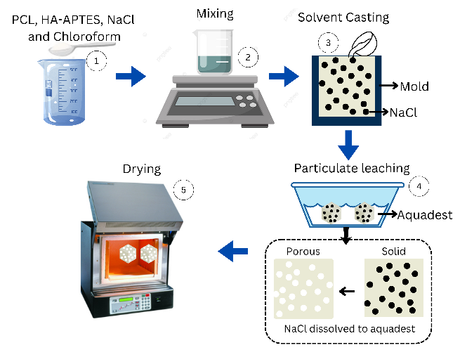
Figure 1 Schematic of the research procedure

Table 1. Sample Variation Code
Spesimen | Variation
Spesimen | APTES (%) | Ratio Porogen
A0N4 | 0 | 4:1
A1N4 | 1 | 4:1
A3N4 | 3 | 4:1
A5N4 | 5 | 4:1
A3N6 | 3 | 6:1
A3N8 | 3 | 8:1

Material
PCL CAPA-6800 (Mw = 80,000, density = 1.14 g/cm3) from petroshop, Hydroxyapatite (HA) with particle size 10×200 nm from sigma-aldrich, Sodium chloride from Merck, and 3-aminotriethoxysilane (APTES) from Guangzhou Double Peach Fine Chemical Co., Ltd.
FTIR test was performed using the Thermo Scientific Nicolet IS10 instrument with a wavelength of 400-4000 cm-1. Digital microscope (merek) dengan perbesaran 50-500x. Tensile and compressive test using the Universal Testing Machine Hung ta HT 2402 Seri 4035 and the ASTM D638 and ASTM D5024-95 standard was used for composite materials with the speed 2 mm/min.
To determine the 3D scaffolds degradation rate, an in vitro Hydrolysis Degradation test was conducted. It was performed by immersing the specimen in Phosphate Buffer Solution (PBS) with the same temperature as the body (37ºC). The samples were weighed before immersion and 5, 10, and 15 days after. Finally, the following formula (1) is used to measure weight loss:
$$W=\left(\frac{mb-ma}{mb}\right)x100 \%$$ | (1)

Where ma and mb are the measured mass after and before immersion, respectively. After the weight loss value is obtained, the lifetime of the sample is predicted using the linear regression method, and the test specimen is in the form of a cube cube with side length 1 cm.

RESULTS AND DISCUSSION
Figure 2 shows the results of the FTIR test on the HA/APTES modification, where several peaks belonging to the functional groups of HA and APTES are observed. There are 3 waves with strong intensities, namely at 1025.68 cm⁻¹, 599.53 cm⁻¹, and 561.74 cm⁻¹, which indicate the presence of P-O asymmetrical stretching and P-O symmetrical stretching bonds in the phosphate ion (PO43⁻). The peak at 1419.49 cm⁻¹ shows the C=O asymmetrical stretching bond in the carbonate ion. (CO32-). The FTIR characterization results can confirm that hydroxyapatite [Ca₁₀(PO₄)₆(OH)₂] is present, although there are no OH bonds because the OH bonds are presumed to have formed siloxane bonds [21].
At the wave peak of 470.62 cm⁻¹, there is a Si-O-Si bending siloxane bond, at 1654.594 cm⁻¹ and 1510.053 cm⁻¹, there are N-H deformation and bending bonds, at 790.7048 cm⁻¹, there is a Si-O bending bond, and at 873.04 cm⁻¹, there is a Si-N bond indicating that silanol forms a siloxane bond with the NH2 group located on the surface of hydroxyapatite [22], [23]. Additionally, there is a possibility of overlap between the phosphate functional group and siloxane in the 1130-1000 cm⁻¹ region due to the strong intensity of the phosphate group in that region [24]. The results of this test indicate that APTES successfully bonded with nano-hydroxyapatite, as evidenced by the presence of the NH₂ group that can bond with PCL.
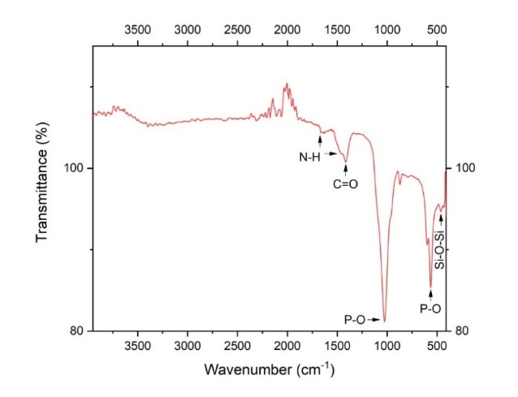
Figure. 2. Fourier transforms infrared spectroscopy (FTIR) spectra of HA/APTES

From Figure 3, it can be seen that the morphology of all samples has evenly distributed pores, and the addition of the silane coupling agent (APTES) up to 5% does not cause significant differences. Figure 4 shows the porosity analysis results using ImageJ software, indicating that the addition of APTES has relatively the same porosity values across APTES variations up to 5%. Therefore, it can be concluded that the addition of the APTES coupling agent does not have a significant effect on the porosity morphology [25].

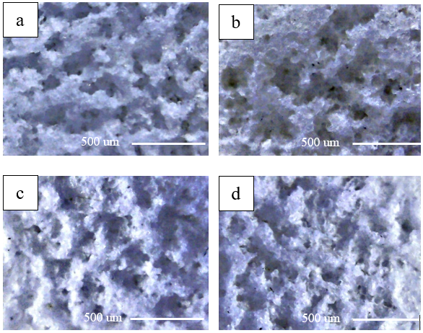
Figure 3. Pengujian digital microscope pada sampel (a) A0N4, (b) A1N4, (c) A3N4, and (d) A5N4

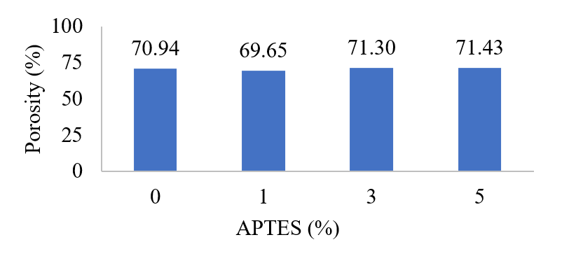
Figure 4. Effect of APTES on porosity

In Figure 5, the morphology of all samples shows a uniform distribution of porosity, indicating that the method used has appropriate parameters to produce a homogeneous 3D scaffold. Figure 6 shows the analysis results using ImageJ, indicating that with the addition of a 4:1 ratio of NaCl to the composite (PCL/HA) up to 6:1 and 8:1, the porosity increased to 74.53% and 78.16%, respectively. From these results, it can be concluded that the higher the amount of porogen used, the greater the increase in porosity (ika 2024). This occurs because the NaCl used as a porogen dissolves and acts as a space holder, so the more NaCl used, the more the space holder, which then becomes porosity (pores), will increase.
The standard application of 3D scaffolds for bone implants has a porosity value of 50-90%. Therefore, based on these test results, all samples have met the minimum requirements as 3D scaffold implants [6], [26].

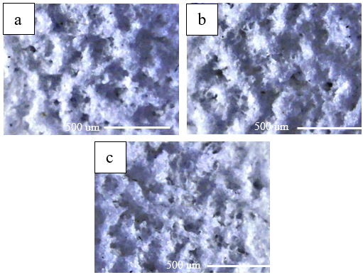
Figure 5. Representative Digital Microscope on (a) A3N4, (b) A3N6, and (c) A3N8
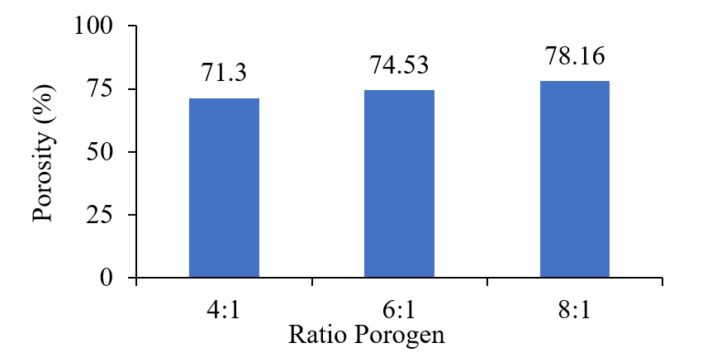
Figure 6. Effect ratio porogen on Porosity

Figure 7 shows the tensile test results on APTES variations, indicating that the addition of APTES increases tensile strength with the highest values occurring in sample A1N4 using 1% APTES, showing a tensile strength increase of 138%. However, adding more than 1% results in a decrease of up to 25% in the 5% APTES variation.
Based on this, it can be concluded that APTES can enhance tensile strength by strengthening the interface bonds in the composite. However, excessive APTES addition will cause some APTES to not form good bonds due to incomplete hydrolysis reactions. A surplus of APTES will be distributed within the composite as free molecules. These free molecules cause a decrease in the mechanical properties of the 3D PCL/HA composite scaffold [27], [28], [29].
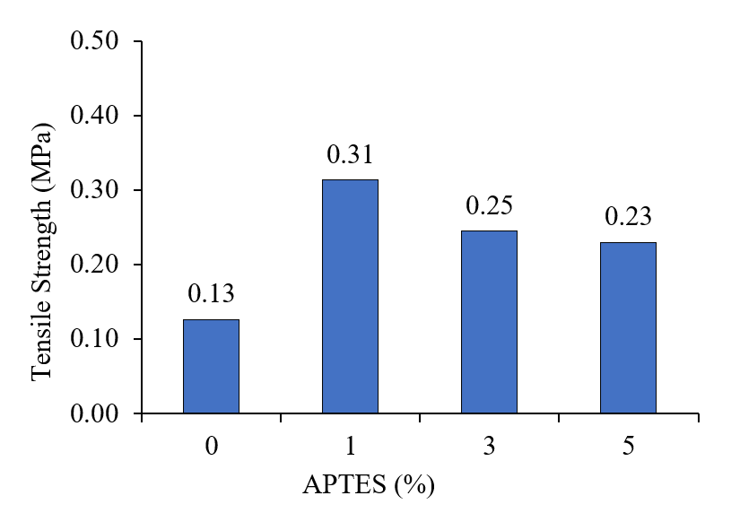
Figure 7. Effect APTES on Tensile Strength

Figure 8 shows the tensile test results at various porogen ratios, indicating that as the porogen ratio increases, the tensile strength values decrease. The highest decrease occurs at a ratio of 8:1 between the porogen (NaCl) and the composite (PCL/HA), which is 84%. This happens because NaCl, as the space holder agent used, dissolves during the leaching process and causes the formation of pores. Thus, with the increasing use of NaCl, the porosity of the PCL/HA 3D scaffolds will increase [14], [30].
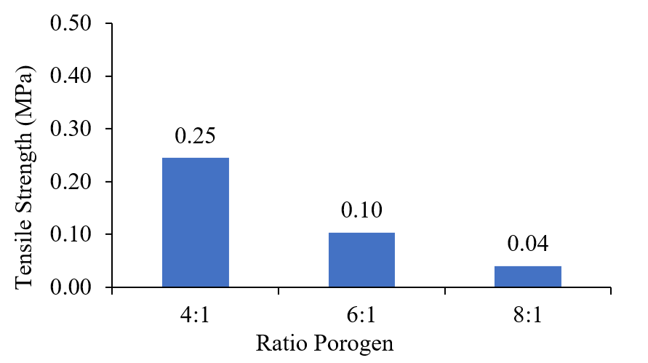
Figure 8. Effect Ratio Porogen on Tensile Strength

Figure 9 shows the results of the compressive test on the APTES variations, indicating that the highest compressive strength occurred in sample A1N4, which used 1% APTES, with a compressive strength increase of 283%. However, the addition of more than 1% resulted in a compressive strength decrease of up to 59% in the 5% APTES variation.
It can be concluded that APTES can increase compressive strength by strengthening the interface bond in the composite. However, excessive addition of APTES will cause some APTES to not form good bonds due to incomplete hydrolysis reactions. A surplus amount of APTES will be distributed within the composite as free molecules. These free molecules cause a reduction in the mechanical properties of the 3D PCL/HA composite scaffold [27], [29].
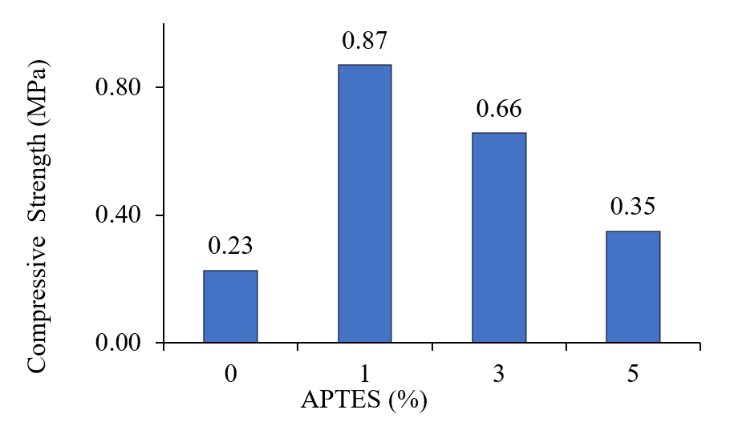
Figure 9. Effect APTES on Compressive Strength

Figure 10 shows the effect of the porogen ratio on compressive strength, indicating that as the porogen ratio increases, the compressive strength value decreases. The highest decrease occurs at a ratio of 8:1 between the porogen (NaCl) and the composite (PCL/HA), which is 78%. This happens because NaCl, as the space holder agent used, dissolves during the leaching process and causes the formation of pores. Thus, with the increasing use of NaCl, the porosity of the PCL/HA 3D scaffolds will increase [14], [30].

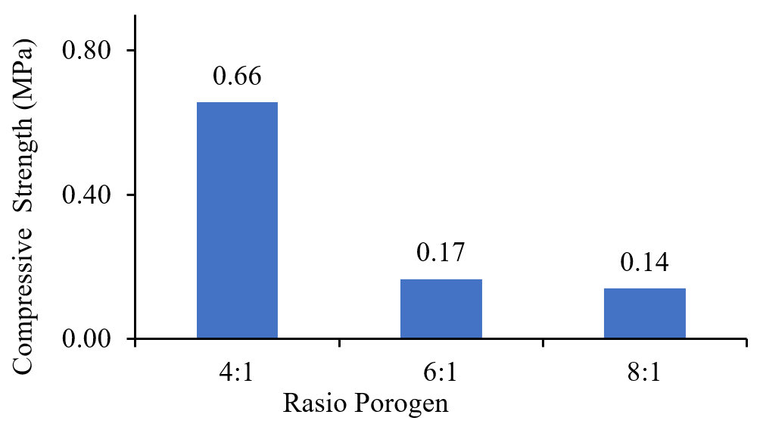
Figure 10. Effect Ratio Porogen on Compressive Strength

Figure 11 (a) shows the results of the weight loss test evaluated over 15 days with evaluations every 5 days. From the image, it can be seen that the addition of APTES tends to reduce weight loss. With the addition of 1% APTES, there is a 32% reduction in the degradation rate. However, after adding more than 1%, there is an increase of up to 49% in the 5% APTES variation.
Based on the weight loss test results, APTES can reduce the degradation rate by increasing the strength of the interface bonding in the composite. With stronger bonds, the composite becomes more resistant to degradation, resulting in a decrease in weight loss [28], [31]. Meanwhile, the addition of the porogen ratio increases the weight loss rate by up to 34% in the A3N8 sample with an 8:1 ratio.
In Figure 11 (b), the effect of the porogen ratio on weight loss is shown. From the figure, it can be seen that with the addition of the porogen ratio, the weight loss value increases. The highest increase occurs in the sample with an 8:1 ratio between the porogen and the composite, which is 34%. This happens because the higher the porogen ratio, the greater the porosity, and with increased porosity, the surface area exposed to the environment (PBS) also increases, leading to a higher weight loss value [32].

(a)

(b)
Figure 11. Effect of (a) APTES and (b) Porogen Ratio on Rate of Weight Loss

The predicted lifetime of the composite can be observed from the amount of weight loss over a certain period. When the weight loss reaches 100%, it can be said that the material has been substituted with human bone tissue. The lifetime of the samples with APTES addition can be seen in Table 2. From the table, it is evident that the addition of APTES can increase the lifetime by 120% at the 1% APTES variation. However, with the addition of more than 1%, there is a decrease in lifetime by 27% at the 5% APTES variation. This occurs because the addition of APTES can enhance the bond strength at the composite interface, thereby increasing the lifetime. On the other hand, with the addition of more than 1%, there is APTES that does not bond well due to incomplete hydrolysis reactions. Causing the interface strength to be uneven, thus the lifetime will decrease

Table 2. The Effect of APTES on Lifetime
Sample | Lifetime (day)
A0N4 | 170
A1N4 | 380
A3N4 | 320
A5N4 | 274

Table 3 shows the estimated lifetime at various porogen ratios. It can be seen that as the porogen ratio increases, the lifetime will decrease. The highest decrease occurs at a ratio of 8:1 between the porogen and the composite, which is 58%. This happens because as the porogen ratio increases, the porosity will also increase. With the increase in porosity, the surface area exposed to the environment (PBS) will also increase, resulting in a larger weight loss value. A large weight loss value leads to a decrease in lifetime

Table 3. The Effect of Porogen Ratio on Lifetime
Sample | Lifetime (day)
A3N4 | 320
A3N6 | 253
A3N8 | 134

The standard application of 3D scaffolds for bone implants has a porosity value of 50-90%. Therefore, based on these test results, all samples have met the minimum requirements as 3D scaffold implants [6], [26].
Meanwhile, the standard tensile strength value for cancellous bone is 1.5 – 38 MPa and compressive strength is 5-10 MPa. Based on the results of the mechanical tests conducted, the sample with the highest strength value is the A1N4 variation with a tensile strength of 0.31 MPa and a compressive strength of 0.87 MPa. However, this variation still does not meet the standard, so to improve the mechanical strength of the PCL/HA composite, more advanced fabrication techniques such as freeze drying and 3D printing can be employed [33], [34].
The standard application for bone implants is to have a lifetime of 3-24 months [35]. Therefore, based on the results of this weight loss test, all samples can be candidates for bone replacement, with the longest duration being sample A1N4, which is 380 days. (12 Months).

CONCLUSION
This study shows that the addition of 1% APTES significantly increases tensile strength up to 138% and compressive strength up to 283% in PCL/HA composites, due to the reinforcement of the matrix and HA particle interface. However, APTES concentrations above 1% reduce mechanical strength due to incomplete hydrolysis reactions. A higher porogen ratio (4:1 to 8:1) increases porosity up to 78.16%, but decreases tensile strength by 84% and compressive strength by 78% due to the dominance of the porous structure. In terms of biodegradation, 1% APTES extends the scaffold's lifetime to 380 days (12 months), while a higher porogen ratio accelerates degradation. The best sample, A1N4 (APTES 1%, porogen ratio 4:1), shows an optimal balance between mechanical properties, porosity, and biodegradation, although it has not yet met the clinical standards for cancellous bone. The development of advanced fabrication techniques is recommended to enhance the performance of this scaffold as a potential candidate for bone regeneration.

ACKNOWLEDGMENT
This research is funded by the Deputy for Strengthening Research and Development, Ministry of Research and Technology/National Research and Innovation Agency with the research title "Development of Composite Materials as Bioabsorbable Implants in Supporting National Medical Device Independence" for the year 2021 and contract number 1018/PKS/ITS/2021.

REFERENCES
[1] N. Xue et al., “Bone Tissue Engineering in the Treatment of Bone Defects,” Pharmaceuticals, vol. 15, no. 7, pp. 1–24, 2022, doi: 10.3390/ph15070879.
[2] N. Fazeli, E. Arefian, S. Irani, A. Ardeshirylajimi, and E. Seyedjafari, “3D-Printed PCL Scaffolds Coated with Nanobioceramics Enhance Osteogenic Differentiation of Stem Cells,” ACS Omega, vol. 6, no. 51, pp. 35284–35296, 2021, doi: 10.1021/acsomega.1c04015.
[3] J. Khotib, C. S. Lasandara, S. Samirah, and A. S. Budiatin, “Acceleration of Bone Fracture Healing through the Use of Natural Bovine Hydroxyapatite Implant on Bone Defect Animal Model,” Folia Medica Indones., vol. 55, no. 3, p. 176, 2019, doi: 10.20473/fmi.v55i3.15495.
[4] Z. Ebrahimi, S. Irani, A. Ardeshirylajimi, and E. Seyedjafari, “Enhanced osteogenic differentiation of stem cells by 3D printed PCL scaffolds coated with collagen and hydroxyapatite,” Sci. Rep., vol. 12, no. 1, pp. 1–15, 2022, doi: 10.1038/s41598-022-15602-y.
[5] J. W. Kim, K. H. Shin, Y. H. Koh, M. J. Hah, J. Moon, and H. E. Kim, “Production of poly(ε-caprolactone)/hydroxyapatite composite scaffolds with a tailored macro/micro-porous structure, high mechanical properties, and excellent bioactivity,” Materials (Basel)., vol. 10, no. 10, 2017, doi: 10.3390/ma10101123.
[6] T. R. Kim et al., “Evaluation of structural and mechanical properties of porous artificial bone scaffolds fabricated via advanced TBA-based freeze-gel casting technique,” Appl. Sci., vol. 9, no. 9, pp. 1–17, 2019, doi: 10.3390/app9091965.
[7] S. Park et al., “3D-Printed Poly(Ε-Caprolactone)/Hydroxyapatite Scaffolds Modified With Alkaline Hydrolysis Enhance Osteogenesis in Vitro,” Polymers (Basel)., vol. 13, no. 2, pp. 1–11, 2021, doi: 10.3390/polym13020257.
[8] H. Y. Jang, J. Y. Shin, S. H. Oh, J. H. Byun, and J. H. Lee, “PCL/HA Hybrid Microspheres for Effective Osteogenic Differentiation and Bone Regeneration,” ACS Biomater. Sci. Eng., vol. 6, no. 9, pp. 5172–5180, 2020, doi: 10.1021/acsbiomaterials.0c00550.
[9] H. Shi, Z. Zhou, W. Li, Y. Fan, Z. Li, and J. Wei, “Hydroxyapatite based materials for bone tissue engineering: A brief and comprehensive introduction,” Crystals, vol. 11, no. 2, pp. 1–18, 2021, doi: 10.3390/cryst11020149.
[10] G. M. Raghavendra, K. Varaprasad, and T. Jayaramudu, Biomaterials: Design, Development and Biomedical Applications. Elsevier Inc., 2015. doi: 10.1016/B978-0-323-32889-0.00002-9.
[11] S. Tajvar, A. Hadjizadeh, and S. S. Samandari, “Scaffold degradation in bone tissue engineering: An overview,” Int. Biodeterior. Biodegrad., vol. 180, no. February, p. 105599, 2023, doi: 10.1016/j.ibiod.2023.105599.
[12] C. Ruiz-Aguilar, U. Olivares-Pinto, R. A. L. Drew, E. A. Aguilar-Reyes, and I. Alfonso, “Porogen Effect on Structural and Physical Properties of β-TCP Scaffolds for Bone Tissue Regeneration,” Irbm, vol. 42, no. 5, pp. 302–312, 2021, doi: 10.1016/j.irbm.2020.05.007.
[13] R. Dwivedi et al., Polycaprolactone as biomaterial for bone scaffolds: Review of literature, vol. 10, no. 1. Craniofacial Research Foundation, 2020. doi: 10.1016/j.jobcr.2019.10.003.
[14] E. Şahin and M. Çiftçioğlu, “Compositional, microstructural and mechanical effects of NaCl porogens in brushite cement scaffolds,” J. Mech. Behav. Biomed. Mater., vol. 116, no. October 2020, 2021, doi: 10.1016/j.jmbbm.2021.104363.
[15] H. Kim, H. Hwangbo, Y. W. Koo, and G. Kim, “Fabrication of mechanically reinforced gelatin/hydroxyapatite bio-composite scaffolds by core/shell nozzle printing for bone tissue engineering,” Int. J. Mol. Sci., vol. 21, no. 9, pp. 1–15, 2020, doi: 10.3390/ijms21093401.
[16] F. R. Mansour, S. Waheed, B. Paull, and F. Maya, “Porogens and porogen selection in the preparation of porous polymer monoliths,” J. Sep. Sci., vol. 43, no. 1, pp. 56–69, 2020, doi: 10.1002/jssc.201900876.
[17] N. Rezania, M. Asadi-Eydivand, N. Abolfathi, S. Bonakdar, M. Mehrjoo, and M. Solati-Hashjin, “Three-dimensional printing of polycaprolactone/hydroxyapatite bone tissue engineering scaffolds mechanical properties and biological behavior,” J. Mater. Sci. Mater. Med., vol. 33, no. 3, 2022, doi: 10.1007/s10856-022-06653-8.
[18] E. Malikmammadov, T. E. Tanir, A. Kiziltay, V. Hasirci, and N. Hasirci, PCL and PCL-based materials in biomedical applications, vol. 29, no. 7–9. Taylor & Francis, 2018. doi: 10.1080/09205063.2017.1394711.
[19] A. Y. Al-Maharma, S. P. Patil, and B. Markert, “Effects of porosity on the mechanical properties of additively manufactured components: a critical review,” Mater. Res. Express, vol. 7, no. 12, 2020, doi: 10.1088/2053-1591/abcc5d.
[20] P. Yos and M. Todo, “Improvement of compressive properties of porous HA scaffold by introducing PCL secondary phase,” Adv. Mater. Res., vol. 858, pp. 96–102, 2014, doi: 10.4028/www.scientific.net/AMR.858.96.
[21] B. H. Atak et al., “Preparation and characterization of amine functional nano-hydroxyapatite/chitosan bionanocomposite for bone tissue engineering applications,” Carbohydr. Polym., vol. 164, pp. 200–213, 2017, doi: 10.1016/j.carbpol.2017.01.100.
[22] J. Peng, X. Zhao, W. Wang, and X. Gong, “Durable Self-Cleaning Surfaces with Superhydrophobic and Highly Oleophobic Properties,” Langmuir, vol. 35, pp. 8404–8412, 2019, doi: 10.1021/acs.langmuir.9b01507.
[23] R. R. R. Kannan, W. A. Stirk, and J. Van Staden, “Synthesis of silver nanoparticles using the seaweed Codium capitatum P.C. Silva (Chlorophyceae),” South African J. Bot., vol. 86, pp. 1–4, 2013, doi: 10.1016/j.sajb.2013.01.003.
[24] C. Y. K. Lung, Z. Sarfraz, A. Habib, A. S. Khan, and J. P. Matinlinna, “Effect of silanization of hydroxyapatite fillers on physical and mechanical properties of a bis-GMA based resin composite,” J. Mech. Behav. Biomed. Mater., vol. 54, pp. 283–294, 2016, doi: 10.1016/j.jmbbm.2015.09.033.
[25] P. Yu-Song, “Surface modification of nanocrystalline hydroxyapatite,” Micro Nano Lett., vol. 6, no. 3, pp. 129–132, 2011, doi: 10.1049/mnl.2010.0187.
[26] J. K. Sherwood et al., “A three-dimensional osteochondral composite scaffold for articular cartilage repair,” Biomaterials, vol. 23, no. 24, pp. 4739–4751, 2002, doi: 10.1016/S0142-9612(02)00223-5.
[27] J. ALDABIB, “Effect of Silane Coupling Agent Content on Mechanical Properties of Hydroxyapatite/Poly(methyl methacrylate) Denture Base Composite,” Int. J. Chem. Technol., vol. 5, no. 1, pp. 37–45, 2020, doi: 10.32571/ijct.783998.
[28] C. Shuai, L. Yu, P. Feng, C. Gao, and S. Peng, “Interfacial reinforcement in bioceramic/biopolymer composite bone scaffold: The role of coupling agent,” Colloids Surfaces B Biointerfaces, vol. 193, no. February, 2020, doi: 10.1016/j.colsurfb.2020.111083.
[29] W. L. Tham, W. S. Chow, and Z. A. Mohd Ishak, “Effects of titanate coupling agent on the mechanical, thermal, and morphological properties of poly(methyl methacrylate)/hydroxyapatite denture base composites,” J. Compos. Mater., vol. 45, no. 22, pp. 2335–2345, 2011, doi: 10.1177/0021998311401085.
[30] A. Larrañaga et al., “A study of the mechanical properties and cytocompatibility of lactide and caprolactone based scaffolds filled with inorganic bioactive particles,” Mater. Sci. Eng. C, vol. 42, pp. 451–460, 2014, doi: 10.1016/j.msec.2014.05.061.
[31] I. Berktas, A. N. Ghafar, P. Fontana, A. Caputcu, Y. Menceloglu, and B. S. Okan, “Facile synthesis of graphene from waste tire/silica hybrid additives and optimization study for the fabrication of thermally enhanced cement grouts,” Molecules, vol. 25, no. 4, 2020, doi: 10.3390/molecules25040886.
[32] N. İ. Büyük, D. Aksu, and G. Torun Köse, “Effect of different pore sizes of 3D printed PLA-based scaffold in bone tissue engineering,” Int. J. Polym. Mater. Polym. Biomater., vol. 72, no. 13, pp. 1021–1031, 2023, doi: 10.1080/00914037.2022.2075869.
[33] C. C. Kuo, H. Qin, Y. Cheng, X. Jiang, and X. Shi, “An integrated manufacturing strategy to fabricate delivery system using gelatin/alginate hybrid hydrogels: 3D printing and freeze-drying,” Food Hydrocoll., vol. 111, no. August 2020, 2021, doi: 10.1016/j.foodhyd.2020.106262.
[34] M. Mabrouk, H. H. Beherei, and D. B. Das, “Recent progress in the fabrication techniques of 3D scaffolds for tissue engineering,” Mater. Sci. Eng. C, vol. 110, no. February, 2020, doi: 10.1016/j.msec.2020.110716.
[35] M. N. Sarian et al., “Potential bioactive coating system for high-performance absorbable magnesium bone implants,” Bioact. Mater., vol. 12, no. October 2021, pp. 42–63, 2022, doi: 10.1016/j.bioactmat.2021.10.034.

