Car Seatbelt Monitoring System Using Real-Time Object Detection Algorithm Under Low-light and Bright-light Conditions | 

Agus Suryanto¹, Dwi Haryo Wicaksono², Anggraini Mulwinda³, M. Harlanu⁴, Mario Norman Syah⁵
^{1,2,3,4,5} Department of Electrical Engineering, Universitas Negeri Semarang, Indonesia

Abstract  Seatbelt usage is essential for minimizing injury risk during vehicular accidents. The monitoring seatbelt system in modern vehicles is easily tricked to avoid the warning alert. Car seatbelt detection using real-time object detection is employed to monitor seatbelt usage. However, the accuracy of such systems needs to be further evaluated under low-light and bright-light conditions. This study aims to develop a car seatbelt monitoring system using a real-time object detection algorithm, which will be tested in low-light and bright-light scenarios. The real-time object detection algorithm will utilize the YOLO (You Only Look Once) algorithm, which works by dividing the input image into a grid and predicting bounding boxes and class probabilities for each grid cell simultaneously. YOLO is trained to detect people with and without seatbelts by classifying these scenarios based on the visual characteristics captured in the image. If a driver or passenger is detected without a seatbelt, an alert system, such as a buzzer and Telegram notification, will be activated to notify the user of the violation. This system has an accuracy of 95.75%, precision of 99.1%, recall of 96.2%, and an F1-score of 97.2%. The results show that the system can generate a better confidence score during the bright-light than the low-light conditions.  .  This is an open-access article under the CC BY-SA license   | Keywords:  Monitoring; Internet of Things; Seatbelt; You Only Look Once  Article History:  Received:  Revised:  Accepted:  Published:  Corresponding Author:  Agus Suryanto  Electrical Engineering Department, Universitas Negeri Semarang, Indonesia  Email: agusku2@mail.unnes.ac.id

INTRODUCTION
Safety in driving is an essential aspect of using transportation. However, many drivers still neglect it, including the use of seatbelts. The use of seatbelts in motor vehicles is useful in minimizing the risk of injury or death in the event of a traffic accident. An ideal driver is said to always use a seatbelt when driving. However, many drivers of four-wheeled vehicles are unwilling to use seatbelts. They merely fasten it to the buckle to silence the warning buzzer without actually wearing it on their bodies. Using a combination of lap and shoulder seatbelts is an efficient way to minimize the seriousness and mortality rate of injuries caused by vehicle collisions [1].
The absence of seatbelt use among new drivers, particularly those aged 15 to 17, significantly increases the risk of morbidity and mortality in motor vehicle accidents, with studies showing over 20% greater odds of mortality and nearly two-thirds of pediatric spinal fractures occurring without seatbelts [2]. In 2020, only 49% of vehicle passengers were using seatbelts during accidents [3]. Therefore, a driver monitoring system is needed to ensure the proper use of seatbelts.
An object detected by a camera requires an algorithm to process it. Algorithms such as Faster R-CNN use two stages in object detection, which results in longer processing times but higher accuracy [4]. Additionally, object detection algorithms like YOLO and SSD tend to excel in speed, while R-CNN and its variants perform better in terms of accuracy [5]. The RetinaNet algorithm has a slower speed due to its more complex architecture, which results in higher accuracy for detecting small objects [6]. For object detection systems that require speed, the use of the YOLO algorithm is considered appropriate. YOLO can detect objects quickly while maintaining accuracy because it uses a simpler architecture, requiring only a single pass of the image through the network [7].
The ETLE (Electronic Traffic Law Enforcement) system, which can monitor driver behavior, has been implemented. The penalties issued are diverse, including violations of seatbelt usage while driving [8]. However, this method is still not effective, as the monitoring cameras are not installed in all locations and are only present at certain points [9]. The YOLO algorithm has been applied in various fields, including ETLE systems. The YOLO algorithm in ETLE systems can detect riders who are not wearing helmets [10].
Many studies have detected seatbelts using different methods and concepts. One study used the YOLOv5 algorithm to detect seatbelts by determining whether the seatbelt was properly worn by the driver or not [11]. In [12], focused on detecting seatbelts based on weather conditions, which affected the lighting inside the car using the S-AlexNet method. Other works detect seatbelts using different methods called local predictor, a global assembler, and a shape modeling process. In the work [13], develop object detection for autonomous vehicles in various light conditions. The algorithm performance depends on the training data with specific light conditions. However, in the other light conditions it can reduce the effectiveness of the algorithm. Object detection algorithms that are used in [14] have robust performance in low-light conditions to detect vulnerable road users. Seatbelt detection was divided into properly worn seatbelt over the shoulder (seatbelt ON), improperly worn seatbelt (seatbelt UNDER), and no seatbelt used (seatbelt OFF). The seatbelt detection system can be applied to drivers in the car cabin and form a Driver Monitoring System (DMS) or general passengers in the Occupant Monitoring System (OMS) [15]. Furthermore, in [16] detecting seatbelts by categorizing them into three conditions: properly used seatbelt, seatbelt worn behind the back, and no seatbelt used. The model used was YOLO. However, it needs more evaluation in seatbelt detection systems with YOLO algorithm performance under low-light and bright-light conditions, because the lighting conditions in the car cabin are not necessarily the same.
This study focuses on the development of a car seatbelt monitoring system using the YOLOv5 algorithm and evaluated under low-light and bright-light conditions. The YOLOv5 algorithm is trained to detect drivers with and without seatbelts. The detection result will activate the buzzer and send the notification alert via Telegram. The experiment results show the accuracy of the seatbelt detection under low-light and bright-light.

METHOD

Real-time Object Detection Algorithm
The object detection method used in this study is YOLO (You Only Look Once). YOLO is an algorithm developed to detect objects in real-time based on a Convolutional Neural Network (CNN). Essentially, YOLO works by dividing the input image into an SxS grid. If the object to be detected is located in the center of a grid cell, that cell will detect the object. Each grid cell will predict bounding boxes (B) with dimensions and a confidence score (C). Each bounding box has 5 parameters, namely Pc (the confidence score that the box contains an object), bx (the x-coordinate of the box), by (the y-coordinate of the box), bh (the height of the box), and bw (the width of the box). The result from YOLO is a tensor SxSx(BX5+C) [17].

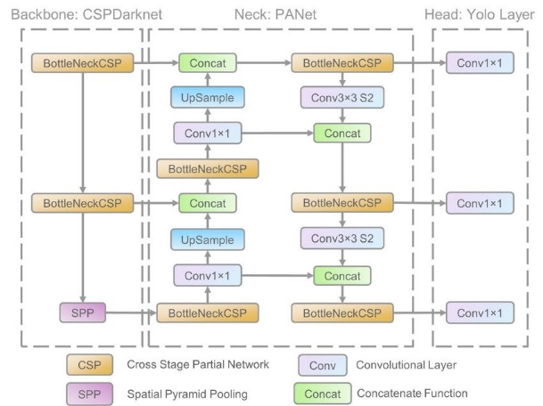
Figure 1. Architecture of YOLOv5

The architecture of YOLOv5 is shown in Figure 1. The YOLOv5 has a lightweight model while maintaining accuracy in object detection [18], [19]. Therefore, YOLOv5 can be more easily implemented into hardware quickly [20], [21]. YOLOv5 is divided into three parts: the backbone, the neck, and the prediction head [22]. The backbone of YOLOv5 is Darknet 53, which is a modern network architecture designed primarily for feature extraction, which utilizes small convolutional filter sizes along with residual connections to enhance the network's ability to capture intricate details while maintaining efficient performance. The combination of these elements helps improve both accuracy and speed in object detection tasks [23]. The neck of YOLOv5 serves as a bridge between the backbone and the head. Its role is to aggregate and refine the features extracted by the backbone, concentrating on improving both spatial and semantic information across different scales to enhance detection accuracy [17]. The head of YOLOv5 comprises three branches, with each one responsible for predicting features at varying scales. Each branch generates bounding boxes, class probabilities, and confidence scores, facilitating precise object detection across different sizes and categories [24].

Material
This research utilized both hardware and software components to support the development and implementation of the proposed system. The specifications of the hardware used are detailed in Table 1. The software employed includes Google Colab, Raspberry Pi Imager, VNC Viewer, Roboflow, and Telegram. These tools facilitated data processing, system configuration, and communication between devices.
The research relied on an image-based dataset consisting of 1,617 images. The dataset includes objects such as seatbelts and faces, which are critical for the research objectives. The images were sourced from data platforms like Roboflow and through manual collection by capturing photographs of individuals simulated as drivers, both wearing and not wearing seatbelts.
Table 1. Hardware Specifications
Device | Specifications
Lenovo Ideapad Slim i5 laptop | Core i5 RAM 8GB
Raspberry Pi 4 | Broadcom BCM2711, quad-core Cortex-A72
Relay 1 channel | 3.75 V – 6 V
Buzzer | 3V – 12V
LED | Red
LM2596 step-down | Input: 4.5 V – 40 V  Output: 1.23 V – 37 V
Cable | NYAF
Smartphone | MediaTek Helio G88; GPU Mali-G52), (RAM: 6 GB), (128 GB)
Webcam HD 1080DPI | HD 1080DPI
Micro SD 64 GB, class 10 | 64 GB
Lux meter | 0 – 200.000 lux

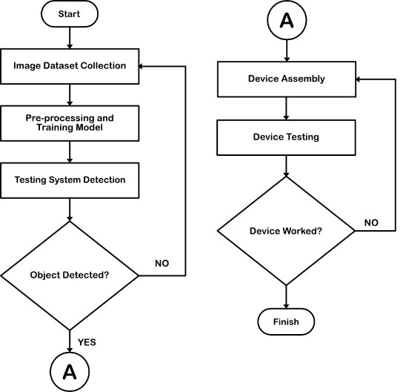

Figure 2. Car Seatbealt Detection Research Workflow

Research Workflow
Based on Figure 2, this research follows the workflow as described below:
- Dataset collection. This stage is responsible for collecting the dataset that will be used to create the detection model. The dataset will then be annotated, labeled, and divided into three parts: train set, valid set, and test set.
- Pre-processing and training model. The data that has been divided will be prepared for the next step, which is feeding it into the training model.
- Testing system detection. The detection model produced from the training will be tested to evaluate the real-world performance of the model. If the system is unable to detect objects, in this case the face and seatbelt, the process will return to the dataset collection stage.
- Device assembly. At this stage, the components used in the seatbelt monitoring system will be combined into a single circuit.
- Device testing. The assembled device will be tested to assess its performance when applied directly in a car.

Dataset Collection
This research used a raw dataset of 1617 images obtained from data sites such as Roboflow, as well as through manual collection by taking pictures of individuals simulated as drivers wearing and not wearing seatbelts. The raw dataset will be annotated and labeled to classify objects in each image. Annotation and labeling are performed manually using Roboflow.
The annotation process provides a bounding box around an object in an image, allowing the model to learn how to detect similar objects. Meanwhile, labeling assigns a class name to the detected object, in this case consisting of two classes: "seatbelt" and "face." The dataset that has been annotated and labeled will be divided into three sets: training data, validation data, and testing data. The division ratio is 70% for training data, 20% for validation data, and 10% for testing data.

Pre-processing
The split dataset will undergo pre-processing before training to improve the quality of the data used in the detection model [25]. This process consists of resizing, auto-orienting, and augmentation. All of these processes are performed in Roboflow. The resize dimensions used are 640x640 pixels. Auto-orient ensures that all datasets are in the same orientation. The augmentation methods used include vertical flip, grayscale (15%), and saturation (-25% to +25%). This process will increase the amount of training data used, thereby improving the model's performance. The total number of datasets used after the augmentation process becomes 2,749, with 2264 for the train set, 323 for the valid set, and 162 for the test set.

Training Model
The training process utilizes the YOLOv5 algorithm with the PyTorch library on Google Colab's virtual GPU to generate model weights and performance metrics for detecting driver faces and seatbelts. The YOLOv5 model has 10 variations based on its architectural shape, namely YOLOv5n, YOLOv5s, YOLOv5m, YOLOv5l, YOLOv5x, YOLOv5n6, YOLOv5s6, YOLOv5m6, YOLOv5l6, and YOLOv5x6 + TTA. However, only YOLOv5n, YOLOv5s, YOLOv5m, YOLOv5l, and YOLOv5x are considered in various studies [25]. YOLOv5n and YOLOv5s are lightweight versions of YOLOv5 that are suitable for low-capability devices [26]. This research uses the YOLOv5s variation because it offers advantages in model complexity while keeping the model weight lightweight [27].
This research utilizes several parameters in the model training, including an image size of 640x640 pixels. Increasing the size can enhance detection accuracy but requires more memory and computation time; a batch size of 64, where a larger batch size leads to faster training processes; and 100 epochs, where a higher number of epochs allows the model to learn from the data more extensively. The training process for this research took 1.294 hours. The resulting model will be used to detect face and seatbelt objects.

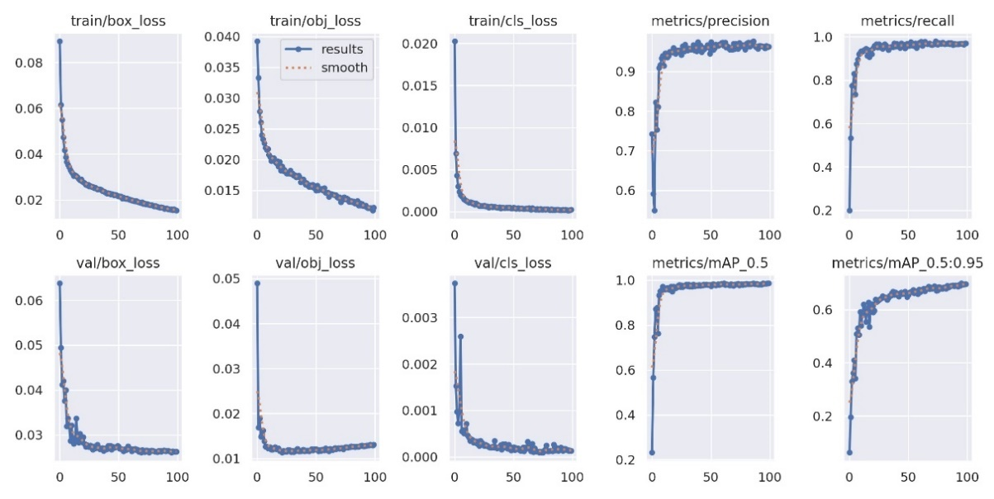
Figure 3. YOLOv5s Training Model Results

The training process of the YOLOv5s model resulted in several performance parameters for the developed model, including a precision value of 0.962 (96.2%), a recall value of 0.97 (97%), and a mean Average Precision (mAP) value of 0.985 (98.5%). In addition to these numerical performance parameters, there is a graph generated to assess the performance of the created model, as shown in Figure 3.

Device Assembly
The design of the monitoring system device is shown in Figure 4. The monitoring device operates using voltage sourced from the car battery through the ignition switch. This voltage source can power the Raspberry Pi, which acts as the central processing unit of the architecture, enabling it to detect objects. The webcam connected to the Raspberry Pi 4 will serve as the medium for detecting objects. When objects such as a face and seatbelt are captured by the webcam, this input will be processed by the Raspberry Pi 4. The result of this processing will be a signal, including both component responses and Telegram notifications.
The circuit responds differently based on seatbelt detection. When the seatbelt is detected, the LED and buzzer remain inactive, while the relay stays in a closed state. Conversely, if the seatbelt is not detected, the LED and buzzer activate, and the relay switches to an open state. The relay is connected to the car's starter motor via the "Start" circuit on the ignition key, making seatbelt detection a prerequisite for starting the car's engine.

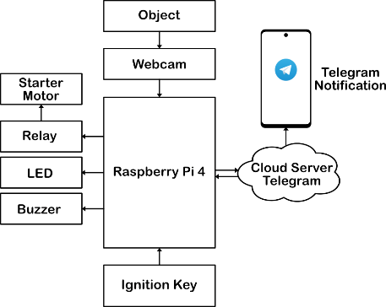
Figure 4. Monitoring Device Design

Telegram notifications will be sent to the driver's smartphone every 5 minutes while the driver is detected not wearing a seatbelt. The interval of 5 minutes was chosen so that the driver does not feel overly disturbed, compared to sending notifications every time the driver is detected not wearing a seatbelt.

Testing and Evaluation
The testing conducted on the system consists of detection system testing, monitoring system testing, device testing, and Telegram notification testing. In the detection system testing, the parameters sought are evaluation values such as accuracy, precision, recall, and F1-score derived from tests using the test data. This evaluation is obtained by examining TP (true positive), FP (false positive), FN (false negative), and TN (true negative) from the confusion matrix table. The confusion matrix is displayed in Table 2.
TP indicates that the prediction is true, and the actual value is positive; FP indicates that the prediction is true, but the actual value is negative; FN indicates that the prediction is false, but the actual value is positive; TN indicates that the prediction is false, and the actual value is negative [28]. The evaluation is obtained using the following formulas:

Table 2. Confusion Matrix
 |  | Actual
 |  | Positive | Negative
Predicted | True | TP | FP
Predicted | False | FN | TN

$\text{Accuracy =}\frac{\text{TP+TN}}{\text{TP+FP+FN+TN}}$ | (1)
$\text{Precision }\text{=}\frac{\text{T}\text{P}}{\text{TP+FP}}$ | (2)
$\text{Recall }\text{=}\frac{\text{T}\text{P}}{\text{TP+F}\text{N}}$ | (3)
$\text{F1-Score }\text{=}\text{2 x}\left(\frac{\text{Precision x Recall}}{\text{Precision+Recall}}\right)$ | (4)

Accuracy measures how many true predictions there are out of the total data. Precision measures how many true predictions are positive out of all positive predictions. Recall measures how many true predictions are positive out of all actual positives. Meanwhile, F1-score measures the harmonic mean between precision and recall to achieve a balance. In addition to those parameters, there are parameters that can determine the percentage of errors made by the system during testing. The calculations used are as follows:
$\%Error=\left(1-Accuracy\right) x 100\%$ | (5)

In the testing of the monitoring system, device testing, and Telegram notifications, a direct test will be conducted by connecting the device to the car's electrical system, specifically the ignition switch. This test aims to evaluate the device's performance in generating responses based on monitoring the driver's seatbelt usage and the intensity of light entering the vehicle.

RESULTS AND DISCUSSION

Detection System Testing
The detection system in this research was tested using a test dataset consisting of 162 images containing seatbelt and face objects. This test used a confidence threshold of 0.5 and an IoU (Intersection over Union) threshold of 0.45. A confidence threshold of 0.5 was chosen to ensure that only object detections with confidence above 0.5 (50%) would be considered valid, while the IoU threshold of 0.45 was selected to provide a balance between precision and recall, ensuring that the detected objects are relevant to the ground truth. Sample results from the detection system testing are displayed in Figure 5 and Figure 6.

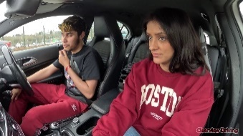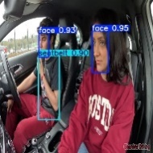
(a) (b)
Figure 5. (a) Before being Detected (b) After being Detected
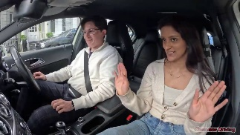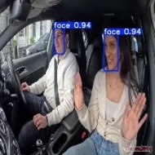
(a) (b)
Figure 6. (a) Before being detected (b) After being detected

Table 3. Confusion Matrix
No | Object | TP | FN | FP | TN
1 | Face | 219 | 0 | 4 | 11
2 | Seatbelt | 171 | 14 | 0 | 21

Table 4. Matriks evaluasi
No | Object | Accuracy | Precision | Recall | F1-Score
1 | Face | 0.983 | 0.982 | 1 | 0.984
2 | Seatbelt | 0.932 | 1 | 0.924 | 0.96
Average |  | 0.9575 | 0.991 | 0.962 | 0.972

Based on Figure 5 and Figure 6, images are displayed before and after the object detection process. Before detection, the images remain in their original size, but after processing, they are resized to 640x640 pixels to fit the detection system's requirements. Additionally, there are bounding boxes indicating that the system has detected an object, accompanied by class labels and confidence scores that express how confident the system is in detecting the object compared to the ground truth during model training. There was an error in the object detection system testing, wherein Figure 6(a), the driver is wearing a seatbelt, but in Figure 6(b), the system failed to detect the driver’s seatbelt. This incident can serve as an evaluation of the performance of the object detection model during testing. Evaluation can begin by identifying the number of TP (true positive), FN (false negative), FP (false positive), and TN (true negative) for each class. The counts for each parameter in this test are presented in Table 3. Based on the results from Table 3, the evaluation of the detection system in terms of accuracy, precision, recall, and F1-score can be summarized as shown in Table 4.

Car Seatbelt Monitoring Device
All components used for the car seatbelt monitoring device are connected into a single circuit as shown in Figure 7. The monitoring device is powered through an NYAF cable connected to the car's ignition switch at the "ACC" and "ON" positions. Meanwhile, the connection to the starter motor is controlled by interrupting the "Start" line on the ignition switch via a relay.

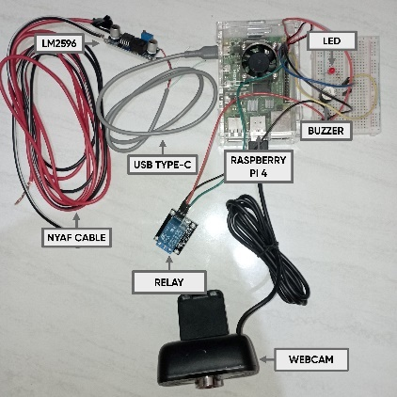
Figure 7. Seatbelt Monitoring Device

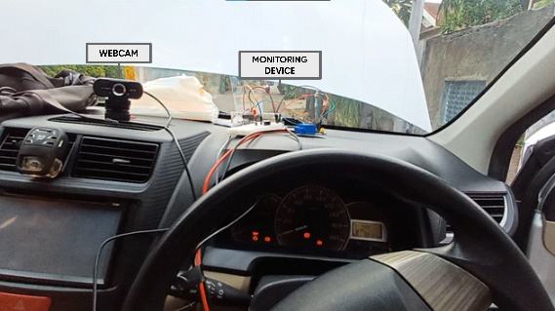
Figure 8. Placement of The Monitoring Device

The monitoring device will be placed inside the car's dashboard, while the webcam will be positioned on top of the air conditioning unit at the center front of the car and directed toward the driver, as shown in Figure 8. his placement of the webcam was chosen because it tends to capture clearer and more focused images of the driver's body area compared to other positions.

Car Seatbelt Monitoring Device Testing
The monitoring system is tested by observing the detection performance of the seatbelt and face based on the light intensity inside the car in real-time. The tests are conducted under two conditions, with each condition being tested ten times. In the first condition, which is bright-light, the performance results are displayed on Table 5.

Table 5. Bright-light Test Results
Conf.  Seatbelt | Conf.  Face | Light  Intensity | Detection Speed | Test Time
94 | 89 | 5081 | 1495.6 | 11.19
95 | 80 | 4645 | 1518.3 | 11.19
94 | 82 | 4305 | 1528.4 | 11.19
95 | 90 | 4879 | 1506.6 | 11.19
96 | 92 | 4550 | 1520.6 | 11.19
78 | 94 | 3926 | 1500.8 | 11.19
71 | 96 | 3735 | 1524.6 | 11.19
65 | 94 | 3617 | 1522.0 | 11.19
88 | 94 | 4341 | 1518.6 | 11.19
79 | 92 | 4263 | 1502.6 | 11.19
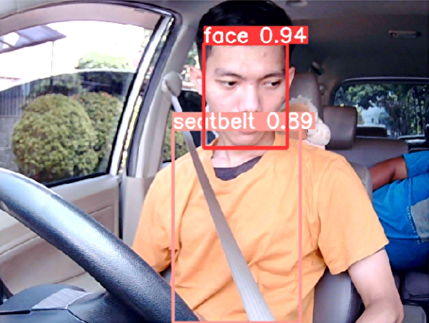
Figure 9. Bright-light Test Sample

Based on Table 5, the results of the monitoring system tests during the bright-light are obtained. The average confidence for detecting faces is 90.3%, while for the seatbelt object, it is 85.5%. The average light intensity entering the car is 4334.2 lux. Meanwhile, the average object detection speed is 1513.81 ms. The tests were conducted at 11:19 AM. The results of the system testing are displayed in Figure 9.
In the second condition, under low-light settings, the performance results are presented in Table 6. Based on Table 6, the results of the monitoring system testing in the low-light conditions are obtained. The average confidence for the face object is 87.7%, while for the seatbelt object, it is 83.6%. The average light intensity entering the car is 2295.8 lux. The average object detection speed is 1512.29 ms. The testing was conducted at 5:59 PM. The results of the testing during the low-light conditions are displayed in Figure 10.

Table 6. Low-light Test Results
Conf.  Seatbelt  (%) | Conf.  Face | Light  Intensity | Detection Speed | Test Time
83 | 89 | 2552 | 1418.8 | 17.59
79 | 90 | 2592 | 1457.9 | 17.59
80 | 87 | 2146 | 1461.3 | 17.59
78 | 83 | 2354 | 1439.9 | 17.59
85 | 93 | 2103 | 1441.1 | 17.59
88 | 89 | 2313 | 1592.8 | 17.59
90 | 94 | 2480 | 1488.2 | 17.59
85 | 79 | 2260 | 1568.5 | 17.59
83 | 94 | 1975 | 1788.4 | 17.59
85 | 79 | 2183 | 1466.0 | 17.59

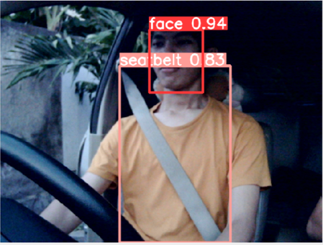
Figure 10. Low-light Test Sample

A test is performed to assess the car seatbelt monitoring response, which includes the relay, buzzer, LED, and Telegram notifications, based on the driver's detection status. Table 7 shows system response when the system detects the seatbelt and face, the LED and buzzer notification components are off, the relay condition that was initially open becomes closed, and the driver’s smartphone does not receive a Telegram notification. During testing in the car, the driver can start the engine by activating the starter motor via the ignition switch. The average confidence value for seatbelt detection is 81.4%, while the average confidence value for face detection is 94.4%. All these tests were conducted with an average light intensity of 4124.6 lux, performed during the daytime at 13:25. The results of the test, when the driver is using the seatbelt, are shown in Figure 11.

Table 7. Test Result with Seatbelt
Conf.  Seatbelt | Conf.  Face | Light  Intensity | Notification | LED & Buzzer | Relay | Time
89 | 94 | 3758 | Not Sent | Off | Close | 13.25
80 | 95 | 3843 | Not Sent | Off | Close | 13.25
82 | 94 | 3925 | Not Sent | Off | Close | 13.25
90 | 95 | 4436 | Not Sent | Off | Close | 13.25
92 | 96 | 4606 | Not Sent | Off | Close | 13.25
78 | 94 | 4246 | Not Sent | Off | Close | 13.25
71 | 96 | 3827 | Not Sent | Off | Close | 13.25
65 | 94 | 3789 | Not Sent | Off | Close | 13.25
88 | 94 | 4631 | Not Sent | Off | Close | 13.25
79 | 92 | 4185 | Not Sent | Off | Close | 13.25

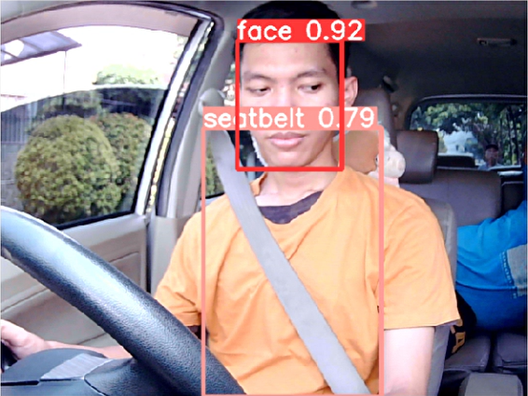
Figure 11. Result of Test Using Seatbelt

Table 8. Not Use Seatbelt
Conf.  Seatbelt | Conf.  Face | Light  Intensity | Notification | LED & Buzzer | Relay | Time
- | 94 | 3974 | Sent | On | Open | 13.30
- | 89 | 3914 | Not Sent | On | Open | 13.31
- | 95 | 3735 | Not Sent | On | Open | 13.32
- | 94 | 3891 | Not Sent | On | Open | 13.33
- | 95 | 4341 | Sent | On | Open | 13.35
- | 96 | 4263 | Not Sent | On | Open | 13.36
- | 95 | 4550 | Not Sent | On | Open | 13.37
- | 93 | 4645 | Not Sent | On | Open | 13.38
- | 95 | 4305 | Not Sent | On | Open | 13.39
- | 94 | 4167 | Not Sent | On | Open | 13.40

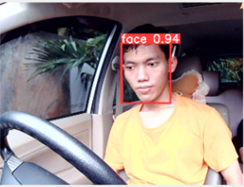
Figure 12. Result of Test Without Seatbelt

The test result without a seatbelt is displayed in Table 8. Based on the results, the test is conducted 10 times when the driver is not wearing a seatbelt, the monitoring device can detect objects without any detection errors or sensor responses. If the seatbelt is not detected but the face is, the LED and buzzer activate, the relay remains open, and the driver's smartphone receives a Telegram notification every 5 minutes. As a result, in the test conducted in the car, the starter motor cannot be activated to start the engine through the ignition switch. The average confidence value for face detection is 94%. All tests were conducted with an average light intensity of 4178.5 lux. A sample image from the testing conducted is shown in Figure 12.

Telegram Notification Testing
Telegram notifications are sent when the driver is detected not wearing their seatbelt. The system automatically sends notifications to the driver's smartphone via the Telegram application.
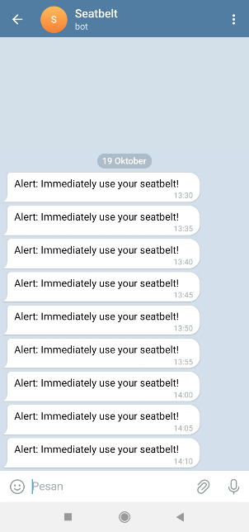
Figure 13. Telegram Notification
Notifications are sent every 5 minutes while the driver is not detected wearing the seatbelt. The format of the Telegram notification received on the smartphone is shown in Figure 13.

Result Analysis
Based on Table 4 from the detection system testing, it shows that from 162 test images, the average of each parameter results in an accuracy of 0.9575 (95.75%) out of 100%, a precision of 0.991 (99.1%) out of 100%, a recall of 0.962 (96.2%) out of 100%, and an F1-score of 0.972 (97.2%) out of 100%. In addition to these values, there are values that can be generated to determine the error rate of the system in performing detection based on its classes. The error values generated for each class are displayed in Figure 14.
Overall, the performance of the detection system shows a tendency to be better when detecting the driver’s face compared to the seatbelt. The performance in detecting face objects is 0.983 or 98.3% (accuracy), 0.982 or 98.2% (precision), 1 or 100% (recall), and 0.984 or 98.4% (F1-score) with an error rate of 1.7%. In contrast, the performance in detecting seatbelts is 0.932 or 93.2% (accuracy), 1 or 100% (precision), 0.924 or 92.4% (recall), and 0.96 or 96% (F1-score) with an error rate of 6.8%.
Face detection excels in accuracy, recall, F1-score, and error rates but is weak in precision. Meanwhile, seatbelt detection only excels in precision. This discrepancy may be due to the smaller number of seatbelt objects in the dataset compared to face objects, with 1237 seatbelt objects and 2539 face objects, leading the system to struggle in detecting seatbelt objects under various conditions and driver positions. Additionally, the larger size of the seatbelt object and the extensive background that includes the driver’s body may also contribute to this issue. In contrast, face objects are smaller and have less background interference.

Figure 14. Error Detection System
Low-light
Bright-light
Figure 15. Confidence Score Comparison

Based on the monitoring system tests conducted during bright-light and low-light conditions, the confidence values generated for each class tend to fluctuate. These fluctuations can occur due to various factors, such as the seatbelt being obstructed by the driver’s hand and movements of the driver’s body and face itself [29]. Furthermore, there are differences in the average confidence values produced for each class, as shown in Figure 15.
Based on Figure 15, the monitoring system can produce better confidence values for the face object compared to the seatbelt object. During the bright-light conditions, the average confidence value for the face is 90.3%, while for the seatbelt, it is 85.5%. In the low-light conditions, the average confidence value for the face is 87.7%, and for the seatbelt, it is 83.6%. This may be due to the fact that the face object is generally smaller than the seatbelt, and face objects experience fewer interruptions, such as being obscured by other objects. In contrast, the seatbelt object is more likely to be obstructed, such as when it is covered by the driver's hand while driving. The average intensity of light entering the car during each test is shown in Figure 16.

Low-light
Bright-light
Figure 16. Comparison of Light Intensity

Low-light
Bright-light
Figure 17 Comparison of Detection Speeds

Based on Figure 16, the average intensity of light entering the car in the evening is lower (low-light) at 1512.29 lux compared to during the day (bright-light), which is 4334.2 lux. This can be a factor for the lower confidence scores produced in the low-light conditions compared to during the bright-light conditions, as the reduced light entering the car affects the object detection results [30].
The object detection speed values in each test conducted 10 times tend to be stable. The average object detection speed produced is displayed in Figure 17. The average object detection speed during each test showed no significant difference, with a mere gap of 1.72 ms. The average detection speed during bright-light conditions testing was 1513.81 ms, while in the low-light conditons, it measured 1512.29 ms. This consistent speed is influenced by the object detection model used and the input size of the images, which affects Raspberry Pi's performance in processing images captured in real-time.
In the monitoring device test when the driver is wearing a seatbelt, the system detects both the face and the seatbelt. As a result, the device responds by changing the relay condition from open to closed, and it does not activate the LED and buzzer components. No Telegram notification is sent to the driver’s smartphone. Because the relay condition is closed, the driver can start the vehicle's engine using the ignition key.
Then, in the device test when the driver is not wearing a seatbelt, the system only detects the face, causing the device to respond by activating the LED and buzzer, while the relay remains in an open condition. The Telegram notification is successfully sent to the driver’s smartphone every 5 minutes as long as the driver is still detected not wearing the seatbelt. For example, when the driver is detected not wearing a seatbelt at 13:30, the system immediately sends a Telegram notification to the driver’s smartphone. Five minutes later, at 13:35, the system still does not detect the seatbelt. The system automatically sends another Telegram notification to the driver’s smartphone, and this continues until the system detects the seatbelt. Because the relay remains in an open condition, the driver cannot start the vehicle's engine using the ignition key. This is due to the connection in the ignition key’s “Start” position being interrupted with the vehicle's starter motor component.
The Telegram notification interface received by the driver's smartphone is shown in Figure 13. The notification contains a message stating, “Alert: Immediately use your Seatbelt!” This is to urge the driver to put on their seatbelt immediately.

Discussion
In this study, the YOLOv5 model developed can detect the use of seatbelts and the driver's face. From the results obtained, there is an imbalance in performance between the results of “face” and “seatbelt” detection. The “face” detection is better in all parameters obtained than the “seatbelt” detection. This could be due to the larger number of annotations used in the “face” dataset, compared to “seatbelt”. This reinforces the results of the work in [31] on the unbalanced number of datasets per class can reduce the performance of object detection when predicting an image. In addition, it reinforces the results of [32], that overall performance depends on how much the dataset represents the original distribution rather than its size, and algorithmic models with good performance do not always provide the best performance for limited datasets. It can be concluded that the representation and the quantity of datasets for each object class to be detected significantly influence the achievement of optimal performance.
In a study [11], the detection model developed to identify seatbelts had an average precision of 89%, recall of 81%, and confidence score 80% using the YOLOv5 method. Implementasi model deteksi seatbelt tersebut dilakukan dengan memberikan input gambar dan real time video dengan kondisi cahaya normal terang. While the proposed monitoring system research has an average precision of 99.1%, precision 96.2%, with a more complex implementation, namely in 2 light conditions, physical notifications in the form of LEDs and buzzers connected to the car's electrical system as a condition for the driver to start the car engine, and connected to the driver's smartphone Telegram. Resulting in an average confidence value when bright light is 87.9% and when low-light is 85.65%. So, the proposed monitoring system research is better than this research.
In [33] made a seat belt detection system using the YOLOv7 algorithm connected to the Jetson Nano, Camera, Buzzer, and display. The seat belt object detection system is divided into 2, namely unbuckled and buckled. The buzzer will sound if the driver is detected not using a seat belt, and vice versa. The detection model produced an average F1-score of 98%, precision of 99.7% (buckled) and 99.5% (unbuckled). The implementation of the system is installed in the car, but it is not connected to the car's electricity. Unlike this research, which is integrated with the car's electricity as an input source and disconnects the cable to the starter dynamo, there is a notification LED that is connected to the driver's smartphone Telegram. The resulting detection performance is lower, with an average F1-score of 97.2%, while the seatbelt precision superiority is 100%. Despite using YOLOv7, which is superior to YOLOv5, in fact, the research only used 1240 datasets compared to the proposed monitoring system research using 1617 datasets. This again strengthens the research [32].
This research monitoring system performs well when detecting objects in bright-light conditions compared to low-light conditions. This supports the research of [34], that there is a decrease in detection performance when performed in low-light conditions. They innovated to dynamically enhance low-light images with multiple levels using a convolutional neural network, generating filters and exposure maps. Such research can be a development for this proposed monitoring system to improve the performance during detection in low-light conditions and reduce the error value so that the monitoring system can correctly detect seat belt objects and driver faces.
Finally, in the study [16], seatbelts were divided into three conditions: seatbelt used correctly, seatbelt fastened behind, and seatbelt not fastened at all. The model achieved 93% accuracy in detecting these conditions using the YOLO algorithm. While, this proposed research has almost the same accuracy in detecting seatbelt, which is 93.2%. However, what makes the difference is the implementation of the system model that is directly applied in real (physical) in the car's electricity as a condition for starting the car engine and connected to the internet of things network. These results can provide practical insights for future research and industrial development.

CONCLUSION
This study aims to develop car seatbelt monitoring system of the usage of seatbelts by drivers using the YOLOv5 algorithm to detect seatbelt and face objects. The performance of the monitoring detection system yields an accuracy of 95.75%, precision of 99.1%, recall of 96.2%, and an F1-score of 97.2%. The monitoring system generates an average confidence score of 85.5% for the seatbelt and 90.3% for the face, with an average detection speed of 1513.81 ms during bright-light with an intensity of 4334.2 lux, while a confidence score during low-light conditions is 83.6% for seatbelt and 87.7% for the face, with an average speed of 1512.29 ms during low-light with intensity of 1512.29 lux. The system performs better under bright-light conditions compared to low-light conditions. The monitoring device successfully connects to the car's ignition system, providing responses based on seatbelt detection results through LED, buzzer, relay, and Telegram notifications. Notifications are successfully sent every 5 minutes.
For future research, it is recommended to use a larger and more diverse dataset under various conditions (e.g., low lighting, obstruction by hands or clothing, different object positions) to enhance the detection model's performance. Additionally, the monitoring device could be optimized for better performance by using lighter algorithms while preserving accuracy, thereby improving the real-time object detection speed. Moreover, Telegram notifications could be expanded into a surveillance system linked to law enforcement, such as the police.

REFERENCES
[1] A. Takeda, A. Kuwahara, M. Takaso, M. Nakamura, Y. Miyata, and M. Hitosugi, “Correct Use of a Conventional Lap-and-Shoulder Seatbelt Is Safest for Pregnant Rear-Seat Passengers: Proposal for Additional Safety Measures,” Appl. Sci., vol. 12, no. 17, p. 8776, 2022.
[2] V. Sarwahi et al., “Seatbelts Save Lives, and Spines, in Motor Vehicle Accidents,” Spine (Phila. Pa. 1976)., vol. 46, no. 23, pp. 1637–1644, Dec. 2021, doi: 10.1097/BRS.0000000000004072.
[3] V. A. Adewopo, N. Elsayed, Z. ElSayed, M. Ozer, A. Abdelgawad, and M. Bayoumi, “A review on action recognition for accident detection in smart city transportation systems,” J. Electr. Syst. Inf. Technol., vol. 10, no. 1, 2023, doi: 10.1186/s43067-023-00124-y.
[4] Z. Wang et al., “An improved Faster R-CNN model for multi-object tomato maturity detection in complex scenarios,” Ecol. Inform., vol. 72, p. 101886, 2022, doi: https://doi.org/10.1016/j.ecoinf.2022.101886.
[5] R. Kaur and S. Singh, “A comprehensive review of object detection with deep learning,” Digit. Signal Process., vol. 132, p. 103812, 2023.
[6] L. Tan, T. Huangfu, L. Wu, and W. Chen, “Comparison of RetinaNet, SSD, and YOLO v3 for real-time pill identification,” BMC Med. Inform. Decis. Mak., vol. 21, pp. 1–11, 2021.
[7] H.-J. Jeong, K.-S. Park, and Y.-G. Ha, “Image Preprocessing for Efficient Training of YOLO Deep Learning Networks,” in 2018 IEEE International Conference on Big Data and Smart Computing (BigComp), 2018, pp. 635–637. doi: 10.1109/BigComp.2018.00113.
[8] Y. Indarsih, “Application of Electronic Traffic Law Enforcement (E-TLE) Ticketing System Management at Polda West Java,” Enrich. J. Manag., vol. 11, no. 2, pp. 402–406, 2021.
[9] Y. Yuliantoro and A. Sulchan, “The effectiveness against traffic violations with electronic traffic law enforcement (ETLE),” Law Dev. J., vol. 3, no. 4, pp. 736–742, 2021.
[10] D. S, V. K. C. N. S, V. Duraivelu, B. Easwaran, S. R, and A. H, “Enhancing Road Safety with Real-Time Helmet Detection and E-Challan Issuance using YOLO and OCR,” in 2024 International Conference on Cognitive Robotics and Intelligent Systems (ICC - ROBINS), 2024, pp. 644–649. doi: 10.1109/ICC-ROBINS60238.2024.10533911.
[11] K. Rohman and T. B. Sasongko, “Fast Detection of Seatbelt Driver Based on Image Capturing,” JURTEKSI (Jurnal Teknol. dan Sist. Informasi), vol. 9, no. 3, pp. 473–480, Jun. 2023, doi: 10.33330/jurteksi.v9i3.2276.
[12] O. Hosameldeen, “Deep learning-based car seatbelt classifier resilient to weather conditions,” Int. J. Eng. Technol., vol. 9, no. 1, pp. 229–237, Feb. 2020, doi: 10.14419/ijet.v9i1.30050.
[13] H. Lin et al., “A Study on Data Selection for Object Detection in Various Lighting Conditions for Autonomous Vehicles,” J. Imaging, vol. 10, no. 7, 2024, doi: 10.3390/jimaging10070153.
[14] K. H. Divya Prasad, M. S. Jincy, and S. Ganapathy, “Detection and performance analysis of vulnerable road users in low light conditions using YOLO,” Proc. 2024 10th Int. Conf. Commun. Signal Process. ICCSP 2024, pp. 862–867, 2024, doi: 10.1109/ICCSP60870.2024.10544095.
[15] L. H. Backar, M. A. Khalifa, and M. A.-M. Salem, “In-Vehicle Monitoring for Passengers’ Safety,” in 2022 IEEE 12th International Conference on Consumer Electronics (ICCE-Berlin), 2022, pp. 1–6. doi: 10.1109/ICCE-Berlin56473.2022.9937111.
[16] A. Kashevnik, A. Ali, I. Lashkov, and N. Shilov, “Seat Belt Fastness Detection Based on Image Analysis from Vehicle In-Cabin Camera,” in 2020 26th Conference of Open Innovations Association (FRUCT), IEEE, Apr. 2020, pp. 143–150. doi: 10.23919/FRUCT48808.2020.9087474.
[17] J. Terven, D.-M. Córdova-Esparza, and J.-A. Romero-González, “A comprehensive review of yolo architectures in computer vision: From yolov1 to yolov8 and yolo-nas,” Mach. Learn. Knowl. Extr., vol. 5, no. 4, pp. 1680–1716, 2023.
[18] X. Cong, S. Li, F. Chen, C. Liu, and Y. Meng, “A review of YOLO object detection algorithms based on deep learning,” Front. Comput. Intell. Syst., vol. 4, no. 2, pp. 17–20, 2023.
[19] O. E. Olorunshola, M. E. Irhebhude, and A. E. Evwiekpaefe, “A Comparative Study of YOLOv5 and YOLOv7 Object Detection Algorithms,” J. Comput. Soc. Informatics, vol. 2, no. 1, pp. 1–12, 2023, doi: 10.33736/jcsi.5070.2023.
[20] F. Yu et al., “Improved YOLO-v5 model for boosting face mask recognition accuracy on heterogeneous IoT computing platforms,” Internet of Things, vol. 23, p. 100881, 2023.
[21] C. Dang et al., “The Accelerated Inference of a Novel Optimized YOLOv5-LITE on Low-Power Devices for Railway Track Damage Detection,” IEEE Access, vol. 11, pp. 134846–134865, 2023, doi: 10.1109/ACCESS.2023.3334973.
[22] A. Hossain, M. T. Islam, and A. F. Almutairi, “A deep learning model to classify and detect brain abnormalities in portable microwave based imaging system,” Sci. Rep., vol. 12, no. 1, p. 6319, 2022.
[23] H. Lai, B. Liu, H. Y. Kan, C.-T. Lam, and S. K. Im, “YOLOv8-lite: An Interpretable Lightweight Object Detector for Real-Time UAV Detection,” in 2023 9th International Conference on Computer and Communications (ICCC), 2023, pp. 1707–1713. doi: 10.1109/ICCC59590.2023.10507293.
[24] R. Xu, H. Lin, K. Lu, L. Cao, and Y. Liu, “A Forest Fire Detection System Based on Ensemble Learning,” Forests, vol. 12, p. 217, Feb. 2021, doi: 10.3390/f12020217.
[25] E. Casas, L. Ramos, C. Romero, and F. Rivas-Echeverría, “A comparative study of YOLOv5 and YOLOv8 for corrosion segmentation tasks in metal surfaces,” Array, vol. 22, p. 100351, 2024, doi: https://doi.org/10.1016/j.array.2024.100351.
[26] Z. Zhou, “Detection and counting method of pigs based on YOLOV5_Plus: A combination of Yolov5 and attention mechanism,” Math. Probl. Eng., vol. 2022, no. 1, p. 7078670, 2022.
[27] C. Wang et al., “A Low-Altitude Remote Sensing Inspection Method on Rural Living Environments Based on a Modified YOLOv5s-ViT,” Remote Sens., vol. 14, no. 19, p. 4784, 2022.
[28] S. Orozco-Arias, J. S. Piña, R. Tabares-Soto, L. F. Castillo-Ossa, R. Guyot, and G. Isaza, “Measuring performance metrics of machine learning algorithms for detecting and classifying transposable elements,” Processes, vol. 8, no. 6, p. 638, 2020.
[29] J. Zhu, Z. Wang, S. Wang, and S. Chen, “Moving object detection based on background compensation and deep learning,” Symmetry (Basel)., vol. 12, no. 12, p. 1965, 2020.
[30] J. A. Rodríguez-Rodríguez, E. López-Rubio, J. A. Ángel-Ruiz, and M. A. Molina-Cabello, “The Impact of Noise and Brightness on Object Detection Methods,” Sensors, vol. 24, no. 3, p. 821, 2024.
[31] H. Lee and S. Ahn, “Improving the Performance of Object Detection by Preserving Balanced Class Distribution,” Mathematics, vol. 11, no. 21, p. 4460, Oct. 2023, doi: 10.3390/math11214460.
[32] A. Althnian et al., “Impact of Dataset Size on Classification Performance: An Empirical Evaluation in the Medical Domain,” Appl. Sci., vol. 11, no. 2, p. 796, Jan. 2021, doi: 10.3390/app11020796.
[33] L. Nkuzo, M. Sibiya, and E. D. Markus, “A Comprehensive Analysis of Real-Time Car Safety Belt Detection Using the YOLOv7 Algorithm,” Algorithms, vol. 16, no. 9, p. 400, Aug. 2023, doi: 10.3390/a16090400.
[34] H. Guo, T. Lu, and Y. Wu, “Dynamic Low-Light Image Enhancement for Object Detection via End-to-End Training,” in 2020 25th International Conference on Pattern Recognition (ICPR), IEEE, Jan. 2021, pp. 5611–5618. doi: 10.1109/ICPR48806.2021.9412802.

