Land cover changes, built-up and vegetation density, and UHI phenomenon in Pekanbaru City | 

Meassa Monikha Sari^{1*}, Atri Prautama Dewi², Valdya Hartati Lestari³, Sonya Okta Deviro³
¹Department of Civil Engineering, Universitas Serang Raya, Indonesia
²Department of Architecture, Universitas Pancasila, Indonesia
³Magister Program of Natural Resources and Environmental Management Science, IPB University, Indonesia

Abstract  Pekanbaru city has a high population growth rate and currently experiencing increasing urbanization which triggers urban expansion. Urban development causes changes in land cover patterns and a decrease in environmental quality. The development of residential areas and infrastructure causes a reduction in vegetation, which has an impact on Land Surface Temperature (LST) and allows the emergence of the Urban Heat Island (UHI) phenomenon. This study aims to analyze the changes of land cover, the correlation of LST to NDBI and NDVI, then investigate the UHI phenomenon in Pekanbaru City. The method of research is quantitative. The data sources used are Pekanbaru City administrative map and Landsat 8 OLI/TIRS imageries in 2018 and 2023, then spatially analyzed by ARGIS and QGIS. The study concluded that in 5 years, there was a change in land cover in the city of Pekanbaru, where the area of water bodies increased by 23%, palm increased by 5%, built land increased by 34% and vegetation increased by 10%, while the area of bare land decreased by 57%. In addition, there are significant changes in built-up and vegetation density. The correlation between LST and NDBI has a positive relationship; however, LST is negatively correlated with NDVI. There was an Urban Heat Island (UHI) phenomenon in Pekanbaru City in 2018 and 2023, characterized by a more significant surface temperature than the UHI threshold value.  This is an open access article under the CC BY-SA license   | Keywords:  Building; Land; Temperature; Urban  Article History:  Received:  Revised:  Accepted:  Published:  Corresponding Author:  Meassa Monikha Sari  Department of Civil Engineering  Universitas Serang Raya, Indonesia  Email: meassamonikha@unsera.ac.id

INTRODUCTION
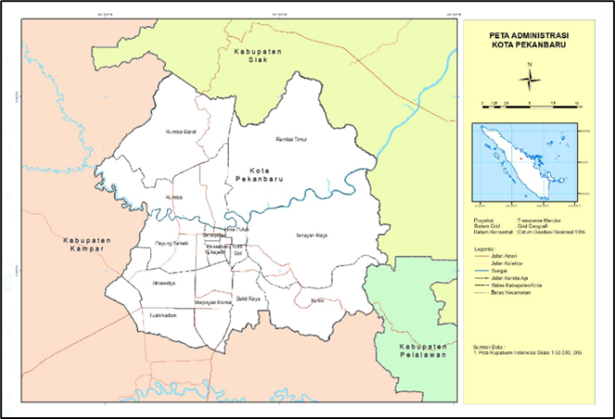
Land conversion and deteriorating environmental quality are the causes of the city's rapid development and expansion. Due to changes in land use brought about by urbanization, there is a greater demand for available space. The land that was initially empty and filled with vegetation has been turned into residential areas, offices, and also industrial centers that can increase the temperature in an area. Land that has undergone area conversion, initially in the form of water catchment areas or green open spaces, has changed to urban areas that cause an increase in surface temperature. The Environmental quality of urban region will degrade if land conversion is focused on building infrastructure and amenities. This land cover change also has positive and negative impacts, but the negative impacts of this land use change occur on ecological and environmental systems in urban areas. Pekanbaru City will have a population of 1,123,000 in 2024, with a population growth rate of 2.99% in 2020-2023 [1]. Rapid urbanization has resulted in notable advancements in public services, basic infrastructure, and living standards for the population [2]. Population accretion and urbanization accelerate urban growth, ultimately changing land cover and land use patterns [3]. During the urbanization process, urban expansion results in significant changes to the urban land surface, causing the original rural land to transition into urban land through irreversible change. Through this technique, impermeable cement, asphalt, brick, tile, and other materials are used in place of natural soil and vegetation [4][5]. The negative impacts that are also caused are the increase in CO₂ emissions and environmental temperature due to the increase in the human population and activities such as reducing vegetation cover in urban areas [6]. It occurs due to the facilitation of population needs caused by population expansion. Raising high temperatures can lead to elevated ecological and environmental problems, such as biodiversity loss [7]. An increase in environmental temperature will decrease the comfort of the environment and harm people’s health and activities. Vegetation has an important role in reducing land surface temperature. Through photosynthesis, shading, and evapotranspiration, vegetation can lower the air temperature to keep the environment cool [14]. Reduced land cover for agriculture and water is linked to higher solar radiation absorption, which raises LST and has detrimental impacts on the climate and human existence [8][9][10]
Land cover change is one of the things that drives the Urban Heat Island (UHI) phenomenon. The UHI phenomenon is caused by the land surface that previously absorbed hot temperatures from sunlight, but it is reflected into the air which is then trapped in urban areas. The UHI phenomenon is a phenomenon that contributes to global warming. The UHI phenomenon could be identified using Land Surface Temperature (LST) data. LST is the average temperature of the earth's surface visualized in the form of pixels with different types of earth's surface. The impact of the UHI phenomenon is an increase in air pollution and environmental degradation[11]. A study on the urban heat island phenomenon is important, considering that the air temperature continues to increase in urban areas and can create an uncomfortable environment for the community. The urban environment, air quality, plant and animal growth and development, and human health are all impacted by the UHI, either directly or indirectly [12]. On the other hand, mitigation of the impact of this phenomenon is one of the main issues in sustainable urban development. This study aims to analyze how land cover changes and the correlation of LST to NDBI and NDVI then define the UHI phenomenon in Pekanbaru City in 2018 and 2023. The result of the study can be a consideration for policymakers in spatial and regional planning that prioritizes community amenities while maintaining environmental sustainability.

METHOD
Location of study
This research was carried out in Pekanbaru City, which is located at the geographical coordinates of 101°14' – 101°34' E and 0°25' – 0°45' N, on path/row 127/60, in Figure 1.
Figure 1. Study location (Pekanbaru City)

Methods
An image or piece of data captured by the Landsat satellite, a remote sensing satellite deployed by NASA and other affiliated organizations, is known as Landsat imagery. The state of the Earth's surface, including changes in the environment, land use, vegetation cover, urbanization, and natural disasters, is tracked, observed, and analyzed using this imagery. The Landsat-7 and Landsat-8 imagery from 2014 to 2019 was conducted with a quantitative analysis of the surface of UHI effect's temporal and spatial features in Shenzhen, China [13]. The Landsat TM, ETM+, and OLI sensor satellite pictures to evaluate the spatiotemporal variance in surface of UHI impacts in Mekelle City, Northern Ethiopia [14]. Then, the Landsat-5 and Landsat-8 satellite imagery was used to investigate the spatiotemporal variations in the UHI’s surface impacts in Edmonton, Canada [15]. The data sources used in the study are the Pekanbaru City administrative shapefile map and Landsat 8 OLI/TIRS imageries. The 2018 image data was taken at the time of acquisition on January 30, 2018 with a cloud cover of 6.16; while for 2023, an image of May 20, 2023 with a cloud cover of 8.54 was used. Data analyzed is using QGIS and ArcGIS. The stages of the research are shown in Figure 2.
The Normalized Difference Built-up Index (NDBI) is a method for measuring the density of built-up land used to determine the level of built-up area density. The NDBI analysis was carried out to measure the density of built-up area calculated by equations[16].
$NDBI=\frac{\left(SWIR-NIR\right)}{(SWIR+NIR)}$ (1)

Figure 2. Study flowchart

The Normalized Difference Vegetation Index (NDVI) indicates the level of vegetation density or the greenness level of an area. The NDVI's value falls between 1 and 1. Its values are near zero or negative for regions without vegetation, such as rocks, sand, and concrete surfaces, and positive for vegetation, such as crops, shrubs, grasses, and woods [17][18]. Therefore, more vigorous green vegetation cover is indicated by more significant NDVI values [10]. The NDVI is calculated by the equation [16].

$NDVI=\frac{\left(NIR-RED\right)}{\left(NIR+RED\right)}$ (2)$SWIR-NIR$

where: SWIR = Short Wave Infrared; NIR = Near Infrared; RED = Infrared

The NDBI and NDVI categories are classified according to Table 1 and Table 2.

Table 1. Built-up Classification (NDBI)

Class | NDBI Score | Description
1 | (-1) – 0 | No settlement
2 | 0 – 0,1 | Rare settlement
3 | 0,1 – 0,2 | Dense settlement
4 | 0,2 - 1 | High dense settlement

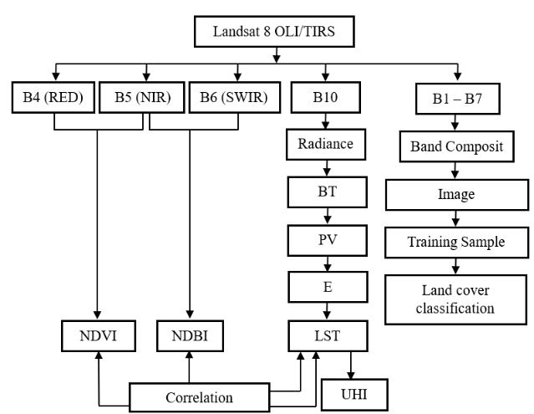
Table 2. Vegetation Classification (NDVI) [19]

Class | NDVI Score | Description
1 | (-1) – (-0,03) | Not vegetated
2 | (-0,03 – 0,15 | Very low vegetation
3 | 0,15 – 0,26 | Low vegetation
4 | 0,26 – 0,35 | Moderate vegetation
5 | 0,35 - 1 | High vegetation

Land Surface Temperature (LST) is a condition influenced by the interaction between energy on the earth's surface, atmosphere, surface thermal properties, and the media below the ground surface. Surface temperatures in a given region can be analyzed using Landsat satellite imagery by extracting information from thermal channels [20]. LST is calculated using a split-window algorithm, a dynamic formula that can represent information about ground surface temperature [21]. The Digital Number (DN) value must be converted into a TOA spectral radiance value and then transformed into a surface temperature value using a predetermined equation[20].
$L_{λ}=M_{L} x Q_{cal}+A_{L}$ (3)
where: $L_{λ}$ = TOA spectral radiance; $M_{L}$ = Band-specific multiplicative rescaling factor from the metadata; $A_{L}$ = Band-specific additive rescaling factor from the metadata; $Q_{cal}$= Quantized and calibrated standard product pixel values (level 1 pixel value in DN).

$BT=\frac{K_{2}}{Ln\left(\frac{K_{1}}{L_{λ}}\right)+1}$ (4)

where: $BT$= brightness temperature (°K); $L_{λ}$= TOA spectral radiance; $K_{1}$= callibration constant of first thermal line;$K_{2}$ = callibration constant of second thermal line

Furthermore, the Fractional Vegetation Cover was calculated to estimate the fractional size of an area covered with vegetation [22].

$F_{v}=\frac{\left(NDVI-{NDVI}_{min}\right)}{\left({NDVI}_{max}-{NDVI}_{min}\right)}$ (5)

where: $F_{v}$ = Fractional vegetation cover; ${NDVI}_{min}$= minimum vegetation index; ${NDVI}_{max}$= maximum vegetation index

Then, calculate the Emissivity by equation below [23].

$ɛ=0.004 x F_{v}+0.986$ (6)

where: 0,004 = average of vegetation emissivity;
0,986 = emissivity of bare land

Land Surface Temperature is calculated by equation [22].

$LST=\left(\frac{BT}{1+W}x\frac{BT}{1+p}x ln\left(ɛ\right)\right)-273.15$ (7)
where: LST = Land surface temperature (°C); $BT$ = Brightness temperature (°K); $W$ = wavelength of emitted radiation (0.000115 m); $ɛ$ = object emissivity; $p=\frac{hc}{s}$ (1.438 x 10-2 mK); h = Planck constant (6.26 x 10⁻³⁴ Js); c = light velocity (2.998 x 10⁸ ms⁻¹); s = Stefan Boltzman constant (1.38 x 10⁻²³ JK⁻¹)

Urban Heat Island (UHI) was determined using LSTs obtained from previous analysis. The UHI index is carried out using the following equation [22][24].

${UHI}_{threshold}=µn+σ\frac{1}{2}$ (8)

${UHI}_{index}=T_{mean}- {UHI}_{threshold}$ (9)

where: μ = average of LST; σ = deviation standard of LST; T_{mean} = the median value of the LST

RESULTS AND DISCUSSION
Land cover changes
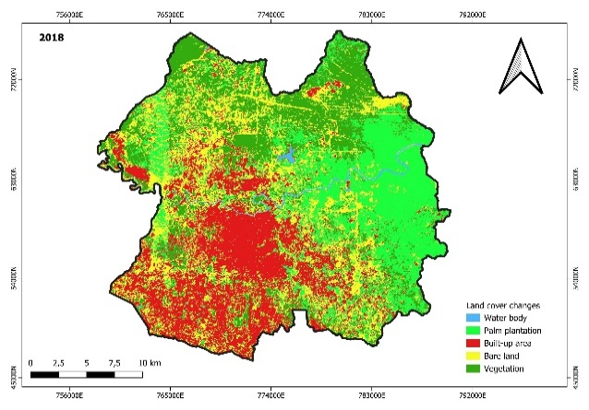
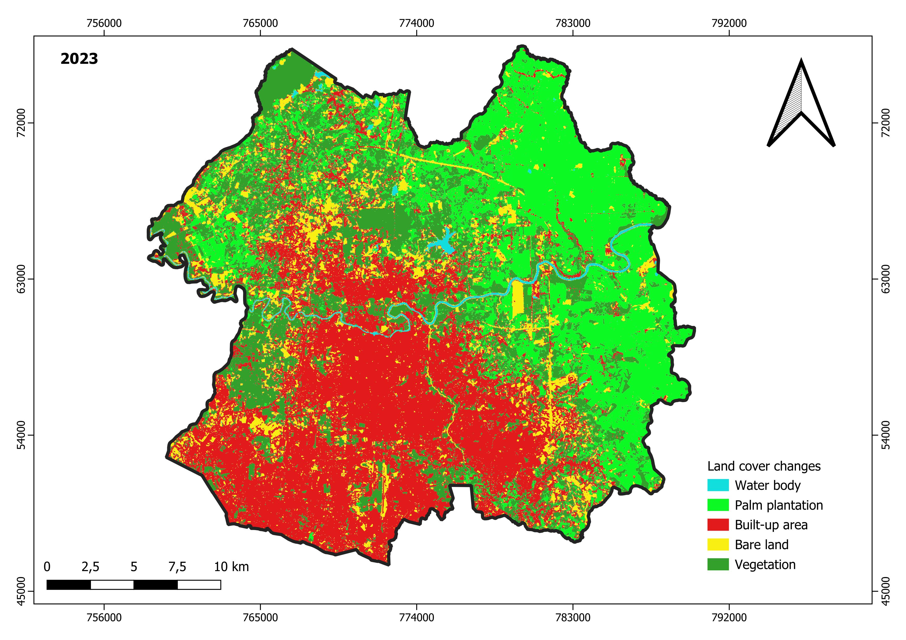
Land cover in Sharqiyah was separated into four groups, are vegetation, built-up, bare land and water body [25].
2018
2023

Figure 3. Land cover changes in 2018 and 2023

This study classified into five classes: water body, palm plantation, built-up area, bare land and vegetation. The class grouping uses guided classification, a method of grouping pixels based on the value of the reflecting based on the selected sample area. The sample training was adjusted to Google Satellite. The land cover classification in this study uses the maximum likelihood algorithm. Figure 3 shows a significant change in land cover between 2018 and 2023. In 2018, water bodies had an area of 530 ha; the palm area covered an area of 17.024 ha; the built-up area had 17.017 ha, bare land of 14,525 ha and vegetation of 14.735 ha. It can be seen that palm plantations and built-up areas dominate land cover in the Pekanbaru City area, with the percentage of palm plantation area at 26.67%, slightly larger than built-up area. The land cover of palm plantations in 2018 was the widest compared to others. After the massive forest and land fires in 2015, many people planted palms to replace the forests.
In 2023, the water body had an area of 653 ha, palm plantation of 17,905 ha, built-up area 22,877 ha, bare land 6,217 ha and vegetation 16,179 ha. Palm and built -up areas in 2023 still dominate land cover, but the area of built-up areas has become much more prominent, namely 35.84% of the total area of Pekanbaru City, than palm area with a percentage of 28.05%. Water body and vegetation have also increased, but bare land in 2023 is much less than in 2018. The types of land cover for water bodies, palm, built land and vegetation have increased in the area, while the area of open land has decreased drastically. A significant change occurred in bare land, where during a period of 5 years, there was a reduction in area of 8,308 ha or a decrease of 57%; on the contrary, the built-up area increased significantly by 5,860 ha or an increase of 34%.

Normalized difference built-up index (NDBI)
In order to meet the needs of the settlement's inhabitants, land requirements become the most important aspect of the region or urban area’s growth [26]. The density of buildings in remote sensing was identified using the NDBI, designed to show the appearance of the built-up area compared to other objects because this index is very sensitive to the built land [27]. The results of the NDBI analysis provide a clear picture of land cover change and urban development in the region [28]. The results of the NDBI analysis are shown in Figure 4. There is a very significant difference in built-up distribution between 2018 and 2023. The area of built-up area in 2023 increased sharply, marked by black; on the contrary, the area of yellow no-settlement areas has decreased, following the changes in the land cover conditions. If it is compared, the area of no settlement in 2018 is more significant than in 2023, as are the areas of highly dense settlement. There is a depression in the areas with no settlement and highly dense settlement areas. The none-settlement class in 2023 decreased by around 2% compared to 2018, and the class of high-dense settlement sharply dropped by about 71%. The rare settlement class was about 2,589 ha, which was raised around 54% in 2023, or it became 3,987 ha. It also happened that the dense settlement class was 68 ha, then became 81 ha in 2023. The dense settlement area raised by about 19%. This result is in line with the research [22].

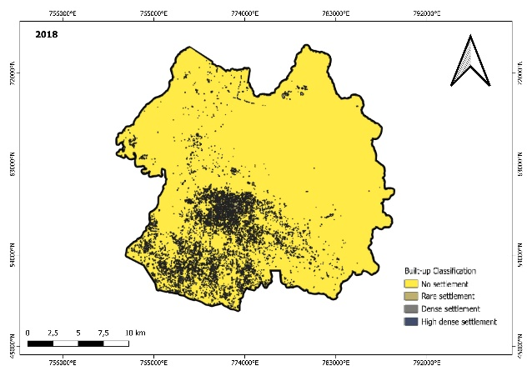
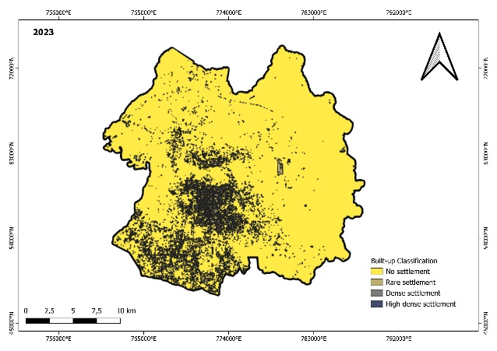
2018
2023

Figure 4. Built-up distribution in 2018 and 2023

When the 2023 NDBI is plotted with Google Satellite and adjusted to Figure 1, it can be seen that the highly dense built-up areas are in Tuahmadani District, Binawidya District, Pekanbaru Kota District, Sukajadi District, Senapelan District, Sail District and part of Marpoyan Damai District and Bukit Raya District. This area is densely populated, the center of government, and the center of activities of the Pekanbaru City population.

Normalized difference vegetation index (NDVI)
The results of the NDVI analysis illustrate the impact of urbanization and environmental change on vegetation in the study area [28]. The higher the level of vegetation class, the more vegetation density. On the other hand, if the level of vegetation density is getting lower, it indicates that the type of land cover has very low vegetation or is not vegetated.

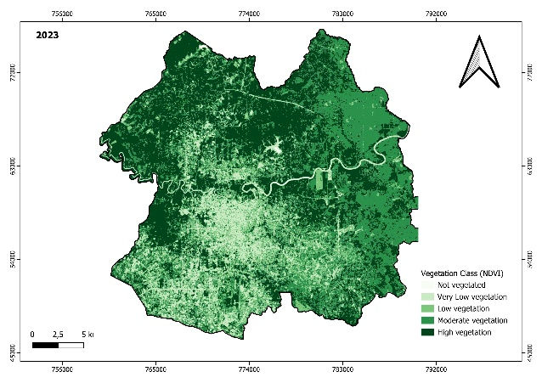
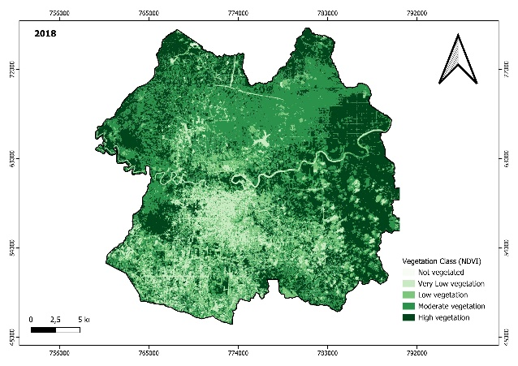
2023
2018

Figure 5. Vegetation distribution in 2018 and 2023

The distribution of vegetation is shown in Figure 5. The NDVI value of Pekanbaru City in 2018 is in the range of -0.031054 – 0.495183, while in 2023, it has an NDVI in the range of -0.044966 – 0.524878. The vegetation in Pekanbaru City in 2018 is dominated by dark green colors located in the eastern, northwestern, and northern areas of Pekanbaru City. It shows that the area is still overgrown with much vegetation, which means it is in the moderate or high vegetation class. Some areas with light green color indicate areas that do not have much vegetation scattered around the city center. The dominance of bright green is located in the center of Pekanbaru City, which shows that the area is a very low vegetation or not vegetated. Compared to 2023, the density of vegetation in the east of Pekanbaru City decreased from high to moderat; on the contrary, in the north, it increased to high greenery. Based on the large of area, 2018 the not vegetated class was 8 ha or 0.01% of the total Pekanbaru City’s area. The very low vegetation class is 5,379 ha or 8.43%, the low vegetation class is 11,396 ha or 17.85%, the moderate vegetation class of 25,179 ha or 39.45%, and the high vegetation class of 21,870 ha or 34.26% of the total Pekanbaru City’s area. In 2023, the high vegetation class was 27,405 ha, increasing to 25% compared to 2018. However, the not-vegetated area also increased within 5 years by 1.225%; the high vegetation class rose by 25%. On the contrary, the low and moderate vegetation class area declined by about 17%. Vegetation in Pekanbaru City is in the form of forests, mixed gardens, shrubs, and palm plantation. If it is associated with land use and land cover, in the city of Pekanbaru, there has been an increase in the area of palm plantations, or it can be said that the dominant vegetation is palm.

Land surface temperature (LST)
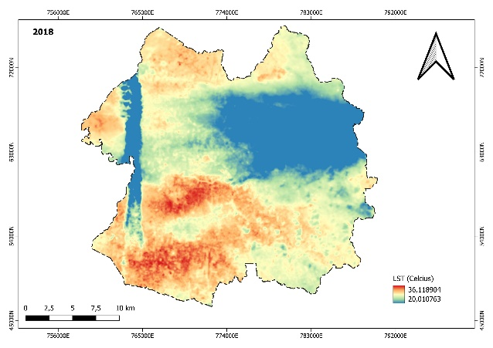
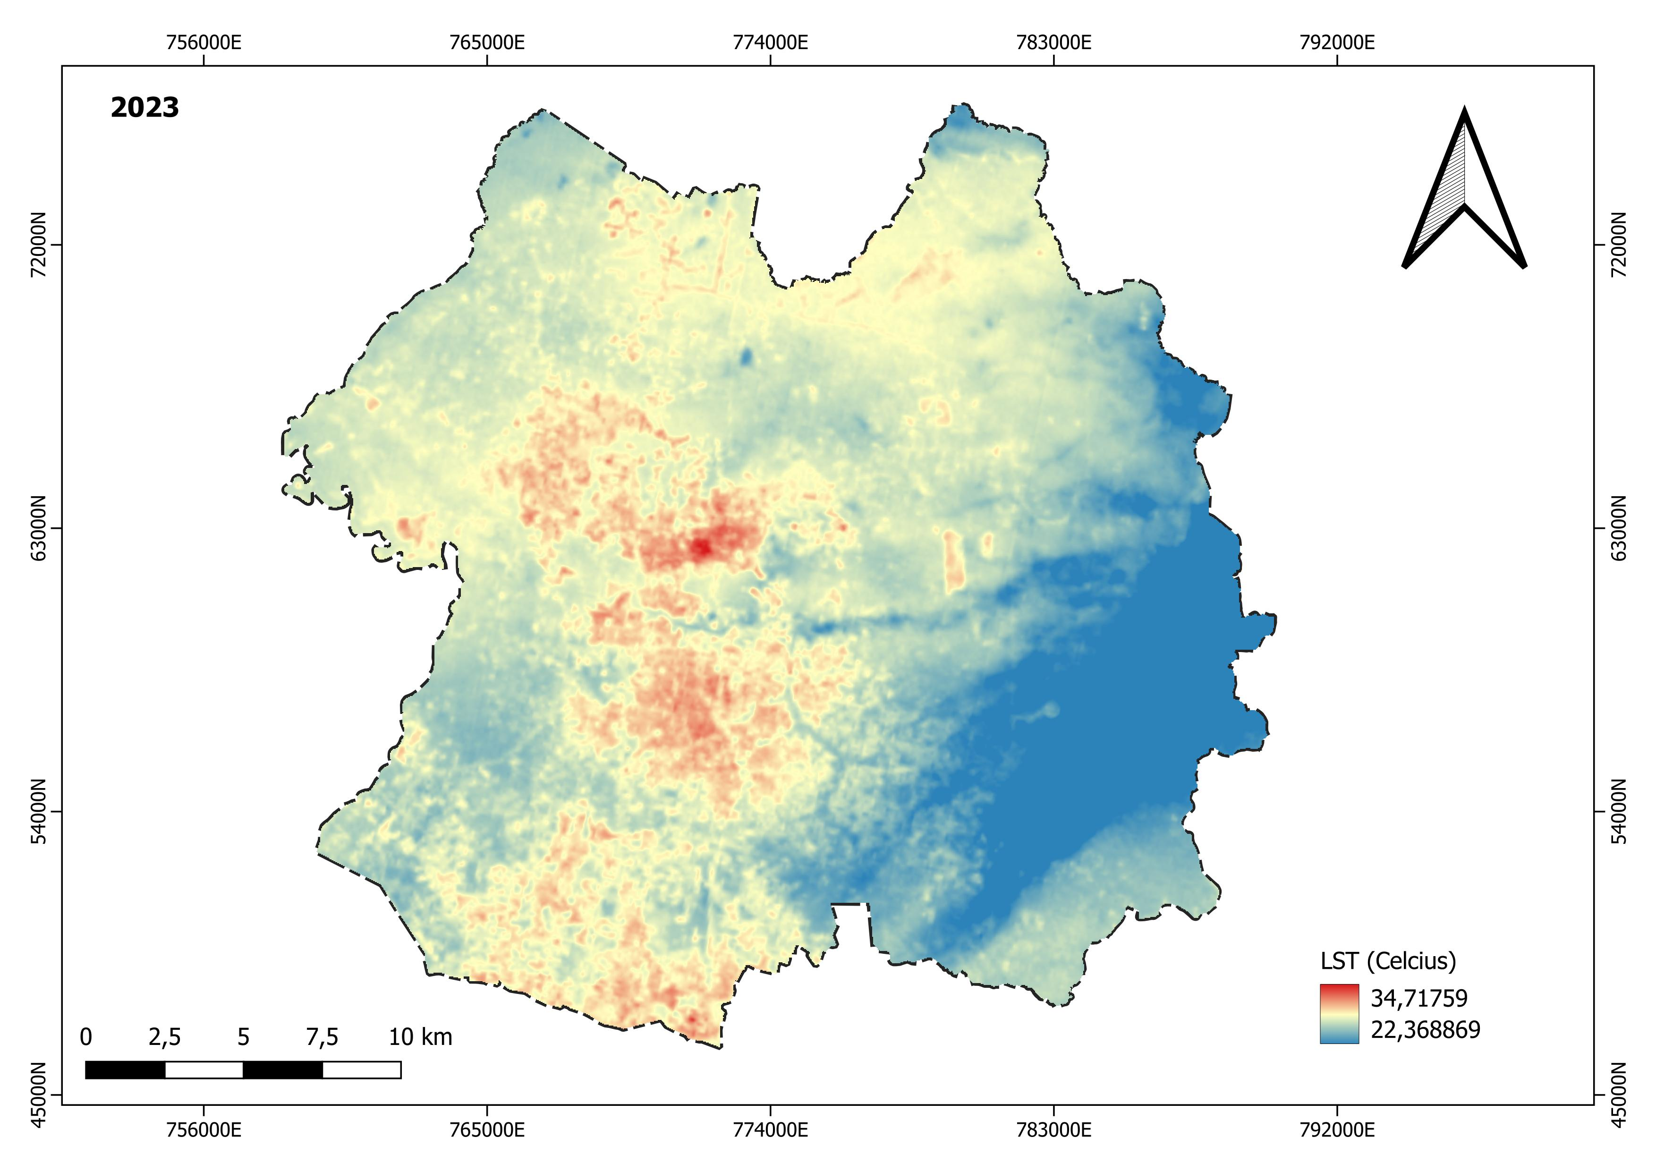
Land surface temperature is the average surface temperature resulting from the reflection of an object recorded by satellite images at a particular time. The LST is influenced by numerous elements, including elevation, slope, water bodies, vegetation cover, and the degree of urban building [23]. The results of the LST analysis were used to characterize the influence of local conditions on Urban Heat Island (UHI). The results of the LST analysis are shown in Figure 6.
2018
2023
Figure 6. Distribution of LST in 2018 and 2023

In 2018, the land surface temperature ranged from 20-36°C. The red color describes areas with high temperatures in the southern and southwestern parts of the region, which are areas of high building density. The yellow and green colors depict areas with moderate temperatures scattered over most of the region. The blue color represents an area with lower temperatures, indicating the possibility of a water body or an area with a relatively high level of vegetation. In 2023, LST analysis showed that the temperature ranges from 22-34 °C. The minimum temperature in 2023 is higher than in 2018, but the maximum temperature is lower than in 2018. In 2023, areas with higher temperatures are still visible. However, the distribution has changed slightly, and it is seen as more concentrated in city’s center and some western parts of the region. The areas with moderate temperatures are still dominant, but there is a shift in distribution compared to 2018. The area with low temperatures is more expansive than in 2018, especially in the eastern and northeastern parts of the region. These conditions may indicate an increase in vegetation density or better land management. Vegetation density plays a very crucial role in increasing or decreasing soil surface temperature. Vegetation can minimize air temperature and retain sunlight above the canopy so that the temperature below the stand (ground surface temperature) is lower due to shade. It utilizes evapotranspiration to lower oneself and its surroundings.
In 2023, the maximum temperature is lower than in 2018. This year, there has been a change in the distribution of high-class temperatures, most likely due to changes in land cover or differences in vegetation density classes. Based on data sourced from the www.sipongi.menlhk.go.id, forest and land fires in Riau that occurred in 2015 were the largest, with a burned land area of 183,808.59 ha, then in 2016, there were forest and land fires again which caused an impact on the burned area of 85,219.51 ha. These two forest and land fires are likely to be among the factors causing the higher LST in Riau, one of which is in Pekanbaru City in 2018. After the incident, the dominant land was planted with oil palm. Palm plantation is one of the leading causes of deforestation, but its existence has slightly reduced the LST in Pekanbaru City in 2023.
The analyzed of area large based on LST is shown by Figure 7. In 2018, the area recorded with a 20-25°C temperature was 20,539 ha, then in 2023, it decreased by about 36%. The area recorded of 25-30°C was 28,689 ha in 2018, but it rose sharply by around 69% and became 48,416 ha in 2023. In 2018, the area recorded with more than 30°C temperature was 14,604 ha, which decreased drastically by about 84% in 2023. These changes indicate a shift in ground surface temperatures during that period, with more areas switching to warmer temperatures (25-30°C) in 2023.

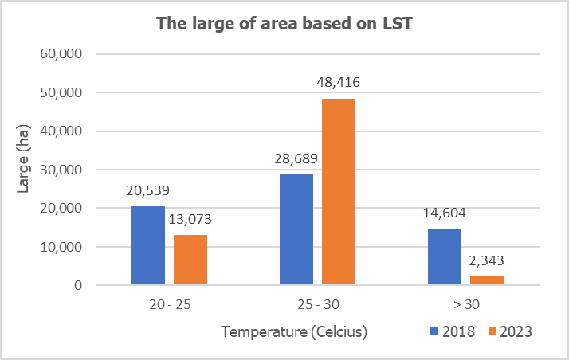

Figure 7. The change of LST area

Correlation of LST, NDBI and NDVI
The correlated LST with NDVI and NDBI is used to analyze the impact of the existence of vegetation density and built-up area on UHI because UHI can be used as an ecological evaluation index of an urban area [29]. The correlation between LST and NDBI is shown in Figure 8.

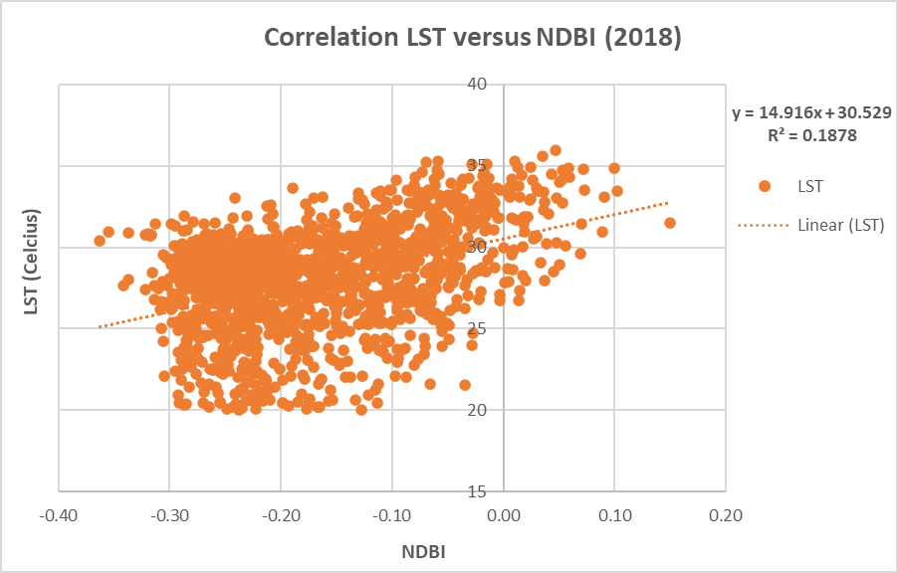
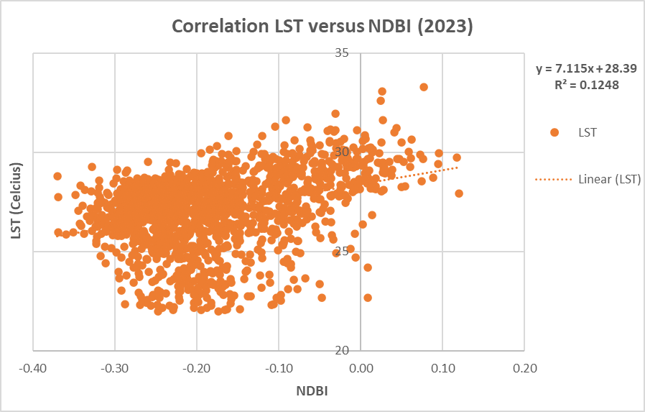

Figure 8. LST versus NDBI

Figure 8, in 2018, the NDBI points are concentrated between -0.20 to -0.10 and LST between 25°C to 30°C. Several points indicate higher LST close to 35°C. The linear equation of LST versus NDBI in 2018 is below, with determination coefficient (R²) value was 0.1878 or 18.78%.

$y=14.916x+30.529$ (10)

In 2023, most of NDBI points are concentrated between -0.20 to 0.10 and the LST between 25°C to 30°C. The linear equation of LST versus NDBI in 2023 is below.

$y=7.115x+28.39$ (11)

The value of determination coefficient (R²) is 0.1248 or 12.48%.
Both 2018 and 2023, it can be interpreted that LST and NDBI have a positive or directly proportional correlation, which is indicated by a positive value in front of the regression coefficient. The correlation between LST and NDBI is similar in providing a linear relationship. When NDBI increases, LST tends to increase [30]. Referring to the equation produced in 2023, with an increase in the NDBI value by one digit, it will increase the LST value by 7.115°C, which, if calculated, will make the LST value 35.505°C in 2023. Alternatively, if it is projected into an increase in NDBI of 0.25 figures, it will increase the LST value by 1.78°C, which, if calculated, will make the LST value to 30.17°C in 2023. Areas with higher building density (higher NDBI) tend to have higher land surface temperatures. The coefficients of the two equations significant and show a fairly close relationship and influence between LST and NDBI results [8], [23]. In both 2018 and 2023, the value of the determination coefficients was close to 0. The value of the determination coefficient indicates the extent to which the contribution of the free variable in the regression model can explain the variation of its bound variable. This value means that the ability of the NDBI variable to explain the LST variable is very limited, even though it has a positive correlation. It was explained that if the value is close to 1 (one) and away from 0 (zero), it means that the independent variables can provide all the information needed to predict the dependent variables [31].
When compared between the two years, 2018, the NDBI variable had more influence on the LST than 2023. The denser the built-up area, the higher the LST due to the heat insulation effect produced by buildings and highways. Additionally, because of the dense, tall, poorly developed land and water under the same solar radiation circumstances, surface temperatures are high throughout the built-up area. Additionally, because of the tall, dense, and inadequately ventilated artificial structures, the surface temperatures are high throughout the built-up region. Large open regions on unused land absorb heat rapidly, resulting in a high surface temperature [32][45]. The LST of empty and built-up land is higher than that of other land use types, according to earlier research [33][34][35]. Meanwhile, the correlation between LST and NDVI in Pekanbaru City is shown in Figure 9.

Figure 9. LST versus NDVI

The 2018 plot shows most points concentrated around NDVI values of 0.30 to 0.49, and the LST value ranges from 22°C to close to 35°C. The linear equation of LST and NDVI is shown below with the value of determination coefficient (R²) is 0.0589 or 5.89%.

$y=-7.6912x+30.506$ (12)

The plotted of 2023, a scatter plot, reflects where the most of the NDVI points are concentrated around of 0.30 to 0.52, and the LST value ranges from 22°C to close to 35°C. The linear equation for 2023 is below.

$y=-3.7906x+28.446$ (13)

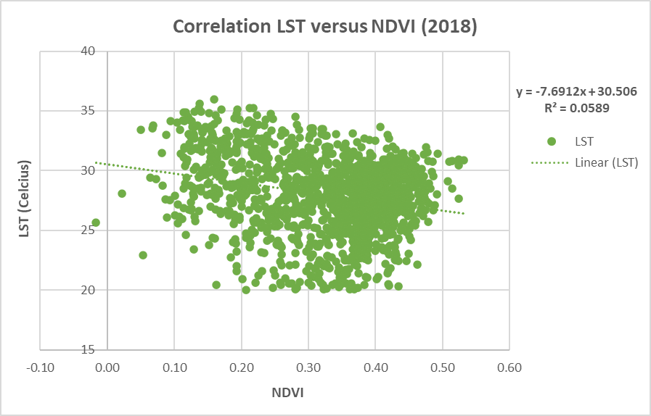
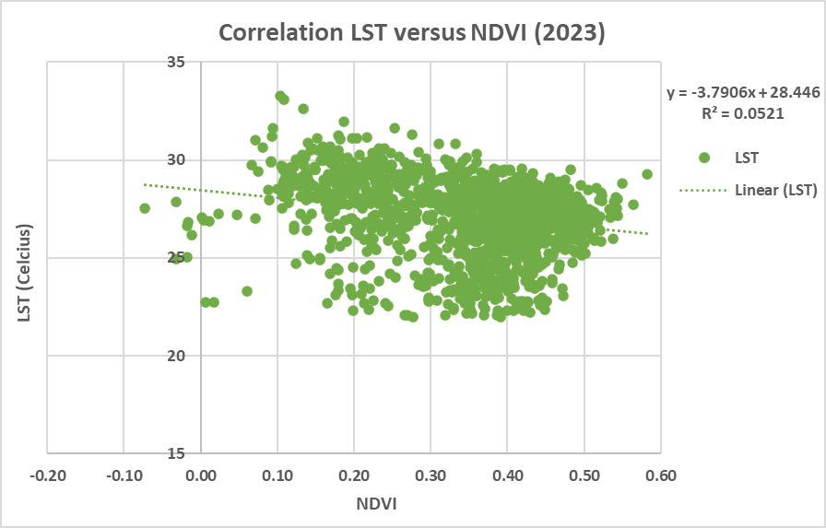
The coefficient of determination (R²) value is 0.0521 or 5.21%. In both 2018 and 2023, LST has negative or inversely proportional correlation to NDVI, which is indicated by a negative value in front of the regression coefficient. From the two figures, the linear regression line shows that as the NDVI increases, the LST tends to decrease. These results are following [36]. If the LST is high, then the NDVI value is low, and vice versa. The area with higher vegetation density (higher NDVI) tends to have lower LST [37]. Referring to equation (13), increasing the NDVI value by one digit will decrease the LST value by 3.7906°C, which, if calculated, will make the LST value drop to 32.24°C in 2023. If projected into an increase in NDVI of 0.25 figures, it will increase the LST value by 0.95°C, which, if calculated, will make the LST value drop to 29.39°C in 2023. When compared, 2023 has a more significant correlation value than 2018. In 2018, the availability of vegetation in the city of Pekanbaru was relatively lower than with 2023. Vegetation can function as a heat filter, reducing surface temperature by absorbing heat and producing cool air. With the availability of lower vegetation, the surface temperature of Pekanbaru City in 2018 was higher. For this reason, it is necessary to propagate vegetation under its environmental conditions to reduce the value of LST.

The phenomenon of Urban Heat Island (UHI) in Pekanbaru City
Urbanization causes the LST of urban regions to be higher than that of the surrounding non-urban environment, a phenomenon known as the UHI [38]. It commonly happens in the province’s capital or the city’s center. The results of the LST are further processed to obtain the UHI value. From the processing results shown by Table 3.

Table 3. UHI threshold dan UHI Index
Variable | Year
Variable | 2018 | 2023
Tmax (°C) | 36.12 | 34.72
Tmin (°C) | 20.01 | 22.37
µ | 25.54 | 26.38
σ | 6.23 | 3.13
UHI threshold | 28.65 | 27.95
UHI index | 27.95 | -1.57

The UHI threshold value in 2018 was higher than in 2023, which aligns with the LST value in both years. A negative UHI index value of -3.12 in 2018 and -1.57 in 2023 shows that there is indeed a UHI phenomenon. Analysis of the temperature threshold where the UHI phenomenon occurs in Pekanbaru City shows that the area is indeed experiencing the effects of UHI. The threshold obtained for the 2018 UHI phenomenon is 28.65°C, while the UHI threshold value in 2023 is 27.95°C. If in 2018 the ground surface temperature exceeds 28.65°C, and in 2023, it exceeds 27.95°C, it indicates the existence of a UHI phenomenon in the Pekanbaru City area.
It explained that UHI is formed when the surface that is supposed to absorb the heat from the sun reflects more of it back into the air and is trapped within the urban scope. The surface reflects more heat due to the conversion of land from vegetation to asphalt, concrete, multistorey buildings, and other infrastructure used to accommodate the needs and increase in the number of populations. The development of cities with benthic and specific patterns is related to the spatial pattern of UHI, which is formed based on the dominance of the city center and can lower the surface temperature. At the same time, the more complex the shape of the area and the wider the gap between buildings can increase the temperature.
Based on the results of Figure 10, the blue box on the map highlights the urban area of Pekanbaru City, known as a large urban area, which is still being developed with various developments and is dense with many waterproof surfaces. Urban areas are likely to experience UHI than the surrounding rural areas. Transect analysis determined how UHI affects different locations, from urban centers to rural areas. The results of the transect analysis are shown by a graph with the x-axis being the distance (kilometers) and the y-axis being the temperature (Celsius). The analysis of the rural-urban transect in 2018 shows that the distance very close to the city, about 1-2 km from the city has the highest temperature; the temperature drops drastically at a distance of 3-6 km from the city center, then the farther away from the city center the temperature varies.
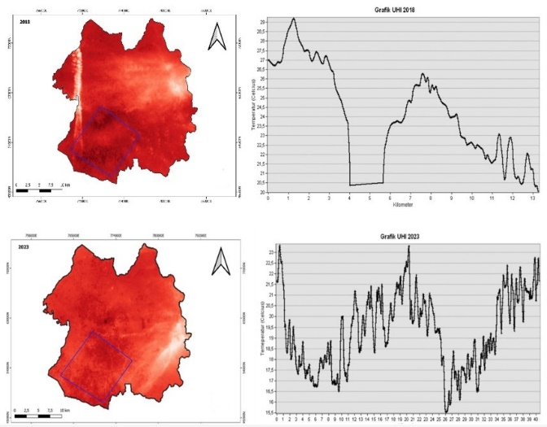

Figure 10. UHI phenomenon in Pekanbaru City in 2018 and 2023

Almost the same as in 2018, in 2023, the closest distance from the city center provides the highest temperature and a transect distance of 20 km. The lowest temperature at the transect distance is around 25-26 km from the city center. The farther away the city center, the lower the temperature. However, in 2023, the temperature variation along the transect is more than in 2018, but the temperature distribution in 2023 is lower than in 2018. Several factors, such as density level, topographic conditions, wind patterns, land use and humidity can cause temperature changes along the variable transect. North-South transect analysis shows that the South-Southwest area has a higher temperature distribution than the West-East transect. Several studies in other cities have shown that the effects of UHI are more pronounced in the southern part of the city than in the northern part due to wind patterns that tend to blow from the north, bringing cold air from the countryside to the city. The results of the previous analysis show that the development of Pekanbaru City is more inclined to the South, characterized by a high level of built-up land and a low level of vegetation in the Southern sector, compared to other parts.
According to the results of the analysis, the distribution of UHI tends to occur in the activities of the residential sector or built land cover. The vegetation condition in the area is rare, so the evapotranspiration process needs to be improved. The study’s results also show that the distribution of UHI is influenced by the conditions and activities of land cover types, especially in built-up land cover. The growth and formation of this land cover is influenced by the centers of activity in the city of Pekanbaru. The center of the activity will encourage different land uses around the central points of the city's activities. The UHI phenomenon is also greatly influenced by local wind conditions [39] Urbanization affects local winds through UHI and surface roughness enhancement [3] [40].
As the population and urban area grow, the intensity of UHI will likewise rise. The increase in the population directly and indirectly will impact increasing the local air temperature. Emissions from human body temperature have a direct impact. However, human activities like using more vehicles that emit greenhouse gases and emissions from items around the house have an indirect effect. Numerous elements, such as the local climate, socioeconomic circumstances, urban scale, and urban form, contribute to UHI [41]. In order to reduce the effects of UHI, several strategies can be carried out in the city of Pekanbaru, for example by increasing green open space and water bodies, using environmentally friendly materials in building construction development, optimizing urban design with the concept of green infrastructure and encouraging sustainable transportation. In addition, law enforcement for violations of regulations that cause environmental damage must be firmer, and public awareness about the effects of UHI also needs to be optimized to encourage participation in mitigation efforts and obtain better city quality.

CONCLUSION
This study concludes that in a span of 5 years (2018 – 2023), there has been a change in land cover in the city of Pekanbaru, where the area of water bodies increased by 23%, palm plantation increased by 5%, built-up land increased by 34% and vegetation increased by 10%, while the area of bare land decreased by 57%. In addition, there are significant changes in building density and vegetation. The correlation between LST and NDBI has a positive relationship; on the contrary, LST is negatively correlated with NDVI in Pekanbaru City. There was an Urban Heat Island (UHI) phenomenon in of Pekanbaru in 2018 and 2023, characterized by a more significant surface temperature than the value of the UHI threshold. In 2018, the UHI threshold was obtained at 28.65°C, while the UHI threshold in 2023 was 27.95°C, meaning that the UHI threshold in 2018 and 2023 exceeded the surface temperature, indicating the phenomenon of urban heat islands in the Pekanbaru City area.

ACKNOWLEDGMENT
We thank to our colleague, Albasri, S.Hut., M.Hut (Universitas Halu Oleo) who giving us insight, experiences, and greatly GIS coaching.

REFERENCES

[1] “BPS-Statistics of Pekanbaru Municipality. Riau,” Kota Pekanbaru, 2024.
[2] W. He, X. Li, J. Yang, H. Ni, dan X. Sang, “How land use functions evolve in the process of rapid urbanization: Evidence from Jiangsu Province, China,” J Clean Prod, vol. 380, 2022, doi: 10.1016/j.jclepro.2022.134877.
[3] Z. Zheng, X. Lin, L. Chen, C. Yan, dan T. Sun, “Effects of urbanization and topography on thermal comfort during a heat wave event: A case study of Fuzhou, China,” Sustain Cities Soc, vol. 102, 2024, doi: 10.1016/j.scs.2024.105233.
[4] Y. C. Chen, C. Y. Chen, A. Matzarakis, J. K. Liu, dan T. P. Lin, “Modeling of mean radiant temperature based on comparison of airborne remote sensing data with surface measured data,” Atmos Res, vol. 174–175, 2016, doi: 10.1016/j.atmosres.2016.01.004.
[5] A. Abulibdeh, “Analysis of urban heat island characteristics and mitigation strategies for eight arid and semi-arid gulf region cities,” Environ Earth Sci, vol. 80, no. 7, 2021, doi: 10.1007/s12665-021-09540-7.
[6] X. Q. Zhang, “The trends, promises and challenges of urbanisation in the world,” Habitat Int, vol. 54, 2016, doi: 10.1016/j.habitatint.2015.11.018.
[7] X. X. Li dan L. K. Norford, “Evaluation of cool roof and vegetations in mitigating urban heat island in a tropical city, Singapore,” Urban Clim, vol. 16, 2016, doi: 10.1016/j.uclim.2015.12.002.
[8] A. Hamed Fahmy, M. Amin Abdelfatah, dan G. El-Fiky, “Investigating land use land cover changes and their effects on land surface temperature and urban heat islands in Sharqiyah Governorate, Egypt,” Egyptian Journal of Remote Sensing and Space Science, vol. 26, no. 2, 2023, doi: 10.1016/j.ejrs.2023.04.001.
[9] M. Fadhil, M. N. Hamoodi, dan A. R. T. Ziboon, “Mitigating urban heat island effects in urban environments: strategies and tools,” dalam IOP Conference Series: Earth and Environmental Science, 2023. doi: 10.1088/1755-1315/1129/1/012025.
[10] S. Huang, L. Tang, J. P. Hupy, Y. Wang, dan G. Shao, “A commentary review on the use of normalized difference vegetation index (NDVI) in the era of popular remote sensing,” 2021. doi: 10.1007/s11676-020-01155-1.
[11] R. Kotharkar dan A. Bagade, “Evaluating urban heat island in the critical local climate zones of an Indian city,” Landsc Urban Plan, vol. 169, 2018, doi: 10.1016/j.landurbplan.2017.08.009.
[12] S. Jain, S. Sannigrahi, S. Sen, S. Bhatt, S. Chakraborti, dan S. Rahmat, “Urban heat island intensity and its mitigation strategies in the fast-growing urban area,” Journal of Urban Management, vol. 9, no. 1, 2020, doi: 10.1016/j.jum.2019.09.004.
[13] X. Xu dkk., “Long-term analysis of the urban heat island effect using multisource Landsat images considering inter-class differences in land surface temperature products,” Science of the Total Environment, vol. 858, 2023, doi: 10.1016/j.scitotenv.2022.159777.
[14] S. Tesfamariam, V. Govindu, dan A. Uncha, “Spatio-temporal analysis of urban heat island (UHI) and its effect on urban ecology: The case of Mekelle city, Northern Ethiopia,” Heliyon, vol. 9, no. 2, 2023, doi: 10.1016/j.heliyon.2023.e13098.
[15] N. P. Y. Welegedara, S. K. Agrawal, dan G. Lotfi, “Exploring spatiotemporal changes of the urban heat Island effect in high-latitude cities at a neighbourhood level: A case of Edmonton, Canada,” Sustain Cities Soc, vol. 90, 2023, doi: 10.1016/j.scs.2023.104403.
[16] G. Guo, Z. Wu, R. Xiao, Y. Chen, X. Liu, dan X. Zhang, “Impacts of urban biophysical composition on land surface temperature in urban heat island clusters,” Landsc Urban Plan, vol. 135, 2015, doi: 10.1016/j.landurbplan.2014.11.007.
[17] N. Pettorelli, J. O. Vik, A. Mysterud, J. M. Gaillard, C. J. Tucker, dan N. C. Stenseth, “Using the satellite-derived NDVI to assess ecological responses to environmental change,” 2005. doi: 10.1016/j.tree.2005.05.011.
[18] Y. Zheng, L. Tang, dan H. Wang, “An improved approach for monitoring urban built-up areas by combining NPP-VIIRS nighttime light, NDVI, NDWI, and NDBI,” J Clean Prod, vol. 328, hlm. 129488, Des 2021, doi: 10.1016/j.jclepro.2021.129488.
[19] Permenhut, Peraturan Menteri Kehutanan Republik Indonesia Nomor P.12/Menhut-II/2012 Tentang Perubahan Kedua atas Peraturan Menteri Kehutanan Nomor p.32/Menhut-II/2009 Tentang Tata Cara Penyusunan Rencana Teknik Rehabilitasi Hutan dan Lahan Daerah Aliran Sungai (RTk RHL-DAS). Indonesia, 2012.
[20] USGS, Landsat 8 (L8) Data Users Handbook. South Dakota: United States Geological Survey, 2018.
[21] M. S. Latif, “Land Surface Temperature Retrival of Landsat-8 Data Using Split Window Algorithm- A Case Study of Ranchi District,” Internal Journal of Engineering Development and Research, vol. 2, no. 4, 2014.
[22] Mas’uddin, L. Karlinasari, S. Pertiwi, dan Erizal, “Urban Heat Island Index Change Detection Based on Land Surface Temperature, Normalized Difference Vegetation Index, Normalized Difference Built-Up Index: A Case Study,” Journal of Ecological Engineering, vol. 24, no. 11, 2023, doi: 10.12911/22998993/171371.
[23] Y. Ma dkk., “Spatiotemporal Characteristics and Influencing Factors of Urban Heat Island Based on Geographically Weighted Regression Model: A Case Study of Urumqi City,” Land (Basel), vol. 12, no. 11, 2023, doi: 10.3390/land12112012.
[24] G. Kaplan, U. Avdan, dan Z. Y. Avdan, “Urban Heat Island Analysis Using the Landsat 8 Satellite Data: A Case Study in Skopje, Macedonia,” 2018. doi: 10.3390/ecrs-2-05171.
[25] S. Lee, S. M. Hong, dan H. S. Jung, “A support vector machine for landslide susceptibility mapping in Gangwon Province, Korea,” Sustainability (Switzerland), vol. 9, no. 1, 2017, doi: 10.3390/su9010048.
[26] M. Ichsan Ali, A. Hafid Hasim, dan M. Raiz Abidin, “Monitoring the built-up area transformation using urban index and normalized difference built-up index analysis,” International Journal of Engineering, Transactions B: Applications, vol. 32, no. 5, 2019, doi: 10.5829/ije.2019.32.05b.04.
[27] A. R. As-syakur, I. W. S. Adnyana, I. W. Arthana, dan I. W. Nuarsa, “Enhanced built-UP and bareness index (EBBI) for mapping built-UP and bare land in an urban area,” Remote Sens (Basel), vol. 4, no. 10, 2012, doi: 10.3390/rs4102957.
[28] T. Anthony, A. A. A. Shohan, A. Oludare, S. Alsulamy, A. Al Kafy, dan K. M. Khedher, “Spatial analysis of land cover changes for detecting environmental degradation and promoting sustainability,” Kuwait Journal of Science, vol. 51, no. 2, 2024, doi: 10.1016/j.kjs.2024.100197.
[29] L. Liu dan Y. Zhang, “Urban heat island analysis using the landsat TM data and ASTER Data: A case study in Hong Kong,” Remote Sens (Basel), vol. 3, no. 7, 2011, doi: 10.3390/rs3071535.
[30] K. Mansour, M. A. Aziz, S. Hashim, dan H. Effat, “Impact of anthropogenic activities on urban heat islands in major cities of El-Minya Governorate, Egypt,” Egyptian Journal of Remote Sensing and Space Science, vol. 25, no. 2, 2022, doi: 10.1016/j.ejrs.2022.03.014.
[31] I. Ghozali, “Aplikasi Analisis multivariete dengan program IBM SPSS 23 (Edisi 8),” Cetakan ke VIII. Semarang: Badan Penerbit Universitas Diponegoro, vol. 96, 2016.
[32] S. Zhou dkk., “Temporal and Spatial Variation of Land Surface Temperature and Its Driving Factors in Zhengzhou City in China from 2005 to 2020,” Remote Sens (Basel), vol. 14, no. 17, 2022, doi: 10.3390/rs14174281.
[33] A. Amindin, S. Pouyan, H. R. Pourghasemi, S. Yousefi, dan J. P. Tiefenbacher, “Spatial and temporal analysis of urban heat island using Landsat satellite images,” Environmental Science and Pollution Research, vol. 28, no. 30, 2021, doi: 10.1007/s11356-021-13693-0.
[34] R. Kaur dan P. Pandey, “Spatial trends of surface urban heat island in Bathinda: a semiarid city of northwestern India,” International Journal of Environmental Science and Technology, vol. 19, no. 11, 2022, doi: 10.1007/s13762-021-03742-z.
[35] J. Song, S. Du, X. Feng, dan L. Guo, “The relationships between landscape compositions and land surface temperature: Quantifying their resolution sensitivity with spatial regression models,” Landsc Urban Plan, vol. 123, 2014, doi: 10.1016/j.landurbplan.2013.11.014.
[36] S. A. Gorgani, M. Panahi, dan F. Rezaie, “The Relationship between NDVI and LST in the urban area of Mashhad, Iran,” International Conference on Civil Engineering Architecture & Urban Sustainable Development, 2013.
[37] S. Guha, H. Govil, A. Dey, dan N. Gill, “Analytical study of land surface temperature with NDVI and NDBI using Landsat 8 OLI and TIRS data in Florence and Naples city, Italy,” Eur J Remote Sens, vol. 51, no. 1, 2018, doi: 10.1080/22797254.2018.1474494.
[38] Y. Yang, S. Guangrong, Z. Chen, S. Hao, Z. Zhouyiling, dan Y. Shan, “Quantitative analysis and prediction of urban heat island intensity on urban-rural gradient: A case study of Shanghai,” Science of the Total Environment, vol. 829, 2022, doi: 10.1016/j.scitotenv.2022.154264.
[39] A. Tabassum, S.-H. Hong, K. Park, dan J.-J. Baik, “Simulating urban heat islands and local winds in the Dhaka metropolitan area, Bangladesh,” Urban Clim, vol. 59, hlm. 102284, Feb 2025, doi: 10.1016/j.uclim.2024.102284.
[40] J. R. Rajeswari, C. V. Srinivas, dan B. Venkatraman, “Impact of urbanization on boundary-layer parameters and mesoscale circulations over tropical coastal city, Chennai,” Meteorology and Atmospheric Physics, vol. 134, no. 1, 2022, doi: 10.1007/s00703-021-00843-9.
[41] Y. Chen, Q. Weng, L. Tang, L. Wang, H. Xing, dan Q. Liu, “Developing an intelligent cloud attention network to support global urban green spaces mapping,” ISPRS Journal of Photogrammetry and Remote Sensing, vol. 198, 2023, doi: 10.1016/j.isprsjprs.2023.03.005.

