Sustainable Competitiveness through Community Empowerment and Success Factors of SMEs? | 

Hayu Kartika ^{1*}, Hartrisari Hardjomidjojo², Machfud², Endang Warsiki²
¹Doctoral Program in Agroindustrial Engineering , Department of Agroindustrial Technology, Bogor Agricultural University,
Indonesia
² Department of Agroindustrial Technology, Bogor Agricultural University, Indonesia

Abstract  This study aims to examine the relationship between sustainable competitiveness and community empowerment within the context of small and medium enterprises (SMEs) through a systematic literature review. The main focus of this review is to explore how community empowerment can serve as a supporting factor in enhancing the sustainable competitiveness of SMEs. Literature was collected from the Scopus database covering the period 2021–2025 and analyzed using the VOSviewer bibliometric tool. The findings indicate that the topics of sustainable competitiveness and community empowerment are still rarely discussed in an integrated manner, although both are significantly related. The study identifies six key dimensions contributing to sustainable competitiveness in SMEs: Economic, Social, Environmental, Technological, Organizational, and Human Resources. Community empowerment, particularly within the social dimension, plays a crucial role in supporting business sustainability, strengthening collaborative networks, and improving local community welfare. These findings provide a foundation for developing more inclusive business strategies and policies based on local potential, in order to build a more adaptive, innovative, and competitive business ecosystem amid global challenges  This is an open access article under the CC BY-SA license   | Keywords:  Sustainable Competitiveness; Community Empowerment; Success Factors; SMEs  Article History:  Received:  Revised:  Accepted:  Published:  Corresponding Author:  Hayu Kartika  Doctoral Program in Agroindustrial Engineerin, Department of Agroindustrial Technology, Bogor Agricultural University (IPB University), Indonesia  Email: kartikahayu@apps.ipb.ac.id

INTRODUCTION
In the context of Sustainable Competitiveness (SC) in small and medium enterprises (SMEs), the emphasis is on the ability of SMEs to be able to maintain their competitive advantage for a long time and SMEs are required to always be ready to face technological changes and dynamic market competition [1]. The form of sustainable competitiveness is closely related to the issue of the relationship with the environmental sustainability of SMEs and the existence of innovation in business. Environmental sustainability here is intended as a form of effort by SMEs to minimize negative impacts on the environment by carrying out SME practices that lead to environmentally friendly product results and produce minimal waste [2]. In achieving sustainable competitiveness, SMEs require an integrated implementation of Environmental, Social, and Governance (ESG) so that this integration can reduce environmental impacts and increase operational efficiency, SMEs' reputation, and competitiveness in the global market [3][4].
Sustainable competitiveness not only influences the increase in economic profits of SMEs but also serves as a foundation for strengthening resilience in running a business that will face market changes and environmental policies [5]. Dalam konteks ini, Jhon et al [3] researching the impact of implementing SC, namely reducing operational costs by up to 20% and increasing energy by 30%, increasing brand loyalty and increasing customer satisfaction, and increasing employee loyalty and productivity, in addition, SMEs tend to be more resistant to economic crises and market volatility.
Conceptual development related to ESG, especially in the Social (S) pillar, is very important to pay more attention to. So far, many have focused on and emphasized the economic pillar, but the social pillar has not been discussed empirically. The implementation of ESG must be able to have a real social impact, namely: by adopting a relational approach where that aims to improve the welfare of workers, communities, and SMEs in a more sustainable ecosystem [6]. This rational approach is built in the context of empowerment, the success of community empowerment depends on strong relationships between SMEs, workers and local communities and the empowerment process also requires local potential, empowerment capital, social communities and the capabilities of the actors involved [6][7].
Community empowerment is often discussed and used in the context of tourism sector development where the role of local partners or communities is needed to build cooperation and social networks play an important role in the resilience of an organization [8]. There is not much discussion of empowerment carried out in the food processing industry sector, but the author found one journal that discussed a sustainable empowerment model in the context of SME development where empowerment here emphasizes the use of resources, access to funding, community involvement where the discussion focuses on the economic, social and environmental dimensions of SMEs [7]. The organizational dimension needs to be taken into consideration in the concept of community empowerment in SMEs, this is by the research results of Ikhfi et al [9] which highlights the role of the community involved in all stages starting from the planning stage, implementation and monitoring of activities so that they are not only involved but also have a role in the organization that is formed or established. Considering that community empowerment within an organization is one of the things that can increase the sustainable competitiveness of SMEs, where developing an organization or SME is not only focused on internal development, but the organization can also contribute significantly to the external environment which can also have a broad impact on the welfare of the community and surrounding society that can be sustainable.
For this reason, this research begins with a systematic review process, where this process is a very important part of creating a view using a systematic approach process in selecting, evaluating, and synthesizing research so that researchers can obtain a conclusion [10]. This research study provides stages by determining research objectives, describing research procedures, and presenting the results using bibiliometric visualization and systematic review analysis that focuses on sustainable competitiveness, community empowerment and key success factors for sustainable SMEs competitiveness.
With the purpose of the study, several research questions (RQ) of this study, namely:
RQ1: Current research developments on the topic of sustainable competitiveness through community empowerment in SMEs?
RQ2: What are the key factors of SMEs' success in creating sustainable competitiveness in SMEs?

METHOD
The method used in this study uses a systematic literature review, the search was conducted in an electronic database. The systematic review begins with planning using literature references from 5 years ago from now, determining research questions, determining keywords, searching for articles in electronic databases, analyzing data visualization with VOS viewer, and compiling the results of the review.

Search for Information Sources
The electronic database used in the article search is the Scopus Database. With the following search criteria:
1. The articles used have a period of 5 years, namely 2021-2025
2. Using a search using two keywords in the Scopus database, namely sustainable competitiveness of SMEs and community empowerment
3. The articles used are only those related to sustainable competitiveness and community empowerment in SMEs
4. The articles used are research articles
5. The article contains information related to key success factors in implementing sustainable competitiveness in SMEs

The search begins by determining the main keywords, namely sustainable competitiveness of SMEs and community empowerment. The search uses a database in Scopus with the search string Title-Abstract-Keyword.
For the keyword sustainable competitiveness of SMEs with a period span of 2021-2025 which was accessed on March 2, 2025, 266 documents of sustainable competitiveness of SMEs were obtained Figure 1.
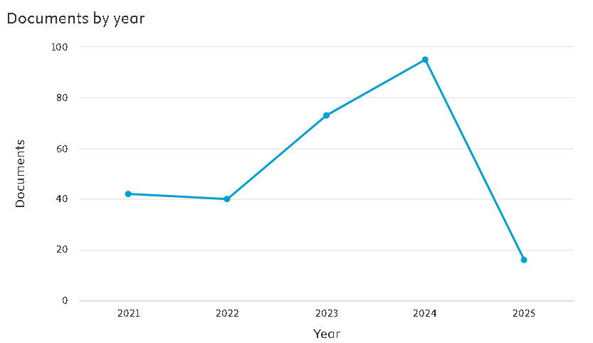
Figure 1. Articles with the Keyword sustainable competitiveness SMEs
In Figure 1, it can be seen that the keyword sustainable competitiveness SMEs in the 2021-2025 period is: 42 articles in 2021, 40 articles in 2022, 73 articles in 2023, 95 articles in 2024 and 16 articles in 2025. Note that for 2025 there may be an increase because the data access for this research was carried out on March 5, 2025. From this graph, it can be seen that the discussion of the keyword sustainable competitiveness tends to increase.
For the keyword Community Empowerment in SMEs with a period spanning 2021-2025, 20 articles were obtained, the number of which can be seen each year in Figure 2.
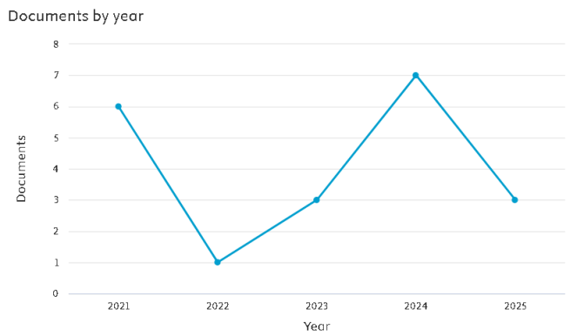
Figure 2. Articles with the Keywords Community Empowerment in SMEs
In Figure 2, it can be seen that the second keyword, namely Community Empowerment of SMEs in the 2021-2025 period, is: 6 articles in 2021, 1 article in 2022, 3 articles in 2023, 7 articles in 2024 and 3 articles in 2025. With a note that for 2025 there may be an increase because the data access for this research was carried out on March 5, 2025. From the graph above, it can also be seen that the theme with the keyword community empowerment in SMEs tends to have opportunities to be explored further.
Methods
The collection of study articles carried out article mapping using the bibliometric visualization of Vos Viewer from articles that had undergone a filtering process according to the stages of the Prisma process. Figure 3. Vos viewer is a graphical representation of a bibliometric map that provides an overview of the structure of the scientific field in the form of groups that are located close to each other and have close relationships between clusters [11]
Determination of study selection was carried out using the PRISMA (Preferred Reporting Items for Systematic Reviews and Meta-Analyses) procedure. This approach helps in the systematic review stages through the process of identification, screening, eligibility, and evaluation of inclusion in the article [12][3].

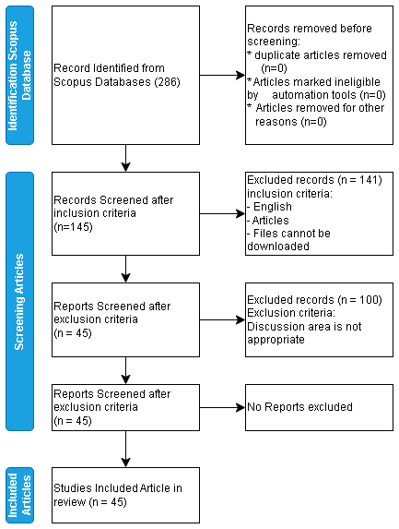
Figure 3. Article Screening Process

The article screening used in the review process follows the rules of the PRISMA stages. Figure 3 shows that there are 3 stages of the screening flow, namely the identification stage, the article screening stage, and the articles included in the review.
An important part of the identification stage is determining keywords by creating the right combination of keywords in searching for literature in the database [13]. The search was conducted on the Scopus database conducted in March 2025 by considering the terms: “Sustainable Competitiveness SMEs", “Community Empowermen in SMEs”. This combination was entered into the Title-Abs-Key search on Scopus. Resulting in 286 articles.
The initial screening stage of 286 articles was carried out through the inclusion and exclusion process using exclusion criteria in terms of article type, English language, and accessible documents, resulting in 145 articles.
The next screening stage is related to the discussion area of ​​research articles in the industrial and business fields of SMEs and discusses the success factors of sustainable competitiveness and SMEs that involve the community in their organizations, from these considerations the final results were 45 articles and these articles will be included and are eligible to be included in the systematic review.

RESULTS AND DISCUSSION
Subject Area
Search on the Scopus database using the TITLE-ABS-KEY search. For key 1 using the search sustainable AND competitiveness AND SMEs there are 22 Subject Areas of discussion related to the sustainability of competitiveness in SMEs in the 2021-2025 period. However, researchers only categorize the subject areas into the top 10. (Figure 4)

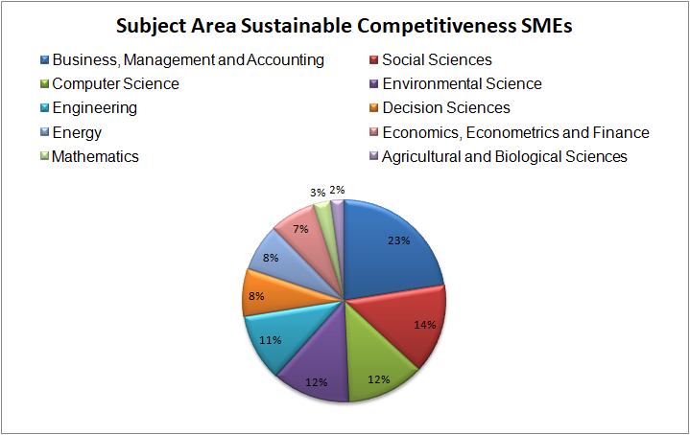
Figure 4. Subject Area Sustainable Competitiveness
Source: Scopus Database

In Figure 4 above are 10 areas of discussion related to sustainable competitiveness. The largest discussion related to sustainable competitiveness is in the subjects are Business, Management and accounting, which is 23%. Key 2 uses the Community AND Empowerment AND SMEs search search during the 2021-2025 period, there are 13 subject areas (Figure 5).
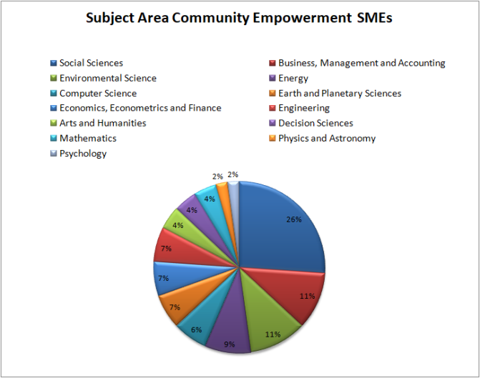
Figure 5. Subject Area Community Empowerment
Source: Scopus Database

SMEs related to the discussion in social science, which is 24%. Based on the search for the subject area of ​​the keywords above, the search in the context of the role of community empowerment in sustainable competitiveness in SMEs is still widely undiscussed in the references found. The role of this community has a significant influence on the sustainability of SMEs and the community around SMES. If SMEs implement community empowerment in a more structured, collaborative and local potential-based manner in the empowerment process, SMEs will be able to improve welfare and create SMEs that can be competitive [14][7].

Topics and Keywords
Determining keywords at the initial stage is an important part of describing the level of Co-occurrence in the study. This analysis is intended to determine the main research topic regarding sustainable competitiveness in SMEs. Therefore, this analysis uses the help of VosViewer software. The minimum number of keyword occurrences is set at three occurrences. Figure 4 shows the Co-Occurance map, the map it produces and identifies four clusters (Table1) with common topics and keywords that often appear in each cluster as follows: cluster 1 "Competitiveness" and "Community Empowerment", in Cluster 2 "SMEs", Cluster 3 "Innovation" and "Sustainable Development" for Cluster 4 "Rural Community", "Tourism" and "Empowerment".
Based on the results of the Co-Occurance analysis for keywords focused on the topic of this article, namely the discussion of sustainable competitiveness through community empowerment in SMEs, keywords that are related to the same cluster are the keywords sustainable competitiveness and SMEs. Meanwhile, community empowerment has not been connected in the same cluster. This indicates that topics related to community empowerment in SMEs still need to be explored a lot.
Table 1. Co-Occurrence Analysis Results
Cluster | Keyword | Occurre-nces | Total Link Strenght
1  (RED) | Competitiveness | 14 | 14
1  (RED) | Community Empowerment | 14 | 11
1  (RED) | Sustainability | 9 | 14
1  (RED) | Management | 4 | 4
2  (GREEN) | SMES | 16 | 61
2  (GREEN) | Competitive advantage | 8 | 49
2  (GREEN) | Sustainable Competitiveness | 4 | 4
2  (GREEN) | Organisational growth transition | 3 | 48
3  (BLUE) | Innovation | 5 | 4
3  (BLUE) | Sustainable Development | 5 | 2
3  (BLUE) | ESG | 4 | 10
4  (YELLOW) | Rural Community | 4 | 8
4  (YELLOW) | Tourism | 4 | 6
4  (YELLOW) | Empowerment | 4 | 6
Source: Vos Viewer Results

Visualization of the network results for Co-Occurrence can be seen in Figure 6, which illustrates the relationship between each keyword in the article search results.
Next is to see the results of the density between keywords. Color density is a file that shows the density of each text from the keyword. In the visualization, the denser an item is, the brighter the color will be seen, but if the density of an item decreases, it will look increasingly faded [15]. Figure 7
From the visual density results of Figure 7, keywords such as "SMEs", "competitiveness", "community empowerment", and "sustainability" appear to have a high density (yellow zone). This means that this topic is the most discussed and is the main focus of the study. As for topics that can be closely related, keywords such as "innovation", "sustainable competitiveness", and "sustainable development" are closely related to the main topic and often appear together, but are not as dense as the main keywords. Specific or Targeted Topics: Keywords such as "rural community empowerment" appear in areas with lower density, indicating that they are more specific or have not been widely discussed in the literature.

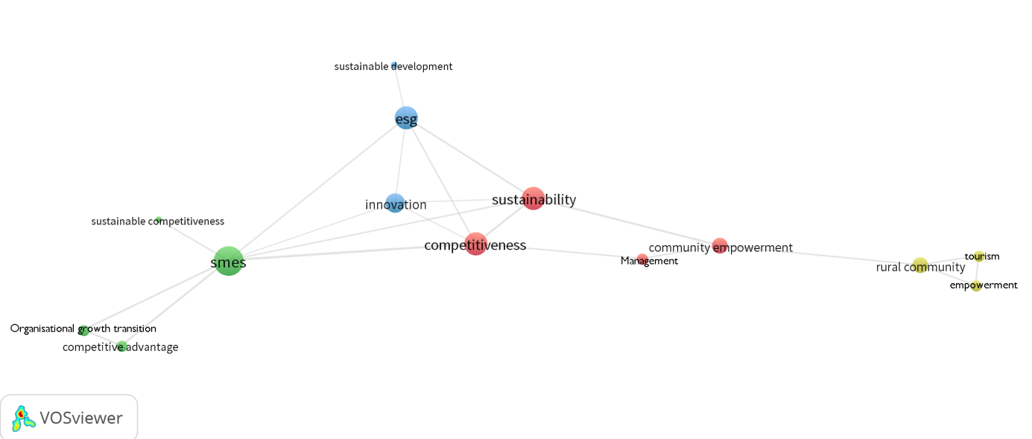

Figure 6. Keyword Cluster
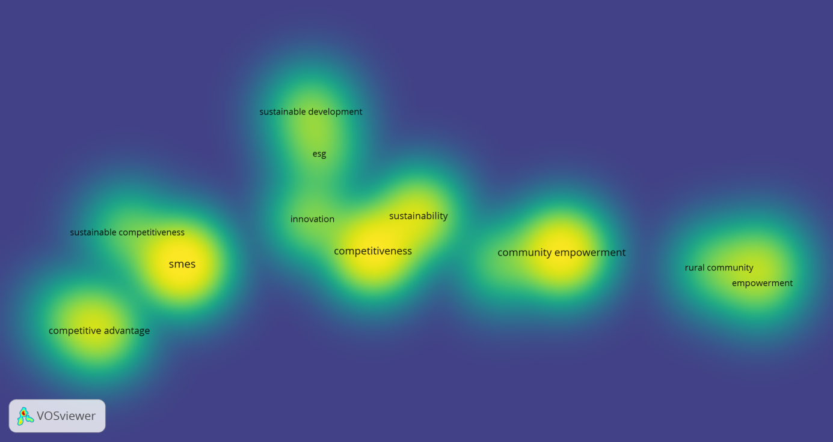
Figure 7. Visual Density

Success Factors for Sustainable Competitiveness
Key success factors are factors that influence the achievement of achieving success such as in business, career, profession and so on. From the results of the literature review, the key success factors found in achieving sustainable competitiveness can be seen in table 2. Key success factors in helping SMEs adapt to changing consumer needs and expectations will result in increased competitive value and competitiveness for SMEs [16].

Table 2. Key Success Factors
Sector | Journal Publication | Method | Key Success Factors  for Sustainable competitiveness of SMEs | Reference
Agriculture | Sustainability | system-based approach, comparative analysis approach | Utilization of information and data developments, Use of digital platforms, Involvement of various stakeholders and institutions. | [17]
Accommodation | International Journal of Business Ecosystem & Strategy | Qualitative with interviews, thematic analysis, TOE and RBV | Technology Sustainability, Executive Support, Resources and Organizational Capacity, Regulations that support sustainability Support from local communities for sustainable practices. | [18]
Accommodation | Sustainability | Partial Least Squares Structural Equation Modeling (PLS-SEM), | Flexibility, technological innovation, new knowledge and developing resources, Strong network with business associations or partners | [19]
Non-Specific | Sustainability | Simple linear regression, one-way ANOVA, and T-test | Proper human resource management, continuous innovation, and increased investment in ICT | [1]
Service | International Review of Management and Marketing | Quantitative and qualitative methods, including analysis of variance (ANOVA) and thematic analysis for interviews | Managerial Capacity, Funding and Financial Resources, Technology Infrastructure, Accessibility and Infrastructure, Partnerships and Collaboration | [20]
Food Processing | Food Research | matrix IFE (Internal Factor Evaluation) and EFE (External Factor Evaluation). | Product quality, innovation, and competitive prices, development of tourism areas, government support and technology, Support from business partners, training programs, and access to funding | [21]
Agriculture | Journal of Environmental Management and Tourism | Regression analysis, Forecasting | Financial Stability, Supportive Infrastructure, Conducive Policy Environment, Adaptation to Changes in the External Environment, Collaboration with Financial Institutions, Human Resources Competency Improvement, Operational Digitalization. | [22]
Non-Specific | Sustainability | Structural Equation Modeling (SEM), Principal Component Analysis (PCA). | Collaboration, Availability of competent and trained human resources, Leadership that supports sustainability and innovation, Knowledge Infrastructure, Organizational Culture, Use of Technology. | [23]
Food Processing | International Journal of Emerging Markets | Smart PLS-SEM | Relationships with Customers and Stakeholders, Leadership Involvement, Balance of Interests, CSR Awareness and Consistency, Adequate Infrastructure and Technology, Appropriate Performance Measurement System | [24]
Manufacturing | Cogent Business & Management | Qualitative and Quantitative methods. Covariance-Based Structural Equation Model (CB-SEM). | External Support, Intangible Assets, Flexibility, Speed ​​and Quality of Innovation. Human Resource Management, CSR Implementation. | [25]
Manufacturing | Frontiers in Environmental Science | Partial Least Squares Structural Equation Modeling (PLS-SEM) | Environmental Regulatory Support, Collaboration, Investment in Green Intellectual Capital (GIC), Absorptive Capacity (AC), Commitment to Green Innovation (GI). | [2]
Non spesific | Jurnal Optimasi Sistem Industri | Quantitative research with a causal approach, Structural Equation Modeling-Partial Least Squares (SEM-PLS). | Effective Government Support,Collaboration with External Institutions, Continuous Education and Training, Financial Capacity and Infrastructure. | [26]
Industrial | International Journal of Advanced Computer Science and Applications | Descriptive research design, Structural Equation Modeling, SEM, SPSS and AMOS | Collaboration, Innovation as Competitive Core, Commitment to Continuous Improvement, Effective Resource Management, Appropriate Use of Technology, Capacity for Adaptation, Deep Understanding of the Market | [27]
Tourism | MDPI - Water | Quantitative and Qualitative narrative descriptive. | Collaboration with Stakeholders, The Right Investment Approach, Focus on High Value Niche Markets, Adaptability to Crisis, Optimization of Resources, Innovation and Technology. | [28]
Non spesific | International Journal of Economics and Management | Exploratory qualitative methods | Collaboration and Networking, Use of Technology, Operational Flexibility, Market Understanding, Effective Resource Management, Commitment to Sustainability, Training and Development | [29]
Food | Journal of Infrastructure, Policy and Development | Life Cycle Assessment (LCA), ESG (Environmental, Social, Governance) | Stakeholder Engagement, Access to Funding, Management Commitment, Efficient Technology Adoption, Innovation, Effective monitoring system | [3]
Non spesific | Sustainability | Qualitative methods | Management Commitment, Internal Competency Training and Development, Use of Data and Analytics from social media to understand market trends. | [5]
food, health and beauty |  | Qualitative methods | Characteristics of Technology Providers, Collaboration Between Stakeholders, Appropriate Technology | [30]
handicrafts and creative industries | International Journal of Sustainable Development and Planning | PLS-SEM (Partial Least Squares Structural Equation Modeling) | Collaboration with Business Partners, Utilization of Appropriate Technology, Innovation Capabilities, Human Resource Competence, Utilization of Digital Data. | [31]
logistics | Journal of Infrastructure, Policy and Development | Regression analysis, Testing of relationships | Close Collaboration, Trust as a Foundation, Development of Shared Culture and Values, Focus on Creating Shared Value | [32]
Textile | Journal of Human, Earth, and Future | Qualitative Approach, Business Model Canvas | Collaboration with Stakeholders, environmentally friendly products, Management Commitment, Ability to continuously innovate in design,Use of Appropriate Technology | [33]
Non spesific | Journal of the Knowledge Economy | Descriptive statistical analysis, Principal Component Analysis (PCA), | Knowledge, Intellectual capital utilization, Collaboration, Culture, innovation | [34]
Fashion Industry | Review of Managerial Science | Qualitative approach | Partnership collaborations that contribute to SDGs | [35]
Manufaktur | African Journal of Applied Research | ISM, MIC MAC | Government policy, customer pressure, technological and managerial readiness | [36]
Agri-food | Sustainability | content analysis, source triangulation | Partnership collaboration, Customer Education, Innovation and Technology, Policy and Regulation | [4]

Source: Self-Elaboration

Based on table 2 above, the author will categorize the key success factors which can be seen in table 3. These key factors are divided into 6 dimensions, namely: Economic, Social, Environment, Technology, Organization, and Human.

Economic Dimensions
The economic dimension of sustainability is greatly influenced by the financial stability of SMEs, access to financing is one of the things that can increase the competitiveness and resilience of SMEs in the long term and is able to contribute directly to national economic development in a sustainable and inclusive manner [22]. In addition, SMEs must also be able to demonstrate the importance of brand identity and response to market opportunities, so they are required to have a strong understanding of the market, which is a key component in sustainability [28].

Social Dimensions
An important aspect that is sometimes overlooked is social, where if this is paid attention to it will have a big impact on society, improving reputation and long-term sustainability [37]. Support from local communities plays an important role in driving the success of sustainable practices, which is influenced by community knowledge about the benefits of sustainability, so it is very important to increase community awareness and education as a strategic step [18].
Collaboration is a key point in achieving successful SME development, cross-sector partnership collaboration is a strategic foundation in strengthening SME competitiveness and the success of this collaboration requires effective management, policy support, and strengthening infrastructure, this is intended to ensure long-term sustainability [20].

Environment Dimensions
The environmental dimension plays an important role in sustainability, environmental policies and regulations as drivers of the integration of sustainable practices. Adaptive, collaborative and contextual policies are needed to accelerate the sustainability transformation by considering the large role of SMEs in the supply chain and the cumulative environmental impacts [4]. The development of environmentally friendly products in SMEs can be carried out in a real way with a sustainable approach by integrating it into the product life cycle. In addition, this integration needs to be supported by innovation, environmental awareness and a planned production strategy [33].

Technology Dimensions
Technological innovation is an important foundation that can help business actors manage resources more efficiently, reduce waste and increase productivity, with the use of technologies such as digital transformation, AI, ICT and data analytics enabling SMEs to collect, analyze and utilize them to support better and more responsive decision making [17]. For SMEs to improve sustainable competitiveness, innovation from technology is needed as a strategic solution. However, SMEs usually face limitations in resources and R&D capacity, so assistance is needed in the form of technology transfer such as assistance in developing new products, improving product standards, digital marketing, and production efficiency [30].

Organization Dimenssions
An organization is an entity that has resources, capabilities, managerial structures, and strategies that play a role in adopting sustainable practices, where the organization is the key to success in adopting sustainable practices, especially in developing countries [18]. The main challenges within the organization are related to capacity and management, there are obstacles related to this such as: lack of skilled workers and less than optimal organizational structure, ineffective coordination between stakeholders, limited financial resources and technological infrastructure [20]. To increase the competitiveness of SMEs sustainably in the current digital era, SMEs also need to have adequate Information and Communication Technology (ICT). Without this, SMEs will have difficulty competing, be slow to innovate and lose dynamic market opportunities [1].
Support the success of information management, knowledge and intellectual capital development in SMEs is influenced by organizational culture, where this organizational culture is included in the context of the SMEs network, namely creating a collaborative culture, being open to learning and encouraging trust between network members so that it can facilitate the creation and exchange of knowledge effectively [34]. In developing or increasing the sustainable competitiveness of SMEs, the main foundation in this sustainability practice requires commitment from management. This must be aligned with business objectives that lead to and apply sustainability practices [3].

Human Dimensions
Competent human resources are an important prerequisite for businesses to be able to adapt to changes such as facing market demands, new technologies and sustainability strategies. SMEs need to collaborate with related companies and institutions to assist in improving the skills and retraining of their human resources [29].
Human resources must have new knowledge because it is one of the strategic assets that drives innovation, increasing competence and how to adapt to market changes, new knowledge enriches human capital (improving skills), structural capital (better systems and processes) and relational capital (strategic partnerships) for the long-term competitiveness of SMEs.

Table 3. Dimensions and factors of sustainable competitiveness of SMEs
Dimenssion | Factors | Referance
Economic | Financial Capacity and Stability | [22], [26]
Economic | Funding and Financial Resources | [20], [3]
Economic | competitive prices | [21]
Economic | Understanding of the Market | [27],[28], [29], [5]
Social | Support from local communities | [18], [26]
Social | Collaboration and Patnership | [20], [23], [26], [27], [28], [29], [30], [31], [32],[33], [34], [35], [4]
Social | Corporate Social Responsibility | [24],[25], [4]
Social | Relationships with Customers | [24]
Environment | Environmental Regulatory and Policy | [2], [22], [36], [4]
Environment | environmentally friendly products | [33]
Technology | Technological innovation | [17], [1], [20], [21], [23], [24], [26], [2], [3], [28], [31], [4], [30], [33]
Technology | Technology Sustainability | [18], [30]
Technology | Utilization of Digital Data | [31], [17]
 | Appropriate Technology | [30], [31], [33]
Organization | Organizational Capacity | [18], [23], [27]
Organization | Infrastructure | [26], [20]
Organization | Managerial Capacity | [20], [2], [36]
Organization | investment in ICT | [1]
Organization | Organizational Culture | [23], [32],  [34]
Organization | Management Commitment | [3], [5], [33]
Human | Education and Training | [26], [4], [23], [29]
Human | Human Resources Competency | [1], [22], [23], [29], [31]
Human | New Knowladge | [19], [34]
Source: Self-Elaboration

Based on table 3, In an effort to achieve organizational goals sustainably, there are various dimensions and factors that must be considered. Based on the results of literature synthesis, there are six main dimensions, namely: economic, social, environmental, technological, organizational, and human resources. Each dimension has supporting factors that contribute directly or indirectly to the success of the organization's strategy and operations.
1. Economic Dimension
The economic dimension emphasizes the importance of financial strength and market competitiveness in supporting organizational sustainability. Factors such as financial capacity and stability, financial resources, competitive pricing, and market understanding are key to ensuring business continuity and adaptation to market dynamics. ([3],[20]–[22],[26]–[29])
2. Social Dimension
Social factors reflect the importance of a harmonious relationship between an organization and its social environment. This includes support from the local community, collaboration and partnership, corporate social responsibility (CSR), and good relationships with customers. These social aspects not only enhance the organization's reputation, but also strengthen social acceptance of the organization's existence and activities. ([4],[5],[18],[20], [23]–[35])
3. Environmental Dimension
Awareness of environmental issues is also an integral part of sustainability. Organizations need to comply with environmental policies and regulations, and develop environmentally friendly products to minimize negative impacts on ecosystems and meet consumer demands for sustainable products. ([2], [4],[22],[33],[36])
4. Technology Dimension
Technology is an important supporting factor in increasing organizational efficiency and competitiveness. Factors such as technological innovation, technological sustainability, digital data utilization, and appropriate use of technology all play a role in driving digital transformation and increasing organizational capabilities in the industrial era 4.0. ([1]–[4], [17], [18], [20]–[31], [33])
5. Organizational Dimension
The organizational dimension focuses on internal aspects such as organizational capacity, infrastructure, managerial capacity, and strategic investment, all of which support the achievement of long-term goals. Strong internal capabilities enable organizations to manage change, overcome challenges, and innovate sustainably.
([1],[2], [18],[20],[23],[26],[27],[36])
6. Human Dimension
The human dimension reflects the importance of developing and managing competent individuals to drive organizational performance and innovation. Important factors in this dimension include education and training, availability and quality of human resources, competence, and new knowledge. Investment in human resource development is the foundation for increasing the competitiveness of the organization in a sustainable manner. ([1],[4],[19],[22],[23],[26], [29],[31],[34])

CONCLUSION
Literature search related to sustainable competitiveness through community empowerment using a search on the Scopus database did not find any direct connection with SMEs. So the discussion related to "Sustainable Competitiveness of SMEs" and "Empowerment of SMEs Community" has its own context. If traced further from the keywords used, these two discussions are related but do not have a direct connection (Figure 5).
Research trends related to "Sustainable Competitiveness of SMEs" and "Community Empowerment in SMEs" in the last 4 years, namely 2021-2024, have seen a significant increase. For the trend in 2025, further conclusions cannot be drawn because the data in writing this article was last taken on March 5, 2025. In the Co-Occurrence analysis, the keywords do not yet have a strong interconnection from the keywords "Community Empowerment" and "Sustainable Competitiveness", this shows that these concepts have not been widely discussed together, where community empowerment in the context of the social dimension has not been given much attention in creating sustainable competitiveness in SMEs.
Community empowerment studies in improving the sustainability of SMEs competitiveness need to be explored further where the impact of this community empowerment will affect the resilience of SMEs and the welfare of the surrounding community in the SMEs environment indirectly will also increase national development, especially for developing countries. This is in line with the results of the key success factors, 6 dimensions must be considered so that SMEs have sustainable competitiveness, namely the dimensions of Economy, Social, Environment, Technology, Organization, and Human Resources.

ACKNOWLEDGMENT
This study article is supported by funding assistance for further studies from Mercu Buana University in completing Doctoral studies at IPB University.

REFERENCES

[1] B. Kahouli, A. Nafla, and N. Chaaben, “Exploring the Influence of the Information and Communication Technology Dimensions on the Sustainability of Competitiveness in Small and Medium-sized Enterprises in the Hail Region,” Sustainability, vol. 15, no. 16325, pp. 1–19, 2023, doi: https://doi.org/10.3390/su152316325.
[2] J. M. Sohu et al., “Driving sustainable competitiveness : unveiling the nexus of green intellectual capital and environmental regulations on greening SME performance,” Front. Environ. Sci., no. February, pp. 1–13, 2024, doi: https://doi.org/10.3389/fenvs.2024.1348994.
[3] J. Pinedo-López, R. Baena-Navarro, Y. Carriazo-Regino, A. Urrea-Ortiz, and D. Reyes-Guevara, “Sustainability strategies: A proposal for food sector SMEs, based on the integration of life cycle assessment and ESG strategies,” J. Infrastructure, Policy Dev., vol. 8, no. 12, pp. 1–30, 2024, doi: https://doi.org/10.24294/jipd.v8i12.8934.
[4] G. Camelo and M. Nogueira, “The ESG Menu: Integrating Sustainable Practices in the Portuguese Agri-Food Sector,” Sustain., vol. 16, no. 11, 2024, doi: https://doi.org/10.3390/su16114377.
[5] E. Korcsmáros and B. Csinger, “Sustainable Competitiveness in the Case of SMEs—Opportunities Provided by Social Media in an International Comparison,” Sustain., vol. 14, no. 19, pp. 1–18, 2022, doi: https://doi.org/10.3390/su141912505.
[6] L. Becchetti, E. Bobbio, F. Prizia, and L. Semplici, “Going Deeper into the S of ESG: A Relational Approach to the Definition of Social Responsibility,” Sustain., vol. 14, no. 15, pp. 1–22, 2022, doi: https://doi.org/10.3390/su14159668.
[7] M. Hermansyah, I. Santoso, S. Wijana, Sucipto, and A. Fudholi, “Implementation of Participatory Rural Appraisal (PRA) in empowering gaplek SMEs using Partial Least Square (PLS) analysis,” Int. J. Sustain. Dev. Plan., vol. 16, no. 3, pp. 543–550, 2021, doi: https://doi.org/10.18280/ijsdp.160315.
[8] H. Azwar, M. H. Hanafiah, A. A. Ghani, M. Azinuddin, and N. S. M. Shariffuddin, “Community-Based Tourism (Cbt) Moving Forward: Penta Helix Development Strategy Through Community Local Wisdom Empowerment,” Plan. Malaysia, vol. 21, no. 1, pp. 72–88, 2023, doi: https://doi.org/10.21837/pm.v21i25.1225.
[9] I. Imaniah, M. Shahreza, and E. Purwanto, “Effective Development communication strategies for enhancing MSME empowerment in the Cikadu Tourism Village, Tanjung Lesung,” E3S Web Conf., vol. 592, pp. 1–16, 2024, doi: https://doi.org/10.1051/e3sconf/202459206013.
[10] S. Gouveia, D. H. de la Iglesia, J. L. Abrantes, and A. J. López Rivero, “Transforming Strategy and Value Creation Through Digitalization?,” Adm. Sci., vol. 14, no. 11, 2024, doi: https://doi.org/10.3390/admsci14110307.
[11] N. J. van Eck and L. Waltman, “Software survey: VOSviewer, a Computer Program for Bibliometric Mapping,” Scientometrics, vol. 84, no. 2, pp. 523–538, 2010, doi: https://doi.org/10.1007/s11192-009-0146-3.
[12] V. Mishra and M. P. Mishra, “Prisma for Review of Management Literature – Method, Merits, and Limitations – an Academic Review,” Rev. Manag. Lit., vol. 2, pp. 125–136, 2023, doi: https://doi.org/10.1108/s2754-586520230000002007.
[13] S. Kraus, M. Breier, and S. Dasí-Rodríguez, “The art of crafting a systematic literature review in entrepreneurship research,” Int. Entrep. Manag. J., vol. 16, no. 3, pp. 1023–1042, 2020, doi: https://doi.org/10.1007/s11365-020-00635-4.
[14] Purwowibowo, “Improving Community Welfare Through the Cultivation of Coffee: A Case Study of Bondowoso’s Coffee Republic, Indonesia,” Acad. J. Interdiscip. Stud., vol. 12, no. 2, pp. 315–322, 2023, doi: https://doi.org/10.36941/ajis-2023-0051.
[15] N. J. van Eck and L. Waltman, “VOSviewer Manual version 1.6.19,” Leiden: Univeristeit Leiden, no. January, p. 54, 2023, [Online]. Available: http://www.vosviewer.com/documentation/Manual_VOSviewer_1.6.1.pdf.
[16] M. Hamdouna and M. Khmelyarchuk, “Technological Innovations Shaping Sustainable Competitiveness—A Systematic Review,” Sustain., vol. 17, no. 5, 2025, doi: https://doi.org/10.3390/su17051953.
[17] A. Figurek and A. Thrassou, “An Integrated Framework for Sustainable Development in Agri-Food SMEs,” Sustain., vol. 15, no. 12, 2023, doi: https://doi.org/10.3390/ su15129387 Academic.
[18] M. F. Islam, “Exploring key drivers of tourism sustainability practices and their impact on sustainable competitive performance in the accommodation industry,” Int. J. Bus. Ecosyst. Strateg., vol. 6, no. 1, pp. 28–44, 2024, doi: http://dx.doi.org/10.36096/ijbes.v6i1.465.
[19] L. Rienda and L. Ruiz-fern, “Internationalization and Sustainable Hotel Competitiveness : Resilience and Network Ties to Increase Tourism Sustainability,” Sustainability, vol. 16, no. 3267, pp. 1–12, 2024, doi: https://doi.org/10.3390/ su16083267 Academic.
[20] K. L. Armas, C. Dela Cruz, J. E. Navarro, and V. Viloria, “Triple Helix for Sustainable Development Goals: An Impact Assessment of Shared Service Facility for Micro, Small, and Medium Enterprises Competitiveness in the Philippines,” Int. Rev. Manag. Mark., vol. 14, no. 3, pp. 65–73, 2024, doi: https://doi.org/10.32479/irmm.16103.
[21] C. Novia, S. Syaiful, and D. Utomo, “Analysis of strategies for increasing the competitiveness of jackfruit chips small medium enterprises in Malang Regency, Indonesia,” Food Res., vol. 8, no. 5, pp. 303–309, 2024, doi: https://doi.org/10.26656/fr.2017.8(5).639R
[22] A. Belgibayeva, O. Denissova, M. Kozlova, I. Savchenko, A. Tleubayev, and G. Siximbayeva, “Analysis of Sustainable Development of SMEs in Agriculture,” J. Environ. Manag. Tour., vol. VII, no. 4, 2022, doi: https://doi.org/10.14505/jemt.v13.3(59).09
[23] R. D. Acosta-Velásquez, J. León-Pulido, A. García-Pérez, W. S. Fajardo-Moreno, and L. Espinosa-Leal, “Contemporary Management Practice Applying the Dynamic Absorptive Capacity Measurement Model ( PM 4 AC ) for Improved Business Sustainability,” Sustainability, vol. 14, no. 11036, pp. 1–12, 2022, doi: https://doi.org/10.3390/su141711036.
[24] T. T. Le, “Corporate social responsibility and SMEs ’ performance : mediating role of corporate image , corporate reputation and customer loyalty,” Int. J. Emerg. Mark., vol. 18, no. 10, pp. 4565–4590, 2023, doi: https://doi.org/10.1108/IJOEM-07-2021-1164.
[25] T. Le Thanh, N. Q. Huan, T. Thi, and T. Hong, “Determinants for competitiveness in the context of international integration pressure : Case of small and medium enterprises in emerging economy – Vietnam,” Cogent Bus. Manag., vol. 8, no. 1, 2021, doi: https://doi.org/10.1080/23311975.2021.1893246.
[26] H. Rahman, S. Oktavia, N. Shetye, and W. L. S. Azonhoumon, “Enhancing Operations for Sustainability in Indonesian SMEs through Climate Change Awareness and Business Orientation,” J. Optimasi Sist. Ind., vol. 23, no. 1, pp. 109–119, 2024, doi: https://doi.org/10.25077/josi.v23.n1.p109-119.2024.
[27] R. R. P. Advincula, C. G. Chavesta, and L. Ocares-Cunyarachi, “Innovation Management Model as a Source of Business Competitiveness for Industrial SMEs,” Int. J. Adv. Comput. Sci. Appl., vol. 13, no. 8, pp. 620–627, 2022, doi: http://doi.org/10.14569/IJACSA.2022.0130871.
[28] E. Santos, R. A. Castanho, and D. Meyer, “Is Investment Contributing to Competitiveness in Nautical Tourism in the Atlantic Area?,” Water (Switzerland), vol. 14, no. 19, pp. 1–17, 2022, doi: https://doi.org/10.3390/w14192964.
[29] H. A. Halima, S. R. M. Zainala, and N. H. Ahmada, “Strategic Foresight and Agility: Upholding Sustainable Competitiveness Among SMEs During COVID-19 Pandemic,” Int. J. Econ. Manag., vol. 16, no. SpecialIssue1, pp. 81–97, 2022, doi: http://doi.org/10.47836/ijeamsi.16.1.006.
[30] O. Khongmalai and A. Distanont, “Technology Transfer Model to Enhance Sustainable Competitiveness of SMEs,” Proc. Eur. Conf. Manag. Leadersh. Gov., vol. 2022-Novem, pp. 222–228, 2022, doi: DOI: https://doi.org/10.34190/ecmlg.18.1.906.
[31] R. Machmud, N. F. Wuryaningrat, and D. Mutiarasari, “Technopreneurship-Based Competitiveness and Innovation at Small Business in Gorontalo City,” Int. J. Sustain. Dev. Plan., vol. 17, no. 4, pp. 1117–1122, 2022, doi: https://doi.org/10.18280/ijsdp.170408.
[32] Y. Chen, “The sustainable development of small and midsize enterprises in China on green reverse logistics,” J. Infrastructure, Policy Dev., vol. 8, no. 11, p. 8209, Oct. 2024, doi: https://doi.org/10.24294/jipd.v8i11.8209.
[33] R. Hurriyati, D. Dagustani, A. Surachim, S. Sulastri, and L. Lisnawati, “Triple-Layered Business Model Canvas Environment Based in the Fashion Industry,” J. Human, Earth, Futur., vol. 4, no. 4, pp. 411–423, 2023, doi: http://dx.doi.org/10. 28991/HEF-2023-04-04-03.
[34] R. V. D. Jordão and J. C. Novas, “Information and Knowledge Management, Intellectual Capital, and Sustainable Growth in Networked Small and Medium Enterprises,” J. Knowl. Econ., vol. 15, no. 1, pp. 563–595, 2024, doi: https://doi.org/10.1007/s13132-022-01043-5.
[35] P. Castellani, C. Rossato, E. Giaretta, and A. Vargas-Sánchez, “Partner selection strategies of SMEs for reaching the Sustainable Development Goals,” Rev. Manag. Sci., vol. 18, no. 5, pp. 1317–1352, 2024, doi: https://doi.org/10.1007/s11846-023-00656-7.
[36] D. V. Bhise, M. A. Kumbhalkar, M. M. Sardeshmukh, S. A. Choudhari, S. H. Sarje, and N. B. Kardekar, “Study for Identification and Classification of Advanced Manufacturing Technology Implementation Drivers in Small and Medium Enterprises,” African J. Appl. Res., vol. 11, no. 1, pp. 388–407, 2025, doi: https://doi.org/10.26437/ajar.v11i1.
[37] C. R. Carag et al., “Development and Validation of a Knowledge Audit Framework for SMEs,” Asian J. Mechatronics, Electr. Eng., vol. 2, no. 1, pp. 69–94, 2023, doi: https://doi.org/10.55927/ajmee.v2i1.4090.

