TE-LSTM: Enhancing Maintenance Strategy from Winding Temperature Prediction for Induction Motors in the Oil and Gas Industry  Joko Supriyono¹*, Imam Mukhlash², Mohammad Iqbal³, Dimas Anton Asfani⁴  ¹Interdisciplinary School of Management and Technology, Institut Teknologi Sepuluh Nopember Surabaya Indonesia. Electrical Engineering Specialist, Saudi Aramco, Saudi Arabia.  ²Department of Mathematics, Institut Teknologi Sepuluh Nopember Surabaya, Indonesia,  ³Department of Mathematics, Institut Teknologi Sepuluh Nopember Surabaya, Indonesia,  ⁴Department of Electrical Engineering, Institut Teknologi Sepuluh Nopember Surabaya, Indonesia | 

Abstract  This study proposes a deep learning model called TE-LSTM to predict winding temperatures in induction motors used in oil and gas operations. The proposed model combines a transformer encoder-based architecture with long short-term memory (LSTM) to capture complex temporal dependencies and sensor behaviors. Data from induction motors equipped with three stator winding temperature sensors were collected at 1-min intervals from January 2021 to September 2024, yielding approximately two million data points per motor. These motors were designed with Class F insulation and had stage 1 and stage 2 alarms set at 257°F and 285°F, respectively. The proposed TE-LSTM model is effective in predicting potential failures and enables proactive maintenance strategies. By accurately forecasting winding temperatures, the model can significantly reduce unplanned downtime and associated costs, thereby optimizing maintenance operations and enhancing reliability in the oil and gas industry. This study has contributed to the development of advanced predictive maintenance techniques for critical industrial equipment. The anticipated outcomes include improved maintenance planning, reduced repair costs, and enhanced operational reliability. This study not only addresses the specific challenges faced by the oil and gas industry but also contributes to the broader field of predictive maintenance by proposing innovative methodologies for RUL estimation and fault detection.  This is an open access article under the CC BY-SA license   | Keywords:  Induction Motor;Winding Temperature;Transformer;LSTM; Predictive Maintenance;  Article History:  Received: January 5, 2025  Revised: February 7, 2025  Accepted:  Published:  Corresponding Author:  Joko Supriyono  Interdisciplinary School of Management and Technology, Institut Teknologi Sepuluh Nopember Surabaya Indonesia  Email: Joko.Supriyono@gmail.com  7032231003@Student.its.ac.id

INTRODUCTION
Faults in induction motors can halt production lines in factories, leading to downtime and resulting in production and economic losses. Therefore, it is crucial to ensure that motors operate reliably [1]. Induction motor (IM) drives are used in numerous applications such as conveyers, cranes and ventilation systems and petroleum industry [2]. The reliability and performance of these motors are vital for maintaining efficient and safe industrial processes. The percentage of failures in IM components are as follows, bearing related faults 40%, Stator winding related faults 38%, Rotor related faults: 10%, Other faults: 12% [3].
IM’s are critical in industry, consuming 40-50% of the capacity generated. However, IM are subjected to various faults, a rule of thumb in industry says that there is a 50% loss of insulation life for every 10 Deg C increase in the temperature [4]. Early fault detection can prevent costly failures and downtime. Fault diagnosis of electrical motors is related to various parts of the motor: insulation, bearings, shaft, stator damage, and rotor damage. It is also based on various diagnostic signals, for example, acoustic, vibration, and infrared signals [5].
The requirement for condition monitoring has increased recently because of the widespread use of automation and consequent reduction in direct man-machine interface to supervise the system operation. Condition monitoring is a good graphical trend of the machine parameters for the purpose of detection, analysis, and correction of the machine problems before the failure takes place. Early detection of faults in induction motors is crucial to avoid production downtime and catastrophic failures [6]. Prognostics Health Management (PHM) of induction motors has been an important research topic [7]. Accurate remaining useful life (RUL) prediction of machines is important for condition-based maintenance (CBM) to improve the reliability and cost of maintenance [8]. PHM transitions maintenance activities from the traditional reactive methods, such as post-failure repairs, routine maintenance, and situational servicing, to proactive predictive maintenance. The core of predictive maintenance lies in the prediction of RUL. Accurate implementation of RUL prediction aids in strategically scheduling production tasks and devising rational maintenance plans, thereby maximizing production efficiency [2].

INDUCTION MOTOR
Three-phase AC motors occupy about 60% of total industrial electricity consumption, and the driving system of IM is widely used as well. AC induction motors are the most common motors in industry. Generally, an induction AC motor can achieve higher power factors (PF) and efficiency at full load or near full load operation [9]. Figure 1 shows the 3D model of the basic machine of IM. The winding of the basic machine is distributed and made of copper. In addition, the stator and rotor cores are made of silicon steel sheets. The rotor bars are located at the top of the rotor and close to the airgap to reduce the leakage flux [10]. Some construction parts such as frames, cooling system, shafts, bearings, and terminal boxes can be seen in Figure 2. Figure 2 presents a rather complete cutaway view of a modern induction motor. It has a single stack magnetic core; thus, axial ventilation is used by a fan on the shaft located beyond the bearings. The heat evacuation area is increased by the fined stator frame.
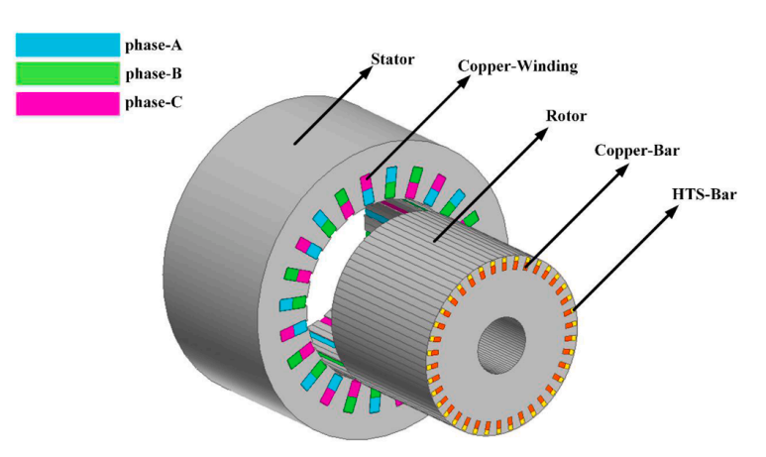Figure 1. 3D model of induction motor [3]

In the oil and gas industries, induction motors play a vital role in maintaining uninterrupted operations. Electric motors are widely used in the industries. One common type of electric motor is the induction motor (IM), which is known for its simplicity, high reliability, and affordability [24] . These motors typically employ Class F insulation, which has a standard maximum winding temperature of 311°F (155°C), as outlined in IEEE standard 43. However, when monitoring capabilities are limited, this threshold is often adjusted for safety reasons. In scenarios in which the winding temperature is monitored by
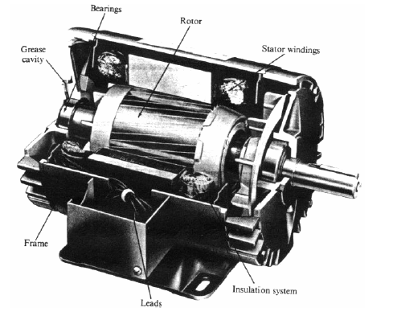

Figure 2. Complete cutaway view IM [31]
only three sensors, a more conservative approach is necessary.
To account for potential temperature variations that could cause detection due to the sparse sensor array, the maximum allowable temperature was reduced to 287°F (approximately 142°C). These precautionary measures help to safeguard motor integrity and longevity. Based on this adjusted limit, a two-tier alarm system was implemented as follows:
The initial alarm (H) was activated at 257°F (about 125°C). The critical alarm (HH) was triggered at 285°F (around 141°C). This tiered system allows for graduated responses to rising temperatures. When the H alarm sounds at 257°F, it provides an early warning that allows operators to initiate preventive actions. The HH alarm at 285°F serves as a final caution signal, indicating that the temperature is approaching the adjusted maximum.
Advanced predictive models are being explored to enhance this protective strategy. In this study, a TE-LSTM model combines the transformer encoder and LSTM architecture used to forecast potential alarm triggers. By anticipating these critical events, operators can implement more proactive maintenance strategies, thereby reducing the risks of unexpected shutdowns, production interruptions, and other operational hazards associated with motor overheating.
Key components of an induction motor consist of a stator: the stationary part creates a rotating magnetic field. Rotor: The rotating part driven by magnetic field. Windings: Copper or aluminum conductors that carry electric current and produce magnetic fields. Insulation: This material electrically isolates and protects windings. Insulation class defines the thermal capability of motor-winding insulation materials. The two common classes are F and B, which are described in Table 1.

Table 1. Winding insulation class characteristics
Characteristic | Class F | Class B
Maximum operating temperature | 155°C (311°F) | 130°C  (266°F)
Temp Rise Allowance | 105°C (221°F) | 80°C(176°F)

In recent years, the demand for accurate and robust Fault Detection and Diagnosis (FDD) methods for complex industrial systems has increased steadily. The key aim is to ensure that these complex systems can be safer and more reliable in operation, to minimize unscheduled machines and/or process downtime. Unexpected downtime due to machine failures has become a major issue in production plants, especially when the machines are expected to run continuously for extended hours. Faults may occur in a system or a process, either independently or simultaneously. Simple faults can be detected by a single measurement. But, in complex systems, it is often difficult to measure the system or process states directly. As such, more efficient and automated measures are needed to facilitate FDD of complex systems [12].
Reliability and availability of IMs are crucial to ensure trouble-free and continuous operation in the industry. However, IMs are exposed to many unavoidable stresses, such as the mechanical, electrical, thermal and environmental stresses, throughout the operation due to variation in the external loading, deviation in power supply, surplus heat, inadequate lubrications and incompetent sealing, dusty environment, manufacturing defect and natural aging. This creates some modes of unexpected faults in different components of the IM. These faults are usually left unnoticed in their primary stage; and this ends up with the catastrophic motor failure. Consequently, industry must bear a huge financial loss due to the shutdown process or sometimes severe human wounds. To avoid the likelihoods of catastrophic motor failure, early fault detection and diagnosis of the IM components that begin to degrade is done in the industry [13]. Early fault detection is very important to improve reliability by providing predictive maintenance and reducing unscheduled shutdowns [14]. The primary contributions of this study are as follows:
We propose a hybrid deep learning model called TE-LSTM for estimate winding temperature of induction motors accurately by extracting sensor behaviors from transformer-encoder and learning the short and long-term dependencies from long short-term memory. We present a comprehensive analysis of real-world data from induction motors in the oil and gas industry, collected from available data from operating plants. We demonstrated the proposed model to show its effectiveness in predicting potential failures, thereby enabling proactive maintenance strategies to reduce unplanned downtime and associated costs.

LITERATURE REVIEW
Industrial System Maintenance: Preventive maintenance (PM) is to inspect and maintain equipment according to the scheduled time rules. Preventive maintenance is to check and maintain the equipment according to the schedule. This can effectively ensure the reliability and availability of the equipment during regular operation and effectively avoid the economic loss of shutdown caused by sudden equipment failure [21]. Recent advancements in industrial systems maintenance have highlighted various strategies, including preventive maintenance (PM), condition-based maintenance (CBM), predictive maintenance (PdM), and hybrid approaches. These strategies aim at improving system reliability, reducing downtime, and optimizing operational performance, particularly for complex and critical machinery. The following summarizes the key developments and approaches across these maintenance strategies:
Preventive Maintenance, A novel Preventive Maintenance Strategy Optimization (PMSO) model was introduced to balance system reliability and cost. The proposed model applies to a two-level surrogate model to estimate failure probabilities and optimize maintenance intervals over different operational periods. The proposed approach has demonstrated effectiveness in reducing operational costs and improving lifecycle safety through multiple case studies [11]. Although this model offers significant structural reliability improvements, it lacks real-time adaptability to dynamic system conditions and external environmental factors, such as temperature and humidity. Incorporating IoT and machine learning into real-time maintenance adjustments can enhance a model’s flexibility and responsiveness. Most preventive maintenance is based on inspection of the components and operation, such as, i.e normal or failure [11]. Maintenance operations consist of repair, replacement, or upgrading of components or equipment itself [15].
Reliability-Centered Maintenance (RCM) is a systematic approach to optimizing maintenance strategies for physical assets, focusing on preserving their operational functions in the current operating context. This methodology defines economical maintenance practices to restore and maintain the operational ability of components while emphasizing asset management and cost reduction. RCM achieves these goals by carefully balancing preventive and corrective maintenance strategies. The maintenance process involves a comprehensive analysis of system functions, potential failures, and their consequences, leading to the development of tailored maintenance plans that prioritize critical components and eliminate unnecessary tasks [16]. By implementing RCM, organizations can significantly improve equipment reliability, reduce downtime, extend asset life, and optimize maintenance costs, ultimately enhancing overall operational efficiency.
Condition-Based Maintenance: CBM has become increasingly important for ensuring reliable operations. A significant contribution is the development of a CBM strategy for redundant systems using reinforcement learning (RL).The proposed method dynamically optimizes maintenance by reducing both the cost and system downtime. It is particularly effective in redundant systems where it outperforms traditional strategies in terms of cost-effectiveness and reliability. CBM is an advanced maintenance strategy that uses real-time monitoring and data analysis to determine when maintenance activities should be performed. This method can benefit from integration with more advanced machine learning techniques, such as deep learning, to handle real-time, high-dimensional data more effectively [17].
In another CBM model tailored for dynamic environments, a Markov Decision Process (MDP) was employed to account for external factors such as environmental degradation. This strategy allows maintenance decisions to be adjusted dynamically based on real-time environmental conditions, such as temperature and humidity. The study provided comprehensive numerical validations demonstrating the robustness of the proposed model [4]. Although this model effectively handles dynamic conditions, more advanced machine learning algorithms can further improve its ability to manage high-dimensional data and nonlinear interactions between system components and the environment [17]. In Condition-Based Maintenance (CBM), system data are acquired and processed to determine the system status, proposing maintenance tasks when parameters reach unacceptable levels, where Predictive Maintenance (PdM) where statistics and system data are used for early prediction of future faults and defects [22] . One task in PdM is to estimate the engine failure time to help the decision-making on maintenance strategies, called diagnostic task [18]. Predictive Maintenance (PdM) has also seen advancements, particularly through the integration of deep learning techniques to predict the remaining useful life (RUL) of critical components. Deep learning model has been applied in PdM, such as LSTM using different feature representations [19]. A dynamic PdM strategy utilizing a combination of Convolutional Neural Networks (CNN) and Bidirectional Long Short-Term Memory (Bi-LSTM) models demonstrated superior performance in predicting the RUL of systems, which led to more informed maintenance decisions. This approach was validated using NASA’s turbofan engine dataset, which highlighted its ability to improve both system reliability and maintenance efficiency [19]. Although promising, this method focuses on individual components and can be extended to multicomponent systems. Additionally, integrating this predictive approach with decision-support systems can enhance the capacity of the system to automate real-time maintenance decisions [19].
PdM strategies have evolved significantly with the introduction of machine learning (ML) and deep learning (DL). These approaches improve operational reliability by predicting potential failures in industrial systems. DL approaches are increasingly popular compared to ML for improving fault detection in rotating machinery, such as induction motors [20], and sand-cement factory. The TransLSTM model demonstrated promising performance compared to the traditional model [21]. Slightly different from TransLSTM using Bidirectional LSTM for text problems, we propose a hybrid model Transformer-Encoder with LSTM called TE-LSTM to apply it on winding temperature prediction in oil and gas industry.
Effective maintenance strategies for induction motors during oil and gas operations include preventive, condition-based, predictive, and reliability-centered approaches. Preventive maintenance consists of scheduled inspections and servicing based on time intervals or operating hours. CBM utilizes real-time monitoring of motor parameters to detect emerging issues, whereas predictive maintenance leverages data analysis to forecast future failures. Reliability-centered maintenance takes a systematic approach, analyzing failure modes and consequences to prioritize maintenance activities and balance costs with risks [16]. These strategies aim at optimizing motor reliability, extending the equipment life, and preventing catastrophic failures, which is particularly crucial for critical motors in remote or offshore locations. Implementation often involves a combination of approaches tailored to the specific requirements and constraints of each operation. Advanced monitoring technologies and data analytics are integral to enabling more proactive and cost-effective maintenance practices in the industry [16].
MOTOR HEALTH INDEX
Developing a comprehensive health index for induction motors involves integrating multiple Predictive Maintenance Strategies for Electric Motors parameters to quantify the overall condition on a numerical scale, typically 0-1, 0 and 1, where 1 indicates a completely healthy motor and values close to 0 indicate a motor nearing failure [23]. Key components include electrical parameters (e.g., insulation resistance, polarization index, partial discharge levels), mechanical factors (e.g., vibration, bearing condition, alignment), environmental considerations (e.g., temperature, humidity, contaminants), and operational data (e.g., load profile, duty cycle). Appropriate weighting of these parameters is crucial because their relative importance may vary depending on the motor type, application, and operating environment. Implementing these indices enables condition-based and predictive maintenance strategies that optimize the reliability and maintenance costs of critical motors in challenging oil and gas environments.
The implementation of predictive maintenance for induction motors during oil and gas operations requires a structured approach. The key steps include prioritizing critical assets, deploying appropriate sensors, integrating diverse data streams, and developing machine learning models. Establishing clear thresholds for maintenance actions and providing staff training on new technologies are critical for successful adoption. Continuous improvement through regular model evaluation and the incorporation of maintenance feedback ensures that the system remains effective over time. Challenges in implementation include ensuring data quality in harsh environments, developing generalizable models, and integrating with existing systems while maintaining cybersecurity. Overcoming these challenges is essential to fully realize the potential of predictive maintenance for improving motor reliability and operational efficiency in the oil and gas industry. Condition monitoring (CM) is essential for PdM because it allows continuous tracking of machinery performance. Hybrid models like LSTM-Transformer, offer substantial improvements in fault detection accuracy, as shown in industrial applications, such as mine water inflow prediction [22].

DEEP LEARNING HYBRID MODEL
Transformer model and hybrid CNN and LSTM model to identify early warning forecasting of large induction motors were performed which indicating accurate result [23]. Hybrid deep learning models that combine transformer architectures have recently emerged as an increasingly feasible and successful means to handle the challenges posed by complex multivariate time-series data. It is useful to manage long-term dependencies using LSTM, which will help in better prediction of systems like induction motors. The use of preventive maintenance and predictive techniques together has grown to form a more complete means of increasing industrial system reliability. A practical strategy involves the use of a decision table that combines predictive maintenance and under resource constraints, such as budgeted costs or labor availability. This enables maintenance planners to dynamically optimize schedules, improving the sustainability of any system. Despite this, the application of advanced AI methods, such as deep reinforcement learning, to real-time maintenance scheduling for complex, high-dimensional systems have not been explored [24]. Accurate implementation of RUL prediction aids in strategically scheduling production tasks and devising rational maintenance plans, thereby maximizing production efficiency [25].

RESEARCH GAP
To have better intuition on our contributions, we summarize a few major research gaps in this work. Although many strides have already been made in the predictive maintenance of induction motors, we still can mention some challenges, as follows:
Deep Learning model: This work presents a hybrid deep learning model which differs from other related works, such as: [18] and [23]. The previously mentioned models combined LSTM with no Transformer-based model. In that case, we argue that they may fail to capture the long-term dependencies of the sensor data as Transformer has ability to do sequential data processing.
This work introduces winding temperature prediction especially for its early warning and failure time. To the best of our knowledge, this work is the first study to analyze it using TE-LSTM model.
Primary Data: This work observed primary data for winding temperature in one of oil and gas industry which will be available upon the request. In this work, the study is expected to alleviate some of these limitations by introducing a hybrid TE-LSTM that caters well for both long-term dependencies and local patterns in motor temperature data, creating an opportunity base for better interpretability and cross-domain transfer learning tasks.

METHODOLOGY
In this study, we propose a schematic representation of the process of developing a TE-LSTM model (Transformer-Encoder Long Short-Term Memory) to predict the winding temperature and useful life of electrical machines. The key steps involved in this process are as follows and can be seen in Figure 3.
Data Collection and Data Processing:
Sensor Data Acquisition: Real-time data from multiple sensors, including winding temperature, vibration, and electrical current, are collected at minute intervals.
Data Cleaning:
Duplicate data points are removed, and missing values are handled using clean method [25]. The preprocessed dataset was then divided, with 90% of the data allocated for training the model and the remaining 10% set aside for validation to ensure robust model performance.
Sliding Window Method [26]
The time series data are organized into sequential windows to capture temporal dependencies. The data is normalized using both the min-max and z-score techniques to ensure the model’s stability and convergence [27].

TE-LSTM
Combines the Transformer-Encoder with global attention mechanism with LSTM to allow learning from sequential dependencies. The motor winding temperature records from a real pump that was running for more than 10 years were used for this study. This creates the following series of processing steps, and the analysis workflow is as follows:

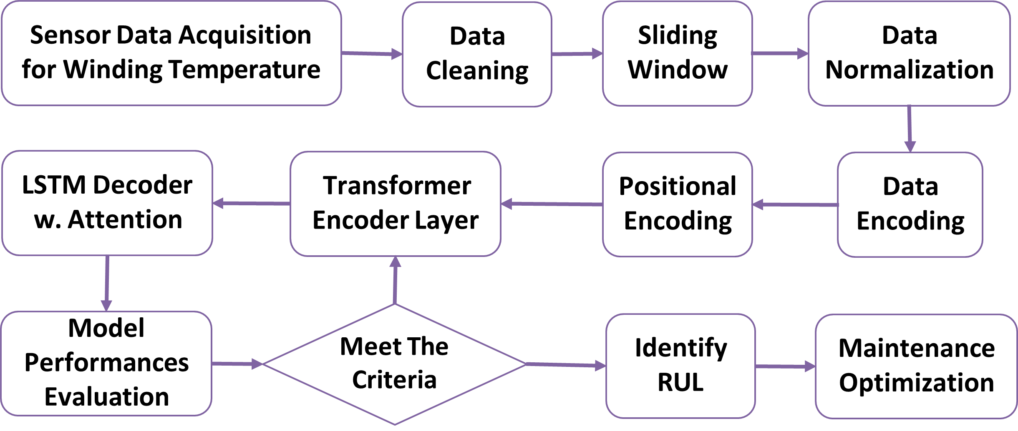

Figure 3. A framework of TE-LSTM for
Winding Temperature Prediction
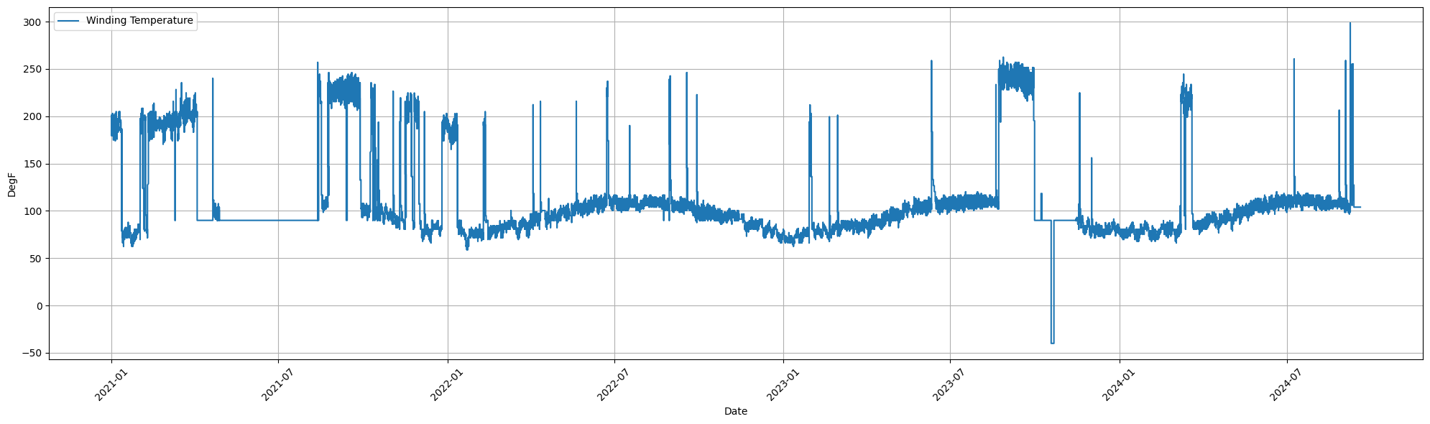
- Input Data and Encoding: The actual temperature data of the induction motors were represented as a time-series sequence. This is a very common use of positional encoding because it preserves the order or sequence such that the model understands the time aspect of data.

Figure 4. Winding temperature of Motor A (4.16 kV, 470HP) from 1/1/2021 to 31/12/2024

- The Transformer Encoder: The encoder takes the input sequence and processes it with multiple attention heads to model long-range dependencies in the temperature data. This allows the model to remember past sensor readings when predicting future temperatures.
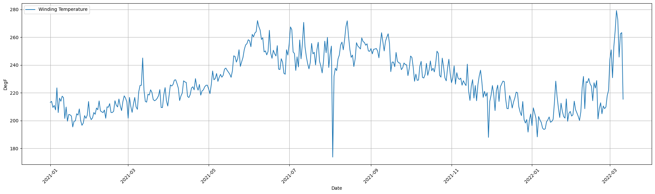
- LSTM Decoder with Attention: The LSTM decoder reads the encoded sequence and pays attention to both short-term and long- and short trends inside it. The attention mechanism provides additional context to the LSTM calculated by weighing the critical time steps; thus, the LSTM can be used to make more accurate temperature predictions.

Figure 5. Winding temperature of Motor B (4.16 kV, 600 HP)

- Predictions: This is the last step in which a prediction of temperature is made for the next step so that it can be checked whether it approaches alarm levels H and HH.
This hybrid approach leverages the benefits of Transformer and LSTM architectures, allowing better capture of long-term dependencies and short-term patterns in the temperature data, which can help a model produce improved models for predicting winding temperatures in induction motors. In this study, data from two motors were collected. Both motors were specified with a voltage level of 4.16 kV, 3 phase, 60 Hz, asynchronous motor, for which Motor A power output was 470 HP and Motor B was 600 HP. Motor A data were collected between January 2021 and September 2024. This resulted in over two million data points per motor, which were recorded at 1-min intervals. Motor B, data were collected for a daily average and resulted in fewer data points (around 700 data points).
Two methods were used to handle NaNs: replacement with a fixed value of 90°F and removal of affected data’s. The replacement value of 90°F was chosen because during periods when the motor was not in operation, the winding temperature stabilized around 90°F while the motor’s space heater was still in operation. The data were then normalized using both Z-Score and Min-Max normalization techniques, and the dataset was split into training (90%) and testing (10%) sets.

BUILDING THE MODEL
The Transformer and Long Short-Term Memory (LSTM) models are foundational deep learning architectures used in time-series forecasting and sequence modeling. Transformer architecture was introduced by Vaswani et al. (2017) and revolutionized sequence modeling by removing the need for recurrent connections in traditional sequence models like RNNs and LSTMs. In contrast, transformer models rely on self-attention mechanisms, which allow a model to attend to all positions in the sequence simultaneously. This allows the model to capture the global dependencies between the input and output sequences.

TRANSFORMER MODEL
In the context of temperature prediction for induction motors, transformers excel at capturing long-range dependencies in sensor data, which is crucial for accurate temperature prediction. Below is the sequence of building the models:
- Data Encoding: The preprocessed data are converted into tensors for efficient processing by the neural network model.
- Positional Encoding: Position information is embedded in the input sequence to preserve the temporal context.
- Transformer Encoder Module: The Transformer Encoder module is employed to extract features and patterns from sequential data. The Transformer encoder is a powerful mechanism for learning meaningful representations from time-series data, and its integration is crucial for model success.
- LSTM Decoder with Attention: The transformer output is then processed by an LSTM decoder employing an attention mechanism. This combination allows the model to focus on the relevant input sequences, which enhances its predictive performance.
In model performance evaluation, the loss value is calculated using the mean square error, and optimization was performed to minimize the loss, typically using the Adam optimizer[28]. Finally, the model’s performance was evaluated using the mean absolute error and root mean squared error as key metrics.

LONG SHORT-TERM MEMORY (LSTM)
The LSTM network, introduced by Hochreiter and Schmidhuber (1997), is a type of Recurrent Neural Network (RNN) that addresses the vanishing gradient problem, which hinders the learning of long-range dependencies. LSTM uses gating mechanisms to control the flow of information through the network, enabling it to maintain information over long sequences. The key components of an LSTM unit include:
- Input Gate: This gate controls the information of input data.
- Forget Gate: The gate decides the information to discard from the cell state.
- Memory-cell Gate: The gate updates the cell state with new information.
- Output Gate: This gate determines the output at each time step.
Memory-cell gate in the LSTM helps preserve long-term dependencies, making it suitable for sequence prediction tasks, such as predicting future temperature values based on previous readings. The LSTM's ability to learn temporal dependencies from time-series data complements the Transformer's self-attention mechanism [29]. While the Transformer captures global relationships, the LSTM focuses on learning temporal dynamics, and the combination of both architectures is effective for predicting winding temperatures in induction motors.
HYBRID TE-LSTM MODEL
The TE-LSTM model combines the Transformer’s global attention mechanism with LSTM’s strength relative to learning sequential dependencies. The proposed hybrid model is particularly useful for time-series data because understanding both long-term dependencies and short-term trends is crucial for accurate forecasting. The overview of the proposed model architecture is described as follows:
The model takes as input time-series data, i.e., the winding temperature readings of the induction motors. Positional Encoding is to encode the token embedding into positional embedding in order to help the transformer-encoder model aware with the sequence order by following formula below [18].

$$PE\left(pos,2i\right)=sin\left(\frac{pos}{{10000}^{\frac{2i}{d_{\text{model}}}}}\right)$$
$$PE\left(pos,2i+1\right)=cos\left(\frac{pos}{{10000}^{\frac{2i}{d_{\text{model}}}}}\right)$$
with pos is the position, i is the dimension and $d_{\text{model}}$ is the model size.
Positional embeddings are fed through the layers of encoder. Each layer applies Self-Attention and Feedforward layers to extract useful patterns from the data. Transformer-Encoder Block: The core of the Transformer is its self-attention mechanism, which computes attention scores for each pair of elements in a sequence. This allows the model to weigh the importance of each element in the sequence when making predictions. Mathematically, the self-attention mechanism can be defined as follows[30]:
$$\text{Attention}\left(Q,K,V\right)=\text{softmax}\left(\frac{QK^{T}}{\sqrt{d_{k}}}\right)V$$
with:
$Q$ represents the query matrix, and
$K$ is the key matrix, and
$V$ is the value matrix, and
$d_{k}$ is the dimension of matrix $K$.
This mechanism allows the Transformer-Encoder to focus on different parts of the input sequence depending on the importance of each part, which makes it highly effective for time-series forecasting. LSTM decoder with attention mechanism: The output from the transformer encoder is input to the LSTM_decoder. The concept behind the LSTM block, which specifically focuses on capturing the temporal dependencies in the teh data and attention mechanism, is that they can look back to relevant time stamps, which facilitate better predictions. Learn attention scores with linear layers + tanh between the Recognition Exception squad. Output Layer: Finally, the LSTM decoder produces predictions of the temperature for the next step in accordance with the learned temperature from the prior steps. TE-LSTM combines the Transformer-Encoder with global attention mechanism with LSTM to allow learning from sequential dependencies.
METRIC EVALUATION AND PERFORMANCE
The Mean Squared Error (MSE) loss function is used to evaluate model performance during training. The MSE is defined as follows [31]:

$$MSE=\frac{1}{n}\sum_{i=1}^{n}{{\left(y_{i}-{\hat{y}}_{i}\right)}^{2}}$$

with $y_{i}$ is the true temperature value and ${\hat{y}}_{i}$ is the predicted value. The lower the MSE value, the better the model performance. The Adam optimizer is implemented to update the model parameters as it computes adaptive learning rates for each parameter, thus ensuring that gradients with noisy signal don't affect our models training [28].

REMAINING USEFUL LIFETIME STEPS
The model is trained using a time-series dataset with 90% allocation for training and 10% for testing. The trained model could predict when critical temperature thresholds (H and HH alarms) would be reached, providing valuable information for proactive maintenance decisions. To calculate the Remaining Useful Lifetime (RUL) of an induction motor based on temperature thresholds, this study considers early warning (EW) temperatures of 257°F and failure temperatures of 285°F. The TE-LSTM model was used to predict the RUL of the induction motors. The critical temperature ranges for the induction motor are early warning (257°F) and failure (285°F. The 28°F difference represents the range at which the motor lifespan rapidly decreases. By implementing this advanced predictive maintenance technique, industries can more accurately estimate the RUL of induction motors, optimize maintenance schedules, and prevent unexpected failures. Figure 1 shows the TE-LSTM winding temperature prediction methodology.
The model is trained using a time-series dataset with 90% allocation for training and 10% for testing. The trained model could predict when critical temperature thresholds (H and HH alarms) would be reached, providing valuable information for proactive maintenance decisions. To calculate the Remaining Useful Lifetime (RUL) of an induction motor based on temperature thresholds, this study considers early warning (EW) temperatures of 257°F and failure temperatures of 285°F. The TE-LSTM model was used to predict the RUL of the induction motors. Critical temperatures are possible overheating or typical operation.

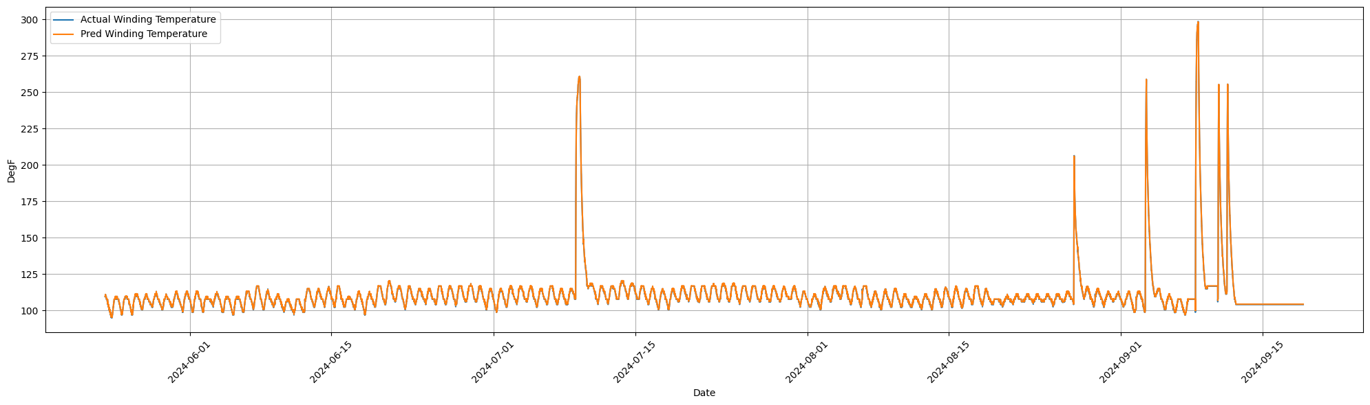
Figure 6. Winding Temperature Estimation according to Motor A 470 HP, 4.16 kV, 3P, and 60 Hz from TE-LSTM.

DISCUSSION AND RESULT

Model prediction, the TE-LSTM model was also evaluated. The model's predictions were highly accurate for both early and failed failure detection. The graphs depict the performance of the two motors, highlighting the strengths and limitations of the predictive models. The predicted winding temperature (orange line) for Motor A generally matches the actual winding temperature (blue line) throughout the period, demonstrating the model’s proficiency in tracking overall temperature trends. Nonetheless, discrepancies in the magnitude and timing of significant temperature spikes are noted, especially in early July and mid-September. The motor usually operates within 100°F to 125°F, but spikes above 275°F indicate possible overheating or atypical operation. The TE-LSTM model for Motor B demonstrated its ability to capture the overall temperature trends, closely following the actual winding temperature variations from early February to mid-March. The actual temperature fluctuated rapidly between 200°F and 275°F, and the model effectively predicted these changes, although with a smoother profile. These results that the Transformer-LSTM model successfully identified the underlying temperature patterns; however, further tuning is required to enhance the model’s responsiveness to sharp temperature fluctuations. Validating thermal models under operational conditions has been a focus of prior research, highlighting the importance of accurate winding temperature prediction for optimizing machine performance. In summary, although the models exhibit strengths in tracking general temperature trends, the observed discrepancies in the spike magnitudes and sharp variations indicated areas for model refinement.
The TE-LSTM model's predictions closely mirror the actual winding temperature curve, although it has a less erratic profile. The actual temperature fluctuates swiftly between 200°F and 275°F, and although the model accurately forecasts these variations, it might benefit from additional adjustments to more accurately reflect these abrupt changes. Researchers have emphasized the importance of precise winding temperature prediction for fully exploiting motor performance, as well as the need for validating thermal models under operative conditions to ensure their efficacy. The Transformer-LSTM model's ability to track overall temperature trends is commendable; further tunning might be necessary to enhance the accuracy
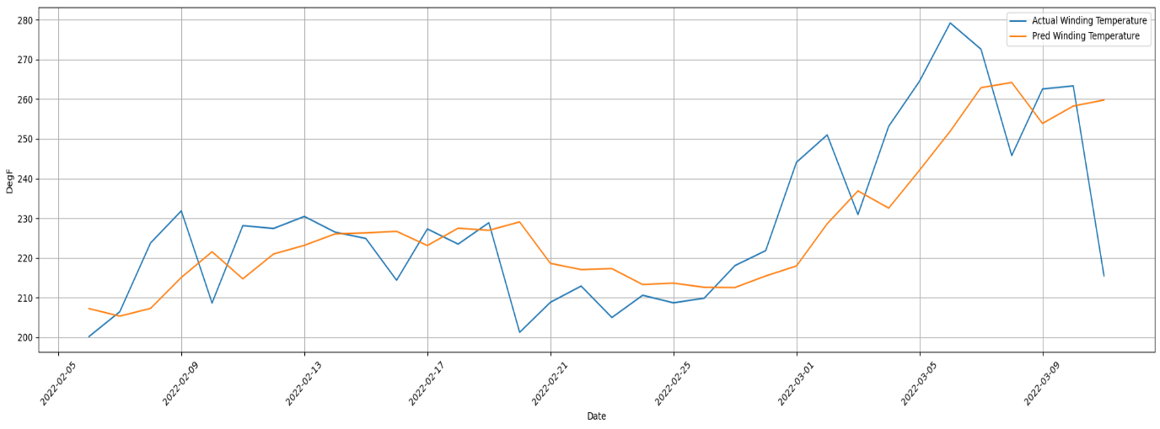

Figure 7. Winding Temperature Estimation of Motor B for 600 HP, 4.16 kV, 3P, and 60 Hz from TE-LSTM.

The TE-LSTM model for Motor B demonstrated its ability to capture the overall temperature trends, closely following the actual winding temperature variations from early February to mid-March. The actual temperature fluctuated rapidly between 200°F and 275°F, and the model effectively predicted these changes, although with a smoother profile. These results show that the Transformer-LSTM model successfully identified the underlying temperature patterns; however, further tuning is required to enhance the model’s responsiveness to sharp temperature fluctuations. Validating thermal models under operational conditions has been a focus of prior research, highlighting the importance of accurate winding temperature prediction for optimizing machine performance. In summary, although the models exhibit strengths in tracking general temperature trends, the observed discrepancies in the spike magnitudes and sharp variations indicated areas for model refinement.
The TE-LSTM model's predictions closely mirror the actual winding temperature curve, although it has a less erratic profile. The actual temperature fluctuates swiftly between 200°F and 275°F, and although the model accurately forecasts these variations, it might benefit from additional adjustments to more accurately reflect these abrupt changes. Researchers have emphasized the importance of precise winding temperature prediction for fully exploiting motor performance, as well as the need for validating thermal models under operative conditions to ensure their efficacy. The Transformer-LSTM model's ability to track overall temperature trends is commendable; further tuning might be necessary to enhance accuracy.
PERFORMANCE EVALUATION
The root mean square error of Motor B was 15.12, reflecting the error margin between the predicted and actual temperature values or performance degradation over time The RMSE is commonly used to assess prediction model accuracy, with lower values indicating better fitting between predicted and observed data. The estimated failure date for Motor B was March 7, 2022, whereas the actual failure occurred on March 5, 2022, resulting in a Remaining Useful Life error of 2 days. This implies that the model slightly underestimated the failure time, predicting that it would occur two days later than it did. Accurate estimation of the RUL is crucial for predictive maintenance strategies that optimize equipment use and minimize downtime.

Table 2. Metric Evaluation Models for Motors A and B
Motor | Number of data points | RMSE
A | 2073000 | 0.33
B | 700 | 15.12
Motor A had a significantly lower RMSE than Motor B. This indicates that the predictions for Motor A were closer to the actual values, resulting in better performance and accuracy. Motor B's higher RMSE indicates larger discrepancies between the predicted and actual values, indicating less accurate predictions. More data training and testing also enhance model accuracy
REMAINING USEFUL LIFETIME PREDICTION RESULTS
In this part, we predict the RUL of Motors A and B using the proposed model. The evaluation is based on the root mean square error which can be used for determining the performance and reliability of the predictive models. For Motor B, the predicted failure date was March 7, 2022; however, the actual failure occurred on March 5, 2022, resulting in an RUL error of 2 days. The prediction Motor B's remaining useful life is underestimated because the failure occurred sooner than expected. In contrast, the prediction for Motor A was spot-on, with an estimated failure date of July 9, 2024, which perfectly aligned with the actual failure date, resulting in an RUL error of 0 days. These results have significant implications for maintenance planning and risk management. The slight underestimation for Motor B could affect the maintenance scheduling and introduce risks if the equipment is not promptly serviced or replaced. On the flip side, the precise prediction for Motor A indicates a highly reliable model for RUL estimation, which can facilitate proactive maintenance strategies and improve system reliability.
Accurate prediction of the RUL is vital for machinery health management, as it enables optimization of the maintenance schedules and reduces the risk of unforeseen failures. Research in degradation modeling and RUL prediction for competing failure processes has aimed at developing analytical expressions for RUL estimation and tackling the challenges of offline estimation and online parameter updating. The accuracy of the RUL predictions is impacted by the amount of data collected. Predicting the remaining useful life of the machine is crucial for safe and efficient operation.

CONCLUSION
A hybrid Transformer-Encoder with an LSTM architecture (TE-LSTM) considerably improved the temperature alarm prediction of induction motors. This hybrid deep learning model can also predict motor and other equipment performance of assets, which helps change maintenance strategies from reactive to proactive—reducing unplanned downtime while boosting operational effectiveness. This model is very useful in the oil and gas industry because it mitigates frequent motor failures, which helps to increase reliability, maintain production uptime, and reduce operational costs.

FUTURE DISCUSSION
Despite these advancements, several research gaps remain in the field of maintenance strategies.Most studies are focused on either static environments or predetermined damage intervals, which cannot be used in real-world dynamic situations. Future studies should better incorporate IoT device-operated real-time information to gain an accurate and necessary understanding of ICT system health. The addition of deep learning capabilities to TE-LSTM means that it can be used in larger industrial systems, resulting in better optimization of maintenance schedules based on prior research. Many predictive maintenance models I have seen and worked on focus on a single part; however, in the real world, it is not that simple since sometimes we are dealing with multi-component systems. Further research is required on multi-component systems with interdependence, which require sophisticated time-based maintenance scheduling strategies. Resource constraint integration: There seems to be little exploration into integrating resource constraints (e.g. a constrained maintenance budget and workforce) with dynamic types of maintenance. To summarize, these areas can form the foundation for an integrated decision-making framework that will assist in creating sustainable, efficient industrial-based preventive strategies.

REFERENCES
[1] A. Glowacz, M. Sulowicz, J. Zielonka, Z. Li, W. Glowacz, and A. Kumar, “Acoustic fault diagnosis of three-phase induction motors using smartphone and deep learning,” Expert Syst Appl, vol. 262, Mar. 2025, doi: 10.1016/j.eswa.2024.125633.
[2] S. Lv, S. Liu, H. Li, Y. Wang, G. Liu, and W. Dai, “A hybrid method combining Lévy process and neural network for predicting remaining useful life of rotating machinery,” Advanced Engineering Informatics, vol. 61, Aug. 2024, doi: 10.1016/j.aei.2024.102490.
[3] P. V. Jover Rodríguez and A. Arkkio, “Detection of stator winding fault in induction motor using fuzzy logic,” Applied Soft Computing Journal, vol. 8, no. 2, pp. 1112–1120, Mar. 2008, doi: 10.1016/j.asoc.2007.05.016.
[4] G. Abdelmadjid, B. S. Mohamed, T. Mohamed, S. Ahmed, and M. Youcef, “An improved stator winding fault tolerance architecture for vector control of induction motor: Theory and experiment,” Electric Power Systems Research, vol. 104, pp. 129–137, 2013, doi: 10.1016/j.epsr.2013.06.023.
[5] A. Glowacz, “Thermographic fault diagnosis of electrical faults of commutator and induction motors,” Eng Appl Artif Intell, vol. 121, May 2023, doi: 10.1016/j.engappai.2023.105962.
[6] N. Rama Devi, D. V S S Siva Sarma, and P. V Ramana Rao, “Diagnosis and Classification of Stator Winding Insulation Faults on a Three-phase Induction Motor using Wavelet and MNN”, doi: 10.1109/TDEI.2016.005576.
[7] L. Zheng, Y. He, X. Chen, and X. Pu, “Optimization of dilated convolution networks with application in remaining useful life prediction of induction motors,” Measurement (Lond), vol. 200, Aug. 2022, doi: 10.1016/j.measurement.2022.111588.
[8] A. K. Mahamad, S. Saon, and T. Hiyama, “Predicting remaining useful life of rotating machinery based artificial neural network,” in Computers and Mathematics with Applications, Aug. 2010, pp. 1078–1087. doi: 10.1016/j.camwa.2010.03.065.
[9] H. C. Chuang, G. De Li, and C. T. Lee, “The efficiency improvement of AC induction motor with constant frequency technology,” Energy, vol. 174, pp. 805–813, May 2019, doi: 10.1016/j.energy.2019.03.019.
[10] N. Arish, M. Ardestani, and A. Hekmati, “Optimum Structure of Rotor Slot for a 20 kW HTS Induction Motor,” Physica C: Superconductivity and its Applications, vol. 582, Mar. 2021, doi: 10.1016/j.physc.2021.1353829.
[11] Y. Shi et al., “A new preventive maintenance strategy optimization model considering lifecycle safety,” Reliab Eng Syst Saf, vol. 221, May 2022, doi: 10.1016/j.ress.2022.108325.
[12] M. Seera, C. P. Lim, D. Ishak, and H. Singh, “Offline and online fault detection and diagnosis of induction motors using a hybrid soft computing model,” Applied Soft Computing Journal, vol. 13, no. 12, pp. 4493–4507, 2013, doi: 10.1016/j.asoc.2013.08.002.
[13] P. Gangsar and R. Tiwari, “Signal based condition monitoring techniques for fault detection and diagnosis of induction motors: A state-of-the-art review,” Oct. 01, 2020, Academic Press. doi: 10.1016/j.ymssp.2020.106908.
[14] Y. Lv, F. Fang, T. Yang, and C. E. Romero, “An early fault detection method for induced draft fans based on MSET with informative memory matrix selection,” ISA Trans, vol. 102, pp. 325–334, Jul. 2020, doi: 10.1016/j.isatra.2020.02.018.
[15] J. Arts, R. N. Boute, S. Loeys, and H. E. van Staden, “Fifty years of maintenance optimization: Reflections and perspectives,” 2024, Elsevier B.V. doi: 10.1016/j.ejor.2024.07.002.
[16] M. H. Enjavimadar and M. Rastegar, “Optimal reliability-centered maintenance strategy based on the failure modes and effect analysis in power distribution systems,” Electric Power Systems Research, vol. 203, Feb. 2022, doi: 10.1016/j.epsr.2021.107647.
[17] Y. Luo, X. Zhao, B. Liu, and S. He, “Condition-based maintenance policy for systems under dynamic environment,” Reliab Eng Syst Saf, vol. 246, Jun. 2024, doi: 10.1016/j.ress.2024.110072.
[18] B. P. Muliatama, I. Mukhlash, M. Iqbal, N. Hidayat, and M. Kimura, “Raw mill Engine Failure Detection from Transformer Gated Convolutional Unit Networks.”
[19] L. Wang, Z. Zhu, and X. Zhao, “Dynamic predictive maintenance strategy for system remaining useful life prediction via deep learning ensemble method,” Reliab Eng Syst Saf, vol. 245, May 2024, doi: 10.1016/j.ress.2024.110012.
[20] O. Das, D. Bagci Das, and D. Birant, “Machine learning for fault analysis in rotating machinery: A comprehensive review,” Jun. 01, 2023, Elsevier Ltd. doi: 10.1016/j.heliyon.2023.e17584.
[21] S. Riaz, A. Saghir, M. J. Khan, H. Khan, H. S. Khan, and M. J. Khan, “TransLSTM: A hybrid LSTM-Transformer model for fine-grained suggestion mining,” Natural Language Processing Journal, vol. 8, p. 100089, Sep. 2024, doi: 10.1016/j.nlp.2024.100089.
[22] J. Shi, S. Wang, P. Qu, and J. Shao, “Time series prediction model using LSTM-Transformer neural network for mine water inflow,” Sci Rep, vol. 14, no. 1, Dec. 2024, doi: 10.1038/s41598-024-69418-z.
[23] J. Supriyono, I. Mukhlash, M. Iqbal, and D. A. Asfani, “Early Warning Forecasting of Large Induction Motor in the Oil and Gas Industry from Deep Learning,” in 2024 IEEE International Symposium on Consumer Technology (ISCT), IEEE, Aug. 2024, pp. 436–442. doi: 10.1109/ISCT62336.2024.10791291.
[24] G. Bilal Yıldız and B. Soylu, “Integrating preventive and predictive maintenance policies with system dynamics: A decision table approach,” Advanced Engineering Informatics, vol. 56, Apr. 2023, doi: 10.1016/j.aei.2023.101952.
[25] J. Peng, D. Shen, T. Nie, and Y. Kou, “RLclean: An unsupervised integrated data cleaning framework based on deep reinforcement learning,” Inf Sci (N Y), vol. 682, Nov. 2024, doi: 10.1016/j.ins.2024.121281.
[26] L. Danay, R. Ramon-Gonen, M. Gorodetski, and D. G. Schwartz, “Evaluating the effectiveness of a sliding window technique in machine learning models for mortality prediction in ICU cardiac arrest patients,” Int J Med Inform, vol. 191, Nov. 2024, doi: 10.1016/j.ijmedinf.2024.105565.
[27] F. T. Lima and V. M. A. Souza, “A Large Comparison of Normalization Methods on Time Series,” Big Data Research, vol. 34, Nov. 2023, doi: 10.1016/j.bdr.2023.100407.
[28] S. K. Purohit and S. Panigrahi, “Novel deterministic and probabilistic forecasting methods for crude oil price employing optimized deep learning, statistical and hybrid models,” Inf Sci (N Y), vol. 658, Feb. 2024, doi: 10.1016/j.ins.2023.120021.
[29] Y. Dai, J. Wei, and F. Qin, “Recurrent neural network (RNN) and long short-term memory neural network (LSTM) based data-driven methods for identifying cohesive zone law parameters of nickel-modified carbon nanotube reinforced sintered nano-silver adhesives,” Mater Today Commun, vol. 39, Jun. 2024, doi: 10.1016/j.mtcomm.2024.108991.
[30] A. Vaswani et al., “Attention Is All You Need.”
[31] Boldea, S Nasar - Electric Power Engineering Series. Taylor & Francis, 2009).

