An Examination of the Fe₃O₄ Nanomaterial Impact in Conjunction with Magnetorheological Elastomer Material | 

Gigih Priyandoko^{1*}, Ubaidillah², Fitrian Imaduddin², Purbo Suwandono³, Muhammad Ilman Nur Sasongko⁴
¹Department of Electrical Engineering, Faculty of Engineering, Universitas Widya Gama Malang, Indonesia
²Department of Mechanical Engineering, Faculty of Engineering, Universitas Sebelas Maret, Indonesia
³Department of Mechanical Engineering, Faculty of Engineering, Universitas Widya Gama Malang, Indonesia
⁴Faculty of Vocational Studies, Universitas Negeri Malang, Indonesia

Abstract  An advanced class of materials that can be used for vibration damping are magnetorheological elastomers (MREs). These materials have the ability to resist vibration perturbations by adjusting the mechanical properties of the material in response to a magnetic field applied from an external source. The purpose of this study is to determine the effect of adding magnetic magnetite (Fe₃O₄) nanomaterials to MREs. Thus, it is expected that this new material will be more sensitive to the magnetic fields. MREs consist of carbonyl iron powder (CIP), silicone oil, and silicone rubber in the ratio of 30%, 5%, and 65%. Magnetite was then added to the MRE at levels of 0.5%, 1%, 1.5%, and 2%. Observations on this new material include the elemental composition of the material and viscoelastic material testing on various compounded formulations in the laboratory. From the test results, it is found that the addition of 0.5% Fe₃O₄ to MRE is the best choice compared to other mix designs because it has the highest delta tangent value with strong damping performance in the frequency range of 1 to 100 Hz.  This is an open access article under the CC BY-NC license   | Keywords:  Smart Material;  Nanomaterial;  Magnetorheological Elastomer;  Magnetite;  Article History:  Received: May 2, 2019  Revised: May 29, 2019  Accepted: June 2, 2019  Published: June 2, 2019  Corresponding Author:  Gigih Priyandoko  Dept. of Electrical Engineering, Universitas Widya Gama Malang, Indonesia  Email: gigih@widyagama.ac.id

INTRODUCTION
Smart materials have been defined as functional substances that are able to sense and respond to a variety of environmental stimuli. These stimuli may include optical, electrical, magnetic, mechanical, thermal, and chemical signals [1]. These materials can significantly change their properties under controlled conditions [2]. The utilization of smart materials has been instrumental in propelling advancements across a diverse array of disciplines, including but not limited to wearable devices, neuromorphic computing, and biomimetic robotics [3]. These materials can be engineered and customized for particular functional applications, with notable examples including shape memory polymers, intelligent liquid metals, and flexible conductive polymers [3]. The aerospace industry has a marked interest in smart materials due to the aforementioned properties that are characteristic of such materials, namely, self-sensing, self-adaptability, and memory capabilities [4]. A wide array of printing methodologies, including inkjet printing and three-dimensional printing, have been employed to manufacture intelligent micro/ nanodevices that utilize smart materials [1]. As research in this field continues to advance, the integration of smart materials is poised to play a pivotal role in the development of a smart society [3].
Magnetorheological elastomers (MREs), a class of advanced materials, are composed of magnetic particles dispersed within an elastomeric matrix. These particles possess a tunable response to applied magnetic fields, resulting in the ability to adjust the mechanical properties of the material [4], [5], [6], [7]. A comprehensive review of the extant literature reveals a substantial corpus of research identifying the significant influences on MRE performance, including the fabrication process, particle type and size, matrix material, and additives [8]. MREs exhibit field-dependent stiffness and damping properties, rendering them suitable for a range of applications, including the use of vibration absorbers, isolators, soft actuators, and sensors [4], [9]. The characteristics of the MRE can be changed by adjusting the strength of the insulator through an external magnetic field created by applying an electric current to the insulator coil. The results of the research show that as the current applied to the isolating coil is increased, the magnetic field is increased and the stiffness of the MRE is increased [6], [7].
Nanomaterials are defined as particles or materials with at least one dimension in the 1-100 nm range [10], [11]. The potential applications of nanomaterials encompass a broad spectrum, ranging from traditional materials and medical devices to electronic components and coatings [12]. Magnetite (Fe₃O₄) magnetic nanoparticles have recently attracted considerable research interest owing to their multifaceted applications. This compound is an iron oxide with magnetic and electrical properties. It is ferrimagnetic. Fe₃O₄ is a magnetic material with a unique set of properties that make it the mineral with the strongest magnetic properties found in nature. Its magnetic properties are influenced by a variety of factors including oxidation level, particle size, and method of synthesizing [13], [14], [15], [16], [17].
The purpose of this research is to investigate the effect of the addition of Fe₃O₄ nanoparticle, which has strong magnetic properties, on MRE. Meanwhile, the MRE commonly researched by the authors is vibration damping. Thus, with the addition of Fe₃O₄ nanomaterial, it is expected that the new MRE will be more sensitive to magnetic fields. This opens up the potential of MRE-based vibration dampers in applications where tunable magnetic fields, which provide tunable stiffness of the MRE, can be used to significantly reduce undesirable vibration.

MATERIAL AND METHODOLOGY
The manufacture of MREs involves the use of multiple materials, including carbonyl iron powder (CIP), silicone oil, and silicone rubber [18], [19], [20], [21], [22]. In the present research, the material mixture of MR elastomer was modified with the addition of Fe₃O₄ nanomaterial. This modified material is henceforth referred to as the new MRE. The procedure for producing new MRE is outlined in Figure 1 and generally encompasses three steps.
Initial steps entail the amalgamation of materials, namely silicone rubber, silicone oil, micrometer-sized iron carbonyl magnetic particles (CIPs), and Fe₃O₄ nanomaterial. The percentage by weight for each of the materials can be found in Table 1.

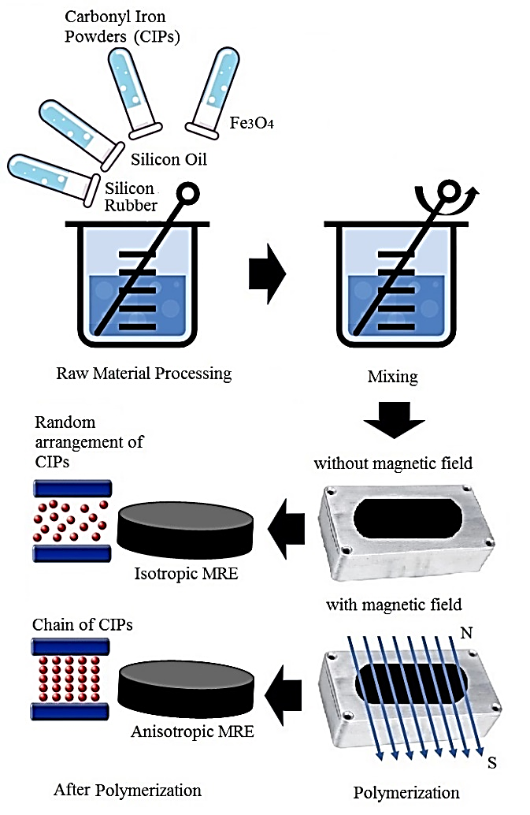
Figure 1. The Step-by-step new MRE Fabrication

Table 1. The Weight Percentage for Each Material
Name | Silicone oil | Silicone rubber | CIPs | Fe₃O₄
MRE-1 | 5% | 65% | 30% | 0%
MRE-2 | 5% | 65% | 29.5% | 0.5%
MRE-3 | 5% | 65% | 29% | 1.0%
MRE-4 | 5% | 65% | 28% | 2.0%

The first step in developing new MREs is to select the right materials. The materials of choice are CIPs, a low magnesium and manganese compound from Sigma-Aldrich. Silica oil Dow Coring Corporation 200® liquid with a viscosity of 60,000 cSt (25 ºC) was supplied by Sigma-Aldrich. Sigma-Aldrich. Permatex provided transparent RTV (100% silicone rubber). Stirring is carried out at room temperature. The subsequent step involves the incorporation of CIP into the polymer matrix, a process that occurs during the stirring procedure, resulting in the presence of air bubbles. It is imperative to eliminate the air bubbles in the new MRE sample. The final step entails the transfer of the mixture's outcomes from the preceding steps into a mold of a designated size. The mold is then left for a duration of several hours to facilitate the hardening of the sample. Subsequently, the mold is filled with the sample material mixture and polymerized for 2-3 hours at elevated temperatures (200-500 ⁰C). At ambient temperature, the polymerization is continued for up to 24 hours [19], [20], [23], [24], [25].
The classification of the new MRE samples is based on the observed particle distribution and subsequent analysis of the resulting architectures. In the case of the isotropic type, the particles are arranged in a random pattern, while in the anisotropic type, the arrangement of the particles occurs in a chain configuration. The occurrence of anisotropy arises due to the polymerization process, specifically in the final stage, when a magnetic field is applied to the composite matrix, leading to the alignment of the iron particles in the sample. Conversely, the isotropic form arises in the absence of an external magnetic field during the polymer hardening process, resulting in a random and irregular arrangement of the iron particles within the sample. The dimensions of the MRE used in this study can be seen in Figure 2, where the diameter is 3 cm and the thickness is 0.5 cm.

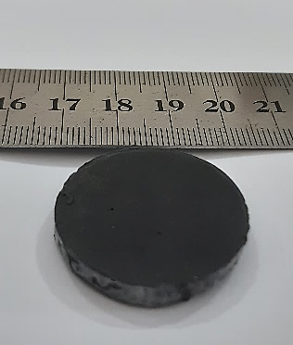
Figure 2. The Dimension of new MRE Sample

After obtaining the shape and dimensions of the new MRE sample, several sample tests will be carried out. First, the test has been employed to explore the morphological properties of isotropic new MRE. A scanning electron microscope SEM-EDX (Scanning Electron Microscope-Energy Dispersive X-ray Spectroscopy) is used to take high-resolution images of a sample's surface and analyze its elemental composition.
Viscoelastic materials have two main components of modulus: Storage modulus, which indicates the ability of the material to store elastic energy. Loss modulus, which indicates the energy lost as heat due to internal friction within the material. The higher the loss modulus, the more energy is absorbed and lost as heat. If the loss modulus increases with temperature, the material is likely to undergo viscoelastic relaxation or phase transition (e.g. glass transition in polymers). The ratio of loss modulus to storage modulus is called tan δ (damping factor), which indicates how effective the material is at damping mechanical energy. The second test uses the TA Instrument DHR1 Rheometer is an instrument that is used to determine the rheological properties of a sample in response to a given force. The loss modulus, storage modulus, and tan δ (damping factor) of the material are measured in this research.

RESULTS AND DISCUSSION
Microstructures of new MRE have been observed by SEM mainly regarding magnetic particle dispersion in the matrix. Typically, NEW MRE samples were first cut perpendicular to the disk surface after immersion in liquid nitrogen before SEM observation. In addition, energy dispersive X-ray spectroscopy (EDAX) with Fe-mapping image analysis was used to characterize the orientation of the magnetic particles within the rubber matrix. The randomly dispersed particles of the various volume fractions of the isotropic new MRE observed by SEM are shown in Figures 3-4. Meanwhile, the weight % and atomic % elemental composition of the isotropic new MRE are listed in Tables 2-3.

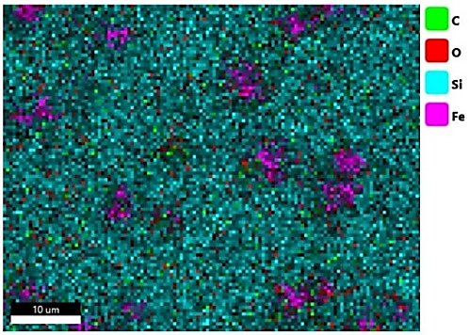
Figure 3. Dispersed Particles of Sample new MRE

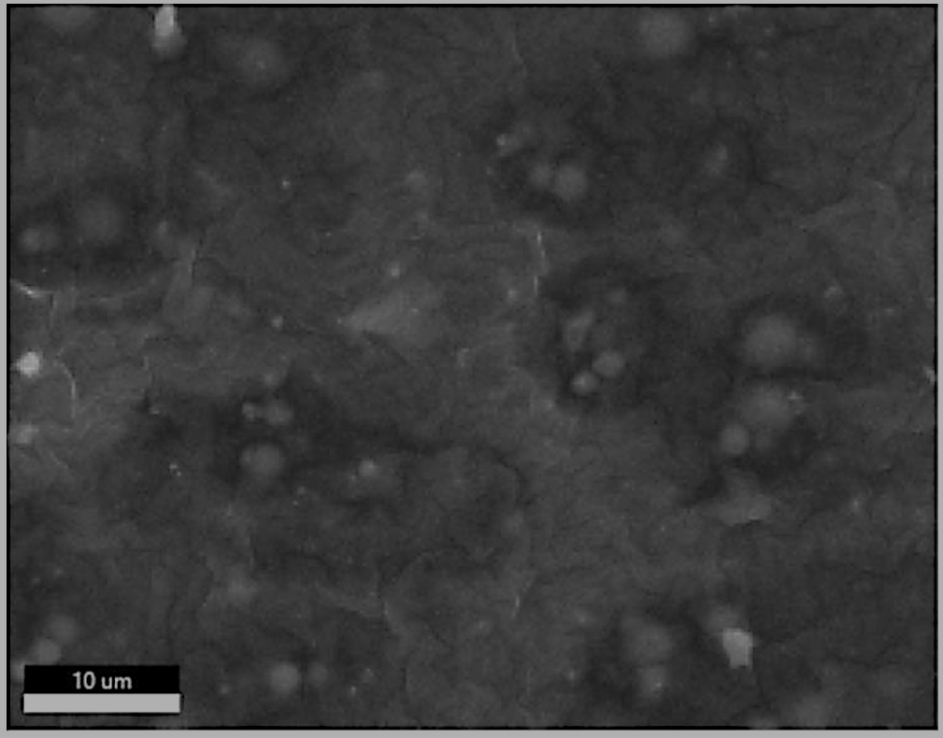
Figure 4. Surface Image of Sample new MRE
Table 2. Elemental Composition Weight %
Element | MRE-1 | MRE-2 | MRE-3 | MRE-4
C | 52.02 | 50.65 | 50.00 | 50.3
O | 25.96 | 30.62 | 25.47 | 23.64
Si | 16.22 | 13.61 | 15.53 | 18.13
Fe | 5.80 | 5.12 | 9.01 | 7.93

Table 3. Elemental Composition Atomic %
Element | MRE-1 | MRE-2 | MRE-3 | MRE-4
C | 65.28 | 62.88 | 64.36 | 64.90
O | 24.45 | 28.53 | 24.60 | 22.90
Si | 8.70 | 7.22 | 8.54 | 10.00
Fe | 1.57 | 1.37 | 2.49 | 2.20

Based on Tables 2-3, several patterns of compositional change were observed. Carbon (C) remained relatively stable at about 50-52% in all samples, indicating that it is the major component. Oxygen (O) showed an increase in MRE-2, followed by a slight decrease in MRE-3 and MRE-4, indicating increased oxidation in MRE-2. Silicon (S) content decreased slightly in MRE-2, but increased again in MRE-3 and MRE-4, indicating variation in silica content between samples. Iron (Fe) content showed a slight decrease from MRE-1 to MRE-4, which may be due to the addition of Fe₃O₄ causing a redistribution of iron in the material. Overall, the changes in elements observed were relatively small with no significant trends. The most notable changes were in oxygen and iron, possibly related to the modifications made in each sample.
As shown in Table 2-3, there is a decrease in weight % from MRE-1 to MRE-3. Carbon experienced a slight decrease from 52.02% to 50.00% in MRE-3. This could be due to the increase of other elements such as oxygen (O) and silicon (Si). In MRE-4, carbon increased slightly back to 50.30%, suggesting that the modification performed may not have significantly changed the carbon content. Although the weight % of carbon decreased slightly, the atomic percentage remained high (62.88% - 65.28%). This indicates that although the mass of carbon is slightly reduced, the proportion of carbon atoms is still dominant in the material structure. It can be concluded that carbon remains the dominant element in all samples. The decrease in weight % may be compensated by the increase in other elements such as oxygen and silicon. The relatively stable Atomic % indicates that changes in the mass distribution are more significant than changes in the number of carbon atoms.
The results for the second test use the TA Instrument DHR1 Rheometer is an instrument that is used to determine the rheological properties of a sample in response to a given force are shown in Figures 5-7, they are storage modulus, loss modulus, and tan δ (damping factor) of the material.

Figure 5. Storage Modulus

Figure 6. Loss Modulus

Figure 7. Tan δ
Based on the Storage modulus, Loss Modulus, and Tan δ data shown in Figures 5-7, MRE-1 performance has variable tan delta values, with maximum values at low frequencies (217,869 at 1,167 Hz). It shows good attenuation at low frequencies. MRE-2 performance has the highest tan delta at mid-frequencies (242,524 at 1,167 Hz), indicating strong damping potential. It is shown effective at absorbing energy in this frequency range. MRE-3 performance has the lowest tan delta at most frequencies, indicating less attenuation and less effectiveness in vibration-damping applications. MRE-4 performance has a fairly good tan δ but degrades at high frequencies. It has shown that can still perform well in damping, but not as effective as MRE-2. For vibration damping in the 1-100 Hz frequency range, MRE-2 is the best choice as it has the highest tan δ at intermediate frequencies, indicating strong damping capability. MRE-1 also performs well at low frequencies. MRE-4 is still viable, but less optimal than MRE-2. MRE-3, with the lowest value, is not recommended for this application. Therefore, for effective vibration-damping applications in this frequency range, MRE-2 should be selected as the primary material.

CONCLUSION
It can be concluded from this research that an MRE add the Fe₃O₄ nanomaterial has been created. For vibration damping in the 1-100 Hz frequency range: MRE-2 is the best choice as it has the highest tan delta value and strong damping performance at intermediate frequencies. MRE-1 is also an excellent choice with high stiffness and good damping capability. MRE-4 is still feasible, but less optimal than MRE-1 and MRE-2. MRE-3, with the lowest tan delta and storage modulus values, is not recommended for this application. Therefore, for optimum vibration damping applications in the 1-100 Hz frequency range, MRE-2 should be selected as the primary material, followed by MRE-1 as an excellent alternative.

ACKNOWLEDGMENT
The authors intend to express their warmest appreciation towards the Ministry of Research, Technology, and Higher Education, the Republic of Indonesia, for their full support in this research through the DRTPM research grant under the Fundamental Research scheme, Universitas Widya Gama Malang, Indonesia.

REFERENCES
[1] M. Su and Y. Song, “Printable smart materials and devices: strategies and applications,” Chemical reviews, vol. 122, no. 5, pp. 5144–5164, 2021.
[2] T. Ramakrishnan et al., “Recent developments in stimuli responsive smart materials and applications: an overview,” Journal of Nanomaterials, vol. 2022, no. 1, p. 4031059, 2022.
[3] W. Hu, H. Zhang, K. Salaita, and H. Sirringhaus, “SmartMat: Smart materials to Smart world,” SmartMat, vol. 1, no. 1, 2020.
[4] A. A. Basheer, “Advances in the smart materials applications in the aerospace industries,” Aircraft Engineering and Aerospace Technology, vol. 92, no. 7, pp. 1027–1035, 2020.
[5] V. G. Kamble, J. Thimmaiah, and S. Kolekar, “Magneto-sensitive elastomers–materials, fabrication, and characterisation: state of the art,” Emerging Materials Research, vol. 13, no. 3, pp. 262–288, 2024.
[6] G. Priyandoko, P. Suwandono, M. I. N. Sasongko, U. Ubaidillah, and S. T. Wicaksono, “Developing adjustable stiffness for smart material of magnetorheological elastomer to diminish vibration,” Sinergi, vol. 28, no. 1, p. 163, Dec. 2023, doi: 10.22441/sinergi.2024.1.016.
[7] G. Priyandoko, F. Hunaini, F. Imaduddin, U. Ubaidillah, P. Suwandono, and M. I. N. Sasongko, “Development of a Vibration Isolator on the Basis of a Magneto-Rheological Elastomer,” Adv. Sci. Technol. Res. J., vol. 18, no. 8, pp. 272–280, Dec. 2024, doi: 10.12913/22998624/194441.
[8] S. S. Kang, K. Choi, J.-D. Nam, and H. J. Choi, “Magnetorheological elastomers: Fabrication, characteristics, and application,” Materials, vol. 13, no. 20, p. 4597, 2020.
[9] A. Saber and R. Sedaghati, “The Modeling of Magnetorheological Elastomers: A State‐of‐the‐Art Review,” Advanced Engineering Materials, vol. 25, no. 16, p. 2300182, 2023.
[10] M. Fabbiani, F. Cesano, F. Pellegrino, and C. Negri, “Design, Characterization and Applications of Functional Nanomaterials,” Molecules, vol. 26, no. 23, p. 7097, 2021.
[11] N. Baig, I. Kammakakam, and W. Falath, “Nanomaterials: A review of synthesis methods, properties, recent progress, and challenges,” Materials advances, vol. 2, no. 6, pp. 1821–1871, 2021.
[12] Q. Wu, W. Miao, Y. Zhang, H. Gao, and D. Hui, “Mechanical properties of nanomaterials: A review,” Nanotechnology Reviews, vol. 9, no. 1, pp. 259–273, 2020.
[13] L. Wang et al., “Electromagnetic Absorption by Magnetic Oxide Nanomaterials: A Review,” ACS Applied Nano Materials, vol. 6, no. 24, pp. 22611–22634, 2023.
[14] A. Khalid, R. Ahmed, M. Taha, and T. Soliman, “Fe3O4 nanoparticles and Fe3O4@ SiO2 core-shell: synthesize, structural, morphological, linear, and nonlinear optical properties,” Journal of Alloys and Compounds, vol. 947, p. 169639, 2023.
[15] Y.-J. Hsiao, Y. Nagarjuna, C.-A. Tsai, and S.-C. Wang, “High selectivity Fe3O4 nanoparticle to volatile organic compound (VOC) for MEMS gas sensors,” Materials Research Express, vol. 7, no. 6, p. 065013, 2020.
[16] S. Liu, B. Yu, S. Wang, Y. Shen, and H. Cong, “Preparation, surface functionalization and application of Fe3O4 magnetic nano-particles,” Advances in colloid and Interface Science, vol. 281, p. 102165, 2020.
[17] H. Ren et al., “Recent Advances in the Application of Magnetite (Fe3O4) in Lithium-Ion Batteries: Synthesis, Electrochemical Performance, and Characterization Techniques,” Chemistry of Materials, vol. 36, no. 19, pp. 9299–9319, 2024.
[18] N. S. Sobri, D. Rajandran, K. Hudha, N. A. Haniffah, Z. Abd Kadir, and M. S. Rahmat, “Isotropic And Anisotropic Polarizations of Magnetorheological Elastomer,” Zulfaqar Journal of Defence Science, Engineering & Technology, vol. 6, no. 1, 2023.
[19] A. K. Bastola and M. Hossain, “A Review on Magneto-Mechanical Characterizations of Magnetorheological Elastomers,” Composites Part B: Engineering, vol. 200, p. 108348, Nov. 2020, doi: 10.1016/j.compositesb.2020. 108348.
[20] S. R. Kumbhar, S. Maji, and B. Kumar, “Automotive Vibration and Noise Control using Smart Materials: A State of Art and Challenges,” World Journal of Engineering, vol. 11, no. 4, pp. 413–420, Aug. 2014, doi: 10.1260/1708-5284.11.4.413.
[21] Z. Chen et al., “Investigation of a new metamaterial magnetorheological elastomer isolator with tunable vibration bandgaps,” Mechanical Systems and Signal Processing, vol. 170, p. 108806, 2022.
[22] X. B. Nguyen, T. Komatsuzaki, and H. T. Truong, “Novel semiactive suspension using a magnetorheological elastomer (MRE)-based absorber and adaptive neural network controller for systems with input constraints,” Mechanical Sciences, vol. 11, no. 2, pp. 465–479, 2020.
[23] D. Lin, F. Yang, D. Gong, and R. Li, “A new vibration isolator integrating tunable stiffness-damping and active driving properties based on radial-chains magnetorheological elastomer,” Mechanical Systems and Signal Processing, vol. 183, p. 109633, 2023.
[24] C. Liu, M. Hemmatian, R. Sedaghati, and G. Wen, “Development and control of magnetorheological elastomer-based semi-active seat suspension isolator using adaptive neural network,” Frontiers in Materials, vol. 7, p. 171, 2020.
[25] S. U. Khayam, M. Usman, M. A. Umer, and A. Rafique, “Development and Characterization of a Novel Hybrid Magnetorheological Elastomer Incorporating Micro and Nano Size Iron Fillers,” Materials & Design, vol. 192, p. 108748, 2020.

