ULTRA BROADBAND MICROSTRIP ANTENNA USED THREE DUMBBELL DEFECTED GROUND STRUCTURE | 

Puji Haryanto¹, Dian Widi Astuti¹, Mudrik Alaydrus¹, Ahmad Firdausi¹
¹Electrical Engineering Department, Universitas Mercu Buana, Indonesia

Abstract  This study focused on enhancing a microstrip antenna's bandwidth operating at 3.5 GHz by incorporating a dumbbell-shaped defected ground structure (DGS). Microstrip antennas are widely used in modern communication systems due to their compact size and low profile, but they typically suffer from narrow bandwidth. To overcome this limitation, the antenna is designed using a Rogers RT5880 substrate (εr = 2.2, thickness = 1.575 mm) and simulated using HFSS 15.0 software. Without the DGS, the antenna exhibits a fractional bandwidth (FBW) of only 1.71%, operating from 3.47 GHz to 3.53 GHz. Including the dumbbell-shaped DGS, the FBW significantly increases to 53.60%, extending the operating range from 2.39 GHz to 4.14 GHz. This substantial improvement is achieved through careful optimization of the DGS parameters. The key contributions of this work are the significant enhancement of FBW and the systematic DGS optimization, resulting in superior antenna performance compared to conventional techniques such as split ring resonators (SRR) and Butler matrix (BM) configurations. Simulation and measurement results show excellent agreement, validating the proposed design. The achieved wideband performance is particularly advantageous for 5G and next-generation communication technologies, offering greater frequency tolerance, support for diverse signal types, increased system capacity, and reliable performance, making the proposed antenna a strong candidate for future wireless applications.  This is an open access article under the CC BY-SA license   | Keywords:  Bandwidth, Microstrip Antenna, DGS, 5G  Article History:  Corresponding Author:  Dian Widi Astuti  Electrical Engineering Department, Universitas Mercu Buana, Indonesia  Email: dian.widiastuti@mercubuana.ac.id

INTRODUCTION
The advent of 5G technology in Indonesia signifies a major advancement in telecommunications, providing enhanced bandwidth and connectivity for various applications. Research on bandwidth enhancement techniques, such as those using DGS in antenna design, has shown significant performance improvements, particularly in supporting high-frequency applications like high-quality video streaming and the Internet of Things (IoT)​. These advancements ensure more efficient and reliable real-time connections, paving the way for innovative wireless communication solutions [1]. Microstrip antennas are widely utilized in wireless communications due to their compact size and cost effective production [2]. However, conventional microstrip antennas often suffer from limitations such as narrow impedance bandwidth and single frequency operation, which restrict their applicability in modern telecommunications [3]​ [4]. To overcome these issues, various bandwidth enhancement techniques have been explored, including the integration of DGS. Research has demonstrated that DGS can significantly improve impedance bandwidth, making microstrip antennas more suitable for advanced wireless applications [5] [6] [7] [8].
This method involves introducing specific defects in the ground plane, which can take different forms such as rectangular, circular, I-shaped, E-shaped, and other geometries​. Research has shown that implementing DGS can effectively improve impedance bandwidth, reduce mutual coupling, and enhance radiation characteristics, making it a valuable approach for modern wireless communication systems [10].
The primary objective in microstrip antenna design is to enhance bandwidth, a critical factor for efficient wireless communication​. With its high design flexibility and the ability to integrate various resonance modes, DGS has emerged as a preferred approach in modern antenna engineering, enabling better efficiency and adaptability for advanced communication systems [11].
The FBW is a crucial parameter in microstrip antennas as it defines the operational frequency range and determines the antenna's adaptability in handling multiple frequency bands. Enhancing FBW is essential for improving antenna performance, particularly in modern communication systems that require wideband operation [12].
Previous research has explored the use of magneto-dielectric (MD) materials, such as FR4 and Rogers RT6006, in combination with advanced resonance techniques to enhance bandwidth​. This approach has successfully achieved a significant increase in FBW, ranging from 10% to 48.67%, demonstrating its effectiveness in improving antenna performance. MD materials provide stable performance because they are homogeneous, while DGS is highly sensitive to the dimensions and patterns of the DGS​. However, despite these advantages, the design process remains complex, requiring precise material selection and structural optimization to achieve the desired bandwidth enhancement [13] [14] ​.
Research utilizing FR4 and Rogers RO4003C substrates, combined with advanced techniques such as the Butler Matrix (BM) method, has shown an improvement in FBW, ranging from 15.83% to 18.46%​. The BM provides precise control over the phase and amplitude distribution of signals, which is essential in phased array systems. In contrast, DGS does not offer this feature due to its passive and structural nature. While this approach enhances antenna performance, the overall bandwidth improvement remains relatively modest​. Additionally, the design process is complex, requiring precise structural and material optimizations to achieve effective bandwidth enhancement [15].
Research utilizing the parasitic element method involved designing and testing two multiple input multiple multiple-output (MIMO) antennas coupled in the H and E planes to validate the proposed concept​ [16]. The parasitic element method is highly effective in enhancing isolation between antenna elements, especially in MIMO configurations. This is difficult to achieve with DGS, which primarily focuses on impedance tuning or bandwidth enhancement. Measurement results indicated that both designs achieved a fractional bandwidth of 14%, operating within the frequency range of 5.0 to 5.8 GHz​. However, despite the successful implementation, the overall bandwidth improvement remains relatively limited, highlighting the need for further optimization in antenna design​.
Research utilizing the hybrid method with DGS at frequencies ranging from 2.47 GHz to 10 GHz has achieved FBW between 3.98% and 14.83%​. The combination of multiple techniques in the hybrid method allows designers to overcome the individual limitations of DGS and tailor antenna performance to meet specific requirements [17] [18] [19] [20] [21]. Additionally, studies incorporating multi-walled carbon nanotube (MWCNT) substrates have demonstrated an FBW of up to 30%, showcasing potential improvements in antenna performance​. However, despite these advancements, the bandwidth enhancement remains relatively modest, and the design process involves a moderate level of complexity​.
Research explored the application of the DGS method to enhance antenna performance, successfully achieving a FBW ranging from 5.09% to 38% across frequencies between 2.4 GHz and 40.9 GHz. While these advancements show promise, the results remain suboptimal when considering the designs implemented. The limitations in performance suggest that further optimization and refinement of the designs are necessary to fully capitalize on the potential of the DGS method [22] [23] [24] [25].
Based on previous research, a microstrip antenna operating at 3.5 GHz for 5G applications has been proposed, utilizing the DGS method to enhance performance. The DGS dumbbell technique is specifically employed to broaden the antenna's bandwidth, addressing limitations identified in earlier studies. This research encompasses the entire process of planning, fabrication, and measurement of the antenna to evaluate its performance and validate the effectiveness of the DGS approach​.
During the antenna design phase, HFSS 15.0 software is utilized for simulations, comparing a conventional microstrip antenna without DGS to a microstrip antenna incorporating DGS. Microstrip antennas are known for their simplicity but often suffer from narrow bandwidth, which this study aims to address. The research focuses on how a dumbbell-shaped DGS can effectively enhance the bandwidth of microstrip antennas operating at 3.5 GHz. The researchers' work builds on previous studies and seeks to improve results in broadening the bandwidth of microstrip antennas by implementing the dumbbell-shaped DGS​.
The following are our contributions:
- Previous studies identified the challenge of narrow bandwidth in conventional microstrip antennas. We developed a microstrip antenna design that incorporates a dumbbell-shaped DGS to expand the antenna's bandwidth, specifically at 3.5 GHz for 5G applications. Simulation results show that the use of the dumbbell DGS successfully increased the FBW from 1.71% to 53.60%, which is much higher than the conventional design. This improvement demonstrates that DGS can overcome the narrow bandwidth issue and provide better performance for modern communication applications.
- We performed optimization of the DGS design parameters, such as the length, width, and height of the dumbbell, to achieve optimal performance in terms of reducing the S₁₁ value and expanding the bandwidth. The optimization results indicate that a dumbbell length of 40 mm, width of 2 mm, and height of 8 mm deliver the best performance, with the lowest S₁₁ value of -33.68 dB and FBW reaching 53.60%. This contribution provides more precise guidelines for designing microstrip antennas with DGS and optimizing their performance for 5G applications.

Material
The microstrip antenna designed in this research uses the Rogers RT5880 substrate, which has a thickness of 1.575 mm and a permittivity of 2.2, offering excellent characteristics for antenna performance. Conventional techniques for enhancing bandwidth, such as SRR, BM, and parasitic elements, are often employed in antenna design. However, these methods tend to offer only marginal improvements or require complex designs, which can limit their practical applicability​.
Previous studies on microstrip antennas with DGS have often failed to fully exploit the potential of specific configurations, such as dumbbell-shaped structures, leaving room for further optimization, especially at 3.5 GHz for 5G applications. This research applies established electromagnetic theory to achieve significant performance improvements, which are rigorously validated through both simulation and measurement. The goal of this study is to design and validate a microstrip antenna with enhanced bandwidth at 3.5 GHz, making it suitable for modern 5G applications, particularly in Indonesia [26] [27] ​.

Conventional Antenna Design
In the initial stage, a conventional antenna design is developed to understand the basic characteristics of microstrip antennas without any additional modifications. This stage involves discussing the conventional antenna design process, focusing on its fundamental design principles and parameters. The performance results from this design are evaluated and used as a reference for subsequent stages of modification aimed at improving antenna performance​.
Figure 1 illustrates the basic design of the microstrip antenna without any additional modifications. This initial design serves as a reference point for evaluating the antenna's performance before any changes are made. Figure 2 presents the frequency performance, as shown by the S₁₁ graph, covering a frequency range of 3.47–3.53 GHz. The graph highlights a main resonant point near 3.5 GHz, where the S₁₁ value is notably low, around -22 dB. This low S₁₁ value indicates that most of the RF (Radio Frequency) power is successfully received by the antenna, with minimal reflection​.

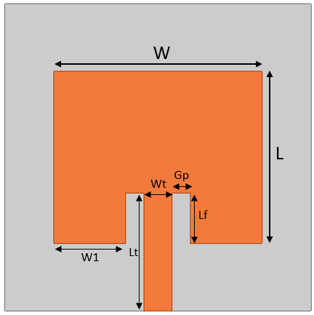

Figure 1 Conventional Antenna Design W = 34 mm, L = 28 mm, W1 = 11.75 mm, Lf = 8.2 mm, Gp = 3 mm, Lt = 19.2 mm, Wt = 4.5 mm
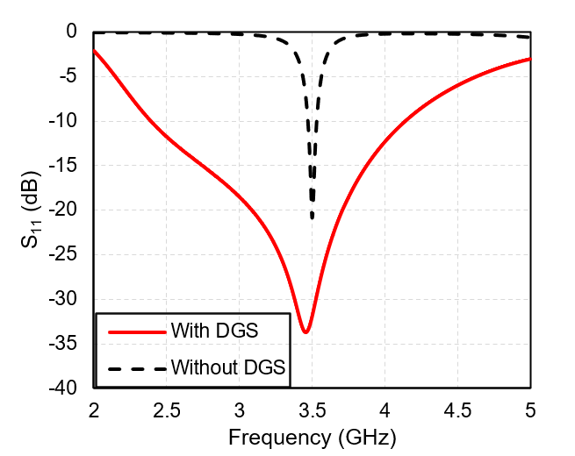

Figure 2 Simulation Results of Conventional Antenna

Microstrip Antenna Design with dumbbell DGS
Figure 3 displays a microstrip antenna designed with a dumbbell-shaped DGS. The figure shows three different antenna designs, each incorporating a varying number of dumbbells. Antenna 1 includes a single dumbbell, Antenna 2 features two dumbbells, and Antenna 3 incorporates three dumbbells. Each design represents a step toward enhancing the antenna's bandwidth through the strategic placement of the dumbbell-shaped DGS​.

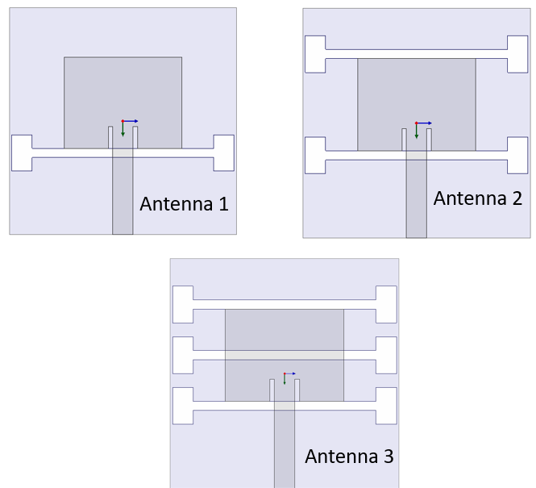

Figure 3 Microstrip Antenna with Dumbbell DGS
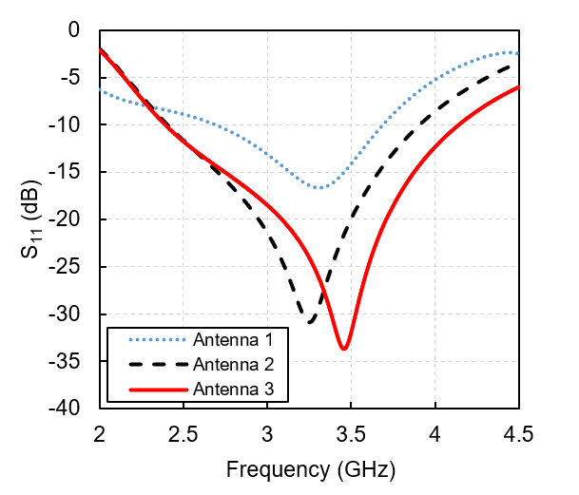

Figure 4 Comparison Graph of Microstrip Antenna Simulation Results with Dumbbell DGS
Figure 4 presents the parameter results for S₁₁ and FBW for each antenna design. Antenna 1, featuring one dumbbell, has an S₁₁ of -16.65 dB and an FBW of 31.35% (2.69 – 3.69 GHz). Antenna 2, with two dumbbells, shows improved performance, achieving an S₁₁ of -30.87 dB and an FBW of 47.47% (2.41 – 3.91 GHz). Meanwhile, Antenna 3, incorporating three dumbbells, has the lowest S₁₁ of -33.68 dB and the highest FBW of 53.60% (2.39 – 4.14 GHz). This data suggests that increasing the number of dumbbells results in better antenna performance, particularly in terms of fractional bandwidth​.
Antenna Design Optimization
The next stage involves antenna design optimization to achieve optimal bandwidth results. Figure 5 illustrates the parameters of the dumbbell that will be optimized. The parameters, including Hw = 4.5 mm, Ht = 8 mm, Wd = 2 mm, Ld = 40 mm, and pd = 9 mm, will be adjusted to determine the best configuration for improving the antenna's performance and maximizing bandwidth​.

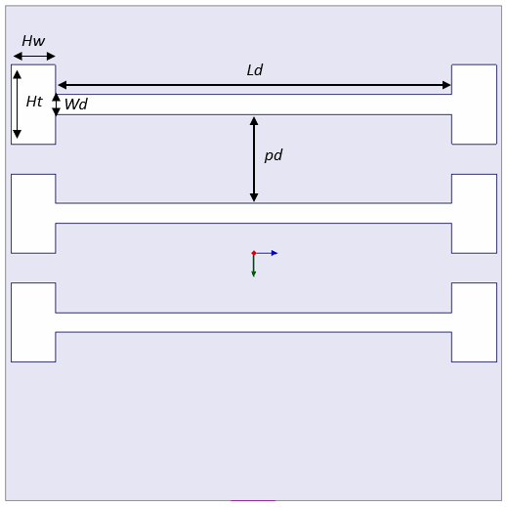

Figure 5 Parameter dumbbell
RESULTS AND DISCUSSION

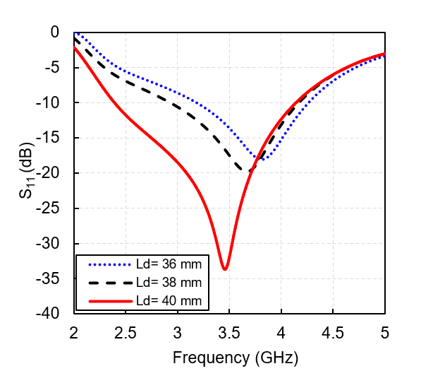

Figure 6 Graph S₁₁ Comparison of Ld
Figure 6 shows the effect of resizing the Ld parameter, presenting the relationship between the S₁₁ parameter and frequency for three different dumbbell lengths Ld = 36 mm, Ld = 38 mm, and Ld = 40 mm. In this experiment, only the Ld parameter is altered, while all other parameters remain fixed. This allows for the observation of how changes in the dumbbell length influence the antenna's performance, particularly its S₁₁ and frequency response​.
Table 1 shows that increasing the length of the dumbbell from 36 mm to 40 mm results in a significant improvement in antenna performance, specifically in terms of the minimum S₁₁ value. The configuration with Ld = 36 mm yields a minimum S₁₁ value of -18.02 dB, while Ld = 38 mm achieves -30.87 dB, and Ld = 40 mm gives the lowest minimum S₁₁ value of -33.68 dB. This data indicates that increasing the length of the dumbbell leads to a more significant reduction in the S₁₁ value, reflecting an improvement in the antenna's reflection performance at the desired frequency​.
In addition, in terms of FBW, it can be observed that increasing the dumbbell length also positively impacts the effective bandwidth. The Ld = 36 mm configuration results in an FBW of 29.03%, while Ld = 38 mm achieves an FBW of 34.93%, and Ld = 40 mm shows the largest FBW of 53.60%. This indicates that a larger dumbbell length not only improves the S₁₁ performance but also expands the operational bandwidth, enhancing the overall antenna efficiency​.

Table 1 Simulation result of dumbbell length, Ld
PARAMETER | S₁₁ | BW (GHz) | FBW%
Ld = 36 mm | -18.02 dB | 3.18 – 4.26 | 29.03
Ld = 38 mm | -30.87 dB | 2.93 – 4.17 | 34.93
Ld = 40 mm | -33.68 dB | 2.39 – 4.14 | 53.60

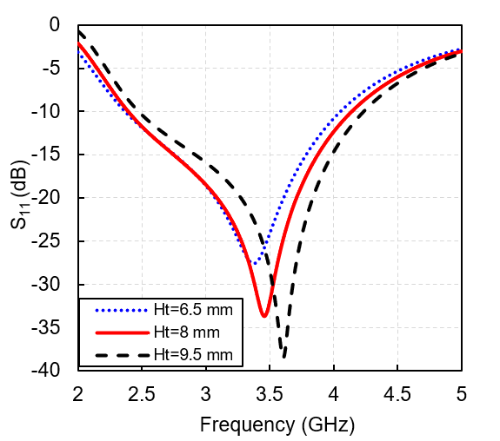

Figure 7 Graph S₁₁ Comparison of Ht
Figure 7 shows the relationship between the S₁₁ parameter and frequency for three variations of height Ht (in mm), namely Ht = 6.5 mm, Ht = 8 mm, and Ht = 9.5 mm. In this case, the Ht parameter is altered while all other parameters remain unchanged. This allows for the observation of how changes in the thickness of the dumbbell affect the antenna's performance, specifically its S₁₁ value and frequency response​.
Table 2 summarizes the minimum S₁₁ and FBW values for each variation in the Ht height. In terms of FBW, the values remain relatively stable within a high range across all Ht variations. At Ht = 6.5 mm, the FBW was recorded at 52.54%, at Ht = 8 mm, the FBW slightly increased to 53.60%, and at Ht = 9.5 mm, the FBW decreased to 52.34%. This data suggests that changes in the Ht height do not significantly impact the effective bandwidth, indicating a stable performance across different height configurations​.

Table 2 Simulation result of dumbbell thickness, Ht
PARAMETER | S₁₁ | BW (GHz) | FBW%
Ht = 6.5 mm | -27.57 dB | 2.37 – 4.05 | 52.54
Ht = 8 mm | -33.68 dB | 2.39 – 4.14 | 53.60
Ht = 9.5 mm | -38.49 dB | 2.39 – 4.14 | 52.34

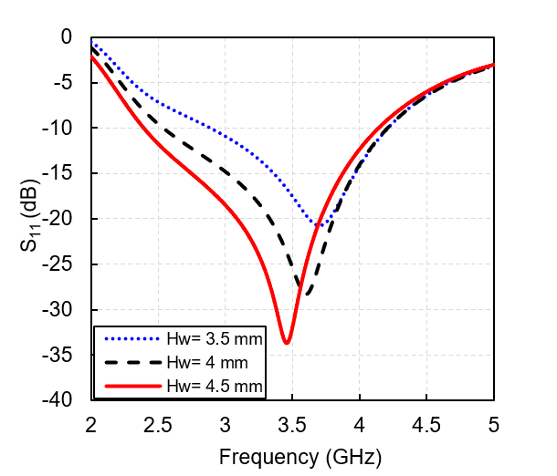

Figure 8 Graph S₁₁ Comparison of Hw
Figure 8 shows that increasing the Hw width from 3.5 mm to 4.5 mm results in a significant decrease in the S₁₁ value. At Hw = 3.5 mm, the minimum S₁₁ value achieved is -20.74 dB, while at Hw = 4 mm, the minimum S₁₁ value drops to -28.29 dB, and at Hw = 4.5 mm, the minimum S₁₁ value reaches -33.68 dB. This indicates that increasing the Hw width improves the antenna's performance by lowering the S₁₁ value, reflecting better reflection efficiency at the given frequency​.
Table 3 summarizes the minimum S₁₁ values and the FBW obtained for simulation results of dumbbell width (Hw). In addition, it can be observed that increasing the Hw also positively impacts the effective bandwidth. At Hw = 3.5 mm, the FBW is recorded at 37.18%, while at Hw = 4 mm, the FBW increases to 49.48%, and at Hw = 4.5 mm, it reaches 53.60%. This indicates that a larger Hw width not only improves the S₁₁ performance but also broadens the operational bandwidth, making the antenna more efficient across a wider frequency range​.
Figure 9 shows the relationship between the S₁₁ parameter and frequency for three variations of Wd width, namely Wd = 1 mm, Wd = 2 mm, and Wd = 3 mm. In this case, the Wd parameter is altered while all other parameters remain fixed. This allows for the analysis of how changing the Wd affects the antenna's performance, specifically its S₁₁ value and frequency response.

PARAMETER | S₁₁ | BW (GHz) | FBW%
Hw = 3.5 mm | -20.74 dB | 2.89 – 4.21 | 37.18
Hw = 4 mm | -28.29 dB | 2.54 – 4.21 | 49.48
Hw = 4.5 mm | -33.68 dB | 2.39 – 4.14 | 53.60

Table 3 Simulation result of dumbbell width, Hw

​ 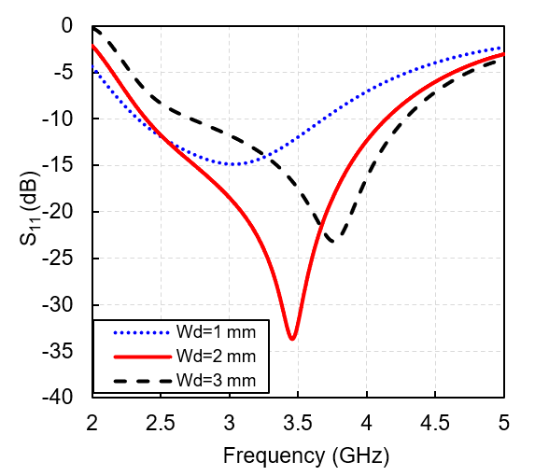

Figure 9 Graph S₁₁ Comparison of Wd

Based on Figure 9, it can be observed that increasing the Wd width from 1 mm to 3 mm results in a reduction in the S₁₁ value. When Wd = 1 mm, the minimum S₁₁ value is -14.86 dB, whereas at Wd = 2 mm, the minimum S₁₁ value decreases to -33.68 dB, and at Wd = 3 mm, it reaches -23.15 dB. This indicates that the most optimal performance is achieved at Wd = 2 mm, where the lowest S₁₁ value is observed, reflecting improved reflection efficiency at the desired frequency​.

The minimum S₁₁ and FBW values for simulation results of dumbbell width (Wd) are summarized in Table 4. In terms of the effective bandwidth FBW, it is evident that the Wd width plays a crucial role. At Wd = 1 mm, the FBW was recorded at 45.18%, while at Wd = 2 mm, the FBW increased to 53.60%. However, at Wd = 3 mm, the FBW decreased to 44.57%, showing that a larger Wd width does not necessarily lead to better results. This suggests that while increasing Wd can enhance FBW up to a certain point, beyond that, the performance may degrade.

Table 4 Simulation result of dumbbell width handle, Wd
PARAMETER | S₁₁ | BW (GHz) | FBW%
Wd = 1 mm | -14.86 dB | 2.33 – 3.69 | 45.18
Wd = 2 mm | -33.68 dB | 2.39 – 4.14 | 53.60
Wd = 3 mm | -23.15 dB | 2.72 – 4.28 | 44.57

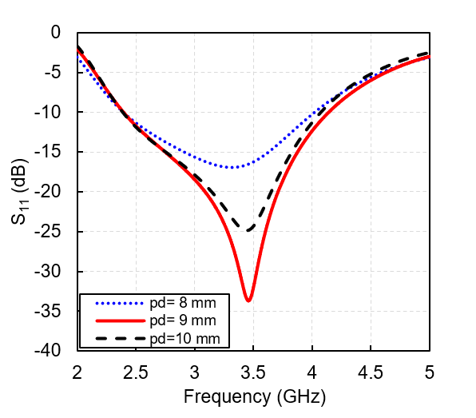

Figure 10 Graph S₁₁ Comparison of pd

Figure 10 shows the relationship between the S₁₁ parameter and frequency for three variations of pd variabels, pd = 8 mm, pd = 9 mm, and pd = 10 mm. Increasing the pd spacing from 8 mm to 9 mm leads to a significant improvement in performance, particularly in reducing the S₁₁ value. At pd = 8 mm, the minimum S₁₁ value is recorded at -16.90 dB. However, when the pd spacing is increased to

9 mm, the minimum S₁₁ value drops considerably to -33.68 dB, indicating a substantial improvement in impedance matching. On the other hand, when the pd spacing is further increased to 10 mm, the minimum S₁₁ value rises slightly to -24.90 dB, suggesting that the optimal pd spacing for the lowest S₁₁ value occurs at pd = 9 mm, reflecting the best reflection efficiency at the given frequency.
Table 5 summarizes the minimum S₁₁ values and FBW for each variation of the pd spacing. In terms of FBW, all pd variable variations exhibit strong performance, with FBW values exceeding 50%. At pd = 8 mm, the FBW is recorded at 50.86%, while at pd = 9 mm, the FBW increases to 53.60%. At pd = 10 mm, the FBW slightly decreases to 52.01%. This indicates that the variation in pd spacing influences the effective bandwidth, with pd = 9 mm yielding the optimal performance.

Table 5 Simulation result of the two dumbbells distance, pd
PARAMETER | S₁₁ | BW (GHz | FBW%
pd = 8 mm | -16.90 dB | 2.39 – 4.02 | 50.86
pd = 9 mm | -33.68 dB | 2.39 – 4.14 | 53.60
pd = 10 mm | -24.90 dB | 2.39 – 4.07 | 52.01

Figure 11 Graph S₁₁ Comparison Without DGS and With DGS

Figure 11 presents a comparison of the S₁₁ parameter between the antenna using DGS and the antenna without DGS. As observed, the antenna with DGS (represented by the red line) exhibits a minimum S₁₁ value of -33.68 dB at a frequency around 3.5 GHz, which is significantly lower than the antenna without DGS (represented by the black line), which has an S₁₁ value of -20.84 dB. This demonstrates that the implementation of DGS improves the antenna's performance by enhancing impedance matching, leading to a reduction in reflection values and thus improving the overall antenna efficiency​.

Table 6 summarizes the S₁₁ and FBW results for both the antenna with and without DGS. The antenna without DGS has an FBW of 1.71%, while the antenna with DGS shows a significant improvement, with an FBW of 53.60%. This indicates that the incorporation of DGS not only enhances the impedance matching but also significantly broadens the antenna's bandwidth, making it more efficient and capable of capturing a wider range of frequencies. The antenna with DGS, when configured with parameters Ld = 40 mm, Wd = 2 mm, Ht = 8 mm, Hw = 4.5 mm, Hs = 3 mm, and pd = 9 mm, demonstrates these notable improvements​.

Table 6 Parameter results without DGS and with DGS
PARAMETER | S₁₁ | BW (GHz) | FBW%
Without DGS | -20.84 dB | 3.47 – 3.53 | 1.71
With DGS | -33.68 dB | 2.39 – 4.14 | 53.60

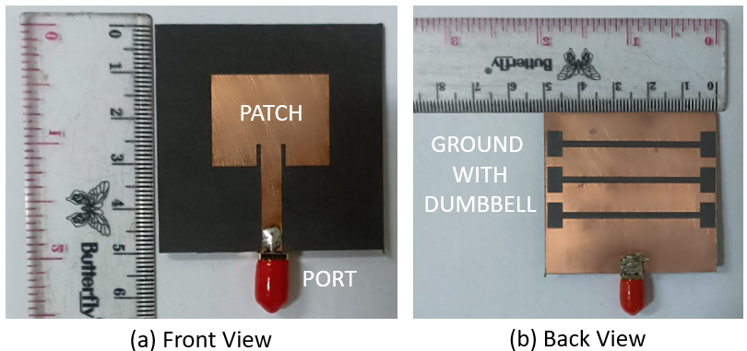

Figure 12 Antenna Fabrication Results
Figure 12 presents the results of the fabricated antenna, which measures 50 mm by 50 mm. The fabrication results are in strong agreement with the simulation results, demonstrating the accuracy and reliability of the design process. The close match between the simulation and the fabricated antenna indicates that the fabrication was successful and the antenna performs as expected.

Figure 13 compares the simulation and measurement results for the S₁₁ parameter across various frequencies. The red line represents the measurement results, while the dashed blue line represents the simulation results. The comparison demonstrates a good agreement between the simulated and measured S₁₁ values, indicating that the antenna performs as expected and that the simulation accurately predicts the antenna's real-world behavior​.
Table 7 summarizes the comparison of the minimum S₁₁ value and FBW between the simulation and measurement results. The simulation results show an FBW of 53.60%, which is slightly higher than the measurement results, which show an FBW of 51.43%. This indicates that the simulation tends to predict a slightly broader effective bandwidth compared to the actual measurement results, suggesting a minor discrepancy between the simulated and real-world performance​.
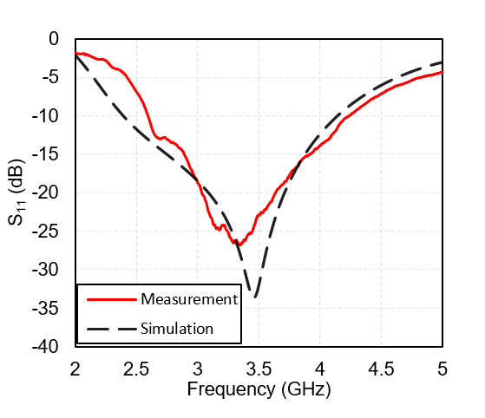

Figure 13 Graph S₁₁ Comparison of Simulation and Measurement

Table 7 Parameter Results Simulation and Measurement
PARAMETER | S₁₁ | BW (GHz | FBW%
Simulation | -33.68 dB | 2.39 – 4.14 | 53.60
Measurement | -27 dB | 2.6 – 4.4 | 51.43

Overall, despite the differences between the simulated and measured results, both show a consistent trend in the performance of the S₁₁ parameter. The simulated results slightly outperform the measured results, showing a lower minimum reflection value and a wider bandwidth. These differences can be attributed to various factors, such as manufacturing tolerances, environmental conditions during measurement, or other factors not fully accounted for in the simulation, which may cause slight deviations between the predicted and actual antenna performance​.
Figure 14 shows the radiation pattern of the antenna compared between the measurement and simulation results. The radiation pattern is presented in the form of a polar diagram, where the blue line represents the measurement results, while the red line represents the simulation results. The figure shows a comparison between the simulated and measured radiation patterns of the antenna. The simulated pattern, represented by the blue dashed line, and the measured pattern, shown by the red solid line, display a similar overall shape, indicating consistency in the antenna's expected performance.

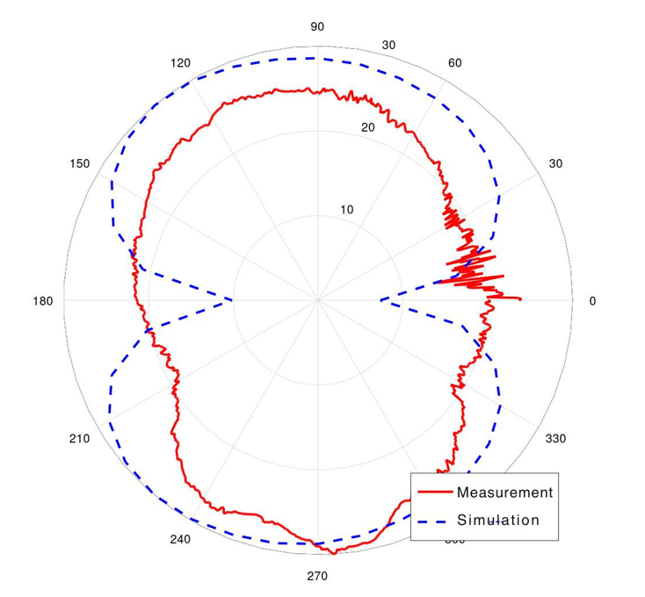

Figure 14 Comparison of simulated and measured Radiation Patterns

The main lobe direction aligns closely in both patterns, demonstrating good agreement in the antenna's primary radiation characteristics. However, there are noticeable deviations in the side lobes and minor variations in other regions, which suggest potential discrepancies caused by practical factors such as environmental influences, fabrication tolerances, or limitations in the measurement setup.
The measured pattern exhibits more irregularities compared to the smooth simulated curve. These irregularities are likely due to noise or interference during measurement. Despite these differences, the general agreement between simulation and measurement confirms the reliability of the antenna design and its ability to meet the intended specifications.
Figure 15 illustrates the electric field (E-field) distribution around a particular structure at six different phases: 0°, 90°, 180°, and 360°. The colors in the figure represent the intensity of the electric field, with red indicating high field intensity and blue indicating low intensity. The electric field distribution at each phase reflects the variation in the resonance pattern, which contributes to the significant enhancement of the antenna's bandwidth performance. This highlights the importance of phase configuration and electric field distribution in designing antennas with improved bandwidth capabilities.

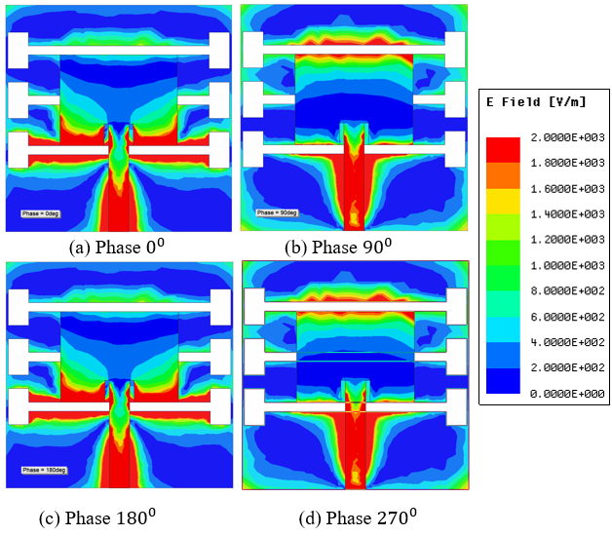

Figure 15 E Field Simulation Results
The E-field distribution at phases 0° and 270° appears similar because these two phases are complementary within a full sinusoidal cycle. The electromagnetic wave's oscillation at these points results in a mirrored distribution of the field. This similarity occurs because the sine wave’s amplitude at 270° is a reflection of its amplitude at 0°, causing similar E-field patterns. At phases 90° and 180°, the E-field distribution differs due to the wave's oscillatory nature. At 90°, the electric field reaches its maximum positive amplitude, while at 180°, the field transitions to the opposite polarity (negative amplitude). This phase difference alters the way energy is distributed across the structure, resulting in variations in the field pattern. The regions with red coloration, indicating a high E-field intensity, are consistently located at the feeding point and the lower DGS area across all phases.
This phenomenon occurs because the feeding point is the location where the input power is delivered to excite the antenna. This area naturally exhibits a high E-field intensity due to the concentration of electromagnetic energy required to drive the antenna. The DGS introduces localized perturbations in the current distribution, enhancing the field intensity at specific regions.

The lower DGS acts as a resonating element, trapping and concentrating the electromagnetic energy. This effect is consistent across all phases because the DGS is designed to improve the antenna's performance by enhancing its radiation characteristics and impedance matching.

Table 8 Comparison of Journal Results
Reff | Freq GHz | FBW% | h (mm) | Sub | Method
[6] | 6 | 48.67 | 2.54 | RT6006 | Split-Ring Resonator (SRR)
[14] | 3.5 | 11.11 | 1.6 | FR4 | Split-Ring Resonator (SRR)
[13] | 3.5 | 10 | 1.575 | RT5880 | Split-Ring Resonator (SRR)
[19] | 10 | 30 | 1,6 | FR4 | Slot patch and DGS
[20] | 10 | 3.98 | 1.57 | RT5880 | DGS and Perforated Patch Configuration
[22] | 2.4 and 5 | 38 and 13 | 1.5 | FR4 | DGS
[23] | 30.5 and 52.4 | 12.72 and 12.28 | 0.508 | RT5880 | DGS
[25] | 2.4 | 12.08 | 1.6 | FR4 | DGS
[9] | 28 | 10.53 | 0.787 | RT5880 | DGS
This work | 3.5 | 53.60 | 1.575 | RT5880 | DGS

Table 8 provides a comparison of antenna designs utilizing DGS across several studies. A recent study by the researcher, using the Rogers RT5880 substrate with DGS, achieved a FBW of 53.60% (2.39 – 4.14 GHz), which is higher than previous studies, where FBW ranged from 10.53% to 48.67%. As indicated in Table 8, both the current study and previous research have explored antenna designs across various frequency ranges, all incorporating DGS to enhance antenna performance. However, there are notable differences in terms of fractional bandwidth, substrate thickness, and design methodologies, emphasizing the adaptability of antenna design and the impact of specific design parameters on the overall antenna characteristics.

Conclusion
This study successfully demonstrates that the use of the Defected Ground Structure (DGS) technique with a dumbbell shape on a microstrip antenna can significantly enhance the FBW of the antenna for 5G applications at a frequency of 3.5 GHz. The antenna designed with DGS on Rogers RT5880 with 1.575 mm substrate thickness achieves an FBW of 53.60%, which is much higher than that of previous studies, including conventional antennas with an FBW of approximately 2%. This improvement shows that the application of DGS can effectively widen the bandwidth, making the antenna more efficient and flexible.

REFERENCES
[1] A. Irfansyah, B. B. Harianto, and N. Pambudiyatno, “Design of Rectangular Microstrip Antenna 1x2 Array for 5G Communication,” in Journal of Physics: Conference Series, IOP Publishing Ltd, Dec. 2021. doi: 10.1088/1742-6596/2117/1/012028.
[2] S. Abulgasem, F. Tubbal, R. Raad, P. I. Theoharis, S. Lu, and S. Iranmanesh, “Antenna Designs for CubeSats: A Review,” 2021, Institute of Electrical and Electronics Engineers Inc. doi: 10.1109/ACCESS.2021.3066632.
[3] Y. Zhang and Y. Li, "Wideband Microstrip Antenna in Small Volume Without Using Fundamental Mode," Electromagnetic Science, vol. 1, no. 2, Art. no. 0020073, Jun. 2023, doi: 10.23919/emsci.2023.0007.
[4] S. Ermiş and M. Demirci, "Improving the Performance of Patch Antenna by Applying Bandwidth Enhancement Techniques for 5G Applications," Tehnički Glasnik, vol. 17, no. 3, pp. 305–312, Sep. 2023, doi: 10.31803/tg-20220819001236.
[5] J. Zhou, Y. Rao, D. Yang, H. J. Qian, and X. Luo, "Compact Wideband BPF With Wide Stopband Using Substrate Integrated Defected Ground Structure," IEEE Microwave and Wireless Components Letters, vol. 31, no. 4, pp. 353–356, Apr. 2021, doi: 10.1109/LMWC.2021.3053756.
[6] V. Rajeshkumar and R. Rajkumar, "SRR Loaded Compact Tri-Band MIMO Antenna for WLAN/WiMAX Applications," Progress In Electromagnetics Research Letters, vol. 95, pp. 43–53, 2021.
[7] A. Karimbu Vallappil, M. K. A. Rahim, B. A. Khawaja, and M. N. Iqbal, “Compact Metamaterial Based 4 × 4 Butler Matrix with Improved Bandwidth for 5G Applications,” IEEE Access, vol. 8, pp. 13573–13583, 2020, doi: 10.1109/ACCESS.2020.2966125.
[8] N. Sakib, S. N. Ibrahim, M. Ibn Ibrahimy, M. S. Islam, and M. M. H. Mahfuz, “Design of Microstrip Patch Antenna on Rubber Substrate with DGS for WBAN Applications,” in 2020 IEEE Region 10 Symposium, TENSYMP 2020, Institute of Electrical and Electronics Engineers Inc., Jun. 2020, pp. 1050–1053. doi: 10.1109/TENSYMP50017.2020.9230707.
[9] E. Sandi, B. Maruddani, D. F. Ronald, and R. Ramadhan, “A wideband microstrip triangle patch antenna with double dumbbell shaped Defective Ground Structure for 5G application,” IOP Conf Ser Mater Sci Eng, vol. 1098, no. 4, p. 042093, Mar. 2021, doi: 10.1088/1757-899x/1098/4/042093.
[10] L. Su, J. Munoz-Enano, P. Velez, J. Martel, F. Medina, and F. Martin, “On the Modeling of Microstrip Lines Loaded with Dumbbell Defect-Ground-Structure (DB-DGS) and Folded DB-DGS Resonators,” IEEE Access, vol. 9, pp. 150878–150888, 2021, doi: 10.1109/ACCESS.2021.3125775.
[11] H. M. Emara, S. K. El Dyasti, H. H. M. Ghouz, M. Fathy, A. Sree, and S. Y. A. Fatah, “Compact High Gain Microstrip Array Antenna Using DGS Structure for 5G Applications,” 2023.
[12] T. Suneetha, S. Alapati, and S. Nagakishore Bhavanam, “Bandwidth Enhancement of Micro Strip Square Patch Antenna with Partial Ground Plane for Wide Band Applications,” International Journal on Engineering Applications, vol. 10, no. 4, pp. 265–271, 2022, doi: 10.15866/irea.v10i4.20442.
[13] Y. G. Adhiyoga, S. F. Rahman, C. Apriono, and E. T. Rahardjo, “Miniaturized 5G Antenna With Enhanced Gain by Using Stacked Structure of Split-Ring Resonator Array and Magneto-Dielectric Composite Material,” IEEE Access, vol. 10, pp. 35876–35887, 2022, doi: 10.1109/ACCESS.2022.3163285.
[14] H. H. Ryanu et al., “A Bandwidth and Gain Enhanced Hexagonal Patch Antenna using Hexagonal Shape SRR,” JURNAL INFOTEL, vol. 16, no. 2, pp. 457–473, May 2024, doi: 10.20895/infotel.v16i2.1118.
[15] N. S. M. Suhaimi, N. M. Mahyuddin, W. Ismail, and I. M. Ibrahim, “Miniaturized 4 × 4 switched-beam Butler Matrix with bandwidth enhancement for 5G communication system,” Alexandria Engineering Journal, vol. 61, no. 12, pp. 13089–13103, Dec. 2022, doi: 10.1016/j.aej.2022.07.014.
[16] H. H. Tran and N. Nguyen-Trong, “Performance Enhancement of MIMO Patch Antenna Using Parasitic Elements,” IEEE Access, vol. 9, pp. 30011–30016, 2021, doi: 10.1109/ACCESS.2021.3058340.
[17] V. G. Ajay, T. Mathew, N. V. Krishna Prasad, and M. S. S. R. K. N. Sarma, “Truncated microstrip patch antenna with dgs based on double looped csrr arrays for enhancement of bandwidth,” Indonesian Journal of Electrical Engineering and Informatics, vol. 8, no. 3, pp. 593–601, Sep. 2020, doi: 10.11591/ijeei.v8i3.2222.
[18] D. W. Astuti, R. Muslim, I. Simanjuntak, T. Firmansyah, D. A. Cahyasiwi, and Y. Natali, “Bandwidth Enhancement for Half Mode Substrate Integrated Waveguide Antenna using Defected Ground Structures,” International Journal of Electronics and Telecommunications, vol. 69, no. 3, pp. 449–454, 2023, doi: 10.24425/ijet.2023.144382.
[19] V. Suryanarayana, M. Satya Anuradha, and S. P. Douglas, “Bandwidth Enhancement of Multiwalled Carbon Nanotube Antenna Using Structural Modifications and DGS in X-Band Applications,” in Proceedings - IEEE 2021 International Conference on Computing, Communication, and Intelligent Systems, ICCCIS 2021, Institute of Electrical and Electronics Engineers Inc., Feb. 2021, pp. 792–797. doi: 10.1109/ICCCIS51004.2021.9397223.
[20] A. Gupta and B. Jharia, “Performance Enhancement of 10GHz Patch Antenna using DGS and Perforated Patch Configuration for Advanced Wireless Communication Systems,” SVU-International Journal of Engineering Sciences and Applications, vol. 5, no. 1, pp. 33–38, Jun. 2024, doi: 10.21608/svusrc.2023.229826.1146.
[21] D. W. Astuti, R. Fadilah, Muslim, D. Rusdiyanto, S. Alam, and Y. Wahyu, “Bandwidth Enhancement of Bow-tie Microstrip Patch Antenna Using Defected Ground Structure for 5G,” Journal of Communications, vol. 17, no. 12, pp. 995–1002, Dec. 2022, doi: 10.12720/jcm.17.12.995-1002.
[22] Z. Bendahmane, S. Ferouani, and C. Sayah, “High Permittivity Substrate and DGS Technique for Dual-Band Star-Shape Slotted Microstrip Patch Antenna Miniaturization,” 2020.
[23] H. M. Emara, S. K. El Dyasti, H. H. M. Ghouz, and M. F. A. Sree, “Design of a Compact Dual-Frequency Microstrip Antenna using DGS Structure for Millimeter-Wave Applications,” Journal of Advanced Research in Applied Sciences and Engineering Technology, vol. 28, no. 3, pp. 221–234, Nov. 2022, doi: 10.37934/araset.28.3.221234.
[24] P. A. M. Mercy and K. S. J. Wilson, “Bandwidth Enhancement of Pentagonal &amp; Circular Microstrip Patch Antenna with DGS for Radar &amp; Satellite Applications,” PriMera Scientific Engineering, vol. 2, Mar. 2023, doi: 10.56831/PSEN-02-046.
[25] K. Mishra, “Bandwidth and Return Loss Enhancement of Microstrip Antenna using DGS,” Int J Res Appl Sci Eng Technol, vol. 9, no. 2, pp. 97–102, Feb. 2021, doi: 10.22214/ijraset.2021.32979.
[26] M. K. Adityo, M. I. Nashiruddin, and M. A. Nugraha, “5G Fixed Wireless Access Network for Urban Residential Market: A Case of Indonesia,” in Proceedings of the 2021 IEEE International Conference on Internet of Things and Intelligence Systems, IoTaIS 2021, Institute of Electrical and Electronics Engineers Inc., 2021, pp. 123–128. doi: 10.1109/IoTaIS53735.2021.9628442.
[27] D. Rusdiyanto, C. Apriono, D. W. Astuti, and Muslim, “Bandwidth and gain enhancement of microstrip antenna using defected ground structure and horizontal patch gap,” SINERGI, vol. 25, no. 2, pp. 153–158, Jun. 2021, doi: 10.22441/sinergi.2021.2.006.

