Shear Strength Enhancement of Fine Sand Soil Using Guar Gum Biopolymer under Varying Curing Conditions | 

Maya Devina Kurniawan¹, Riza Suwondo^{1*}, I Gede Mahardika Susila¹, Andryan Suhendra¹
¹Civil Engineering Department, Faculty of Engineering, Bina Nusantara University

Abstract  This study investigates the effect of Guar Gum biopolymer on the shear strength behaviour of fine sand soil, with the aim of evaluating its potential as a sustainable soil stabilisation agent. A series of direct shear tests, following ASTM D3080-23, were conducted on Guar Gum-treated soil samples with varying biopolymer concentrations (1%, 3%, and 5%) and water content (10%, 12%, and 15%). Curing durations of 2, 5, and 7 days were applied to assess time-dependent strength development. The shear strength parameters, cohesion (c), and internal friction angle (φ)were evaluated to quantify the improvement in soil performance. The results showed that cohesion increased with higher Guar Gum concentration and longer curing times, with the highest cohesion (0.105 kg/cm²) observed at 5% concentration after 7 days. However, the internal friction angle decreased with prolonged curing, suggesting a shift from the frictional to cohesive strength. The water content had a critical impact, with 10–12% yielding optimal results. At a water content of 12 %, the highest internal friction angle (52°) was recorded after 7 days. Overall, the findings confirm that Guar Gum can significantly enhance the shear strength of fine sand when the key parameters are optimised, offering an effective and environmentally friendly alternative to conventional chemical stabilisers in geotechnical applications.  This is an open access article under the CC BY-SA license   | Keywords:  Guar Gum Biopolymer; Soil Stabilization; Shear Strength;  Direct Shear Test; Fine Sand Soil  Article History:  Received: May 2, 2019  Revised: May 29, 2019  Accepted: June 2, 2019  Published: June 2, 2019  Corresponding Author:  Riza Suwondo  Civil Engineering Department, Bina Nusantara University, Indonesia  Email: riza.suwondo@binus.ac.id

INTRODUCTION
In geotechnical engineering, the pursuit of sustainable soil improvement methods has become increasingly important in response to the growing environmental concerns. Issues such as soil degradation, erosion, and depletion of essential nutrients have highlighted the need for alternative solutions to enhance soil properties while minimising the environmental impact. One promising approach is the use of biopolymers, which are organic compounds derived from natural sources, as environmentally friendly soil stabilisers[1], [2], [3].
Traditionally, soil improvement techniques have been broadly classified into two categories: mechanical and chemical stabilisation[4]. Mechanical methods include techniques such as compaction, vibration, anchoring, and the use of geosynthetics, which typically involve the incorporation of cementitious binders to enhance interparticle bonding and reduce pore spaces within the soil matrix [5], [6], [7].
Among the chemical stabilisers, lime and cement are the most commonly used materials[8], [9], [10], [11]. These binders improve the soil strength by forming cementitious compounds through pozzolanic reactions. Other additives, such as bitumen, fly ash, and sodium sulphate, have also been employed for soil stabilisation, as reported by [12], [13], [14], [15], [16], [17], [18]. However, the environmental footprint of these traditional binders, particularly in terms of embodied carbon and long-term sustainability, has prompted researchers to explore alternative low-impact solutions such as biopolymers[19], [20], [21], [22].
Biopolymers are naturally occurring polymers synthesised by biological organisms such as fungi, algae, and bacteria through biosynthesis and biodegradation. They are primarily composed of polysaccharides, which are long chains of monosaccharide units linked by glycosidic bonds[23], [24], [25]. Owing to their natural origin and molecular structure, biopolymers are inherently non-toxic and biodegradable, making them environmentally sustainable alternatives to conventional chemical additives [26], [27], [28], [29]. The application of natural biopolymers in civil engineering dates back to the ancient times. Historical records have indicated that natural bitumen, straw, and sticky rice are used for construction purposes. A notable example is the use of sticky rice mortar, which remains structurally intact, as a binder in the construction of the Great Wall of China [30].
Recent studies have explored the use of biopolymers, particularly guar gum, for eco-friendly soil stabilisation. Yogeshwar and Sonthwal [31] investigated the effectiveness of Guar Gum, a naturally occurring biopolymer, for enhancing the mechanical properties of clay-rich soils. Their study evaluated five different Guar Gum dosages (0.5, 1.0, 1.75, 2.50, and 3.25% by weight of dry soil) to determine the optimal content for soil stabilisation. The key geotechnical parameters assessed included the relationship between the optimum moisture content and maximum dry density, California Bearing Ratio (CBR) under both unsoaked and soaked conditions, and unconfined compressive strength (UCS). The results indicated that 1.0% Guar Gum content yielded the most significant improvement across all measured properties, suggesting that it is the optimal dosage for enhancing the strength and stiffness of clayey soils.
Sujatha and Sivaraman [32] evaluated the potential of Guar Gum, a natural polysaccharide, to enhance the geotechnical properties of clay soils. Their findings revealed that Guar Gum-treated soil exhibited behaviour similar to stiff clay, characterised by higher load-bearing capacity and reduced strain at failure. A significant increase in the stiffness modulus was observed with the addition of Guar Gum, indicating an improved resistance to deformation. The strength gain over time was attributed to the gradual formation of hydrogen bonds between the biopolymer and the soil particles. Although biopolymers are generally susceptible to biological degradation, the study noted minimal strength loss, with continued strength development observed over a 90-day curing period.

Usha et al. [33] investigated the use of Guar Gum and Gellan Gum as sustainable biopolymer additives for stabilising clayey soils. The study involved compaction, unconfined compressive strength, permeability, consistency limits, and consolidation tests using soils treated with varying biopolymer dosages. Biopolymers form hydrogels upon activation, enhancing interparticle bonding and increasing soil strength. The results showed that biopolymer addition increased the dry unit weight, decreased the optimum moisture content, and improved stiffness. Higher biopolymer concentrations reduced the permeability owing to the decreased void ratio. In addition, the treated soils exhibited an increased liquid limit, plastic limit, shrinkage limit, and viscosity. The study concluded that both gum and gellan gum significantly improved the mechanical and consistency properties of weak soils.
Despite the growing interest in Guar Gum for sustainable ground improvement, most existing research has concentrated on highly cohesive soils and mechanical properties such as UCS, CBR, and permeability. What has escaped the attention of previous researchers is the specific influence of Guar Gum on shear strength parameters, cohesion, and internal friction angle, which are fundamental to geotechnical analysis and design. Furthermore, past studies have largely neglected sandy loam soils, which contain both granular and fine particles, and thus represent a distinct soil behaviour profile where the biopolymer-soil interaction may differ.
From a theoretical standpoint, the novelty of this study lies in its focus on the shear strength behaviour governed by particle interlock and bonding mechanisms, and how Guar Gum, a hydrophilic polysaccharide, modifies these interactions in sandy loam soils. Unlike compressive strength which primarily reflects bulk resistance, shear strength (governed by the Mohr–Coulomb failure criterion) reflects both frictional and cohesive contributions, offering deeper insight into the stabilisation mechanism.
This study aims to investigate the effect of Guar Gum biopolymer on the shear strength behaviour of sandy loam soil using direct shear tests in accordance with ASTM D3080-23[34]. This study evaluates the influence of varying Guar Gum concentrations on key shear strength parameters (cohesion and internal friction angle) under different curing and moisture conditions, contributing new insights into the performance of biopolymer-treated mixed-texture soils.

METHOD
The data presented in this study were obtained through a series of controlled laboratory experiments designed to characterise the geotechnical properties of fine sand soil and evaluate its shear strength following Guar Gum biopolymer treatment. Prior to shear strength testing, comprehensive laboratory tests were conducted to determine the basic physical properties of the untreated fine sand. These included measurements of the bulk density, dry density, particle density, and grain size distribution. These baseline tests were essential to ensure sample uniformity and provide a consistent reference for assessing the effects of Guar Gum modification.
Fine sand soil was selected for this study because of its common use in civil and structural engineering applications. Its granular structure and inherently low shear strength make it a suitable candidate for stabilisation studies, particularly for assessing the efficacy of natural biopolymer additives. The soil parameters are listed in Table 1.

Table 1. Table Caption
Parameter | Unit | Value
Maximum Dry Unit Weight | g/cm³ | 1.94
Optimum Water Content | % | 12
Specific Gravity | - | 2.66

Guar Gum, a natural polysaccharide derived from the seeds of Cyamopsis tetragonoloba (guar plant), was selected as the biopolymer additive. The materials used in this study were sourced from Lucid Colloids Ltd. (India) (Figure 1). Guar Gum is known for its hydrophilic and pseudoplastic properties, which enable it to form viscous hydrogels that improve inter-particle bonding and enhance the cohesive behaviour of soil matrices.
Direct shear tests were performed on Guar Gum-treated and untreated soil samples to evaluate the influence of biopolymer content and other variables on the shear strength behaviour. The experimental matrix is expressed as follows:.
- Guar Gum concentrations: 1%, 3%, and 5% by dry weight of soil
- Water contents: 10%, 12%, and 15%
- Curing times: 2, 5, and 7 days
Soil and biopolymer mixtures were prepared by thoroughly blending dry Guar Gum powder with soil, followed by the addition of water to achieve the target moisture content. The samples were then compacted in a shear box and cured under controlled conditions for specified durations.
All direct shear tests were conducted in accordance with the ASTM D3080-04 standards to ensure procedural consistency and data reliability. The objective of the testing was to determine the peak shear strength and the corresponding shear stress–displacement behaviour of each sample. From the test results, key shear strength parameters, including the cohesion (c) and internal friction angle (φ), were derived using the Mohr–Coulomb failure criterion. Comparative analysis was performed between Guar Gum-amended samples and control samples (untreated soil at the same water content) to evaluate the effectiveness of Guar Gum in enhancing shear strength characteristics.

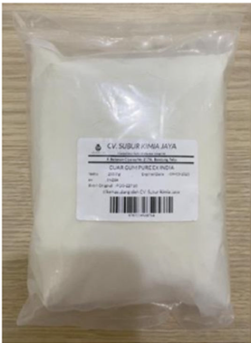
Figure 1. Biopolymer Guar Gum

This study is based on the Mohr–Coulomb failure theory, which defines the shear strength (τ) as a function of cohesion (c) and internal friction angle (φ), expressed as

τ = c + σ·tan(φ) (1)

where, σ is the normal stress. Traditionally, this framework has been applied to granular and cohesive soils without organic modifications. However, the application of biopolymers such as Guar Gum introduces a new bonding mechanism through hydrogen bonding and hydrogel formation, which can influence both c and φ.
The scientific contribution of this study lies in the application and extension of the Mohr–Coulomb theory to biopolymer-treated sandy loam, a soil type that has not been extensively studied. By quantifying how biopolymer concentration, water content, and curing time alter shear strength parameters, this study provides a theory-informed understanding of biopolymer-soil interactions. The results also offer a basis for refining existing strength models to account for natural polymer additives in geotechnical designs.
To illustrate the research process and the theoretical foundation of this study, a conceptual flowchart is presented in Figure 2. This framework outlines the sequential steps from identifying the problem of low shear strength in fine sand soil to the selection of input variables, namely, Guar Gum concentration, water content, and curing time, followed by direct shear testing in accordance with ASTM D3080-04. The output parameters derived from the tests, cohesion (c), and internal friction angle (φ), were interpreted using the Mohr–Coulomb failure criterion. The framework also highlights the theoretical contribution of this study, which lies in applying and extending classical shear strength theory to biopolymer-treated sandy loam soils. This approach provides a structured basis for evaluating the effects of natural polymers on soil behaviour, offering insights into the interplay between biopolymer dosage, moisture content, curing time, and shear strength development.

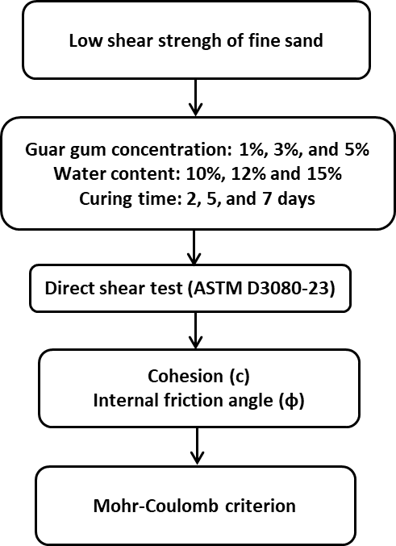

Figure 2. Conceptual Framework of the Research and Theoretical Basis

RESULTS AND DISCUSSION
This section presents and analyses the effects of the Guar Gum biopolymer on the shear strength parameters of fine sand soil, with a specific focus on two key variables: Guar Gum concentration and water content. Each parameter was investigated for multiple curing durations (2, 5, and 7 d) to evaluate the time-dependent behaviour of the treated soil. The results were derived from direct shear tests, and the shear strength parameters, namely, cohesion (c) and internal friction angle (φ), were extracted using the Mohr–Coulomb failure criterion. The influence of Guar Gum concentration is discussed in the first subsection, followed by an analysis of water content in the second, highlighting the combined effects of dosage, moisture, and curing on the overall strength improvement.

Effect of Guar Gum Concentration
This subsection investigates the influence of the Guar Gum concentration on the shear strength behaviour of fine sand soil, with a constant water content of 10% maintained across all samples. Three different biopolymer concentrations (1, 3, and 5% by dry weight of soil) were selected to evaluate the dose-dependent response of the soil to Guar Gum treatment. The analysis was conducted under three distinct curing durations of 2, 5, and 7 d to observe time-dependent changes in strength. The direct shear test results were used to determine the peak shear strength, cohesion (c), and internal friction angle (φ) of the treated soils.
Figure 3 illustrates the effect of Guar Gum concentration and curing time on the cohesion of fine sand soil at a constant water content of 10%. A clear trend emerges: increasing the biopolymer content and extending the curing duration generally enhances the soil cohesion. However, the interaction was not linear, indicating a complex relationship influenced by the biopolymer-soil bonding mechanisms and curing dynamics. At 2 days of curing, cohesion remained low across all Guar Gum concentrations, with the highest value (~0.025 kg/cm²) observed at 5%. This early stage performance suggests an insufficient time for full hydration and polymer network formation. At this point, Guar Gum may act more as a lubricant than a binder, offering minimal mechanical interlocking between soil grains.
After 5 days of curing, the cohesion at 1% Guar Gum sharply increases to approximately 0.09 kg/cm²—the highest among all curing periods at this concentration. This suggests that at lower dosages, the polymer is optimally dispersed, allowing uniform hydrogel formation that bridges the particles and enhances cohesive strength. However, increasing the dosage to 3% and 5% at the same curing time unexpectedly resulted in a reduced cohesion (~0.035 kg/cm²). This reversal indicates that excessive Guar Gum may lead to agglomeration, causing nonuniform bonding and weak zones within the soil matrix. These observations align with previous findings on biopolymer overdosing, in which increased viscosity limits effective mixing and bonding.

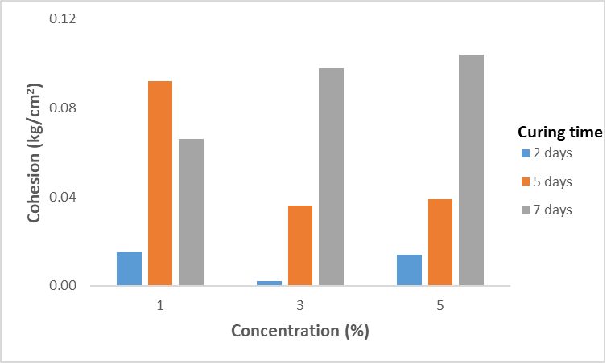
Figure 3. Cohesion of fine sand soil under different Guar Gum concentrations

After 7 d of curing, the behaviour changed significantly. A consistent increase in cohesion was observed as the Guar Gum concentration increased, reaching a maximum of approximately 0.105 kg/cm² at 5%. This trend reflects the time-dependent nature of the hydrogen bonding and hydrogel maturation. During extended curing, Guar Gum undergoes full hydration and forms a more stable and continuous matrix that fills voids and reinforces the interparticle structure. This longer curing duration allows for more effective biopolymer-soil interactions, particularly at higher dosages, where delayed hydration and diffusion are otherwise limiting factors.
These findings provide new insights into biopolymer stabilisation mechanisms by demonstrating that the effectiveness of Guar Gum is not only dose dependent but also strongly influenced by curing time. More importantly, they indicate that there exists an optimal combination of biopolymer content and curing period, which maximises interparticle bonding and, hence, soil cohesion. From a theoretical standpoint, these results suggest that, in biopolymer-treated soils, the cohesion term (c) in the Mohr–Coulomb failure envelope can be significantly enhanced through polymer-induced bonding, provided that the curing conditions support complete gel formation and integration with the soil matrix.
Figure 4 illustrates the variation in the internal friction angle of the Guar Gum-treated fine sand as a function of both the biopolymer concentration and curing time. The results highlight a nonlinear relationship, where the interplay between gel formation, particle interaction, and curing dynamics governs the frictional behaviour of the treated soil.
At 1% Guar Gum concentration, the friction angle was the highest after 2 days of curing (~35°), indicating that at early stages, the biopolymer begins to form thin films or weak gel networks that slightly enhance interparticle interactions. However, as curing progressed to 5 and 7 d, a notable decline in the friction angle was observed, reaching a minimum (~20° at 5 d). This reduction may be attributed to the onset of excessive lubrication caused by immature gel formation, where water remains entrapped within partially hydrated polymer chains, thereby reducing effective grain-to-grain contact.

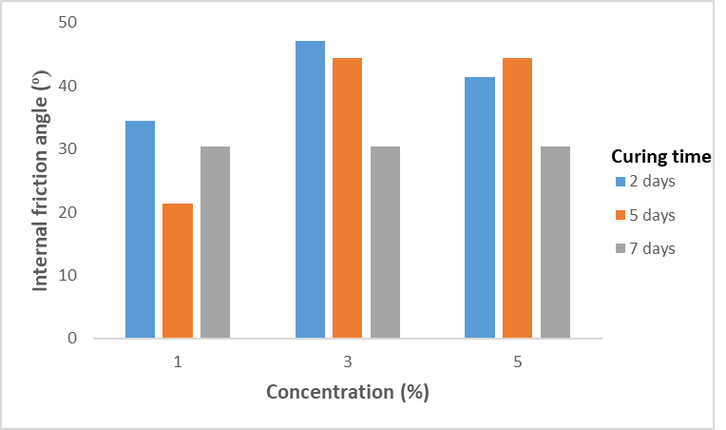
Figure 4. Friction angle of fine sand soil with different Guar Gum concentrations

At a concentration of 3 %, the friction angle increased significantly to approximately 46° at 2 days and remained high at 5 days (~44°), suggesting that a moderate concentration of Guar Gum facilitates improved interlocking and surface resistance between particles. The observed strength at this concentration can be linked to the formation of semi-structured hydrogel networks that bind the particles without overwhelming them with excess moisture. However, at 7 days, the friction angle dropped to ~30°, implying that prolonged curing led to further polymer hydration and matrix filling, shifting the soil behaviour from friction-dominated to cohesion-dominated. This aligns with theoretical expectations, where hydrogel saturation reduces intergranular sliding, which is a key mechanism contributing to the frictional resistance.
A similar trend was noted at 5% concentration, where the internal friction angles peaked at 2–5 days (~40–43°) before decreasing to ~30° after 7 days. The initial improvement can be attributed to the enhanced interparticle friction owing to a denser and more continuous biopolymer network. However, with extended curing, excessive Guar Gum may fill void spaces too extensively, diminishing the role of interlocking by smoothing out particle asperities, leading to a reduced frictional response.
These results suggest that Guar Gum affects the internal friction angle through a time-sensitive balance between interparticle bonding and matrix saturation. During the early curing stages (2–5 days), the partial hydration of Guar Gum strengthens the soil through improved grain contact and moderate cohesion. However, after seven days, the dominance of the cohesive gel fills the voids and reduces the surface roughness, shifting the failure mechanism away from the sliding resistance.
From a theoretical perspective, the findings reveal that the internal friction component (φ) in the Mohr–Coulomb strength envelope is sensitive not only to the soil texture but also to the hydration dynamics and distribution of the biopolymer within the matrix. This study contributes to the understanding of how natural polymers influence frictional strength in mixed soils, and emphasizes the need for optimizing curing duration and dosage to balance frictional and cohesive mechanisms in biopolymer-stabilized systems

Effect of Water Content
This subsection investigates the influence of water content on the shear strength behaviour of fine sand soil treated with a constant 1% concentration of the Guar Gum biopolymer. Water plays a critical role in biopolymer–soil interactions and affects the hydration, gel formation, and polymer distribution within the soil matrix. To evaluate this effect, three different water contents (10 %, 12 %, and 15% by weight) were considered, and direct shear tests were performed after curing durations of 2, 5, and 7 d.
Figure 5 presents the influence of water content on the cohesion of fine sand soil treated with 1% Guar Gum for different curing times. The results clearly demonstrate that the water content plays a critical role in modulating the cohesive strength of biopolymer-treated soil by influencing the hydration behaviour and distribution of the polymer within the soil matrix.
At 10% water content, the highest cohesion values were recorded across all curing periods, with a peak value of approximately 0.09 kg/cm² observed at 5 days of curing. This indicates that 10% moisture provides the optimal hydration conditions for Guar Gum activation, promoting the formation of a well-structured hydrogel network that effectively bridges soil particles and enhances interparticle bonding. The improvement at this water content aligns with the fundamental behaviour of hydrophilic polymers, which require a balanced moisture environment to swell and form effective gel matrices without over-dilution.
At 12% water content, cohesion values were moderate at early curing stages (2–5 days) but dropped significantly by 7 days. This suggests that while initial hydration at 12% supports some gel development, prolonged curing under higher moisture conditions may lead to excess water interfering with the matrix consolidation. Overhydration likely prevents Guar Gum from forming strong interparticle links, dilutes the gel concentration, and weakens the structural integrity of the soil–polymer composite. This transition from moderate bonding to reduced cohesion reflects the sensitivity of Guar Gum to moisture balance and curing duration.

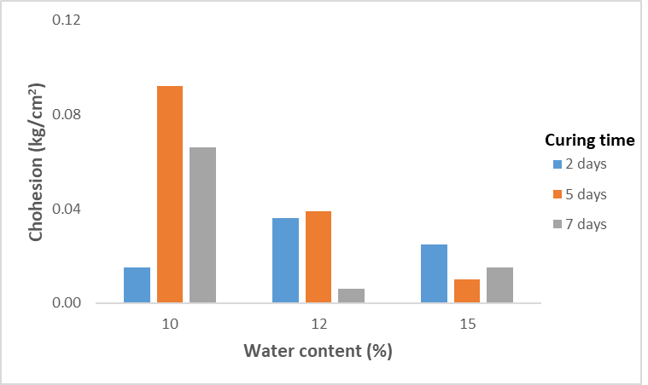
Figure 5. Cohesion of fine sand soil with different water contents

At 15% water content, the lowest cohesion values were consistently observed, regardless of curing duration. This indicates that excessive moisture undermines the stabilising effect of Guar Gum, likely owing to a combination of dilution and pore water pressure retention. High water content may hinder polymer-to-particle contact and promote dispersion rather than gelation, resulting in a poorly connected matrix. Moreover, the persistent presence of excess water reduced the effective stress in the soil, further diminishing the mobilised shear strength.
From a geotechnical perspective, these findings highlight that the water content directly influences the cohesion component (c) in the Mohr–Coulomb failure criterion, not only by controlling polymer hydration but also by determining the physical structure and bonding potential within the soil matrix. The results underscore the existence of an optimum moisture threshold of 10%, which maximises the bonding capacity of the biopolymer and enables effective load transfer between soil particles.
This study provides new insights into how moisture-driven gel behaviour interacts with curing kinetics to determine the mechanical outcome of biopolymer-treated soils. This emphasises the importance of moisture management in field applications, especially for stabilising fine-grained or mixed soils with natural polymers, where underhydration or overhydration can significantly affect the performance.
Figure 6 demonstrates the influence of water content on the internal friction angle of fine sand soil treated with 1% Guar Gum, measured for curing durations of 2, 5, and 7 d. The results revealed that water content is a key variable affecting the frictional component of shear strength, and its impact is strongly dependent on the balance between hydration, polymer distribution, and curing time.
At 10% water content, the friction angle peaked early at ~35° after 2 days, but then declined to ~22° after 5 days and recovered slightly to ~30° after 7 days. This suggests that although 10% moisture initially facilitates partial hydration and some degree of interparticle bonding, extended curing may lead to progressive gel formation that fills the pore spaces and smooth particle surfaces. This process reduces the intergranular roughness and diminishes the sliding resistance, thus lowering the friction angle because cohesive mechanisms begin to dominate over frictional mechanisms.

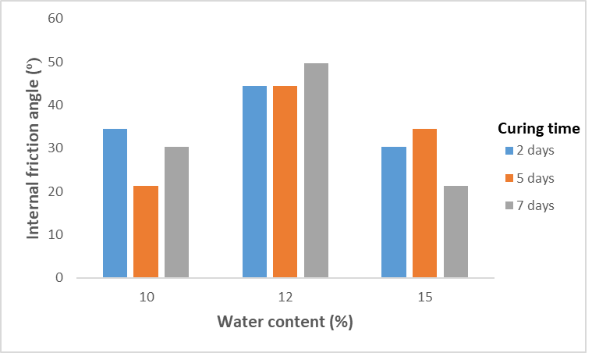
Figure 6. Friction angle of fine sand soil with different water contents

In contrast, at 12% water content, the friction angle remained consistently high across all curing durations of ~45° at 2 and 5 d and reached ~52° at 7 d, which is the highest recorded value in this study. This indicates that 12% moisture provides optimal hydration conditions for Guar Gum activation, resulting in a uniform distribution of the hydrogel throughout the soil matrix. Under these conditions, the gel binds particles and preserves intergranular contact, enabling the development of a structurally robust matrix that maintains frictional resistance, even as cohesion increases. Extended curing appears to strengthen this effect, likely through improved polymer-soil adhesion and network maturity.
At 1 water content of 15 %, the internal friction angle ranged from ~30–35° during early curing, but dropped sharply to ~22° after 7 days. This decline reflects the negative effects of excessive moisture, which can oversaturate the system, leading to biopolymer dilution and reduced inter-particle friction. As the water content increases beyond the optimal range, Guar Gum may act more as a dispersant than a binder, leading to a loss of shear resistance due to reduced particle interlock and elevated pore water pressure.
These findings highlight a clear cause-and-effect relationship between the water content, curing time, and shear strength mechanisms in biopolymer-treated soils. At ideal moisture levels (12%), a synergistic balance was achieved between hydration, interparticle contact, and gel development, maximising both the frictional and cohesive contributions to the shear strength. By contrast, under- or over-saturation disrupts this balance, leading to performance deterioration, particularly for longer curing durations.
From a theoretical perspective, the results suggest that the internal friction angle (φ), as defined in the Mohr–Coulomb failure criterion, is not static in biopolymer-treated soils, but dynamically evolves with curing and moisture conditions. This study advances the understanding of biopolymer–soil interactions by demonstrating that frictional strength is sensitive to the hydration state and that optimal water content is crucial not only for cohesion but also for maintaining shear resistance in stabilised fine-grained soils.

Comparison with previous research
This subsection presents a comparative analysis of the findings of the current study with those of previous studies on biopolymer-treated soils, particularly those incorporating Guar Gum. The comparison focuses on the trends in shear strength parameters (cohesion and internal friction angle) under varying Guar Gum concentrations, water contents, and curing durations. In doing so, the discussion highlights both the alignment and divergence of this study's outcomes with the global literature, thereby reinforcing its scientific contribution.
The observed increase in cohesion with higher Guar Gum concentration and extended curing duration in this study aligns with the findings reported by Sujatha and Sivaraman [32], who demonstrated time-dependent strength gain in clayey soils treated with Guar Gum, attributed to progressive hydrogen bonding and hydrogel network formation. Similarly, Yogeshwar and Sonthwal [31] identified 1% Guar Gum as the optimal dosage for improving unconfined compressive strength (UCS) and California Bearing Ratio (CBR), consistent with the peak cohesion observed in this study at 1% Guar Gum after 5 days of curing. However, while previous studies have focused predominantly on cohesive soils, the current study extends these observations to sandy loam soil and specifically investigates shear strength behaviour, offering a more application-oriented evaluation relevant to geotechnical design.
Overall, this study builds upon and extends the existing literature by applying shear-strength-based evaluation to sandy loam soil, a material type that has received limited attention in biopolymer research. The findings provide a more nuanced understanding of how Guar Gum interacts with mixed soil textures and contribute to the broader body of work aimed at incorporating sustainable, bio-based additives into mainstream soil stabilisation practices.

CONCLUSION
This study investigated the influence of the Guar Gum biopolymer on the shear strength behaviour of fine sand soil through a series of direct shear tests conducted in accordance with ASTM D3080-04. The experimental program focused on evaluating the effects of varying Guar Gum concentrations (1%, 3%, and 5%) and water content (10%, 12%, and 15%) under different curing durations (2, 5, and 7 d), with shear strength parameters (cohesion and internal friction angle) used as key indicators of soil performance.
The results demonstrated that Guar Gum concentration and curing time have a significant effect on soil cohesion. At a constant water content of 10%, the cohesion increased with curing time, with the highest value observed at 5% Guar Gum after seven days. However, excessive concentrations during short curing periods can lead to biopolymer agglomeration and suboptimal bonding. The internal friction angle was generally the highest at 3% concentration and shorter curing times, suggesting that an optimal balance between the frictional and cohesive mechanisms is necessary to maximise the shear resistance.
In terms of water content, 10–12% moisture yielded the most favourable results. The highest cohesion was achieved at 10% water content and 5 days of curing, whereas the internal friction angle peaked at 12% water content after 7 days. Higher moisture levels (15%) were found to reduce both the cohesion and friction angle, likely owing to the dilution of the biopolymer matrix and the disruption of interparticle bonding.
Overall, the findings confirm that Guar Gum is an effective and environmentally friendly soil stabiliser for fine sand soils when key parameters such as biopolymer dosage, moisture content, and curing duration are optimised. This study provides valuable insights into the application of biopolymer-based stabilisation techniques in geotechnical engineering, offering a sustainable alternative to conventional chemical stabilisers.

ACKNOWLEDGMENT
The authors express their sincere gratitude to the Karbonara Research Institute for the invaluable support and resources provided throughout this research. Special thanks are extended to the Civil Engineering Department of BINUS University for their continuous guidance and access to necessary facilities and equipment. The authors acknowledge the use of AI-powered language models, particularly ChatGPT, in assisting with the drafting and refinement of this manuscript, while affirming that the research methodology, analysis, and conclusions remain entirely the work of the author.

AUTHOR CONTRIBUTION
MDK conducted the experiment, RS prepared the manuscript and data analysis, IGMS reviewed the manuscript, AS reviewed the manuscript

DATA AVAILABILITY
Experimental results and analysis https://zenodo.org/records/15200932

REFERENCES

[1] B. Bagriacik, B. Ok, and M. T. M. A. Kahiyah, “An experimental study on improvement of cohesive soil with eco-friendly guar gum,” Soils and Rocks, vol. 44, no. 2, Apr. 2021, doi: 10.28927/SR.2021.060020.
[2] S. Kumar, B. D. Yadav, and R. Raj, “A review on the application of biopolymers (xanthan, agar and guar) for sustainable improvement of soil,” Aug. 01, 2024, Springer Nature. doi: 10.1007/s42452-024-06087-7.
[3] U. Zada et al., “Recent advances in expansive soil stabilization using admixtures: current challenges and opportunities,” Case Studies in Construction Materials, vol. 18, no. November 2022, p. e01985, 2023, doi: 10.1016/j.cscm.2023.e01985.
[4] F. Ayub and S. A. Khan, “An overview of geopolymer composites for stabilization of soft soils,” Constr Build Mater, vol. 404, p. 133195, 2023, doi: https://doi.org/10.1016/j.conbuildmat.2023.133195.
[5] S. R. Rabab’ah, A. A. Sharo, M. M. Alqudah, A. M. Ashteyat, and H. O. Saleh, “Effect of using Oil Shale Ash on geotechnical properties of cement-stabilized expansive soil for pavement applications,” Case Studies in Construction Materials, vol. 19, no. October 2022, p. e02508, 2023, doi: 10.1016/j.cscm.2023.e02508.
[6] P. T. Simatupang, Idrus M. Alatas, Ayu K. Redyananda, and Eko A. Purnomo, “Shear Strength and Durability Behaviors of Compacted Weathered Clay Shale Mixture Using Portland Cement,” Journal of the Civil Engineering Forum, vol. 8, no. May, pp. 169–178, 2022, doi: 10.22146/jcef.3491.
[7] D. Jifang et al., “Dynamic response and densification mechanism of dynamic compaction for silt soil through a large scale field test at Daxing Airport,” Soil Dynamics and Earthquake Engineering, vol. 190, p. 109201, 2025, doi: https://doi.org/10.1016/j.soildyn.2024.109201.
[8] Y. Xiang, H. Liu, G. Dai, and Z. Ji, “Analytical approach to influencing mechanism of cement-soil reinforcement on horizontal dynamic response of single piles,” Soil Dynamics and Earthquake Engineering, vol. 194, p. 109337, 2025, doi: https://doi.org/10.1016/j.soildyn.2025.109337.
[9] H. OuYang, X. Chen, Z. Gong, C. Zuo, G. Dai, and W. Gong, “Large-scale model test study on lateral bearing characteristics of semi-rigid pile with cement-soil reinforcement under multistage loading and unidirectional multi-cycle loading in clay,” Soil Dynamics and Earthquake Engineering, vol. 195, p. 109421, 2025, doi: https://doi.org/10.1016/j.soildyn.2025.109421.
[10] Z. Li, K. Kasama, L. Hu, J. Yu, Y. He, and Y. Yahiro, “The strength evaluation of cement-mixed soil considering mixing quality using image analysis and Bayesian approach,” Comput Geotech, vol. 183, p. 107225, 2025, doi: https://doi.org/10.1016/j.compgeo.2025.107225.
[11] S. Paul, A. Tasnim, and J. Majumder, “Enhancement of micro-mechanical characteristics of expansive soil through synergistic incorporation of jute and nylon fibers with cement,” Results in Engineering, vol. 26, p. 104685, 2025, doi: https://doi.org/10.1016/j.rineng.2025.104685.
[12] M. Saberian, J. Li, M. Boroujeni, D. Law, and C.-Q. Li, “Application of demolition wastes mixed with crushed glass and crumb rubber in pavement base/subbase,” Resour Conserv Recycl, vol. 156, p. 104722, 2020, doi: https://doi.org/10.1016/j.resconrec.2020.104722.
[13] S. Cola, L. Schenato, L. Brezzi, F. C. Tchamaleu Pangop, L. Palmieri, and A. Bisson, “Composite Anchors for Slope Stabilisation: Monitoring of their In-Situ Behaviour with Optical Fibre,” Geosciences (Basel), vol. 9, no. 5, 2019, doi: 10.3390/geosciences9050240.
[14] A. Toghroli, P. Mehrabi, M. Shariati, N. T. Trung, S. Jahandari, and H. Rasekh, “Evaluating the use of recycled concrete aggregate and pozzolanic additives in fiber-reinforced pervious concrete with industrial and recycled fibers,” Constr Build Mater, vol. 252, p. 118997, 2020, doi: https://doi.org/10.1016/j.conbuildmat.2020.118997.
[15] S. Ahmad, M. Shah Alam Ghazi, M. Syed, and M. A. Al-Osta, “Utilization of fly ash with and without secondary additives for stabilizing expansive soils: A review,” Results in Engineering, vol. 22, no. April, p. 102079, 2024, doi: 10.1016/j.rineng.2024.102079.
[16] A. Zeybek, M. Tanyıldızı, İ. Tosun, and A. F. Cabalar, “Geotechnical characteristics of clayey soil stabilized with fly ash and marble dust,” Transportation Geotechnics, vol. 52, p. 101558, 2025, doi: https://doi.org/10.1016/j.trgeo.2025.101558.
[17] J. Balagosa et al., “Field case study of soil columns mixed with wood pellet fly ash blended binder in weathered granite soils,” Case Studies in Construction Materials, vol. 22, p. e04378, 2025, doi: https://doi.org/10.1016/j.cscm.2025.e04378.
[18] W. Hou, J. Wang, D. Feng, S. Liang, F. Liu, and S. Wu, “Experimental Study on Mechanical Properties of Sodium Silicate-Activated Slag/Fly Ash Solidified South China Coastal Soft Soil: Areas of specialization: Geotechnical Engineering,” KSCE Journal of Civil Engineering, vol. 29, no. 5, p. 100125, 2025, doi: https://doi.org/10.1016/j.kscej.2024.100125.
[19] M. Hamid Abed et al., “Experimental feasibility study of using eco- and user-friendly mechanochemically activated slag/fly ash geopolymer for soil stabilization,” Cleaner Materials, vol. 11, no. January, p. 100226, 2024, doi: 10.1016/j.clema.2024.100226.
[20] I. Samuelsson, J. Spross, and S. Larsson, “Integrating life-cycle environmental impact and costs into geotechnical design,” Proceedings of the Institution of Civil Engineers: Engineering Sustainability, vol. 177, pp. 19–30, 2023, doi: 10.1680/jensu.23.00012.
[21] D.-Y. Park, I. Chang, M. Lee, and G.-C. Cho, “Enhancing soil liquefaction resistance and small-strain dynamic properties using cation-crosslinked biopolymer hydrogel,” Soil Dynamics and Earthquake Engineering, vol. 190, p. 109212, 2025, doi: https://doi.org/10.1016/j.soildyn.2025.109212.
[22] D. Feng, Y. Wan, J. Jin, X. He, B. Liang, and Q. Xue, “The effects of wetting-drying and freezing-thawing cycles on mechanical properties of biopolymer-fiber treated soil,” Developments in the Built Environment, vol. 22, p. 100666, 2025, doi: https://doi.org/10.1016/j.dibe.2025.100666.
[23] M. Abdellatef, C. Ho, P. Kobos, B. Gunawan, J. Rimsza, and H. Yoon, “Biopolymer Concrete,” Laboratory Directed Research and Development (LDRD), pp. 1–13, 2022.
[24] I. Chang, J. Im, and G. C. Cho, “Introduction of microbial biopolymers in soil treatment for future environmentally-friendly and sustainable geotechnical engineering,” Sustainability (Switzerland), vol. 8, no. 851, pp. 1–23, 2016, doi: 10.3390/su8030251.
[25] D. Guo et al., “Characterization of xanthan gum biopolymer dehydration and rehydration influence on sandy soil by nuclear magnetic resonance,” Journal of Rock Mechanics and Geotechnical Engineering, 2025, doi: https://doi.org/10.1016/j.jrmge.2025.01.042.
[26] D. M. Cole, D. B. Ringelberg, and C. M. Reynolds, “Small-Scale Mechanical Properties of Biopolymers,” Journal of Geotechnical and Geoenvironmental Engineering, vol. 138, no. 9, pp. 1063–1074, Sep. 2012, doi: 10.1061/(ASCE)GT.1943-5606.0000680.
[27] V. Ivanov and J. Chu, “Applications of microorganisms to geotechnical engineering for bioclogging and biocementation of soil in situ,” Rev Environ Sci Biotechnol, vol. 7, pp. 139–153, Jun. 2008, doi: 10.1007/s11157-007-9126-3.
[28] J. K. Mitchell and C. J. Santamarina, “Biological Considerations in Geotechnical Engineering,” Journal of Geotechnical and Geoenvironmental Engineering, vol. 131, no. 10, pp. 1222–1233, Oct. 2005, doi: 10.1061/(ASCE)1090-0241(2005)131:10(1222).
[29] E. Hartono, W. Diana, A. S. Muntohar, M. Azhar, and L. Indriani, “Effect of curing temperature on the soil physical and mechanical properties on clay shale geopolymer fly ash stabilization,” Sinergi (Indonesia), vol. 29, no. 1, pp. 43–50, 2025, doi: 10.22441/sinergi.2025.1.005.
[30] F. Chang, M. Li, P. Xu, H. Zhou, M. M. Haque, and H. Huang, “Injury severity of motorcycle riders involved in traffic crashes in Hunan, China: A mixed ordered logit approach,” Int J Environ Res Public Health, vol. 13, no. 7, pp. 1–15, 2016, doi: 10.3390/ijerph13070714.
[31] K. C. Yogeshwar and Er. V. K. Sonthwal, “Stabilization of Soil Using Guar Gum Biopolymer,” Int J Res Appl Sci Eng Technol, vol. 11, no. 9, pp. 1018–1027, Sep. 2023, doi: 10.22214/ijraset.2023.55796.
[32] E. Sujatha and S. Sivaraman, “Soil Stabilization Using Biopolymer: A Study on Its Gelling and Hydration Mechanism to Improve Strength,” in Research Developments in Geotechnics, Geo-Informatics and Remote Sensing, Z. A. and K. M. and C. H. I. El-Askary Hesham and Erguler, Ed., Cham: Springer International Publishing, 2022, pp. 59–62.
[33] D. Usha S, A. S, H. P R, A. Dev Madhu, and M. Ann Zachariah, “Guar Gum, Gellan Gum Biopolymer Soil Stabilization,” E3S Web of Conf., vol. 529, 2024, [Online]. Available: https://doi.org/10.1051/e3sconf/202452901053
[34] ASTM, “ASTM D3080/D3080M-23 Standard Test Method for Direct Shear Test of Soils Under Consolidated Drained Conditions,” ASTM Standard Book, 2023.

