A Predictive Safety and Maintenance Framework For Railway Locomotives: Integrating HAZOP, FMEA, and IoT-Based Risk Mitigation | 

Rifki Muhendra¹*, Zain Fadhlurrohman¹, Farhan Indra Pratama Adi¹, Zulkani¹, Andi Turseno¹
¹Industrial Engineering Study Program, Faculty of Engineering, Universitas Bhayangkara Jakarta Raya, Indonesia

Abstract  Safety and maintenance efficiency are critical challenges in the railway industry, particularly in the use of lifting jacks for locomotive maintenance. This study proposes a predictive maintenance framework that integrates the Hazard and Operability Study (HAZOP), Failure Mode and Effect Analysis (FMEA), and Internet of Things (IoT) technology to detect potential failures in real time. A case study was conducted at a locomotive maintenance depot in Indonesia, where several occupational accidents had been recorded due to lifting jack malfunctions. Based on HAZOP and FMEA analysis, components such as stoppers and drive motors were identified as having high Risk Priority Numbers (RPN), each reaching 512, indicating significant failure risks. The proposed IoT system employs HCSR-04 and MPU6050 sensors to accurately monitor the height and inclination of the equipment. Evaluation results show that the system effectively detects anomalies with minimal data deviation and a low data loss rate during a 10-day testing period. The implementation of this system significantly reduces workplace accident risks, improves maintenance efficiency, and supports digital transformation within the industrial environment. These findings demonstrate that the integration of HAZOP-FMEA and IoT is effective for risk mitigation and can be replicated for other railway components. Moreover, this research opens new avenues for developing AI-based predictive systems and implementing digital twins as part of future smart maintenance strategies.  This is an open access article under the CC BY-SA license   | Keywords:  Predictive Maintenance;  IoT;  HAZOP;  FMEA;  Railway Safety  Article History:  Received: May 2, 2019  Revised: May 29, 2019  Accepted: June 2, 2019  Published: June 2, 2019  Corresponding Author:  Rifki Muhendra  Industrial Engineering Study Program, Faculty of Engineering, Universitas Bhayangkara Jakarta Raya, Indonesia  Email: rifki.muhendra@dsn.ubharajaya.ac.id

INTRODUCTION
In the railway industry, locomotive maintenance plays a crucial role in ensuring operational safety and efficiency[1]–[3]. One of the most vital tools in this process is the lifting jack, which is used to elevate locomotives during the inspection and repair of underframe components [4]–[6]. The use of lifting jacks enables technicians to access and maintain essential parts such as the traction system, brakes, and suspension. However, a malfunction of the lifting jack can lead to serious workplace accidents, disrupt train operations, and increase maintenance costs due to unplanned repairs.
Based on case study data from a locomotive maintenance depot in Indonesia, several workplace accidents were reported related to the use of lifting jacks. Between 2020 and 2022, incidents included workers being trapped between the jack stopper and the locomotive underframe, slipping during crane hook installation, and electrical shocks caused by exposed wiring. These incidents resulted in a range of injuries, from minor bruises and lacerations requiring stitches to significant mobility impairments. These findings highlight that, despite regular maintenance practices, the risk of lifting jack failure remains present, indicating the need for more advanced methods to enhance workplace safety.

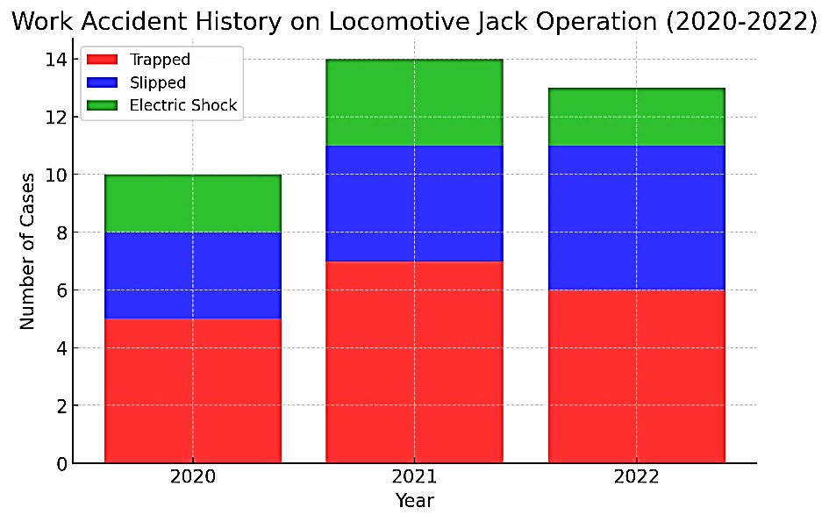
Figure 1. Work Accident History on Locomotive Jack Operation (2020–2022)

To date, conventional methods such as the Hazard and Operability Study (HAZOP) and Failure Mode and Effect Analysis (FMEA) have been widely applied to identify risks and design mitigation strategies. HAZOP is intended to identify potential hazards within operational systems [7]–[9], while FMEA analyzes failure modes and their impacts [10]–[12]. However, both approaches are reactive in nature, where preventive actions are taken only after risks have been identified based on past experiences or incidents. This reactive approach is less effective in addressing risks that require real-time detection and early warning prior to failure occurrence.
Numerous previous studies have been conducted to address technical and safety-related challenges concerning lifting jack systems and railway infrastructure. These studies include stability analysis of jack-up platforms, development of multi-agent control systems, structural design using finite element simulations, and the integration of virtual reality and wireless sensor technologies for equipment condition monitoring. In addition, some research has explored risk evaluation and maintenance frameworks using multi-criteria decision-making methods. A summary of these previous studies is presented in Table 1, serving as a foundation for further research development.

Table 1. Review of Relevant Literature
No | Title | Method | Contribution
1 | Research on vehicle lifting jack structure failure trend on basis of static strength analysis [13] | Nonlinear FEA simulation considering contact between components under typical working conditions. | Provides a simulation-based static analysis method to predict failure trends, enhancing safety and accident prevention.
2 | Stability study on a lifting jack-up platform by moses software[14] | MOSES simulation; case study of one jack-up platform; crane arm angle variation analysis based on CCS standards. | Provided a software-based approach for stability analysis, aiding designers and operators in risk avoidance during offshore lifting.
3 | Asynchronous Resilient Wireless Sensor Network for Train Integrity Monitoring[15] | Prototype design with redundant WSN nodes; simulation and experiments with 20-node networks under interference. | Advances resilient, energy-efficient WSN architecture for safety-critical rail applications and IoT integration.
4 | Suggestion of Maintenance Criteria for Electric Railroad Facilities Based on Fuzzy TOPSIS[16] | DSM and Fuzzy TOPSIS applied for multi-criteria evaluation; quantified weights of technical aspects | Offers a quantitative, structured model for electrical railway facility maintenance planning.
5 | Finite Element Analysis on the Rack of the JC-17B Mobile Lifting Jack[17] | FEA-based simulation using Pro/E and ANSYS; includes stress analysis, modal vibration analysis, and redesign of motor position and rack thickness. | Presents an efficient, simulation-based design method for mobile lifting jack development, supporting future tech upgrades
6 | Consensus Control for Multiagent Systems under Asymmetric Actuator Saturations with Applications to Mobile Train Lifting Jack Systems[6] | Multi-agent system control theory; consensus-based control algorithm; Lyapunov-based stability analysis; real-world TLJS experiments. | Offers an adaptive consensus control for asymmetric actuator systems, applicable to TLJSs for safer and smarter operations.
7 | HIRADC Analysis for Rolling Stock Body Lifting Ngrombo Railway Maintenance Center[18] | HIRADC methodology: hazard identification, risk assessment, control determination for lifting activities. | Provides an applicable HIRADC model for railway maintenance safety system improvement.
8 | Dynamic Simulation of Railway Locomotive and Detection of Electromechanical Equipment Based on Virtual Reality Technology[19] | Matlab-Simulink for motion simulation; VR for visualization and training; CAD for disassembly simulations. | Pioneers VR-integrated simulation in rail operations and training; improves realism and maintenance efficiency.
9 | Mechanical Analysis on the Frame of JC-17B Mobile Lifting Jack[20] | Simulations using Pro/E and ANSYS; static analysis (stress and strain), buckling, and vibration frequency analysis. | Provides a strong theoretical basis for future development of lifting jack frames and prevention of structural resonance.
10 | A Predictive Safety and Maintenance Framework For Railway Locomotives: Integrating HAZOP, FMEA, and IoT-Based Risk Mitigation (Present) | Case study in Indonesian depot; identified risks with HAZOP & FMEA; developed IoT system | Provides a replicable predictive framework for railway components; supports future smart maintenance using AI and digital twin.

While HAZOP and FMEA are both widely applied in industrial safety analysis, the literature reveals that their integration remains limited in scope, often confined to sequential or manual application without digital support. Most studies conduct HAZOP and FMEA separately or use them as static tools for pre-operational risk assessment, which lacks adaptability in dynamic environments such as railway maintenance depots. For example, prior works often use HAZOP to identify hazards and FMEA to prioritize them, yet fail to incorporate real-time data or feedback loops to continuously update risk levels. Additionally, integrated HAZOP-FMEA frameworks often overlook the potential of IoT-based data to enhance failure mode detection and risk prediction. This study addresses these limitations by introducing a fully integrated, real-time predictive system that fuses HAZOP and FMEA with IoT sensor data, enabling dynamic risk re-evaluation and early warning capabilities. This approach goes beyond static risk registers and offers a novel contribution to digital safety systems, particularly in high-risk environments like locomotive maintenance.
Despite the valuable contributions of these studies, none have comprehensively integrated formal risk analysis methods such as HAZOP and FMEA with Internet of Things (IoT) technology into a real-time predictive system for monitoring the condition of locomotive lifting jacks. In fact, workplace accidents involving lifting equipment in railway depots still frequently occur due to undetected functional failures. Therefore, the present study is of particular importance as it offers a predictive safety and maintenance framework that combines structured risk assessment with digital transformation through IoT sensors. This approach is expected to enhance both efficiency and safety in maintenance activities, while also paving the way for the development of intelligent, data-driven maintenance systems in the future.
The advancement of Internet of Things (IoT) technology presents new opportunities to implement sensor-based monitoring systems capable of detecting anomalies in lifting jack operations in real time. IoT enables direct data collection from operating equipment, transmitting information to monitoring systems that analyze failure patterns and provide early warnings[21]–[23]. Through this approach, maintenance practices can shift toward predictive maintenance systems, in which potential issues are identified and addressed proactively—before they disrupt operations.
Although HAZOP and FMEA methods have been widely applied in industry, the integration of these approaches with IoT technology to develop an effective predictive maintenance system remains relatively rare. Currently, there is a lack of comprehensive frameworks that combine HAZOP-FMEA-based risk analysis with real-time IoT-based monitoring in the context of railway maintenance. Yet, such integration has the potential to deliver significant benefits in improving workplace safety and maintenance efficiency.
This study aims to address this gap by first conducting a risk analysis of lifting jack failures before developing an IoT-based monitoring system. The system will employ a combination of sensors to continuously monitor the operational parameters of the lifting jack in real time. The collected data will be analyzed using the Risk Priority Number (RPN) method from FMEA to determine risk levels [11], [12], [24] [24], [25] and design more effective mitigation strategies .
The main contributions of this study include:
- The development of an IoT-based predictive maintenance framework that integrates HAZOP and FMEA methods for detecting lifting jack failures;
- The implementation of IoT sensors in a real-time monitoring system, enabling earlier anomaly detection compared to conventional inspection methods;
- The optimization of risk mitigation strategies through a data-driven approach, thereby improving maintenance efficiency and reducing the likelihood of workplace accidents.
Through this approach, the study aims to provide an innovative solution applicable within the railway industry to enhance both workplace safety and maintenance effectiveness.
This article is structured to provide a comprehensive overview of the conducted research. The Literature Review section discusses the fundamental concepts of locomotive maintenance, the application of HAZOP and FMEA methods in industrial risk management, and the utilization of IoT in predictive maintenance systems. The Research Methodology section outlines the development of the proposed framework, the data collection process, risk analysis, and the design of the IoT-based monitoring system. The Results and Discussion section presents the experimental outcomes and system evaluation, including the effectiveness of integrating HAZOP-FMEA methods with real-time monitoring. Finally, the Conclusion and Recommendations section summarizes the key findings of the study and provides suggestions for future developments in predictive maintenance systems within the railway industry.

METHOD
Research Framework
This study was conducted at a railway company in Indonesia that operates a locomotive maintenance facility utilizing a lifting jack system as the primary tool for servicing the underframe of locomotives. The research focuses on one of the main locomotive maintenance depots, where lifting jacks are routinely used to elevate locomotives for the inspection and repair of critical components such as traction systems, brakes, and suspension. This study proposes a predictive maintenance framework that integrates HAZOP, FMEA, and IoT technologies to enhance occupational safety in locomotive maintenance[26], [27]. The research begins by identifying potential hazards in lifting jack operations using the HAZOP method and assessing failure modes through FMEA. Once the risks are identified, IoT sensors are employed to collect real-time operational data to detect anomalies before failures occur.
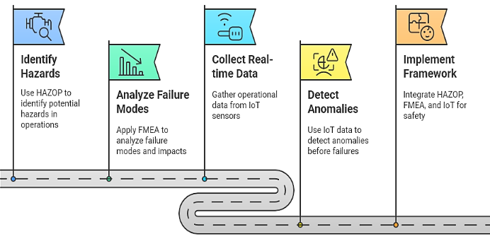
Figure 2. Enhancing Workplace Safety in Locomotive Maintenance
The study begins with hazard identification using the HAZOP (Hazard and Operability Study) method, aimed at identifying potential operational deviations that could lead to accidents or system failures in the lifting jack. Once the hazards are identified, FMEA (Failure Modes and Effects Analysis) is applied to evaluate possible failure modes and their impacts on the system. The results of this analysis are used to determine the level of risk and prioritize the necessary mitigation actions.
To enhance the reliability of predictive maintenance, IoT sensors are installed on the lifting jack to collect real-time operational data. The data collected includes information on the position, tilt, and stability of the lifting jack during operation. Ultrasonic and gyroscope sensors are used to ensure the stopper's position and detect potential imbalances. The collected data is analyzed using anomaly detection algorithms to identify deviations from normal conditions before failures occur. When operational parameters exceed safe limits, the system issues early warnings to enable preventive actions.
The final stage of this study involves the implementation of an integrated framework combining risk analysis through HAZOP and FMEA, IoT-based data collection, and real-time monitoring with anomaly detection. Data from the IoT sensors is transmitted via an ESP32 microcontroller to Google Firebase, enabling real-time monitoring of the lifting jack’s condition. With this system in place, maintenance can be carried out predictively, thereby reducing the risk of equipment failure that could potentially lead to workplace accidents. Overall, the research methodology offers an innovative solution for IoT-based predictive maintenance by leveraging risk analysis and real-time monitoring approaches. This system is expected to enable the lifting jack to operate more safely, efficiently, and free from unexpected failures, ultimately enhancing workplace safety [28].

IoT-Based Predictive Maintenance System
This study proposes an IoT-based predictive maintenance system to enhance occupational safety in the maintenance of locomotive lifting jacks. The system is designed to monitor the condition of the lifting jack in real time by integrating various devices, sensors, and communication technologies. The system architecture consists of several key components, including sensor nodes, a router, a database, and a web- or mobile-based monitoring platform [29], [30].
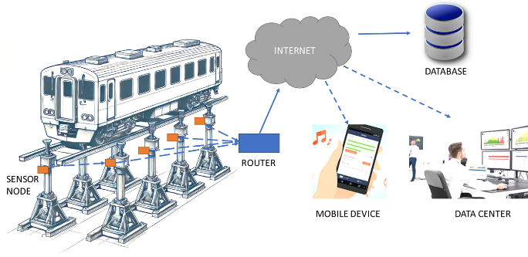
Figure 3. IoT-Based Predictive Maintenance System
The sensor node serves as the core unit of the system, responsible for collecting data from the lifting jack. It comprises a NodeMCU ESP32, which functions as the microcontroller and primary communication module[31], [32]. The ESP32 processes data from the sensors and transmits it to the server via the internet. The HC-SR04 sensor is used to measure the height or distance of the lifting jack stopper to ensure safe positioning during operation [33], [34], while the MPU6050 sensor functions as both an accelerometer and gyroscope to detect tilt or imbalance in the lifting jack[35], [36]. The data collected by these sensors is processed by the ESP32 and transmitted to the internet through a router for further monitoring.
The router acts as a communication bridge between the sensor node and the internet[37]. After the sensor node gathers operational data, the router sends the data to the cloud via an internet connection. The router ensures fast and real-time data transmission to the monitoring system. Once the data is sent online, it is stored in a cloud-based database such as Google Firebase or other web platforms. This database serves as the primary storage for all operational data, which can later be analyzed to detect anomalies or predict lifting jack failures.
The system enables sensor data to be monitored from various devices, including computers at the data center and mobile devices. The data center functions as the monitoring hub, presenting sensor data in the form of graphs, trends, and advanced analytics, allowing operators or technicians to access this information for maintenance decision-making. Additionally, the data can be accessed via mobile devices through a web-based application or Firebase interface. If an anomaly is detected in the lifting jack’s operation, the system will issue a notification or alert to the user, enabling prompt preventive action.
Overall, the system integrates sensor nodes, communication networks, cloud storage, and monitoring platforms to enable effective predictive maintenance. With real-time monitoring, the risk of lifting jack failure can be minimized, maintenance efficiency can be improved, and workplace safety can be better ensured. The implementation of this system will assist operators in maintaining the optimal condition of the lifting jack and preventing accidents caused by equipment failure.

Sensor Data-Based Failure Prediction Algorithm
The methods used in the completion of the research are written in this section. The method includes research chronological, including research design, research procedure (in the form of algorithms, Pseudocode or other), instruments, and analysis techniques used in solving problems. In addition, the description of the course of research should be supported by references so that the explanation can be accepted scientifically [13].
This code is designed to detect potential system failures in an IoT-based environment using the NodeMCU ESP32 as the main microcontroller. The system utilizes two types of sensors: the HC-SR04 for distance measurement and the MPU6050 for detecting tilt angles and acceleration. During the initialization phase, the microcontroller is configured to read data from both sensors and connect the device to a WiFi network in order to transmit the data to Firebase for real-time monitoring.
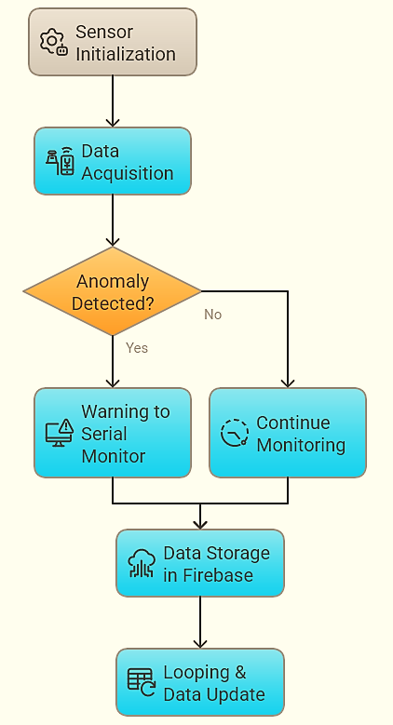
Figure 4. Sensor Data-Based Failure Prediction Algorithm
During the data acquisition process, the HC-SR04 sensor is activated to measure distance using ultrasonic waves, while the MPU6050 reads acceleration values, which are then converted into tilt angles. Once data from both sensors is obtained, the system performs an analysis to detect anomalies. If the detected change in distance exceeds a predefined threshold, the system considers it as a potential mechanical failure. Likewise, if a significant change in tilt angle is detected, the system identifies a possible imbalance in the lifting jack that could affect its stability. In the event of an anomaly, a warning message is displayed through the Serial Monitor.
To ensure the data can be accessed and further analyzed, the system transmits sensor data to Firebase every five seconds, including distance, tilt angle, and anomaly status. Firebase serves as a cloud storage platform that enables users to monitor the data in real time via computer or mobile devices. With each iteration of the loop, new data is updated and compared to the previous data to improve the accuracy of failure pattern detection.

RESULTS AND DISCUSSION
Risk Assessment Results Using HAZOP-FMEA
Results and Discussion should be an objective description of the results and should be in relation to the purposes of research. The discussion also needs to be supported by the reference list [14][15]. Results can be presented in figures, tables, and others that make the readers understand easily.
The HAZOP (Hazard and Operability Study) method was applied to systematically identify potential hazards in the operation of lifting jacks used for locomotive maintenance. This analysis focused on deviations from normal operating conditions that could lead to workplace accidents or equipment failures. Each deviation was categorized based on possible causes, associated risks, and suggested preventive actions.

Table 2. HAZOP Worksheet.
No | Process | Identified Issues | Possible Consequences | Risk Matrix (L, C, R) | Safeguards | Recommendations
1 | Preparing the jack | Jack wheel detaches from the axle | The jack may tilt or fall | 3, 2, M | None | Add a locking nut on the wheels
2 | Lifting process starts | Stopper does not rise and does not push the load support | Load support does not move up, motor overheats, locomotive tilts | 5, 4, E | None | Perform testing before use, add an automatic sensor on the motor, install additional safety nuts on the stopper
3 | Holding the locomotive | Voltage below 220V | The jack cannot sustain the load for long, sudden drop, reduced motor power | 3, 4, H | None | Replace cables between jacks, improve the electrical power distribution system

The HAZOP analysis identified three critical deviations (see table 2): jack wheel instability, stopper malfunction, and unstable electrical supply. These issues pose significant operational and safety risks, potentially leading to accidents or system failures. Mitigation measures such as automatic sensor integration, electrical system reinforcement, and additional safety locks were proposed to enhance system reliability.
Building upon the findings from HAZOP, a Failure Modes and Effects Analysis (FMEA) was conducted to assess potential failure modes, their severity, occurrence likelihood, and detection capability. The Risk Priority Number (RPN) was calculated to rank failure risks and prioritize mitigation strategies.

Table 3 Failure Mode Identification Using FMEA
Component & Function | Material | Failure Mode | Effect of Failure | Cause of Failure | S | O | D | RPN | Control Detection
Stopper (support to hold load movement) | Steel | Stopper does not rise | Load support does not move up, locomotive remains stationary | Stopper nut becomes loose | 8 | 8 | 8 | 512 | Perform pre-operation testing
Drive motor | - | Motor overheats | Potential motor damage, failure to lift load | Stopper does not move up, causing the motor to keep running | 8 | 8 | 8 | 512 | Conduct periodic maintenance on stopper components

The stopper malfunction, motor overheating, and locomotive tilting were identified as the most critical failure modes, each with an RPN exceeding 500, indicating high-risk conditions (see table 3). If left unaddressed, these failures could lead to mechanical damage and workplace accidents. Therefore, implementing preventive measures such as systematic pre-use checks and automatic failure detection sensors was deemed necessary.

Root Cause Analysis Using 5W+1H
To further understand the underlying causes of stopper failures, a 5W+1H (What, Who, Why, When, Where, How) analysis was conducted. This method helps pinpoint failure root causes and determine targeted solutions.

Table 4. 5W+1H Failure Analysis of Stopper Component
What | Who | Why | When | Where | How | Potential Solution
Stopper does not rise and fails to push the load support | Operator | Loose stopper nut | During jack operation | Worksite | Monthly check | Install locking nut and automatic sensor
Motor overheating | Operator | Stopper failure causes motor to keep running | During jack operation | Worksite | Monthly check | Install automatic switch-off sensor
Locomotive tilts | Operator | Uneven jack height | During jack operation | Worksite | Monthly check | Install height sensors to standardize jack height

The 5W+1H analysis confirmed that the primary causes of stopper failure were loose locking mechanisms, excessive motor runtime, and inconsistencies in jack height adjustment (see table 4). To prevent recurrence, locking nuts, automatic shutdown sensors, and jack height sensors were recommended as key solutions.

IoT System Performance Evaluation
The evaluation of the IoT system performance aims to assess the accuracy, stability, and responsiveness of the sensors in monitoring the condition of the lifting jack in real time. The sensor node used in this system consists of an ESP32 microcontroller, an MPU6050 gyroscope, and an HC-SR04 ultrasonic sensor. These components work together to detect changes in the tilt angle and height of the lifting jack and transmit the data to a web-based platform.
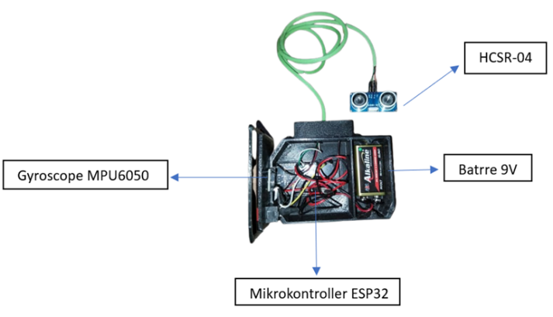
Figure 5. Overview Sensor Node IoT
The sensor node used in this system plays a crucial role in the monitoring process. Figure 5 illustrates the sensor node configuration, which consists of several main components: the ESP32 microcontroller, responsible for processing data and transmitting it to the IoT platform; the MPU6050 gyroscope, which measures the tilt of the lifting jack to detect its stability; and the HC-SR04 ultrasonic sensor, which measures the distance between the lifting jack and the surface to monitor lifting height. In addition, the system uses a 9V battery as the main power source, allowing the device to operate independently.

Figure 6. Distance Measurement Comparison Between the HC-SR04 Sensor and Measuring Tape
The graph in Figure 6 presents a comparison of distance measurements between the HC-SR04 sensor and manual measurements using a measuring tape across ten consecutive trials. The graph indicates that the results from both methods are very close, with nearly identical trend lines. This demonstrates that the HC-SR04 sensor possesses a high degree of accuracy in measuring vertical distance within the lifting jack system. The difference—illustrated by the gray line—remains close to zero at each measurement point, indicating that the deviation between the sensor readings and manual measurements is minimal and consistent. This proves that the HC-SR04 ultrasonic sensor is capable of providing data nearly equivalent to that obtained through conventional measurement methods, making it suitable for use in IoT-based monitoring systems. The consistency of these results also shows that the sensor performs stably across various distance ranges, from short to long, without showing significant deviations. Therefore, the use of the HC-SR04 sensor in this system enhances the efficiency and effectiveness of real-time lifting height monitoring without compromising data accuracy.

Figure 7. Comparison of Tilt Angle Measurements Between MPU6050 Sensor and Inclinometer
The graph above (see figure 7) presents a comparison of tilt angle measurements between the MPU6050 sensor and a manual measurement reference using an inclinometer. The results from ten trials show that both devices exhibit a nearly identical trend pattern, with angle values steadily increasing throughout the trials. The difference line, depicted by the gray curve, indicates that the deviation between MPU6050 and inclinometer readings remains very small and stable, reflecting minimal deviation. This signifies that the MPU6050 sensor demonstrates a high level of accuracy and precision in detecting changes in tilt angle. The sensor’s performance suggests that the gyroscope-accelerometer technology utilized by MPU6050 is reliable enough to replace conventional measuring instruments, particularly in IoT-based angle monitoring systems that require real-time data accuracy and stability. With its high accuracy and low deviation, integrating the MPU6050 into the lifting jack system can significantly contribute to accurately monitoring the equipment’s position and enhancing operational safety.
To statistically validate the accuracy of the HC-SR04 and MPU6050 sensors, a paired t-test was conducted comparing sensor measurements with manual reference values (using a measuring tape and inclinometer, respectively) across ten trials. The null hypothesis assumes no significant difference between the two measurement methods. For distance measurement (HC-SR04 vs. measuring tape), the t-test yielded a p-value of 0.421 (α = 0.05), indicating that there is no statistically significant difference between sensor and manual readings. Similarly, for tilt angle measurement (MPU6050 vs. inclinometer), the p-value was 0.389, also exceeding the 0.05 threshold. These results support the conclusion that both sensors provide measurements that are statistically equivalent to conventional tools, thereby confirming their reliability for use in predictive monitoring systems. The inclusion of this statistical test reinforces the accuracy claims presented earlier in the graphical comparisons (Figures 6 and 7), offering a more robust justification for the adoption of IoT-based measurements in critical maintenance tasks.

Figure 8. Measurement of Sensor Data Transmission to the Database
The graph above (see figure 8) illustrates the number of sensor data transmissions to the database over a 10-day period, from May 6 to May 15, 2024. Four key indicators are presented in this graph: the number of actual data successfully transmitted (Number of data), the ideal number of data that should have been transmitted (Ideal), the number of lost data points (Loss data), and the percentage of data loss (% Loss data). Overall, the number of actual data received is slightly lower than the ideal number each day, indicating some data loss during the transmission process. However, both the absolute and percentage values of data loss remain low and relatively consistent on a daily basis, which reflects the stability of the IoT data communication system. The system's performance in transmitting sensor data to the database can be considered reliable, given the minimal data loss observed. The losses are likely caused by external factors such as network disturbances, brief power interruptions, or server latency. Therefore, the IoT system used in this study demonstrates high reliability and is suitable for continuous long-term monitoring applications.
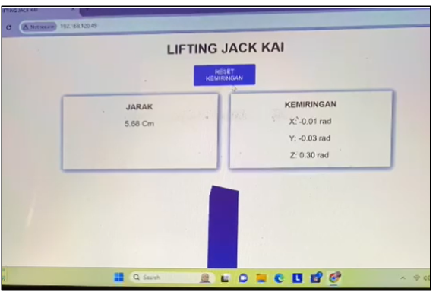
Figure 9. User Web Interface for the Lifting Jack Monitoring System
Figure 9 above displays the web interface of the Lifting Jack monitoring system, which is accessed via a browser on a PC or laptop. This interface shows two key parameters from the sensor readings in real-time: distance and inclination. The detected distance is 5.68 cm, measured by the HCSR-04 ultrasonic sensor. Meanwhile, the inclination values along three axes (X, Y, and Z) are recorded by the MPU6050 sensor, with results of X: -0.01 rad, Y: -0.03 rad, and Z: 0.30 rad, respectively. This information is crucial for accurately monitoring the condition and stability of the lifting jack, especially to ensure that the lifting process occurs within safe inclination limits. The interface is designed to be simple yet informative, facilitating quick user comprehension of the tool’s condition and enhancing the effectiveness of remote monitoring within the implemented IoT system.
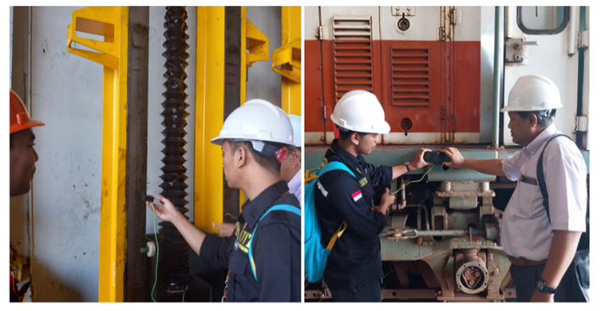
Figure 10. System Implementation in a Locomotive Maintenance Company
Figure 10 illustrates the real-world implementation of the sensor monitoring system at a locomotive maintenance company, carried out by a field technical team. The image shows two main activities during the installation and testing process: on the left side, the team is seen installing or calibrating the sensor on the structure of the lifting jack, which is used to elevate the locomotive body for maintenance or inspection purposes. On the right side of the image, the team appears to be testing sensor readings beneath the locomotive, likely validating distance or inclination measurements directly using a mobile device or mini computer. The presence of personal protective equipment (such as safety helmets and work uniforms) indicates that the activity is conducted following occupational safety procedures. This documentation demonstrates that the developed system is not limited to simulations or laboratory setups but has been successfully deployed in a real industrial environment. It forms part of the ongoing digitalization of locomotive maintenance processes through the application of IoT technology.
Implications for the Railway Industry
- Cost Efficiency & Enhanced Work Safety through Predictive Maintenance
The implementation of IoT-based predictive maintenance in the railway industry offers two major benefits: cost efficiency and improved work safety. By enabling early detection of potential equipment failures, this system helps reduce downtime, extend equipment lifespan, and lower maintenance costs by up to 30–40% compared to time-based maintenance [38]. In this study, the use of HC-SR04 and MPU6050 sensors allows real-time monitoring of distance and inclination on lifting jacks, providing early warnings of deviations that may indicate failure risks.
This approach directly reduces the likelihood of work-related accidents caused by lifting device failures [17]. Moreover, it enhances logistical efficiency, optimizes technician scheduling, and supports historical data analysis for strategic, data-driven decision-making [39]. Through alerts delivered via web interfaces and mobile applications, the system aligns with the safety-by-design principle [40], reducing mental workload, ensuring compliance with SOPs, and strengthening the safety culture in the workplace.
- Potential Application of IoT in Other Railway Maintenance Systems
The success of this predictive maintenance system demonstrates the broader potential of IoT implementation across other critical railway components, such as braking systems, suspension, bearings, and traction motor cooling systems. IoT excels in integrating sensor data collection, real-time transmission, and predictive analytics to identify wear or anomalies before they escalate[41], [42].
Using the same system architecture—comprising sensor nodes, microcontrollers, wireless communication, and cloud storage—railway companies can replicate this framework for various maintenance tasks in depots or onboard trains. For instance, vibration and temperature sensors can be used on wheel bearings to detect overheating or excessive friction, while accelerometers can identify structural imbalances or abnormal impact forces on train frames [43].
This leads to the development of an interconnected maintenance system, where the condition of all major components is monitored centrally via digital platforms. Maintenance can thus shift toward a condition-based approach rather than relying solely on mileage or fixed intervals, enhancing flexibility and operational efficiency [44].
Furthermore, broad IoT adoption supports the realization of a smart railway system, where all assets—static and dynamic—are digitally connected for automated monitoring and control. For example, traction motor cooling systems equipped with temperature and airflow sensors can self-regulate cooling intensity and issue warnings in case of overheating, preventing system failures.
In this way, IoT evolves from a mere technical tool into a foundational element for the digital transformation and automation of railway maintenance. Companies that have successfully applied IoT to lifting jacks can leverage this advantage to expand its use, improving infrastructure integrity, reducing system failure risks, and fostering safer, more efficient, and modern railway operations.

Future Research Directions
While the predictive maintenance framework based on HAZOP-FMEA and IoT developed in this study has demonstrated high effectiveness in monitoring lifting jack systems, several promising avenues remain open for future research. One of the most strategic directions is the integration of Artificial Intelligence (AI) and Machine Learning (ML) into the predictive analytics system. The current anomaly detection approach, which relies on threshold-based parameters, works well for known failure patterns but is limited in identifying novel or complex anomalies. By utilizing ML algorithms such as decision trees, support vector machines, or deep learning, the system could be trained on historical data to detect early signs of failure with greater adaptability and precision. As suggested by [45], ML-driven fault detection systems in rolling stock offer significant improvements in accuracy and responsiveness.
Further research can also explore the application of this framework to other critical railway components, such as braking systems, axle bearings, and traction motors. A multi-sensor approach—integrating vibration, temperature, pressure, and current sensors—could provide more comprehensive insights into the condition of these subsystems. This also opens the opportunity to develop a Digital Twin, a dynamic digital representation of physical assets that enables real-time simulation, diagnostics, and optimization. According to [39], Digital Twins play a pivotal role in Industry 4.0 by facilitating more informed and context-aware maintenance decisions in intelligent transportation systems.
Another important direction involves the integration of IoT-based monitoring systems with enterprise-level management tools, including Enterprise Resource Planning (ERP) and Computerized Maintenance Management Systems (CMMS). Such integration would ensure that sensor-generated data not only serves technical diagnostics but also supports operational workflows, such as spare part inventory management, technician scheduling, and safety auditing, leading to a fully digitized and streamlined maintenance ecosystem. In addition, longitudinal studies are needed to evaluate the real-world performance of the IoT system, particularly its hardware durability in harsh environments and data transmission stability under varying network conditions. This includes assessing long-term energy efficiency and ensuring the system's compatibility with daily operational requirements in railway maintenance contexts.

CONCLUSION
This study developed an IoT-based predictive maintenance framework by integrating HAZOP and FMEA methods to enhance the safety and reliability of locomotive lifting jack systems. The risk analysis identified critical failure points, particularly in the stopper and drive motor, with RPN values reaching 512. The proposed IoT system, using HC-SR04 and MPU6050 sensors, successfully detected anomalies in real time with high accuracy and minimal data loss. Real-world implementation confirmed the system's effectiveness in reducing potential failures and enabling early warnings. This integration demonstrates a significant advancement over conventional maintenance approaches and offers a replicable solution for improving safety and operational efficiency in railway maintenance.

ACKNOWLEDGMENT
This research was self-funded. However, the authors utilized the Industrial Laboratory at the Industrial Engineering Program, Faculty of Engineering, Universitas Bhayangkara Jakarta Raya, and collaborated with an Indonesian locomotive maintenance company. In addition, we would like to express our gratitude to our fellow research team members, whose insights and expertise greatly contributed to this study.

REFERENCES
[1] Ferdy Kusumawardana, Arfan Bakhtiar, and Singgih Saptadi, “Locomotive maintenance facility layout design using systematic layout planning method: Case study of Semarang Poncol locomotive depot,” World J. Adv. Res. Rev., vol. 19, no. 3, 2023.
[2] S. Frisch, P. Hungerländer, A. Jellen, B. Primas, S. Steininger, and D. Weinberger, “Solving a real-world Locomotive Scheduling Problem with Maintenance Constraints,” Transp. Res. Part B Methodol., vol. 150, 2021.
[3] D. Baranovskyi, M. Bulakh, A. Michajłyszyn, S. Myamlin, and L. Muradian, “Determination of the Risk of Failures of Locomotive Diesel Engines in Maintenance,” Energies, vol. 16, no. 13, 2023.
[4] N. Van Thuyen, “Calculation, Design and Manufacturing Super Short Height Hydraulic Jack, Double Acting, Lifting Capacity of 30 Tons for Lifting Bridge Beam to Replace Bearings,” SSRG Int. J. Mech. Eng., vol. 10, no. 6, 2023.
[5] D. R. More, A. A. Patil, A. A. Thakare, N. R. Vartak, and M. S. Ansari, “Design and Fabrication of Motorized Hydraulic Jack System,” Int. J. Res. Appl. Sci. Eng. Technol., vol. 10, no. 4, 2022.
[6] X. He, Z. Wang, C. Gao, and D. Zhou, “Consensus Control for Multiagent Systems under Asymmetric Actuator Saturations with Applications to Mobile Train Lifting Jack Systems,” IEEE Trans. Ind. Informatics, vol. 19, no. 10, 2023.
[7] J. Y. Choi and S. H. Byeon, “Hazop methodology based on the health, safety, and environment engineering,” Int. J. Environ. Res. Public Health, vol. 17, no. 9, 2020.
[8] A. de J. Penelas and J. C. M. Pires, “Hazop analysis in terms of safety operations processes for oil production units: A case study,” Appl. Sci., vol. 11, no. 21, 2021.
[9] M. F. Chia and P. K. Naraharisetti, “HAZOP using Stateflow software: Methodology and case study,” Process Saf. Environ. Prot., vol. 179, 2023.
[10] D. Lee, D. Lee, and J. Na, “Automatic Failure Modes and Effects Analysis of an Electronic Fuel Injection Model,” Appl. Sci., vol. 12, no. 12, 2022.
[11] N. KÖK and M. S. YILDIZ, “New Generation FMEA Method in Automotive Industry: An Application,” J. Turkish Oper. Manag., vol. 7, no. 1, 2023.
[12] H. Dyah Susanti, “Risk prevention of plywood product defects using Failure Mode Effect Analysis (FMEA) in the Indonesian plywood processing industry,” Wood Mater. Sci. Eng., vol. 18, no. 6, 2023.
[13] C. Xia and Y. Sun, “Research on vehicle lifting jack structure failure trend on basis of static strength analysis,” in Applied Mechanics and Materials, 2013, vol. 275–277.
[14] Z. J. Lin, B. Y. Zhang, Y. B. Zhang, D. J. Fu, S. L. Feng, and L. Q. Sun, “Stability study on a lifting jack-up platform by moses software,” in Proceedings of the International Offshore and Polar Engineering Conference, 2019, vol. 1.
[15] M. T. Lazarescu and P. Poolad, “Asynchronous Resilient Wireless Sensor Network for Train Integrity Monitoring,” IEEE Internet Things J., vol. 8, no. 5, 2021.
[16] S. Hwang, J. Kim, H. Kim, H. Kim, and Y. Kim, “Suggestion of maintenance criteria for electric railroad facilities based on fuzzy TOPSIS,” Comput. Mater. Contin., vol. 70, no. 3, 2022.
[17] S. Zhang, Q. Chen, and M. Lei, “Finite Element Analysis on the Rack of the JC-17B Mobile Lifting Jack,” in Advances in Transdisciplinary Engineering, 2023, vol. 40.
[18] W. Riyanta, “HIRADC Analysis for Rolling Stock Body Lifting Ngrombo Railway Maintenance Center,” Civ. Eng. Collab., 2023.
[19] Y. Song and Y. Li, “DYNAMIC SIMULATION OF RAILWAY LOCOMOTIVE AND DETECTION OF ELECTROMECHANICAL EQUIPMENT BASED ON VIRTUAL REALITY TECHNOLOGY,” Int. J. Mechatronics Appl. Mech., vol. 14, 2023.
[20] S. Transportation and S. City, “Mechanical Analysis on the Frame of JC- 17B Mobile Lifting Jack,” vol. 0, pp. 1–6, 2024.
[21] Z. Lv, B. Hu, and H. Lv, “Infrastructure Monitoring and Operation for Smart Cities Based on IoT System,” IEEE Trans. Ind. Informatics, vol. 16, no. 3, pp. 1957–1962, 2020.
[22] S. Abolhassani Khajeh, M. Saberikamarposhti, and A. M. Rahmani, “Real-Time Scheduling in IoT Applications: A Systematic Review,” Sensors, vol. 23, no. 1. 2023.
[23] K. Akila and D. J. Evanjaline, “Strengthening IoT-WSN architecture for environmental monitoring,” Int. J. Innov. Technol. Explor. Eng., vol. 8, no. 11, pp. 3339–3347, 2019.
[24] Y. Dwie Nurcahyanie and A. Cahyono, “Identification and Evaluation of Logistics Operational Risk Using the Fmea Method at PT. XZY,” Aptisi Trans. Technopreneursh., vol. 5, no. 1Sp, 2023.
[25] H. Zheng and Y. Tang, “Deng entropy weighted risk priority number model for failure mode and effects analysis,” Entropy, vol. 22, no. 3, 2020.
[26] M. Achouch et al., “On Predictive Maintenance in Industry 4.0: Overview, Models, and Challenges,” Applied Sciences (Switzerland), vol. 12, no. 16. 2022.
[27] P. Nunes, J. Santos, and E. Rocha, “Challenges in predictive maintenance – A review,” CIRP Journal of Manufacturing Science and Technology, vol. 40. 2023.
[28] I. N. Mihigo, M. Zennaro, A. Uwitonze, J. Rwigema, and M. Rovai, “On-Device IoT-Based Predictive Maintenance Analytics Model: Comparing TinyLSTM and TinyModel from Edge Impulse,” Sensors, vol. 22, no. 14, 2022.
[29] A. Aboshosha, A. Haggag, N. George, and H. A. Hamad, “IoT-based data-driven predictive maintenance relying on fuzzy system and artificial neural networks,” Sci. Rep., vol. 13, no. 1, 2023.
[30] S. Nangia, S. Makkar, and R. Hassan, “IoT based Predictive Maintenance in Manufacturing Sector,” SSRN Electron. J., 2020.
[31] A. Anggrawan, S. Hadi, and C. Satria, “IoT-Based Garbage Container System Using NodeMCU ESP32 Microcontroller,” J. Adv. Inf. Technol., vol. 13, no. 6, 2022.
[32] D. Rosandi, J. Junaidi, D. K. Apriyanto, and A. Surtono, “Design of Water Quality Monitoring System for Koi Fish Farming Using NodeMCU ESP32 and Blynk Application Based on Internet of Things,” J. List. Instrumentasi, dan Elektron. Terap., vol. 4, no. 1, 2023.
[33] B. Luque-Milera et al., “Electronic Prototype of Autonomous Learning for the Crossing of Pedestrians with Visual Disabilities in Lima,” Int. J. online Biomed. Eng., vol. 19, no. 17, 2023.
[34] E. Prayetno, T. Nadapdap, A. S. Susanti, and D. Miranda, “PLTD Engine Tank Oil Volume Monitoring System using HC-SR04 Ultrasonic Sensor Based on Internet of Things (IoT),” Int. J. Electr. Energy Power Syst. Eng., vol. 4, no. 1, 2021.
[35] A. Imran, M. Yantahin, A. M. Mappalotteng, and M. Arham, “DEVELOPMENT OF MONITORING TOWER USING GYROSCOPE SENSOR BASED ON ESP32 MICROCONTROLLER,” J. Appl. Eng. Technol. Sci., vol. 4, no. 1, 2022.
[36] H. Heriyadi, H. R. Fajrin, and W. Kartika, “Prayer Guide Gyroscope Bracelet for The Deaf Using MPU6050 Sensor,” Indones. J. Electron. Electromed. Eng. Med. Informatics, vol. 4, no. 1, 2022.
[37] J. Liu and Y. Jianyin, “Application Prospect of Artificial Intelligence in Computer Network Technology,” Acad. J. Sci. Technol., vol. 6, no. 1, 2023.
[38] S. Elkateb, A. Métwalli, A. Shendy, and A. E. B. Abu-Elanien, “Machine learning and IoT – Based predictive maintenance approach for industrial applications,” Alexandria Eng. J., vol. 88, 2024.
[39] T. Wang, V. J. L. Gan, D. Hu, and H. Liu, “Digital twin-enabled built environment sensing and monitoring through semantic enrichment of BIM with SensorML,” Autom. Constr., vol. 144, 2022.
[40] M. Rausand and S. Haugen, Risk assessment: Theory, methods, and applications. 2020.
[41] H. Chi, Y. Du, and P. M. Brett, “Design of a Marine Environment Monitoring System Based on the Internet of Things,” J. Coast. Res., vol. 110, no. sp1, pp. 256–260, 2020.
[42] X. Li, X. Hao, L. Yin, Y. Ma, M. Sun, and R. Yang, “Development and application of an environment monitoring system based on IPv6,” Sci. Rep., vol. 12, no. 1, 2022.
[43] X. Wang, C. Wei, Y. He, H. Zhang, and Q. Wang, “Research on the correlation between work accidents and safety policies in China,” Processes, vol. 9, no. 5, 2021.
[44] X. Du, N. Wang, S. Lu, A. Zhang, and S.-B. Tsai, “Sustainable competitive advantage under digital transformation: an eco-strategy perspective,” Chinese Manag. Stud., 2024.
[45] S. K. Bhoi et al., “IoT-EMS: An Internet of Things Based Environment Monitoring System in Volunteer Computing Environment,” Intell. Autom. Soft Comput., vol. 32, no. 3, pp. 1493–1507, 2022.

