The Impact of the Inclination Angle of Perforated Screen Facade on Daylight Performance in the Tropics | 

Feny Elsiana^{1*}
¹Department of Architecture, Petra Christian University, Indonesia

Abstract  Daylighting is one of the fundamental aspects of green building principles. Utilizing daylighting in a building offers numerous benefits, including energy efficiency, enhanced comfort, improved workplace productivity, better health, and increased economic value. However, buildings with glazed facades can experience excessive illuminance, uneven daylight distribution, and glare issues without proper shading devices. A perforated screen facade (PSF) is one of the shading devices widely used in buildings with glass facades. PSF minimizes direct solar radiation and enhances daylighting performance while preserving outdoor views. This study focused on one design variable of PSF, the inclination angle, which had not been widely explored in previous research within the context of a tropical climate. The research aimed to evaluate the impact of the PSF inclination angle on daylight performance. The research method was experimental, using radiance-based simulation as a tool. The daylight availability and visual comfort of office buildings with vertical PSF were compared with inclined PSF. The daylight performance metrics analyzed included mean illuminance, useful daylight illuminance, and spatial disturbing glare. The results indicated that implementing an inclined PSF resulted in mean illuminance ranging from 1065 to 1105 lx, useful daylight illuminance between 95.08% and 95.55%, and spatial disturbing glare between 5.1% and 6.5%. A higher PSF inclination angle increased the mean illuminance and spatial disturbing glare and reduced the useful daylight illuminance. Considering its daylight performance, PSF can be applied with an inclination angle to buildings in the tropics, offering broader possibilities for facade design exploration.  This is an open access article under the CC BY-SA license   | Keywords:  Green building;  Mean Illuminance; Regression; Spatial disturbing glare; Useful daylight illuminance  Article History:  Received: May 2, 2019  Revised: May 29, 2019  Accepted: June 2, 2019  Published: June 2, 2019  Corresponding Author:  Feny Elsiana  Department of Architecture, Petra Christian University, Indonesia  Email: feny.elsiana@petra.ac.id

INTRODUCTION
Daylighting is an essential component of green building strategies (Figure 1). The Leadership in Energy and Environmental Design (LEED) certification recognizes and rewards buildings that provide excellent access to daylight [1]. LEED rating systems award credits for daylighting in categories including daylight and views (indoor environmental quality) and optimizing energy performance (energy and atmosphere). Proper daylighting strategies improve comfort and a healthy environment for building occupants [2], visual quality [3] and contribute to reducing building energy consumption [4][5].
Using daylight in buildings offers numerous advantages for occupants, including improved energy efficiency, enhanced comfort, health, and higher economic value. Regarding energy efficiency, daylighting reduces the energy use for electric lighting, the total energy consumption [2, 6, 7] and lower cooling demands [8]. This reduction is crucial, as electric lighting accounts for 25-40% of a building's total energy consumption [9].
Regarding human comfort, daylight is the best light source for enhancing visual performance [10]. It introduces diverse visual effects, significantly enhancing the comfort of the indoor lighting atmosphere [2]. Building occupants prefer natural lighting in their living and working environments. Additionally, daylight is essential for human health, as it stimulates the production of serotonin and melatonin, hormones that help regulate the body's circadian rhythm [10][11].
Buildings should allow occupants to receive sufficient sunlight exposure, facilitating vitamin D synthesis in the skin [12]. Another important aspect of daylighting is its economic value. Tenants tend to spend 5–6% more for office spaces that receive high daylight compared to those with limited daylight [1].
The tropics have significant potential for daylight utilization due to consistently available sunlight throughout the year and relatively stable sunshine duration [13]. Studies have shown that intermediate sky conditions have the highest probability of occurrence in the tropics [14]. In the tropics, cloud formations can change within seconds [15].
Despite the high availability of daylight in tropical climates, its utilization remains limited due to ineffective facade strategies. Fully glazed facades are commonly used in office buildings; however, without proper shading devices, they lead to excessive illuminance, uneven daylight distribution, and glare issues [16][17]. As a result, building occupants often cover glass openings with internal shading and rely on artificial lighting for indoor illumination.
A perforated screen facade (PSF) is a widely implemented shading device in buildings with glass facades [17]. PSFs typically consist of flat, opaque panels with perforations, which are relatively thin compared to their overall dimensions, which form a double skin for glazed facades [6]. These screens are predominantly located in front of fully glazed facades. PSF can reduce direct solar radiation and provide daylight and aesthetic facade while allowing a view outside [18].
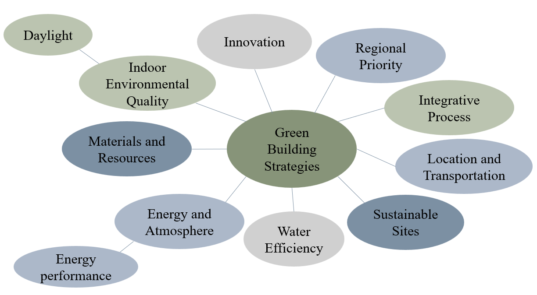
Figure 1. Daylighting as One Strategy in Green Building, Adapted from Leadership in Energy and Environmental Design (LEED)v4.1 Building Design and Construction Scorecard
Previous studies about PSF have primarily focused on non-tropic areas. A study about non-uniform perforated screens took the context of Wuhan [17]. Sherif et al. [19, 20] examined PSF in the context of residential buildings in Jeddah. Additionally, Chi et al. [21] examined the daylight and thermal performance of PSFs in Seville, while Srisamranrungruang and Hiyama [18] explored their implications for daylight, ventilation, and thermal regulation in Japan. A study about the daylight performance of PSF with light shelves [22] and perforated egg crates [16] took context in the tropics. However, research on the daylight performance of PSFs in tropical climates remains limited.
Table 1 illustrates the PSF design variables studied in previous research. These variables include perforation percentages [18][20], PSF rotation angle, and opening aspect ratios [19]. Other parameters investigated include perforation percentage, distribution of openings, shape of openings, orientation [21], perforation percentage, matrix, shape of openings, and orientation [6]. Additionally, previous studies have explored non-uniform perforation patterns [17], perforated egg crates [16], and combinations with daylighting systems such as light shelves [22].
However, prior studies have not explored inclined perforated screens, particularly in tropical climates. Given the widespread use of perforated solar screens as exterior building facades, the flexibility of PSF implementation, particularly in terms of inclination angle, requires further investigation. Examples of buildings incorporating inclined PSFs include 72 Screens in Jaipur, India, and the faceted PSF facade on the office extension building in Lund, designed by Johan Sundberg Arkitektur and Blasberg Andréasson Arkitekter.
The state-of-the-art aspect of this research lies in studying the inclined angle as a key PSF design variable in a tropical climate context. The inclination angle determines how effectively the PSF blocks sunlight while providing sufficient daylight for specific office tasks and minimizing glare. This study aims to evaluate the impact of PSF inclination angle on daylight performance.
The paper is structured as follows: Section 1 introduces the research, including previous studies on the daylight performance of perforated screen facades. Section 2 presents experimental methods, utilizing simulation as a tool. Section 3 discusses the experimental results and analysis, while Section 4 provides the conclusion and directions for future research.

Table 1. Variables of the Perforated Screen Facade in Previous Research
PSF variables | References
PSF variables | [6] | [16] | [19] | [20] | [21] | [18] | [17] | [22]
Perforation percentages | v |  |  | v | v | v
PSF rotation angle |  |  | v
matrix | v
Opening aspect ratio |  |  | v
Distribution openings |  |  |  |  | v
shape of the opening | v |  |  |  | v
Orientation | v |  |  |  | v
Non uniform perforation patterns |  |  |  |  |  |  | v
Perforated screen façade and light shelf |  |  |  |  |  |  |  | v
Perforated egg crates |  | v

METHOD
The research method was experimental, utilizing simulation as a tool. The daylight performance of the inclined PSF was analyzed using Climate Studio, an advanced environmental simulation software based on validated Radiance path-tracing technology [23]. The accuracy of Climate Studio has been verified in previous research [24][25].

Simulation Setup
The office building model was developed using Rhino 8 software. Its dimensions were 6 m in width and 8 m in depth, representing a medium-depth office space. The building’s height was 2.7 m. It featured a south-facing side window with a window-to-wall ratio of 67%. A horizontal shading element, 1 meter wide, was also positioned 2.7 meters above the floor. The material characteristics of the office building are detailed in Table 2.
The perforated screen facade had circular apertures. The distance between each aperture and the aperture diameter were 0.225 m and 0.16 m, respectively (Figure 2). The perforation percentage was set at 40%, aligning with previous research [18], which recommended this value for adequate daylighting without glare. The PSF was positioned 0.5 m away from the side window. Figures 2 and 3 illustrate the elevation and perspective views of the office building, showing the side window and inclined PSF, respectively.
The study was conducted in Surabaya (latitude 7.38° S, longitude 112.79° E), a city in the tropics. The sky condition in Surabaya is classified as intermediate [14]. Climate data from Surabaya-Juanda International Airport was used for this simulation.
Figure 4 shows the placement of sensor grids inside the office building. The sensor grids were positioned 0.5 m apart and set 0.5 m from the wall [26]. The sensor grid height for the daylight availability simulation, including useful daylight illuminance and mean illuminance, was set at 0.8 m above the floor. Meanwhile, the sensor grid height for spatial disturbing glare (sDG) was set at 1.2 m above the floor, corresponding to the eye level of a seated person. The sDG simulation results included analyses for eight different viewing directions at each sensor point (Figure 5). The simulation period covered office building occupancy hours from 8:00 am to 6:00 pm.

Table 2. The Material Characteristics of the Office Building
Room elements | Material | Reflectance (%) | Transmittance
wall | white painted | 70 | N/A
floor | ceramic tile | 39 | N/A
ceiling | white ceiling | 86 | N/A
side window | clear glass | 15 | 77
perforated screen facade | white painted | 90 | N/A

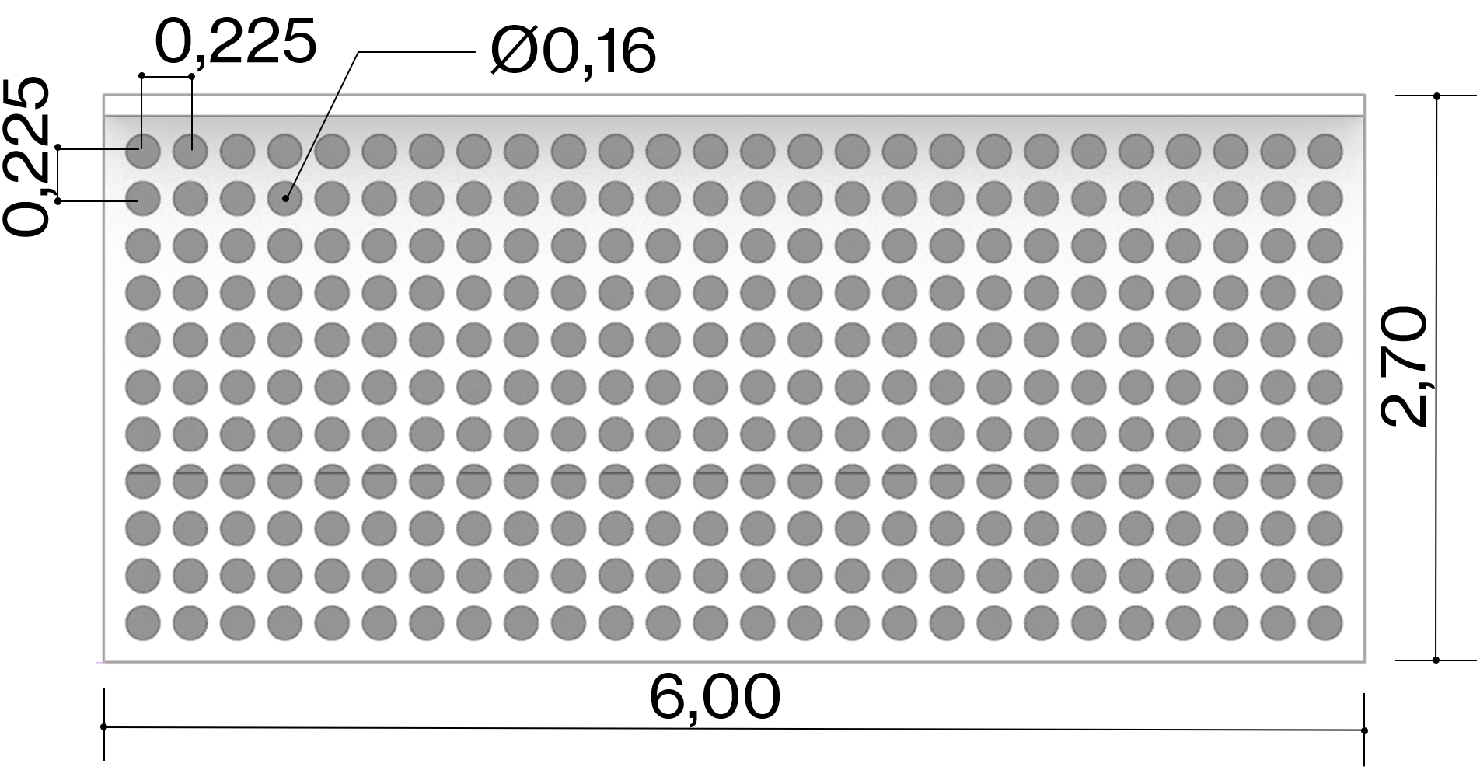
Figure 2. Elevation of the Office Building with Inclined Perforated Screen Facade

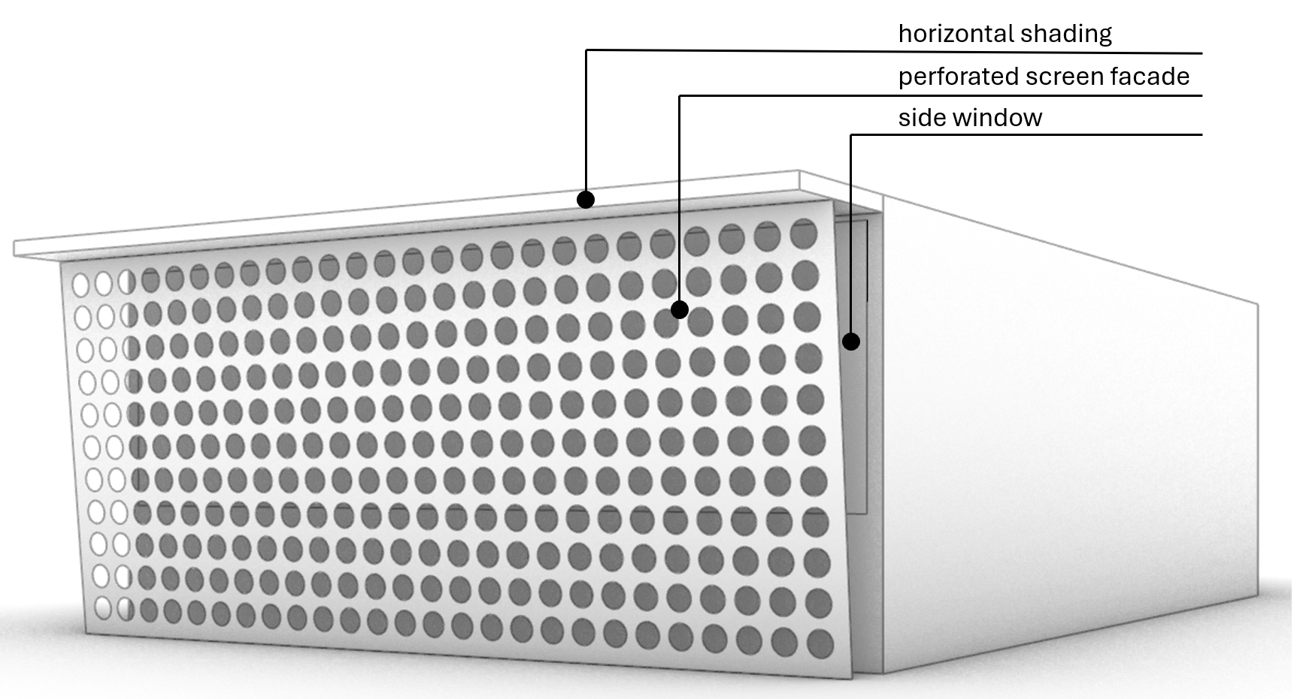
Figure 3. Perspective of Office Building with Side Window and Inclined Perforated Screen Facade

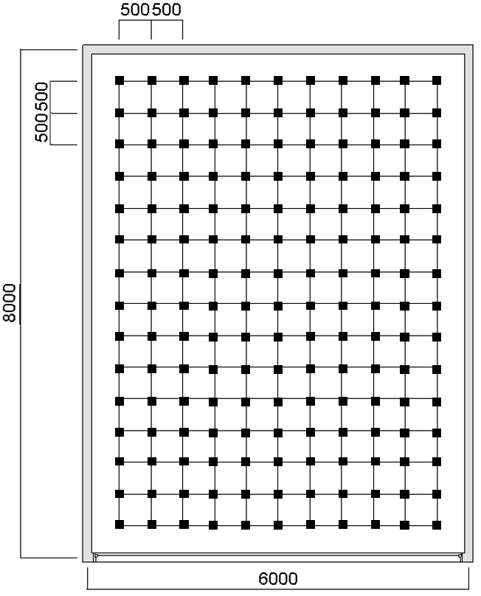
Figure 4. The Sensor Points Placement in the Office Building Plan

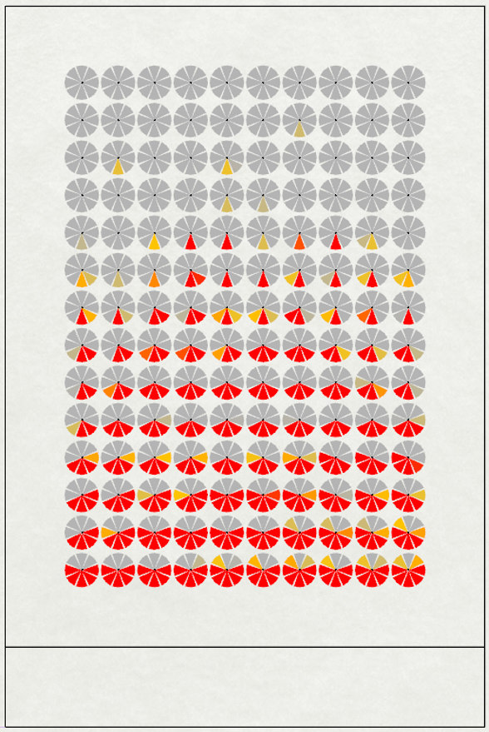
Figure 5. Example of Sensor Points with Eight Views for Spatial Disturbing Glare

Perforated Screen Facade Inclination Angle
Table 3 presents a sectional view of the office building facade in three scenarios: the base case (without PSF), the facade with a vertical PSF (0º), and the facade with an inclined PSF. The base case represented an office building with a side window and 1 m horizontal shading. The base case's daylight availability and visual comfort were compared with those of the vertical and inclined PSFs.
The vertical PSF was tilted on the inclined PSF, and its rotation point was located at mid-height of the PSF. The inclination angle was adjusted in 5° intervals, with a maximum angle 20°. As a shading device, the PSF was inclined to reduce direct solar radiation while enhancing daylight performance.

Table 3. The Section of the Office Building Facade with an Inclined Perforated Screen Facade
Base case  No PSF | PSF inclined 0º (vertical) | PSF inclined 5º
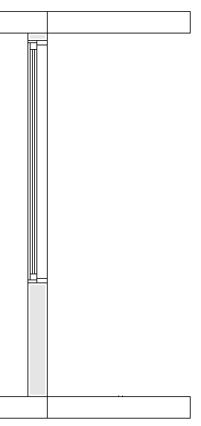 | 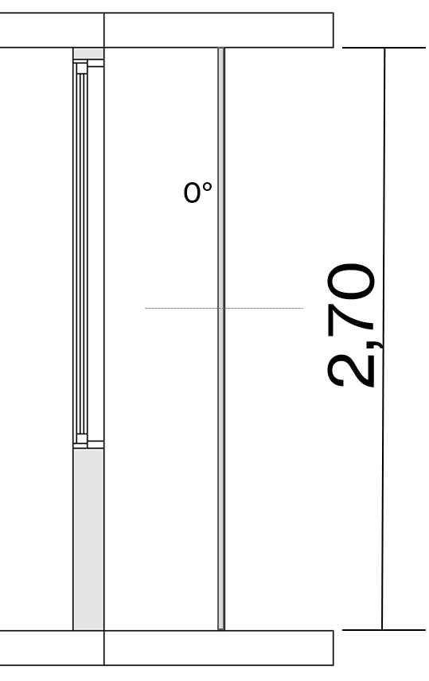 | 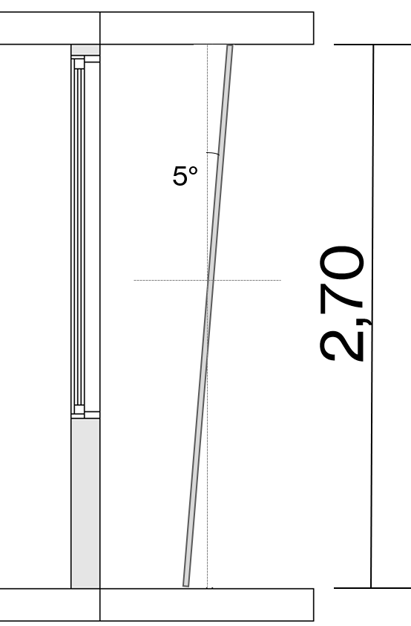
PSF inclined 10º | PSF inclined 15º | PSF inclined 20º
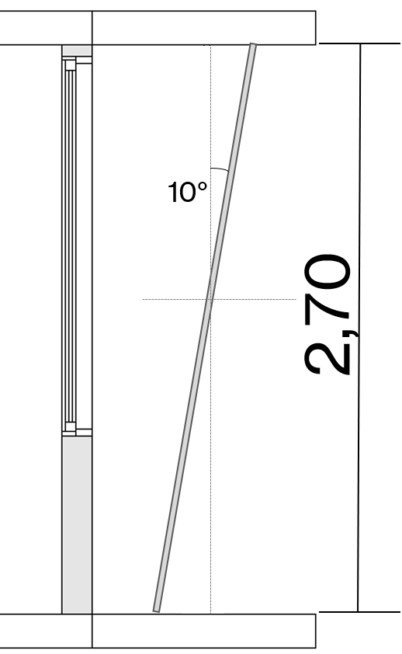 | 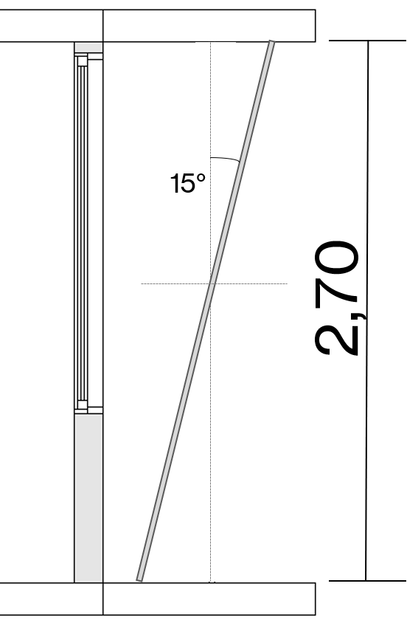 | 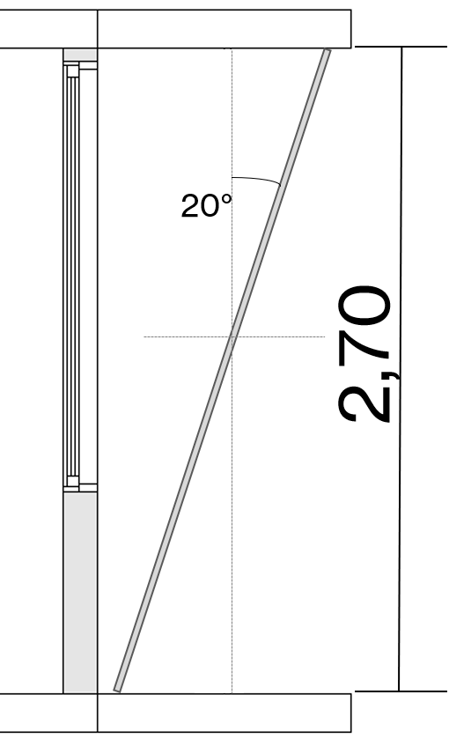

Daylight performance metrics
This study evaluated the daylight performance of inclined perforated screen facades (PSF), focusing on daylight availability and visual comfort. Daylight availability was measured using annual mean illuminance and useful daylight illuminance (UDI). Visual comfort was analyzed through spatial disturbing glare (sDG).
Mean illuminance is the average illuminance across the occupied floor area during all occupied hours. The recommendation of illuminance level for office tasks is 500 lx [27]. According to Leadership in Energy and Environmental Design (LEED) v4.1 [28], illuminance levels must fall between 300 and 3000 lux from 9 a.m. to 3 p.m. for 55% and 75% of the occupied floor area to earn 1 or 2 points respectively.
Useful daylight illuminance (UDI) measures the percentage of occupied hours during which illuminance levels on the work plane fall within ranges considered "useful" by building occupants [26]. The range of UDI is 100-3000 lux (Equation 1). UDI values greater than 3000 lux (UDI-e) indicate occupied times when an oversupply of daylight may cause visual or thermal discomfort or both [21]. Conversely, UDI values less than 100 lux represent times when daylight level is insufficient to serve as the primary illumination source or contribute significantly to artificial lighting [21]
 | (1)
Where t represents the duration of illuminance (E) within the range of 100-3000lx, and T denotes the total occupied hours throughout the year.
Useful daylight illuminance (UDI) is subdivided into UDI-autonomous (300-3000lx) and UDI supplementary (100-300lx). For UDI-autonomous (UDI-a), additional electric lighting is most likely not needed, while for UDI-supplementary (UDI-s), additional electric lighting may be required [21]. High values of UDI are often associated with low energy usage for electric lighting [21]. The recommended target for UDI_{100-3000lx} is ≥ 80% [29].
Spatial disturbing glare (sDG) quantifies the percentage of total views within the occupied floor area affected by disturbing or intolerable glare for at least 5% of occupied hours [30]. sDG is a statistical metric based on the Daylight Glare Probability (DGP) [17]. The computation of sDG is based on DGP hourly values for eight distinct viewing directions at each location within space [31]. Levels of DGP are classified as follows [32]: imperceptible glare (DGP ≤0.34), perceptible glare (0.34<DGP≤0.38), disturbing glare (0.38<DGP≤0.45), and intolerable glare (DGP>0.45)

RESULTS AND DISCUSSION
Daylight Performance of Inclined Perforated Screen Facade
The daylight availability and visual comfort of the building with an inclined Perforated Screen Façade (PSF) are shown in Table 4. The following section will discuss the daylighting performance of the inclined PSF, including mean illuminance, useful daylight illuminance (UDI), and spatial disturbing glare (sDG).
Mean Illuminance
Figure 6 shows the mean illuminance of the base case and office buildings with different inclination angles of the perforated screen façade (PSF). The base case, an office building with a side window and 1 m depth horizontal shading, had the highest mean illuminance level, reaching 1889lx. The mean illuminance level was in the range of 300 to 3000lx. However, 17.14% of the total 140 sensor points near the side window recorded an illuminance level exceeding 3000 lx, marked red (Table 4). An illuminance level above 3000 lx indicates an oversupply of daylight, which may lead to visual discomfort, thermal discomfort, or both.
Implementing a vertical perforated screen facade (0º) as a shading device resulted in a significantly lower mean illuminance, reaching 1060 lx. No sensor points recorded an illuminance level exceeding 3000 lx in office buildings with a vertical PSF. An illuminance level between 300-3000 lx across all sensor points is crucial to support building users in performing visual tasks.
Office buildings incorporating an inclined PSF with angles ranging from 5º to 20º exhibited mean illuminance levels between 1065 lx and 1105 lx. All cases adhered to the recommended illuminance thresholds established by LEED v4.1. Furthermore, no sensor points recorded illuminance levels surpassing 3000 lx in office environments employing PSFs with inclined angles.

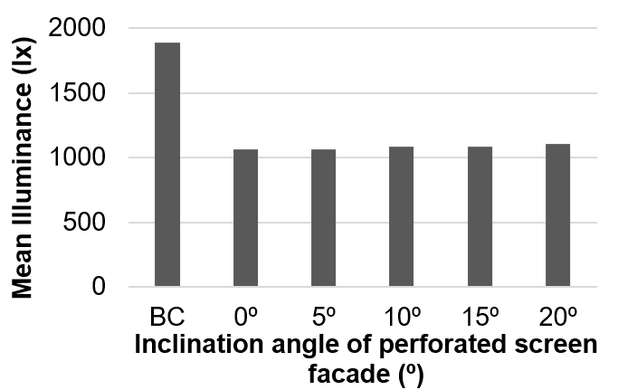
Figure 6. The Mean Illuminance of Base Case and Office Buildings with Different Perforated Screen Facade Inclination Angle

Compared to the base case, integrating a vertical perforated screen façade (0º) in the building façade reduced the mean illuminance by up to 43.9%. Similarly, implementing an inclined PSF reduced the mean illuminance by 41.5% to 43.5%, with inclination angles of 20º and 5º, respectively. These findings demonstrate the effectiveness of PSF as a shading system in tropical climates for reducing mean illuminance. Furthermore, these results align with previous research on integrating PSF in tropical regions [23] and extend the understanding of how inclination angles contribute to mean illuminance reduction.

Useful Daylight Illuminance
Figure 7 illustrates the useful daylight illuminance (UDI) for various inclination angles of the perforated screen facade. The base case, an office building with a side window and horizontal shading of 1-meter depth, recorded the lowest useful daylight illuminance (UDI_{100-3000lx}), occurring for 80.54% of the occupied time. Additionally, the base case exhibited a UDI exceed (>3000lx) value as high as 17.2%. UDI exceed (>3000lx) signifies periods during which an oversupply of daylight may result in visual discomfort, thermal discomfort, or both [21]. Furthermore, the base case recorded the lowest UDI-autonomous (300-3000lx), reaching 79.3%.
The implementation of vertical PSF (0º) in office buildings significantly reduced the UDI exceed value (>3000 lx), reaching 91.51%. In office buildings with vertical PSF, the UDI_{100-3000lx} reached 95.51%, representing an 18.6% improvement compared to the base case. These results highlight the effectiveness of PSF in reducing high illuminance levels, particularly in areas near side windows, and enhancing UDI_{100-3000lx} (Table 4).
The UDI_{100-3000lx} of inclined PSF ranged from 95.55% for an inclination angle of 5º to 95.08% for an inclination angle of 20º. Office buildings with a PSF inclination angle of 5º achieved the highest UDI_{100-3000lx}. Office buildings with PSF, both vertical and inclined, maintained UDI_{100-3000lx} values of at least 80%, meeting the recommended target for UDI_{100-3000lx.}
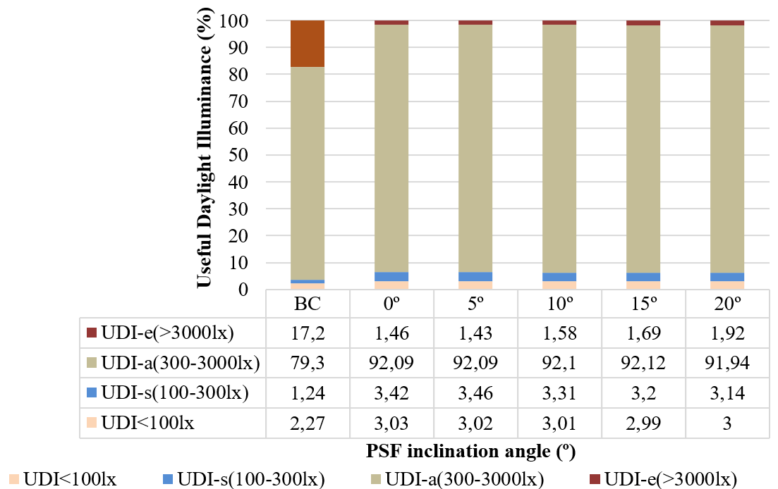
Figure 7. The Useful Daylight Illuminance from Different Inclination Angle of Perforated Screen Facade

Similar to vertical PSF, the implementation of inclined PSF significantly reduced UDI exceed values (>3000 lx), ranging from 88.84% to 91.69% (Table 4). The position of sensor points with UDI_{>3000lx} were near the side window. This reduction highlights the effectiveness of inclined PSF in mitigating excessive illuminance levels and enhancing daylight performance in office buildings.

Spatial Disturbing Glare
The base case had the highest spatial disturbing glare (sDG) level, reaching 23.7. Even with horizontal shading of 1 meter in width, an office building with a side window still had a high percentage of total views across the occupied floor area affected by disturbing or intolerable glare for at least 5% of occupied hours. Table 4 presents a comparison of the sDG plot, showing that sensor points near the side window and the central area of the office building are marked in red, indicating exposure to disturbing glare. Figure 8 compares the annual daylight glare probability simulation, showing that the base case still recorded 7% disturbing glare and 4% intolerable glare. This result was consistent with previous research [16][17] which underscored that office buildings face high daylight levels and glare issues in the absence of proper external shading.
Implementing vertical PSF (0º) as a shading device significantly reduced spatial disturbing glare (sDG), achieving a reduction of 80.2%. An office building with a vertical PSF exhibited an sDG level as high as 4.7%, with no intolerable glare recorded (Figure 8). This result aligns with previous research on Daylight Glare Probability (DGP) reduction achieved through PSF in office rooms in the tropics [22]. Based on DGP, the spatial disturbing glare metric used in this study provides a broader understanding of the visual performance of PSF, considering total views across the occupied floor.
An office building with an inclined PSF exhibited an sDG as high as 5.1% and 6.5% for inclination angles of 5º and 20º, respectively. No intolerable glare was recorded in office buildings with inclined PSF (Figure 8). The implementation of inclined PSF also reduced sDG compared to the base case, achieving reductions of 72.6% and 78.5% for inclination angles of 20º and 5º, respectively. Although inclined PSF resulted in a slightly higher sDG than vertical PSF, it effectively mitigates glare issues in tropical regions.
The reduction of sDG by both vertical and inclined PSF is crucial, as glare problems in tropical climates often lead building users to avoid natural daylight and instead rely on electric lighting as their primary illumination source. These findings align with previous research on PSF in tropical environments [22] while also contributing to a deeper understanding of the role of PSF with specific inclination angles in glare reduction.

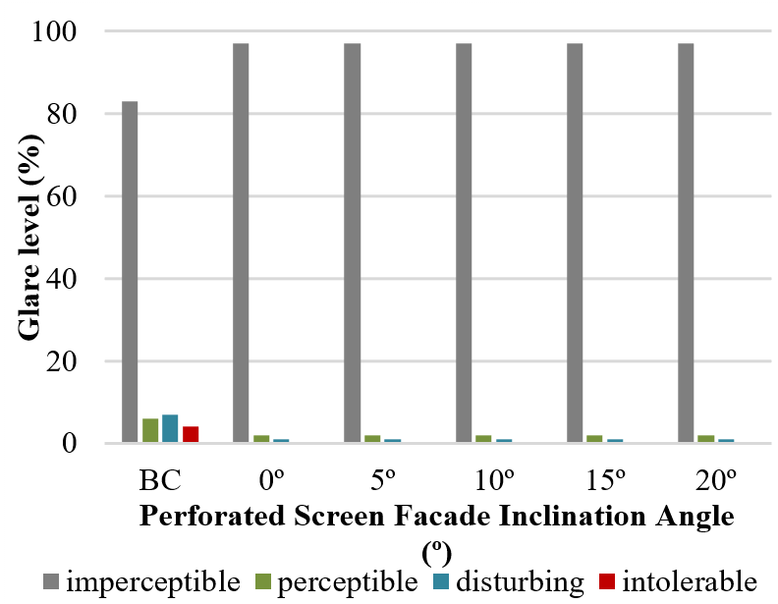
Figure 8. The Glare Level from Different Inclination Angle of Perforated Screen Facade

The Impact of Inclination Angle of Perforated Screen Facade on Daylight Performance
Regression analysis was employed to evaluate the impact of the inclination angle of the perforated screen facade (PSF) on mean illuminance, useful daylight illuminance, and spatial disturbing glare. Figures 9, 10, and 11 present regression analysis plots examining the relationship between the inclination angle of the perforated screen facade (PSF) and various daylight performance metrics. Figure 9 illustrates the regression analysis between the PSF inclination angle and mean illuminance, while Figure 10 examines its correlation with useful daylight illuminance. Meanwhile, Figure 11 displays the regression analysis plot of the PSF inclination angle and spatial disturbing glare.
The regression analysis demonstrated that the PSF inclination angle significantly influenced the mean illuminance, with a coefficient of determination reaching 0.9541. Additionally, a linear relationship between the PSF inclination angle and mean illuminance can be defined as follows:

Mean illuminance = 2,24x + 1057,8 | (2)

For every 0.1 increase in the PSF inclination angle, the mean illuminance is expected to improve by a linear difference of 1058,024. However, this equation exclusively applies to the case of office buildings incorporating inclined PSF in the tropics.
The findings showed that the higher the inclination angle of PSF, the greater the mean illuminance (Figure 9). The amount of light the north or south facade receives varies throughout the seasons. In office buildings facing south, a higher PSF inclination angle increases the portion of the PSF area receiving daylight, particularly in the upper section of the PSF surface. Additionally, ground reflection can contribute to a higher amount of light entering the space, increasing mean illuminance.
Figure 10 shows a regression analysis plot of the PSF inclination angle and useful daylight illuminance. The regression analysis indicated that the PSF inclination angle significantly influences the UDI_{100-3000lx}, with a coefficient of determination reaching 0.8479. A linear relationship between the PSF inclination angle and useful daylight illuminance is outlined in the following equation.

Useful daylight illuminance= -0,0218x + 95,592 | (3)

A 0.1 increment in the inclination angle of the perforated screen facade (PSF) is projected to result in a linear reduction of 95.59 in useful daylight illuminance. This equation is valid only for office buildings with inclined PSF in the tropics.
The findings showed that the higher the inclination angle of PSF, the smaller the useful daylight illuminance (Figure 10). Consistent with the results of the mean illuminance simulation, the higher the PSF inclination angle, the greater the daylight level received by the building, as indicated by the increase in UDI-exceed levels. The rise in UDI_{>3000lx} levels in the building leads to a decrease in UDI_{100–3000 lx} values. Meanwhile, the UDI_{<100lx} values tend to remain constant, as the modifications were applied only to the shading element, specifically the inclination angle of the PSF.
Figure 11 presents a regression analysis plot illustrating the relationship between the PSF inclination angle and spatial disturbing glare (sDG). The analysis confirmed that the PSF inclination angle strongly influences the spatial disturbing glare (sDG), with a high coefficient of determination of 0.8999. Additionally, a linear relationship between the PSF inclination angle and useful daylight illuminance can be defined as follows:

Spatial disturbing glare = 0,082x + 4,6 | (4)

For every 0.1 increase in the PSF inclination angle, the spatial disturbing glare is expected to increase by a linear difference of 4.6082. This equation is valid only in the case of office buildings with inclined PSF in the Tropics.
The higher the PSF inclination angle, the greater the spatial disturbing glare. Consistent with the results of daylight level analysis, an increase in the PSF inclination angle leads to higher daylight levels received by the building, as indicated by the rise in UDI exceed (>3000 lx) levels. According to Chi et al. [21] the presence of UDI_{>3000lx} in a building signifies periods during which excessive daylight potentially leads to visual and thermal discomfort, or both, which, in this case, is marked by an increase in spatial disturbing glare.
Vertical and inclined PSF implementation generally enhanced daylight availability and visual comfort compared to the base case. Vertical and inclined PSF integration significantly reduced mean illuminance and spatial disturbing glare in office buildings. Additionally, the use of PSF improved UDI_{100–3000lx.} These results align with previous research on PSF implementation in tropical regions [22] while contributing to knowledge about the role of PSF with specific inclinations in glare reduction.
Compared to vertical PSF, inclined PSF increased mean illuminance and spatial disturbing glare while decreasing UDI_{100–3000lx} values. However, considering its ability to reduce mean illuminance, increase UDI, and decrease spatial disturbing glare, the findings suggest that the inclination angle of PSF can be applied as an alternative PSF design for office buildings in the tropics.

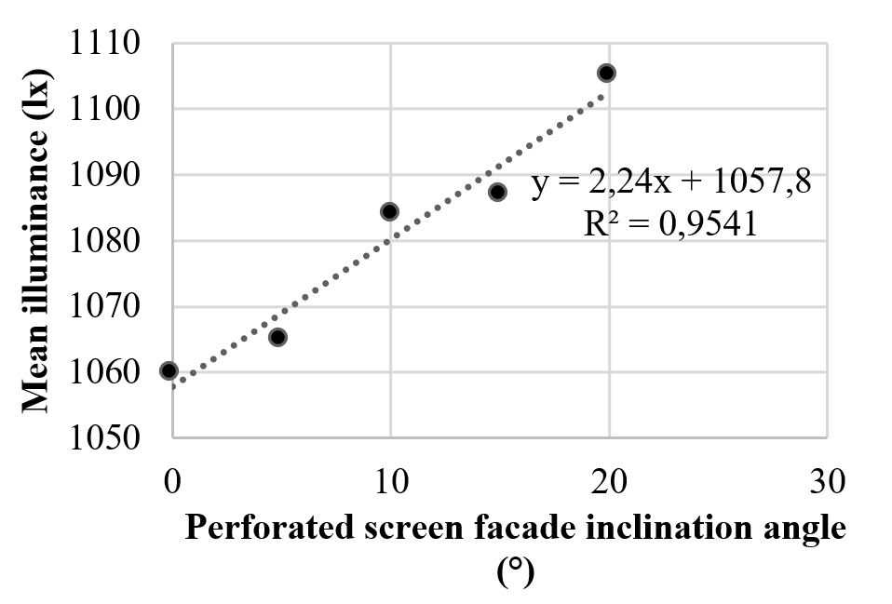
Figure 9. The Relationship Between Perforated Screen Facade Inclination Angle and Mean Illuminance

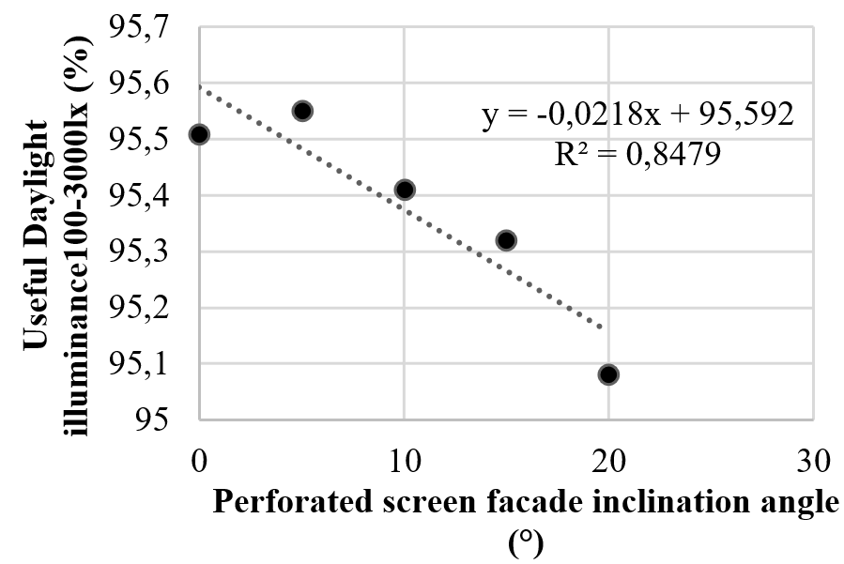
Figure 10. The Relationship between Perforated Screen Facade Inclination Angle and Useful Daylight Illuminance

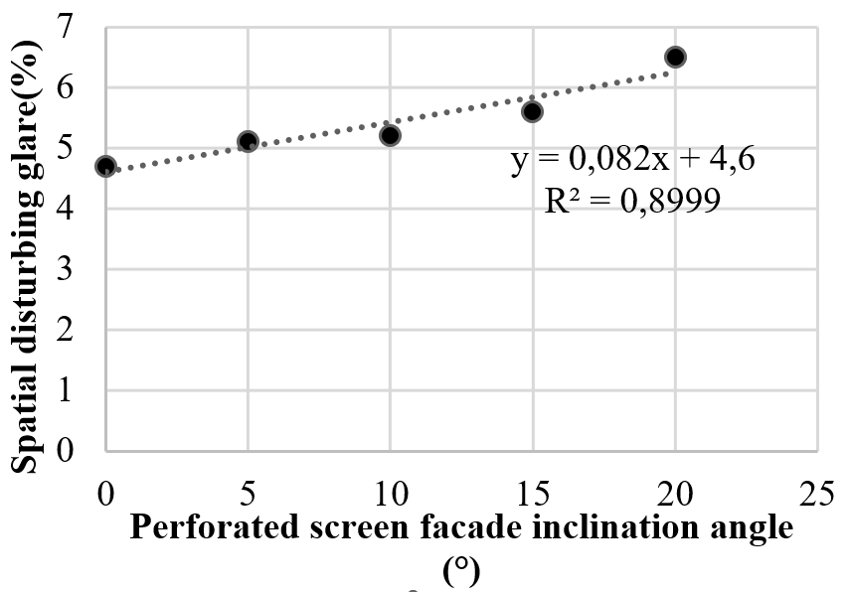
Figure 11. The Relationship between Perforated Screen Facade Inclination Angle and Spatial Disturbing Glare

CONCLUSION
Table 4. The Mean illuminance, Useful Daylight Illuminance-a, and Spatial Disturbing Glare of Different Perforated Screen Facade Inclination Angle
 | Base case | 0º | 5º | 10º | 15º | 20º
Mean illuminance (lx) | 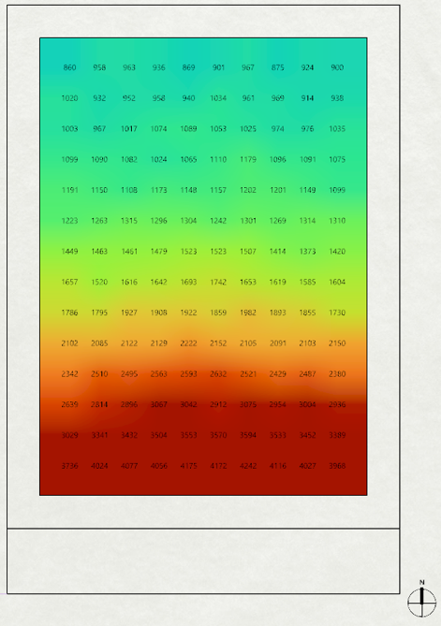 | 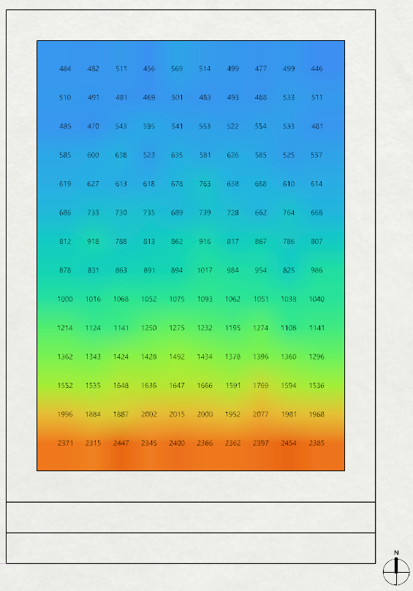 | 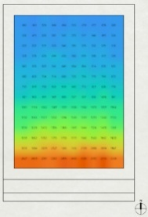 | 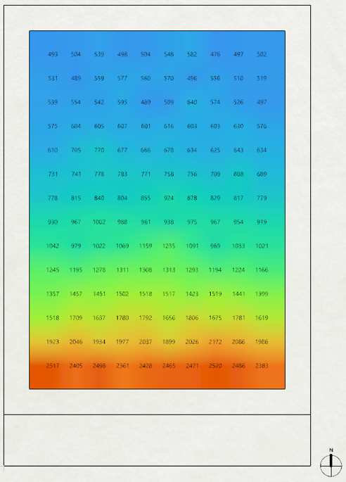 | 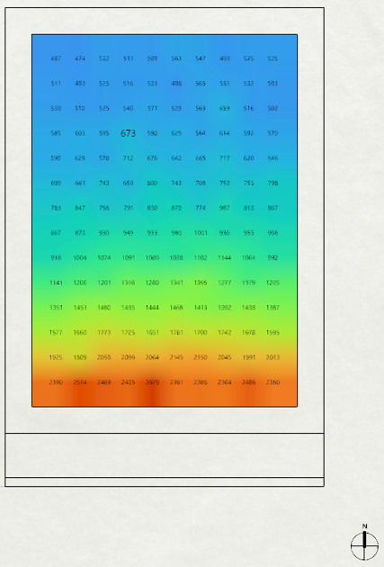 | 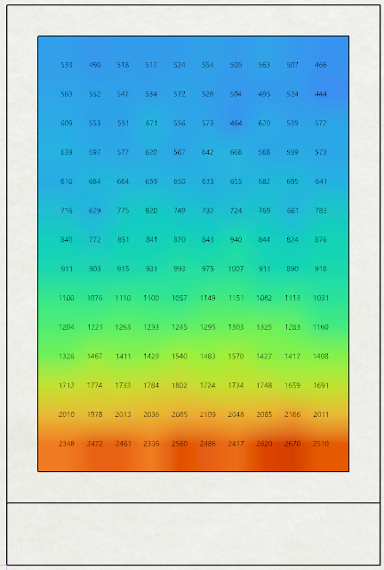
Mean illuminance (lx) | 1889 | 1060 | 1065 | 1084 | 1087 | 1105
Percentage of decrement (%) |  | 43.9 | 43.6 | 42.6 | 42.5 | 41.5
Useful daylight illuminance-a (UDI-a) (%) | 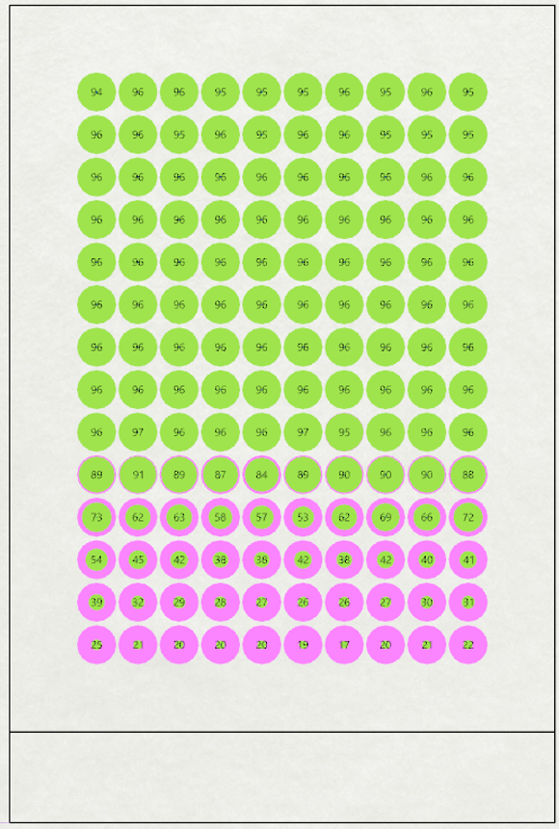 | 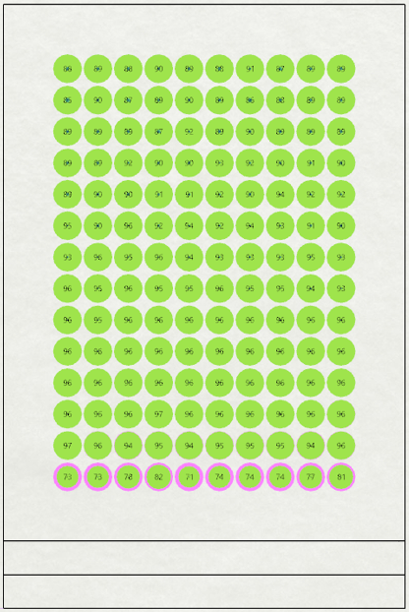 | 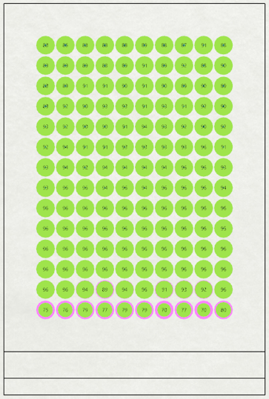 | 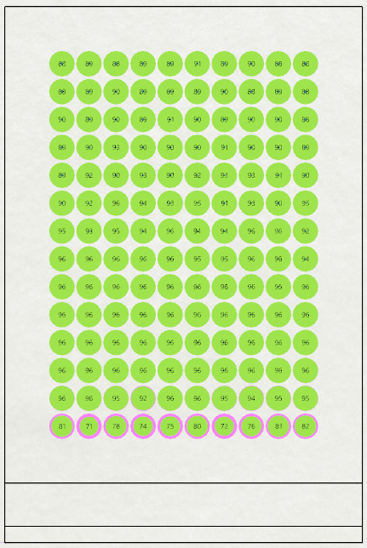 | 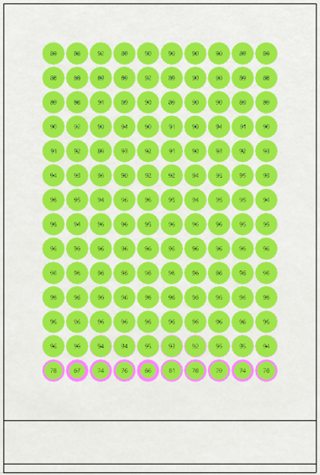 | 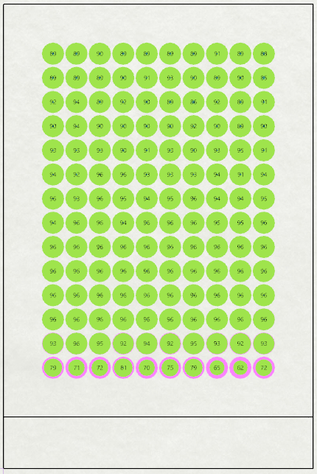
 | 79.3 | 92.1 | 92.1 | 92.1 | 92.1 | 91.9
Percentage of improvement (%) |  | 16.1 | 16.1 | 16.1 | 16.2 | 15.9
Spatial disturbing glare (%) |  | 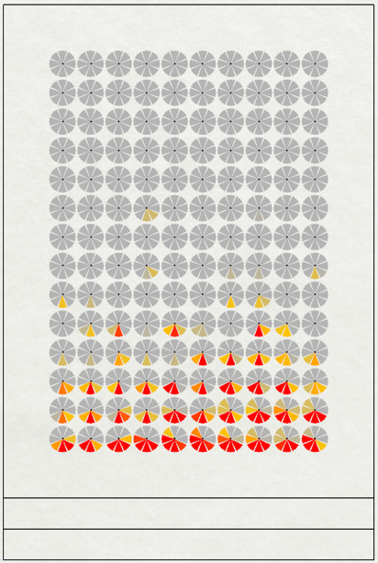 | 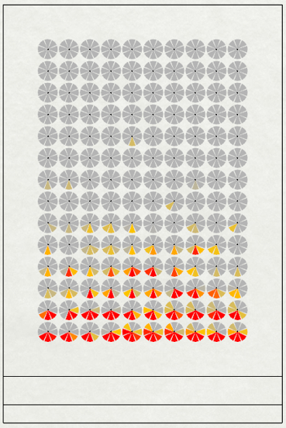 | 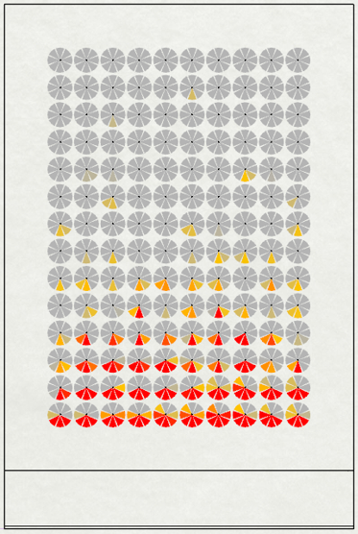 | 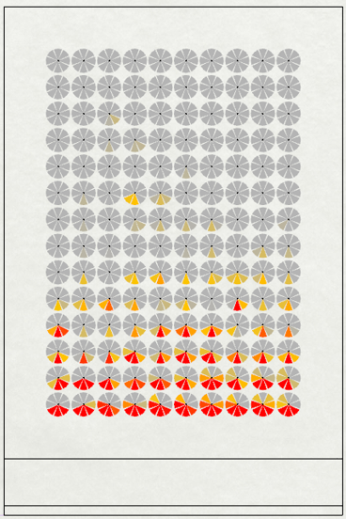 | 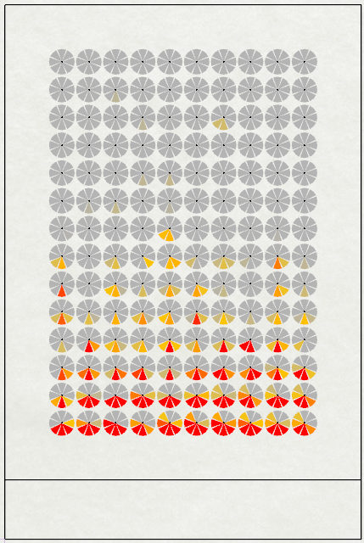
Spatial disturbing glare (%) | 23.7 | 4.7 | 5.1 | 5.2 | 5.6 | 6.5
Percentage of decrement (%) |  | 80.2 | 78.5 | 78.1 | 76.4 | 72.6
Mean illuminance:
Useful daylight illuminance:
Spatial disturbing glare:

This paper evaluated the daylight performance of different inclination angles of perforated screen facade (PSF) in the tropics. Implementing vertical and inclined PSF as a shading device significantly reduced the spatial disturbing glare (sDG) in office buildings, addressing an important issue in tropical regions where excessive glare often leads occupants to rely on electric lighting instead of natural daylight.
The study demonstrates that vertical and inclined PSF improved daylight availability and visual comfort in office buildings. The vertical PSF achieved the highest glare reduction by lowering sDG by 80.2%, while inclined PSF also contributed to mitigating glare at varying angles, achieving 72.6-78.5%. Additionally, PSF integration enhanced daylight availability by decreasing mean illuminance and increasing useful daylight illuminance (UDI_{100-3000lx}). These findings align with previous research on PSF in tropical climates and expand the understanding of how inclination angles of PSF influence glare reduction, offering valuable insights for sustainable building design.
The research introduced and focused on one of the PSF design variables, the inclination angle of PSF. The subsequent investigation should consider other variables such as perforated percentage, orientation, distance between PSF and side window, and external reflectance. This study also focused on daylighting performance only. Future research will focus on the energy performance of inclined PSF integration in buildings within tropical climates. The involvement of user aspects, specifically studies on user perception in buildings with inclined PSF implementation, needs to be explored.

ACKNOWLEDGMENT
The author would like to express their gratitude to the Digital Laboratory of the Architecture Department at Petra University

REFERENCES
- I. Turan, A. Chegut, D. Fink, and C. Reinhart, “The value of daylight in office spaces,” Building and Environment, vol. 168, 106503, Jan. 2020. DOI. 10.1016/j.buildenv.2019.106503.
- Y. Du, N. Li, L. Zhou, Y. A, Y. Jiang, and Y. He, “Impact of natural window views on perceptions of indoor environmental quality: An overground experimental study,” Sustainable Cities and Society, vol. 86, 104133, Nov. 2022. DOI. 10.1016/j.scs.2022.104133.
- K. Zhao and Z. Gou, “Optimizing semi-transparent BIPV windows for balanced daylighting and solar energy performance in office buildings,” Solar Energy, vol. 287, 113229, Feb. 2025. DOI. 10.1016/j.solener.2024.113229.
- I. Çataroğlu Coğul, Z. T. Kazanasmaz, and B. Ekici, “A literature review on sustainable buildings and neighborhoods in terms of daylight, solar energy and human factors,” Journal of Building Engineering, vol. 103, 111989, Jun. 2025. DOI. 10.1016/j.jobe.2025.111989.
- Y. Song, S. K. Lau, S. S. Y. Lau, and D. Song, “A Comparative Study on Architectural Design-Related Requirements of Green Building Rating Systems for New Buildings,” Buildings, vol. 13, no. 1, 124, Jan. 2023. DOI. 10.3390/buildings13010124.
- D. A. Chi, D. Moreno, and J. Navarro, “Impact of perforated solar screens on daylight availability and low energy use in offices,” Advances in Building Energy Research, vol. 15, no. 1, pp. 117–141, 2021. DOI. 10.1080/17512549.2018.1550439.
- H. Lee and J. Seo, “Performance evaluation of external light shelves by applying a prism sheet,” Energies, vol. 13, no. 18, 4618, Sep. 2020. DOI. 10.3390/en13184618.
- E. Ukpong, F. O. Uzuegbunam, E. O. Ibem, and E. Udomiaye, “Daylighting performance evaluation in tropical lecture rooms: A comparative analysis of static and climate-based metrics,” Journal of Building Engineering, vol. 103, 112044, Jun. 2025. DOI. 10.1016/j.jobe.2025.112044.
- S. Shoeb and M. A. R. Joarder, “Daylighting and energy performance optimization of anidolic ceiling systems for tropical office buildings,” Building and Environment, vol. 265, 112032, Nov. 2024. DOI. 10.1016/j.buildenv.2024.112032.
- M. Knoop et al., “Daylight: What makes the difference?,” Lighting Research and Technology, vol. 52, no. 3, pp. 423–442, May 2020. DOI. 10.1177/1477153519869758.
- A. Wirz-Justice, D. J. Skene, and M. Münch, “The relevance of daylight for humans,” Biochemical Pharmacology, vol. 191, 114304, Sep. 2021. DOI. 10.1016/j.bcp.2020.114304.
- F. Okan, H. Zincir, and K. Deveci, “The Effect of Sun Light Exposure to the Level of Vitamin D in Elderly People Living in Nursing Home,” Journal of Clinical Densitometry, vol. 25, no. 2, pp. 261–271, Apr. 2022. DOI. 10.1016/J.JOCD.2021.03.006.
- S. R. Aritonang, R. A. Mangkuto, Atthaillah, and I. Prasetiyo, “Daylighting Design Optimization of Complex Fenestration Systems with External Shading and Horizontal Slats in Tropical Elementary School Classrooms,” Journal of Architectural Engineering, vol. 31, no. 1, 04025001, Mar. 2025. DOI. 10.1061/JAEIED.AEENG-1894.
- F. Elsiana, S. N. N. Ekasiwi, and I. G. N. Antaryama, “The impact of aspect ratio of buildings implementing Horizontal light pipe and shading systems on daylight performance,” Journal of Asian Architecture and Building Engineering, vol. 23, no. 5, pp. 1658–1676, 2024. DOI. 10.1080/13467581.2023.2278450.
- F. Elsiana, S. N. N. Ekasiwi, and I. Gusti Ngurah Antaryama, “Integration of horizontal light pipe and shading systems in office building in the tropics,” Journal of Applied Science and Engineering, vol. 25, no. 1, pp. 231–243, 2022. DOI. 10.6180/jase.202202_25(1).0024.
- S. Sebayang et al., “Investigating perforated egg crates as dynamic shading systems for open-plan offices in tropical climates,” Journal of Building Engineering, vol. 96, 110462, Nov. 2024. DOI. 10.1016/j.jobe.2024.110462.
- L. Huang, K. Zou, X. Zhang, and S. Zhao, “Effects of non-uniform perforated solar screen on daylighting and visual comfort performance,” Journal of Building Engineering, vol. 97, 110684, Nov. 2024. DOI. 10.1016/j.jobe.2024.110684.
- T. Srisamranrungruang and K. Hiyama, “Balancing of natural ventilation, daylight, thermal effect for a building with double-skin perforated facade (DSPF),” Energy and Buildings, vol. 210, 109765, Mar. 2020. DOI. 10.1016/j.enbuild.2020.109765.
- A. H. Sherif, H. M. Sabry, and M. I. Gadelhak, “The impact of changing solar screen rotation angle and its opening aspect ratios on Daylight Availability in residential desert buildings,” Solar Energy, vol. 86, no. 11, pp. 3353–3363, Nov. 2012. DOI. 10.1016/j.solener.2012.09.006.
- A. Sherif, H. Sabry, and T. Rakha, “External perforated Solar Screens for daylighting in residential desert buildings: Identification of minimum perforation percentages,” Solar Energy, vol. 86, no. 6, pp. 1929–1940, Jun. 2012. DOI. 10.1016/j.solener.2012.02.029.
- D. A. Chi, D. Moreno, P. M. Esquivias, and J. Navarro, “Optimization method for perforated solar screen design to improve daylighting using orthogonal arrays and climate-based daylight modelling,” Journal of Building Performance Simulation, vol. 10, no. 2, pp. 144–160, Mar. 2017. DOI. 10.1080/19401493.2016.1197969.
- F. Elsiana and L. S Arifin, “Daylighting Evaluation of Perforated Screen Façade with Light Shelf in the Tropics,” DIMENSI Journal of Architecture and Built Environment, vol. 51, no. 1, pp. 39–48, Jul. 2024. DOI. 10.9744/dimensi.51.1.39-48.
- L. Santos, I. Caetano, A. Leitão, and I. Pereira, “Uncertainty in Daylight Simulations of Algorithmically Generated Complex Shading Screens,” in Proceedings of Building Simulation 2021: 17th Conference of International Building Performance Simulation Association, Bruges, Belgium, Sept. 1-3, 2021, D. Saelens, J Laverge, W. Boydens and L. Helsen. Bruges: IBPSA, 2022. pp. 2261–2268. DOI. 10.26868/25222708.2021.31068.
- M. T. Aguilar-Carrasco, J. Díaz-Borrego, I. Acosta, M. Á. Campano, and S. Domínguez-Amarillo, “Validation of lighting parametric workflow tools of Ladybug and Solemma using CIE test cases,” Journal of Building Engineering, vol. 64, 105608, Apr. 2023. DOI. 10.1016/j.jobe.2022.105608.
- J. Liu, Z. Li, Z. Zhang, L. Xie, and J. Wu, “Evaluation and Optimization of Interior Circadian Daylighting Performance for the Elderly in Traditional Dwellings: A Case Study in Western Hunan, China,” Sustainability, vol. 16, no. 9, 3563, May 2024. DOI. 10.3390/su16093563.
- E. Brembilla and J. Mardaljevic, “Climate-Based Daylight Modelling for compliance verification: Benchmarking multiple state-of-the-art methods,” Building and Environment, vol. 158, pp. 151–164, Jul. 2019. DOI. 10.1016/j.buildenv.2019.04.051.
- A. Ibrahim, M. Alsukkar, Y. Dong, and P. Hu, “Investigations for the daylighting performance of trapezoid profile shadings using multi-objective optimization,” Journal of Building Engineering, vol. 99, 111645, Apr. 2025. DOI. 10.1016/j.jobe.2024.111645.
- United States Green Building Council, “Leadership in Energy and Environmental Design v4.1 Building Design and Construction,” United States Green Building Council, Feb. 2025. [Online]. Available: https://build.usgbc.org/bd+c_guide [Accessed: March. 22, 2025].
- R. A. Mangkuto et al., “Experiment and simulation to determine the optimum orientation of building-integrated photovoltaic on tropical building façades considering annual daylight performance and energy yield,” Energy and Built Environment, vol. 5, no. 3, pp. 414–425, Jun. 2024. DOI. 10.1016/j.enbenv.2023.01.002.
- F. de Luca, A. Sepúlveda, and T. Varjas, “Multi-performance optimization of static shading devices for glare, daylight, view and energy consideration,” Building and Environment, vol. 217, 109110, Jun. 2022. DOI. 10.1016/j.buildenv.2022.109110.
- Y. M. S. Abdelhamid, S. M. Wahba, and M. Elhusseiny, “The Effect of Parametric Patterned Façade Variations on Daylight Quality, Visual Comfort, and Daylight Performance in Architecture Studio-Based Tutoring,” Journal of Daylighting, vol. 10, no. 2, pp. 173–191, Dec. 2023. DOI. 10.15627/jd.2023.15.
- J. Wienold et al., “Cross-validation and robustness of daylight glare metrics,” Lighting Research and Technology, vol. 51, no. 7, pp. 983–1013, Nov. 2019. DOI. 10.1177/1477153519826003.

