Comparative Analysis of Acoustic Fan Booster Damage Detection Using a Single Feature Approach | 

Rikko Putra Youlia¹, Dedik Romahadi^{1,2,}*, Aberham Genetu Feleke², Irfan Evi Nugroho³, Alina⁴
¹Department of Mechanical Engineering, Universitas Mercu Buana, Jakarta, Indonesia
²School of Mechanical Engineering, Beijing Institute of Technology, China
³PT. Molex Ayus, Jakarta, Indonesia
⁴Department of Information Systems, Universitas Terbuka, Tangerang, Indonesia

Abstract  Machine failure detection frequently uses non-destructive monitoring techniques such as vibration analysis. Although vibration analysis can identify machine degradation, the apparatus is often costly and necessitates specialist knowledge. In audio classification, prior researchers typically utilize characteristics represented as pictures or vectors, hence augmenting computing complexity. This research introduces a novel method that substitutes vibration data with a singular numerical feature derived from audio signals. Our objective is to develop a rapid and precise audio-based method for detecting machine damage. The acoustic signals from the machine apparatus were classified into three categories: normal, belt damage, and combined belt and bearing defect. The data processing technique involved lowering the sample rate and segmenting the data to improve computational efficiency and classification performance. We utilize the Welch method and appropriate analysis of Power Spectral Density (PSD) using statistical techniques. We meticulously assess the seven classifier methods for machine defect diagnosis employing 5-fold cross-validation and various confusion metrics, including accuracy, F-score, precision, sensitivity, and specificity. The linear discriminant analysis (LDA) model identifies a singular average PSD-type feature with an accuracy of 92.83%, illustrating the robustness and dependability of our methodology.  This is an open-access article under the CC BY-SA license.   | Keywords:  Acoustic detection;  fault detection;  Power spectral density;  machine learning;  Welch method  Article History:  Received:  Revised:  Accepted:  Published:  *Corresponding Author:  Dedik Romahadi  ¹Mechanical Engineering Department, Universitas Mercu Buana, Indonesia  ²School of Mechanical Engineering, Beijing Institute of Technology, China  Email: dedik.romahadi@mercubuana.ac.id

INTRODUCTION
Rotating machinery constitutes the foundation of the manufacturing industry. Any damage or malfunction in these components during operation might severely affect the system's performance [1], [2]. Consequently, it is crucial to develop effective and accurate methods for diagnosing and categorizing problems to improve machine reliability and substantially decrease operational and maintenance costs [3], [4]. The Electric Power Research Institute reports that bearing components constitute an astonishing 41% of failures in rotating machinery. Consequently, machines with rotating components have emerged as a significant focus of research, with an opportunity to employ artificial intelligence methodologies for high-performance maintenance practices [5], [6], [7].
Cost-effective maintenance of industrial machinery often involves the use of rotating components to carry out specific tasks. This system includes gears, rotor rods, rotors connected by fasteners, and bearings. Rolling bearings are vital in industrial equipment, as they allow for the rotation of low-friction components [8]. As a result, previous studies have thoroughly explored rolling bearings. The primary causes of problems are generally related to localized wear on the inner race (BPFI), outer race (BPFO), or the balls (BSF) of the bearing. Defects on the rolling surface may include cracks, voids, and fragments. The most common type of damage happens when a ball makes contact with a small imperfection. A crash between a rolling component and a flaw generates a bump that causes high-frequency vibrations throughout the structure [9]. According to Lou et al. [10], when capacitive contact occurs, applying a voltage that exceeds 73% of the total breakdown voltage leads to metal erosion inside the bearing and damages the lubricating layer of the bearing. As a result, the capacitive contact transforms into a resistive contact, which helps reduce electrical erosion while also accelerating oxidation.
The essential components of a condition monitoring system are defect identification and severity assessment [11]. This is vital, especially in critical systems necessitating continuous operation. Various approaches have been suggested to monitor and diagnose rolling element bearings, given their vital role in rotating machinery and the severe consequences of undetected damage [12]. A predominant approach involves analyzing vibration signals, as exemplified by Georgoulas and Nikolakopoulos. Chen et al. [13] emphasized that sampling frequency significantly influences fault diagnosis performance, underscoring the importance of data acquisition settings. Most diagnostic methods aim to identify faults and assess their severity, essential for uninterrupted functioning in critical systems [14], [15]. The ball passing frequency, a typical defect frequency, arises from periodic impacts dictated as determined by the bearing’s shape and rotational rate. Despite the presence of noise from other components, which can obscure or distort signals, researchers have discussed the capabilities of the FFT in diagnosing bearing faults as undeniably reliable and well-established. While FFT-based analysis is powerful, its implementation can be costly due to the required specialized equipment. To address this limitation, a promising alternative involves substituting vibration signals with audio signals captured by a mobile phone.
Non-destructive monitoring techniques, specifically vibration and acoustics, are the predominant methods employed for diagnosing machine failures [16]. Recent review studies have been undertaken to elucidate common defects in rolling bearings, and analytical methodologies, including the research presented by [17]. Other reviews focus on identifying the most reliable indicators to enhance defect detection accuracy. Kuncan [18] evaluated different machine learning techniques, such as Support Vector Machine (SVM), k-nearest neighbors (KNN), Artificial Neural Network (ANN), Linear Discriminant Analysis (LDA), Logistic Regression (LR), and Gray Relational Analysis (GRA) used for detecting bearing faults. The GRA approach achieved a 100% success rate across the complete set of four signal datasets analyzed for bearing signal classification, while SVM and LDA also yielded commendable classification outcomes. Hosseini et al. [19] proposed algorithm emphasizes the benefits of employing a Projection Recurrent Neural Network within an SVM framework. The findings suggest that the suggested model exceeds the recently developed models in fault detection accuracy. An extensive analysis of the most commonly utilized ML models for bearing defect detection is provided to ensure appropriate deployment [20].
Synthesizing this literature highlights that while vibration and acoustics-based monitoring, combined with advanced ML algorithms, have shown promise, many studies either focus solely on one signal type or do not thoroughly assess the effectiveness of specific feature extraction techniques. Moreover, the reviewed works rarely address the identification of machine damage types using single features that are computationally efficient and effective across different signal sources. Despite extensive work in this area, there remains a lack of explicit investigations into using a single Power Spectral Density (PSD) feature, specifically the statistical value of the Welch method, with an optimal classifier to directly identify and classify machine damage types. This gap is particularly crucial, given that such a streamlined approach could simplify deployment and reduce computational costs in real-world applications. To address this gap, our research applies the statistical value of the Welch method as a feature extraction technique, evaluated using a 5-fold cross-validation scheme to ensure robust system performance. This approach leverages the promise of audio-based monitoring and the proven power of ML techniques, offering a practical and cost-effective alternative to traditional vibration-based diagnostics.

MATERIAL AND METHOD
Our research aimed to develop a robust system for accurately categorizing various types of machine damage based on the analysis of acoustic patterns. The procedure for identifying damage typically includes five key steps: data collection, sound preprocessing, feature extraction, feature selection, and classification. The approach for defect identification is shown in Figure 1. The machine’s acoustic data undergoes a preprocessing step to reduce computational time and ensure suitability for further analysis.
Figure 1. The overview of the machine acoustic signal classification process.

During the second stage, the data within each segment is transformed into PSD using the Welch algorithm, with adjustments made to account for statistical variations. Next, the Synthetic Minority Over-sampling Technique (SMOTE) is applied to generate additional samples. The feature selection process then minimizes the influence of unnecessary factors. Since only a limited number of features are available, each feature’s contribution to the classification performance is thoroughly evaluated.

Audio Acquisition & Preprocessing
The data processing tasks were executed on a desktop computer powered by Windows 11 64-bit, using an RTX 4080 Super graphics card and a 14th-generation Intel Core i9 CPU. The analysis was carried out in MATLAB (version 2023b) [21], utilizing the Welch method and classifiers from the MATLAB toolbox to extract machine sound data from the dataset. Table 1 summarizes the number of samples used for classification. The audio recordings were captured using the built-in recording function of a Vivo V21 mobile device at a sampling rate of 48 kHz, with a maximum bitrate of 127 kbps and support for stereo channels. The recordings were saved in the m4a format. The fan booster apparatus used for these recordings is shown in Figure 2, with its specifications provided in Tables 2 and 3.
During the data collection stage, we gathered sound samples from three different machine scenarios involving fan boosters, which were categorized as follows: (a) the vehicle belt is in standard condition with properly adjusted tension, (b) the van belt is loosely secured with incorrect tension adjustment, and (c) the serpentine belt is inadequately fastened, and the bearings exhibit defects. Next, the audio data was downsampled from 48 kHz to 22.05 kHz to enhance computational efficiency. We also converted the audio channel configuration from stereo to mono. Originally, each category had over 3 hours of audio recordings. To manage this, we segmented the audio into non-overlapping 5-second sections. The audio data had a sampling rate of 22.05 kHz, a bit rate of 22.05 kbps, was recorded in a mono-channel configuration, and was saved in the m4a format.

Audio Signal Feature Extraction & Selection
The Welch algorithm creates a modified frequency domain representations for each data segment and then averages these results to calculate the PSD [22]. Constructed from the PSD estimates of different time-series segments, the modified periodogram, produced using the Welch method, offers an estimate of the true PSD, which has no inherent correlation. This averaging approach minimizes fluctuations.

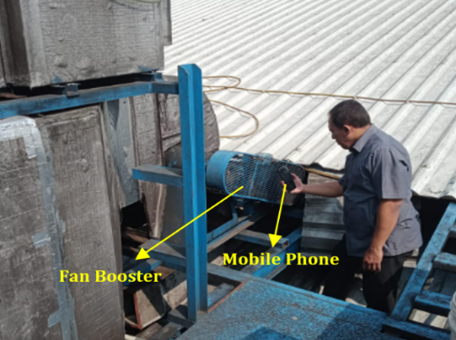
Figure 2. Data acquisition on the fan booster machine.

Table 1. Number of samples
Classes | Number | Percentage
Belt | 2350 | 34.18
Belt-Bearing | 2275 | 33.09
Normal | 2250 | 32.73

Table 2. Specifications of the fan assembly
No. | Description | Specification
1 | Brand | Topindo Fan
2 | Type | RSH 500
3 | Serial Number | -
4 | Fan Speed | 1400 rpm
5 | Power Supply | 3 PH, 380/660 V, 50 hZ
6 | Capacity | 7800 m³/h
7 | Static Pressure | 875 Pa (N/M²)
8 | Fan belt | Type V Belt B72

Table 3. Motor configuration
No. | Description | Specification
1 | Type | 1A1325-4
2 | Serial Number | -
3 | Power | 50 Hz: 5.5 Kw
4 | Power Input | 380/660 V 11.84 / 6.82 A ~ 440 VA 11.84 A
5 | Speed | 1440 rpm
6 | Efficiency | 85%

This study aims to use the Welch method to derive PSD estimates from machine audio signals. By applying the Hann window function to each segment, the Welch method calculates a modified periodogram and then combines these to produce an average result. Because the segments typically overlap, data at the outer edges of each segment, influenced by the window function, may differ from neighboring segment edges. Windowing is employed to reduce information loss.
The auditory data 𝑥 and 𝑦, each comprising 𝑁 samples, are partitioned into blocks x^{(k)} and y^{(k)} of length 𝐿. The relevant blocks in the estimated spectrum , derived from this technique, are presented in Equation 1.

(1)

The vector w signifies a taper window applied to data of length L, while f_{s} denotes the sampling rate. The symbol X represents the discrete-time Fourier transform evaluated at frequency f, which ranges from 0 to half the Nyquist frequency. The factor of 2 arises from using a one-sided spectral representation that includes only positive frequencies. The symbol Y represents the complex conjugate. The cross-spectrum is computed by averaging the components in Equation 2.

(2)

Adhering to the Welch method protocol, distinct 5-second intervals of EEG data were analyzed without overlap using a short-time Fourier transform to compute PSD properties. Seven statistical measures, including mean, median, mode, standard deviation, variance, minimum, and maximum, were applied to generate PSD attributes from each interval. The most relevant feature was then identified by evaluating the computational significance of these measures, prioritizing outcomes derived from their analytical results.

(3)

Equation 3 illustrates how the SMOTE algorithm produces synthetic samples to address the imbalance in class sample sizes [23]. Let x represent the original sample, r be a random number within the interval [0,1], I a random integer ranging from 1 to the nearest sample count, and z denote the nearest sample.

Classification
We obtained multiple enhanced features after applying the SMOTE algorithm for data balancing. We conducted experiments with seven different models: k-nearest neighbors (KNN), linear discriminant analysis (LDA), support vector machine (SVM), naïve Bayes (NB), artificial neural network (ANN), random forest (RF), and decision tree (DT). These models were used to assess how well various attributes identified damage to the fan booster. The tests utilized optimal PSD features extracted from the recorded acoustic data. To ensure the reliability of the outcomes, we performed both training and cross-validation by splitting the dataset into five parts. Figure 3 shows the training and testing process in one iteration. SMOTE is applied only in the training phase. The selection of the best features is also done only in the training stage. The trained model is tested with one type of PSD feature. The type of feature used is obtained from information during training. It is ensured that the data in the testing phase differs from the data during training. The final outcome is determined by assessing the model's accuracy during testing.
Figure 3. One iteration overview of the training and testing process.

The highest-performing PSD parameters for each class are stochastically partitioned into two distinct groups: a model-training cohort and an evaluation cohort. Predictive reliability is gauged through criteria including F-score (synthesizing precision and sensitivity), classification exactness, true negative identification (specificity), detection rate (recall), and overall correctness.

Calculation of Model Performance
Assessment is conducted within the framework of supervised learning [24]. The confusion matrix structure assigns rows to represent true class labels and columns to denote model-predicted classifications. A scholarly method suggests inverting this association, rows for predicted outcomes and columns for actual labels, to refine error analysis, particularly in cases where distinct groups are erroneously mapped to identical categories. The matrix spans two axes: "ground truth" and "model output," both encompassing identical class labels. Each cell in the matrix captures a specific pairing of real-world and algorithmic classifications. Correct identifications (TP) arise when predictions align with positive ground truths. Correct rejections (TN) occur when both actual and predicted labels are negative. Misclassifications include false alarms (FP), where negatives are incorrectly flagged as positives, and misses (FN), where positives are inaccurately dismissed as negatives.

(4)

Evaluating model performance metrics, Equation 4 can evaluate the accuracy of the model's prediction findings. Equation 5 is used to assess how well the model performs, focusing on its recall or sensitivity metric.

(5)

Utilize Equation 6 to compute how precise the model is in pinpointing the exact nature of the machine damage.

(6)

Equation 7 is applied to calculate the specificity parameter.

(7)

The F-score parameter is computed using Equation 8.

(8)

RESULTS
Pre-processing and Feature Extraction Results
Before beginning feature extraction, it is important to preprocess and examine the data to ensure smooth implementation of the classification process. Figure 4 presents the depiction of machine sounds within the temporal domain. We randomly chose three machine noise samples from each category recorded in the same session. In the temporal domain, signals show similar magnitudes and distributions. Therefore, it is crucial to identify unique features to highlight pattern differences across various classes. To streamline computational demands, dimensionality reduction is achieved through feature selection. Figure 5 demonstrates the application of the Welch algorithm for spectral estimation, enabling bidirectional conversion of audio signals between their temporal waveforms and frequency-domain representations. This method optimizes the analysis of signal energy distribution across spectral bands.
Each fault state exhibits unique PSD signatures. Broadly, dominant energy concentration typically spans the 0–1 kHz spectral band. A loose van belt condition manifests a marked amplification of spectral energy below 1 kHz and near 7 kHz. Conversely, combined belt instability and bearing degradation reveal intensified energy within the 0–1 kHz range, with a distinct maximum near 0.3 kHz. This contrast highlights how mechanical faults alter frequency-specific energy distributions. Using PSD can help identify unique patterns specific to each category.

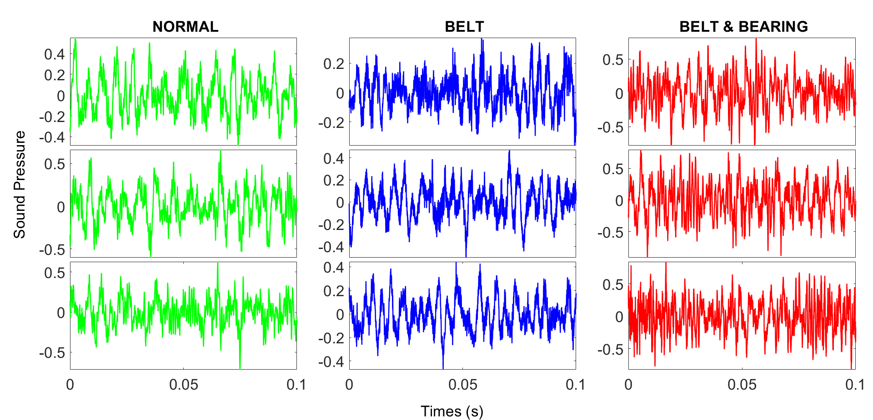
Figure 4. Machine audio in the time domain

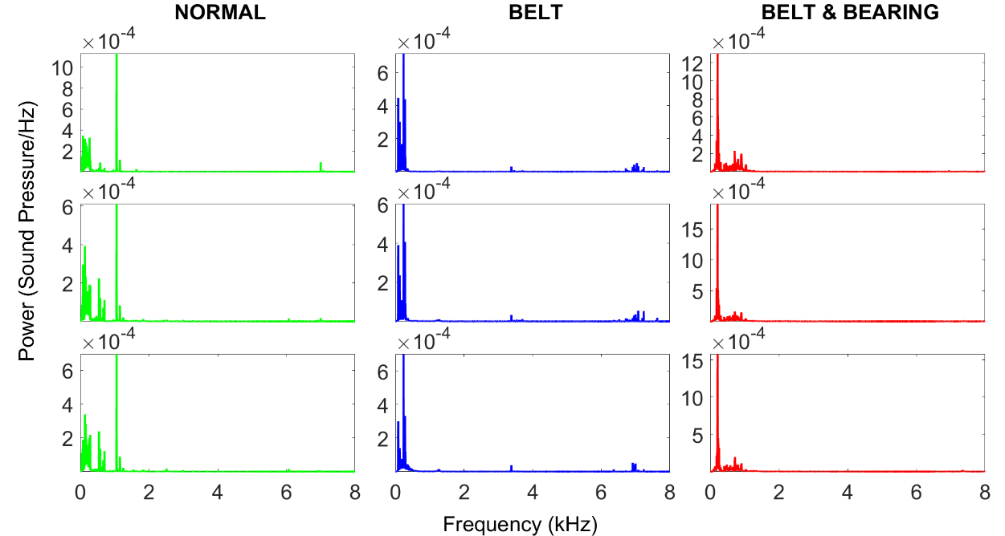
Figure 5. Power spectral density

Since the PSD dataset contains a large number of series, many of which are not useful for classification, we adopted seven statistical techniques to isolate the most relevant PSD features. This approach simplifies the workflow and boosts classification effectiveness.

Feature Selection Results
In the context of machine learning and statistics, feature selection refers to identifying and retaining only the most important features from a larger dataset. We calculate accuracy to determine seven essential parameters that improve the model's precision in classifying machine audio. Consequently, we identified the paramount characteristic of the categorization process. This pattern suggests that the classification model will encounter difficulties in precisely discriminating between each class based on the given attributes. The first feature, along with any features derived from the mean of PSD, exhibit the highest accuracy across several classifiers, as illustrated in Figure 6. Feature 1 is the principal attribute designated for categorization purposes. The results demonstrate that the average PSD type feature exerts the greatest influence in differentiating among the various class types. Following the results of the feature selection procedure, we utilize the average PSD feature for all categories during the testing phase. Using fewer features in machine learning has several significant advantages. Models tend to be simpler and easier to understand, which improves interpretability.

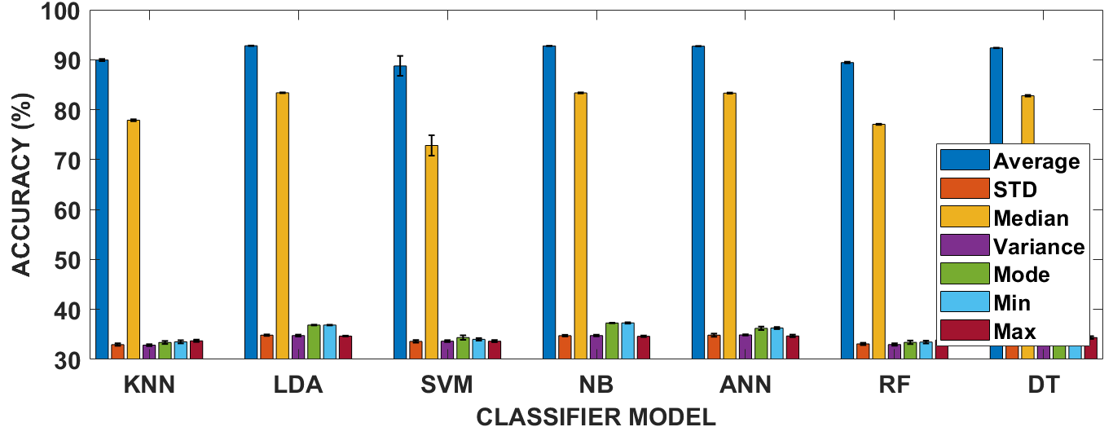
Figure 6. Each feature type's performance in the training phase

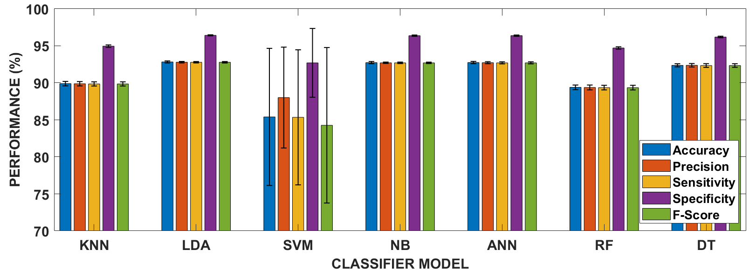
Figure 7. Each classifier model's performance in the testing phase

Models with fewer features tend to be faster to train and run, as they require fewer calculations and computational resources. Using many features in machine learning or deep learning classification can cause several problems. One of the main issues is overfitting, where the model becomes too tailored to the training data, resulting in high accuracy there but poor performance on new, unseen test data. In addition, the curse of dimensionality phenomenon also appears, where the more features, the data becomes sparser, making it difficult for the model to find clear patterns. On the other hand, the presence of multicollinearity among several correlated features can cause redundancy in the information learned by the model, distorting coefficient estimates, and making it difficult to interpret the model.

Classifier Performance
This is attributable to the disparity in the number of samples remaining. We employ the SMOTE algorithm to impute missing samples. The average performance metrics, as shown in Figure 7, are utilized to examine the efficacy of the classification model. Eliminating all attributes except the average PSD does not diminish the accuracy of each classifier model. Primarily, misclassification commonly happens within the category of normal class types. However, LDA is highly effective at correctly identifying every machine condition using only a single feature. The model demonstrates the highest accuracy compared to other models in classifying average PSD features. The average PSD accuracy achieved was 92.83%, 92.79% precision, 92.79% sensitivity, 96.42% specificity, and 92.78% F-score. All other parameters have an accuracy exceeding 92%, even at their lowest. The results substantiate the effectiveness of our proposed methodology in identifying various sorts of machine malfunctions through the analysis of sound data.

DISCUSSION
The results presented in this study provide a compelling narrative on the effectiveness of the proposed approach for classifying machine faults based on audio data. Figures 5 highlight the distinctive differences in the PSD of the machine sounds across various fault classes, forming the basis for robust feature extraction. Figure 6 clearly demonstrates that the average PSD consistently achieves the highest classification accuracy, validating its strong discriminatory power. Furthermore, Figure 7 illustrates that using only the average PSD feature does not compromise classifier performance, particularly when using the LDA model, which achieves an accuracy of 92.83%.
The logical progression from data inspection to feature extraction and selection underscores the robustness of the methodology. Initially, the raw time-domain signals exhibit similar magnitudes and distributions as shown in Figure 4, suggesting minimal distinguishing information. The transformation to the frequency domain reveals class-dependent patterns that are more pronounced. Recognizing the computational and interpretive challenges of high-dimensional data, we employed seven statistical methods to extract the most salient features, ultimately identifying the average PSD as the most informative.
This finding has a direct causal link to the final model’s success: reducing the dimensionality of the feature space by selecting the average PSD not only speeds up computation but also minimizes the risk of overfitting and redundancy. The superior performance of the LDA classifier in all performance metrics above 90% is a testament to the effectiveness of this feature selection strategy. This addresses the “curse of dimensionality” and multicollinearity concerns often associated with high-dimensional feature sets.
When compared to previous studies, our findings align and extend the existing knowledge base. Prior works, such as those by Li et al. [3] and Wang et al. [12], employed vibration and audio-based features then applied to deep learning models for machine fault diagnosis. These studies reported high accuracy rates, often exceeding 90%, but relied on multiple features and complex architectures. In contrast, our work demonstrates that by leveraging a single well-chosen feature and a simpler classifier, we can achieve comparable accuracy levels. This outcome suggests that simpler models can rival more complex ones when the most informative feature is used, reinforcing the notion that model complexity does not always equate to better performance.
Moreover, our results challenge the prevailing reliance on deep learning models for audio classification in machine condition monitoring. Unlike these approaches, our methodology is faster, more interpretable, and requires significantly fewer computational resources. This directly supports arguments in recent literature advocating for more resource-efficient models in industrial settings [25], [26]. Our findings thus offer a practical alternative for scenarios with constrained resources or real-time monitoring needs.
In sum, our work contributes to the field by demonstrating that a single feature, the average PSD, can achieve high classification accuracy, challenging the assumption that complex feature sets are always necessary. LDA can outperform more computationally intensive models, confirming that simpler models can be more robust when the feature is highly discriminative. Sound-based monitoring can be a viable alternative to vibration-based approaches, offering a low-cost, accessible solution for machine health monitoring. These insights strengthen the argument for lightweight, interpretable models in industrial diagnostics, especially in settings where simplicity, speed, and cost-effectiveness are critical.

CONCLUSION
By using a cellphone, we successfully detected damage to the fan booster machine through careful analysis of the recorded audio signals. Each machine state had recordings that extended beyond 3 hours. The architecture of the fan booster defect identification system was built through sequential phases: acoustic signal acquisition, preprocessing (including noise filtering and amplitude normalization), Welch-algorithm-driven spectral feature extraction, and evaluative refinement of discriminative attributes using validation metrics. This methodology prioritizes computational efficiency while isolating fault-specific spectral patterns and comparing the results of seven different classification models. Among these models, the LDA classifier demonstrated the best performance, effectively classifying the average PSD feature and achieving an accuracy of 92.83%. Importantly, the minimum performance for all evaluated parameters consistently stayed above 92%, indicating the robustness and reliability of the approach.

ACKNOWLEDGMENT
The authors extend their sincere appreciation to Universitas Mercu Buana for the generous financial support provided under contract No. 02-5/794/B-SPK/III/2024. This support played a crucial role in enabling the successful completion of this research work.

REFERENCES
[1] S. Gawde, S. Patil, S. Kumar, P. Kamat, K. Kotecha, and S. Alfarhood, “Explainable Predictive Maintenance of Rotating Machines Using LIME, SHAP, PDP, ICE,” IEEE Access, vol. 12, pp. 29345–29361, 2024, doi: 10.1109/ACCESS.2024.3367110.
[2] T. Wang, G. Lu, and P. Yan, “A novel statistical time-frequency analysis for rotating machine condition monitoring,” IEEE Transactions on Industrial Electronics, vol. 67, no. 1, pp. 531–541, Jan. 2020, doi: 10.1109/TIE.2019.2896109.
[3] X. Li, W. Zhang, Q. Ding, and J. Q. Sun, “Intelligent rotating machinery fault diagnosis based on deep learning using data augmentation,” J Intell Manuf, vol. 31, no. 2, pp. 433–452, Feb. 2020, doi: 10.1007/S10845-018-1456-1.
[4] D. Romahadi, A. A. Luthfie, W. Suprihatiningsih, and H. Xiong, “Designing expert system for centrifugal using vibration signal and Bayesian Networks,” Int J Adv Sci Eng Inf Technol, vol. 12, no. 1, pp. 23–31, 2022, doi: 10.18517/IJASEIT.12.1.12448.
[5] C. Y. Lee and T. A. Le, “Intelligence bearing fault diagnosis model using multiple feature extraction and binary particle swarm optimization with extended memory,” IEEE Access, vol. 8, pp. 198343–198356, 2020, doi: 10.1109/ACCESS.2020.3035081.
[6] W. Mao, J. Chen, X. Liang, and X. Zhang, “A New Online Detection Approach for Rolling Bearing Incipient Fault via Self-Adaptive Deep Feature Matching,” IEEE Trans Instrum Meas, vol. 69, no. 2, pp. 443–456, Feb. 2020, doi: 10.1109/TIM.2019.2903699.
[7] L. He, C. Yi, Q. Zhou, and J. H. Lin, “Fast Convolutional Sparse Dictionary Learning Based on LocOMP and Its Application to Bearing Fault Detection,” IEEE Trans Instrum Meas, vol. 71, 2022, doi: 10.1109/TIM.2022.3193962.
[8] J. Pacheco-Chérrez, J. A. Fortoul-Díaz, F. Cortés-Santacruz, L. María Aloso-Valerdi, and D. I. Ibarra-Zarate, “Bearing fault detection with vibration and acoustic signals: Comparison among different machine leaning classification methods,” Eng Fail Anal, vol. 139, p. 106515, Sep. 2022, doi: 10.1016/J.ENGFAILANAL.2022.106515.
[9] X. Xu, X. Huang, H. Bian, J. Wu, C. Liang, and F. Cong, “Total Process of Fault Diagnosis for Wind Turbine Gearbox, from the Perspective of Combination with Feature Extraction and Machine Learning: A Review,” Energy and AI, p. 100318, Nov. 2023, doi: 10.1016/J.EGYAI.2023.100318.
[10] Z. Lou et al., “Formation of Corrugated Damage on Bearing Race under Different AC Shaft Voltages,” Materials, vol. 17, no. 4, Feb. 2024, doi: 10.3390/MA17040859/S1.
[11] S. N. Chegini, M. J. H. Manjili, and A. Bagheri, “New fault diagnosis approaches for detecting the bearing slight degradation,” Meccanica, vol. 55, no. 1, pp. 261–286, Jan. 2020, doi: 10.1007/s11012-019-01116-x.
[12] Y. S. Wang, N. N. Liu, H. Guo, and X. L. Wang, “An engine-fault-diagnosis system based on sound intensity analysis and wavelet packet pre-processing neural network,” Eng Appl Artif Intell, vol. 94, p. 103765, Sep. 2020, doi: 10.1016/j.engappai.2020.103765.
[13] J. Park, S. Kim, J. H. Choi, and S. H. Lee, “Frequency energy shift method for bearing fault prognosis using microphone sensor,” Mech Syst Signal Process, vol. 147, p. 107068, Jan. 2021, doi: 10.1016/j.ymssp.2020.107068.
[14] P. Sharma, S. Chandra Rana, and R. Nath Barman, “Experimental study on fault analysis of a needle roller bearing with wear evaluation,” Mater Today Proc, vol. 24, pp. 567–575, Jan. 2020, doi: 10.1016/j.matpr.2020.04.310.
[15] N. Indah, J. Yunas, A. A. Hamzah, R. Latif, D. S. Khaerudini, and Subekti, “Analyzing the Vibration and Mechanical Properties of the MEMS Membrane with Planar Spring Arms Design for Energy Harvesting,” AIP Conf Proc, vol. 3115, no. 1, Sep. 2024, doi: 10.1063/5.0207450/3313646.
[16] C. Pichler et al., “Acoustic Condition Monitoring: Signal Analysis for Large Machinery Halls,” Conference Record - IEEE Instrumentation and Measurement Technology Conference, 2022, doi: 10.1109/I2MTC48687.2022.9806680.
[17] T. Chen, L. Guo, H. Gao, T. Feng, and Y. Yu, “Clustering Weighted Envelope Spectrum for Rolling Bearing Fault Diagnosis,” IEEE Transactions on Automation Science and Engineering, 2024, doi: 10.1109/TASE.2024.3403665.
[18] M. Kuncan, “An Intelligent Approach for Bearing Fault Diagnosis: Combination of 1D-LBP and GRA,” IEEE Access, vol. 8, pp. 137517–137529, Jan. 2020, doi: 10.1109/ACCESS.2020.3011980.
[19] N. K. Hosseini, H. Toshani, S. Abdi, and S. Sharifzadeh, “Enhanced Bearing Fault Detection in Induction Motors Using Projection-Based SVM,” IEEE Trans Ind Appl, 2025, doi: 10.1109/TIA.2025.3536425.
[20] T. Chen and D. Yu, “A Novel Method for Enhanced Demodulation of Bearing Fault Signals Based on Acoustic Metamaterials,” IEEE Trans Industr Inform, vol. 18, no. 10, pp. 6857–6864, Oct. 2022, doi: 10.1109/TII.2022.3143161.
[21] The MathWorks Inc., “MATLAB Version: 23.2.0.2409890 (R2023b),” 2023, The MathWorks Inc.
[22] A. S. Siva, S. G. Rameshkumar, and K. Dhayalini, “Supraharmonic Analysis by Welch’s-Power Spectral Density Estimation,” 2024 3rd International Conference on Power, Control and Computing Technologies, ICPC2T 2024, pp. 357–362, 2024, doi: 10.1109/ICPC2T60072.2024.10474764.
[23] C. Song, T. Zhao, L. Xu, and X. Huang, “Probabilistic prediction of uniaxial compressive strength for rocks from sparse data using Bayesian Gaussian process regression with Synthetic Minority Oversampling Technique (SMOTE),” Comput Geotech, vol. 165, p. 105850, Jan. 2024, doi: 10.1016/J.COMPGEO.2023.105850.
[24] M. Hasnain, M. F. Pasha, I. Ghani, M. Imran, M. Y. Alzahrani, and R. Budiarto, “Evaluating Trust Prediction and Confusion Matrix Measures for Web Services Ranking,” IEEE Access, vol. 8, pp. 90847–90861, 2020, doi: 10.1109/ACCESS.2020.2994222.
[25] X. Liu, D. Pei, G. Lodewijks, Z. Zhao, J. M.-A. P. Technology, and undefined 2020, “Acoustic signal based fault detection on belt conveyor idlers using machine learning,” Elsevier, Accessed: Nov. 20, 2023. [Online]. Available: https://www.sciencedirect.com/science/article/pii/S0921883120301898
[26] B. Chen, L. Xie, Y. Li, and B. Gao, “Acoustical damage detection of wind turbine yaw system using Bayesian network,” Renew Energy, vol. 160, pp. 1364–1372, Nov. 2020, doi: 10.1016/j.renene.2020.07.062.

