An Effective and Efficient Vehicle detection using modified YOLOv10 | 

Imanuel Kutika^{1*}, Vicky Nolant Setyanto Lahimade¹, Tomi Heri Julianus Todingan¹, Alwin Sambul, Steven Ray Sentinuwo¹, Muhamad Dwisnanto Putro¹, Hebron Prasetya¹(10pt Bold)
¹Department of Engineering, Universitas Sam Ratulangi, Indonesia

Abstract  Vehicle detection facilitates the automation of transportation traffic analysis, which is currently highly developed. Vision systems play an important role in recognizing the type and size of vehicles. Vehicle detection remains a challenge to improve performance and efficiency. Optimization supports this system to be reliable in real case applications. On the other hand, YOLOv10n is the most efficient version of YOLO, which provides great opportunities in feature extraction development to improve its performance. This research aims to enhance vehicle detection by introducing an improved version of the YOLOv10n architecture through the incorporation of a scale-aware attention approach. We propose the Expanded Refinement Efficient Multi-Scale Attention (ER-EMA) module, designed to improve feature encoding capturing vehicle characteristics across varying receptive fields. The ER-EMA module is composed of two key components: the Expanded Converted Inverted Block (ECIB) and the Convolutional Refinement Block (CRB), which together utilize diverse convolutional kernels to extract and refine multi-frequency spatial features. Integrating ER-EMA into the YOLOv10n framework results in a more compact and effective detection model. Evaluation results reveal that the implemented algorithm improves mAP@50 by 1% lowering the parameter size simultaneously by 0.1M and computing utilization cost by 0.1 GFLOPS on the Vehicle-COCO dataset. On the UA-DETRAC benchmark, the enhanced model achieves a 4% gain in mAP@50:95, with a reduction of 0.2M parameters and 0.4 GFLOPS, outperforming the benchmark YOLOv10n and previous works in both accuracy and efficiency.  This is an open access article under the CC BY-SA license   | Keywords:  Deep Learning;  Efficient Model;  Vehicle Detection;  YOLOV10,  Article History:  Received: May 2, 2019  Revised: May 29, 2019  Accepted: June 2, 2019  Published: June 2, 2019  Corresponding Author:  Imanuel Kutika  Department of Engineering, Universitas Sam Ratulangi, Indonesia  Email: imanuelkutika026@student.unsrat.ac.id

INTRODUCTION
Urbanization and demographic expansion have significantly increased vehicle usage in both urban and rural environments, contributing to traffic congestion and prolonged commuting times [1], [2]. According to the 2024 INRIX Global Traffic Scoreboard, global drivers lose an average of 88 hours annually due to traffic delays [3]. It is urgent to address these challenges by developing accurate and efficient vehicle detection systems capable of adapting to dynamic road conditions and traffic scenarios.
Object detection, a subfield of computer vision, plays a vital role in intelligent transportation systems. Modern detection methods, especially based on CNN frameworks have shown considerable success due to their ability to learn discriminative features directly from visual data [4],[5],[6]. In this context, the YOLO variant models have gained prominence for balancing detection accuracy with computational efficiency. The recent introduction of YOLOv10 offers improvements over its predecessors through strategies such as model pruning, architecture simplification, and the novel “Consistent Dual Assignment” mechanism, which exclude the need of Non-Maximum Suppression (NMS) [7], [8].
YOLOv10 includes various scaled versions, with the YOLOv10n model tailored for low-latency and edge-device deployment. Although YOLOv10n provides efficiency, it may still underperform in scenarios involving scale variation, partial occlusion, or cluttered scenes. To enhance performance under these conditions, attention mechanisms such as the Efficient Multi-scale Attention (EMA) block have been introduced to improve spatial feature representation by capturing relationships across different resolutions [9]. However, current EMA-based approaches often lose essential fine-grained details due to limited feature refinement capabilities during extraction.
Recent studies highlight a growing interest in optimizing YOLO-based architectures across various application domains. For instance, YOLOv8 variants have been adapted for specialized tasks such as fish and sea turtle detection in marine biology [10],[11],[12], as well as tomato and wheat spike recognition in agricultural environments [15], [16]. In aerial surveillance, BGF-YOLOv10 and LD-YOLOv10 have been developed to detect small objects from unmanned aerial vehicles, focusing on enhancing detection accuracy while maintaining low computational cost [13], [14]. Within the transportation domain, YOLOv3-tiny and YOLOv4-tiny have been applied to vehicle detection tasks including traffic violation monitoring and autonomous driving systems [17], [19]. Other models such as YOLO-CSP, ShortYOLO-SPP, and YOLOv5-NAM [18], [20], [21] further illustrate efforts to balance real-time performance with detection robustness, particularly under challenging conditions involving occlusion or small objects.
While recent studies have demonstrated significant progress in adapting various YOLO-based models most of these works focus on lightweight optimization and domain-specific enhancements. However, these models often face limitations in handling scale variation, occlusion, and dense object scenarios. YOLOv10 represents recent evolution in the YOLO frameworks, introducing key innovations namely the Consistent Dual Assignment strategy and improved architectural efficiency. Despite these advancements, limited research has explored the synthesis of refined multi-scale attention techniques within the YOLOv10 framework to enhance performance in complex environments such as vehicle detection under dense traffic, varying object scales, and partial occlusion. This gap underscores the need for further enhancement of YOLOv10 through attention-based modules to improve its robustness in real-world, high-density detection tasks.
To address this gap, this study proposes an improved vehicle detection framework by enhancing YOLOv10n with a novel feature extraction module tailored for lightweight detectors. The model integrates an ER-EMA module into the backbone, which improves feature quality through better spatial representation and scale adaptability. By doing so, it aims to achieve higher detection accuracy without compromising speed or resource efficiency. Designed for edge-device compatibility, this method supports real-time applications on low-cost hardware. The main contributions are following:
- A novel vehicle detection architecture is proposed to localize the vehicle optimally using modified YOLOv10-nano, which achieves better performance and efficient computation cost.
- Expanded Refinement of Efficient Multi-Scale Attention (ER-EMA) is offered to enhance extraction feature performance and maintain the efficiency by combining it with the original EMA.
- Expanded Convolution Inverted Block (ECIB) is introduced to expand the channel capacity by adding normalization and activation functions to ensure better feature extraction.
- Convolutional Refinement Block (CRB) to refine and optimize feature representations.
- Comprehensive performance analysis, runtime efficiency and ablation study conduct on the proposed architecture and compared against several efficient object detection models on previous works and attention modules.
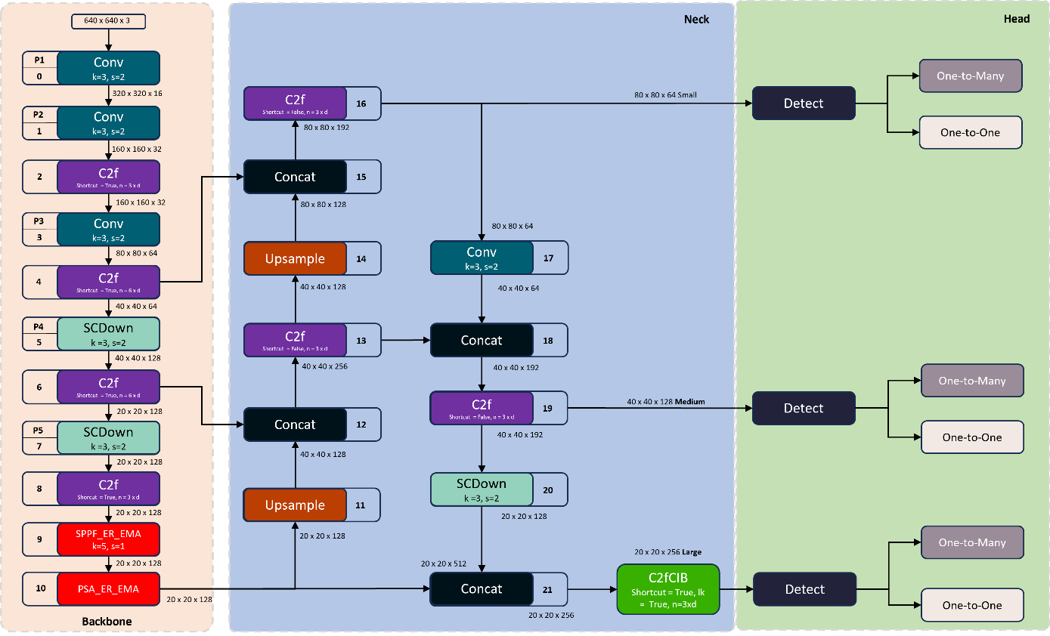
Figure 1. ER-EMA-YOLOv10n architecture. It consists of backbone, neck and head to detect, distribute and extract information with improvement on SPPF and PSA block at the backbone.

METHOD
In this section, the proposed architecture is explained in detail and focuses on improved performance and decreasing computation load on vehicle detection.

ER-EMA-YOLOv10n Architecture
The backbone of the ER-EMA-YOLOv10n architecture, shown in Figure 1, serves as the core feature extractor, leveraging multi-kernel convolutional layers to learn object patterns through iterative weight updates during training.

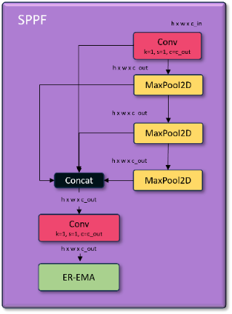
Figure 2. Pyramid-Based Spatial Pooling Block on ER-EMA-YOLOv10n.

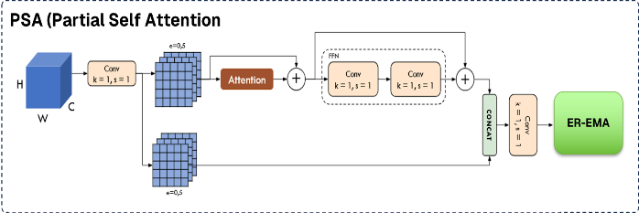
Figure 3. PSA block on ER-EMA-YOLOv10n. PSA enhances global feature representation.

The Pyramid-based Spatial Pooling in YOLOv10 designed to expand the receptive field during feature extraction, enables it to adapting on objects with diverse dimensions. Figure 2 show operation on spatial max pooling in 2D with different window (5, 9, 13). The Partial Self-Attention (PSA) block, adapted from the self-attention mechanism, enhances global feature representation while maintaining computational efficiency, as illustrated in Figure 3. Applying attention to a subset of feature channels, PSA effectively captures global context with reduced overhead compared to full self-attention, offering a balance between accuracy and efficiency. Block SPPF and PSA both modified with adding ER-EMA block at the end to enrich the extraction features.
The neck in the YOLOv10 architecture is a crucial segment which handles and fuses features of various levels and sizes from the backbone, aligning the resolution between the head and the backbone. The head is the part of the architecture responsible for classifying each detected object and calculating the probability for each object class. Its regression predicting each bounding box, including the One-To-Many head that sustains the native form and adjustment goal to produce a collection of forecasts. It also includes the One-to-One head using an alignment approach for label tagging that establishing each true labels is corresponded with a single forecast using CIOU loss is used to calculate the convergence area amongst correlated to truth regions and the aspect ratio [23].

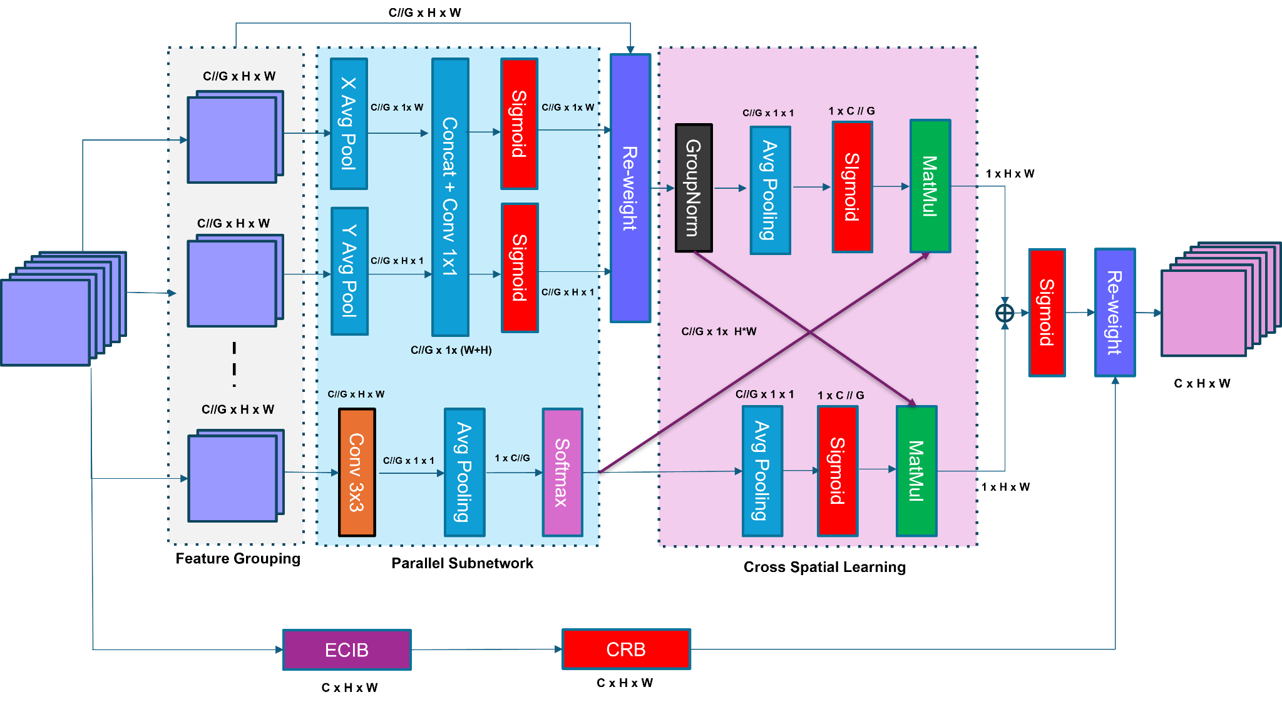
Figure 4. ER-EMA attention model included in SPPF and PSA block on ER-EMA-YOLOv10n. Enhances feature extraction across different scales while expanding the feature context.
Expanded Refinement of Efficient Multi Scale Attention (ER-EMA)
In order to create a robust detection model, it needs multiple types of vehicle detection simultaneously. This module seeks improvements of EMA (Efficient Multi Scale Attention) by boosting performance and enhancing feature extraction across different scales. Besides, this module refines the network ability to identify vehicles of various magnitudes. ER-EMA module is located in each block of the SPPF and PSA respectively, as shown on Figure 1,2,3. This work includes several block components working together to relate features in different frequencies within the proposed method.
ER-EMA consists of the EMA attention module as a context and ECIB and CRB lock as shown on Figure 4. EMA starts with feature grouping to partition X into G feature subsets spanning the stream dimensions direction for learning and extracting different semantics with G // C, learnt emphasis weight descriptors is set to be utilized for strengthen the feature encoding of interest region in each subset as described as follows (1)

$X = [X_{0},X_{i},...,X_{G-1}], X_{i}∈ {R.}^{C//G × H × W}$ (1)
Parallel subnetworks in EMA make two features associated the height of the image and share 1⨯1 convolution process, not reducing the dimensionality in the 1⨯1 branch using a process resembling to the Coordinate Attention (CA) [23]. After performing the 1⨯1 convolution, the output is split into two branch vectors continue with Sigmoid are applied fitting a binary distribution 2D data on the straight convolution [24]. EMA enables distinctive trans-channel interactions among the twin aligned paths at the 1⨯1 branch, the model layout among both channels combined with multiplication. Conversely, 3⨯3 convolution branch acquires proximal trans-channel feature cross-talk thereby expanding the representation. This module adjusts the magnitude of diverse channels and upholds exact spatial data blocks within the channels.
Cross spatial learning is a strategy to encoding holistic context and model broad associations. The primary spatial attention representation is obtained by operate the yield of the synchronous times with a matrix product. Similarly, 2D holistic mean pooling is used to extract holistic spatial data in the section to make a subsequent spatial weight representation that upholds spatial address details. Activation maps for every cluster are calculated, combining the two-weight point. The 2D holistic pooling operation as follows (2)

$Z_{C} =\frac{1}{H × W} \sum_{j}^{H}{}\sum_{i}^{W}{} {X_{C}}_{}\left(i,j\right).$ (2)
Expanded Convolution Inverted Block (ECIB)
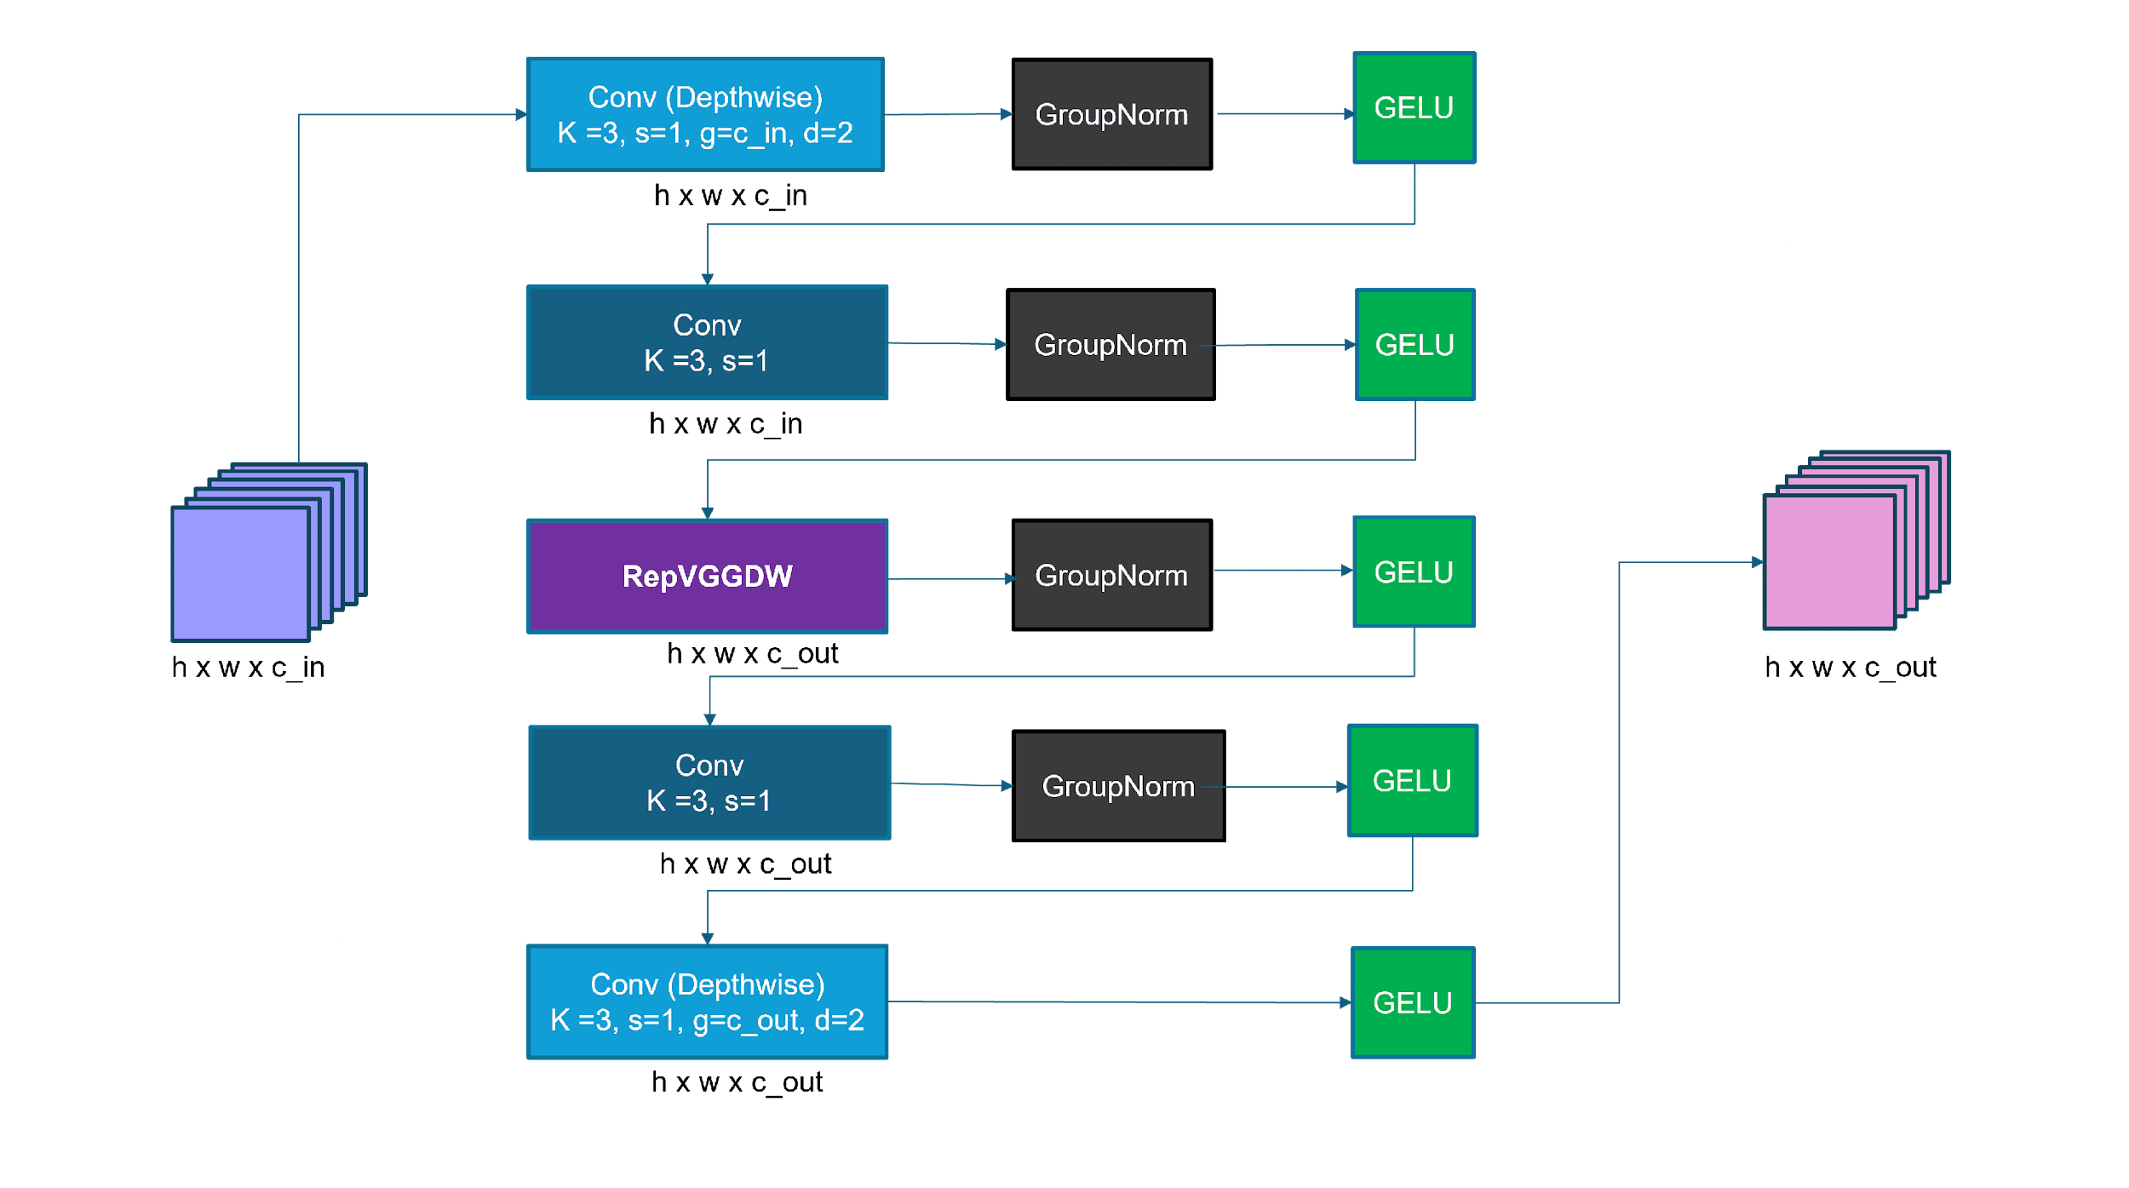
Figure 5. ECIB block on ER-EMA attention module.
This work introduces a new block in the new branch that provides a representation of the existing feature map as shown in figure 5. This block presents significant potential for further development into a unified module, aimed at improving performance while preserving computational efficiency. The ECIB block starts with $x$ as the input features, continues with 3⨯3 depthwise convolution. It referred as CDW₁ that shown in (3), (4)
${ECIB}_{} = {CDW}_{5}(C_{4}( {CDW}_{3}(C_{2}({CDW}_{1}(x))))),$ (3)
${CDW}_{1} = GELU (GN ( C_{DW(3⨯3)}(x)))$ (4)
In the next process, group normalization as GN [25] applied to input data and achieved more stable data representations for faster training after convolution. GELU (Gaussian Error Linear Unit) applied, providing a smoother representation and preserving information by offering more stable gradients for complex learning [26]. The process continues with 1⨯1 convolution as C₂ as shown (5)
$C_{2} = GELU (GN ( C_{(1⨯1)}({CDW}_{1}))).$ (5)
where
$REP = SILU( ( C_{DW3⨯3}(C_{2})) +( C_{DW7⨯7}(C_{2}))).$ (6)
REP is a REPVGGDW block that performs depthwise convolutions with 3⨯3 and 7⨯7 kernels to obtain a broad feature representation with SILU (Sigmoid Linear Unit). Improving the smoothness of gradient flow, preventing losing features. The process continues with the feature map result from CDW3 in C4, following a similar process on C2. It continues and concludes at CDW5, which applies a 3×3 convolution followed directly by GELU activation, as shown in the following (8).
${CDW}_{5} = GELU (GN ( C_{DW(3⨯3)}(C_{4}))).$ (8)
Convolutional Refinement Block (CRB)
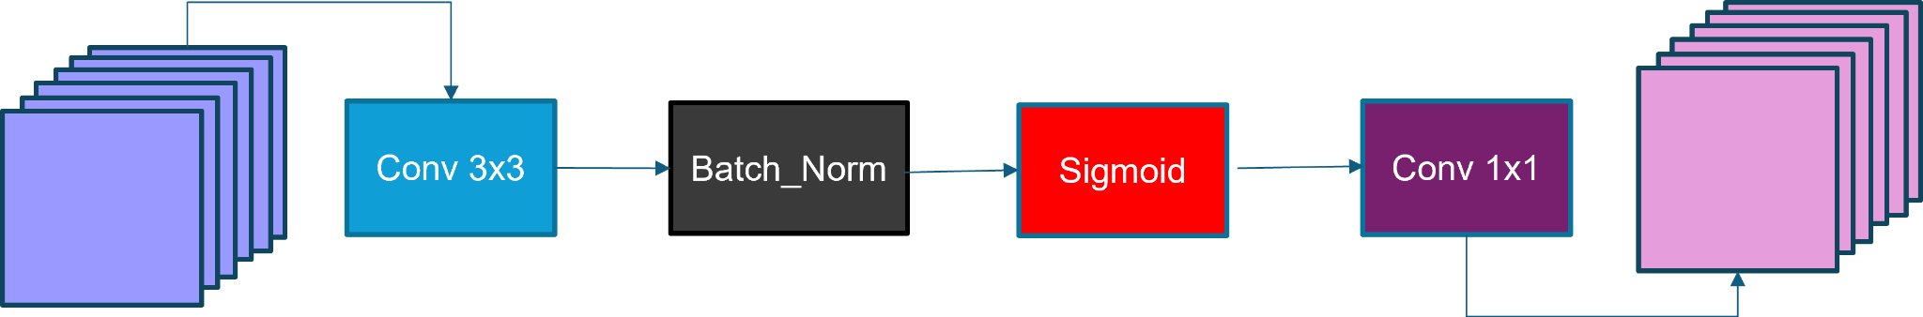
Figure 6. CRB block on ER-EMA attention module.
CRB begins with performing a 3⨯3 convolution that is effective to capture fine details like edge and texture of small shapes with efficiency. This process continues by batch normalization with aim to sustain the convergence on data features. Sigmoid function is used as the activation to determine the probability values of the generated feature map as follows (9)
${CRB}_{} = σ (BN ( C_{(3⨯3)}(x)))$. (9)
On Figure 6, process ends with 1⨯1 convolution that is used to mix the features to make a better representation. The result will be concatenated with EMA modules to elevate the performance of ER-EMA.
RESULTS AND DISCUSSION
Training Configuration
The following Table 1 outlines the proposed research using a computer equipped with high specifications for deep learning experiments. Training data is processed using an NVIDIA GPU Colorful, with a RAM capacity of 12 GB, which is well-suited for training complex models. The feed graphic is altered to a dimension of 640 ⨯ 640 for efficiency purposes, without sacrificing spatial information accuracy.

Table 1. Training and Evaluation Setup
Properties | Deployment
Device | AMD Ryzen 5 3500 6-Core
GPU | NVDIA RTX Colorful 12 GB
Image Size | 640 ⨯ 640 pixels
Epochs | 300(Vehicle-COCO),  100 (UA-DETRACT)
Batch Size | 16
Optimizer | SGD
Learning Rate | 0,01

Training was conducted over 300 epochs in Vehicle-COCO and followed by 100 epochs in UA-DETRACT dataset with the same requirements on the rest. Training data using a batch size of 16 to ensure stable training. The Stochastic Gradient Descent (SGD) solver was used owing to its sturdiness dealing with huge datasets. The learning rate was set at 0.01 to achieve a reach fitting rate. These configurations contribute in order to get optimal results on vehicle detection.

Table 2. Inference Setup
Properties | Deployment
System Software | Ubuntu
Compiler | Python 3.9.20
Framework | Pytorch 2.0
CPU | AMD Ryzen 5 3500 6-Core
Visual Dimension | 640 ⨯ 640 pixels

For the inference stage in Table 2, the method and evaluation were executed on a CPU setup computer. This allows evaluation of the architecture competence in limited computational resource condition.

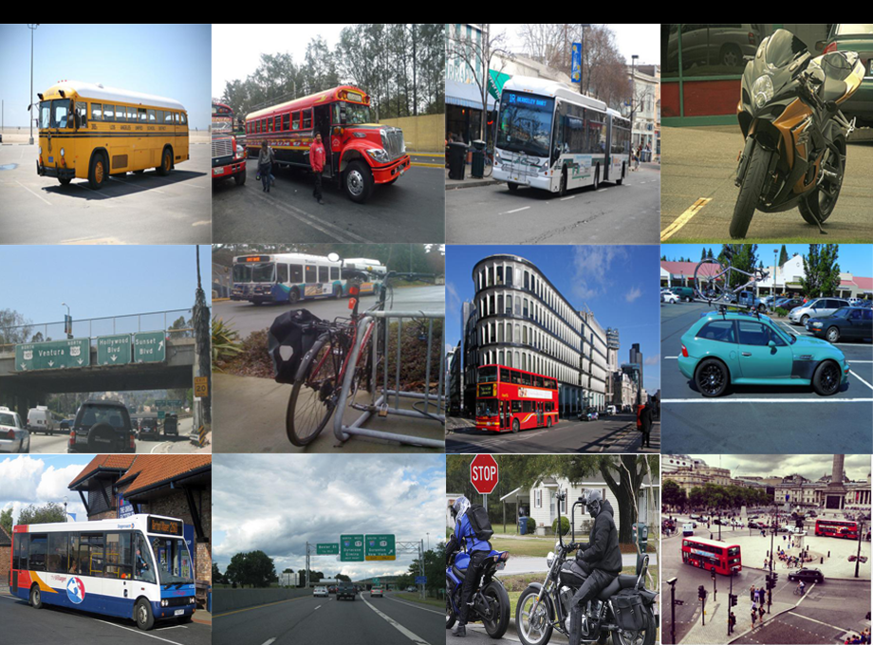
Figure 7. Vehicle Coco Dataset

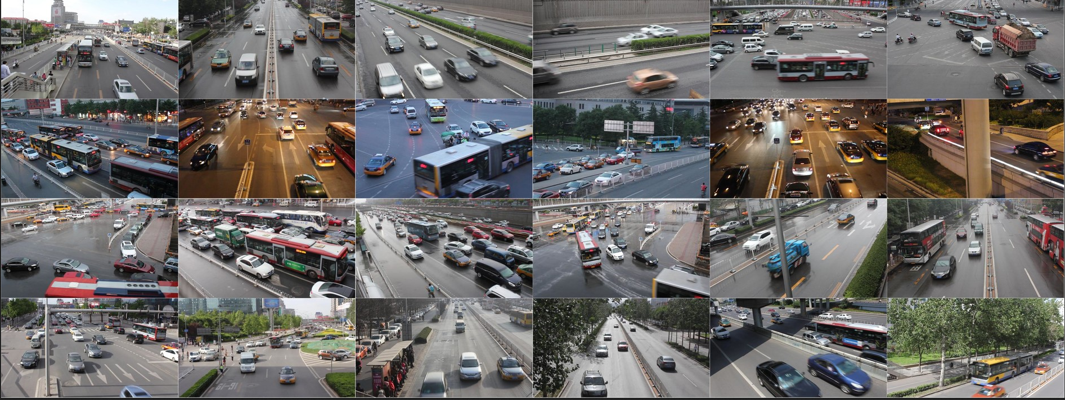
Figure 8. UA-DETRACT Dataset
Evaluation of Dataset
The dataset is a part of MS COCO dataset family [27] that has 18,998 images, consisting of 13,300 images for training data and 3,788 images for validation as shows in Table 3. The images are labelled into four classes: car, bus, truck, and motorcycle. This dataset was used in previous research by Chauduri as shown in Figure 7 [17].

Table 3. Vehicle-Coco Dataset properties
Properties | Visual data
Training Data | 13.300
Validation Data | 3.788

Another dataset used in this work is UA-DETRACT. It consists of 100 surveillance traffic tracking videos, collected from 24 locations under various weather conditions. The dataset splits into 60 group timeline for training and 40 group timeline for testing [28], with detailed configuration shown in Table 4. It annotates four vehicle types: car, bus, van, and others as shown in Figure 8. This dataset was used in previous research by the work of Yuhai Wang et al [21].
Table 4. UA-DETRACT Dataset properties
Properties | Visual data
Training Data | 83.791
Validation Data | 56.340

Each datasets evaluated and analyzed into comparation. The dataset evaluation demonstrates the accuracy of the vehicle detection model and its reliability under various road conditions and highlights how robust the offered architecture is in answering the adversities of vehicle recognition. The ablation study becomes important phase for specifically appraising the developments in the model by analyzing each component of the architecture. This allows for confirming which changes contributed to the performance improvements.

Table 5. Comparison of the proposed architecture with other models on Vehicle-COCO dataset
Model | G  FLOP  S | Para  Meter  (M) | mAP 50  % | mAP  50:95  %
YOLOv4-tiny [17] | 16.2 | 6.0 | 55.2 | -
YOLOv5-CSP [18] | 16.0 | 7.0 | 52.1 | -
LittleYOLO-SPP [19] | 12.9 | 8.7 | 52.9 | -
YOLOv5-NAM [20] | 16.0 | 7.0 | 56.1 | -
ShortYOLO-CSP [21] | 12.9 | 8.7 | 63.3 | -
ER-EMA-YOLOv10n | 8.3 | 2.6 | 64.5 | 45.2

Table 5 displays the spectacle comparison between ER-EMA-YOLOv10n architecture and previous methods. The outcome demonstrate that the proposed framework achieves superior accuracy along with computational efficiency. Specifically, ER-EMA-YOLOv10n exhibits enhanced capability in detecting various vehicle types, outperforming other frameworks precision comparison and resource usage. Compared to ShortYOLO-CSP, the model achieves an improvement of 0.8% in mAP@50, while reducing the parameter’s tally by 6.1 million, lowering computing resource load by 4.6 GFLOPS.

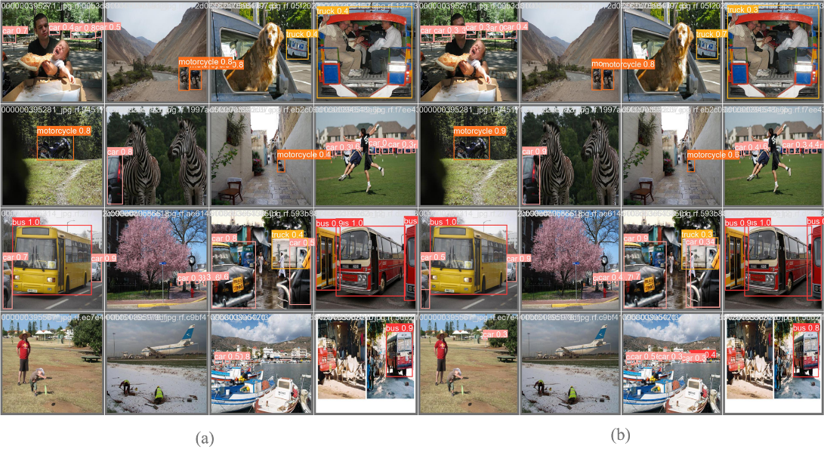
Figure 9. Comparisons on Vehicle-COCO dataset: (a) YOLOv10n original (b) ER-EMA-YOLOv10n

Table 6. Comparison of the proposed architecture with another framework on UA-DETRACT
Model | G  FLOP  S | Para  Meter  (M) |  | mAP  50  % |  | mAP  50:95  %
YOLOv3-tiny-FPGA [22] | 12.9 | 8.7 | 59.9 |  | -
YOLOv5-NAM [20] | 16.0 | 7.0 | 51.2 |  | -
YOLOv6n [23] | 11.3 | 4.6 | 53.6 |  | -
YOLOv7-tiny [23] | 13.0 | 6.0 | 47.2 |  | -
YOLOv5-IPA-MSCCR[23] | 15.6 | 6.4 |  | 56.5 |  |  | -
ER-EMA-YOLOv10n | 8.3 | 2.5 |  | 64.1 |  |  | 48.2

Table 6 highlight the architecture’s level of performance to classify and distinguish the diversity of vehicles on the traffic road. ER-EMA-YOLOv10n exhibits enhanced capability in detecting various vehicle types, outperforming other models in terms of accuracy and resource usage. It is better compared to previous works like YOLOv5-IPA-MSCCR with improvement of 8.4% in mAP@50. In addition, this model reduces the parameter’s tally by 3.9 million and decreases computing resource cost by 7.3 GFLOPS making this model become more efficient.
Table 7 presents the comparison of the proposed model with several different attention modules used in the YOLOv10n architecture. In this experiment, the YOLOv10n architecture was augmented with various attention modules under identical conditions. This demonstrates that the proposed model outperforms other attention-based variants on the subjects of both accuracy and efficiency, with only a minimal compromise in inference speed.
Table 7. Comparison of the proposed model with other attention module on Vehicle-COCO dataset.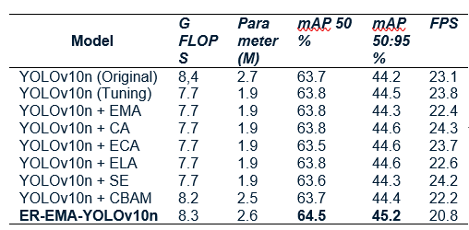

The slight decrease in speed is attributed to the inclusion of proposed blocks, which introduce an additional processing branch, thereby affecting detection speed. Compared to CBAM, the proposed model achieves superior accuracy on 64.5% mAP@50 compared to 63.7%, and 45.2% mAP@50:95 compared to 44.4%. In terms of computational efficiency, the proposed model also maintains a more favorable balance between accuracy and computational usage with 0.1 GFLOPS less and decrease 0.1 M parameter than original YOLOv10n.
In terms of detection comparison, Figure 9 (a) show that the original YOLOv10 encounters difficulties in detecting vehicle objects with precision across different types with some vehicles not detected in (a). Conversely, Figure 9(b) shows elevated accuracy and consistent object detection which lead to capturing even on small vehicle objects.

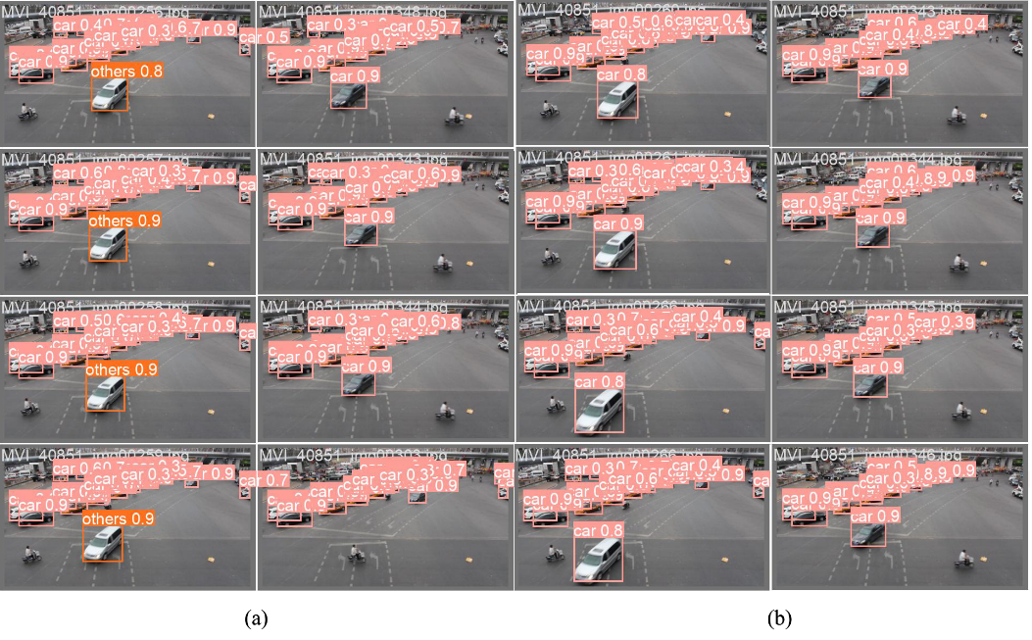
Figure 10. Comparison on UA-DETRAC dataset: (a) YOLOv10n original model, (b) ER-EMA-YOLOv10-n model (ours)

The evaluation results of the proposed architecture tested on UA-DETRACT validation subset datasets shown on Figure 10. It demonstrates significant upgrades in subject of precision and efficiency compared to the YOLOv10n variant. Figures 10(a) indicate that the YOLOv10n origin version confronts with difficulties in detecting vehicle with precision across different types. In contrast, 10(b) show improved precision with consistent object detection, featuring accurate bounding boxes that ensure better recognition.

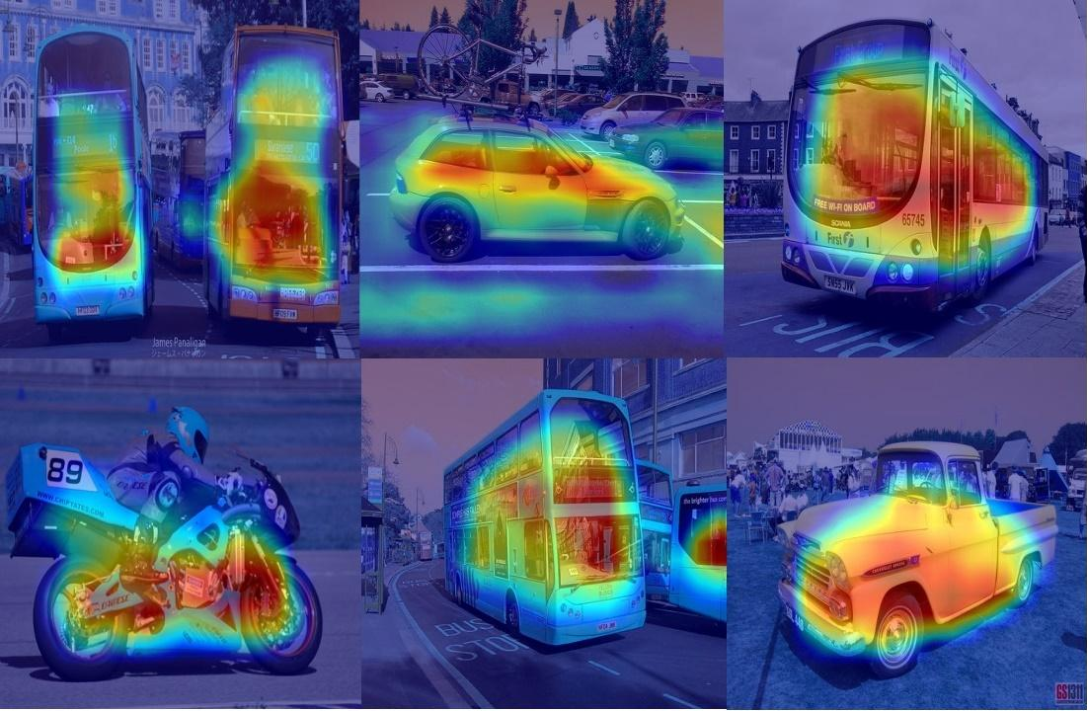
Figure 11. Heatmaps on various vehicle types on COCO dataset.

Heatmap results of the ER-EMA-YOLOv10n model on COCO dataset, focusing on the detection of different vehicle types with varying scale features on Figure 11. Moderate-activation areas (green, yellow and red) contribute to general object recognition, while low-activation areas (dark blue) represent backgrounds and irrelevant regions. The proposed model improves detection accuracy compared to the YOLOv10n base model. When compared, the metrics shows mAP@50 is 64.5% versus 63.7% and mAP@50-95% is 45.2% versus 44.2%. Accuracy gained around 0,7 – 1%.

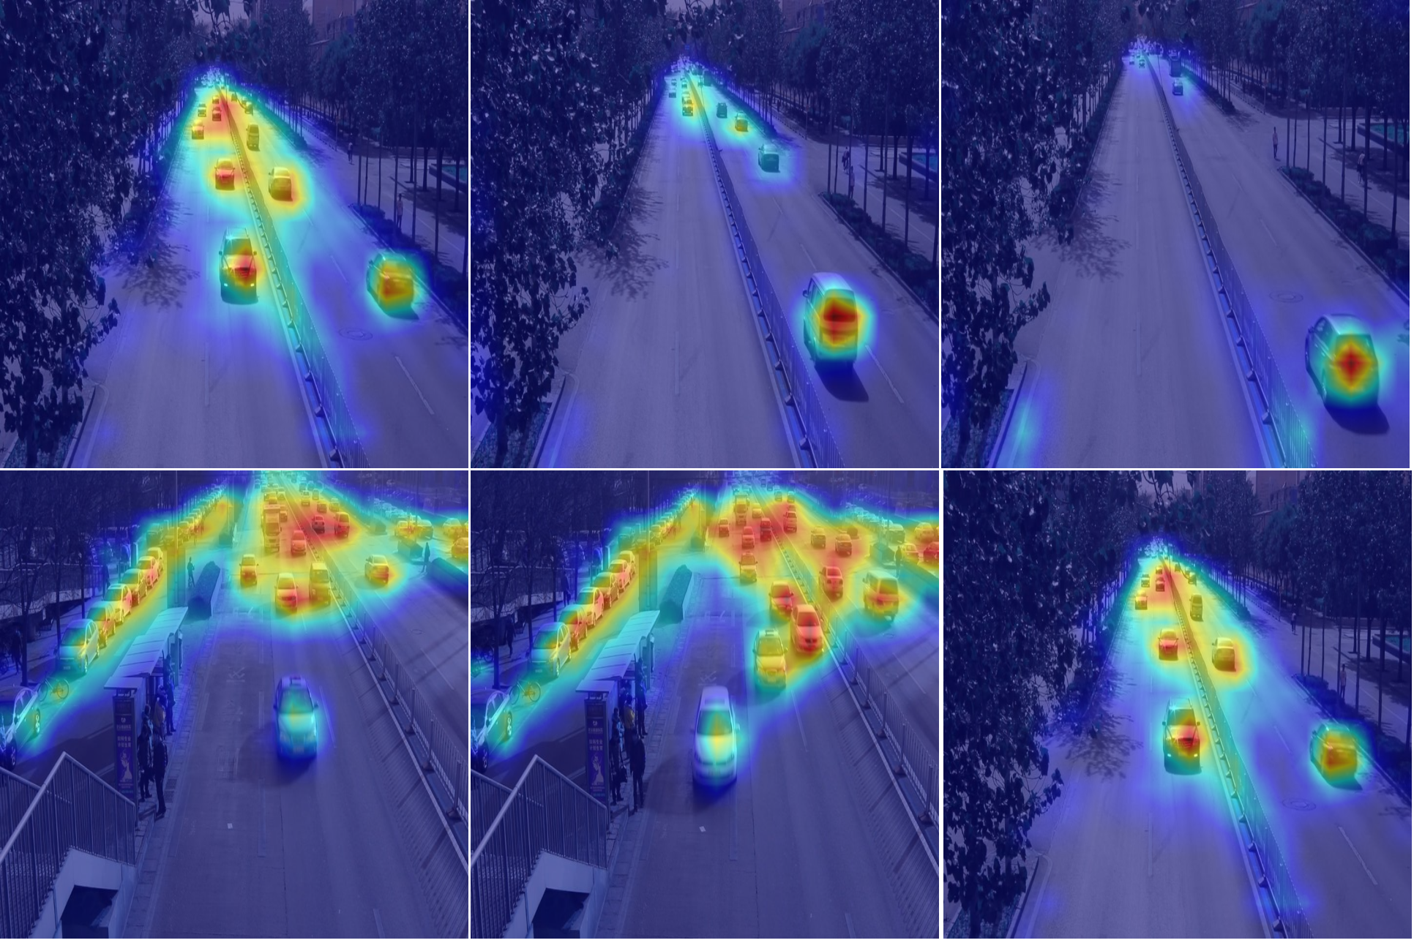
Figure 12. Heatmap on traffic condition in UA-DETRACT dataset.

On Figure 12, the heatmap of the ER-EMA-YOLOv10n model on UA-DETRACT dataset, focusing of detection of different vehicle type on the road traffic. Moderate-activation areas (green, yellow and red) contribute to general object recognition, while low-activation areas (dark blue) represent backgrounds and irrelevant regions. The proposed model enhances performance that the original, reducing noise on the background. The accuracy shows an improvement that shown on mAP@50-95% is 48.2% versus 44.2% with the original. These evaluations show that ER-EMA-YOLOv10n performs better feature extraction, improves accuracy, and offers greater computational efficiency compared to the original YOLOv10n. Because it focuses on important visual features while ignoring less relevant areas, making it more robust and optimized vehicle detection.

Ablation Study
Both datasets evaluated and analyzed into ablation studies. The ablation study focuses on the impact of each component in the model architecture along with its contribution to elevated performance. The dataset evaluation demonstrates the accuracy of the vehicle detection model and its reliability under various road conditions and highlights how robust the proposed model is in addressing the challenges of vehicle detection. The ablation study is a crucial phase for specifically evaluating the developments in the model by analyzing each component of the architecture. This allows for confirming which changes contributed to the performance improvements.

Table. 8 Ablation study about the proposed model on Vehicle-COCO dataset
Model | G  FLOP  S | Para  Mete  r  (M) | mAP  50  % | mAP  50:95  %
YOLOv10n | 8.4 | 2.7 | 63.7 | 44.2
YOLOv10n + EMA | 8.5 | 2.7 | 64.1 | 44.9
YOLOv10n + EMA + ECIB | 8.0 | 2.6 | 63.5 | 44.1
YOLOv10n + EMA + CRB | 8.0 | 2.6 | 63.8 | 44.7
ER-EMA-YOLOv10n | 8.3 | 2.6 | 64.5 | 45.2

Table 8 reveal the outcomes of the ablation study executed in various modification of YOLOv10n model. It examines the individual contributions of the ECIB and CRB components, as well as their combined effect. It highlights the performance improvements through the integration of these modules, while maintaining computational efficiency. The proposed module combination yields a 1% increase in mAP@50:95, indicating a notable enhancement in detection performance. In terms of model efficiency, the approach results in a reduction of 0.1 million parameters and a saving of 0.1 GFLOPs in computational cost.

Table 6. Ablation study about the proposed model on UA-DETRACT dataset
Model | G  FLOP  s | Para  Meter  (M) | mAP  50  % | mAP  50:95  %
YOLOv10n | 8.4 | 2.7 | 58.9 | 44.2
EMA-YOLOv10n | 8.5 | 2.7 | 59.3 | 44.3
ER-EMA-YOLOv10-n | 8.0 | 2.5 | 64.1 | 48.2

Table 9 presents the ablation study comparing the baseline YOLOv10n, combined EMA-YOLOv10n, and the ER-EMA-YOLOv10n. The proposed method demonstrates a significant improvement in performance, achieving a 4% increase in mAP@50:95. In terms of computational efficiency, the model also shows a reduction of 0.2 million parameters and a saving of 0.4 GFLOPs in computational load. As a note, experiments conducted on the UA-DETRAC, the architecture was slightly modified by discarding the CRB block and utilizing only the ECIB block. To further optimize the receptive field, the ECIB block was adapted with a dilation factor of 2, effectively enlarging the receptive field without increasing the parameter count or computational complexity. This adjustment is particularly important due to the nature of the UA-DETRAC dataset, which consists of extensive video footage captured from road surveillance, leading to a high volume of similar or near-identical images.

Runtime Efficiency
Runtime efficiency is a critical metric in evaluating the usability of vehicle objects. It measures how efficient the model is in terms of speed, number of parameters, and computational load. It provides a comparative analysis of the runtime between YOLOv10n and ER-EMA-YOLOv10n using a CPU.

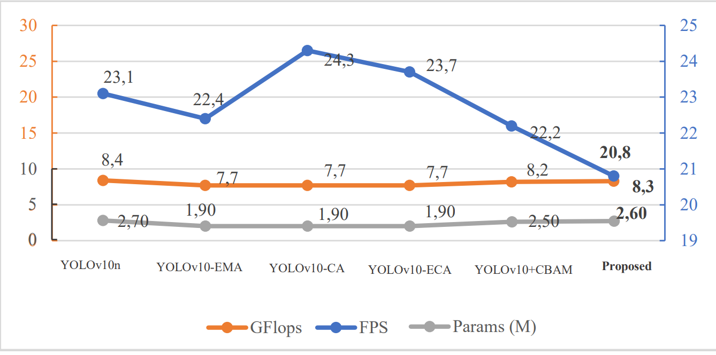
Figure 13. Comparison runtime efficiency among original YOLOv10, other attention module and proposed model.
As observed in Figure 13, the ER-EMA-YOLOv10n model shows a significant improvement in runtime efficiency. There is a decrease of 0,1 M in the number of parameters on the Vehicle-COCO dataset and 0,2 M in the UA-DETRACT dataset. There is also an efficiency on computational load as 0,1 GFLOPS in Vehicle-COCO dataset and 0,4 GFLOPS in the UA-DETRACT dataset. These improvements can be belonged to the depthwise technique, along with pruning of the number of channels in the backbone, resulting in a more efficient architecture. In terms of speed, there is a slight decrease also because of the use of depthwise convolution and the location of ECIB and ERB blocks on ER-EMA that add a branch that create some overhead that results in decreasing FPS speed on CPU runtime application. It shows a 3.32 FPS decrease compared to YOLOv10n original model.

CONCLUSION
This research presents some approaches to improving the performance of vehicle detection models. First by introducing ER-EMA-YOLOv10n models that consist of YOLOv10n as main architecture, and ER-EMA as a cutting-edge attention module. ER-EMA consists of two novel blocks called Expanded Convolution Inverted Block (ECIB), and Convolutional Refinement Block (CRB). This model trains on two datasets, namely Vehicle-COCO and UA-DETRACT. Our method significantly enhances performance compared to the baseline model and previous works. The ER-EMA-YOLOv10n version achieves a mAP 50% accuracy of 64.5%, surpassing the original model by 0.7%, and a mAP 50-95% accuracy of 45.2%, exceeding the original by 1% on the Vehicle-COCO dataset.
Significant performance improvement is also demonstrated on the UA-DETRACT dataset. It produces a mAP 50% of 64.1%, surpassing the original by 5.2%, and a mAP 50-95% of 48.2%, exceeding the original by 4%. In addition, our model also reduces the parameter’s tally and GFLOPS for compute resource efficiency. On Vehicle-COCO dataset, the model has 2,646,552 parameters, 62,032 fewer than the original model, and 8.3 GFLOPS, which is 0.1 more efficient than the original model. Similar efficiency is observed on the UA-DETRACT dataset, with 2,572,040 parameters, 136,644 fewer than the original model, and 8.0 GFLOPS, which is 0.4 more efficient than the original. These findings demonstrate that ER-EMA-YOLOv10n offers a balanced improvement in both precision and computational efficiency, making it more robust for vehicle detection.
Future exploration could highlight on elevating the performance of the YOLOv10n architecture by further exploring modifications in the neck component, particularly investigating the integration of a Path Aggregation Network (PAN) to boost detection accuracy or improve computational efficiency. Additionally, another promising direction is to adapt and deploy the proposed model in real-time applications, such as vehicle counting for intelligent traffic management systems. Future work could explore improvements in performance, computational efficiency, speed enhancement, latency reduction, adaptation to similar object detection tasks, and real-time application usage. This study focuses on contributing to the development of algorithmic models for vehicle detection.

ACKNOWLEDGMENT
The authors are sincerely thankful for the AIVISION research team for their immense support, and expertise in computer vision and deep learning with providing the necessary resources.

REFERENCES
- Porru et al., "Smart mobility and public transport: Opportunities and challenges in rural and urban areas," J. Traffic Transp. Eng. (Engl. Ed.), vol. 7, pp. 88–97, 2020. DOI. 10.1016/j.jtte.2019.10.002.
- Y. Gao and J. Zhu, "Characteristics, Impacts and Trends of Urban Transportation," Encyclopedia, vol. 2, pp. 1168–1182, 2022. DOI. 10.3390/encyclopedia2020078.
- World Geospatial Industry Council, Annual Report 2024, Catalogue 11020001.71, ISSN 0215-2274, vol. 38, 2025.
- Z. Zou, K. Chen, Z. Shi, Y. Guo and J. Ye, "Object Detection in 20 Years: A Survey," in Proceedings of the IEEE, vol. 111, no. 3, pp. 257-276, March 2023, DOI. 10.1109/JPROC.2023.3238524.
- M. D. Putro, D. -L. Nguyen and K. -H. Jo, "A Fast CPU Real-Time Facial Expression Detector Using Sequential Attention Network for Human–Robot Interaction," in IEEE Transactions on Industrial Informatics, vol. 18, no. 11, pp. 7665-7674, Nov. 2022, DOI. 10.1109/TII.2022.3145862.
- M. M. Taye, "Theoretical Understanding of Convolutional Neural Network: Concepts, Architectures, Applications, Future Directions," Computation, vol. 11, p. 52, 2023. DOI. 10.3390/computation11030052.
- J. Terven, D. M. Córdova-Esparza, and J. A. Romero-González, "A comprehensive review of YOLO architectures in computer vision: From YOLOv1 to YOLOv8 and YOLO-NAS," Mach. Learn. Knowl. Extr., vol. 5, no. 4, pp. 1680–1716, 2023. DOI. 10.3390/make5040083.
- M. Hussain and R. Khanam, "In-depth review of YOLOv1 to YOLOv10 variants for enhanced photovoltaic defect detection," Solar, vol. 4, no. 3, pp. 351–386, Jun. 2024.M. M. Taye, "Theoretical Understanding of Convolutional Neural Network: Concepts, Architectures, Applications, Future Directions," Computation, vol. 11, p. 52, 2023. DOI. 10.3390/solar4030016.
- D. Ouyang et al., "Efficient Multi-Scale Attention Module with Cross-Spatial Learning," ICASSP 2023 - 2023 IEEE International Conference on Acoustics, Speech and Signal Processing (ICASSP), Rhodes Island, Greece, 2023, pp. 1-5, DOI. 10.1109/ICASSP49357.2023.10096516.
- R. Bharath, H. U. Ujwal, K. Chandan, R. C. Ravindranath, R. Chandramma and H. R. Rakshith, "Advancing Marine Species Detection: A Comparative Analysis of YOLOv5 and YOLOv8 in Challenging Underwater Environment," 2024 First International Conference for Women in Computing (InCoWoCo), Pune, India, 2024, pp. 1-8, DOI: 10.1109/InCoWoCo64194.2024.10863206.
- Zhang and S. Chen, "Research on Improved Lightweight Fish Detection Algorithm Based on Yolov8n," J. Mar. Sci. Eng., vol. 12, p. 1726, 2024, DOI: 10.3390/jmse1210172.
- M. D. Putro et al., "Streamlining Deep Learning Network for Real-time Sea Turtle Detection," J. Rekayasa Elektrika, vol. 20, p. 3, 2024, DOI: 10.17529/jre.v20i3.35236
- J. Mei and W. Zhu, "BGF-YOLOv10: Small Object Detection Algorithm from Unmanned Aerial Vehicle Perspective Based on Improved YOLOv10," Sensors, vol. 24, p. 6911, 2024, DOI: 10.3390/s24216911.
- X. Qiu et al., "LD-YOLOv10: A Lightweight Target Detection Algorithm for Drone Scenarios Based on YOLOv10," Electronics, vol. 13, p. 3269, 2024, DOI. 10.3390/electronics13163269.
- A. Li et al., "D3-YOLOv10: Improved YOLOv10-Based Lightweight Tomato Detection Algorithm Under Facility Scenario," Agriculture, vol. 14, p. 2268, 2024, DOI. 10.3390/agriculture14122268.
- S. Guan et al., "Real-time Detection and Counting of Wheat Spikes Based on Improved YOLOv10," Agronomy, vol. 14, p. 1936, 2024. DOI. 10.3390/agronomy14091936.
- A. Chaudhuri, "Smart traffic management of vehicles using faster R-CNN based deep learning method," Scientific Reports, vol. 14, no. 1, p. 10357, 2024. DOI. 10.1038/s41598-024-60596-4.
- E. Rani, "LittleYOLO-SPP: A delicate real-time vehicle detection algorithm," Optik, vol. 225, p. 165818, 2021, DOI. 0.1016/j.ijleo.2020.165818.
- P. E. Rani and S. S. Jamiya, "ShortYOLO-CSP: A decisive incremental improvement for real-time vehicle detection," J. Real-Time Image Process., vol. 20, no. 1, p. 3, 2023, DOI. 10.1007/s11554-023-01256-0
- J. Wang, Y. Dong, S. Zhao and Z. Zhang, "A high-precision vehicle detection and tracking method based on the attention mechanism," Sensors, vol. 23, no. 2, p. 724, 2023. DOI. 10.3390/s23020724
- Y. Wang et al., "Lightweight vehicle detection based on improved YOLOv5s," Sensors, vol. 24, no. 4, p. 1182, 2024, DOI. 10.3390/s24041182
- J. Zhai, B. Li, S. Lv and Q. Zhou, "FPGA-based vehicle detection and tracking accelerator," Sensors, vol. 23, no. 4, p. 2208, 2023, DOI. 10.3390/s23042208.
- S. Du, B. Zhang, P. Zhang and P. Xiang, "An Improved Bounding Box Regression Loss Function Based on CIOU Loss for Multi-scale Object Detection," 2021 IEEE 2nd International Conference on Pattern Recognition and Machine Learning (PRML), Chengdu, China, 2021, pp. 92-98, DOI. 10.1109/PRML52754.2021.9520717.
- S. R. Dubey, S. K. Singh and B. B. Chaudhuri, "Activation Functions in Deep Learning: A Comprehensive Survey and Benchmark," Neurocomputing, vol. 503, pp. 92–108, 2022, DOI. 10.1016/j.neucom.2022.06.111.
- L. Huang, J. Qin, Y. Zhou, F. Zhu, L. Liu and L. Shao, "Normalization Techniques in Training DNNs: Methodology, Analysis and Application," in IEEE Transactions on Pattern Analysis and Machine Intelligence, vol. 45, no. 8, pp. 10173-10196, Aug. 2023, DOI. 10.1109/TPAMI.2023.3250241.
- A. Nguyen, K. Pham, D. Ngo, T. Ngo and L. Pham, "An Analysis of State-of-the-art Activation Functions For Supervised Deep Neural Network," 2021 International Conference on System Science and Engineering (ICSSE), Ho Chi Minh City, Vietnam, 2021, pp. 215-220, DOI. 10.1109/ICSSE52999.2021.9538437.
- T.-Y. Lin et al., "Microsoft COCO: Common COCO dataset, "Vehicles-COCO dataset," [Online]. Available: https://universe.roboflow.com/vehicle-mscoco/vehicles-coco. [Accessed: Jan. 29, 2025].
- L. Wen et al., "UA-DETRAC: A New Benchmark and Protocol for Multi-Object Detection and Tracking," Comput. Vis. Image Understand., vol. 193, p. 102907, 2020, DOI. 10.1016/j.cviu.2020.102907.

