Development of Automatic Size-Sorting System for Catfish Seeds Using Photodiode Sensors | 

Irmansyah¹*, Rifqi Eka Saputra¹, Mahfuddin Zuhri¹, Heriyanto Syafutra¹
¹Applied Physics Division, Department of Physics, Faculty of Mathematics and Natural Science, IPB University, Bogor, Indonesia

Abstract  In catfish farming, uniform seed size is crucial to ensure balanced growth and minimize competition for feed. Generally, the size sorting process is carried out manually through visual observation and separation using nets. Although this method can help, the process is laborious, time-consuming, and can cause stress or injury to the fish. Several technologies can be applied to sort catfish seeds, including the use of sensors to determine length and more sophisticated methods using machine learning. However, the choice used needs to consider the farmers' ability to adopt the technology. This study developed an automatic sorting system using a photodiode sensor and an Arduino-based microcontroller at a low cost. This system is designed to detect variations in fish body length when passing through the sorting channel through a laser beam interference detection mechanism to indicate its size. Four photodiodes are positioned at certain distances to determine different size categories. When fish interfere with one or more laser beams, the system will classify their size and automatically direct them to the appropriate container. The test results showed that the prototype could group catfish seeds into four size categories: less than 7 cm, 7–8 cm, 9–10 cm, and 11–12 cm. The system had an accuracy of 67.50% and a misclassification rate of 32.50%. Despite these limitations, the automated sorting process significantly reduced human intervention and stress on the fish. In addition, the system showed a 100% positive impact on the survival rate of fry after sorting.  This is an open access article under the CC BY-SA license   | Keywords:  (Aquaculture technology; Automatic sorting; Body length, Catfish ;Microcontroller; Photodiode)  Article History:  Received: May 13, 2025  Revised: May 29, 2025  Accepted: June 2, 2025  Published: June 2, 2025  Corresponding Author:  Irmansyah  Applied Physics Division, Department of Physics, Faculty of Mathematics and Natural Science, IPB University, Bogor, Indonesia  Email: irmansyah@apps.ipb.ac.id

INTRODUCTION
Catfish farming is one of the most promising freshwater fisheries sectors in Indonesia [1]. Based on data from the Ministry of Maritime Affairs and Fisheries of the Republic of Indonesia, in 2023, catfish cultivation production will be 1.13 milion tons. With the increasing demand for catfish consumption, this cultivation activity is a promising economic opportunity for the community, especially in rural areas [2]. To maintain productivity and efficiency, paying attention to several technical aspects, such as fish growth, feed distribution, and efficiency in managing cultivation ponds, is necessary [3], [4].
One of the significant challenges in catfish cultivation is the difference in the size of fish seeds or seedlings, which can cause larger individuals to dominate smaller individuals, thus creating an imbalance in the competition for food [5], [6]. In addition, catfish also have cannibalistic traits, so differences in size can increase the chances of cannibalism and reduce cultivation productivity [7], [8]. Therefore, periodically sorting catfish sizes is essential to maintain population uniformity and increase cultivation productivity [9].
The process of sorting catfish based on size commonly used today is still manual, using simple tools, such as trays that are given holes according to the size of the catfish to be sorted. This sorting process has several weaknesses, including taking a long time, depending on the operator's expertise, and potentially causing stress to the fish due to repeated physical handling. Technological solutions that are more efficient and accurate and help reduce dependence on manual labor are necessary to increase cultivation productivity.
Several researchers have reported various approaches to predict fish size using image processing and automatic fish counting. However, automatic fish seed classification technology, especially for catfish, is still very limited. [10] has reported an automatic fish sorting system based on machine vision equipped with a stereo camera to identify fish size in real time and direct the fish to the sorting gate at the end of the conveyor. [11] developed a weight-based fish sorting device using a strain gauge sensor and Arduino Uno to classify fish into three size groups. [12] successfully applied a moment-invariant image processing algorithm to identify species and distinguish fish sizes in a polyculture system and showed a high correlation between digital images and fish mass and length. Meanwhile, [13] reported the development of an automatic tool for counting and classifying catfish seeds based on size using YOLOv8, MobileNetV2, and OpenMV camera. Although these methods show promising results, unfortunately in their development they require complex hardware, high costs, and controlled environmental testing, thus limiting their practicality in application and use for small-scale cultivation. Therefore, despite the availability of various advanced solutions, there is still a gap in the development of low-cost, real-time, and minimally invasive fish seed systems that are suitable for the needs of small and medium farmers.
Along with the development of sensor and microcontroller technology, which is supported by ease and affordability, opportunities have emerged to automate various processes in aquaculture [14], [15], [16] Low-cost components such as photodiodes, laser diodes, and Arduino are increasingly being explored in multiple applications, such as water quality monitoring and automatic feeding systems. With proper design and adaptation to field conditions, this technology can provide real solutions that are easy to implement, especially for small-scale fish farmers.
This study proposes a novel real-time catfish seed sorting system based on photodiode sensors and Arduino microcontrollers, offering a low-cost and minimally invasive alternative to existing solutions. This system consists of three main parts: the first storage part, the second size detector part, and the third sorting part. The system automatically removes catfish placed in the storage part one by one through a channel with water flow using a gravity mechanism. Several photodiode sensors are installed at several locations in the channel to detect the size of the catfish. The information obtained in this section is then forwarded to the sorting section to direct the motor to the final storage tank according to the size. The main advantage of this method is its ability to sort in real-time and with minimal contact, thus minimizing stress on the fish. With a faster and more accurate sorting process, cultivation productivity increases, labor costs become more efficient, and a healthier and more uniform maintenance environment for catfish is created.
This study introduces the first implementation of a real-time, low-cost automatic fish seed sorting system using photodiode sensors to classify catfish seed sizes based on body length. The main contribution of this research is the design and implementation of an automated length-based sorting system using photodiode sensors and Arduino microcontrollers. This system can be an alternative solution for farmers to minimize fish handling, reduce operational labor, and enhance the uniformity and efficiency of catfish seed cultivation.

METHOD
The prototype uses photodiode and laser diode sensors as a body length detection system [17] for fish seeds. The signal from the photodiode sensor is processed by Arduino Uno to control the movement of the servo motor, directing the path of fish seeds, whose length is already known, to the container according to their size category. This system is designed to sort the size of fish seeds into four categories: less than 7 cm, 7–8 cm, 9–10 cm, and 11–12 cm.

Material
The electronic components needed make this device readily available on the market in Indonesia at a low cost. The list of electronic components and their functions can be seen in Table 1.

Table 1. List components, and function of the developed prototype
Components | Functions
Arduino Uno | Central Processing Unit, controlling the flow of data and instructions
Laser diode KY-008 | Light source to activate the photodiode
Photodiode | Sensor to detect the light from the photodiode.
16x2 Character LCD display | Display notifications, status, or measurement results
Servomotor | To direct the path of fish seeds
Power adaptor | Voltage source to turn on the device
Project box | Device casing with size (7.5 cm x 10 cm x 3.5 cm)
PVC Pipe | Frame of developed prototype

Methods
Figure 1(a) shows a block diagram of the prototype of an automatic catfish seed sorter. This diagram explains the system architecture, consisting of three main parts: input, processor, and output. In the input section, there is a laser diode array and a photodiode array to detect the body length of catfish seeds. The detection data is sent to the processing unit (Arduino Uno), which functions as a Central Processing Unit (CPU) to run the classification algorithm to determine the fish seeds' body length category. As an output section, there is an LCD to display the classification results and a servo motor to move the sorting line to the container according to size. All of these electronic components work with a voltage of 5V.
Figure 1(b) shows the electronic circuit of the developed prototype. Four photodiodes are connected to the Arduino digital pins, each on pins 2, 3, 4, and 5. Meanwhile, the four laser diodes are only connected to a 5V voltage source and ground without going through the control pin of Arduino, so the laser diodes will light up continuously as long as the prototype is in active (ON) condition, because it receives HIGH logic directly. Arduino digital pin 7 is used to send control signals to the servo motor to regulate rotational movement. The 2x16 character LCD module is equipped with an I2C interface for efficient use of pins, so it only requires a connection to analog pins 4 and 5 on the Arduino as a data communication path. All components, including photodiodes, laser diodes, motors, and LCDs, get their power supply directly from an external 5V adapter, not from the Arduino output. This configuration was chosen to ensure that the current requirements of each component are met without disrupting the power supply to the microcontroller, so that system performance remains optimal [18].

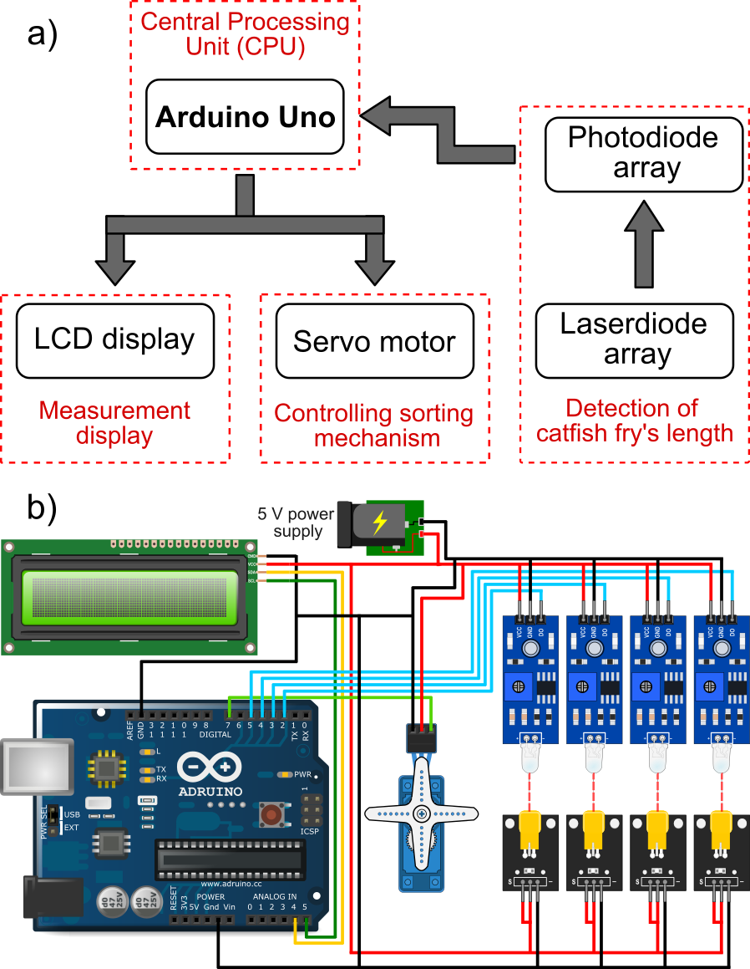

Figure 1. a) The block diagram, and b) the electronic circuits of the automatic catfish seed sorter prototype.

The automatic sorting of catfish seeds based on body length follows the logic flow shown in Figure 2(a). When the fish enters the sorting tube, the system starts monitoring the status of four optical sensors consisting of laser diodes and photodiode pairs. Each pair of laser diode and photodiode is positioned transversely to the direction of seed movement in the sorting tube, as shown in Figure 2(b). The distance between the laser-diode and photodiode pairs represents the classification length of the seeds. The number of photodiodes disturbed by the fish body is used to estimate the catfish's length. The detection process starts from photodiode-1; if the signal from photodiode-1 is disconnected (OFF) because catfish seeds block it, the system continues to check the status of other photodiodes sequentially. The classification logic based on the number of photodiodes that are dead (OFF) is as follows:
- Only photodiode-2 is OFF (photodiodes-3 and -4 remain ON); The length of the fish seeds is around 7–8 cm
- Photodiodes-2 and -3 are OFF; The length of the fish seed is around 9–10 cm
- Photodiodes-2, -3, and -4 are OFF; The length of the fish seed is around 11–12 cm
- If only photodiode-1 is OFF (photodiodes-2, -3, and -4 are ON); The length of the seed is <7 cm
After the length of the catfish is identified, the system drives the servo motor to direct the fish to the appropriate sorting channel. The rotation angle of the servo motor based on the size category of the seed length is as follows:
- 30° for size < 7 cm
- 70° for size 7–8 cm
- 110° for size 9–10 cm
- 150° for size 11–12 cm
The classification design in this prototype can automatically sort catfish seeds into four size categories efficiently and in real time, improving the accuracy of seed sorting in catfish farming activities.

RESULTS AND DISCUSSION
The prototype of an automatic sorting system for catfish seeds using a photodiode–laser diode sensor and Arduino control has been successfully created. It can potentially replace the manual sorting process. This system aims to minimize human intervention to reduce stress on fish seeds during handling, while maintaining classification accuracy. The performance of the prototype was evaluated through a classification test of catfish seeds with varying body lengths, where its effectiveness was assessed based on its accuracy in grouping seeds into containers according to their respective size categories: <7 cm, 7–8 cm, 9–10 cm, and 11–12 cm [13].

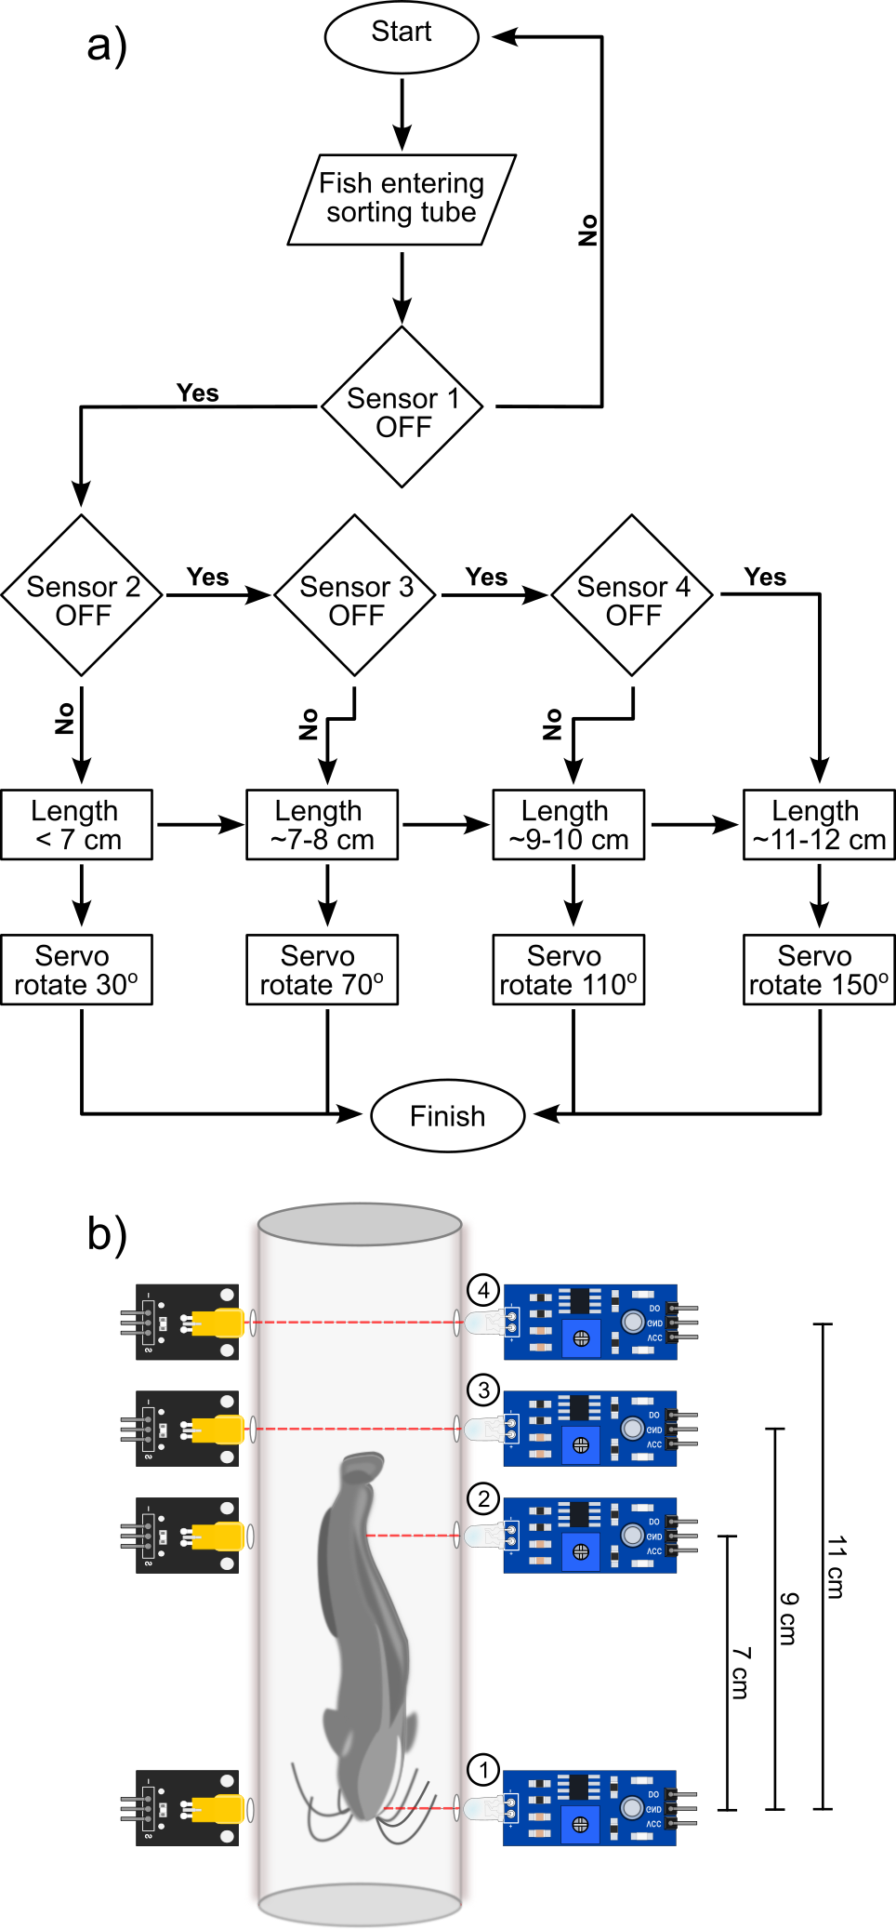

Figure 2. (a) Flowchart of catfish seed classification process based on body length using photodiode–laser diode sensor system and servo motor. b) Illustration of catfish seed sorting tube.

The prototype test results can be seen in Table 2. The system can perfectly classify seeds with a size of <7 cm, without errors. This success indicates that the detection system works well when blocking photodiode-1 and skipping the other three photodiodes. In this case, the OFF condition reading is only on photodiode-1, resulting in a definite classification decision by Arduino. This success shows the prototype's potential to reduce sorting time and stress from manual handling, at least for the small seed category [13], [19] This prototype still shows relatively small errors in the other three categories, namely 12.50% for the 7–8 cm category, 7.50% for 9–10 cm, and 12.50% for 11–12 cm.
The performance assessment of the developed system gave results, the system had an accuracy of 67.50% and a classification error of 32.50%. Based on observations of fish fry during and after the sorting process, the system showed a 100% positive impact on the survival rate of fish fry. We believe that the automatic sorting process carried out by this system will significantly reduce human intervention and stress on fish.
There are still misclassifications, thought to be caused by various factors related to the limitations of the classification system and biological variations in the behavior of catfish seeds [20]. Body position is crucial in determining whether the fish seeds properly block the laser beam [21]. As is known, seeds do not always swim straight, and can rotate or tilt when passing through the sorting tube. This behavior will disturb the laser beam break pattern so that the photodiode status conditions may become inconsistent, leading to incorrect body length estimation.
Another essential aspect that affects the detection process is the tilt of the selection tube of about 20° to the horizontal. This tilt is intended to help the movement of the seeds downward following gravity so that they can pass through the detection path at a relatively stable speed without additional mechanical propulsion. However, this tilt can also affect the accuracy if the seeds slide too fast or are not perpendicular to the sensor. The position of the fish that is tilted or not parallel to the sensor plane causes the laser beam to be blocked, which does not correlate with the actual length of the seeds, resulting in inaccurate classification. Therefore, optimizing the tilt angle to balance smooth movement and measurement accuracy is necessary.
Variations in the swimming or falling speed of the seeds also contribute to misclassification. Faster-moving seeds may not trigger the sensors in the expected sequence. In such cases, the sensors only receive partial or unstable interference signals, which makes the detection logic prone to errors due to the threshold-based decision-making algorithm. This logic is quite compelling for basic classification, but it cannot handle cases of ambiguity or smooth size transitions. The use of fuzzy logic or the addition of redundant sensors can be a solution for the next stage of development [22], [23], [24]. From a functional standpoint, the Arduino’s simple threshold-based logic allows a good decision-making process to drive the servo motor to the correct receptacle. Each input from the photodiode is processed in real-time and mapped to one of four servo motor rotation angle states based on a combination of sensor states.

Tabel 2. Results of the catfish seed sorting test by the developed prototype
Actual length (cm) | Number of catfish seeds accommodated in |  |  |  | Percentage of error
Actual length (cm) | Container-1  (<7 cm) | Container-2  (~7 – 8 cm) | Container-3  (9 – 10 cm) | Container-4  (11 – 12 cm) | Percentage of error
6 | 10 | 0 | 0 | 0 | 0%
7 | 5 | 5 | 0 | 0 | 12.5%
9 | 0 | 3 | 7 | 0 | 7.5%
11 | 0 | 0 | 5 | 5 | 12.5%

The use of dedicated digital pins to read the status of the photodiode sensor and an external 5V power supply separate from the Arduino 5V output can maintain the stability of system operation and minimize current fluctuations, which often occur in microcontroller systems when several components are active simultaneously [18], [22], [25] This power supply configuration contributes to measurement consistency [26], [27].
In addition to the things discussed above, the system's accuracy can be affected by external factors such as environmental lighting [18] and water turbidity in the sorting tube [28]. In real conditions in the field (cultivation location), these factors can vary more than in the laboratory environment, reducing detection accuracy. Therefore, the system's next version can consider optical protection or sensor calibration to ambient light intensity.
Despite some shortcomings, this automatic sorting system has advantages over manual methods. Manual sorting takes more time and effort and causes stress to seeds due to physical handling. However, this prototype provides a classification process with an automatic and non-contact method. Thus, the survival and growth of seeds after sorting can be improved [29], [30]. The physical photo of the prototype in Figure 3 shows that this system can be built with cheap and readily available materials, such as PVC pipes. Thus, this technology can be adopted on a small to medium scale.
Several approaches can be used to improve classification accuracy in future development. Among them are increasing the number of sensor pairs to refine the resolution of size detection and reduce ambiguity between categories. In addition, recognizing the shape and orientation of fish in more detail can be achieved using a combination of optical sensors with image recognition systems (such as camera-based computer vision and OpenCV algorithms) [31]. With the advancement of edge computing technology and the availability of microcontroller modules equipped with cameras or camera modules for Raspberry Pi at low prices, this integration is increasingly realistic [32]. The prototype of the developed catfish seed sorting system offers an initial solution that is economical, simple, and accurate enough to automate the process. The performance evaluation of the system has shown its effectiveness in sorting seeds with a large size category and shows the potential for further development in the medium size category. This technology provides the basis for developing a more precise and adaptive intelligent sorting system to be widely applied in the aquaculture industry because the developed sorting system can be easily adopted or adjusted for other types of fish seeds.

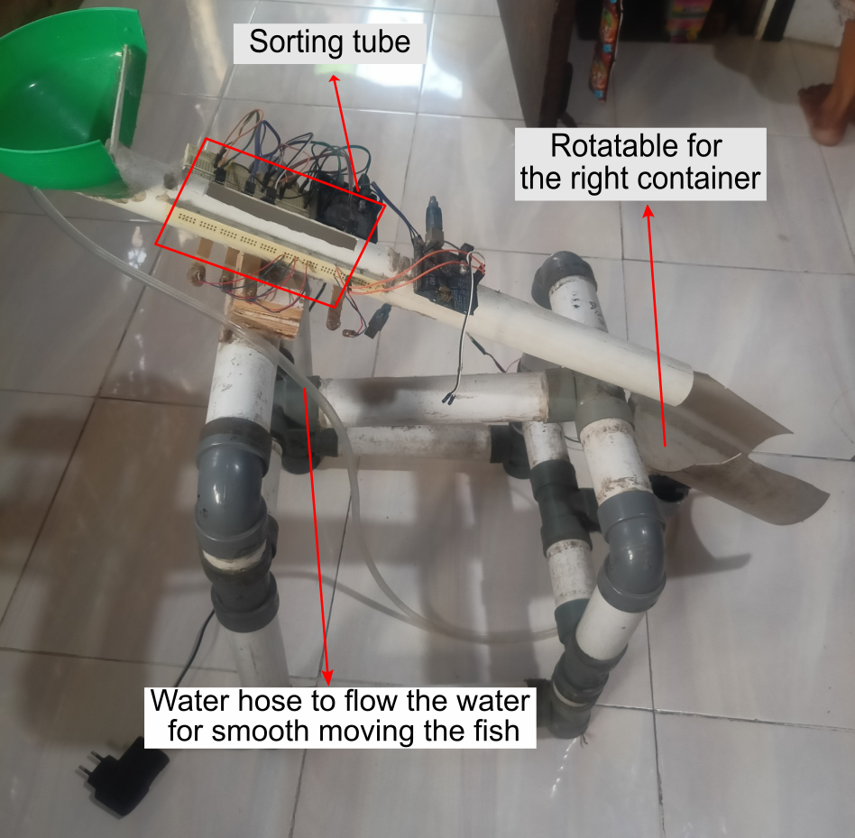
Figure 3. The photograph of the developed catfish seed sorting prototype

CONCLUSION
In conclusion, this study successfully developed and tested an automatic catfish seed sorting prototype using a combination of laser photodiode sensors and Arduino. The prototype successfully categorized seeds into four size groups (<7 cm, 7–8 cm, 9–10 cm, and 11–12 cm). The test results of 40 catfish seeds of various sizes showed that the prototype detected the <7 cm seed category very accurately, with an error rate of 0%. However, the prototype still showed errors in other size categories, prompting optimization of the classification method, including integrating more sophisticated detection or decision algorithms, or testing with a larger number of catfish seeds to make the assessment more accurate. Although there are still limitations, this prototype offers several things: automating the sorting process, real-time operation, reducing human involvement, and minimizing stress on fish seeds. The use of low-cost components and the modular design of this prototype make it adaptable for small-scale aquaculture operations and further development.

ACKNOWLEDGMENT
This research was supported by IPB University Division Grant for Applied Physics Division in 2023.

REFERENCES
[1] I. Diatin, D. Shafruddin, N. Hude, M. Sholihah, and I. Mutsmir, “Production performance and financial feasibility analysis of farming catfish (Clarias gariepinus) utilizing water exchange system, aquaponic, and biofloc technology,” J. Saudi Soc. Agric. Sci., vol. 20, no. 5, pp. 344–351, Jul. 2021, doi: 10.1016/j.jssas.2021.04.001.
[2] S. Hegde et al., “Economic contribution of the U.S. catfish industry,” Aquac. Econ. Manag., vol. 26, no. 4, pp. 384–413, Oct. 2022, doi: 10.1080/13657305.2021.2008050.
[3] R. O. Ajagbe, S. O. Ajagbe, and M. I. Adeoba, “ASSESSMENT OF CHALLENGES AND COPING STRATEGIES OF MAJOR INPUT RESOURCES IN CATFISH FARMING,” vol. 24, no. 3, pp. 25–32, 2024.
[4] J. E. Barasa and D. F. Ouma, “Towards Sustainability in Seed Supply for African Catfish, Clarias gariepinus (Burchell, 1822) Culture in Kenya: Lessons from Asian Catfishes Industry,” Aquac. Res., vol. 2024, no. 1, Jan. 2024, doi: 10.1155/2024/1341858.
[5] L. S. Pereira, A. A. Agostinho, and K. O. Winemiller, “Revisiting cannibalism in fishes,” Rev. Fish Biol. Fish., vol. 27, no. 3, pp. 499–513, Sep. 2017, doi: 10.1007/s11160-017-9469-y.
[6] S. Yang et al., “To what extent is cannibalism genetically controlled in fish? A case study in juvenile hybrid catfish Silurus meridionalis–asotus and the progenitors,” Aquaculture, vol. 437, pp. 208–214, Feb. 2015, doi: 10.1016/j.aquaculture.2014.12.005.
[7] C. E. Indriastuti, M. Z. Junior, M. A. Suprayudi, E. Supriyono, and A. Alimuddin, “Cannibalism, survival and growth performance of juvenile African catfish Clarias gariepinus in relation to photoperiod and 17β‐Oestradiol treatment,” Aquac. Res., vol. 53, no. 12, pp. 4437–4448, Aug. 2022, doi: 10.1111/are.15941.
[8] B. Heltonika et al., “Cannibalism performance of asian redtail catfish (hemibagrus nemurus) fed ration supplemented with different doses of 17α-methyltestosterone,” Indones. Aquac. J., vol. 18, no. 1, p. 27, Jun. 2023, doi: 10.15578/iaj.18.1.2023.27-35.
[9] G. Kumar, C. Engle, S. Hegde, and J. van Senten, “Economics of U.S. catfish farming practices: Profitability, economies of size, and liquidity,” J. World Aquac. Soc., vol. 51, no. 4, pp. 829–846, Aug. 2020, doi: 10.1111/jwas.12717.
[10] J. Rantung, H. Luntungan, and Y. Tondok, “Design of an Automatic Fish Sorting System on a Conveyor based on Machine Vision,” IRE Journals, vol. 7, no. 7, pp. 218–224, 2024.
[11] M. Basyir, M. Kamal, and M. Kamal, “Design and Construction of an Arduino-Driven Weight-Based Fish Sorting Tool,” INTI J., vol. 2024, no. 1, Oct. 2024, doi: 10.61453/INTIj.202438.
[12] B. Zion, A. Shklyar, and I. Karplus, “Sorting fish by computer vision,” Comput. Electron. Agric., vol. 23, no. 3, pp. 175–187, Sep. 1999, doi: 10.1016/S0168-1699(99)00030-7.
[13] U. D. Rosiani, N. Asrobika, D. S. Nugraha, M. Astiningrum, M. Hani’Ah, and G. Budiprasetyo, “Automated Catfish Seed Counting and Size Classification Using YOLOv8 and MobileNetV2,” in 2024 IEEE 10th Information Technology International Seminar (ITIS), IEEE, Nov. 2024, pp. 264–270. doi: 10.1109/ITIS64716.2024.10845543.
[14] H. Syafutra, E. Rustami, S. Claudia, S. D. Hardiningtyas, S. Supriyanto, and M. Zuhri, “DEVELOPMENT OF LOW-COST OPTICAL SENSOR-BASED DEVICE FOR REAL-TIME MICROALGAE CONCENTRATION MEASUREMENT,” Indones. Phys. Rev., vol. 8, no. 2, pp. 429–447, May 2025, doi: 10.29303/ipr.v8i2.473.
[15] B. Santoso, D. Syauqy, and A. S. Budi, “Multi-Lane Automated Catfish Seed Counting System Using Real-Time Operating System on Embedded Platforms,” J. Inf. Technol. Comput. Sci., vol. 10, no. 1, pp. 26–36, May 2025, doi: 10.25126/jitecs.2025101412.
[16] E. F. Ike Putri, M. N. Hadi, U. Masfufah, and M. Sarosa, “Arduino-based Catfish Seed Counter Read on Mobile Devices,” IOP Conf. Ser. Mater. Sci. Eng., vol. 453, p. 012057, Nov. 2018, doi: 10.1088/1757-899X/453/1/012057.
[17] S. Patel et al., “Design and development of a sensor assembly based on 1-D photodiode arrays for distance offset measurements,” Measurement, vol. 199, p. 111482, Aug. 2022, doi: 10.1016/j.measurement.2022.111482.
[18] H. Syafutra et al., “Development of portable color detector: its application for determination of Munsell Soil Color,” SAINS TANAH - J. Soil Sci. Agroclimatol., vol. 22, no. 1, p. 1, Jan. 2025, doi: 10.20961/stjssa.v22i1.91351.
[19] J. Xu and Y. Lu, “Prototyping and evaluation of a novel machine vision system for real-time, automated quality grading of sweetpotatoes,” Comput. Electron. Agric., vol. 219, p. 108826, Apr. 2024, doi: 10.1016/j.compag.2024.108826.
[20] T. Chandra Segaran et al., “Catfishes: A global review of the literature,” Heliyon, vol. 9, no. 9, p. e20081, Sep. 2023, doi: 10.1016/j.heliyon.2023.e20081.
[21] X. Zhang, Z. Gong, X. Liang, W. Sun, J. Ma, and H. Wang, “Line Laser Scanning Combined with Machine Learning for Fish Head Cutting Position Identification,” Foods, vol. 12, no. 24, p. 4518, Dec. 2023, doi: 10.3390/foods12244518.
[22] J. C. González, C. Dalforno, R. Suppi, and E. Luque, “A Fuzzy Logic Fish School Model,” 2009, pp. 13–22. doi: 10.1007/978-3-642-01970-8_2.
[23] A. Khudoyberdiev, M. Abdul Jaleel, I. Ullah, and D. Kim, “Enhanced Water Quality Control Based on Predictive Optimization for Smart Fish Farming,” Comput. Mater. Contin., vol. 75, no. 3, pp. 5471–5499, 2023, doi: 10.32604/cmc.2023.036898.
[24] N. Bravata, D. Kelly, J. Eickholt, J. Bryan, S. Miehls, and D. Zielinski, “Applications of deep convolutional neural networks to predict length, circumference, and weight from mostly dewatered images of fish,” Ecol. Evol., vol. 10, no. 17, pp. 9313–9325, Sep. 2020, doi: 10.1002/ece3.6618.
[25] O. R. Khalaf and A. A. Almukhtar, “Design and Implementation of Arduino-Based Sterilization Robot,” Control Syst. Optim. Lett., vol. 1, no. 3, pp. 181–185, Nov. 2023, doi: 10.59247/csol.v1i3.62.
[26] E. J. Davis and B. H. Clowers, “Low-cost Arduino controlled dual-polarity high voltage power supply,” HardwareX, vol. 13, p. e00382, Mar. 2023, doi: 10.1016/j.ohx.2022.e00382.
[27] Safaa Najah Saud Al-Humairi, “Design and Development of an Advanced Load Control System via Arduino,” Al-Iraqia J. Sci. Eng. Res., vol. 3, no. 4, Jan. 2025, doi: 10.58564/IJSER.3.4.2024.276.
[28] T. Matos, M. S. Martins, R. Henriques, and L. M. Goncalves, “A review of methods and instruments to monitor turbidity and suspended sediment concentration,” J. Water Process Eng., vol. 64, p. 105624, Jul. 2024, doi: 10.1016/j.jwpe.2024.105624.
[29] A. Sivaranjani, S. Senthilrani, B. Ashok kumar, and A. Senthil Murugan, “An Overview of Various Computer Vision-based Grading System for Various Agricultural Products,” J. Hortic. Sci. Biotechnol., vol. 97, no. 2, pp. 137–159, Mar. 2022, doi: 10.1080/14620316.2021.1970631.
[30] Y. Xia, Y. Xu, J. Li, C. Zhang, and S. Fan, “Recent advances in emerging techniques for non-destructive detection of seed viability: A review,” Artif. Intell. Agric., vol. 1, pp. 35–47, Mar. 2019, doi: 10.1016/j.aiia.2019.05.001.
[31] J. G. A. Barbedo, “A Review on the Use of Computer Vision and Artificial Intelligence for Fish Recognition, Monitoring, and Management,” Fishes, vol. 7, no. 6, p. 335, Nov. 2022, doi: 10.3390/fishes7060335.
[32] Y. Zhao, H. Qin, L. Xu, H. Yu, and Y. Chen, “A review of deep learning-based stereo vision techniques for phenotype feature and behavioral analysis of fish in aquaculture,” Artif. Intell. Rev., vol. 58, no. 1, p. 7, Nov. 2024, doi: 10.1007/s10462-024-10960-7.

