Real-Time Deep Neural Network-based Waste Detection and Classification using a Camera Sensor | 

Arsyad Ramadhan Darlis, Lita Lidyawati, Faradilla Rizqi Trisani
Department of Electrical Engineering, Institut Teknologi Nasional Bandung, Indonesia

Abstract  Waste generation is a growing environmental concern, with manual sorting methods often being inefficient and error-prone, particularly under varying lighting and environmental conditions. In Indonesia, waste is typically categorized into organic and nonorganic, yet existing automated classification systems lack real-time capabilities and robustness in dynamic settings. This study proposes a novel real-time waste detection and classification system using a deep neural network, implemented on the Jetson Nano platform with a camera sensor. The system utilizes the ResNet-18 convolutional neural network architecture and is developed using Python. It is designed to distinguish between organic and nonorganic waste in real-time. Training was conducted over 30 epochs, and the system was tested under various lighting conditions—morning, daytime, afternoon, and nighttime. Results show high accuracy: 95.24% in the morning, 95.24% during the day, 90.45% in the afternoon, and 86.90% at night, with an average accuracy of 91.96%. Performance was influenced by factors such as lighting intensity, distance, waste position, changes in organic waste, and occlusion by plastic. The proposed system offers a significant improvement over traditional and existing methods by enabling accurate, real-time waste classification under diverse conditions, contributing to more efficient and intelligent waste management.  This is an open access article under the CC BY-SA license.   | Keywords:  Waste Detection and Classification; Jetson Nano; convolutional neural network; Real-time  Article History:  Received: May 2, 2019  Revised: May 29, 2019  Accepted: June 2, 2019  Published: June 2, 2019  Corresponding Author:  Arsyad Ramadhan Darlis  Department of Electrical Engineering, Institut Teknologi Nasional Bandung, Indonesia  Email: arsyad@itenas.ac.id

INTRODUCTION
Waste is an unavoidable part of human life because everyone creates and produces waste. In Indonesia, waste is generally classified into two types based on its composition: organic waste and nonorganic waste. Organic waste can be decomposed and further broken down with the help of other bacteria. By contrast, nonorganic waste, often a byproduct of human activities, is resistant to bacterial decomposition [1]. The importance of a strong legal framework and cross-border collaboration in combating plastic pollution, particularly in marine environments. This regulatory perspective supports the integration of technologies like real-time deep neural network-based waste detection, as such systems can provide timely, accurate data that strengthens monitoring, enforcement, and compliance with environmental laws. The synergy between legal instruments and AI-driven waste management tools can enhance both prevention and response strategies [2]. Effective solid waste classification is a crucial aspect of waste disposal and recycling processes to maintain a sustainable environment. CNNs have emerged as a powerful tool for solid waste classification, thanks to their ability to learn features from images and classify objects accurately [3]. Furthermore, many people are still unaware of the distinction between organic and nonorganic waste. This lack of awareness leads to careless disposal of garbage, resulting in ineffective waste management. Maintaining cleanliness is essential in any environment, starting with the immediate surroundings, such as the living environment and public spaces, which include schools, markets, and hospitals [4]. A system that can educate and assist the community in distinguishing waste types is necessary, ensuring proper disposal using an accurate classification system.
Several studies on waste classification have been previously conducted. For example, research [5]-[7] focused on identifying images of organic and nonorganic waste using the convolutional neural network (CNN) method, which applies CNNs for waste image classification. Additionally, the study in [8] developed a waste image classification system using a multilayer hybrid CNN using the TrashNet dataset, created by Mindy Yang and Gary Thung from Stanford University. Another research [9] explored waste management using Artificial Intelligence (AI) technology combined with a CNN. Additionally, research in [10] Landfills pose serious environmental risks, including eutrophication, toxins, and pollution. It investigates household waste, classifying it into organic and recyclable types. Smart automated segregation offers a simple yet effective way to reduce landfill toxins by accurately distinguishing between the two [11]. Furthermore, the research in [12] an automated waste classification system that combines EfficientNet-based feature extraction with PCA for dimensionality reduction, enabling accurate and efficient categorization of waste [12].
This study presents a design for classifying organic and nonorganic waste images using an AI system and hardware, specifically the Jetson Nano and cameras. The field of AI in computer science is defined as the study of intelligent agents. The NVIDIA Jetson Nano is a small and powerful single-board computer that allows multiple neural networks to operate in parallel, making it suitable for applications such as image classification, object detection, segmentation, and speech processing. This computer includes a comprehensive development environment (JetPack SDK) and a range of libraries for embedded applications, deep learning, IoT, computer vision, graphics, multimedia, and other applications [13].
In this study, the Python programming language is used to implement one of the AI methods, CNN with the ResNet architecture, on the Jetson Nano. Traditional waste sorting methods remain inefficient and unsustainable, highlighting the need for innovative AI-based solutions for effective waste management [14]. This method is widely applied in various fields, such as social life, agriculture, health, and research [15]–[18]. The ResNet architecture includes several variations, such as ResNet-18, ResNet-34, ResNet-50, ResNet-101, and ResNet-152. While the ResNet model produces better input data, it also offers a highly stable training process and mitigates gradient errors during training [19]. ResNet-18, which is used in this study, comprises 16 convolution layers, two downsampling layers, and several fully connected layers [20].
In this study, the system distinguishes between organic and nonorganic waste types in real-time with a certain level of accuracy, using a camera directly pointed at waste objects and processed by the Jetson Nano. The research gap addressed here lies in the lack of existing systems that can perform real-time waste classification under varied lighting conditions using deep neural networks on embedded, low-power platforms. Unlike previous works, this study combines accuracy, efficiency, and portability, targeting real-time performance and robustness in uncontrolled, everyday settings.
Our work aims to deploy a deep neural network on embedded hardware (Jetson Nano) for real-time waste classification using a camera sensor, tested under different lighting conditions. This integration, while ensuring a balance of performance and resource usage, enhances the feasibility of practical implementation in public spaces. Therefore, this research not only addresses a relevant societal problem but also contributes technically by advancing waste classification systems toward more accessible, robust, and scalable real-world applications.

METHOD
In this study, the system is divided into two main components: hardware and software design. Figure 1 presents a block diagram of the system hardware used in this study.
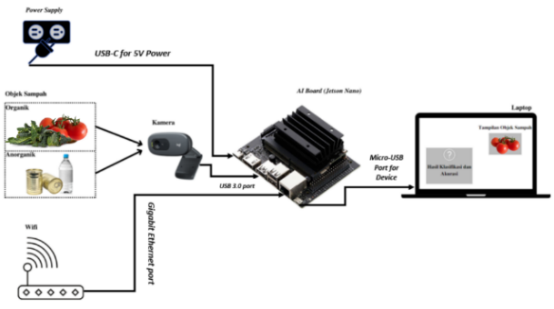
Figure 1. Diagram of the System Hardware Blocks
As shown in the block diagram image above, to perform image classification and accuracy assessment, the AI Board is first connected to a Wi-Fi network via an Ethernet cable, and the camera is linked to the AI Board’s USB 3.0 port. Next, the laptop is connected to the AI Board using the Micro-USB port for Device Mode. Then, the AI Board is connected to a 5 V DC power supply using a USB-C cable. Once all devices are connected, the camera must be activated to classify organic and nonorganic waste in real-time. The camera focuses on the organic and nonorganic waste objects, and the AI Board will process the images, thereby displaying the objects on the laptop screen.
The dataset collection process is conducted in real-time on the AI Board, followed by a training process to train the system and generate a model. Once the model is obtained, a testing process is performed to evaluate its accuracy, along with the waste classification results. The differences between organic and nonorganic waste types are displayed on the laptop screen, showing the classification outcomes for each image.
The software used to design the system in this study is the online Jupyter Lab. Jupyter Notebooks and Labs provide an interactive web-based environment that integrates code execution, text, math, plotting, and multimedia into a single document, making them highly effective for the learning process [21]. The Python programming language was employed in this study due to its versatility as an object-oriented programming language, widely used for various applications and supported across multiple platforms. [22]. The system software design is depicted in Figure 2.
Figure 2 shows the first step, where the organic and nonorganic waste objects are captured by the activated camera, and real-time classification of waste types will be performed. A dataset of organic and nonorganic waste images was previously collected for classification. After obtaining the dataset, the data is divided into training and testing sets. The training process then begins, during which the system learns to analyze several examples of image datasets for classification, resulting in the development of a model. Once the model is obtained, it is tested on the system to evaluate its accuracy and classify the images. The specifications of these devices are shown in Table 1.

Table 1. Device Specifications
Testing Devices | Specification
Laptop | Processor: AMD Ryzen 3 3250 U with Radeon Graphics 2.60 GHz  RAM: 8.00 GB  Operating System: Windows 11
NVIDIA Jetson Nano 2 GB | CPU : Quad-core ARM® A57 @ 1.43  GHz Memory: 2 GB 64-bit LPDDR4 25.6 GB/s  Storage: microSD (Card not included)
Logitech C270 Camera | Max. Resolution: 720 p/30 fps.  Mega pixel camera: 0.9.  Focus type: fixed focus.  Lens type: plastic.  Built-in microphone: Mono.  Microphone range: 1 m maximum  Diagonal field of view (dFoV): 55°

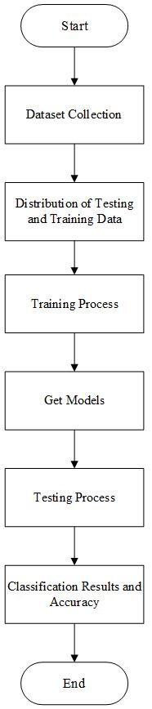
Figure 2. Flowchart of the System Software

The images used in this study comprise two types of household waste: organic and nonorganic. These images are captured using a real-time camera. The image data is then divided into the following two categories: training data and testing data. The types of waste used in this study are shown in Table 2.
Table 2. Research Data Types
Variable | Variable definition
Organic Waste | Bottle and Can
Nonorganic Waste | Kale and Tomato

RESULTS AND DISCUSSION
The training dataset in this study includes a function for making predictions and running the CNN method with the ResNet-18 architecture. As shown in Figure 3, several images depicting organic and nonorganic waste are used for classification in this study.
Figure 3 (a) shows a dataset of organic waste types used in this study, along with the waste conditions determined by the author. Organic waste has 210 datasets. Figure 3 (b) depicts a dataset for nonorganic waste types used in this study, along with the waste conditions determined by the author. Meanwhile, nonorganic waste has 210 datasets. Therefore, the total number of organic and nonorganic waste datasets collected was 420 images.

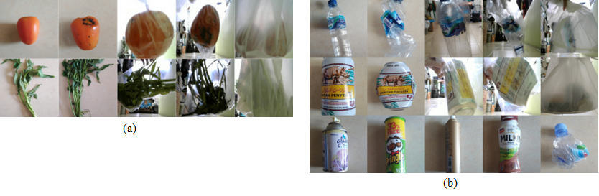
(a)
(b)
Figure 3. (a) Image Dataset of Organic Waste, (b) Image Dataset of Nonorganic Waste

The collected dataset will undergo a training trial process in the model to obtain an accurate real-time classification model for organic and nonorganic waste. This procedure employs 30 epochs, with the training results graph shown in Figure 4 below. An epoch refers to the number of times the machine learning process is repeated. Increasing the number of epochs can extend the processing time but not necessarily lead to high accuracy. Ideally, good results can be achieved with a high accuracy [23].
In this study, the CNN method was applied using the PyTorch model for the testing process. The authors then describe how many different types of organic and nonorganic wastes can be identified through accuracy testing. The first step in the testing procedure is to turn on the camera, which operates in real-time, as shown in Figure 5.

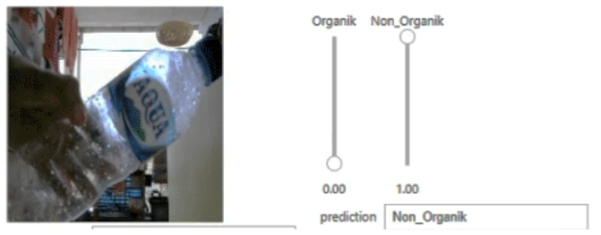
Figure 5. Real-time Display of Organic and Nonorganic Waste Classification

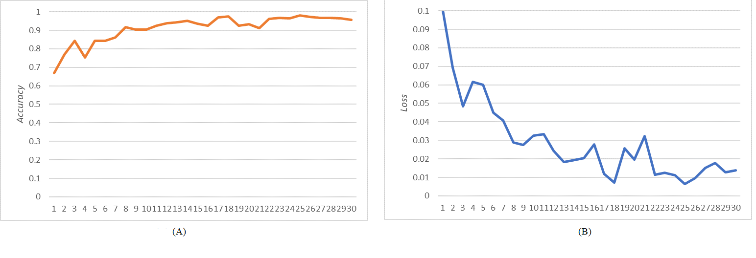
(a)
(b)
Figure 4. (a) Accuracy Training Graph and (b) Loss Training Graph

This test was performed at four different times to account for variations in light intensity during the morning, afternoon, evening, and night. A lux meter was used to measure the light intensity, with the measurements taken outside. The lux meter is a photoelectronic device that measures luminance, commonly used in industries such as paints and polymers, automobiles, pharmaceuticals, building automation, and large-scale photography. This device can detect visible, ultraviolet, and infrared light, accurately measuring the amount of visible light perceived by the human eye [24]. The measured light intensity values were 785 lux in the morning, 621 lux during the day, 441 lux in the afternoon, and 2.8 lux at night. As more tests were performed in this system, the error value decreased.
The testing process in this study, conducted in the morning, was performed following the conditions set by the authors, with a total of 84 data points. Figure 6 depicts the results of the tests performed in the morning.

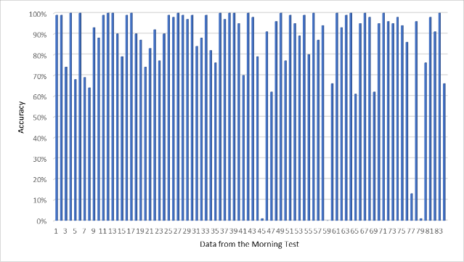
Figure 6. Morning Bar Graph of Organic and Nonorganic Waste Classification

As shown in the diagram above, the testing data is the same as the training data. The classification accuracy of organic and nonorganic waste in the morning can be calculated as follows:

$Accuracy=\frac{Number of Correct Prediction}{Total Number of Prediction}$ (1)

Therefore, the accuracy level obtained in the morning testing was calculated to be 95.24%. Four misclassifications of organic and nonorganic waste were identified, and the accuracy for those instances was less than 0.5% or 50%.
The testing process in this study, performed in the morning, was conducted following the conditions set by the authors, with a total of 84 data points. Figure 7 depicts the results of the tests performed during the day.

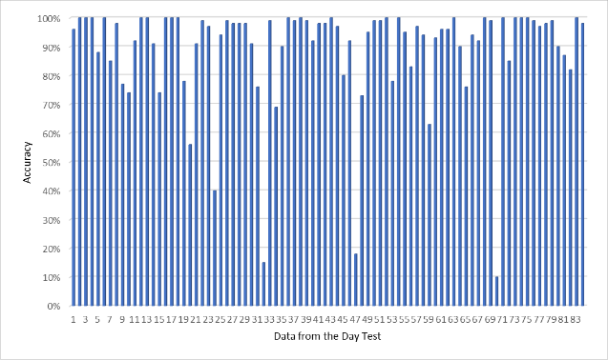
Figure 7. Day Bar Graph of Organic and Nonorganic Waste Classification

As shown in the diagram above, the testing data is the same as the training data. The calculated accuracy level for classifying organic and nonorganic waste during the day is 95.24%, with 4 data points having an accuracy of less than 0.5 or 50%. The lowest accuracy recorded in the daytime test was 0.18%, or 18%, which occurred for nonorganic waste, specifically a bottle of a different brand.
The testing process in this study, conducted in the morning, was performed following the conditions set by the authors, with a total of 84 data points. Figure 8 depicts the results of the tests performed in the afternoon.
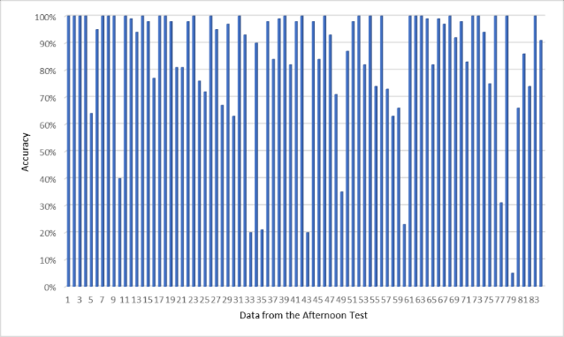
Figure 8. Afternoon Bar Graph of the Organic and Nonorganic Waste Classification

The accuracy level calculated during the afternoon test was 90.45%, with a total of 76 detected waste items and eight incorrect or undetected items, where the accuracy for those instances was less than 0.5 or 50%. The type of waste most often misclassified by the system was organic waste, specifically water spinach, which was obstructed by white plastic.
The testing process in this study, performed in the morning, was performed following the conditions set by the authors, with a total of 84 data points. Figure 9 depicts the results of the tests performed at night.

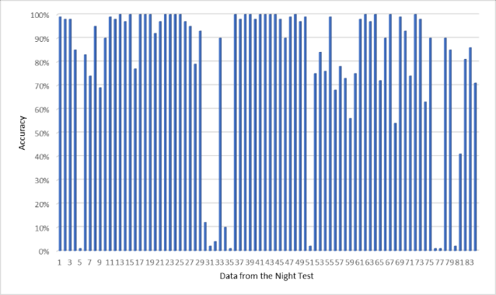
Figure 9. Night Bar Graph of the Organic and Nonorganic Waste Classification

The level of accuracy obtained in the morning testing was calculated to be 86.90%. With 73 correct tests and 11 incorrect tests, the type of waste was organic waste in the form of kale and tomatoes blocked by clear, white plastic, with an accuracy value of less than 0.5 or 50%.
Therefore, this overall accuracy rate for this study is 91.96%. The study uses a threshold value of 0.5 or 50%, indicating that if the test results fall below 0.5 or 50%, the system cannot correctly classify the waste type. The average accuracy rate for classifying organic and nonorganic waste is 91.96%, indicating that the model can correctly waste types. However, several types of waste whose classification results are incorrect or incorrect still exist. The average accuracy during nighttime is 86.40%, which is the lowest test value, mainly due to the reduced light intensity factor at night compared to the morning, day, and night conditions.
The authors then assessed the effect of light intensity and time conditions on accuracy using simple linear regression in Excel. A regression model is a statistical term used to estimate the relationship between variables. In this case, the linear regression model investigates the relationship between a dependent variable (Y) and one or more independent variables (X) [25].

Table 3. Output Summary: Effect of Light Intensity on Accuracy
Regression Statistics
Multiple R | 0.965216161
R Square | 0.931642237
Adjusted R Square | 0.897463356
Standard Error | 1.366645972
Observations | 4

The results in Table 3 are obtained from light intensity category data, which are sorted from the smallest to the highest light levels, with the least light occurring at night and the most during the day. The multiple R-value, representing the correlation between light intensity and accuracy, was 0.965, indicating a strong correlation in the regression relationship coefficient. This finding indicates that light intensity positively affects accuracy, with the best results obtained in the morning and during the day, reaching 95.54%. The R squared value, or the coefficient of determination, was calculated to be 0.931, or 93.1%, indicating that light intensity accounts for 93.1% of the variation in accuracy, while other factors contribute to the remaining influence.
Several factors contribute to incorrect classification results of organic and nonorganic waste, including a lack of data on organic and nonorganic waste at varying distances, positions, or locations, as well as waste obstructed by plastic. Consequently, when the camera captures a moving object in multiple positions, the system may misclassify the type of garbage. The physical condition of organic waste, such as changes in shape and color, can also affect its classification accuracy. Additionally, factors such as light intensity (e.g., trash being obscured by clear or white plastic at night) can further reduce the classification accuracy.

CONCLUSION
In this study, CNN with the ResNet-18 architecture was used for the real-time classification of organic and nonorganic waste. The evaluation model achieved an accuracy of 0.98333, with a loss value of 0.00436 and 30 epochs. The classification accuracy for organic and nonorganic waste exhibited real-time variations of 95.24% in the morning, 95.24% during the day, 90.44% in the afternoon, and 88.46% at night. The overall accuracy rate of the system was 91.96%. Users can directly point the waste object at the activated camera to view the real-time organic and nonorganic waste classification results. The classification accuracy is influenced by factors such as light intensity, distance, the position or location of different wastes, the changing physical conditions of organic waste, and waste obstructed by plastic.

ACKNOWLEDGMENT
This work was supported by Research Grant form Kemdiktisaintek in 125/C3/DT.05.00/PL/2025 and 23/SPK/Rektorat/Itenas/VI/2025.

REFERENCES
- N. F. Hidayanti, “Processing of organic and inorganic waste can increase income during The Covid-19 Pandemic,” Indonesian Interdisciplinary Journal of Sharia Economics (IIJSE), 2022, 5, 167–175.
- K. Hanim et al, “Legal Aspect of Plastic Waste Management in Indonesia and Malaysia: Addressing Marine Plastic Debris”, Sustainability, 14(12), MDPI, 2022.
- T.O.J. Alalibo, N.O. Nwazor, “Comparative Analysis Convolutional Neural Network Models for Solid Waste Categorization”, IRE Journals. Vol 6, issue 12, June 2023
- R. L. Ardiati, “Cultural efforts to maintain environmental sustainability: A study of the pragmatics of politeness on ethical planks in rural Sunda,” Research Horizon, 2022, 2, 455–464.
- R. D. Ramadhani, A. N. A. Thohari, C. Kartiko, A. Junaidi, and T. G. Laksana, “Implementation of deep learning for organic and anorganic waste classification on android mobile,” International Conference on Innovation in Science and Technology (ICIST 2020), 2021, 75–79.
- Q., Zhang, Q. Yang, X. Zhang, Q. Bao, J. Su, and X. Liu, “Waste image classification based on transfer learning and convolutional neural network,” Waste Management, 2021, 135, 150–157.
- M. Diqi, “Waste Classification using CNN Algorithm,” International Conference on Information Science and Technology Innovation (ICoSTEC), 2022, 1, 130–135.
- C. Shi, C. Tan, T. Wang, and L. Wang, “A waste classification method based on a multilayer hybrid convolution neural network,” Applied Sciences,11(18), 8572, 2021.
- A. B. Jude, et al. ”An artificial intelligence based predictive approach for smart waste management,” Wirel. Pers. Commun., 2021, 1–21.
- M. H. Widianto, A. P. Wahyu, and D. Gusna, “Prototype design internet of things based waste management using image processing,” Advances in Science, Technology and Engineering Systems Journal, 2021, 6, 709–715.
- M. Chhabra, et al, “Intelligence Waste Classification Approach Based on Improved Multi-Layered Convolutional Neural Network”, Multimedia Tools and Applications an International Journals, Springer Nature, 83:84095-84120, 2024.
- H. Santoso, et al, “A Hybrid Model for Dry Waste Classification using Transfer Learning and Dimensionality Reduction”, International Journal on Informatics Visualization, Vol. 8, No. 2, 2024.
- A. A. Süzen, Duman, B. and Şen, B. “Benchmark analysis of jetson Tx2, jetson nano and raspberry pi using deep-cnn,” 2020 International Congress on Human-Computer Interaction, Optimization and Robotic Applications (HORA), 2020, 1–5.
- D.V. Yevle, P.S. Mann, “Artificial Intelligence Based Classification for Waste Management: A Survey based on Taxonomy, Classification, & Future Direction,” Computer Science Review, Vol. 56, Elsevier, 2025.
- A. Chavda, J. Dsouza, S. Badgujar, and A. Damani, “Multi-stage CNN architecture for face mask detection,” 2021 6th International Conference for Convergence in Technology (I2CT), 2021, 1–8.
- J. Chaoraingern, et al, “Artificial Intelligence for the Classification of Plastic Waste Utilizing TinyML on Low-Cost Embedded System,” International Journal on Advanced Science Engineering Information Technology, Vol. 13, No.6, 2023.
- L.W. Ming, et al, “AI as a Driver of Efficiency in Waste Management and Resource Recovery,” International Transactions on Artificial Intelligence, vol. 2, No. 2, pp. 128-134, 2024.
- Q. Teng, K. Wang, L. Zhang, and J. He, “The layer-wise training convolutional neural networks using local loss for sensor-based human activity recognition,” IEEE Sens J, 2020, 20, 7265–7274.
- D.H. Itam, et al, “Enhanced Convolutional Neural Network Methodology for Solid Waste Classification Utilizing Data Augmentation Techniques”,Waste Management Bulletin,Vol. 2, Issue 4, pp. 184-193, Elsevier, 2024.
- X. Ou, et al. “Moving object detection method via ResNet-18 with encoder–decoder structure in complex scenes,” IEEE Access, Vol. 7, 108152–108160, 2019.
- G.Y. Temel, et al, “Using Jupiter Notebooks as Digital Assessment tools: An emphirical examination of student teacher’s attitudes and skills towards digital assessment”, Education and Information Technology Journal, Springer Science and Business Media LLC, 2025.
- D. Lafuente, et al. “A Gentle introduction to machine learning for chemists: an undergraduate workshop using python notebooks for visualization, data processing, analysis, and modeling,” J. Chem. Educ., 2021, 98, 2892–2898.
- W. Hastomo, A. S. B. Karno, N. Kalbuana, and A. Meiriki, “Characteristic parameters of epoch deep learning to predict Covid-19 data in Indonesia,” Journal of Physics: Conference Series, 2021, 1933, 1, 012050.
- A. Sonar, B. Amre, Y. Advankar, S. Babar, and T. M. Furia, “Calibration of Lux Meter using Comparison Method,” NTASU, 2021, 9, 720–724.
- S. I. Bangdiwala, “Regression: simple linear,” Int J Inj Contr Saf Promot, 2018, 25, 113–115.

