Enhanced Classification of Multi Abnormal Brain Tumors Detection Using Customized Inception V3 | 

Nagaraju Arumalla¹, Veerraju Gampala²
1,2 Department of Computer Science and Engineering, Koneru Lakshmaiah Education Foundation,
Vaddeswaram, Guntur, Andhra Pradesh 522302, India

Abstract  Nowadays, one of the deadliest diseases in the world is brain tumor (BT). Patients who are misdiagnosed face significantly lower chances of survival. To diagnosis brain abnormalities, Magnetic resonance imaging (MRI) images are very crucial. Currently, Deep Learning (DL) is an important tool in BT detection, but there are even challenges in achieving optimal accuracy. This work goals to bridge these gaps by introducing an enhanced transfer learning (TL) method for classifying meningioma, glioma, pituitary gland and no-tumor, thus increasing accuracy in early BT detection. In this work, the pretrained Inception V3 model is picked to detect abnormalities in the given input. Initially, images were resized to a uniform size, excess boundaries were cropped, noise was removed using the Bilateral filter, and data augmentation methods are adapted to minimize overfitting and ensure accurate, efficient training. Our suggested DL method with pretrained Inception V3 model produces reliable results in training and validation accuracy. Evaluation on a test-image demonstrates exceptional training accuracy is 94.9% and validation accuracy of 93.8%, and by varying k-value training accuracy is 96.8% and validation accuracy is 95.3%. The model’s effectiveness is further supported by comprehensive metrics, including a sensitivity of 92.8%, and specificity 93.5%.   | Keywords:  Bilateral Filter  Brain Tumor  Customized Inception V3  Data Augmentation  Deep Learning  Transfer Learning  Corresponding Author:  Nagaraju Arumalla  Department of Computer Science and Engineering, Koneru Lakshmaiah Education Foundation, Vaddeswaram, Guntur, Andhra Pradesh 522302, India  Email: raju051285@gmail.com

INTRODUCTION (R: 31, G: 78, B: 121)
A tumor refers to the unregulated progress of cancer cells occurring in some portions of the body. These tumors can exhibit significant variability in respect of type, characteristics, and the methods employed for treatment. Present-day, BTs are categorized into numerous discrete categories [1]. Malignant BTs epitomize one of the important severe types of cancer, characterized by inadequate survival measures that have largely remained stagnant over the last sixty years. Recent advancements in cancer immunotherapies present a favorable path for the potential treatment of BT that is otherwise deemed inoperable. However, despite the encouraging results seen in other forms of cancer, progress in BT treatment remains limited. The preprocessing of raw MRI images is a vital step in ensuring accurate segmentation of BT [2].
TL methods have proved their efficacy, particularly in circumstances wherever there is paucity of labeled data for training [3]. BTs characterize a substantial medical concern, ranked as the tenth leading cause of mortality in the US. It is estimated that around 700,000 individuals are affected by BTs, with 80 percent classified as benign and 20 percent as malignant [4]. Misclassification of a BT can have severe repercussions, reducing a patient's likelihood of survival. Accordingly, there has been an raising focus on the training of mechanized image processing technologies targeted at seizing the shortcomings associated with manual diagnosis [5].
Numerous researchers have explored a variability of algorithms for the identification and grouping of BTs, placing significant emphasis on enhancing performance and reducing errors. DL Techniques, especially Convolutional Neural Networks (CNN), have earned prominence in the creation of automated systems that facilitate accurate classification and segmentation of BTs within reduced timeframes. DL capitalizes on the expertise of pre-trained models, particularly within the realm of medical imagery, concentrating specifically on the classification of BTs.
The suggested technique forms upon prior research in ensemble techniques by utilizing a combination of pre-trained Inception V3 models along with supplementary layers, creating a fine-tuned version that achieves a remarkable accuracy rate of 99%.
A collection of techniques is adapted to identify BTs in MRI images, with DL methods showing substantial advancements in this area. This study seeks to compare the models used for BT detection specifically within the framework of DL approaches [6].
The categorization of BTs is a key step following tumor detection, acting a decisive role in the growth of effective treatment strategies. Timely identification of tumors not only enhances therapeutic interventions but also serves as a potentially life-saving action. In a specific research initiative, a dataset comprising of MRI images of the human brain was utilized, featuring both tumor-affected and non-tumor-bearing images.
This dataset underwent an extensive preprocessing phase that incorporated various image manipulation methods, such as filtering, blurring, and cropping. The preprocessing was applied on dataset and data augmentation through a range of random transformations. A CNN was implemented, leveraging pre-existing data, to specifically determine the existence of a tumor. If a tumor was detected, the model proceeded to classify it into one of three distinct categories: glioma tumor, meningioma tumor, or pituitary tumor [7].
The following are our main contributions to this study:
- MRI images have been enhanced through the use of the "Bilateral filter" to remove noise from the images.
- In order to cut down on processing time, extra boundaries have been removed from the images during cropping.
- A unique customized pretrained Inception V3 model has been presented in this research work to categorize four tumor types: pituitary, glioma, meningioma, and no-tumor.
- Dataset has been tested on different pretrained ResNet50, vgg16, and DenseNet121 models, in addition to the pretrained customized Inception V3 model.
- The suggested method's effectiveness has been assessed with metrics such as training accuracy, validation accuracy, sensitivity, and specificity and compared to other cutting-edge architectures.
LITERAURE REVIEW
Several research articles have been available in the field of BT detection, primarily leveraging conventional Machine Learning (ML) and other algorithms to detect irregularities within the human brain. Much of this exploration has emphasized the recognition of tumors, with some endeavors also focusing on classifying the type of tumor present. While ML algorithms were predominantly utilized prior to the advent of DL, these approaches often relied on handcrafted feature extraction. This reliance can lead to inaccuracies in feature extraction, resulting in missed tumor classifications and detections. ​Consequently, DL models, particularly CNNs, are gaining traction in image categorization jobs directly to their capability to certainly extract and study significant features from images.​ Certain advancements are outlined below.
Yazdan et al. [8] steered an analysis driven on the multiclass classification of BTs into four distinct categories. To enhance image quality, noise was eliminated by means of a fuzzy similarity-based non-local means filter. They also introduced different CNN alongside existing models, to measure the execution of data consisting of 3,264 images sourced from Kaggle. ​In spans of results, the proposed multiscale CNN model accomplished an accuracy of 91.2% and an F1-score of 91%. The technique was found to demand extensive computational resources and time, yielding suboptimal results.
Saeedi et al. [9] introduced two DL models coupled with various ML classifiers for identifying numerous types of BTs. They developed a 2D CNN models. The dataset was taken from Kaggle and comprised 3,264 images classified into four types of tumors. ​The methodology achieved accuracy rate for 2D CNN is 93.44% and auto-encoder model is 90.92%.​ Additionally, they tested numerous ML models, achieving that the multilayer perceptron yielded the lowermost accuracy at 28%, however the kNN classifier attained the utmost of 86%. However, the overall findings of the proposed method were modest, and other evaluation system of measurement not executed.
Malla et al. [10] proposed a model for classifying BTs through a TL-based Deep Convolutional Neural Network (DCNN) model that utilizes a pretrained VGGNet model, earlier proficient on a enormous dataset. To enhance performance further, they froze the levels of the CNN and incorporated output layer with global average pooling to mitigate overfitting problems. ​They got testing accuracy of 98.93%.​ Nevertheless, this attempt has limitations, as it relies on a basic technique and a limited dataset, and is primarily focused on binary classification; hence, there is a necessity for multi-class grouping enhancement.
Ozkaraca et al. [11] suggested a method for classifying multiple types of BTs using a dense CNN architecture, incorporating basic CNN, VGG16, and DenseNet models. All models utilized TL, with MRI images from Kaggle, which includes a sum of 7,021 MRI images. The corpus was split into training and validating subsets in an 80% to 20% ratio. ​The proposed systems accomplished accuracy rates varying from 94% to 97%, demonstrating effective performance.​ However, a significant drawback of this method is taking more processing time and the less response.
Rasheed et al. [12] focused on recognizing BTs employing adaptive noise filtering and geometric features. They applied structural segmentation in combination with a Support Vector Machine (SVM) classifier to classify tumors as either basic or malicious. The tumor region was identified by analyzing differences in pixel brightness. ​Their suggested model achieved an accuracy of 98%, but it was limited to binary classification.​ Anand et al. [13] undertook a study aimed at classifying BTs by using VGG19, a CNN with augmentation, and a CNN without augmentation. They achieved an accuracy of 98%. A study on the diagnosis of brain tumors based on performance analysis on several CNNs was given by Khushi et al. [14].
METHOD
This part presents a comprehensive approach that encompasses all phases from data acquisition to the evaluation of results. One of the most important phases of the suggested methodology is data preprocessing, which includes operations like image cropping, noise reduction, and data augmentation. After that, the pretrained models for the BT grouping into glioma, pituitary, meningioma, and no-tumor classes are fed the preprocessed dataset. These models include VGG16, ResNet50, DenseNet121, and a customized version of Inception V3. Based on their noteworthy benefits—such as transfer learning advantages, architectural suitability, design flexibility, and strong support from both the ML and DL communities, pretrained deep learning models are the preferred option. The ability of these models to extract and learn intricate patterns and features from images, a crucial skill for accurate tumor identification has improved.
The main approach used was to employ the pretrained Inception V3 model as a feature extractor. This method was adjusted to specifically tailor the learned features for the task of BT classification by deleting the top layer of the Inception V3 architecture and adding new layers. With this modification, the model was able to capture complex features in an efficient manner, which is essential for obtaining precise classifications. An automated method for recognizing and categorizing various BT types is presented in this study. To achieve this goal, TL was employed. Using the Inception V3 design as a pretrained paradigm, the main network produced convolutional activation maps that were then used for tumor identification and classification. The accuracy of the predictions served as the basis for performance evaluation.
Material
The dataset contains a total of 7023 MRI images, which have been grouped into four distinct classes and organized into separate training and validation folders [15]. The dimensions of the images vary, and the size of the images within each class is not uniform. To ensure consistency and enhance results, every image was resized to 250 × 250 pixels. The main object of the brain scan has extra space surrounding it, which makes accurate classification difficult. To solve this problem, threshold values were set to create a binary mask. Then, extra boundaries were removed, and the images were cropped using the contour values from the dual mask. Additionally, there is noise in the dataset that may compromise the accuracy of classification. A bilateral filter was used to denoise the dataset to lessen this effect. 5,712 pictures total from four dissimilar types of glioma, pituitary, meningioma, and no-tumor were included in the training set. Table 1 shows the brain tumor types and data distribution into testing and validation folders. By training the DL method with MRI images, the intricate features required for accurate tumor classification were able to be obtained. 1,311 pictures from the same four tumor classes made up the testing set. The MRI pictures were kept aside especially to assess how well the model performed and how well it could identify BTs with accuracy.
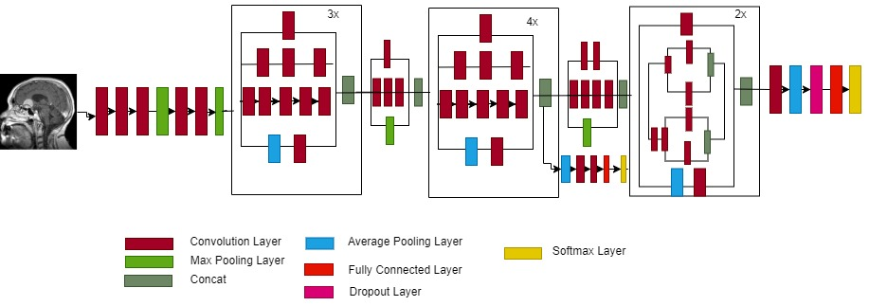
Data augmentation is used to generate additional images prior to preprocessed data being sent to DL techniques. Using this technique has the main benefit of improving the accuracy and prediction of the model. It also aids in preventing the issue of data overfitting. The height shift range of 0.05, which indicates the upper limit of the total width and height as a fraction of 1.0, was applied to the rotated image data at a 70-
degree angle. Moreover, additional data samples were moved in both vertical and horizontal directions using a 0.1 zoom range. Dropout layers were also employed to prevent overfitting of the data.
Table 1. Brain tumor types and data distribution.
S.No. | Type of Brain Tumor | Training Dataset | Testing Dataset
1 | Glioma | 1321 | 300
2 | Pituitary | 1457 | 300
3 | Meningioma | 1339 | 306
4 | No Tumor | 1595 | 405

Proposed Model
The customized pretrained Inception V3 model was used in this study by adding a few layers and using the Inception V3 model's output. Getting good results from the multi-classification of BTs was the main goal. Because of this, different deep learning models were experimented with, and data samples were preprocessed before being put into a deep learning model. Tests were also conducted on ResNet50, DenseNet121, and VGG16. Training and validation accuracy of Inception V3 performed the best out of start-of-art-models. In order to improve outcomes and guarantee higher accuracy, the Inception V3 model was modified. Figure 1 illustrates the specifics of how Inception V3 model applied to our preprocessed data. The following is a comprehensive description of the several DL models that were utilized.

Figure 1. Inception V3 Architecture.

We have experimented with several pretrained DL models, one of which is the VGG16 model [16]. Three fully connected layers and thirteen convolutional layers make up this architecture's sixteen layers. Three color channels and a 224 x 224 input are processed by the model. The ResNet-50 model [17], which was first released in 2015, is a member of the residual network group and is distinguished through its residual units, which aid in training deeper networks and reducing the vanishing gradient issue in deep networks. There are four different stages in this architecture, and the sum of layers or chunks varies with each stage. The 121 layers of Gao Huang's[18] deep learning model DenseNet121 are arranged into dense chunks by a predetermined sum of layers, conversion layers that down sample the feature engineering and shrink its mass, and extra layers like output and global average pooling.
The model's updated weights are first loaded for training purposes; Additionally, we confirm that the weights of the base model are not used for training once more; In order to let the basic model retain its existing information and emphasis on innovative customs layers for training data, we establish the base model layers. An additional global average pooling layer [19] was included in order to determine the average value of each feature engineering across its spatial dimension and minimize the feature engineering's dimension to a stable size. This made it easier to extract the basic model's most important features. Equation 1 shows how this layer functions.
$G_{Avg_{P}}=\left(\frac{1}{h×ω}\right)×Σ\left[∑x\left(ⅈ,\dot{j},c\right)\right]$ (1)
h: height, w: width, specifies total number of spatial dimensions
X: is the dimension of tensor
c: shows channel, i,j identifies the feature map's location value within the channel.
$Y=Relu(Z)$ (2)
Where $Z=W ×X+b$ (3)
W × X displays the weight matrix W multiplied by the input vector X and the bias vector b, which is added to the result element-by-element.
When Relu is applied element-by-element to Z, the following happens for the input Z to Relu:
$$Relu\left(Z\right)=0 when Z<0$$
$= Z when Z≥0$ (4)
A final output layer that is fully connected and has a total number of units equal to the entire number of classes—four in the case of classification—is then added. for goals, utilizing SoftMax's activation function [20]. Predicting the ultimate classification of photographs and the class to which they belong is the main objective of this layer. The SoftMax function is used to normalize the result into a distribution for the entire classification. The following equalization illustrates in what way SoftMax performs the probability that an image fits to respective class.
$α\left(z_{i}\right)=\frac{ⅇ^{z_{i}}}{\sum_{j=1}^{k}{ⅇ^{z_{j}}}}$ (5)
α : SoftMax function, Z is input vector, $ⅇ^{z_{i}}$is exponential function for input vector
$ⅇ^{z_{j}}$ is exponential function for output vector, k is number of classes in multi classifier
Customized Inception V3 Model
To train different pre-trained deep learning models like ResNet50, DenseNet121, VGG16, and Inception V3, as stated in the sections above, we added a global average pooling layer, a fully connected layer through a ReLu function, and a final layer through a SoftMax function. Inception V3 performs better than the other models and delivers sophisticated validation accuracy. However, more accuracy was still required for more accurate classification and prediction. We selected the Inception V3 model and added more layers to optimize it because of this. Figure 2 is displayed beneath. displays the Inception V3 model's modified architecture.
As indicated before, the first global average pooling layer was included in the Inception V3 model to make it unique. The feature map's spatial dimension was lowered by this layer to one value for each channel. This can help lower the constraints in successive layers, improving a model's computational efficiency. Another advantage of the layer is that it lessens overfitting issues with little data. In brief, this layer is a stage of
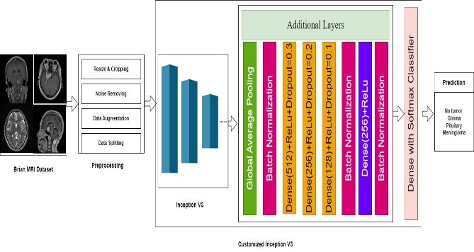
transition between the base model and upper tiers of the model. The operation of the layer has been conferred. Additional Batch normalization is used to regularize the activation of neural network layers [21].
Figure 2. Customized Proposed Inception V3 Model
Three dense layers with different unit sizes were also applied, along with a dropout layer and the ReLu function. In the first and second dense layers of 256 units, 512 units were given a ReLu with dropouts of 0.3 and 0.2, while 128 units in the third dense layer received dropouts of 0.1 and 0.3. The ReLu activation function, previously described, is represented by equation 5. By removing the fractional portion of input during training, the dropout layer [22], a regularization procedure primarily intended to solve the overfiring issue, also helped the network to acquire and seize farther vigorous and broad properties. Initially, a Bernoulli distribution is used to sample every portion separately from a binary mask through a dropout proportion of p. To keep the activation's predicted value constant, a second scaled output computation is done. The formulas below illustrate how dropout operates.
Moreover, batch normalization is used over to regularize the neural network and dense layer activation through 256 units. Deeper features are extracted using the ReLu activation function and sent to an additional batch normalizing layer. In order to further predict the likelihood of classifying brain tumors as gliomas, meningiomas, pituitary, or no tumor, the last output layer applies the SoftMax function, which is stated in equation 5, after receiving the additional normalized activation output. For better results, these hyperparameters were further adjusted. To ensure that our dataset experiences progressive model convergence and fine-tuning, a learning rate of 0.00001 was selected. Experimentation was used to determine this value, which proved designate useful aimed at our job. In addition, a batch size of 16 was chosen to balance training effectiveness and memory usage on our hardware configuration. Our main goal in choosing this batch size was to use the GPU (graphical processing unit) resources efficiently without using up too much memory while still producing an accurate and useful result. We tried and adjusted the Adam optimizer with the following settings to get the optimal convergence speed and model performance: epsilon = 1e-08, beta_1 = 0.91, and beta_2 = 0.9994. We were able to enhance the outcomes by choosing and determining the Adam optimizer's behavior using these settings.
Thus, all the hyperparameters are set correctly; however, the early stopping criteria are not applied during model training. For the purpose of validating the model and assessing its efficacy, we selected 100 epochs to train all of the models for. In connection with performance measures, we also like to measure how the methods respond, acquire from, and justify the data. The model that yielded the best results was chosen and modified.
Using the previously described hyperparameters and spare layers, we first trained the system in our proposed model by freezing the base system layers. Since the system couldn’t employ deep structures on the dataset because it had previously been trained on larger data, we were unable to produce satisfactory results. Additionally, by unfreezing the layer, we were able to train the model using customized layers, which allowed it to learn both custom layer features and pre-trained features. We added or applied a global average pooling layer along with dropout, dense layers, and Batch Normalization. For the following reasons, these layers support the customized Inception V3 model: By decreasing the spatial dimensions of the feature map, the global average pooling layer speeds up training and uses less memory. Additionally, Batch Normalization lowers the possibility of vanishing or blowing gradients and improves training process stability. Subsequent dropout layers increase the model's robustness and reduce overfitting by randomly deactivating a portion of the neurons during training. Additionally, dense layers were introduced, which are in charge of encapsulating intricate patterns, structures, and nonlinear relationships in data. Models are able to modify their representations to fit particular tasks by adding more dense layers. Utilizing the previously mentioned optimized approach, we achieved superior outcomes.

FINDINGS AND DISCUSSIONS
This section presents the findings of our customized Inception V3 model and several deep learning models on a publicly accessible brain tumor dataset. A variety of deep learning models were assessed for validation accuracy, and based on the findings, additional work was done to customize the models that were selected based on validation accuracy. Additionally, the suggested customized pretrained Inception V3 model may be assessed according to the following metrics: Sensitivity [23], Specificity [24], and Accuracy [25].
(i) Accuracy: It is used to specify the accurate performance of newly introduced technique. The expression of
accuracy is given as,
$M=\frac{+}{+++}$ (6)

where, true positive is denoted as , true negative is indicated as ,false positive is represented as , and false negative is signified as .
(ii) Sensitivity: Sensitivity is used to compute the ratio of true positives identified precisely by Customized Inception V3 to the total amount of true positives. Moreover, sensitivity is formulated as,
$=\frac{}{+}$ (7)
where, sensitivity is specified as .
(iii) Specificity: Specificity assesses the ratio of quantity of true negatives recognized accurately by the Customized Inception V3 to the quantity of true negatives. Here, the expression of specificity is demonstrated as,
$=\frac{}{+}$ (8)
Here, specificity is mentioned as .
RESULTS AND DISCUSSION
Figure 3 shows the investigation of Customized Inception V3 by considering training and testing data. Figure 3(a) illustrates the estimation of classification methods using training accuracy. For 70% training data, the Customized Inception V3 gained a training accuracy of 94.9%, while the accuracy obtained by existing techniques, such as ResNet50 is 84.7%, DenseNet121 is 85.4%, and VGG16 is 87.9%. Here, a higher performance of 10.2%, 9.5%, and 7% achieved by Customized Inception V3. The investigation using validation accuracy of various methods is exhibited in Figure 3(b). For 30% testing data, the Customized Inception V3 gained a validation accuracy of 93.8%, while the accuracy obtained by existing techniques, such as ResNet50 is 78.2%, DenseNet121 is 81.5%, and VGG16 is 82.5%. Here, a higher performance of 15.6%, 12.3%, and 11.3% achieved by Customized Inception V3. The investigation using sensitivity of various methods is exhibited in Figure 3(c). Customized Inception V3 gained a sensitivity of 92.8% for 70% training data and the existing methods, like, ResNet50, DenseNet121 and VGG16 attained sensitivity of 84.5%, 85.8%, and 86.9%. It displays that performance enhancement of Customized Inception V3 is 8.3%, 7%, and 5.9%. In Figure 13(d), specificity-based evaluation of Customized Inception V3 is portrayed. The existing models like ResNet50, DenseNet121 and VGG16 gained the specificity value of 78.2%, 79.3%, and 79.9%, for 70% of training data, while the Customized Inception V3 attained the specificity value of 91.5%. This demonstrates that Customized Inception V3 produces a high performance of 13.3%, 12.2%, and 11.6%.
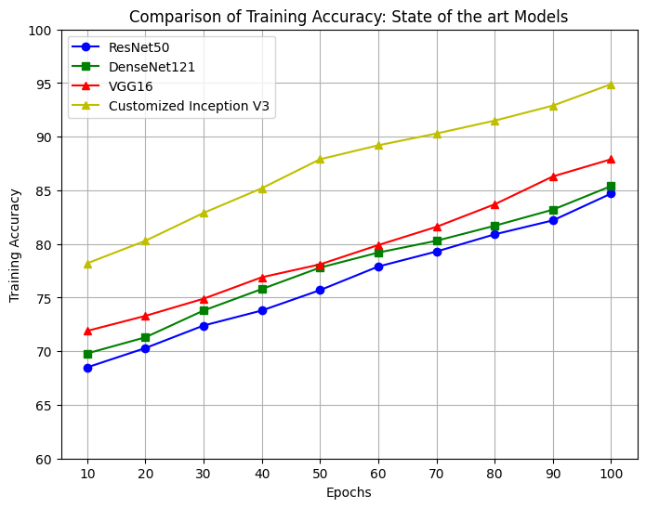 | 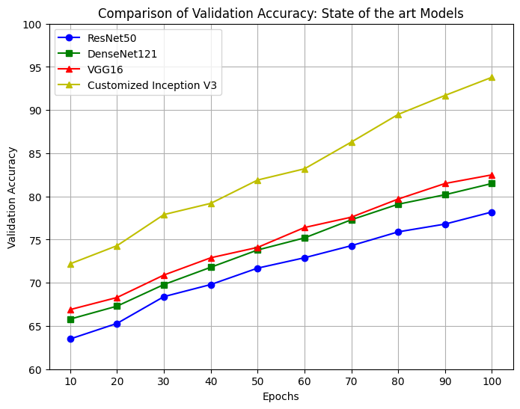
(a) | (b)
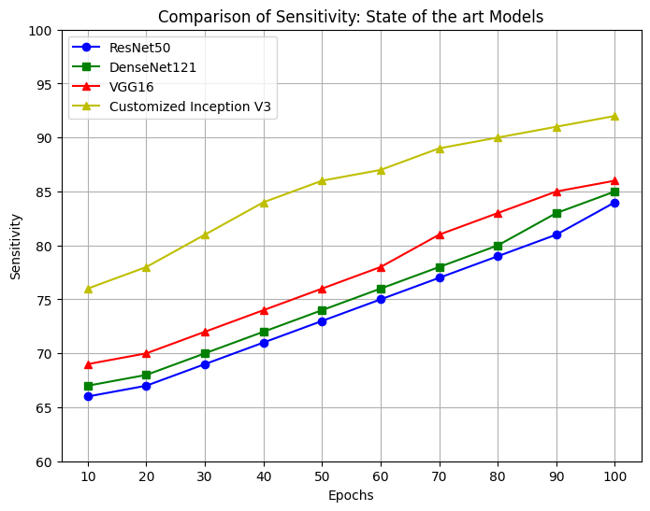 | 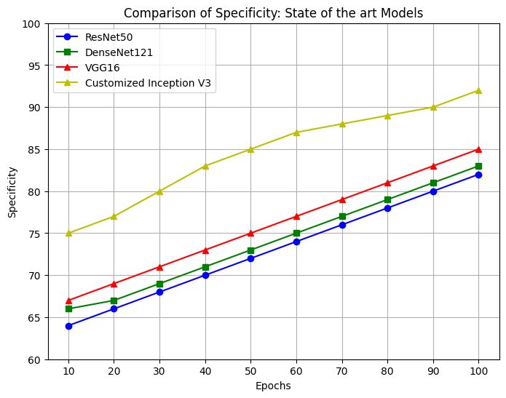
(c) | (d)
Figure 3. Comparative assessment based on training and testing data a) Training accuracy b) Validation accuracy c) Sensitivity d) Specificity
Evaluation by varying k-value
Figure 4 exemplifies the evaluation of Customized Inception V3 employed for BT regarding K-value. The comparative assessment of Customized Inception V3 in terms of training accuracy is depicted in Figure 4(a). Here, the accuracy values gained by Customized Inception V3 is 96.8% for the k-value 8, and the accuracy values acquired by ResNet50 is 77.5%, DenseNet121 is 79.9%, and VGG16 is 84.5%. The percentage improvement gained by the Customized Inception V3 is 19.3%, 16.9%, and 12.3%. The investigation using validation accuracy of various methods is exhibited in Figure 4(b). For 30% testing data with k-value 8, the Customized Inception V3 gained a validation accuracy of 95.3%, while the accuracy obtained by existing techniques, such as ResNet50 is 74.3%, DenseNet121 is 76.4%, and VGG16 is 82.3%. Here, a higher performance of 21%, 18.9%, and 13% achieved by Customized Inception V3. Figure 4(c) exemplifies the investigation using sensitivity with k-value. The sensitivity acquired by the Customized Inception V3 is 92.8%, 76.5% by ResNet50, 78.3% by DenseNet121, and 83.5.2% by VGG16 for K-value 5. The Customized Inception V3 achieved enhanced performance by 16.3%, 14.5%, and 9.3% than the mentioned existing approaches. Figure 4(d) displays the comparative exploration of Customized Inception V3 based on specificity. For k-value 6, the existing methods, namely ResNet50, DenseNet121, and VGG16 acquired the specificity of 77.9%, 79.2%, and 84.3%, while Customized Inception V3 gained the specificity of 93.5%. The percentage improvement attained by Customized Inception V3 based on sensitivity is 15.6%, 14.3%, and 9.2%.
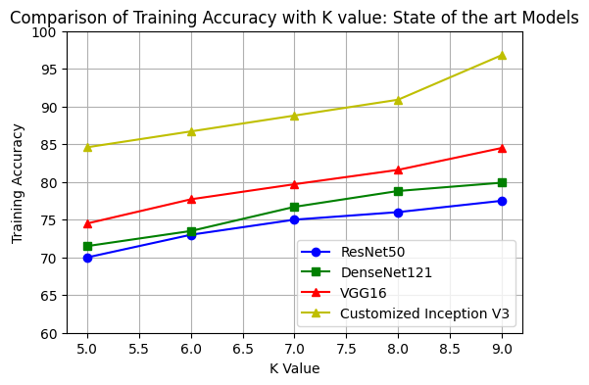 | 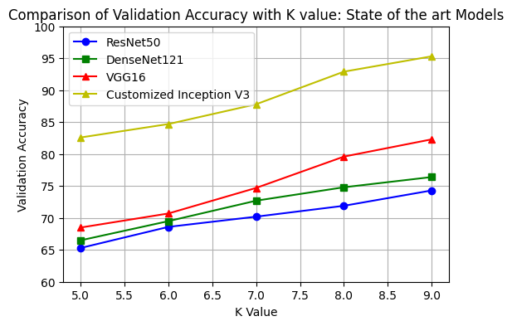
(a) | (b)
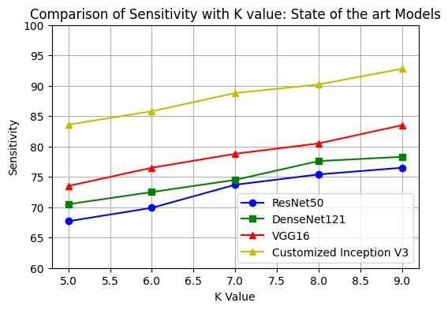 | 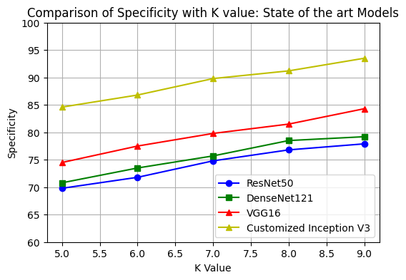
(c) | (d)
Figure 4. Comparative assessment based on k-value a) Training Accuracy b) Validation Accuracy c) Sensitivity d) Specificity
Comparative discussion
The comparison of numerous methods is assessed by altering k-value, training, and testing data, and the comparative discussion of Customized Inception V3 is represented in Table 2. At 80% of training data, the Customized Inception V3 gained a highest value of training accuracy by 94.9%, validation accuracy of 93.8, sensitivity of 92.8%, and specificity of 91.5%. The training accuracy of existing models, namely ResNet50, DenseNet121, and VGG16 attained the value of 84.7%, 85.4%, and 87.9%. The validation accuracy of existing models, namely ResNet50, DenseNet121, and VGG16, attained the value of 78.2%, 81.5%, and 82.5%. Moreover, the sensitivity value of the ResNet50 is 84.5%, DenseNet121 is 85.8%, and VGG16 is 86.9%. The values of specificity executed by other models are 78.2%, 79.3%, and 79.9%. The overall BT categorization process is enhanced by employing Customized Inception V3, which is created by adding customized layers. Thus, by fusing these techniques Customized Inception V3 model obtained better performance and classified BT more accurately.

Table 2. Comparative discussion
Variation | Metrics | ResNet50 | DenseNet121 | VGG16 | Customized Inception V3
Brain Tumor-MRI-Dataset [16] | Training Accuracy (%) | 84.7 | 85.4 | 87.9 | 94.9
Brain Tumor-MRI-Dataset [16] | Validation Accuracy (%) | 78.2 | 81.5 | 82.5 | 93.8
Brain Tumor-MRI-Dataset [16] | Sensitivity (%) | 84.5 | 85.8 | 86.9 | 92.8
Brain Tumor-MRI-Dataset [16] | Specificity (%) | 78.2 | 79.3 | 79.9 | 91.5
K-value (Brain Tumor-MRI-Dataset [16]) | Training Accuracy (%) | 77.5 | 79.9 | 84.5 | 96.8
K-value (Brain Tumor-MRI-Dataset [16]) | Validation Accuracy (%) | 74.3 | 76.4 | 82.3 | 95.3
K-value (Brain Tumor-MRI-Dataset [16]) | Sensitivity (%) | 76.5 | 78.3 | 83.5 | 92.8
K-value (Brain Tumor-MRI-Dataset [16]) | Specificity (%) | 77.9 | 79.2 | 84.3 | 93.5

CONCLUSION
This study was carried out with the goal of employing deep learning models to identify brain tumors. Several DL models, with a customized pretrained Inception V3 model, were tested for this. The primary goal was to save patients' lives by achieving the results of more precise and effective tumor detection. A multi-type of BT dataset that is openly accessible on Kaggle was used to test models. After additional fine-tuning and modification, the suggested model's accuracy increased to 94.9% with a 5.1% miss classification rate. Initially, the model's accuracy was 89.29%. Additionally, K-fold cross-validation was employed to measure the accuracy of the findings generated by the suggested model. The accuracy of the suggested model was 96.8%. Our Customized Inception V3 model performs better than other cutting-edge models.

REFERENCES

- P. Gupta, M. Shringirishi, and D. singh, ‘‘Implementation of brain tumor segmentation in brain MR images using K-means clustering and fuzzy Cmeans algorithm,’’ Int. J. Comput. Technol., vol. 5, no. 1, pp. 54–59, 2006. [Online]. Available: https://www.cirworld.com
- J. Liu, M. Li, J.Wang, F.Wu, T. Liu, and Y. Pan, ‘‘A survey of MRI-based brain tumor segmentation methods,’’ Tsinghua Sci. Technol., vol. 19, no. 6, pp. 578–595, Dec. 2014. [Online]. Available: https://www.abta.org/
- R. Tr, U. K. Lilhore, P. M, S. Simaiya, A. Kaur, and M. Hamdi, ‘‘Predictive analysis of heart diseases with machine learning approaches,’’ Malaysian J. Comput. Sci., pp. 132–148, Mar. 2022, doi: 10.22452/mjcs.sp2022no1.10.
- M. L. Rahman, A. W. Reza, and S. I. Shabuj, ‘‘An Internet of Things-based automatic brain tumor detection system,’’ Indonesian J. Electr. Eng. Comput. Sci., vol. 25, no. 1, p. 214, Jan. 2022, doi:10.11591/ijeecs.v25.i1.pp214-222.
- M. Nazir, S. Shakil, and K. Khurshid, ‘‘Role of deep learning in brain tumor detection and classification (2015 to 2020): A review,’’ Computerized Med. Imag. Graph., vol. 91, Jul. 2021, Art. no. 101940, doi:10.1016/j.compmedimag.2021.101940.
- N. Çinar, B. Kaya, and M. Kaya, ‘‘Comparison of deep learning models for brain tumor classification using MRI images,’’ in Proc. Int. Conf. Decis. Aid Sci. Appl. (DASA), Mar. 2022, pp. 1382–1385, doi:10.1109/DASA54658.2022.9765250.
- N. Geethanjali, V. Pushpalatha, C. Ramya, L. Sandhiya, and S. Subhashri, ‘‘Brain tumor detection and classification using deep learning,’’ in Proc. Winter Summit Smart Comput. Netw. (WiSSCoN), Mar. 2023, pp. 1–6, doi:10.1109/WiSSCoN56857.2023.10133851.
- S. A. Yazdan, R. Ahmad, N. Iqbal, A. Rizwan, A. N. Khan, and D.-H. Kim, ‘‘An efficient multi-scale convolutional neural network based multi-class brain MRI classification for SaMD,’’ Tomography, vol. 8, no. 4, pp. 1905–1927, Jul. 2022, doi: 10.3390/tomography 8040161.
- S. Saeedi, S. Rezayi, H. Keshavarz, and S. R. N. Kalhori, ‘‘MRI-based brain tumor detection using convolutional deep learning methods and chosen machine learning techniques,’’ BMC Med. Informat. Decis. Making, vol. 23, no. 1, pp. 1–17, Jan. 2023, doi: 10.1186/s12911-023-02114-6.
- P. P. Malla, S. Sahu, and A. I. Alutaibi, ‘‘Classification of tumor in brain MR images using deep convolutional neural network and global average pooling,’’ Processes, vol. 11, no. 3, p. 679, Feb. 2023, doi:10.3390/pr11030679.
- O. Özkaraca, O. İ. Bağrıaçık, H. Gürüler, F. Khan, J. Hussain, J. Khan, and U. E. Laila, ‘‘Multiple brain tumor classification with dense CNN architecture using brain MRI images,’’ Life, vol. 13, no. 2, p. 349, Jan. 2023, doi: 10.3390/life13020349.
- M. Rasheed, M. W. Iqbal, A. Jaffar, M. U. Ashraf, K. A. Almarhabi, A. M. Alghamdi, and A. A. Bahaddad, ‘‘Recognizing brain tumors using adaptive noise filtering and statistical features,’’ Diagnostics, vol. 13, no. 8, p. 1451, Apr. 2023, doi: 10.3390/diagnostics13081451.
- V. Anand, S. Gupta, D. Gupta, Y. Gulzar, Q. Xin, S. Juneja, A. Shah, and A. Shaikh, ‘‘Weighted average ensemble deep learning model for stratification of brain tumor in MRI images,’’ Diagnostics, vol. 13, no. 7, p. 1320, Apr. 2023, doi: 10.3390/diagnostics 13071320.
- H. M. T. Khushi, T. Masood, A. Jaffar, S. Akram, and S. M. Bhatti, Performance analysis of state-of-the-art CNN architectures for brain tumour detection’’ Int. J. Imag. Syst. Technol., vol. 33, pp. 1–15, Aug. 2023, doi: 10.1002/ima.22949.
- Dataset:https://www.kaggle.com/datasets/masoudnickparvar/brain-tumor-mri-dataset
- K. Simonyan and A. Zisserman, ‘‘Very deep convolutional networks for large-scale image recognition,’’ in Proc. 3rd Int. Conf. Learn. Represent. (ICLR, 2015, pp. 1–14).
- K. He, X. Zhang, S. Ren, and J. Sun, ‘‘Deep residual learning for image recognition,’’ in Proc. IEEE Conf. Comput. Vis. Pattern Recognit. (CVPR), Jun. 2016, pp. 770–778, doi: 10.1109/CVPR.2016.90.
- G. Huang, Z. Liu, L. Van Der Maaten, and K. Q. Weinberger, ‘‘Densely connected convolutional networks,’’ in Proc. IEEE Conf. Comput. Vis. Pattern Recognit. (CVPR), Jul. 2017, pp. 2261–2269, doi:10.1109/CVPR.2017.243.
- A. Al-Sabaawi, H. M. Ibrahim, Z. M. Arkah, M. Al-Amidie, and L. Alzubaidi, ‘‘Amended convolutional neural network with global average pooling for image classification,’’ in Proc. Int. Conf. Intell. Syst. Design Appl., 2021, pp. 171–180, doi: 10.1007/978-3-030-71187-0_16.
- Z. Qin, D. Kim, and T. Gedeon, ‘‘Rethinking Softmax with crossentropy: Neural network classifier as mutual information estimator,’’ 2019, arXiv:1911.10688.
- N. Bjorck, C. P. Gomes, B. Selman, and K. Q.Weinberger, ‘‘Understanding batch normalization,’’ in Proc. Adv. Neural Inf. Process. Syst., vol. 31, 2018, pp. 1–12.
- N. Srivastava, G. Hinton, A. Krizhevsky, I. Sutskever, and R. Salakhutdinov, ‘‘Dropout: A simple way to prevent neural networks from overfitting,’’ J. Mach. Learn. Res., vol. 15, pp. 1929–1958, Jan. 2014.
- Y. Gao, F. Song, P. Zhang, J. Liu, J. Cui, Y. Ma, G. Zhang, and J. Luo, ‘‘Improving the subtype classification of non-small cell lung cancer by elastic deformation based machine learning,’’ J. Digit. Imag., vol. 34, no. 3, pp. 605–617, May 2021, doi: 10.1007/S10278-021-00455-0.
- K. D. Lai, T. T. Nguyen, and T. H. Le, ‘‘Detection of lung nodules on ct images based on the convolutional neural network with attention mechanism,’’ Ann. Emerg. Technol. Comput., vol. 5, no. 2, pp. 77–89, 2021, doi: 10.33166/AETIC.2021.02.007.
- Q. Mao, S. Zhao, L. Ren, Z. Li, D. Tong, X. Yuan, and H. Li, ‘‘Intelligent immune clonal optimization algorithm for pulmonary nodule classification,’’ Math. Biosci. Eng., vol. 18, no. 4, pp. 4146–4161, 2021, doi: 10.3934/MBE.2021208.Book
BIOGRAPHIES OF AUTHORS
 | NagaRaju Arumalla (2202031144) Pursuing PhD in Computer Science and Engineering From Koneru Lakshmaiah Education Foundation, Andhra Pradesh earned his Master’s Degree in Information Technology from Vignan University, Andhra Pradesh, Bachelor Degree in Information Technology from Vignan’s Engineering College affiliated to Jawaharlal Nehru Technological University, Kakinada, He is currently working as an Assistant Professor in the Department of Computer Science and Engineering, Koneru Lakshmaiah Education Foundation, Green Fields, Vaddeswaram, Guntur, Andhra Pradesh, India, Pincode:522302.He has more than 12 years of Teaching Experience, I have 12 research publications in journals 01 paper indexed by SCOPUS. I have guided 05 UG projects and 1 PG projects. I have filed 1 Indian patent and been granted 1 Australian patent. I have organized one National workshop and one National Conference. He has received "Best Teacher Award 2014-15” from Chalapathi Institute of Engineering and Technology, I have professional memberships of CSI, ISTE, IAENG,, IACSIT, UACEE and CSTA. He has completed 14 online certification courses from reputed universities and organizations like Coursera, NPTEL Microsoft, IBM etc. My research interests are Artificial Intelligence, Machine Learning, Deep Learning. He can be contacted at email: anagaraju@kluniversity.in
 | Dr. Veerraju Gampala  earned his doctorate from Acharya Nagarjuna University, Guntur, Master Degree in Computer Science and Engineering from JNTU University, Kakinada, Bachelor Degree, from JNTU University, Hyderabad. He is currently working as an Associate Professor in the Department of Computer Science and Engineering, Koneru Lakshmaiah Education Foundation (KL University), Guntur, Andhra Pradesh.He has more than 18 years of Teaching and 6 years of Research experience. He has 50 research publications in reputed journals which are indexed by Web of Science (SCIE) and SCOPUS also. He published two books and two patents. He guided 20 UG projects and 4 PG projects. He has organized one National workshop. He is currently guiding three PhD scholars.  He has received "Best Teacher Award” in 2012, 2013, and 2014 from GMR Institute of Technology. He has professional memberships of CSI, ISTE, CRSI, IACSIT, UACEE and CSTA. He has completed global certifications such TensorFlow, AWS Certified Cloud Practitioner, Robotic Process Automation, Angular, Node.js, Rest API etc. He has completed more than 50 online certification courses from reputed universities and organizations like Coursera, edx, saylor etc. Apart from research, administration he has implemented OBE based teaching in classroom, flipped learning etc. His research interests are Cryptography, Cloud Computing, Machine Learning, Deep Learning, and Bigdata Analytics. He can be contacted at email: veerraju5a8@gmail.com .

