Technology Development of NiO-Modified Activated Carbon from Polyethylene Terephthalate (PET) Bottle Waste for Adsorbed Natural Gas (ANG) Storage | 

Yuliusman^{1*}, Athaya Khanza Kamilia¹, Anggi Nugroho Utomo¹, Nasruddin²
¹Department of Chemical Engineering, Universitas Indonesia, Depok, West Java, 16424, Indonesia
²Department of Mechanical Engineering, Universitas Indonesia, Depok, West Java, 16424, Indonesia

Abstract  Conventional natural gas storage methods such as Compressed Natural Gas (CNG) and Liquefied Natural Gas (LNG) require high pressures or cryogenic temperatures, leading to high energy consumption, safety risks, and costly infrastructure. Adsorbed Natural Gas (ANG) offers a more efficient and safer alternative by utilizing porous adsorbents to store gas at lower pressures. This study explores the use of waste polyethylene terephthalate (PET) bottles as a sustainable precursor for producing activated carbon, addressing the dual challenge of energy storage and plastic waste management. Activated carbon was synthesized through pre-treatment, carbonization, chemical activation with 4 M KOH, and physical activation under N₂ gas flow. To enhance adsorption performance, the carbon was modified with NiO via metal impregnation at concentrations of 0.5%, 1%, and 2%. Characterization using iodine number, SEM, and EDS revealed that the 2% NiO-impregnated sample achieved the highest surface area of 997.65 m²/g. Methane adsorption–desorption capacities were measured volumetrically at 28 °C and up to 9 bar. The 2% NiO sample exhibited the highest methane uptake at 138.9 g/kg. The novelty of this research lies in the development of NiO-modified PET-based activated carbon, a combination rarely explored, offering a low-cost and environmentally friendly adsorbent for ANG applications.  This is an open access article under the CC BY-SA license   | Keywords:  Activated Carbon;  Absorbed Natural Gas (ANG); Polyethylene Terephthalate (PET) Bottles Waste; NiO  Article History:  Received:  Revised:  Accepted:  Published:  Corresponding Author:  Yuliusman  Chemical Engineering Department, Universitas Indonesia Indonesia  Email: usman@che.ui.ac.id

INTRODUCTION
Energy demand is a fundamental aspect of human development [1]. With Indonesia’s population growing at 0.9% per year, energy consumption is projected to increase by approximately 5.4% in 2023, reaching 137 million TOE (tons of oil equivalent) (Ministry of Energy and Mineral Resources, 2023). In 2020, Indonesia's primary energy supply was 1.44 billion BOE (barrels of oil equivalent), with coal (38.46%), oil (32.82%), and natural gas (17.44%) being the major sources. Increasing the share of natural gas is therefore essential to ensure a cleaner energy transition [2].
Natural gas is a form of fossil energy Natural gas, composed predominantly of methane (CH₄), is a promising energy source with reserves of 42.36 TSCF (trillion standard cubic feet) recorded in Indonesia as of 2021. However, its utilization is constrained by transportation and storage challenges due to its low volumetric energy density and high-pressure requirements. Conventional methods like Compressed Natural Gas (CNG) and Liquefied Natural Gas (LNG) involve high pressure or cryogenic conditions, leading to significant energy input, safety risks, and infrastructure costs.
Currently, a method for transporting natural gas called Adsorbed Natural Gas (ANG) has been developed. ANG technology is a method of storing natural gas in porous materials with the help of adsorption processes. This technology allows natural gas to be stored at room temperature with lower pressure compared to Compressed Natural Gas (CNG) while maintaining the same storage capacity, offering advantages in terms of economy and safety [3]. However, the performance of this technology depends on the type and condition of the adsorbent used. Efficient adsorbents for ANG technology are those with many pore structures, resulting in a high surface area of up to 1000 m²/g [4]. Activated carbon is the most commonly used adsorbent due to its porous nature with high adsorption capacity, where its pore volume can reach 0.2 to 1.0 cm³/g [5].
Activated carbon is the most widely studied ANG adsorbent due to its high surface area (up to 1000 m²/g) and tunable pore volume (0.2–1.0 cm³/g). Traditional precursors include coal, wood, or coconut shells, but recent research has explored waste-derived carbon materials to improve sustainability. Polyethylene terephthalate (PET) plastic waste is rich in carbon (~60%) and presents a viable alternative [6]. Indonesia generates around 3.22 MMT of plastic waste annually, ranking second globally in marine plastic pollution (National Geographic, 2018), yet its valorization as adsorbent material remains underutilized [7].
To produce activated carbon, the raw materials undergo two main stages: carbonization and activation, aimed at removing volatile substances (volatile matter) and opening the pores in the activated carbon. In chemical activation, potassium hydroxide (KOH) is the best activator as it produces adsorbents with well-developed microporosity (0.23-0.75 cm³/g) [8]. The most commonly used physical activator is N₂ gas because of its non-reactive nature, helping to prevent oxidation of the carbon material and maintain a high surface area of the activated carbon [9]. To enhance the ability of activated carbon to adsorb gas, impregnation can be performed to fill the pores of the activated carbon with metal salt solutions, such as transition metals and alkaline earth metals. According to research Dai et al. in 2007, metal impregnation using 1% NiO (Nickel Oxide) resulted in high methane gas adsorption and desorption capacity, namely 133.5 v/v and 122.2 v/v [10].
Based on this background, research was conducted on the production of activated carbon using polyethylene terephthalate (PET) raw material, which was carbonized, chemically activated with potassium hydroxide (KOH), physically activated with N2 gas, and impregnated with a (Ni(NO₃)₂·6H₂O) metal solution. The use of KOH as an active substance to produce activated carbon with good moisture content, ash content, iodine number and surface area [11].
The novelty of this research lies in utilizing PET bottle waste to produce NiO-modified activated carbon as a low-cost, sustainable ANG adsorbent. To our knowledge, no prior studies have explored the combination of PET-derived carbon and NiO impregnation for ANG storage under moderate conditions.
This study investigates the preparation of activated carbon from PET waste through carbonization, chemical activation with 4 M KOH, physical activation under N₂ flow, and NiO impregnation using Ni(NO₃)₂·6H₂O at varying concentrations. The resulting materials were evaluated in terms of their surface morphology, surface area, and methane adsorption–desorption capacity under ANG conditions. This work aims to demonstrate a circular economy approach by transforming plastic waste into functional materials for clean energy applications. Figure 1 presents the schematic of the ANG testing apparatus used in this research [12].
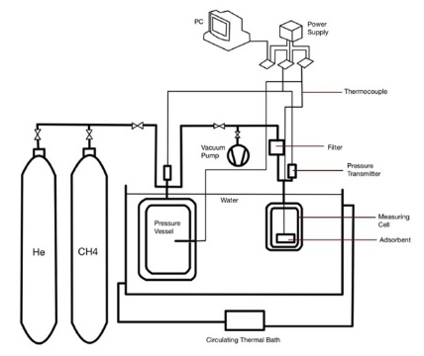

Figure 1. ANG Testing Apparatus Schematic
METHOD
Material
This research was conducted through several main processes: carbonization, chemical activation, physical activation, and metal impregnation. Characterization tests were performed utilizing iodine number test. The surface morphology of the activated carbon samples was observed using scanning electron microscopy (SEM, Zeiss). The determining of elemental components in the activated carbon sample, were investigated via energy dispersive X-ray spectroscopy (EDS, Bruker). The activated carbon was then tested in ANG technology to determine the storage and release capacity of natural gas.

Methods
This study applies an integrated experimental approach to synthesize NiO-modified activated carbon from polyethylene terephthalate (PET) waste for use in Adsorbed Natural Gas (ANG) systems. The process begins with the preparation of PET bottles through washing and cutting, followed by carbonization at 480 °C for 120 minutes to eliminate volatile matter. The resulting char is chemically activated with 4 M KOH at 80 °C for 120 minutes, washed with HCl, and subsequently physically activated using nitrogen gas flow (100 ml/min) at 800 °C for 120 minutes. To improve gas adsorption performance, the activated carbon is impregnated with Ni(NO₃)₂.6H₂O at 0.5%, 1%, and 2% concentrations, then dried and calcined to form NiO within the porous structure.
The samples are characterized using iodine number tests for surface area estimation, scanning electron microscopy (SEM) for surface morphology, and energy-dispersive X-ray spectroscopy (EDS) for elemental analysis. Methane adsorption–desorption capacities are measured using a volumetric method at pressures of 3, 5, 7, and 9 bar, and temperatures of 28, 31, and 35 °C. The findings support a theoretical contribution by combining waste valorization with transition metal functionalization, offering a novel, sustainable, and efficient material for ANG applications.
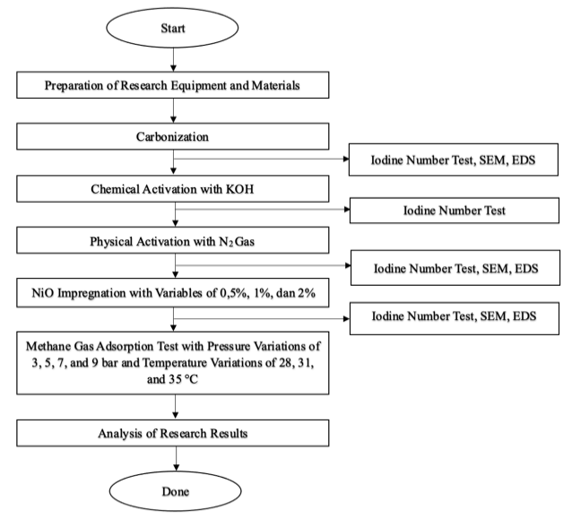

Figure 2. Research Flowchart

RESULTS AND DISCUSSION
Carbonization Results
The carbonization process is the initial stage in the production of activated carbon. The principle at work involves the release of volatile substances contained in the plastic, leaving behind pure carbon. As the volatile compounds are removed, pores form in the carbon. Temperature is the most crucial factor in the carbonization stage. At temperatures between 100-200°C, white smoke appears, and the smell of burning plastic can be detected, indicating that the volatile compounds have evaporated at their boiling points. During this phase, the ester bonds in the PET plastic polymer chain break down when heated, producing terephthalic acid (TPA) and ethylene glycol as monomers formed during PET production. Then, at approximately 250°C, PET undergoes thermal decomposition, resulting in simpler compounds such as CO₂, CO, water, and other byproducts. As the temperature increases, specifically around 300°C, black residue in the form of remaining carbon begins to form. At the maximum temperature of 480°C, it is considered that the carbon content has been optimally obtained and porosity or open pores have formed in the carbon. The carbonization process in this study resulted in an average yield of 11.53%, due to the high temperature over an extended carbonization period, leading to excessive decomposition. Table 1 shows the all yield value.

Table 1. Carbonization Yield
No. | Mass Before Carbonizati  on (g) | Mass After Carbonization (g) | Yield (%)
1. | 43.42 | 4.24 | 9.58
2. | 42.11 | 4.52 | 10.91
3. | 44.41 | 4.33 | 9.88
4. | 42.87 | 3.52 | 8.08
5. | 42.65 | 5.20 | 11.99
6. | 52.48 | 13.67 | 11.74
Yield Average |  |  | 11.53

Chemical Activation Results
The purpose of chemical activation is to decompose the molecules in the carbon, forming a porous structure that can increase adsorption capacity. Additionally, activation can change the chemical and structural properties of the activated carbon, making it more effective in capturing and binding contaminated molecules. In this research, a chemical activator containing a metal hydroxide, specifically 4 M potassium hydroxide (KOH), was used. During the stirring process, a reaction occurs between the carbon and the KOH activator, as shown in the following chemical equations:
$$4KOH+C→4K+{CO}_{2}+2H_{2}O$$
$$6KOH+C→2K+3H_{2}+2K_{2}{CO}_{3}$$
$$4KOH+2{CO}_{2}→2H_{2}O+2K_{2}{CO}_{3}$$
KOH, acting as a strong base, can remove impurities in the carbon resulting from carbonization. When KOH interacts with carbon, KOH is adsorbed, resulting in a reaction that forms an intermediate compound, potassium carbonate (K₂CO₃). In this context, the carbonate compound plays a role in controlling the size and distribution of pores in the activated carbon. The oxygen content in KOH also reacts with carbon (C), leading to partial oxidation that produces carbon dioxide. During the process, hydrogen gas is also released due to thermal decomposition reactions. From this dehydration reaction, carbon is eroded, and the surface area of the activated carbon increases due to the formation of additional pores.

Physical Activation Results
After the chemical activation stage, the carbon is further activated physically to expand the pores, resulting in mesoporosity within the carbon structure. In this research, physical activation was performed by heating at 800°C for 2 hours with a nitrogen gas flow of 100 ml/min. Nitrogen gas acts as an activating gas that reacts with carbon to open pores, increasing the surface area, and also as an inert gas that prevents oxygen from entering and reacting, which could cause combustion. The physical activation yielded an average of 79.93%, due to the presence of residual volatile compounds from the previous stage, which eventually burned off at high temperatures. Table 2 shows the yield of physical activation.
Table 2. Physical Activation Yield
No. | Mass Before Physical Activation (g) | Mass After Physical Activation (g) | Yield (%)
1. | 50.3 | 46.61 | 92.66
2. | 60.05 | 46.49 | 77.42
3. | 59.13 | 40.51 | 68.51
4. | 60 | 48.67 | 81.12
Yield Average |  |  | 79.93

Metal Oxide Impregnation Results
The final step in the production of activated carbon is metal oxide impregnation, an additional treatment to enhance adsorption capabilities. In this study, nickel (II) nitrate hexahydrate (Ni(NO₃)₂·6H₂O) dissolved in distilled water was used as the impregnator. The activated carbon was impregnated in a NiO solution at a ratio of 1:2 through a stirring process at 70°C for 2 hours. During this stage, a decomposition reaction occurs, resulting in the formation of NiO, CO₂, and H₂O. The activated carbon was then dried in an oven at 110°C to remove moisture and volatile substances on the carbon surface after impregnation. The heating process also plays a role in the dissociation of nitrate hexahydrate into NiO [13].
Iodine Number Results
The iodine number indicates the adsorption capacity of activated carbon towards iodine, reflecting the ability of activated carbon to adsorb iodine components. In this study, an iodine number test was conducted to determine the surface area and adsorption capacity of the produced activated carbon samples. Table 3 shows the iodine number results and the surface area calculated by the author.

Table 3. Iodine Numbers
Sample | Iodin Number (mg/g) | Surface Area (m²/g)
Carbonization | 1025.45 | 1019.89
Chemical activation | 1025 | 1019.44
Physcial activation | 946.73 | 941.6
NiO 0.5% | 930.74 | 925.69
NiO 1% | 978.65 | 973.35
NiO 2% | 1003.09 | 997.65

Based on the table, a decrease in the iodine number is observed from the carbonization sample to the physical activation sample. This may be due to the high temperatures used during the physical activation process, causing the pores that had already formed to be damaged or closed due to excessive heat. Meanwhile, for the impregnated samples, the sample with the highest iodine number is the one impregnated with 2% NiO. The modified activated carbon has an increasing iodine number because new pores and active sites are formed on the activated carbon.

Scanning Electro Microscopy (SEM) Characterization
Characterization method used SEM to observe the surface structure of activated carbon samples. In this study, tests were conducted on three samples: the carbonization stage sample, the physical activation stage sample, and the impregnated sample with the highest iodine number. The result of SEM test shows in figure 2 and figure 3.

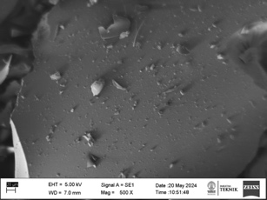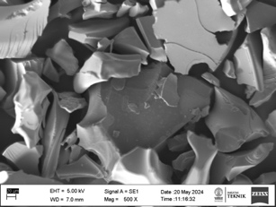
(a) (b)

Figure 3. SEM Test Results for Physical Activation Sample at 500x Magnification (a) and 1000x Magnification (b)

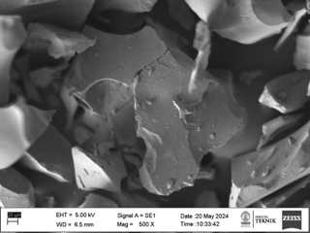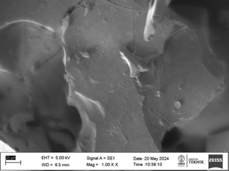
(a) (b)

Figure 4. SEM Test Results for 2% NiO Impregnated Sample at 500x Magnification (a) and 1000x Magnification (b)

In the carbonization sample, only plates containing some powder in the form of ash or impurities are visible. Then, the physical activation sample shows the formation of pores due to the reaction between carbon and the KOH activator and N₂ gas. Additionally, it can also be seen that the attached impurities are reduced. The SEM images of the 2% NiO-impregnated sample show a noticeably rougher and more heterogeneous surface compared to other samples. This morphological change indicates the formation of larger and more irregular pores, suggesting that NiO plays a significant role in enhancing pore development during the activation process

Energy Dispersive X-Ray Spectroscopy (EDS) Characterization
EDS testing is a characterization method aimed at determining the elemental components in the activated carbon sample. In this study, testing was conducted on three samples: the carbonization stage sample, the physical activation sample, and the impregnation result with the best iodine number. Table 4 shows the EDS test results containing the components in each sample.

Table 4. EDS Characterization Results
Element | Carbonization Sample (%) | Physical Activation Sample (%wt) | NiO 2% Impregnation Sample (%wt)
C | 88.77 | 87.91 | 73.86
O | 6.29 | 0.51 | 15.19
Pt | 4.95 | 11.58 | 6.14
Ni | - | - | 4.82

Void Volume Results Results
Void volume testing can characterize the porosity and volume of activated carbon. In this stage, an inert gas, helium, is used due to its non-reactive nature with activated carbon, ensuring no chemical or structural changes in the activated carbon. The calculation of void volume is done by measuring the moles of helium entering the filling tank and the adsorption tank. Two types of samples were tested: KNI sample (physical activation) and KI sample (impregnation) with void volume values as shown in Table 5.
Table 5. Void Volume
Sample | Void Volume (cm³)
KNI | 319.273
KI | 329.346

From the table above, it is known that the void volume value in the KI sample is higher than that in the KNI sample. This indicates that the KI sample has a larger volume or space that can accommodate adsorbed natural gas. This higher volume is due to the formation of more or wider pores after the impregnation process.

Natural Gas Adsorption Results
The natural gas adsorption capacity test is the main stage in the series of tests. In this stage, a sample of 2.5 grams is used with methane gas as the adsorbate. The variations conducted are temperature variations (28°C, 31°C, and 35°C) and pressure variations (3, 5, 7, and 9 bar). This testing is performed isothermally, where the temperature is maintained during testing with varying pressures. Figure 4 is a graph obtained from the adsorption capacity calculations in the study.
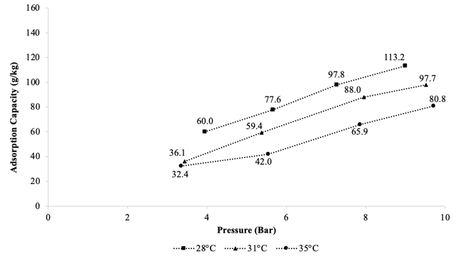
(a)
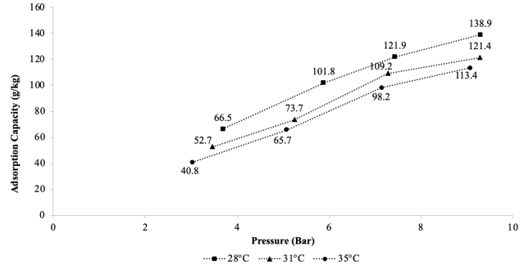
(b)
Figure 5. Adsorption Results for KNI (a) and KI (b)
Overall, it can be seen that both graphs show an increase in adsorption capacity with increasing pressure. The higher the adsorption pressure, the density of natural gas increases, which enhances the interaction between the natural gas and the activated carbon [14]. With higher pressure, natural gas is also pushed into the pores of the activated carbon, allowing for greater absorption. On the other hand, the effect of temperature on the adsorption capacity of natural gas shows a different pattern, where lower temperatures result in a higher quantity of adsorbate per unit mass of adsorbent. This adsorption process is exothermic, meaning that at lower temperatures, natural gas has lower kinetic energy, making it easier to be attracted to the pores of the activated carbon. Additionally, a difference in the highest adsorption capacity can be observed between the KNI and KI samples, with an increase of 22.68%.
Natural Gas Desorption Results
In addition to the adsorption capacity test, a natural gas desorption capacity test was conducted as a performance parameter for activated carbon. The desorption capacity value is generally lower than the storage capacity because some natural gas gets trapped in the activated carbon. In this study, the desorption capacity can be calculated by measuring the amount of gas released when the pressure is reduced from 9 bar to 1 bar using a Coriolis flow meter. Figure 5 shows the percentage of the sample that desorbed and remained in the activated carbon based on the adsorption value.
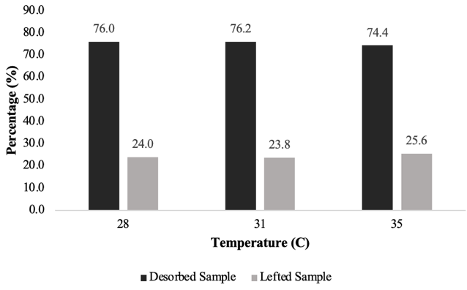

(a)
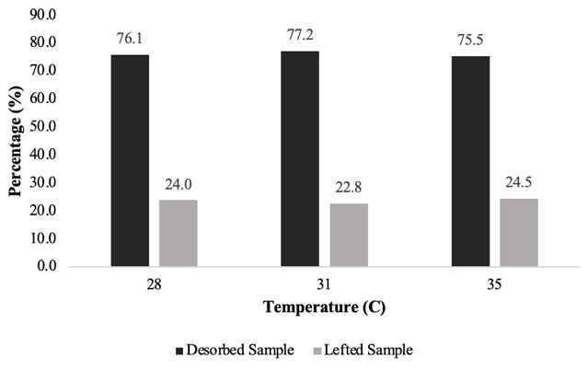(b)
Figure 6 Desorption Percentage of KNI (a) and KI (b)
The amount of residual natural gas indicates that active sites are reduced due to incomplete desorption, where Van der Waals forces occur between the natural gas and the activated carbon surface. The isothermal desorption process is considered inefficient because the system struggles to absorb heat [15]. Additionally, it is known that the higher the operating temperature of the system, the better the desorption capability. This is because desorption is an endothermic process, where high temperatures provide more thermal energy to the system, making it easier to break the adsorption between natural gas molecules and the adsorbent surface.
Once the desorption capacity data is obtained, the efficiency of the desorption process can be calculated. This is done by dividing the amount of natural gas desorbed at 1 bar pressure by the cumulative amount of gas adsorbed at 9 bar pressure. Based on the graph in Figure 6, it can be proven that the test data results for the KI sample are superior to the KNI sample, which is also evidenced by the larger surface area and void volume of the KI sample.
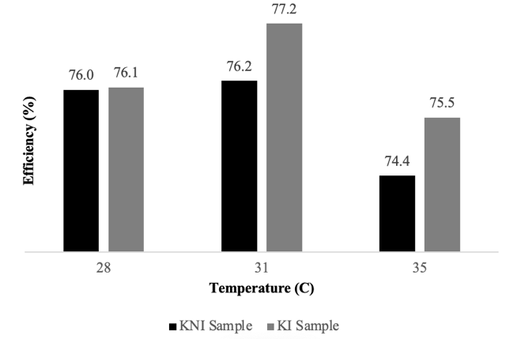

Figure 7. Efficiency of Desorption of KNI dan KI
When natural gas is desorbed, heat is absorbed, leading to a decrease in system temperature, which shifts the equilibrium to the right and reduces the release of gas molecules. Therefore, the desorption process requires heat, so as the system temperature increases, the desorption process improves [15]. However, in Figure 8, a decrease in desorption efficiency is observed for both samples tested at 35 °C. This could be due to changes in the structure of the activated carbon used or increased ion movement at high temperatures, making it more difficult for the adsorbed ions to detach from the activated carbon surface.

CONCLUSION
Based on the research results and data analysis conducted by the author, several conclusions can be drawn. The production of activated carbon through chemical activation with KOH and physical activation with nitrogen gas results in a decrease in surface area based on iodine number calculations but produces activated carbon with better pore structure. With NiO impregnation, the iodine number and surface area of the activated carbon increase. The best concentration was found to be 2% b/v NiO impregnation, with a surface area of 997.65 m²/g. Additionally, in the natural gas adsorption and desorption tests, the highest storage capacity was for the 2% b/v NiO impregnated sample at 9 bar pressure and 28 °C temperature. Under these conditions, the storage capacity was 138.886 g/kg with a desorption efficiency of 76.05%. This study demonstrates the feasibility of converting PET into effective ANG adsorbents.
ACKNOWLEDGMENT
This research was supported by 2020 Activated Carbon Research Group. In addition, we thank our colleagues from Chemical Engineering Department, University of Indonesia who provided insight and expertise that greatly assisted the research, although they may not agree with all of the interpretations/conclusions of this paper.

REFERENCES
- A. Serpe et al., “2002-2022: 20 years of e-waste regulation in the European Union and the worldwide trends in legislation and innovation technologies for a circular economy,” RSC Sustain., pp. 1039–1083, 2024, doi: 10.1039/d4su00548a.
- Purwanto, W. W., Muharam, Y., Pratama, Y. W., Hartono, D., Soedirman, H., & Anindhito, R. (2016). Status and outlook of natural gas industry development in Indonesia. Journal of Natural Gas Science and Engineering, 29, 55-65.
- Haghighatjoo, F., & Rahimpour, M. R. (2024). Adsorbed natural gas storage and transmission technology. In Advances in Natural Gas: Formation, Processing, and Applications. Volume 6: Natural Gas Transportation and Storage (pp. 107-123).
- Zheng, A. L. T., Teo, E. Y. L., Seenivasagam, S., Yiu, P. H., Boonyuen, S., Chung, E. L. T., & Andou, Y. (2025). Recent review on porous adsorbents for water decontamination: strategies for enhanced removal of tetracycline. Journal of Porous Materials, 32(1), 1-25.
- Sabio, M. M., & Reinoso, F. R., “Role of chemical activation in the development of carbon porosity”, Colloids and Surfaces A: Physicochemical and Engineering Aspects, 241(1-3), 15–25, 2024, https://doi.org/10.1016/j.colsurfa.2004.04.007
- Yuliusman, M. P. Ayu, A. Hanafi, and A. R. Nafisah, “Activated Carbon Preparation from Durian Peel Wastes,” Recent Prog. Energy, Communities Cities, vol. 030020, no. September 2020, pp. 1–6, 2021.
- Sharifian, S., & Asasian-Kolur, N., “Polyethylene terephthalate (PET) waste to carbon materials: Theory, methods and applications”, Journal of Analytical and Applied Pyrolysis, 163, 105496, 2022, https://doi.org/10.1016/j.jaap.2022.105496
- Béguin, F., Raymundo-Piñero, E., & Frackowiak, E. (2009). Electrical double-layer capacitors and pseudocapacitors. Carbons for electrochemical energy storage and conversion systems, 329-375.
- Heidarinejad, Z., Dehghani, M. H., Heidari, M., Javedan, G., Ali, I., & Sillanpää, M. “Methods for preparation and activation of activated carbon: a review”. Environmental Chemistry Letters, 18(2), 393–415, 2020, https://doi.org/10.1007/s10311-019-00955-0
- Ruangudomsakul, M., Osakoo, N., Keawkumay, C., Kongmanklang, C., Butburee, T., Kiatphuengporn, S., ... & Khemthong, P. (2021). Influential properties of activated carbon on dispersion of nickel phosphides and catalytic performance in hydrodeoxygenation of palm oil. Catalysis Today, 367, 153-164.
- Hofman, P. S., Rufford, T. E., Chan, K. I., & May, E. F. (2012). A dynamic column breakthrough apparatus for adsorption capacity measurements with quantitative uncertainties. Adsorption, 18, 251-263.
- Martin, A., & Nasruddin, N. Adsorpsi Isothermal Hidrogen pada Karbon Aktif Berbahan Dasar Cangkang Sawit pada Temperatur 45 OC (Doctoral dissertation, Riau University).
- Abbas, H., Nadeem, K., Hafeez, A., Hassan, A., Saeed, N., & Krenn, H. (2019). A comparative study of magnetic, photocatalytic and dielectric properties of NiO nanoparticles synthesized by sol-gel and composite hydroxide mediated method. Ceramics International, 45(14), 17289-17297.
- Matranga, K. R., Myers, A. L., & Glandt, E. D. (1992). Storage of natural gas by adsorption on activated carbon. Chemical engineering science, 47(7), 1569-1579.
- Xu, J. X., Li, T. X., Chao, J. W., Yan, T. S., & Wang, R. Z. (2019). High energy-density multi-form thermochemical energy storage based on multi-step sorption processes. Energy, 185, 1131-1142.

