INTERIORITY IN DEAF SPACE : APPLICATION OF THE DEAF EXHIBITION CENTER BUILDING DESIGN CONCEPT

Rachmita Maun Harahap¹
¹Lecturer of Interior Design, Faculty of Design and Creative Art, Universitas Mercu Buana
Jl. Raya Meruya Selatan, Kembangan, Jakarta 11650, Indonesia
Email: rachmita.mh@mercubuana.ac.id

Abstract - This study aims to show the implementation of deaf space design guidelines application in the Deaf Exhibition Center building. Even to increase society understanding of the need for public space access facilities for hearing disabilities. Deaf space design guidelines is considered an important aspect in determining design concepts and is influenced by hearing disabilities behavioral characteristics of interiority (relations between space and humans). Context of hearing disability behavior which includes a series of stages of exploration process and interpretation by subject in it gives birth to an interiority. Interiority is the presence of oneself being able to comfort him/herself in spaces him/herself in spaces. Interiority isn’t merely a spatial concept, but its concept in which disunited spaces can be one uniting body, mind, and space. The interiority in exhibition space toward hearing disability behavior can be implemented in design concept for hearing disability, so hearing disability users or visitors can engage in community intraction conversations and need space called "deaf space". This study aims of to contribute to application of deaf space design principles in Deaf Exhibition Center building which is accessible to hearing disability or normal hearing (including wheelchair users, blind people) who are more independent and productive.

Keywords: interiority, hearing disabilitiy behaviour, deaf space design, Deaf Exhibition Center in Bekasi

Copyright © 2019 Universitas Mercu Buana. All right reserved.

Received: July 27, 2019 | Revised: .........., 2019 | Accepted: ........, 2019

INTRODUCTION
The condition of interiority in exhibiton space in Indonesia for hearing disabilities (deaf, deaf-dumb and hearing impaired) is still very alarming, because standard of exhibition space design application is the same as normal hearing person. Interiority in the exhibiton space is based on the behavioral characteristics of physical environment needed by hearing disability users. The implementation design method that seems to be a space design for hearing disability is a deaf space design approach that focuses on behavior. Deaf space design as a customized design method for understanding interiority with behavior. The purpose of study is to improve the quality of interiority to level of physical comfort and behavior of hearing disability users in the process of exhibiton activities (workshops, exhibitions, cultural arts, shows and so on). Through the design to be analyzed are the circulation system, interior space system and information and communication system in Deaf Exibition Center (DEC) building for hearing disability.

Interiority defined as a character’s thoughts, feeling, reactions, and inner struggles, and how we access them, wheter it’s in first person or third (Kole, 2017). It is human sense of place in the world is mediated through everyday interaction with both human and space (Seamon, 1985). Through focusing attention on human everyday routine interactions human come to understand how a sense of interiority is inherently linked to the quality of daily relations with designed environments (Dyck, 2005; Tuan, 1977). According to Atmodiwirjo & Yatmo (2018), interiority is relational, adopting an everydayness frame from diverse user’s perspectives is imperative to improve human experiences and spatial justice within design practice (Atmodiwirjo & Yatmo, 2018). This is critically important for hearing disability like mine whose subjective experience of interiority is constantly being disputed and denied by hostile materiality. Assuming an everyday frame also reveals that not all body-space encounters evoke a sense of insideness. As Dovey (2008) notes: “The built environment reflects the identities, differences and struggles of gender, class, race, culture and age” (Dovey, 2008). For normal hearing persons, so our interiority is constantly in dispute, as designed environments privilege standard of visual gesture while excluding others. The results of hearing disability formulation are: 1) Anthropometry involves the systematic measurement of physical properties of human body, primarily dimensional descriptors of body size and shape, 2) Medium and visual communication well known by deaf sign language, 3) Visual access will be familiar through the communities or can be excepted when they are in the same organization or states even though we do have a standard national sign language, and 4) utilize visual information could help inside or outside of social environment. The four design concepts of deaf space are required freedom in moving, alternating and communicating signed language by different interactions. The interiority in exhibition space toward hearing disability behavior can be implemented in design concept for hearing disability, so hearing disability users or visitors can engage in community intraction conversations and need space called "deaf space”.
Definition of hearing disability is the condition of individuals who are unable to hear in terms of speech or other sounds, both in degrees of frequency and intensity (Moores, 2001), so it can be concluded that hearing disability people can’t use their hearing abilities (audio). However, hearing disability prioritizes them visual abilities in reading the surroundings. This is aimed at interiority towards hearing disability behavior which needs to be noted that applying of deaf space design in DEC space that desired for hearing disability users or visitors can be targeted, namely the space design approach for hearing disability. A suitable approach to solving this DEC space design problem is hearing disability space (deaf space) design. The deaf space design is used and adapted to interiority to the characteristics of hearing disability behavior (Halim, 2005).
The principles of hearing disability behavior that appropriate for solving the DEC building problem are the principle of Deaf Space Design Guidelines. The principle developed by Bauman (2005) has been used in the design of Gallaudet's university buildings that are intended for hearing disability students. In 2005, the Deaf Space Project (by Bauman) created a catalogue for any architect to access the design options to maximize deaf space elements. There are five distinct space elements that can be considered when constructing a “Deaf Space” design principles, namely (Bauman, 2005) : 1) space and proximity, 2) sensory reach, 3) mobility and proximity, 4) light and color, dan (5) acoustics.

METHOD
The method used is descriptive qualitative. Descriptive research was form of obtaining an overview of interiority in DEC space toward hearing disability behavior. Whereas, qualitative research is form of gaining an understanding of the characteristics of hearing disability (deaf, deaf-dumb, hard of hearing) behavior and obtaining new theories to be used as scientific works, namely deaf space design principles. Data collection techniques in the form of literature studies, field observations, and documentation so that data can help process problems of object space design.
The problem of the object of interiority research in the DEC space by paying attention to hearing disability behavior characteristics to realize the interiority function in the DEC space that has met the principles of deaf space design principles. The definition of deaf space design is an interior design concept and architecture to utilize landscape space and ways that touch the main point in the experience of hearing disability behavior (Bauman, 2005). Deaf space design principles are interior design and architectural guidelines that improve how hearing disability interacts with the built environment (Bauman, 2005). Interiority support must be adapted to the diversity of interior design and architecture that has sprung up. That is, interior designers and architects have thought about practicing interior space in everyday space that meets communication and spatial needs for hearing disability.
The next step is to analyze the problems of the object design space as a basis for formulating the concept. From the problem analysis will produce a design concept that is used as a guideline for deaf space design. This design guideline is produced in the form of activities and needs of the DEC space that have been designed. Then, deaf space design principles are applied to the design guidelines that have been produced previously. Deaf space design can solve DEC space design problems, namely circulation problems, arrangement or arrangement of table chairs, air conditioning, lighting, color and acoustics. The deaf space design principles applied to the design are as follows (Bauman, 2005) :

a. Space and Proximity
In order to maintain clear visual communication individuals stand at a distance where they can see facial expression and full dimension of the signer’s “signing space” (Bauman, 2005). There space between two signers tends to be greater than that of a spoken conversation. As conversation groups grow in numbers the space between individuals increases to allow visual connection for all parties. This basic dimension of the space between people impacts the basic layout of furnishings and building spaces (Bauman, 2005).

Figure 1 : Space and Proximity.
Source : Bauman, 2005

b. Sensory Reach
Spatial orientation and the awareness of activities within our surroundings are essential to maintaining a sense of well-being (Bauman, 2005). Deaf people “read” the activities in their surroundings that may not be immediately apparent to many hearing people through an acute sensitivity of visual and tactile cues such as the movement of shadows, vibrations, or even the reading of subtle shifts in the expression/position of others around them. Many aspects of the built environment can be designed to facilitate spatial awareness “in 360 degrees” and facilitate orientation and wayfinding (Bauman, 2005).

Figure 2 : Sensory Reach. Source : Bauman, 2005

c. Mobility and Proximity
While walking together in conversation signers will tend to maintain a wide distance for clear visual communication (Bauman, 2005). The signers will also shift their gaze between the conversation and their surroundings scanning for hazards and maintaining proper direction. If one senses the slightest hazard they alert their companion, adjust and continue without interruption. The proper design of circulation and gathering spaces enable singers to move through space uninterrupted (Bauman, 2005).


Figure 3 : Mobility and Proximity.
Source : Bauman, 2005

d. Light and Color
Poor lighting conditions such as glare, shadow patterns, backlighting interrupt visual communication and are major contributors to the causes of eye fatigue that can lead to a loss of concentration and even physical exhaustion (Bauman, 2005). Proper Electric lighting and architectural elements used to control daylight can be configured to provide a soft, diffused light “attuned to deaf eyes”. Color can be used to contrast skin tone to highlight sign language and facilitate visual wayfinding (Bauman, 2005).


Figure 4. Light and Color. Source : Bauman, 2005

e. Accoustics
Deaf individuals experience many different kinds and degrees of hearing levels. Many use assistive devices such as hearing aids or cochlear implants to enhance sound (Bauman, 2005). No matter the level of hearing, many deaf people do sense sound in a way that can be a major distraction, especially for individuals with assistive hearing devices. Reverberation caused by sound waves reflected by hard building surfaces can be especially distracting, even painful, for individuals using assistive devices (Bauman, 2005). Spaces should be designed to reduce reverberation and other sources of background noise.
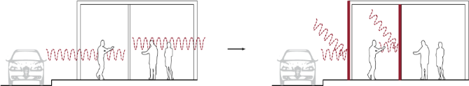
Figure 5. Acoustic (Bauman, 2005).
RESULTS AND DISCUSSION
Building Deaf Exhibition Center data and located in Jatiasih, Bekasi. The area of exhibition space is 7 m x 16,5 m, the secretariat room and office room are 6,25 m x 6 m and the pantry is 3 m x 5,5 m, and the prayer room is 1,5 m x 3 m and 3 toilets each with a length of 1.5 m x 2 m. The site is on north side of road, the main noise source comes from the road (south side) so that in structuring the zoning of building, the public area is on the southernmost side. While semi private and private areas in north but placement is parallel. There is one midpoint that connects the three zones so that visual range of hearing disability users can cover all three zones simultaneously.

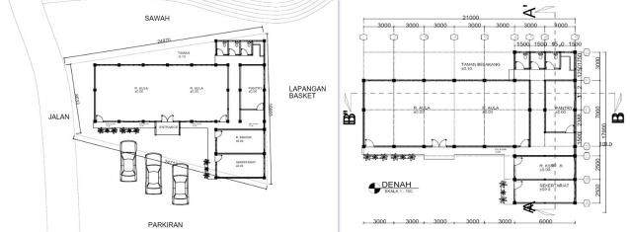

Figure 6. Site plan and floor plan of Deaf Exhibition Center in Bekasi. Source : doc. by Author, 2018

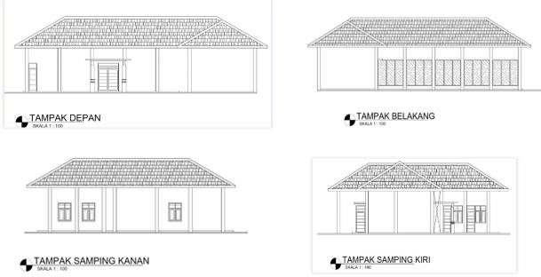
Figure 7. Front view. Source : doc. by Author, 2018

Figure 8. Back view. Source : doc. by Author, 2018
Figure 9 : right side view.
Source : doc. by Author, 2018

Figure 10: left side view.
Source : doc. by Author, 2018

In figure 6, shape of the DEC building mass is a linear shape T. The linear shape T is chosen because the shape resembles radial but still has a side so that it can facilitate the passage inside the building.

DISCUSSION RESULT

1. Space and Proximity
The effect of interiority in the DEC space can form space and proximity that is convenient for activities for hearing disability users who need visual cues in communicating. Facial expressions and body movements are very important for hearing disability users in communicating so they need sufficient landscape space. In communicating, the space needed by hearing disability users is different from normal hearing person.
Interiority in space and proximity can be applied, namely the room and display space. The issue of spatial shape is adjusted to deaf behavior. The form of interior space that is deemed to be in accordance with hearing disability behavior is a U or circle shape because it is flexible, broad and dynamic. This form is chosen based on deaf habits in activities. Unconsciously, a group of hearing disability people will form a circle or U pattern so that they can see everyone. They will avoid squares or elongated shapes that can block the view.

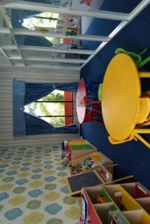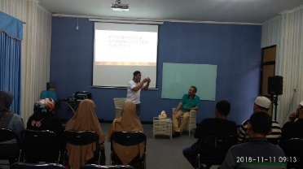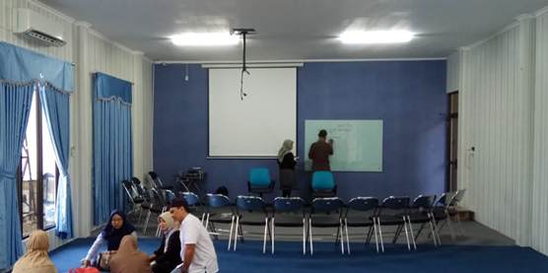

Figure 11. Interior space of DEC : arrangement seating and table u-shaped and or circles. Source : doc. by Author, 2018

In hearing disability space design concept, the corridor is an important area and requires many design features that add visual marks to hearing disability users. Activities of hearing disability visitors in the corridor, for example, are chatting with friends while passing through the corridor. At that time, the sense of sight is focused on communicating with the other person so that it is less alert to the conditions around. Therefore the leveling between the corridor and the outside space shouldn’t have a difference in height, the contrast and angles need to be refined so as not to endanger.

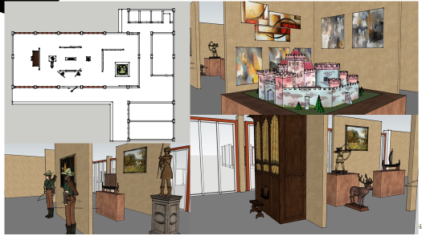

Figure 12 : Lay out of interior space of DEC : wide circulation according to gestures of hearing disability behavior. Source : by designer Author, 2018

Although in the radial circulation path, a crossroad will be found a little, but it still needs to be addressed with the right design. Smoothing the corners at the intersection can minimize the danger of collisions between corridor users in the opposite direction, it can also help users know the users of the corridor behind them.

2. Sensory Reach
The role of interiority in the DEC space of this sensory reach can be applied to increase sensory stimuli possessed by hearing disability people. By using other senses, hearing disability users are expected to be able to read situations that occur around them. For example, the addition of transparent glass on the door of the room so that people in other rooms can find out if there is an interest in entering the exhibition room.

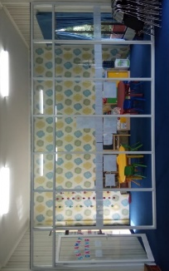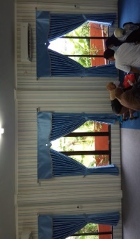
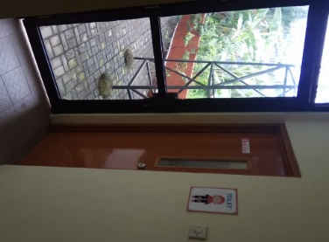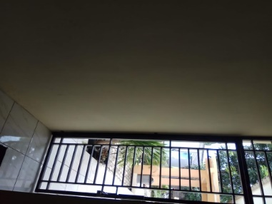

Figure 13. Transparent wall and glass door material in the middle of the exhibition room activities. Source : doc. by Author, 2018

The use of signage in the DEC room is also needed as a marker. For example, the use of signage on the DEC is an exit sign or evacuation route and a fire or hazard sign that is installed in each class. With the presence of this signage, hearing disability people can know of any danger without having to be warned in the form of a visual alarm bell. Alarm system (signal) 3 different colored lights on the ceiling (electric control center in the basement) telephone controller and doorbell (figure 14)
The evacuation system for disaster alarms and fires uses sound alarms and danger indicator lights on each side of the room door. The light blinks and can be located on the front wall or on the ceiling like a lamp that serves to illuminate the room. Disaster evacuation routes both fire and other disasters must be placed in each room, of course with a description of the position of space. The map is bright and contrasting, and provides clear information. The evacuation route must end in a safe place, it can be an open field or yard.

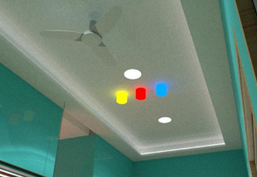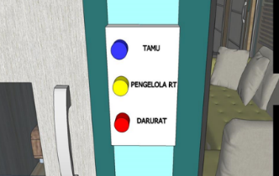

Figure 14. Bell Alarm system (signal) 3 different colored lights on the ceiling (electric control center in the basement) telephone controller and doorbell. Source : by designer Author, 2018

3. Mobility and Proximity
The interiority in mobility and proximity in the DEC space that aims to discuss the dimensions of visual movement space of hearing disability users. Hearing disability users need a wide visual space dimension compared to the normal hearing space movement needs. The need for the dimensions of the visual movement space of hearing disability users is influenced by the distance and extent of views needed by hearing disability users.
In communicating, hearing disability users rely on their visual abilities. If they are too focused on the conversation, they don't pay too much attention to the surroundings. They need interiority to wide visual movement space so that it can allow them to keep paying attention to the road and the interlocutor. The visual movement space discussed in this principle is the width of the road and the use of stairs or ramp. Calculation of roads and use of stairs and ramps need to be considered in the comfort of hearing disability body movements.
The width of road in the DEC building is designed to be wider than width of road, so that hearing disability users can freely pay attention to the surroundings. The width of the pedestrian lane on the DEC is around ± 3 m².
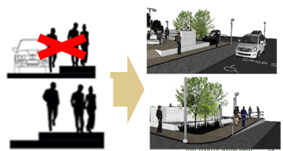
Figure 15. Corridor/circulation width, ramp and drop out in DEC building. Source : Worrel, 2011 (left). Design solution by designer : Author, 2018 (right)

Interiority in space specifically for persons with disabilities usually requires a ramp to make it easier for wheelchair users and blind sticks to move to different heights. The DEC building is included in the building for persons with disabilities so it must be friendly to the disabled. At some point, there is the use of a ramp in order to facilitate access to hearing disability users.

4. Light and Color
Interiority in light and color toward hearing disability behavior regarding color selection and processing of light in space. Color and light can affect hearing disability behavior so that they can see and read the situation comfortably, so the color chosen must contrast with cream, gray, bright blue and soft green skin. That way, deaf users when watching someone speak or speak sign language.
The choice of colors in DEC interior tends to be a combination of pastel and gray colors. However, because this DEC is dominated by adult hearing disability users. Special areas for small children, the colors chosen are fresh colors and can increase their knowledge of colors.

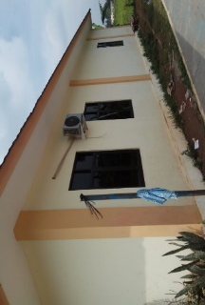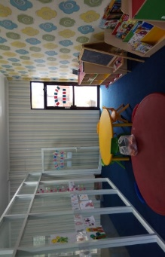
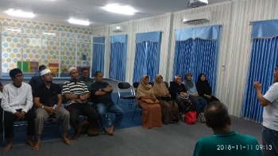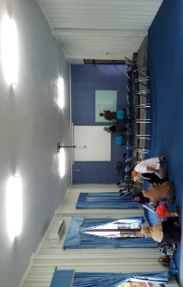

Figure 16. Colour selection of pastel, gray and cream blue in exhibition room, while cream and orange young are outside exhibition room.
Source : doc. Author, 2018

The ideal processing of light according to the deaf space design guidelines is light that is soft on eyes, not blinding, and avoids dark or dim spaces. In DEC space more use of natural lighting. The use of large openings allows natural light to enter the room so that there are no dim or dark corners. This DEC building uses skylight roofs in several spacious rooms. In another room a large window is provided so that natural light can enter freely. This is also intended to reduce the cost of using artificial light.

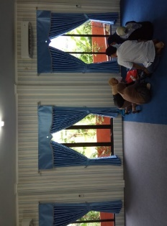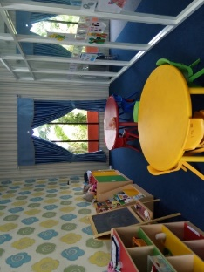

Figure 17. The natural lighting of window openings of transparent and artificial glass materials is given bright and clear lights that are also not dazzling.
Source : doc. Author, 2018

The lighting system in DEC's interior space uses artificial lighting. But for some spaces with special conditioning can be used natural and artificial lighting with electric lights. To avoid excessive glare, shading can be used in buildings. Shading can be divided into :

Artificial shading, which is obtained from the presence of openings in space, sufficient traction, proper orientation of space and openings, application of blur glass, curtains, curtains, blinds, and so on.

Natural shading obtained from proper vegetation selection.

In the circulation function, method and type of lighting is linear, which is direct. The lamp is mounted on the top of the wall and ceiling

5. Accoustics
Accoustic processing of interiority in DEC space to reduce the level of distrasion or noise is an important matter that needs to be considered so that hearing disability users can communicate with others and also concentrate on other people's conversations using a hearing aid. Although they have a deficiency in hearing but for those who use hearing aids or cochlear implants, loud sounds and even the sound of air conditioning machines can interfere with their hearing. Therefore, the ideal acoustics in the room must be quiet and comfortable.
However, quiet acoustic processing does not have to be applied in every room. Acoustic processing can be given to a room that requires peace of mind. DEC room that requires pure sound and vibration produced by sound sources, so that the room can be soundproofed so as not to be disturbed by outside noise.

CONCLUSION
The role of interiority in the Deaf Exhibition Center room can adjust hearing disability behavior in communication, using visual gesture, visual cues and so on. This is certainly different from normal hearing people, because with visual and visual gesture signals, a wider room dimension, as well as good lighting, is needed to avoid glare.
The approach to deaf space design principles that focuses on hearing disability characteristics as a method of application of DEC space design is quite precise and positive, so that this space can create functions of exhibition activities (cultural arts, workshops, performance arts and so on and improve physical and psychological comfort of deaf users).

ACKNOWLEDGMENT
Thank you for Mr. Hery Koeswara and Mrs. Nur Indah Harahap, owners of DEC building in Bekasi were permitted to conduct my research. So, thank you my team is Lala, student of Architecture engineering, University of Mercu Buana – Kranggan Campus and Yosua Adiputra, student of Interior Design University of Mercu Buana – Kranggan Campus as designer of the DEC building.

REFERENCES
Atmodiwirjo, P. & Yatmo, Y. A. (2018). Interiority as relational. Interiority, 1 (2), 87-90.
Bauman, Hansel. (2005). Deaf space. Gallaudet University’s Architects .
(https://www.gallaudet.edu/campus-design-and-planning/deafspace)
Dovey, K. (2008). Framing Places: Mediating power in built form. (2nd ed.), (pp. 46-60). Oxon: Routledge
Dyck, I. (2005). Feminist geography, the ‘everyday’, and local–global relations: hidden spaces of place-making. The Canadian Geographer / Le Géographe canadien, 49(3), 233–243.
Halim, Deddy. 2005. Architecture psychology. Jakarta: Grasindo. (Book)
Harahap, R. M., Santosa, I., Wahyudi, D., & Martokusumo, W. Innovative of assistive technology access for students with hearing disability with universal design principles approach. https://media.neliti.com/media/publications/196104-ID-inovasi-akses-assistive-technology-untuk_j2JnEzN.pdf
Kole, Mary. 2017. What Is Interiority? An Interiority Definition, and Why It Matters. https://kidlit.com/2017/10/23/what-interiority-is-and-why-it-matters/
McCarthy, C. (2005). Toward a definition of interiority. Space and Culture, 8 (2), 112-125
Moores, Donald F. 2001. Educating The Deaf: Psychology, Principles, and Practices. Boston: Houghton Mifflin Company. (Book)
Seamon, D., & Mugerauer, R. (Eds.). (1985). Dwelling, place, environment: Towards a phenomenology of person and world. New York: Columbia University.
Tuan, Y. (1977). Space and place: The perspective of experience. Minneapolis, MN.: University of Minnesota.

