STUDY OF FLUID FLOW CHARACTERISTICS IN THE MERIDIONAL CROSS SECTION OF A HORIZONTAL AXIS SEA CURRENT TURBINE MODEL

Wulfilla M. Rumaherang^{1*}, Jonny Latuny¹
¹Department of Mechanical Engineering, Faculty of Engineering, Universitas Pattimura
Jl, Dr. J. Leimena, Kampus Poka-Ambon 91234, Indonesia

*Corresponding Author Email: max.rumaherang@fatek.unpatti.ac.id

Abstract - The ducted tidal turbine models have been developed to utilize the conversion of the kinetic energy on ocean currents. The research in refining the turbine characteristics has been carried out by modifying the turbine’s shape and size. This study investigated flow characteristics in the meridional section of five ducted turbines models for seawater flow with velocity U₀ = 1.5 m/s. The ducted turbine design and construction have five different impeller house diameters and fixed inlet and outlet diameter. The potential energy flow theory and experimental data are used to analyze the flow characteristics of the model. The results obtained show that flow velocity in the x-direction at the inlet and outlet cross-section is getting smaller with the reduction of the impeller house cross section. Each impeller house size reduction increases the flow speed in the impeller house cross-section and also pressure on all other cross-sections tested. In the inlet area, the increased pressure indicates that there is a decrease in speed flow and discharge coefficient value. The discharge coefficient value drops from C_{Q} = 0.9 at the diameter ratio of dr = 1 to C_{Q} = 0.56 at the diameter ratio of dr = 0.37. In the impeller area, the flow velocity increases from 1.76 at the ratio of dr = 1 meter to 4.8 m / s at dr = 0.37. At diameter ratio values of 0.83 and 0.73, the velocity distribution along the experimental data range shows an approximately uniform distribution pattern. The vortex and wake are formed, when the diameter ratio reaches 0.1 and the diameter ratio increases from 0.49 to 0.37.

Keywords: ducted turbine, diameter ratio, flow characteristics

INTRODUCTION
Seawater currents in the straits between small islands in Maluku have speed flows reaching 2.5 m/s, it is one of the potentials energy resources to converted into electrical energy [1]. One of the ocean's current technologies is the horizontal ducted turbine [2][3], which is currently mostly in its development studies within the construction of tidal power equipment [3].
The turbine performance optimization studies are still conducted through the design and testing of various models, shapes, and sizes to increase power at smaller rotor sizes, which is rotating at faster rotational speeds to support gearbox and generator operations which reduce the cost per kilowatt generated on tidal power [4].
Tidal turbine performance is a relationship of power, rotation, and thrust parameters as a function of the free speed of ocean currents. The performance of ducted tidal turbine model is closely dependent on the properties of the fluid flow through each cross-section whose principle is similar to the flow on the shrouded wind turbines which its experimental studies have been carried out by others [5,6,7,8].
The angle of outlet diffuser extraction influences the characteristics of the fluid flow through the cross-section of the shrouded wind turbine. The negative value of pressure is performed at the vortex behind the diffuser flange and it increases the fluid flow velocity which enters the diffuser [6]. The optimal angle of diffuser extraction is at α=+15º, wherein this condition the inlet airspeed reaches the maximum value [6].
The coefficient of performance of micro wind turbines has increased by around 60% and the speed ratio has increased by 33% by adding a simple cone diffuser. This values is a result of comparison to turbines without shrouded structure. Flow analysis is carried out to investigate the effect of the diffuser angle (yaw angle) on static pressure along the section surface with an angle of -45º to 45º [7]. It is to investigate the value of correlation coefficient of pressure from the inlet to the diffuser outlet. Another method to analyze the fluid flow in the ducted turbine is by using the disk actuators theory approach developed by Betz and others [8], [9], where the main feature of the flow plane is the flow tube which separates the flow that passes through the disk from the flow that bypassed from the disk. The flow of inside and outside the ducted is assumed to be stable, incompressible and invisible, with limited vorticity to the ducted downstream surface [9].
Previous studies have explained that the increase in turbine power and efficiency which are obtained through the studies of the power coefficient, thrust, resistance coefficient, and axial induction factor and changing the shape and size of the turbine [4]. These parameters are very dependent on the flow velocity profile through the ducted turbine. For a certain free flow velocity, the shape and size are determined by flow velocity in the duct. Reduction of the channel cross-section accelerates the flow through of the rotor plane which is also reduces rotor thrust loading [10].
In this study an investigation of the average speed and pressure in the turbine based on the velocity and pressure profiles of the flow passing through the meridional cross-section of the ducted turbine is carried out. The study is similar to the ones of Crees Well [7] and Aly M. Elsahaby [5]. In this study, five cases of the shape and geometry of ducted turbines [10] with fixed inlet and outlet diameters are investigated with a flow characteristics of constant free flow speed at U₀=1.5 m/s.
This study also illustrates that the average velocity and pressure and discharge coefficients in the impeller area which is theoretically obtained by using the potential flow theory [11] and the approach of flow around the body as well as experimental measurements [12] on each turbine section. Flow velocity in the ducted is analyzed for turbulent flow with commonly used factor of 1/7th of power law [7] and uses continuance and Bernoulli principles [8] and actuator disc model [13].

METHOD

Material
Power density and Turbine Geometry
The peak power of the turbine determines by the momentum theory described by Fraenkel equation [14], [15]. The ocean current velocity at the Haya Strait site reaches 2.5 m/s, with power density reaches 3755 W/m2 [16]. The water flow velocity, power density data and power requirements generated by the fluid determines dimensions and geometry of the turbine by using the continuity principle. The turbine geometry-shape in this research was calculated and constructed in earlier studies [17].
2.2. Velocity profile in the ducted structure
The flow velocity profile that passes through the cross-section is analyzed using the turbulent flow approach. The velocity distribution at each distance of r of the ducted structure is expressed as a 1/7th of power law, where the elemental velocity can be written as [7][8]:
$\frac{v}{U_{o}}={\left(\frac{r}{R}\right)}^{1/7}$ …………………..…………(1)
In all five-turbine cases, the shape and size of the shroud and hub sections determine the flow angle from the inlet to the outlet section. The flow direction in the ducted turbine is formulated through the potential flow theory in the duct. 1D flow analysis in the x-direction in front of the turbine uses the theory of potential flow functions for uniform flow and flow around the hub and shroud as shown in figure 1. For uniform flow $ψ_{1}=uy=u_{0}r\sin{θ}$ and for flow at $ψ_{2}=qθ/2π$ of flow source and $ψ_{2}=-qθ/2π$ for sink. Superposition of uniform flow in the x-direction at the front (source) at the origin is expressed:
$ψ=ψ_{1}+ψ_{2}$ …..……………………. (2)
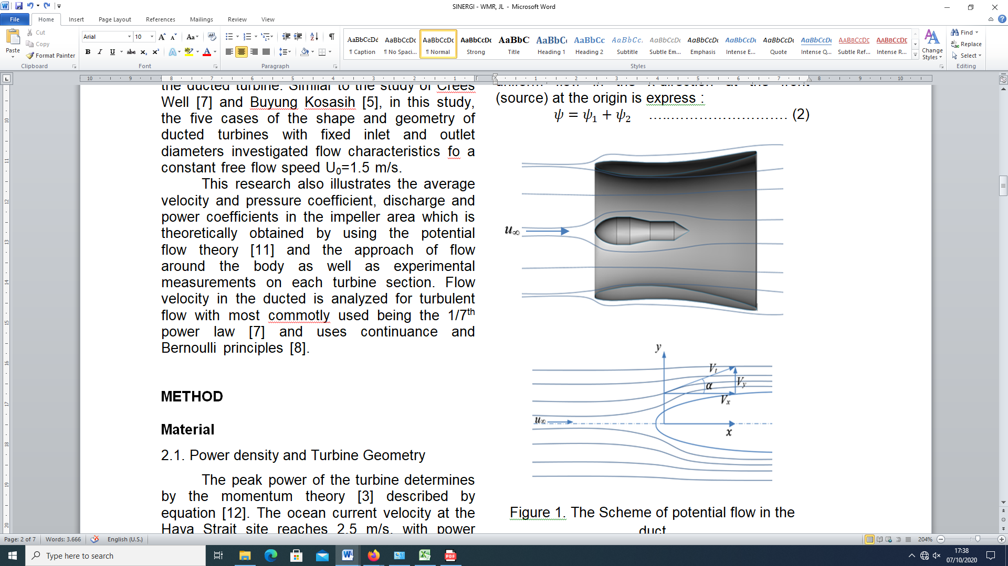
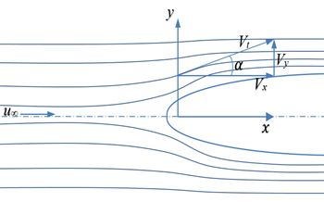
Figure 1. The contour of potential flow in the duct section
The slope angle between the velocity resultant on the flow line at each radius r is expressed as α. The velocity in the x-direction at each distance y = r_{i} , which is determined by the theory of flow around the body which is expressed as:
$v_{ri}=v_{t}cosα_{i}$ …………………… (3)
2.4. Performance Coefficient
The average speed and pressure on each turbine section are calculated by using:
$V=\sum_{i=1}^{n}{v_{ri/n}}$ ……………...… (4)
The pressure at each point in the turbine is calculated by the Bernoulli equation by using:
$P_{ri}=Pa+0.5ρv_{ri}^{2}$ ………….. (5)
The average velocity and pressure on each turbine cross-section are calculated by using:
$P=\sum_{i=1}^{n}{P_{ri/n}}$ ……..………… (6)
Equations (3) and (5) describe the flow velocity dan pressure distributions at each turbine cross-section which its radius is expressed as the relationship between the speed and pressure to y/R (p, V_{x}=f(y/R) for each turbine case.
The average pressure and velocity values at the inlet section is determined by the discharge coefficient value, where the discharge coefficient can be written as:
$C_{Q}=\frac{V∙Ao}{U_{o}∙A_{o}}=\frac{V}{U_{o}}$ …………….. (7)
Where U_{o} and V are the free flow velocity and average velocity in the inlet section, respectively.

Methods
In this research, a design study and testing of a ducted turbine model was conducted at the Haya Strait site in 2015 where a ducted turbine model was used [1]. For the purpose of flow measurement at each section of the turbine section, the testing stand was assembled as shown in Figure 2.
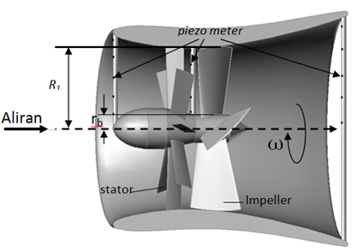
Figure 3. Turbine assembly

The water flow enters to the turbine through the inlet cross-section with a fixed diameter of D₀ = 4.0m to the stator and impeller with a bulb diameter of d_{b} = 0.6m. The flow exits the outlet cross-section at diameter of D₂ = 4.8m. Measurements of flow velocity and pressure were carried out at free flow velocity of U₀ = 1.5 m/s.
To investigate the flow in the turbine, the model turbine is varied into 5 cases with different shapes and sizes as shown in figure 4 and each model employs a diameter ratio of $\overline{d}=D_{1}/D_{2}$ [10].
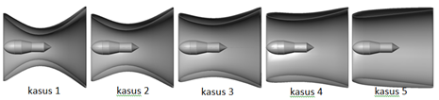

Figure 4. Five cases of turbine shape and size

The ducted data of five turbines geometry and size are shown in table 1.
Table 1. The size of turbine geometries
No | Impeller  Diameter | Diameter  Ratio | Angle
No | DiD₁ (m) | d_{bs}=D1/Do | α₁ | β₁ | β₂
1 | 1.5 | 0.37 | 75 | 33.5 | 35
2 | 2.0 | 0.49 | 75 | 33.5 | 35
3 | 2.5 | 0.61 | 75 | 33.5 | 35
4 | 3.0 | 0.73 | 75 | 33.5 | 35
5 | 3.5 | 0.85 | 75 | 33.5 | 35

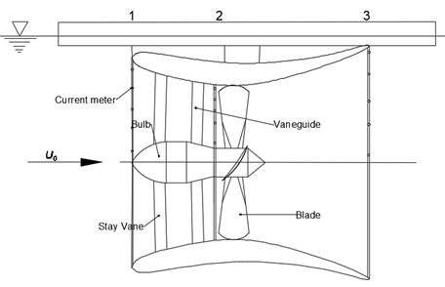
Figure 5. Testing Platform Schematic

The parameters of flow that passes through the turbine section is measured at each cross-section by a current meter that set up at each cross-section [6][18]as shown in Figure 5. The characteristic of flow is measured at the inlet cross-section A₀, the impeller house A₁, and of the outlet diffuser cross-sections A₂. The turbine measurement points are schematically shown in Figure 5. One dimensional flow velocity in the x-direction at each range of 0≤r_{i}≤R is described as the velocity profile. Furthermore, the pressure distributions at each range is calculated using equation (5) (figure 4). The average speed and pressure values at the inlet, impeller housing an outlet cross-section of the turbine are calculated by using equations (4) and (6).

RESULTS AND DISCUSSION

A. Flow velocity and pressure profiles on half of meridians cross-section
The inlet cross-section
Based on the 1D velocity value in the x-axis direction at the range $0≤{r_{i}}/R≤R$ the inlet cross-section illustrates the velocity and pressure profile for the five cases shown in Figure 5. Figure 6 shows that the flow velocity at $0≤{r_{i}}/R≤0.2$ tends to be fixed, while for $0≤{r_{i}}/R≤1$ the condition of flow velocity is influenced by changes in the reduction of the cross-section of the meridians in the impeller house. The results of these theoretical and experimental calculations show that the value of flow velocity of 1D in the x-direction is getting smaller by decreasing the impeller area.
The pressure on the inlet side for each change in impeller diameter D1, is illustrated in Figure 7. Based on equation (5), the inlet pressure changes after narrowing the shape of the diameter cross-section area and to the speed variations in the inlet.
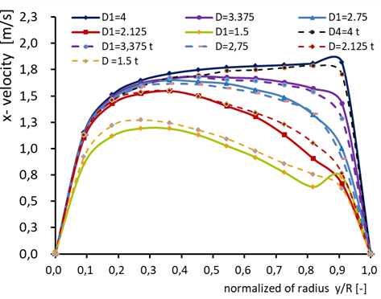
Figure 6. Velocity profiles at inlet cross-section

At diameter D1 = D0 the pressure distribution at the same inclination is overall is within range of 0 / r / R≤1. It is subsequently increased after the decrease in speed according to the reduction of the cross-section at the impeller house.
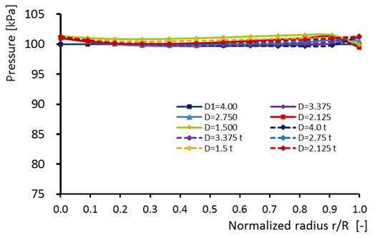
Figure 7. Pressure profiles at inlet cross-section

The impeller house cross-section
The flow through the cross-section of the impeller housing is fully developed into a turbulent flow. Figure 8 shows the velocity and pressure distributions of fluid flow at the impeller house area based on semi-empirical and the range of experimental data.
According to the analysis of the flow in the closed channel, the maximum speed occurs in the central cross-section. The flow velocities near to the periphery are higher than the flow velocities in the hub area. Likewise, the pressure on the impeller shroud area is lower than the pressure on the hub area. This phenomenon shows that the shape of the shroud and turbine hub influences the flow characteristics of the turbine.
The increase in maximum speed at each impeller diameter D₁, compared to speed at D₁ = D0 reaches ∆v = 0.415, 1.097, 1.953 and 2.02 m/s which is concerning the condition where D₁ = D₀. At this point, the pressure difference for each case is ∆p = 600, 2800, 5200 and 10500 kPa. The change in speed at each change of the impeller house cross-section area is in accordance with the continuity principle and the Bernoulli equation. At D₁ = 4 meters, the pressure value in this area is approximately close to the pressure value at the inlet section, which is equal to P=100 kPa.
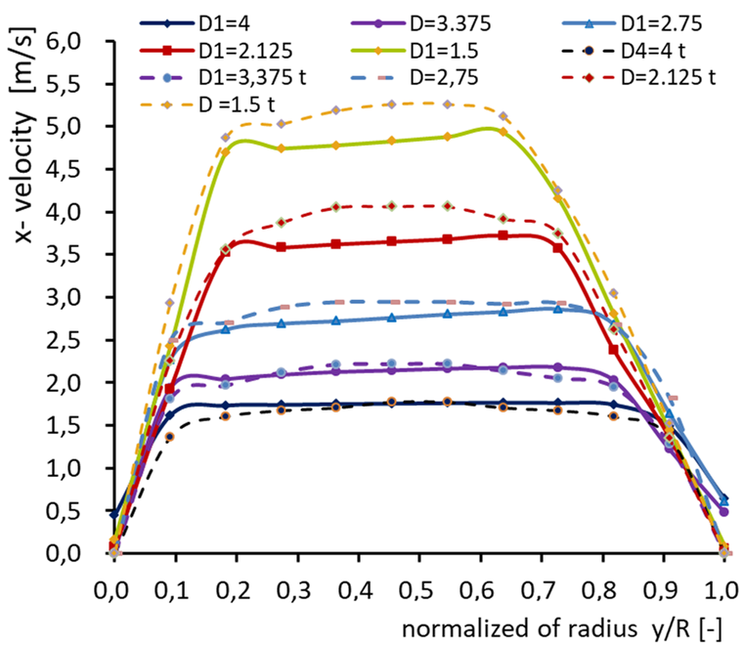
Figure 8. Velocity profiles at the impeller house cross-section

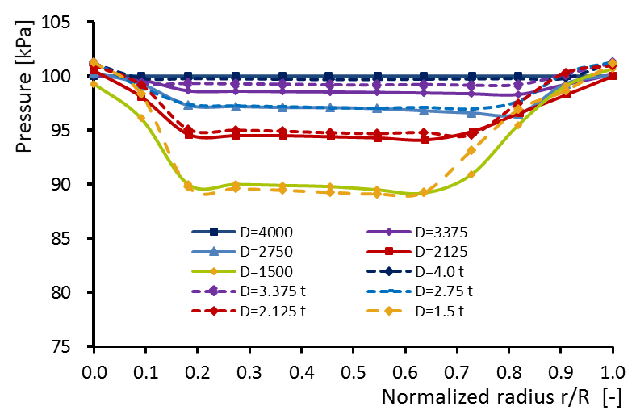
Figure 9. Pressure profiles at the impeller house cross-section

The pressure value on the inlet side for each change of the impeller diameter D₁, is illustrated in Figure 9. Based on equation (5), the inlet pressure changes after the area reduction of the diameter cross-section and in accordance with the conditions of the inlet speed variation. At diameter D₁ = D₀ the pressure distribution at the same inclination is overall range of 0/r/R≤1, subsequent condition occurs where there is small increase of pressure and the decrease in speed when the area of cross-section at the impeller house is reduced.
The Outlet Cross-section
Changes in shape by the reduction in diameter of the cross-section area of the impeller house have an impact on changes in flow patterns, vortices and formed wake and non-uniform flow that changes the contours of the velocity distribution and pressure on the cross-section of the outlet (figure 10, 11). At a diameter ratio of 0.83 and 0.73, the velocity distribution along the data range shows a nearly uniform flow pattern. Vortex and wake start to form when the diameter ratio is equal to 1 and increases at diameter ratio of 0.49 to 0.37. The flow velocity on the x-axis is greater for the small diameter of the impeller housing, while at the larger diameter (D₁ approaches D₀), the flow velocity in the x-direction at the outlet reaches a minimum value which is in accordance to the principle of continuity. Flow velocity in 0.3≤r/R≤0.6 reaches the minimum value in the area near the axis and shroud.

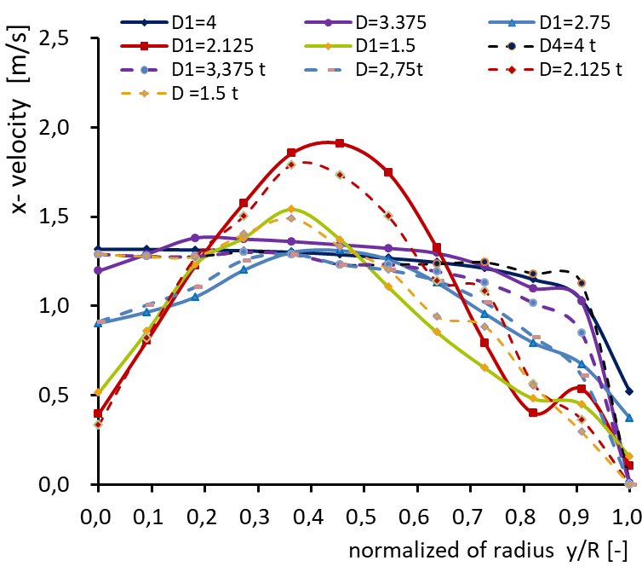
Figure 10. Velocity profile of the outlet cross-section
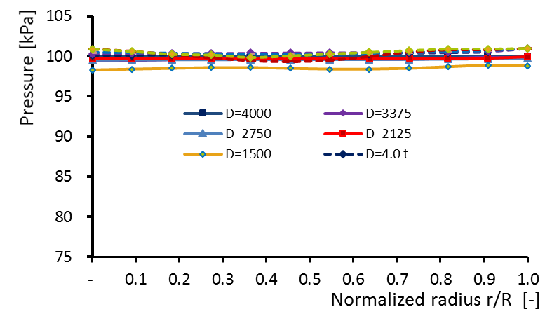Figure 11. Pressure profile of the outlet cross-section

Average speed and pressure on ducted sections.
The average speed and pressure values for each cross-section in the five ducted cases are depicted in Figure 12 and 13. The figure shows the change in average velocity and pressure on each cross section of the ducted turbine. At fixed inlet and outlet diameters, the size of the impeller diameter affects the flow at the front and behind the turbine. The smaller the impeller diameter then fluid velocity at the inlet and the outlet cross-section is smaller, while the fluid velocity in the impeller area is greater. The opposite condition occurs for greater pressure at low speeds at the inlet and outlet, and it is smaller at high speeds at small impeller houses. The distribution of average velocity and pressure in the third inlet area of the turbine section of the five turbine cases is shown in Figure 8.
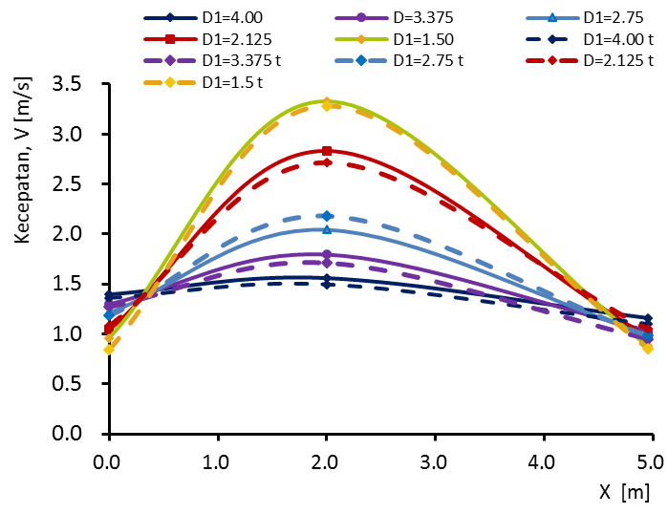
Figure 12. Average velocity for the five ducted cases

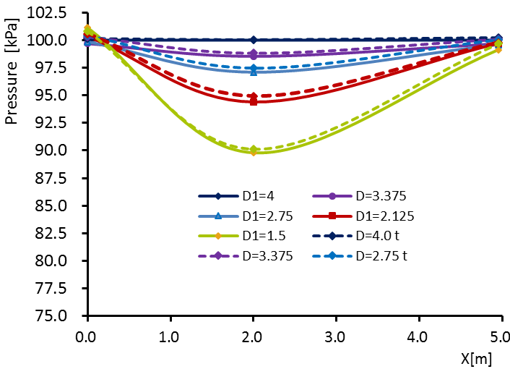

Figure 13. Average pressure for the five ducted cases

Effect of impeller diameter on flow energy parameters in ducted.

Figure 14 shows that the change in Impeller diameter D₁ affects the flow pattern in the ducted turbine, even though the free flow velocity in front of the cross section V₀ = constant. The average speed at the turbine inlet for all five turbine cases ranges from 0.94 to 1.4 m/s. Figure 14 shows that the average value of velocity at the inlet section slows down following the reduction in impeller diameter D₁ in the same inlet size which is thereby reducing the value of the discharge coefficient C_{Q}. Conversely, static pressure value at the inlet section is higher for smaller D₁ diameters. In accordance with Betz's theory, at higher inlet pressures, a portion of the fluid will flow through the outside of the inlet section. The smaller the cross section of the impeller house, increasing volume of fluid will not pass through the duct. This is in accordance to the continuity equation, for which the inlet cross-section area A₀ and free speed V₀ = constant, the C_{Q} discharge coefficient value is only influenced by the shape and size of the impeller house diameter.
In this study the C_{Q} values of the turbine section ranged from 0.64 to 0.93. (figure 9).
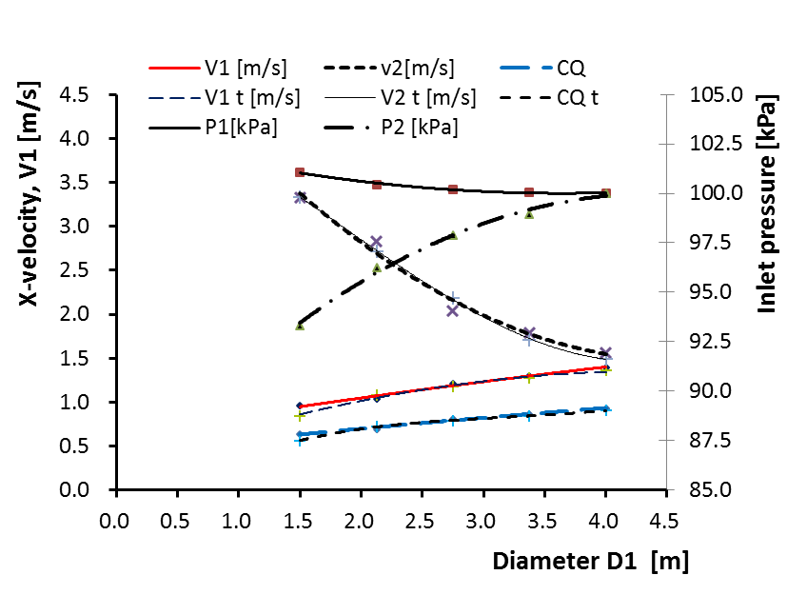 Figure 14. Effect of changes in impeller diameter in velocity, pressure and coefficient of discharge (V, P, C_{Q}) = f (D₁) on the inlet and impeller sides

CONCLUSION

The results presented in the discussion section show that at a fixed inlet and outlet diameter, the reduction in the cross section of the meridians in the impeller area increases the velocity of fluid flow in the impeller housing, as it is according to the principle of conservation of mass, while the pressure in the impeller area decreases with increasing flow velocity. In the inlet region the pressure is basically indicates the rate of inflow into the duct which is getting smaller. This condition shows that the value of the C_{Q} discharge coefficient is proportional to the value of inlet speed reduction. The results of these theoretical and experimental calculations show that the flow velocity in the x-axis direction is smaller by decreasing the impeller area at the inlet and outlet section. In the impeller area the flow velocity increased from 1.76 at d = 1 meter to 4.8 m / s at d = 0.37. The discharge coefficient drops from C_{Q} = 0.9 at D_{B} = 1 to C_{Q} = 0.56 at d = 0.37.

REFERENCES

[1] Rumaherang W. M., Ufie R., Louhenapessy J., Latuny J, “Karakteritik Turbin Propeller Sumbu Horisontal Pembangkit Listrik Tenaga Arus Laut,” in Proseding Archipelago Engineering ALE 2018, 2018, no. April, pp. 90–95.
[2] Laurens J.M., Ait M. Mahrez, Tarfaoui, M, “Design of bare and ducted axial marine current turbines,” Renew. Energy, vol. 89, no. April 2016, pp. 181–187, 2016, [Online]. Available: https://www.sciencedirect.com/science/article/abs/pii/S0960148115304912.
[3] A. Roberts, B. Thomas, P. Sewell, Z. Khan, S. Balmain, and J. Gillman, “Current tidal power technologies and their suitability for applications in coastal and marine areas,” J. Ocean Eng. Mar. Energy, vol. 2, no. 2, pp. 227–245, 2016, doi: 10.1007/s40722-016-0044-8.
[4] M. Shives and C. Crawford, “Developing an empirical model for ducted tidal turbine performance using numerical simulation results,” Proc. Inst. Mech. Eng. Part A J. Power Energy, vol. 226, no. 1, pp. 112–125, 2012, doi: 10.1177/0957650911417958.
[5] A. M. El-Zahaby, A. E. Kabeel, S. S. Elsayed, and M. F. Obiaa, “CFD analysis of flow fields for shrouded wind turbine’s diffuser model with different flange angles,” Alexandria Eng. J., vol. 56, no. 1, pp. 171–179, 2017, doi: 10.1016/j.aej.2016.08.036.
[6] T. A. Khamlaj and M. P. Rumpfkeil, “Theoretical analysis of shrouded horizontal axis wind turbines,” Energies, vol. 10, no. 1, 2017, doi: 10.3390/en10010038.
[7] N. W. Cresswell, G. L. Ingram, and R. G. Dominy, “The impact of diffuser augmentation on a tidal stream turbine,” Ocean Eng., vol. 108, pp. 155–163, 2015, doi: 10.1016/j.oceaneng.2015.07.033.
[8] S. Allsop, C. Peyrard, P. R. Thies, E. Boulougouris, and G. P. Harrison, “Hydrodynamic analysis of a ducted, open centre tidal stream turbine using blade element momentum theory,” Ocean Eng., vol. 141, no. January, pp. 531–542, 2017, doi: 10.1016/j.oceaneng.2017.06.040.
[9] S. Draper and T. Nishino, “Centred and staggered arrangements of tidal turbines,” J. Fluid Mech., vol. 739, no. March, pp. 72–93, 2014, doi: 10.1017/jfm.2013.593.
[10] W. M. Rumaherang, “The effect of diameter ratio on energy parameters of the tidal turbine tidal turbine,” Din. Tek. Mesin, vol. 10, no. 1, p. 1, 2020, doi: 10.29303/dtm.v10i1.306.
[11] Md Shahjada Tarafder and N. Nabila, “Analysis of potential flow around two-dimensional body by finite element method,” J. Mech. Eng. Res., vol. 7, no. 2, pp. 9–22, 2015, doi: 10.5897/jmer2014.0342.
[12] M. Edmunds, A. J. Williams, I. Masters, A. Banerjee, and J. H. VanZwieten, “A spatially nonlinear generalised actuator disk model for the simulation of horizontal axis wind and tidal turbines,” Energy, vol. 194, p. 116803, 2020, doi: 10.1016/j.energy.2019.116803.
[13] R. Bontempo, M. Cardone, M. Manna, and G. Vorraro, “Ducted propeller flow analysis by means of a generalized actuator disk model,” Energy Procedia, vol. 45, pp. 1107–1115, 2014, doi: 10.1016/j.egypro.2014.01.116.
[14] Tonny AdamTheoyana, Purwanto, Widodo Setiyo Pranowo, “Potensi Energi Arus Laut Pada Berbagai Kedalaman Untuk Jurnal Oseanografi,” Undip, vol. 4, pp. 262–269, 2015, [Online]. Available: http://ejournal-s1.undip.ac.id.
[15] Kadir Orhan and Roberto Mayerle, “Assessment of the tidal stream power potential and impacts of tidal current turbines in the Strait of Larantuka, Indonesia,” Energy Procedia, no. 125, pp. 230–239, 2017.
[16] W. M. Rumaherang, R. Ufie, J. Louhenapessy, and J. Latuny, “Design and Evaluation of Energy Characteristics of a Horizontal Venturi Bulb Turbine Based on Sea Current Data of The,” pp. 88–92, 2018.
[17] W. M. Rumaherang, R. Ufie, and J. Latuny, “Optimization of Output Parameters of the Horizontal Tidal Turbine by Modifying Its Meridional Section,” 2018 2nd Borneo Int. Conf. Appl. Math. Eng. BICAME 2018, pp. 18–22, 2018, doi: 10.1109/BICAME45512.2018.1570498954.
[18] R. A. Chihaia, L. A. El-Leathey, G. Cîrciumaru, and N. Tǎnase, “Increasing the energy conversion efficiency for shrouded hydrokinetic turbines using experimental analysis on a scale model,” E3S Web Conf., vol. 85, pp. 0–5, 2019, doi: 10.1051/e3sconf/20198506004.

