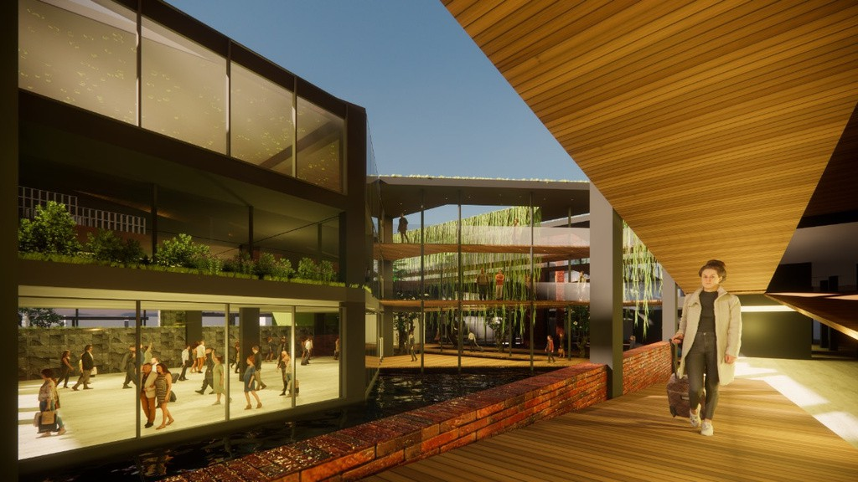
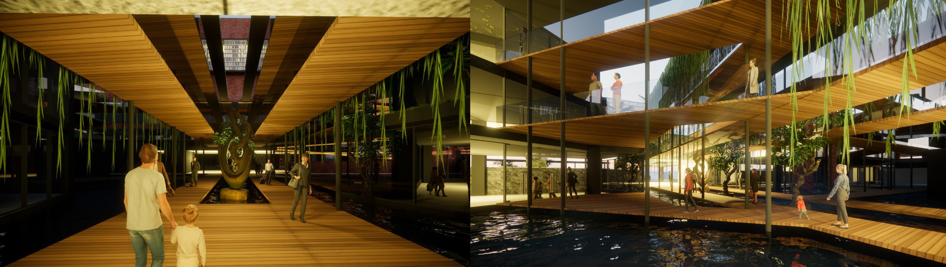
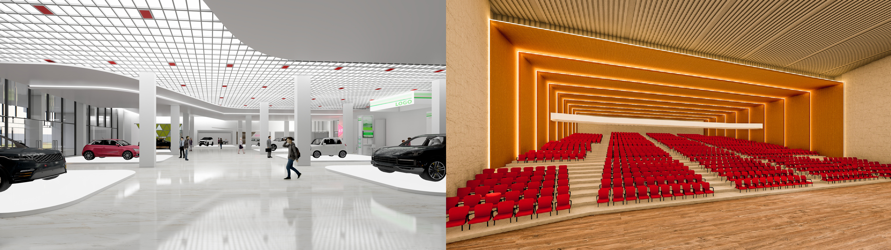
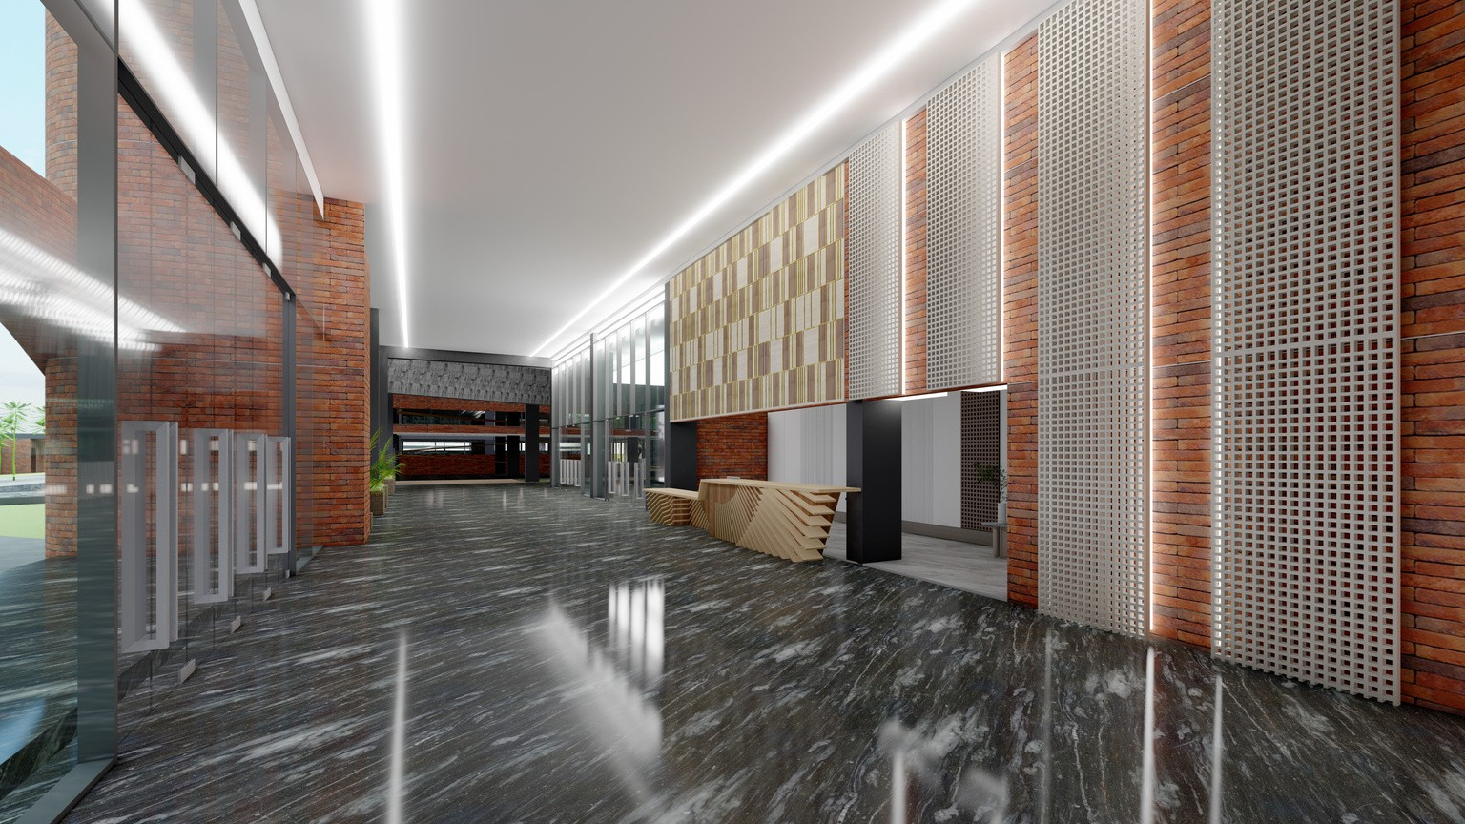
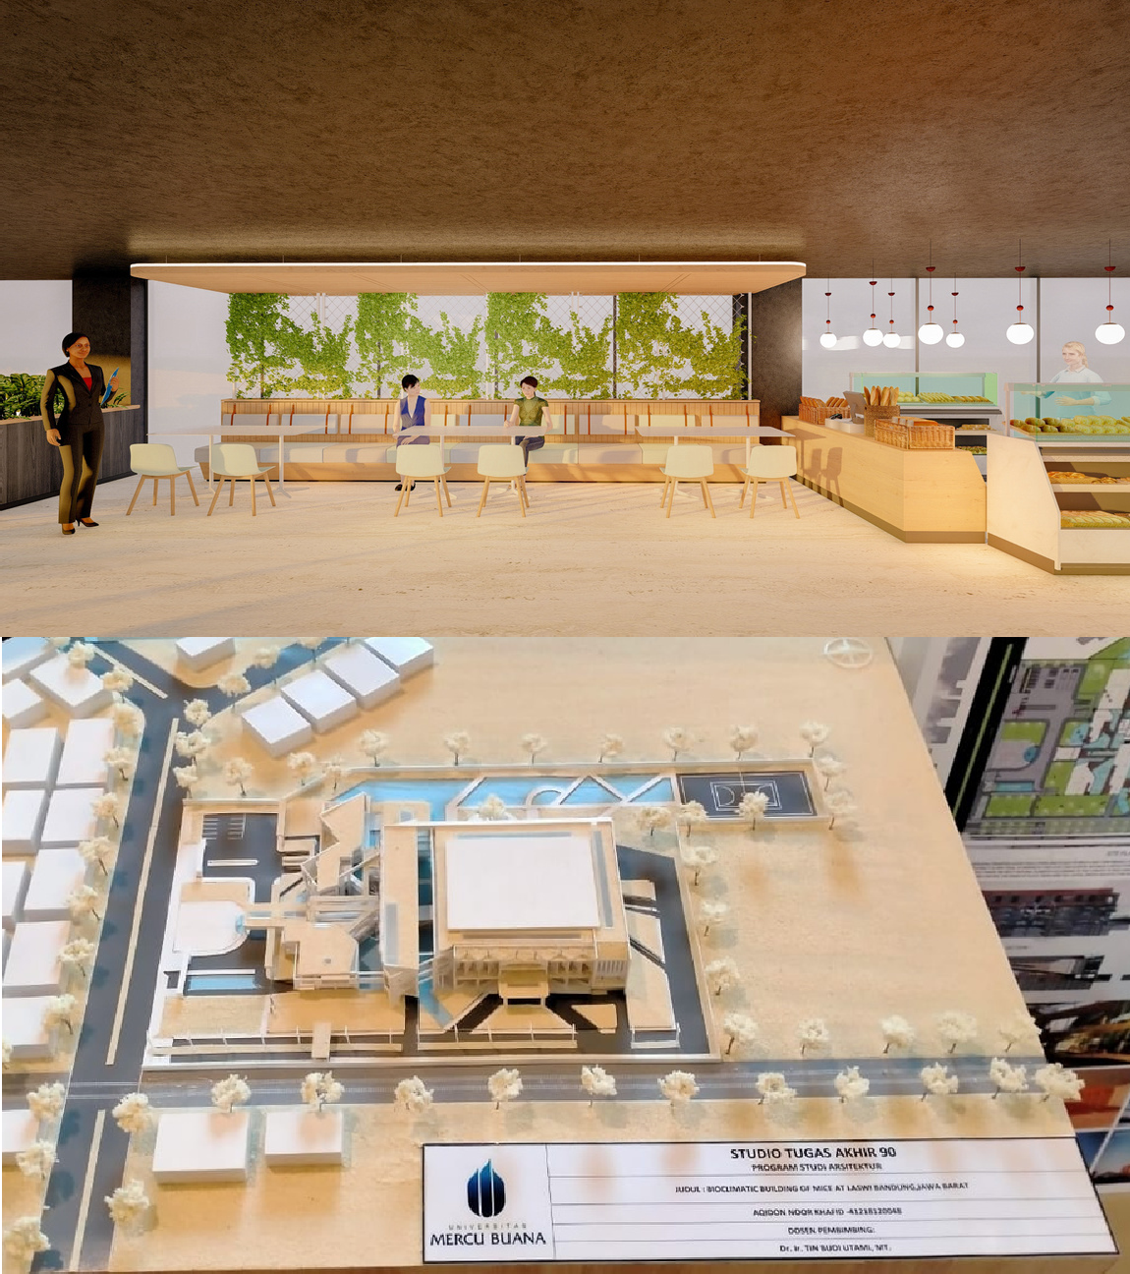



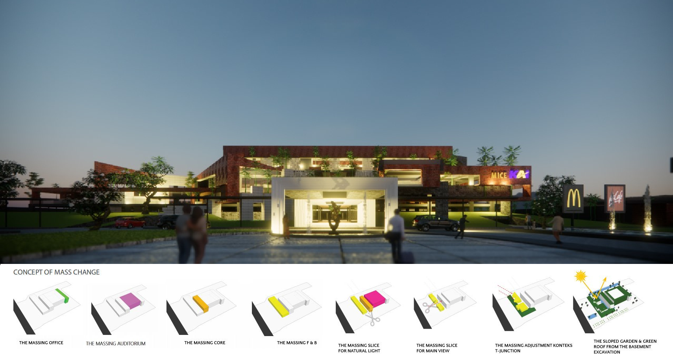
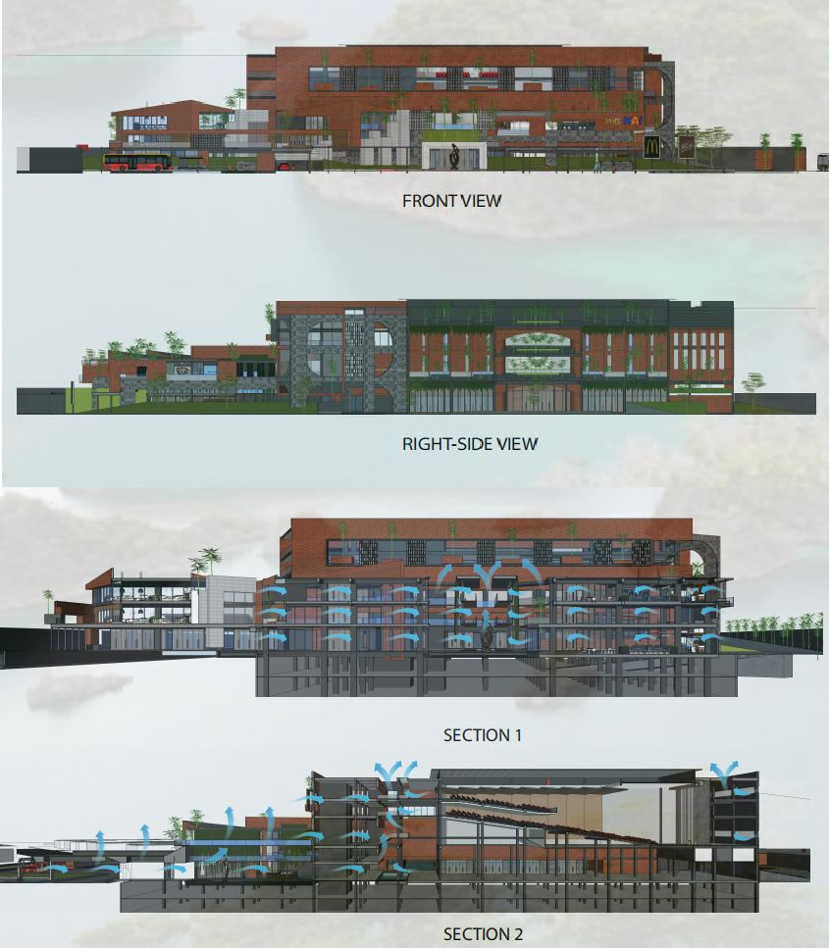
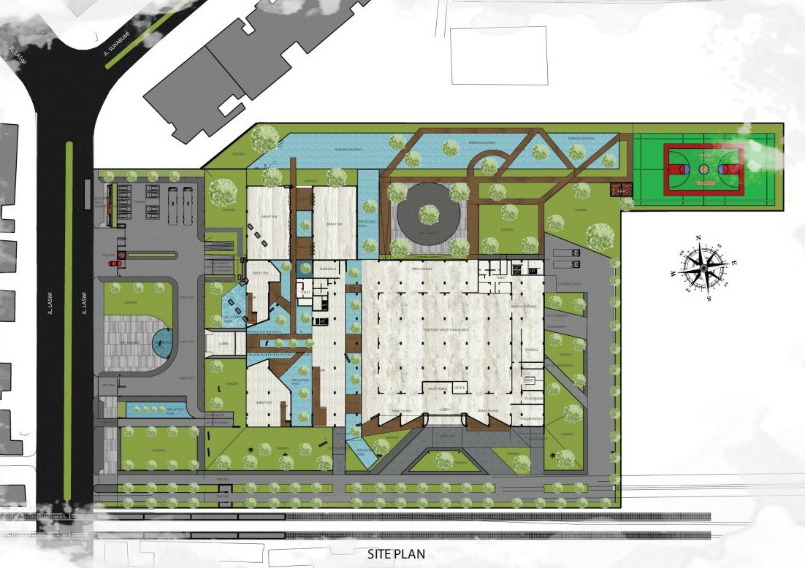
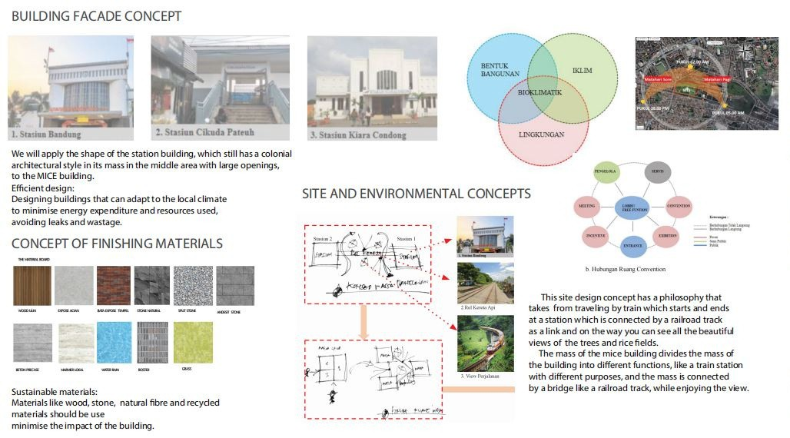
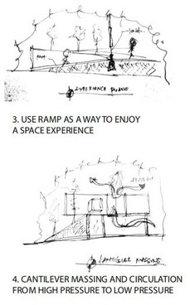
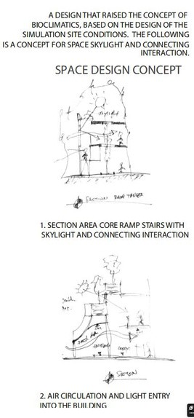
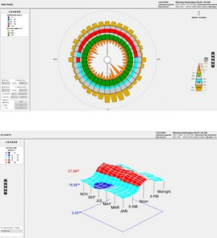
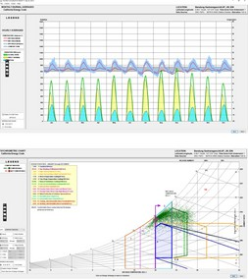
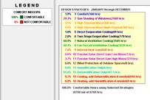
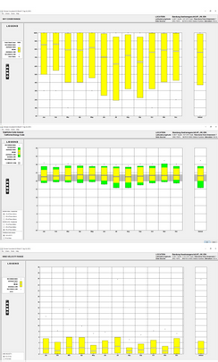
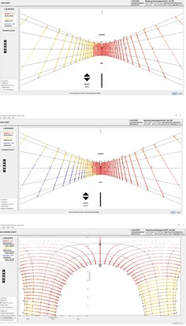
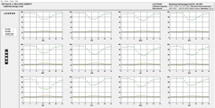
Copyright ©2023 Terakota
This is an open access article under the CC BY-NC license

BIOKLIMATIK BUILDING OF MICE AT LASWI BANDUNG
AQIDON NOOR KHAFID
Program Studi Arsitektur, Universitas Mercu Buana

CAPITAL DRIVEN ARCHITECTURE
Indonesia is a country with a developing economy. We can see the progress of a country from the architectural works in it. Architecture is a product of capitalism, meaning architecture that is driven by capital. If we talk about architecture, it is very much related to commerce, which some consider taboo, when it comes to money. In fact, without money, architecture cannot be built!

WHAT COMES NEXT? ARCHITECTURE THAT SUITS THE ECONOMIC CONTEXT?
Why don't we make an example of a Bioclimatic concept MICE building, because the average MICE building in Indonesia is formal? we make SOMETHING UNIQUE, DIFFERENT, VERY BIOCLIMATIC and energy
efficient

WHAT DOES THIS HAVE TO DO WITH BIOCLIMATICS?
The Bioclimatic MICE concept is one of the design approaches chosen, namely sustainability and dialogue with the climate. So this building will use as little artificial energy as possible so that it will have a big impact on the capital for this building.

FUTURE BIOCLIMATIC DESIGN?
Buildings have a value that will decrease, but that depends on the experimental design of this building. Already thinking about future design inflation.

CLIMATE ANALYSIS

THE SPATIAL ARRANGEMENT OF THIS BUILDING PRIORITIES GOOD CIRCULATION AND IS EASY TO REACH AND USER FRIENDLY. IN ACCORDANCE WITH THE FUNCTIONAL CHARACTER OF THE SPACE WHERE THE MAIN AREA IS POSITIONED IN THE MIDDLE OF THE CORE AND ALSOTHE OFFICE, OF COURSE IT IS VERY IDEAL IN HIERARCHY AND ALSO CIRCULATION. WE MADE A REFLECTION POOL BETWEEN THE MASS OF THIS BUILDING TO RAISE THE THERMAL TEMPERATURE OF THE AIR BEFORE ENTERING THE BUILDING, SOTHAT COOLNESS CAN BE FELT INSIDE. WE INPUT NATURAL ELEMENTS ACCORDING TOTHE CONCEPT OF BIOCLIMATICS WHICH CAN DIALOGUE WITH NATURE, SUCH AS WATER AND ALSO PLANTS. WITH THIS CONCEPT, WE CAN ATTRACT VISITORS TO FEEL A DIFFERENT EXPERIENCE AND CAN FEEL THE SENSE OF PLACE. FROM HERE THE CAPITAL DRIVEN ARCHITECTURE WAS CREATED IN ACCORDANCE WITH THE PURPOSE OF THIS WORK

