ANALYSIS OF SUSTAINABLE DEVELOPMENT CONCEPT IN LEGI MARKET BUILDING IN PONOROGO REGENCY

Hilba Yoga Pratama1, Agung Budi Sardjono2

Master of Architecture, Faculty of Engineering, Diponegoro University, Semarang City

Email: 1 hilbayoga@gmail.com; 2 agungbsardjono@gmail.com

Vitruvian vol xx no y bulan 202x

Diterima: 01 01 2020 | Direvisi: 01 03 2020 | Disetujui: 01 05 2020 | Diterbitkan: 30 06 2020

**ABSTRAK**

*Pasar Legi menjadi tempat untuk aktivitas perdagangan yang utama bagi masyarakat Kabupaten Ponroogo. Dengan seiring perkembangan zaman, Pasar Legi mengalami peningkatan dan perubahan secara signifikan. Pasar Legi mengalami perubahan fisik berupa pembangunan secara keseluruhan, serta terjadi peningkatan infrastruktur berupa fasilitas pendukung yang bertujuan untuk memenuhi kebutuhan dan aktivitas pengunjung maupun pedagang. Pentingnya untuk menganalisa terkait konsep pembangunan berkelanjutan yang mencakup desain bangunan, dan pengelolaan untuk menjaga kesimbangan dalam aspek sosial, budaya, ekonomi, dan ekologi / lingkungan sehingga akan menciptakan sebuah lingkungan yang lebih baik bagi pengunjung, pedagang, maupun masyarakat sekitar. Tujuan penelitian ini ialah menganalisa dan menjelaskan terkait konsep pembangunan berkelanjutan yang diterapkan di Pasar Legi meliputi peningkatan infrastruktur, fasilitas pendukung, desain yang ramah lingkungan, penggunaan sumber daya yang efisien, dan terbarukan. Metode penelitian yang di gunakan pendekatan diskriptif kualitatif dan menggunakan teknik pengumpulan data meliputi wawancara, observasi langsung, serta studi dokumen. Hasil penelitian ini memberikan penjelasakan dan pemahaman yang komprehensif terkait analisa konsep pembangunan berkelanjutan pada bangunan Pasar Legi, dan dampak yang terjadi pada berbagai aspek yang bersangkutan. Sehingga dapat menjadi dasar untuk memberikan rekomendasi sebuah perencanaan dalam pengembangan fasilitas pendukung maupun infrastruktur yang lebih baik pada bangunan Pasar Legi untuk meningkatan kenyamanan, keamanan, kesehatan bagi pedagang maupun pengunjung.*

**Kata Kunci**: Konsep Pembangunan Berkelanjutan, Aspek-Aspek Berkelanjutan, Pasar Legi Kabupaten Ponorogo.

*ABSTRACT*

Legi Market is the main place for trading activities for the people of Ponroogo Regency. Along with the times, Pasar Legi has experienced significant improvements and changes. Pasar Legi underwent physical changes in the form of overall development, as well as an increase in infrastructure in the form of supporting facilities aimed at meeting the needs and activities of visitors and traders. It is important to analyze the concept of sustainable development which includes building design and management to maintain a balance in social, cultural, economic and ecological / environmental aspects so that it will create a better environment for visitors, traders and the surrounding community. The purpose of this study is to analyze and explain the concept of sustainable development that is applied in the Legi Market including improving infrastructure, supporting facilities, environmentally friendly designs, efficient use of resources, and renewables. The research method used is a qualitative descriptive approach and uses data collection techniques including interviews, direct observation, and document studies. The results of this study provide a comprehensive explanation and understanding regarding the analysis of the concept of sustainable development in the Legi Market building, and the impacts that occur on the various aspects concerned. So that it can be the basis for providing recommendations for a plan in the development of better supporting facilities and infrastructure in the Legi Market building to increase comfort, safety, health for traders and visitors.

Keywords: Sustainable Development Concept, Sustainable Aspects, Legi Market Ponorogo Regency.

INTRODUCTION

According to Steele (1997), sustainable development is one way that can fulfill, suffice, and realize current needs without having to reduce and complicate the needs of the next generation. Meanwhile, according to Saliya (2003) sustainable development has many meanings in its interpretation, but broadly speaking sustainable development is the relationship between humans and the natural environment must be balanced. According to Saliya, sustainable architecture is a movement related to architectural design that is friendly and responsive to the surrounding environment.

Sustainable development has the main goal of overcoming problems regarding the conditions that occur in the current time regarding the human population crisis, economic activity, and environmental problems, and the problem of damage to natural resources. The concept of sustainable development seeks to anticipate adverse impacts on the surrounding environment, the comfort of the population, and the health around the case study. so that an increase in the performance of sustainable development arises in an advanced region or urban area. Sustainable development, functions as a safety rule so that the direction of building a building continues to follow the regulations that have been proclaimed through various stages of development by the central government, so that the series can be sustainable in the future.

Legi Market has a history that has lasted for decades, where the Legi Market building has become a place for the main trading activities for the people of Ponroogo Regency. Along with the times, the Legi Market building has experienced significant improvements and changes. In recent years, the Legi Market building has undergone physical changes in the form of overall development, as well as an increase in infrastructure in the form of supporting facilities aimed at meeting the needs and activities of visitors and traders. The Legi Market has a very important and significant role in the life of the people in Ponorogo Regency. The Legi Market is a center of economic activity, where traders from all over the Ponorogo Regency sell various products in the form of agricultural products, clothing, food, and daily necessities. Not only that, Pasar Legi is also a place for cultural and social gatherings where interactions between communities are created in the form of exchanging information so that it will strengthen a community bond in social life. The Legi Market building has a unique and distinctive feature that is very different from other markets, namely in the form of a building with an architectural design that gives rise to uniqueness and represents traditional culture, namely in the form of the Reog Ponorogo art. This appears in the form of the facade of a Legi Market building which gives rise to the motifs contained in the Reog Ponorogo art in the form of peacock feathers, as well as the color philosophy used in this art such as green, red and yellow. The Legi Market maintains a local culture and traditional feel, in this market the visitors who come will feel a distinctive atmosphere with trading activities in the local language, as well as the presence of sellers of Reog Ponorogo art-assembled knick-knacks, and when during the Suro month (Muhharam) there are often performances of the Reog Ponorogo art around the Legi Market area.

So that it will create an interesting and unique experience for Legi Market visitors, especially from out of town. There are efforts to preserve and sustain the Legi Market building from the Ponorogo Regency government to cultivate it as a social and local cultural forum. In this preservation effort in the form of maintaining buildings and supporting facilities, using authentic local products from Ponorogo Regency, as well as introducing local cultural values ​​to young people, these values ​​such as kinship, hospitality, and mutual cooperation are reflected in interaction activities. social relations between visitors and traders who make an inseparable part of people's lives in Ponorogo Regency. In the context of the concept of sustainable development in the Legi Market building it is important to consider sustainability in the form of social, economic, cultural and ecological/environmental aspects. The application of the concept of sustainable development will not only produce short-term benefits, but will also produce long-term positive impacts. From the aspects of sustainable development, it will also produce contributions that build the quality of society in a balanced and holistic manner in the future. The implementation of sustainable development aspects in the Legi Market building can produce very significant benefits, in the form of sustainability of facilities and infrastructure for the creation of trader welfare. Construction of more comfortable spaces for traders, increased accessibility indoors and outdoors, as well as provision of supporting facilities aimed at providing a more humane and better working environment for traders. So that in the future it can increase the attractiveness of market visitors, increase productivity, and generate income for traders, which will ultimately improve the welfare of the people of Ponorogo Regency. By improving better facilities at Legi Market in the form of regular spatial planning and according to standards that have been regulated by the Ministry of PUPR, adequate building lighting, and maintained environmental cleanliness, visitors who come will experience a more comfortable and safe space experience so that they will often Visit Legi Market. Experience in positive shopping activities and the quality of a good service from market managers and from traders will increase market attractiveness, will also invite more visitors, so that in the end it will increase economic activity around Legi Market.

LITERATURE REVIEW

1. Market

The market is a place for people's activities to buy and sell goods, the market is also related to the infrastructure and supporting facilities provided by the local government to support the activities of buying and selling goods, needs and services. The market is also a place for interaction between users, the market is also included in the public space in an area/region (Lukito, 2018).

According to Ginanjar (1980), the market is a place that is used by the community to carry out activities of buying and selling goods or services, this is a form of container for trading activity. In the beginning, the market was a place for meetings and circulation between providers of goods or services and bidders.

According to Gilarso (1998), explaining the narrow meaning of the market, namely a place where there are activities of buyers and sellers to buy and sell goods. The sellers will offer goods in the form of basic ingredients in the hope that they will be bought by visitors (buyers) in order to get money in return. The visitors (buyers) come to the market to carry out shopping activities by paying the price of an item they buy.

According to Sulistiyowati (1999), there are 2 main types of aspects that are reviewed on the function of a market, namely from a physical perspective, and from an economic perspective.

According to Karolina (2005), a market has a classification which is divided into several important aspects, namely in the form of types traded in the market, types of activities, hours of operation, market area, ownership status, and visitor capacity.

According to the 2015 Indonesian National Standards Agency (SNI), concerning the Indonesian National Standard on People's Markets, market classification can be divided into four types, namely:

1. Type I, the total capacity of market traders is more than 750 traders.
2. Type II, the total capacity of market traders is between 501 and 750 traders.
3. Type III, the total capacity of traders is between 250 and 500 traders.
4. Type IV, the total capacity of traders is less than 250 traders.
5. Sustainable Development Concept

According to Brundtland (1987), sustainable development has 4 aspects that need to be considered, namely aspects of economic, social, cultural and ecological development. In the existing aspects of sustainable development that are supported by existing sustainable architectural design theories, such as environmental preservation, urban ecology, energy, water sources, solid awaste, and materials used in the construction of a building. The 4 aspects that guide a sustainable development are as follows:

a. Social Aspect

The social aspect of sustainable development is that the residents of an area provide a forum for activities in the community or community to maintain social interaction and improve social quality that is more appropriate and better in that area.

b. Economic Aspect

Economic aspects in sustainable development that provide solutions for the community to increase their economic level and provide value by providing space for a business in the MSME sector.

c. Cultural Aspect

The cultural aspect of sustainable development is how to bring out the identity of the region with the existence of certain cultures, customs and arts in a building.

d. Environmental / Ecological Aspects

The ecological aspect in development is an element that plays a role in designing areas for climate problems and issues. The energy principle prioritizes sustainable development regarding the use of renewable energy materials in building design which has the goal of being efficient and saving on energy. On the principle of waste management in a building, namely by managing liquid or solid waste and waste from the collection process, to the final processing stage which has the goal is not to have a negative impact on the surrounding environment, so that people can live healthily without feeling anxious. Material principles in the sustainable construction of a building regarding the material chosen for the construction of a building that has the durability of a strong and sturdy material, is friendly to the surrounding environment, and the material in which it is installed is easy and practical.

RESEARCH METHODS

This study uses a qualitative descriptive method as the main approach. According to Sugiyono (2016), a research approach that enables researchers to understand the phenomenon being studied in detail and provide a comprehensive description of the events or context under study. This approach offers the flexibility to explore in-depth understanding of complex and subjective aspects and provides a richer understanding of the phenomenon under study. Purpose The qualitative descriptive method in this study is to gain a very deep understanding of the application of the concept of sustainability to the Legi Market building. By using a qualitative descriptive approach, this study aims to describe in detail the elements of sustainability related to the Leg Market, such as economic, social, environmental and infrastructure aspects.

**Place and time of research**

Research The research was conducted in the Legi Market building located in Ponorogo District, Ponorogo Regency, East Java Province. The time for conducting the research is from August 2022 to October 2022.

**Object of research**

1. The object of this study is the Legi Market, which includes the available facilities, the physical characteristics of the market building, the building structure, and the indoor and outdoor spatial layout.
2. This research may also involve an analysis of the interactions between traders and visitors, as well as the management system.
3. This study will analyze the aspects of sustainable development that are relevant to the Legi Market building. Aspects analyzed about:
4. Economic Aspect, including goods traded, influence on the people's economy, as well as trade patterns.
5. Social Aspects, including user interactions that occur in it, between visitors, sellers, and the surrounding community.
6. Cultural Aspects, including the local culture that is displayed or that appears in the Legi Market building.
7. Ecological / Environmental Aspects, including energy use, environmental impact on activities that occur in the Pasar Legi area, waste management.

The main object of research taken can provide a clear focus regarding the Legi Market and aspects of sustainable development. By focusing on some of the research objects above, it is hoped that it will provide an in-depth understanding of the Legi Market conditions and provide recommendations for more sustainable market development in the future.

**Classification of Research Data**

The data collection method in this study uses primary data collection and secondary data which aims to obtain relevant information. The following describes the data collection method used:

1. Secondary Data

Secondary data refers to data that has been collected by other parties or has existed before, this data is used in this study as a source of information. In the Analysis of the Concept of Sustainable Development at the Legi Market in Ponorogo Regency, secondary data is needed in the form of changes in market structure, historical data about buildings, history of market development, and trading activities that occurred, history of economic, cultural and social changes in Ponorogo Regency that affect Legislative Market. Data in the form of government policies, regulations, rules, or development plans for the Legi Market building. Government policies regarding sustainable development that are currently in effect at the national level which can be a reference for analyzing the concept of sustainable development in the Legi Market building. The secondary data obtained resulted in a deeper and broader understanding regarding aspects of sustainable development at the Legi Market. So that later it will be able to support the discussion and analysis in this research, and can help obtain the information needed to explain and describe aspects of sustainable development in the Legi Market building.

1. Primary Data

Primary data in this study refers to data that has been collected directly. The data is in the form of direct observation carried out by directly observing the aspects contained in the Legi Market building, aiming to gain an understanding of the activities that occur in the Legi Market building and in the environment around the Legi Market, room layout, spatial zoning, building structure markets, supporting facilities, and interaction patterns that are created between visitors and traders or vice versa. Conduct direct observations regarding patterns of energy use, practice of implementing sustainable development aspects at Legi Market, and waste management. Interviews were conducted involving Legi Market managers, visitors, traders, and the surrounding community. The interview was conducted with the aim of obtaining data in the form of information related to perceptions, views, hopes related to aspects of sustainable development at the Legi Market. As well as conducting interviews with practitioners who have extensive knowledge in the field of architecture and sustainable development. The primary data obtained were in the form of historical documents, development plans sourced from reports from the Ponorogom Regency government, regulations / regulations / policies that are related to the Legi Market building.

RESEARCH RESULTS AND DISCUSSION

**Overview of Research Location**

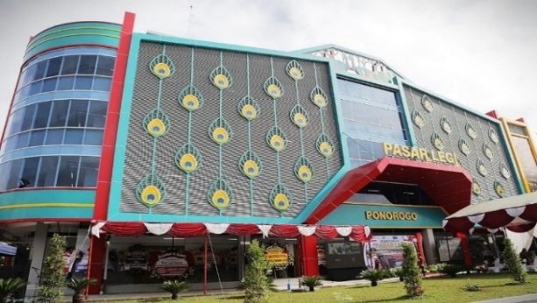

**Figure 1.** Legi Market Building

Source: Personal Documentation, 2022.

One of the developments included in the 2019 RPJMD of Ponorogo Regency is to rebuild or redesign the Legi Market building to improve the welfare of the residents of Ponorogo Regency both in the economic and social fields. The Legi Market which was inaugurated by the Ponorogo Regent, on August 10, 2021. With the construction of this modern market, it will not disturb traditional markets in every sub-district. The Legi market is divided into 2, namely the dry market and the wet market. To improve the facilities of the Legi Market trade center and promotion which have a larger capacity and more than the previous number. Pasar Legi, which has a total area capacity of 32,175 square meters, consists of 2 building masses. This building has 4 floors with the main function of the market. There are 2,497 stalls or kiosks, or the details are 1,053 booths and 1,444 kiosks. In this market building there are also temporary waste disposal facilities, as well as vehicle parking facilities that can accommodate around 1,200 motorcycles and cars.

**The Concept of Sustainable Development at the Legi Market**

1. **Social Aspect**

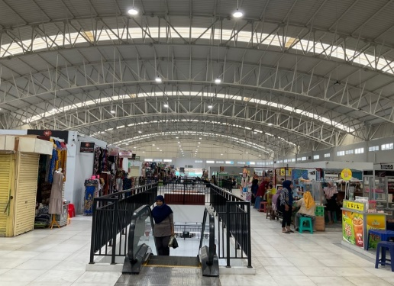

**Figure 2.** Activity conditions on the 4th Floor at the Legi Market

Source: Personal Documentation, 2022.

Legi market which has good functions in terms of social and economic aspects in which it undergoes various processes of change. The Legi market is currently the best pilot market in the East Java Province area, which is a reflection of the social, economic, environmental / ecological and local cultural fields. These aspects are reflected in the various functions that exist in the modern market which contains the goals and functions of a market for the development and progress of the Ponorogo Regency area itself.

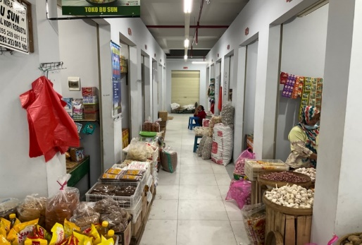

**Figure 3.** Retail situation and activities on the 1st floor at Legi Market

Source: Personal Documentation, 2022.

The retail outlet at Legi Market is a facility that facilitates traders who come from all over Ponorogo Regency to sell their wares, has a size of 3x3 meters and has supporting facilities in the form of a place to put goods for sale or a warehouse, and there are refrigeration facilities on each floor for fruit traders, and vegetables. At Legi Market, there are 2 types of stall placement, namely indoor kiosks which are kiosks positioned inside the building which is on one part of the roof of the Legi Market building. While the outdoor kiosk is a kiosk that is positioned on the outside of the building that is directly related to the outside of the Legi Market building.

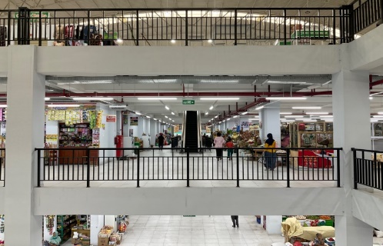

**Figure 4.** Activities and the presence of retail on each floor at the Legi Market

Source: Personal Documentation, 2022.

When placing a retail store, a number of technical matters must be considered, namely keeping the goods sold fresh and not rotting quickly, airflow must be smooth so as not to cause odors on the inside of the Legi Market building, circulation access for shipping goods into and out of the market building, floors and walls. which are easy to clean caused by vegetables, fruit, or meat that fall to the floor or hit the walls of the market building, these are ways to anticipate that the quality and cleanliness of a market environment are maintained.

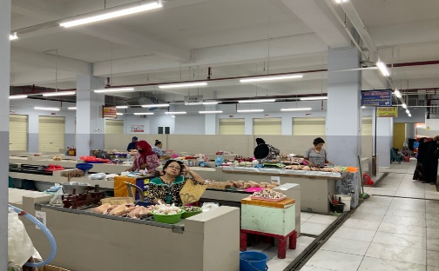

**Figure 5.** Zoning and block division according to what is sold

Source: Personal Documentation, 2022.

The zoning or block arrangement at Legi Market is a form of area separation based on the goods being sold. Markets that have different levels of merchandise must have separators or groupings of block or zoning arrangements in an effort to make it easier for market visitors to find the goods they need, as well as to create a more organized spatial pattern and make it easier to keep Legi Market clean. The arrangement of the pattern of stalls or booths at the Legi Market takes into account various aspects such as access considerations for the types of goods being traded. Consideration of types of goods that cause odors and require management related to the cleanliness of merchandise, such as fish, meat, foodstuffs, vegetables and fruits.

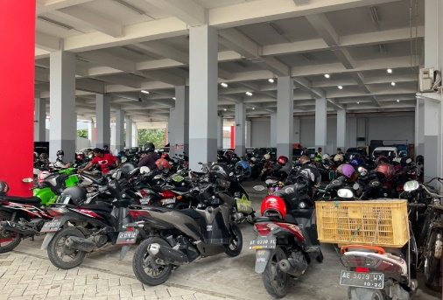

**Figure 6.** Condition of parking area facilities at Legi Market

Source: Personal Documentation, 2022.

The parking area at Pasar Legi is the most important part of supporting facilities and public facilities. This parking lot is one of the facilities that aims to accommodate visitors to the Legi Market and traders selling at the Legi Market to park motorized vehicles and cars. Aims to reduce the accumulation of vehicles in the Legi Market area and in circulation access which disrupts activities in the market area, especially around the market.

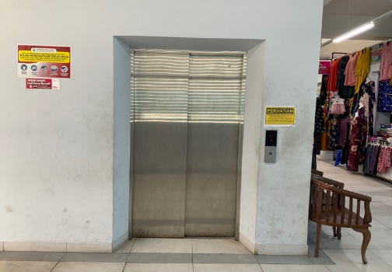

**Figure 7.** Elevator Facility at Legi Market

Source: Personal Documentation, 2022.

There is a vertical circulation facility in the form of an elevator at Legi Market, which is used by traders and buyers to access each floor. The elevator also helps visitors or buyers with disabilities to make it easier to reach the kiosk or booth they are aiming for. This freight elevator is also used for the transportation of goods circulation by traders on the 2nd, 3rd and 4th floors.

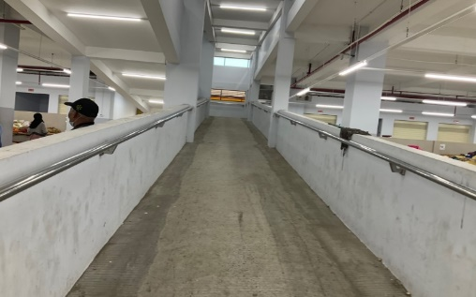

**Figure 8.** Ramp facility as a link between floors at Legi Market

Source: Personal Documentation, 2022.

In this Legi Market building, the connecting circulation between floors is designed using a ram, with a very wide and long size, measuring 2 meters wide by 13 meters long. The ram is easy to access in reaching the floor above, and the design of the ram is not steep, so the ram users don't experience difficulties when passing it. RAM is not only used for human circulation, but is used for the circulation of goods by traders and buyers.

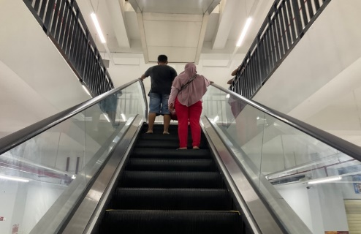

**Figure 9.** Escalator facility as a link between floors at Legi Market

Source: Personal Documentation, 2022.

There is also an escalator facility in this modern Legi Market building, this escalator facility is used by visitors and buyers to reach the intended floor. This escalator makes it very easy for buyers and sellers, if this market still uses ladder circulation it will complicate activities and activities in Legi Market, because it requires more energy and strength to transport goods or when accessing them.

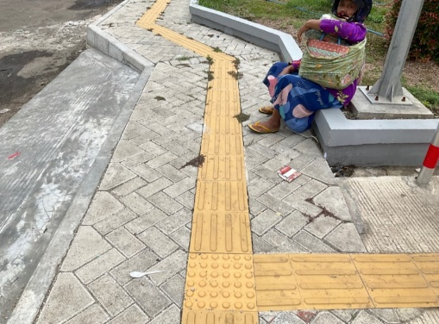

**Figure 10.** Guiding block for disabled pathways at Legi Market

Source: Personal Documentation, 2022.

The Legi Market area is very friendly to disabled facilities, there is a guiding block that functions as a guide for persons with disabilities. This facility is designed as an effort to provide circulation access for the blind so that they can walk independently following the guiding block to the Legi Market building.

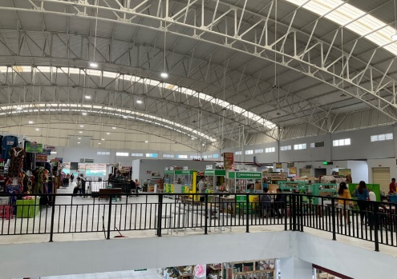

**Figure 11.** Natural lighting in buildings at Legi Market

Source: Personal Documentation, 2022.

Lighting in the Legi Market building during the day uses natural lighting that enters through a transparent roof made of fiber roof, thereby reducing the operational costs of the market. At night the market uses artificial lighting sourced from lamps mounted on the roof ceiling.

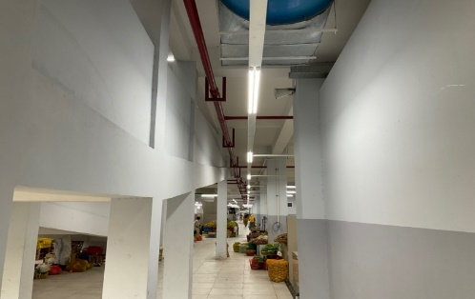

**Figure 12.** Safety system utility at Legi Market

Source: Personal Documentation, 2022.

The Legi Market building also has a safety system that includes a fire detection utility system, a fire alarm system, and a fire fighting utility system. The purpose of this utility system is as a form of prevention and prevention of a building fire disaster.

1. **Economic Aspect**

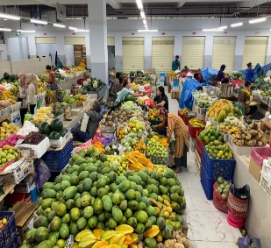 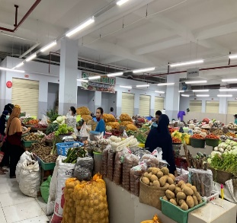

**Figure 13.** Activities that occur in the fruit and vegetable retail zoning at the Legi Market

Source: Personal Documentation, 2022.

Productivity results in the regional agricultural sector (vegetables and fruit) represent a regional economic strength, Ponorogo Regency through an economic strength from the existence of environmental support for the activity of buying and selling agricultural products at the Legi Market. Productivity in the agricultural products of an area represents an effort and effort to create food security for the people of Ponorogo Regency, thereby increasing contribution to the Government of Ponorogo Regency.

The existence of the Legi Market building makes a positive contribution to the people of Ponorogo Regency, namely:

1. Residents are satisfied with the supply of goods that have good quality.
2. Goods sold by traders in the Legi Market vary greatly in goods.
3. Not only providing local goods, providing imported goods.
4. The service is getting better and more comfortable because the environment and situation are neat.
5. The display of goods has been zoned according to type and function so that they are easy to reach and don't experience confusion when looking for them.
6. The circulation to reach the destination of the kiosk/los has been facilitated by the existence of elevator and escalator facilities.
7. With the establishment of the Legi Market with a modern design, the economy of the people in Ponorogo Regency is growing.

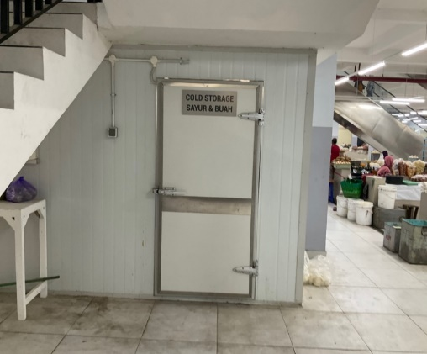

**Figure 14.** Fruit and vegetable cold room facilities at Legi Market

Source: Personal Documentation, 2022.

In the Legi Market building there is a cold storage facility for vegetables and fruits. This cold room is designed for merchandise conditions that require certain temperature conditions, and is used for storage of various merchandise, especially those that spoil quickly and whose conditions deteriorate quickly.

1. **Cultural Aspects**

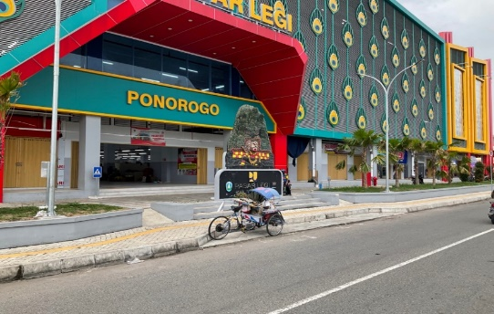

**Figure 15.** Display of building facades at Legi Market

Source: Personal Documentation, 2022.

The cultural aspect of the Legi Market building is contained in the application of a building facade which represents the characteristics and form of an art, custom, and original culture of Ponorogo Regency, namely the Reog art. The motifs on the facade take motifs from peacock feathers. In the Legi Market building, the application of color uses the colors of the Reog art, namely red, yellow and green. So that the Legi Market building is a form of representation of the original culture of Ponorogo Regency.

1. **Environmental / Ecological Aspects**

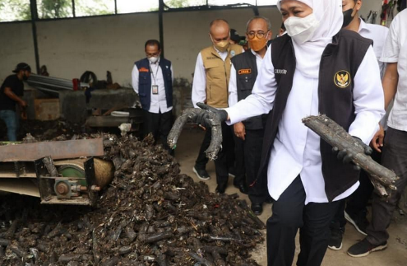

**Figure 16.** Waste Management Innovation carried out by the Government of Ponorogo Regency

Source: Personal Documentation, 2022.

Sustainable development at Legi Market in terms of ecology is making innovations and breakthroughs, namely "waste to energy" waste management whose main purpose is as an alternative to wood and coal fuels. In "Ponorogo Regent Regulation Number 32 of 2018 Concerning the Formation of a Regional Technical Implementation Unit for Waste Management at the Ponorogo Regency Environmental Service", the Ponorogo Regency Government made a waste to energy innovation to solve the problem of piles of waste in the Legi Market area. The innovation of processing waste into briquettes is very meaningful amid the government's efforts to suppress climate change by reducing greenhouse gas production and as an effort to reduce CO2 gas. Processing of recycled waste is one way to create renewable energy that can replace coal briquettes. If you look at piles of waste, it can be processed into briquettes, which replace coal with appropriate technology, which is very simple. The success of "waste to energy" carried out by the Regency Government in Ponorogo will be followed by all Regencies in East Java. The problem of mounting waste can be resolved and provide economic benefits to the region.

CONCLUSION AND SUGGESTION

Conclusion

Sustainable development is not only about concepts that are easy to implement and implement, the concept of sustainable development is a concept that must have links between economic, ecological, social, cultural principles whose main focus is not only on the initial concept, but also focuses on environmental sustainability and balance as well. There needs to be a connection from the Ponorogo district government which has a regional policy, both micro and macro scale for the implementation of the concept of sustainable development of a Legi market building in the future. The Ponorogo Regency Government must need a lot of innovations not only about the concept of sustainable development, sustainable innovation, and policies to create a sustainable building that will benefit the people of Ponorogo Regency in the future.

**Suggestion**

1. Improving accessibility at Legi Market by procuring public transportation system facilities that can be used by market users, whether they be visitors or traders.
2. Build comfortable and safe pedestrian paths around Legi Market for entry into the building.
3. The need to redesign the layout of kiosks and booths that pay attention to sustainable design principles, in the form of using environmentally friendly materials and natural ventilation.
4. The need to optimize the use of standard spaces as stipulated by the Ministry of Public Works Regulations in the form of kiosks or booths with great regard for the flexibility and efficiency of a market space which can later be optimally adapted for long-term/future needs.
5. The need to improve sanitation facilities, in the form of public bathroom facilities, in order to create high market hygiene standards.
6. The need for sanitation management that adopts sustainable sanitation technology, in the form of waste management and sanitation systems that save on water use.
7. The need for the application of renewable energy technology, in the form of biomass energy or solar panels, to fulfill the energy needs of the Legi Market. So that it can help depend on conventional energy sources and reduce the negative impact on the environment.
8. It is necessary to choose materials that are durable and sturdy, so that the Legi Market building lasts.
9. The need for efficient water management, such as the use of low-tech bathrooms and the need for a rainwater collection system so as to reduce consumption of water use in the Legi Market.
10. By optimizing environmentally friendly supporting facilities and infrastructure in the Legi Market building, it can create a healthy, safe, comfortable environment so that the concept of "Sustainable Development" is realized at the Legi Market in Ponorogo Regency.

**ACKNOWLEDGEMENTS**

The author thanks Dr. Ir. Agung Budi Sardjono, M.T. has provided meaningful direction, encouragement, input, and motivation during the preparation of this research. In addition, the authors also thank the Government of Ponorogo Regency, and the Housing and Settlement Public Works Office (DPUPKP) Ponorogo Regency which has been permitted and helped provide information for the smooth running of this research. All contributions of assistance and support provided are very meaningful for the success of this research.

**REFRENCES**

Ardiani, Y. M. (2015). Sustainable Architecture: Arsitektur Berkelanjutan. Jakarta: Erlangga.

Azis, I. J. (2010). Pembangunan Berkelanjutan-Peran dan Kontribusi Emil Salim. Kepustakaan Populer Gramedia.

Brundtland, G. H. (1987). What is sustainable development. Our common future, 8(9).

BSN. (2015). Standar Nasional Indonesia Pasar Rakyat. Jakarta.

Gilarso, T. (1998). Pengantar Ilmu Ekonomi Mikro dan Makro. Yogyakarta: Kanisius.

Ginanjar, N. J. (1980). Masalah Ekonomi Mikro. Jakarta: Acro.

Karolina, Dyah A. (2006). Perancangan Kembali Pasar Setonobetek (Sebagai Pasar dan Pusat Belanja Tradisional) di Kediri. Program Studi Arsitektur Fakultas Teknik Universitas Brawijaya.

Kurniasih, S. (2010). EVALUASI TENTANG PENERAPAN PRINSIP ARSITEKTURBERKELANJUTAN (Sustainable Architecture) Studi Kasus: Gedung Engineering Center & Perpustakaan FTUI. Arsitron Vol. 1 No, 1.

Lukito, Y. N. (2018). Revitalisasi ruang pasar tradisional melalui pendekatan desain dan interaksi pengguna ruang. Deepublish.

Peraturan Bupati Ponorogo. (2018). Nomor 32 Tahun 2018 Tentang Pembentukan Unit Pelaksana Teknis Daerah Pengelolaan Sampah.

Saliya, Y. (2003). Perjalanan Malam Hari. IAI & LSAI, Bandung.

Steele, J. (1997). Sustainable architecture: principles, paradigms, and case studies.

Sudarwani, M. M. (2012). Penerapan green architecture dan green building sebagai upaya pencapaian sustainable architecture. Dinamika Sains, 10(24).

Sugiyono, P. (2016). Metode Penelitian Manajemen (Pendekatan Kuantitatif, Kualitatif, Kombinasi (Mixed Methods), Penelitian Tindakan (Action Research, dan Penelitian Evaluasi). Bandung: Alfabeta Cv.

Sulistyowati, D. Y. (1999). Kajian persaingan pasar tradisional dan pasar swalayan berdasarkan pengamatan perilaku berbelanja di Kota Bandung. ITB, Bandung.

Tanuwidjaja, G., & MULYONO, L. L. A. (2011). Sustainable architectural design in indonesia: responding the current environmental challenges (Doctoral dissertation, Petra Christian University).

**Form Cheklis Author**

*Wajib diisi dan lampirkan di halaman terakhir artikel anda.

Panduan: Silahkan anda beri tanda “v” pada kolom “Terpenuhi” atau “Tidak Terpenuhi” sesuai artikel yang telah anda tulis.

|  |  |  |  |
| --- | --- | --- | --- |
| **No** | **Kategori** | **Terpenuhi** | **Tidak Terpenuhi** |
|  | **JUDUL DAN ABSTRAK** | V |  |
|  | Judul maksimal 3 baris | V |  |
|  | Abstrak maksimum 300 kata | V |  |
|  | Abstrak telah memuat latar belakang | V |  |
|  | Abstrak telah memuat tujuan penelitian | V |  |
|  | Abstrak telah memuat metode penelitian | V |  |
|  | Abstrak telah memuat temuan penelitian | V |  |
|  | Kata kunci maksimal 5 | V |  |
|  | Telah terdapat abstrak dalam bahasa inggris | V |  |
|  | **PENDAHULUAN** | V |  |
|  | Telah memuat latar belakang dari penelitian | V |  |
|  | Telah memuat masalah atau tujuan penelitian | V |  |
|  | Telah memetakan perkembangan teori pada bidang anda | V |  |
|  | Telah memetakan gap penelitian | V |  |
|  | Telah menuliskan *novelty* atau kebaruan dari penelitian anda | V |  |
|  | **METODOLOGI** | V |  |
|  | Telah memaparkan dengan jelas metode yang anda gunakan pada penelitian | V |  |
|  | **HASIL DAN PEMBAHASAN** | V |  |
|  | Telah memaparkan dengan jelas analisa dan diskusi | V |  |
|  | **KESIMPULAN** | V |  |
|  | Kesimpulan yang ditampilkan telah sesuai dengan masalah dan tujuan penelitian | V |  |
|  | **DAFTAR PUSTAKA** | V |  |
|  | Daftar Pustaka telah mengikuti APA Style Sixth Edition | V |  |
|  | Minimal jumlah daftar pustaka adalah 10 rujukan utama (jurnal dan buku) | V |  |
|  | 10 rujukan utama (jurnal dan buku) merupakan rujukan mutakhir (10 tahun terakhir) | V |  |
|  | Seluruh daftar pustaka telah disitasi/diacu ke dalam tubuh artikel | V |  |

**Tanggapan Penulis terhadap Hasil Review**

*Wajib dilampirkan di halaman terakhir artikel anda.

Panduan: Pada saat melakukan submisi artikel, maka form ini dibiarkan kosong saja. Form ini diisi setelah anda mendapat hasil review dari reviewer, dan dikirim di halaman terakhir artikel anda.

|  |  |  |  |
| --- | --- | --- | --- |
| **No.** | **Kategori Penilaian** | **Komentar Reviewer A** | **Tanggapan dan Perbaikan** |
|  | Judul |  |  |
|  | Abstrak |  |  |
|  | Isi Artikel |  |  |
|  | Hasil dan Pembahasan |  |  |
|  | Kesimpulan dan Saranh |  |  |
|  | Daftar Pustaka |  |  |
|  | Catatan Lain |  |  |

|  |  |  |  |
| --- | --- | --- | --- |
| **No.** | **Kategori Penilaian** | **Komentar Reviewer B** | **Tanggapan dan Perbaikan** |
|  | Judul |  |  |
|  | Abstrak |  |  |
|  | Isi Artikel |  |  |
|  | Hasil dan Pembahasan |  |  |
|  | Kesimpulan dan Saranh |  |  |
|  | Daftar Pustaka |  |  |
|  | Catatan Lain |  |  |