JURNAL VISI KOMUNIKASI

Gaya Komunikasi Corporate Social Advocacy pada
#TBSFightForSisterhood di Instagram

Hanif Suranto¹, Cendera Rizky Anugrah Bangun², Charlie Tjokrodinata³,
Enric Feego⁴, Brenda Estherina⁵
Universitas Multimedia Nusantara
cendera.anugrah@umn.ac.id

English Title: Corporate Social Advocacy Communication Style on #TBSFightForSisterhood on Instagram

Abstract - Over the past years, companies have taken a new kind of social stand and publicly spoken on issues unrelated to their core business activities. The topics about gender equality rights or sexual harassment have become one of the main focuses on the corporate agenda, and companies have started advocating those issues actively. This phenomenon is then called corporate activism. This study discusses The Body Shop Indonesia's (TBSI) communication style in voicing corporate activism or corporate social advocacy through #TBSFightForSisterhood on Instagram. TBSI is engaging in corporate activism by addressing and advocating for controversial socio-political issues. This qualitative analysis study explores the themes The Body Shop Indonesia covers in its CSA communication and how The Body Shop frames CSA communication on Instagram. The analysis method used is visual and textual content analysis on Instagram. This study identified four communication frames in The Body Shop’s posts: informative, mobilizing, participatory, and aspirational. In conclusion, the most used communication style is informational, followed by mobilization, participation, and aspiration.
Keywords: Corporate Activism, Corporate Social Advocacy, The Body Shop Indonesia, Communication Style

Abstrak - Selama beberapa tahun terakhir, perusahaan telah mengambil sikap sosial baru dan berbicara di depan umum tentang masalah yang tidak terkait dengan aktivitas inti bisnis mereka. Topik-topik tentang hak kesetaraan gender atau pelecehan seksual telah menjadi isu besar dalam agenda perusahaan, dan perusahaan tidak tinggal diam. Fenomena ini kemudian disebut dengan aktivisme korporasi. Penelitian ini membahas tentang gaya komunikasi The Body Shop Indonesia (TBSI) dalam menyuarakan aktivisme korporat atau advokasi sosial korporat melalui #TBSFightForSisterhood di Instagram. TBSI terlibat dalam aktivisme perusahaan dengan menangani dan mengadvokasi isu-isu sosial-politik yang kontroversial. Analisis kualitatif kami mempelajari tema-tema yang dicakup oleh The Body Shop Indonesia dalam komunikasi CSA dan bagaimana The Body Shop membingkai komunikasi CSA di Instagram. Metode analisis yang digunakan adalah analisis konten visual dan tekstual pada media sosial Instagram. Kami mengidentifikasi empat kerangka komunikasi dalam unggahan The Body Shop: informatif, mobilisasi, partisipatif, dan aspiratif. Kesimpulannya, untuk gaya komunikasi yang paling banyak digunakan adalah informasional, diikuti dengan mobilisasi, partisipasi, dan aspiratif.
Kata kunci: Aktivisme Perusahaan, Gaya Komunikasi, The Body Shop, CSA

INTRODUCTION
One of the interesting phenomena related to corporate behavior in Indonesia today is the growing interest of corporations to be involved in dealing with social and political issues. In contrast to the previous era where corporate involvement was merely supporting the back, now a number of corporations are starting to dare to be directly involved in what is known as activism. In the corporate world, this activism is known as corporate social advocacy (Olkkonen et al, 2019). Every company has two publics as its targets, the internal public and the external public. The internal public of an organization is very diverse, from shareholders, the community, to the employees themselves. while the external public consists of communities formed by the company, communities formed due to their own initiative, the government, the media, and the wider community can be the company's target audience (Bangun)
Over the past decade, multinational American companies have taken a new kind of social stand and publicly spoken on issues unrelated to their core business activities. The rights of racism, gender equity, among others, have become big issues on the corporate agenda, and companies are not quiet about it. This phenomenon has been titled as corporate activism, or in this research later called Corporate Social Advocacy (CSA) (Salla Kettunen).
As a subject of research, corporate activism is located in the domain of corporate social responsibility (CSR). But then, what makes corporate activism different from CSR? The focus has shifted from being a reactive corporate citizen to being a proactive game-changer. Speaking out on pressing social issues without an immediate connection to the company’s financial bottom line is evidently something new ( Parkinson, 2018).
These days, one of the companies in Indonesia that is active in corporate social advocacy activities is The Body Shop Indonesia (TBSI). The company was actively involved in the advocacy process for the Draft Bill on Sexual Violence Elimination (Rancangan Undang Undang Pencegahan Kekerasan Seksual / RUU P-KS), which was actively discussed in the The House of Representatives of the Republic of Indonesia (DPR) between 2021 to 2022. On April 12, 2002, the multiparty effort was eventually successful with the passing on the Sexual Violence Crime Law (UU TPKS) by the DPR. Even though the history of corporate social advocacy activities in the world has been going on for a long time, in Indonesia, this phenomenon is considered to be relatively new.
Despite the rising phenomena of corporate activism, research on corporate social advocacy is still rare in Indonesia. Researchers in the field of communication science or strategic communication in Indonesia have been relatively lukewarm in studying this phenomenon. Therefore, through the case of The Body Shop Indonesia, it is interesting to examine how corporate strategies in Indonesia are aligned with corporate social advocacy activities, and how their communication style is in conveying advocacy messages through their social media.
The internet, specifically social media, is a hotbed of public discourses in Indonesia. Platforms such as Instagram, Facebook, and Twitter are abound with eager Indonesians, especially the younger generation, participating in trending public discourses (https://doi.org/10.1080/1369118X.2014.934388 - Molaei, 2014). One example that can be seen is on social media owned by TBSI, which are active in several social media platforms, two of which are their Instagram accounts: @thebodyshop.impact and @thebodyshopindo.
To support their activism in voicing the ratification of the PKS Bill, TBSI created the #TBSFightForSisterhood hashtag on those two aforementioned accounts. Through the #TBSFightForSisterhood hashtag, TBSI advocated against sexual violence to its Instagram audience. Acting out as an activist, TBSI was actively putting forward values and messages that attempt to convince its audience of the importance of the issue. This is illustrated in the writing and visuals displayed in messages posted on Instagram. As can be seen in one of the posts below, the post contains a visual with "You have the right to say NO" wordings and the caption to support the visual.

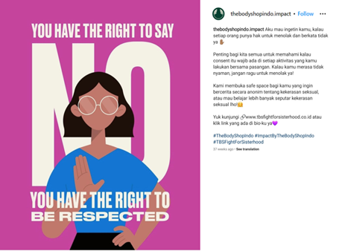

Figure 1. @thebodyshopindo.impact ‘s Instagram Post

RUU P-KS was previously rejected because it was considered as a justification for free sex. The draft was accussed by the opposing lawmakers to justify promiscuity and adultery, which was actually related to one of the articles regulating sex education and reproductive health. The proponents, however, argued that it is important to inform the public about sex and reproductive health education, including adolescents according to their age level. TBSI advocated about the importance of this article on one of their Instagram posts. This post is consistent with their commitment to voice the importance of sex education in order to understand the consequences of conducting sexual activities or to be sexually active.

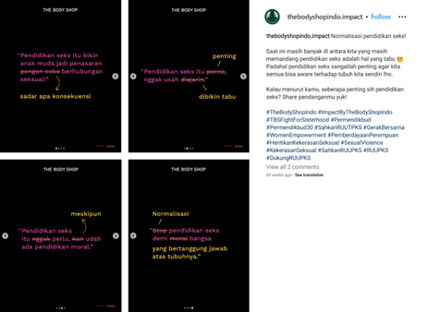

Figure 2. @thebodyshopindo Instagram Post on the importance of sexual eduation

The writing on Figure 2, consists of the following texts:
- Sex education makes young people curious about the consequences of having sex;
- Sex education is important, don’t make it a taboo;
- Sex education is still necessary, even though moral education exists;
- Normalizing sex education, for the sake of the nation’s bodily integrity

Corporate activism is thought to bring companies closer to the realization and maintenance of social justice: Corporate activism allowed corporations to voice their ideals, not unlike a digital influencer or an activist, which, at the same time, are also able to provide a different perspective from a traditional civil society actors, Non-governmental organizations, and political groups. Thus, corporations are no longer participating in the distribution of rights, benefits, and protection through taxation or by being a passive subjects of regulation.
The term 'corporate activism’ has entered the mainstream, implying not only that the time is right but also that it is increasingly expected that corporations are more explicit and more consistent about: (1) the values they have; (2) the causes they promote; (3) and the ideas, ideals, and ideologies they support. What are the examples that come to mind when corporate activism is mentioned? What does corporate activism actually mean?
In 2014, Procter & Gamble focused on women empowerment with their #likeagirl social media campaign (CampaignLive 2015; Always) - an expansion of the idea of confidence into a wider emotional territory beyond just female hygiene products. In the same year, Starbucks closed its stores for racial-bias prevention training (Calfas 2018, This American Life 2018) and Nike started a collaboration with athlete Colin Kaepernick to highlight their pro-diversity commitment.
In conducting corporate advocacy, a corporation may utilise different types of media channels or various styles of messages in order to achieve their objectives. London (2010) introduces different strategies advocates can use to influence attitudes, behaviors, and decisions, as well as to promote change. Corporations may employ different ways to communicate their activities, which include informing, responding, and involving (Morsing & Schultz, 2006). Informing means the corporation is circulating information without engaging with their stakeholders. Meanwhile, engaging pertains to the strategy to respond to their stakeholders’s responses or initiative to engage with the corporation’s activities. Involving takes it to the next level, by encouraging the stakeholders to participate in the activities though dialogues or other types or activities that may encourage active involvement. Furthermore, the way CSR messages are formulated can be explained by the act of framing that organizes, structures, shapes, and emphasizes certain perspectives to a particular issue (Deacon et al., 2010). Thus, frames do not change the factual information about an issue as such, but, instead, highlight a certain perspective while omitting others (Deacon et al. 2010; Hallahan, 1999.) (Laura Olkkonen, 2019)
Elving et al (2015) categorizes communicative CSR actions as aspirational and participatory. Aspirational talk or messaging refers to articulation of ideas, visions, future plans, or contested and policy related issues, which are delivered through aspirational messages or performance. Christensen et al (2013, p.373) describes aspirational talk as a form of communication which focuses on announcing ideals instead of communicating or reflecting actual behavior. However, criticism of aspirational talk is also directed towards corporations that are found to be inconsistent between their messages and their actions. (Cornelissen, 2017). On the other side of the spectrum, Christensen et al. (2013) considers that performing aspirational talks should not always be considered as manipulation, because talking about plans and intentions are actions as well. Thus, aspirational communication can help organizations find answers to CSR-related questions and attempts by presenting their ideas and through self-reflection based on a future-oriented self-Figure (Christensen et al., 2013).
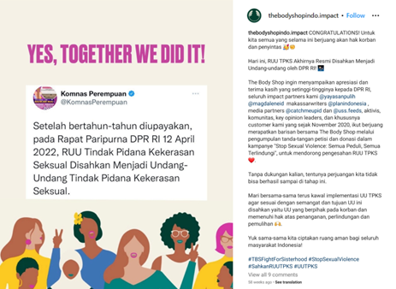
Figure 3. @thebodyshopindo.impact‘s Instagram Post

In the third Figure, the text in the picture is "After years of efforts, at the Plenary Meeting of the DPR RI April 12, 2022, the Bill on the Sexual Violence Elimination was passed into the Sexual Violence Crime Law". In this post, there is an element of "celebration" because TBSI and its fellow advocates were finally successful in supporting the passage of the law. This can also be seen from the post’s caption which read,

“CONGRATULATIONS! For all of us who have been fighting for the rights of victims and survivors. Today, the TPKS Bill has finally been officially passed into law by the DPR RI."

The messages conveyed on The Body Shop Indonesia's social media can be categorized through four types, namely participation, mobilization, informational, and aspirational. Participation, mobilization, and engagement can be enhanced with emotional content (Gómez, 2018). Affective and emotional rhetoric also have persuasive power (Aronczyk et al., 2017). Thus, firms can highlight issues and causes that the stakeholders find important, that they prioritize in their lives and that they are likely to be emotional about (Mangold, 2009)

Theory

Corporate Social Responsibility (CSR) is defined by Roper and Fill (2012) as a concept that helps in ensuring businesses to monitor their business activities and support the law, ethical standards, and international norms. Prasad and Holzinger (2013) argued that CSR has developed from its earlier form of CSR, which focused more on giving back to the society to the triple bottom line, towards the concept of ‘doing well by doing good’ argument. Meanwhile, London and Morfopoulous (2010) argued that CSR is an initiative done by a corporation to bring about critical social change to its stakeholders. This initiative can be inspired by factors such as regulatory obligations, alignment of business objectives and a social change objective, personal motivation of the executives, or other factors. The Roper and Fill, Prasad and Holzinger, as well as London and Morfopoulous agreed that good CSR initiatives can help in improving the reputation of the corporation involved or in charge of the initiatives.
CSR is regulated in the 2012 Government Regulation No.47 on the Social and Environmental Responsibilities of Limited Liability Companies. The regulation made it compulsory for primary industry working with natural resources, to conduct CSR activities and to publish the activities in the media. However, instead of contributing towards the development of the environment and society, CSR implementation in Indonesia is still far from ideal (Nayenggita et al., 2019 - Jurnal Pekerjaan Sosial Vol.2 No.1, p61-66). This reality has also been discussed by Prasad and Holzinger (2013) as the potential dark side of corporate marketing on CSR. Both concluded that, though CSR in itself is neutral, corporations may actually use CSR to market themselves in positive light, without having any effects on social justice development itself. Nwagbara and Belal (2019)’s study supported this argument, which concludes that the subject of their study actively trying to portray themselves as a ‘responsible company’ despite the criticism by the communities in Nigeria. den Hond et al. (2021) believe that CSR should be able to off more than what is outlined in the government regulation and the corporation should design their CSR initiative with their business objectives, in order to achieve positive impact in both profit and social impact.
Maon et al. (2010) saw this through the lens of a seven stages, three cultural phases model. The three cultural phases, the CSR cultural reluctance, grasp, and embedment, indicate three distinct maturity level of a company to fully integrate CSR into their ‘DNA’, which is defined by Maon et al. as knowledge and attitudinal dimensions, strategic dimensions, tactical dimensions, and operational dimension. The three cultural phases are further divided into seven stages: dismissing, self-protecting, compliance-seeking, caring, strategising, and transforming.

Corporate Activism
Chatterji & Toffel (2017) dubbed corporate activism as the preferred terminology encompassing corporate-driven advocacy or activism in socio-political issues. Olkkonen and Jääskeläinen (2019) added that corporations engaging in corporate activism are in a better position to enter into public debate of social issues and through its consistent involvement in advocating an issue, the corporation may be seen as a genuine activist in the same manner as non-governmental organizations or political actors. Atkinson (2017) believes activism to be an important social discourse tool in a democracy. Atkinson identified that activism may attract media attention, which in turn, informs the masses regarding an important social issue and eventually, when enough pressure is exerted, may influence politicians to incorporate the issue into their political agenda.
Political CSR (PSCR) is one of the directions of CSR that is highly debated, from the issues of involvement of the corporate, to the responsibility of a corporate to be active in lobbying the government into passing regulations that address the issue. Scherer et al. (2016) argued that public discourse that involved NGOs and corporations on a social issue to be insufficient. CSR strategy should also incorporate actions that may affect changes by the legislatures to be essential in realizing changes. This is the role of corporate activism.
Baur and Wettstein (2016, p.173) discussed this in their article on Unilever lobbying effort to push for a stronger environmental regulation and Ben & Jerry’s support of gay marriage. The companies weave their activism into the company’s CSR actions, which is also close to their business objectives. Sarkar and Kotler (2018) further argued that the importance of the strategy, combined with the integration of corporate activism into marketing strategies and brand identities is essential in order to increase the success rate of the activism. The integration of marketing strategies and corporate activism is then realized into tactics that are translated into messages. Olkkonen and Jääskeläinen (2019) categorized four types of messages that are used in analyzing their research subject: informative, aspirational, participatory, and mobilizing.

Method
The method used in this research is qualitative content analysis. As the organization that state to be the brand advocate, this method used because this study aims to know about the communication style that The Body Shop Indonesia use in their social media, and how do the corporate social advocacy implemented through their social media posts. We conducted an exploratory study, utilizing empirical data from The Body Shop Indonesia company communication on Instagram, especially under the hashtag #TBSFightForSisterhood. Our analysis covers the Instagram posts of #TBSFightForSisterhood, which consists of 150 posts. This research was assisted by two coders in a split coding arrangement, where the first coder is responsible for posts number 1 to 75, while the second coder is responsible for posts number 76 to 150 The posts are then categorized into four categories: informational, aspirational, participation, and mobilization. More than one category may be found in a single post.
Informational messages often contain signs of third-party verification such as links to other sites. Companies can also include informative influence methods to their messages to make their CSR communication more effective. Indicators of effectiveness can include, for example, liking, sharing, retweeting, and using hashtags, replying to messages, and mentioning other users (Gómez, 2018). Meanwhile, aspirational are messages that are intended to portray an organization as one of the leaders in the cause and messages that are intended to inspire the audience to be at the same side of the issue with the organization. When it comes to the participatory aspect, it is commonly described in words such as “participation”, “inclusion”, “voice”, “involvement”, “collaboration”, “partnerships”, and “engagement”. Messages pertaining to participation are filled with call to actions (CTA) though it is more geared towards personal behavioral changes. Participation also relates to mobilization, which Gómez (2018) defines in the context of CSR communication in social media as content that encourages and engages users to act in favor of a person, organization or a cause, instead of personal actions. Organizations that aim to mobilize can create messages that include information about the cause or issue, or build messages that are encouraging in nature. Participation, mobilization and engagement can be enhanced with emotional content (Gómez, 2018). Olkkonen and Jääskeläinen (2019) also argued that affective and emotional rhetoric also have persuasive power.

Result and Discussion (Times New Roman 12pt, bold)
Based on the 150 posts with #TBSFightForSisterhood contents that the authors have compiled, around 86% of the posts (137 posts) contain at least two types of messages. The breakdown of the messages can be seen below:

No | Dimension | Total | Percentage
1 | Informational | 148 | 99%
2 | Aspirational | 76 | 50%
3 | Participation | 117 | 78%
4 | Mobilization | 130 | 86%
Source: Researcher Coding Results (2023)
Table 1. Categorization of #TBSFightForSisterhood Content on Instagram Based on Communication Style

As we can see from the table above, the result of the Categorization of #TBSFightForSisterhood Content on Instagram Based on Communication Style, the Informational message is in first place with 148 messages or around 99% of the posts. This means The Body Shop Indonesia (TBSI) include many informative influence methods to their messages to make their strategic communication more effective. The next communication style is followed by Mobilization messages with a total of 130 messages, which reached around 86% of the total posts with the aforementioned hashtag. The prevalence of Mobilization messages might indicate that TBSI was not only trying to increase the awareness of their audience, but also to gain concrete support from their audience. This eventually means signing the petition or actively contributing towards the campaign.
While the first two aspects, the Informational and the Mobilization messages, are the fundamental building blocks of convincing their audiences and driving active contribution, TBSI also aimed for less demanding messages through aspirational and participatory messages. Though not as many as Informational and Mobilization messages, Participation messages exist in 78% of the total posts, while Aspirational messages exist in half of the total posts. This might suggest that TBSI may acknowledge that not everyone may actively contribute and listen to their Mobilization messages, but also to give room for the audiences that sympathize with their movement but less inclined to actively support the cause.
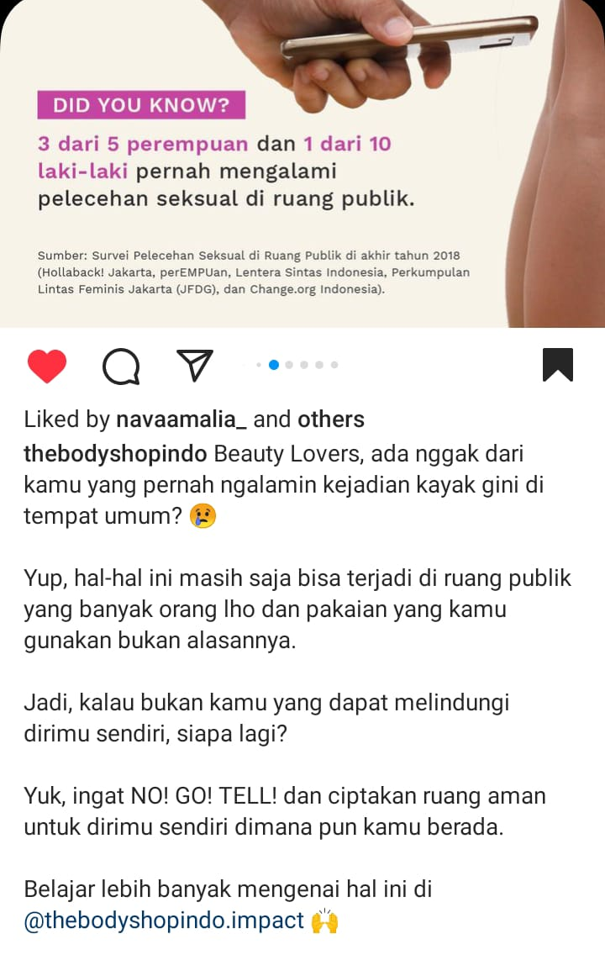
Figure 4. Informational message found on thebodyshopindo’s Instagram post
The informational message usually most of the time also mentioned the counterpart Instagram account. Figure 4 above shows that @thebodyshopindo Instagram account mentioned @thebodyshop.impact account. In some cases the post is replicated on each account while mentioning each other in the caption. The messaging found in the captions is usually designed to evoke a sense of relevance to their audience through questions that ask whether the audience ever experienced a similar situation previously. Following the question, the caption usually continues with stating facts about the situation and ends with a solution that can be done to prevent or alleviate the situation.

Figure 5. Aspirational message found on thebodyshopindo’s Instagram post
All 76 Aspirational messages found on @thebodyshopindo and @thebodyshop.impact Instagram posts are always tied with informational messages. This might indicate TBSI’s strategy to always provide facts and information in convincing their audience of their cause. Though Aspirational messages seem to be on the backseat, a few of those messages are more prominent, as can be seen on Figure 5. The caption is almost entirely consisting of Aspirational messages, pointing out that TBSI is an activist brand. The Informational message can be seen on Figure 6 below, providing information on the achievements and milestones that TBSI and their partners had gone through previously.
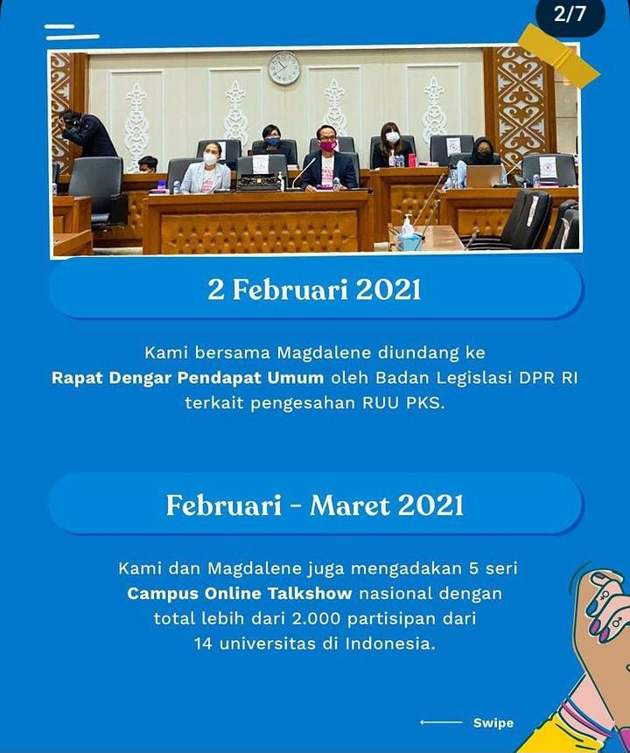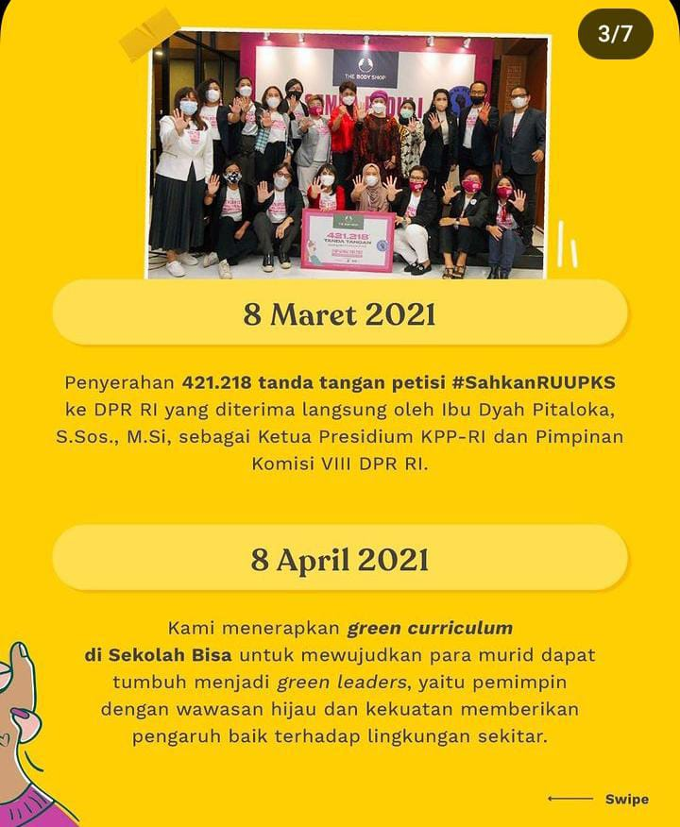
Figure 6. Aspirational message found on thebodyshopindo’s Instagram post
Participation and Mobilization messages are categories that indicate TBSI’s intention to drive action-oriented responses from their audiences. Participation can be seen as less active, which can be seen as CTAs that invite the audiences to adopt behaviors that are inline with the cause.

Figure 7. Participational message found on thebodyshopindo’s Instagram post

On Figure 7, one of the posts that contain Participational message contained the following caption: “Do you know that sexual violence prevention can apparently be taught from an early age!! Are you parents who might be confused how to educate your children to protect themselves from sexual violence? We have the solution for you! We have an educational book titled Saat Tiara dalam Bahaya, which can be used as a reference for you and your children to protect ourselves and prevent sexual violence from happening. Let’s download the book freely on this link or you can click on our bio”. This post also shows that TBSI had the tendency to combine different types of messages, which can be found mixed on the caption, or on the visuals that they provided. In this case, they provided the Informational messages on the visuals, as can be seen from Figure 8 below.
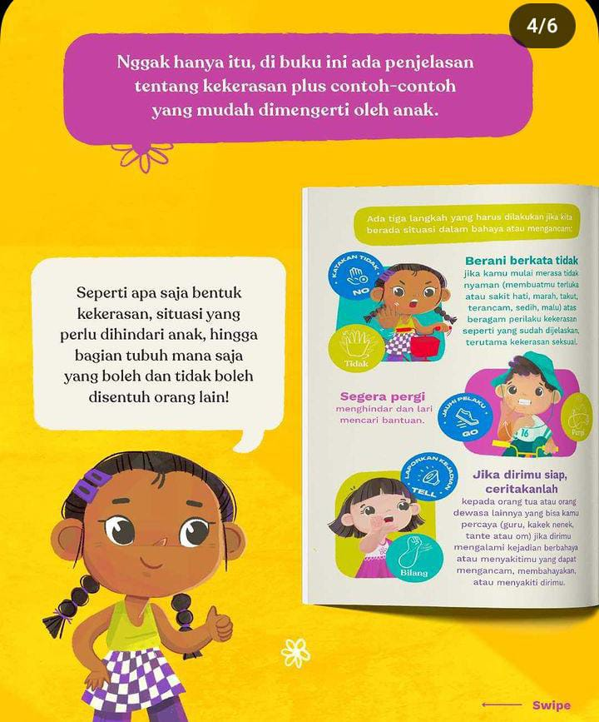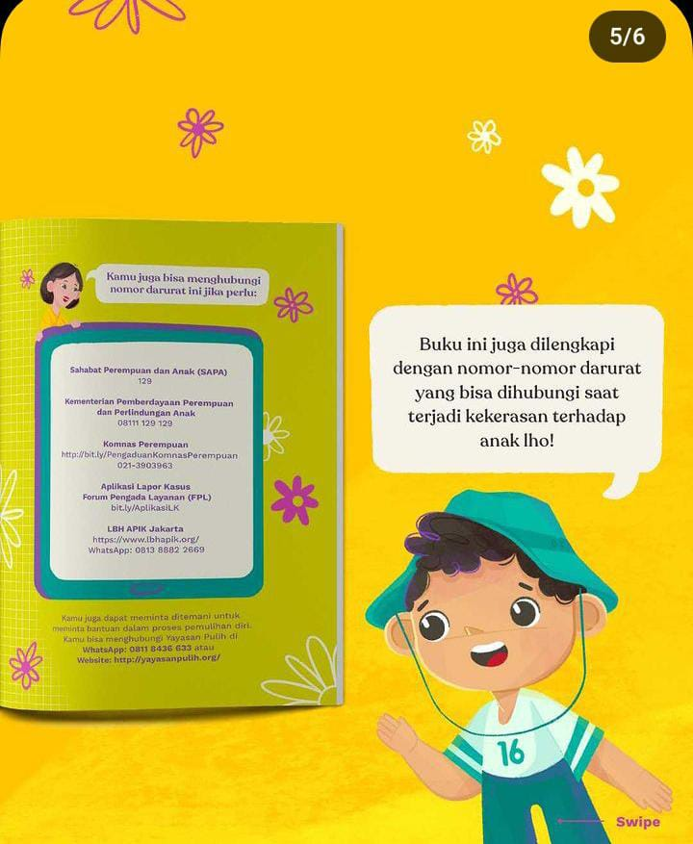
Figure 8. Informational message found on thebodyshopindo’s Instagram post visuals
Out of 117 Participational messages, two of them do not contain Informational message and Aspirational message. The two posts that are devoid of both messages also have Mobilization messages. These two posts are positioned to drive both personal behavioral changes and active participation in the campaign through competition. The post can be seen on Figure 9 below:
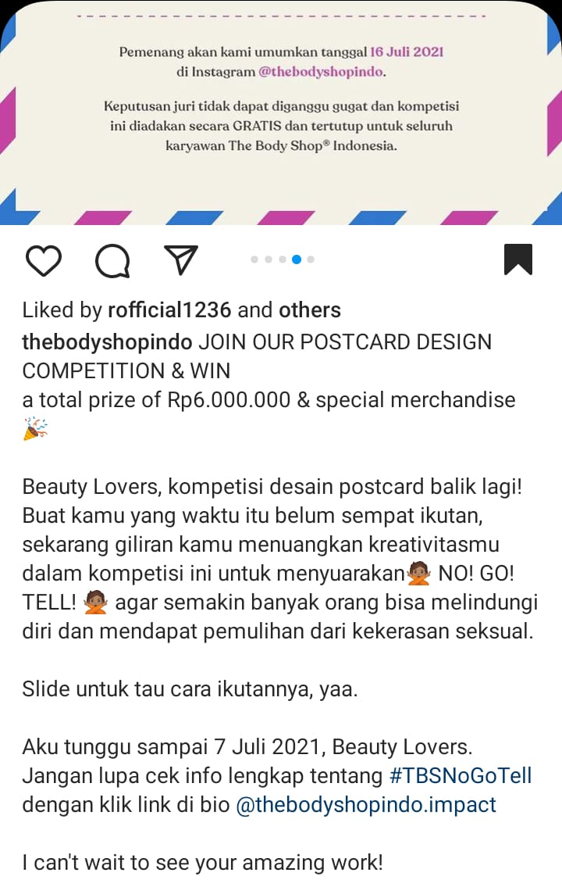
Figure 9. Participational message and Mobilization message found on thebodyshopindo’s Instagram post

Mobilization messages are also found in combination with other types of messages. Below example shows all four types of messages that can be found on a post by @thebodyshopindo on Figure 10:
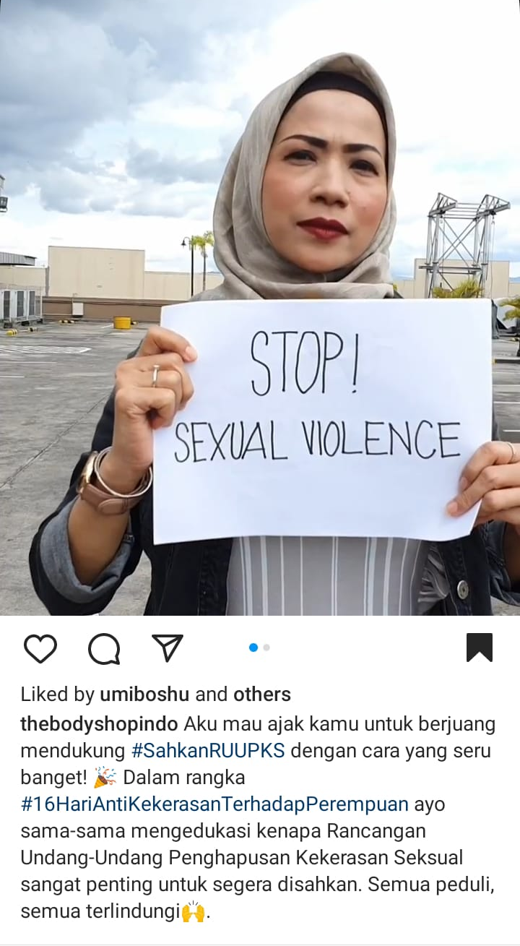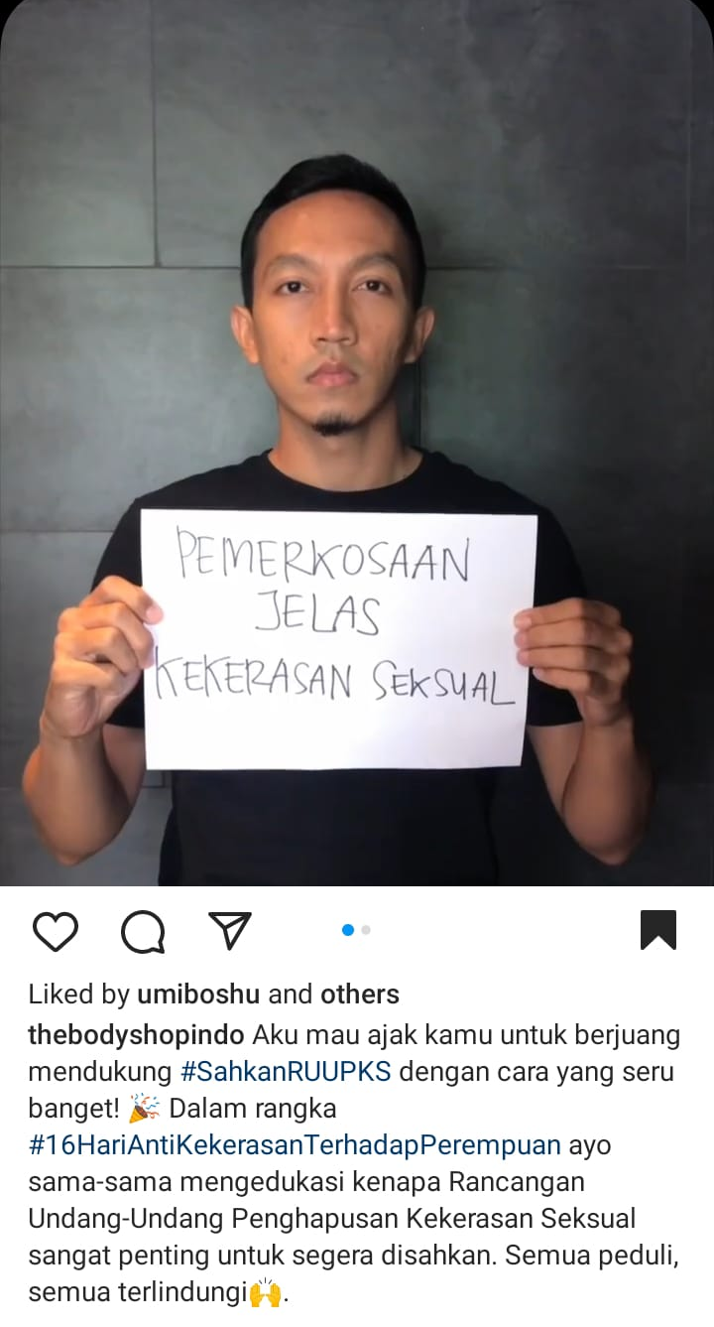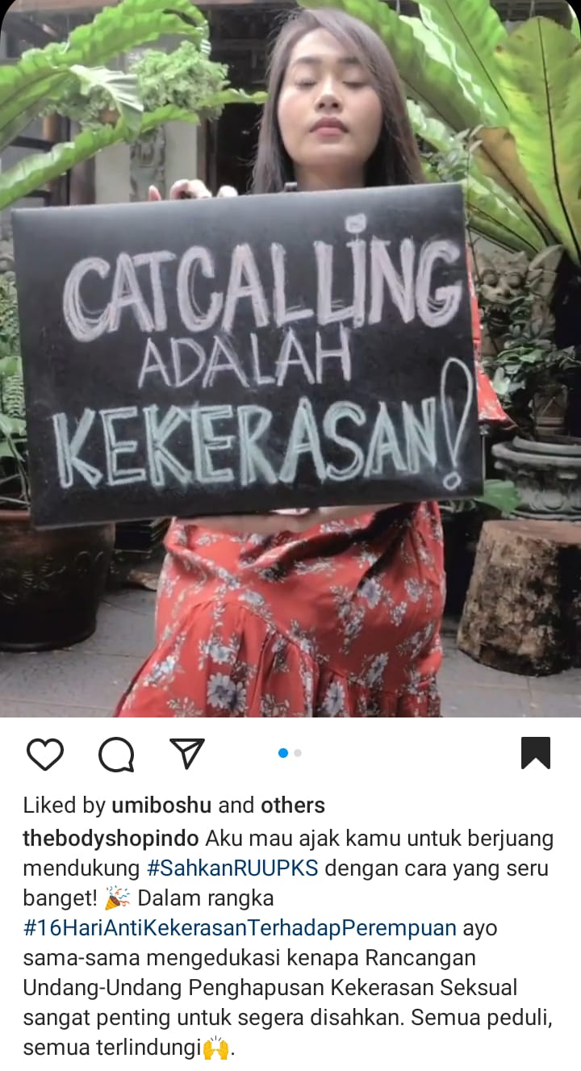
Figure 10. Four types of messages found on thebodyshopindo’s Instagram post
Various types of messages found on Figure 10 are found on a post with video. The video shows various messages, which shows different persons holding a paper or carton containing short phrases. The phrases ranging from informational messages such as “catcalling is violence”, “rape is no doubt, an act of sexual violence”, to participational messages such as “Let’s stop sexual violence”. Aspirational message can visible seen on the caption, which says “Everyone cares (about sexual violence), everyone is safe (from sexual violence)”, and the rest of the caption is designed towards mobilizing the audience to actively participate on making the campaign successful.

No | Number of message types | Total | Percentage
1 | One | 13 | 8.7%
2 | Two | 23 | 15.3%
3 | Three | 44 | 29.3%
4 | Four | 70 | 46.7%
Source: Researcher Coding Results (2023)
Table 2. Number of message types based on the categorization of communication styles

Around 86% of the posts contain at least two messages, which may indicate that almost all posts are designed to provide not only useful information to raise awareness of the issue, but also to drive personal change and active participation. Almost half (46.7%) of the posts contain all four types of messages, followed by three types of messages (almost 30%). Based on the data, TBSI seems to give priority to the Informational messages and the action-oriented messages, or the Participation and Mobilization messages.

Conclusion
Our empirical analysis focused on the social media communication of The Body Shop Indonesia using #TBSFightforSisterhood. It's an example of a company that is engaging in corporate activism by addressing and advocating for controversial socio-political issues. Our qualitative analysis studied what themes The Body Shop Indonesia covers in its CSA communication and how The Body Shop frames CSA communication on Instagram. We identified four communication frames in The Body Shop’s posts: informative, mobilizing, participatory, and aspirational.
One of the end goals of advocacy is to publicly support an issue, person, or a group, often with an aim to raise awareness and convince others to join the cause. With this issue, The Body Shop Indonesia try to show how their message can actually invite others to support the issue under the #TBSFightForSisterhood.

Acknowledgments
Authors would like to thank Universitas Multimedia Nusantara for providing the fund and making this research possible.

REFERENCES

Atkinson, J. D. 2017. Journey into Social Activism: Qualitative Approaches. NY: Fordham University Press

Bangun, C. R. (2016). Peran Departemen Corporate Communication dalam Melakukan Sosialisasi Nilai Perusahaan melalui Media Internal. Ultimacomm: Jurnal Ilmu Komunikasi, 8(2), 45-56.

Baur, D., & Wettstein, F. 2016. CSR’s new challenge: Corporate political advocacy. In M. C. C.
Arruda & B. Rok (Eds.), Understanding ethics and responsibilities in a globalizing world, 171–
187. Cham: Springer.

Chatterji, A. & Toffel, M. W. 2017. Do CEO activists make a difference? Evidence from a quasi-field experiment. Working Paper No. 16-100. Harvard Business School. DOI: 10.2139/ssrn.2742209

den Hond, F., Rehbein, K.A., de Bakker, F.G.A., and Kooijmans-van Lankveld, H. 2014. Playing on Two Chessboards: Reputation Effects between Corporate Social Responsibility (CSR) and Corporate Political Activity (CPA)

London, M and Morfopoulous, Richard G. 2012. Social Entrepreneurship: How to Start Successful Corporate Social Responsibility and Community-Based Initiatives for Advocacy and Change.

Kettunen, Salla. 2020. Corporate Activism – New Kid on the CSR Block: Perceptions of Social Justice in Starbucks’ Corporate Activism Discourses.

Kusuma, S., & Bangun, C. R. A. (2021). Crisis Responsibility Impact on Customer Loyalty Eiger through Post-Crisis Reputation. Jurnal Komunikasi Global, 10(2), 214-228.

Maon, F., Lindgreen, A., & Swaen, V. (2010). Organizational Stages and Cultural Phases: A Critical Review and a Consolidative Model of Corporate Social Responsibility Development. International Journal of Management Reviews, 12(1), 20–38. doi:10.1111/j.1468-2370.2009.00278.x

Nwagbara, U., & Belal, A. (2019). Persuasive language of responsible organization? A critical discourse analysis of corporate social responsibility (CSR) reports of Nigerian oil companies. Accounting, Auditing & Accountability Journal, 32(8)

Olkkonen, Laura, Jääskeläinen, Jannica. 2019. Corporate Activism: Exploring Corporate Social Responsibility (CSR) Communication. Academy of Management Annual Meeting Proceedings

Prasad, A., & Holzinger, I. (2013). Seeing through smoke and mirrors: A critical analysis of marketing CSR. Journal of Business Research, 66(10), 1915–1921

Roper, S., & Fill, C. (2012). Corporate Reputation. Pearson International Content.

Sarkar, C. & Kotler, P. 2018. Brand activism: From purpose to action. Idea Bite Press.

Scherer, A.G., Rasche, A., Palazzo, G. & Spicer, A. 2016. Managing for political corporate social
responsibility: New challenges and directions for PCSR 2.0. Journal of Management Studies, 53 (3): 273-298

