UNDERSTANDING INTERCULTURAL COMMUNICATION IN THE DIGITAL ERA FOR EFFECTIVE ADAPTATION IN MULTICULTURAL CLASSROOMS
David Fero
Institut Agama Kristen Negeri (IAKN) Tarutung
iakn.davidfero@gmail.com

Abstrak. Penelitian ini bertujuan untuk memahami peran komunikasi antarbudaya di kalangan mahasiswa pada era digital dalam menciptakan adaptasi komunikasi yang efektif di ruang kelas multikultural. Kurangnya pemahaman mahasiswa terhadap komunikasi antarbudaya sering kali menjadi penyebab komunikasi yang tidak efektif, bahkan berpotensi memicu kegagalan dalam membangun interaksi yang harmonis. Mahasiswa saat ini merupakan bagian dari Generasi Z, yang lahir dan tumbuh dalam era perkembangan teknologi yang sangat pesat. Oleh karena itu, media sosial seharusnya dapat dimanfaatkan sebagai sumber pengetahuan yang mendukung mahasiswa dalam menyelesaikan berbagai permasalahan, sekaligus meningkatkan kemampuan mereka dalam beradaptasi dengan lingkungan baru. Penelitian ini menggunakan metode deskriptif kualitatif, dengan teknik pengumpulan data melalui wawancara dan dokumentasi. Hasil penelitian menunjukkan bahwa pemahaman komunikasi antarbudaya yang diperoleh mahasiswa baik melalui proses sosialisasi di kelas maupun melalui bantuan media sosial berperan penting dalam mempercepat mereka mengatasi hambatan komunikasi yang muncul. Proses adaptasi terhadap budaya baru juga berlangsung lebih cepat berkat kemudahan akses informasi yang disediakan oleh perkembangan teknologi di era digital. Penelitian ini diharapkan dapat mendorong pengembangan kurikulum yang lebih responsif terhadap keberagaman budaya di ruang kelas multikultural, serta mengintegrasikan pengajaran komunikasi antarbudaya yang berbasis teknologi.
Kata Kunci: Komunikasi Antarbudaya, Sosial Media, Era Digital.

Abstract. This study aims to understand the role of intercultural communication among students in the digital era in creating effective communication adaptation in multicultural classrooms. Lack of understanding of students towards intercultural communication is often the cause of ineffective communication, even potentially triggering failure in building harmonious interactions. Students today are part of Generation Z, who were born and grew up in an era of very rapid technological development. Therefore, social media should be used as a source of knowledge that supports students in solving various problems while increasing their ability to adapt to new environments. This study uses a qualitative descriptive method, with data collection techniques through interviews and documentation. The results of the study show that the understanding of intercultural communication obtained by students both through the socialization process in class and through the help of social media plays an important role in accelerating them to overcome communication barriers that arise. The process of adaptation to a new culture also takes place faster thanks to the ease of access to information provided by technological developments in the digital era. This study is expected to encourage the development of a curriculum that is more responsive to cultural diversity in multicultural classrooms, as well as integrating technology-based intercultural communication teaching.
Keywords: Intercultural Communication, Social Media, Digital Era
INTRODUCTION
A communication-friendly classroom should be able to create an easy, effective, and enjoyable communication atmosphere. In the communication process, each individual needs to be given the opportunity to speak, listen, understand, and participate actively. Indonesia is ranked second as the country with the most languages in the world, after Papua New Guinea. It is recorded that there are around 718 languages spread from Sabang to Merauke. However, unfortunately, differences in language, ethnicity, and culture are still often a source of problems, especially in the context of communication. This often triggers misunderstandings, including in classrooms filled with students from various regional, ethnic, and cultural backgrounds. Differences in understanding or use of language often become obstacles in the communication process. In fact, this should not be a recurring obstacle, considering that cultural and linguistic diversity is the wealth of the Indonesian nation. In fact, in many areas, people still use their native language or regional language in everyday life, both in the family environment and with neighbors.
Students in the Cultural and Religious Tourism Study Program of IAKN Tarutung come from various regions with diverse ethnic backgrounds. Most of the students are indeed from the Batak tribe, considering that this State Christian Institute is located in North Tapanuli, an area where the majority of the population is Batak. However, there are also students from various other regions and tribes, such as Nias, Papua, Padang, NTT, Mentawai, Aceh, West Java, DKI Jakarta, and others. In a multicultural class like this, differences in background often trigger the emergence of ethnocentrism among students.
Ethnocentrism arises due to excessive pride in one's own culture, which, without realizing it, can have a negative impact when communicating with people who have different cultural backgrounds. In addition, problems such as stereotypes also often trigger communication failures between students. These stereotypes have been formed for a long time through social construction in the family environment, society, and even normalized as jokes in the classroom environment.
The lack of understanding by students about intercultural communication and its impact on the effectiveness of communication is the main factor in their difficulty in adapting to a new environment. In fact, this situation should not happen, because differences are something to be proud of. We live in a multicultural country, and diversity should be accepted as wealth, not a barrier.
Understanding intercultural communication is essential, especially in the context of multicultural classrooms and in today's digital age. The development of communication technology has enabled the exchange of ideas and meanings between individuals from different cultural backgrounds. Multicultural classrooms are an ideal space for cross-cultural information exchange, which in turn plays a major role in creating an inclusive learning environment, enhancing intercultural understanding, and enriching the learning experience for both students and teachers. Moreover, intercultural communication also equips students with the skills needed to actively participate in an increasingly connected global society.
According to Ardiansah and Maharani (2021), social media are a means or container used to facilitate interaction between users and have a two-way communication nature. Social media can be a very effective tool in understanding and adapting to intercultural communication. Social media play a role in connecting people from all over the world via the internet, and social media create a wide space for cross-cultural interaction.
Gen-Z grew up and was influenced by an era where technological developments were developing so rapidly, but unfortunately the use of social media has not been maximized by this generation. There are many things that students, in this case Gen-Z, should be able to take advantage of, such as popular technology products, namely social media. Basically, social media can be a source of information that is fast and easy to access in the digital era. According to Mumtaz & Karmilah (2021), digitalization is the development of technology towards full digitalization, where people tend to have a new way of life that cannot be completely separated from electronic devices. The digital era is a period where access to information becomes easier, faster, and its distribution can be done using digital technology in a limited time. The existence of social media can be a space or medium for learning intercultural communication, or things related to new cultures.
Communication is a process of interaction to exchange information. Cultural and language differences are often factors that hinder communication because they create uncertainty. An understanding of intercultural communication is needed to bridge these problems. Socialization related to understanding intercultural communication is an effort to create adjustments to meaning, perception, language differences, symbols and symbols which should also be able to be overcome with the help of information technology in addition to the adaptation process that must be gone through.

THEORITICAL REVIEW

Intercultural communication. According to Deddy Mulyana (2003), intercultural communication is the process of exchanging thoughts and meanings between people of different cultures. Meanwhile, according to Larry A. Samovar (2010), intercultural communication is a form of communication that involves interaction between people whose cultural perceptions and symbol systems are quite different in communication. In Samovar's view, intercultural communication occurs when members of a particular culture give messages to members of another culture. Intercultural communication often involves differences and ethnicities, but intercultural communication also occurs when striking differences arise without having to be accompanied by differences in race and ethnicity. Meanwhile, according to Lutfhi (2018), intercultural communication is the process of exchanging thoughts and meanings between people of different cultures. A person's culture also greatly influences the process of ongoing communication.

Social media. According to Nabila et al. (2020), social media are an online medium that operates with the help of web-based technology that makes changes in terms of communication that used to only be one-way and changed to two-way or can be called interactive dialogue. According to Nasrullah (2015), social media are a medium on the internet that allows users to represent themselves or interact, collaborate, share, communicate with other users to form social bonds virtually.

Digital Era. One of the biggest roles of information technology is the birth of digital technology, which drives massive digitalization in various respects. The digital era has brought major changes in various aspects of life, including education and learning. According to Shepherd (2011), the digital era has an element of the presence of technology that has an impact on the circulation of knowledge in the joints of human life. Digital technology has opened up wider and more equitable access to education for everyone, as well as provided various new opportunities to learn and develop themselves. Improving the quality of learning, digital technology can be used to improve the quality of learning by providing various rich and interactive learning resources.

Intercultural Adaptation. Cai & Rodriguez (1996) argue how communication patterns can help or hinder people from understanding their "new" cultural environment. Kim (2001) that cultural adaptation is a dynamic process when individuals who enter a new environment rebuild and maintain stable and good relationships with their new environment. Cross-Cultural Adaptation (Kim, 2001: 54-57) and Oberg (AFS Intercultural Program, 2013: 1) explain that the adaptation process experienced by a foreigner through three main processes. The first is the arrival process (honeymoon), stress (cultural shock), and adjustment. The Honeymoon process is when someone has been in a new environment, adjusted to the culture and environment, and the person still has high enthusiasm and curiosity and is enthusiastic about the new atmosphere that they will be experienced. The individual may feel foreign, homesick and alone but still lulled by the friendliness of the local people towards foreigners. The Stress Process (cultural shock) is a process where the feeling of enthusiasm and curiosity that is burning turns into a feeling of frustration, irritation and inability to do anything because the reality that is actually not in accordance with the expectations that were had at the beginning of the stage, While the adjustment process. Is a stage where individuals begin to develop various ways to be able to adapt to existing circumstances. A person begins to resolve the crisis experienced during the culture shock process. Adjustment is how individuals find ways, such as learning the language, behavioral patterns, and various things related to the local culture.

METHOD

This study uses a descriptive-qualitative method. This method aims to describe and explain in detail the problems studied, especially in the context of intercultural communication. The descriptive-qualitative approach allows researchers to gain a deep understanding of the phenomena studied, without being tied to quantitative data or numbers. In this process, researchers actively collect data using techniques that are in accordance with the characteristics of qualitative research. Data collection techniques used include interviews and documentation. The informants in this study were students of the Cultural and Religious Tourism Study Program, class of 2023, with a total of 33 participants. The questions asked by students covered various aspects, ranging from intercultural communication theory, practical skills, to the application of concepts in everyday life. The data analysis process begins with collecting information through interviews and documentation in the field, which is then analyzed thematically to identify patterns, meanings, and relevance to the research objectives.

FINDINGS
Understanding intercultural communication in the digital era
Tarutung State Christian Institute (IAKN) is a state university located in Tarutung District and Sipoholon District, North Tapanuli Regency, North Sumatra Province. Tarutung City itself is the capital city as well as the center of government and economy of North Tapanuli Regency.
Most of the people in this area still use regional languages ​​in their daily communication. Based on data from the 2020 Population Census Long Form conducted by the Central Statistics Agency (BPS), it is known that the majority of the population of North Tapanuli Regency is able to speak Indonesian. However, they also maintain the use of regional languages, especially in interactions with family and neighbors/relatives.
The data shows that 88.05% of the community uses regional languages ​​when communicating within the family, while 89.58% use them in interactions with neighbors or relatives. Meanwhile, the level of Indonesian language proficiency among the community reaches 98.77%.
Further information regarding the use of regional languages ​​and Indonesian language proficiency in North Tapanuli Regency can be seen in Figure 1 below.

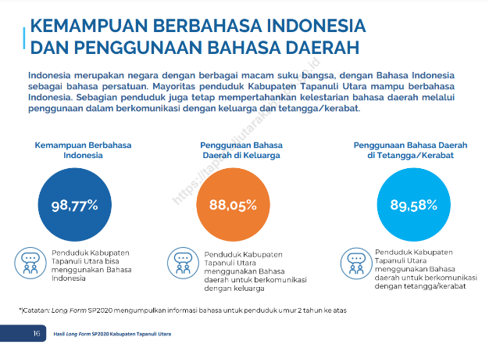
Figure 1. Indonesian language skills and use of regional languages

Furthermore, when viewed based on generational grouping, Generation Z (born between 1997–2012) shows a fairly high level of regional language use. The percentage of Generation Z residents who use regional languages in family communication reaches 88.52%, while use in communication with neighbors or relatives is at 89.45%.
This data shows that the majority of Generation Z, including students from North Tapanuli, still actively use regional languages in daily communication, both in family and social environments. Consequently, in classrooms and off-campus activities, the use of regional languages tends to dominate communication patterns. Therefore, students who come from outside the region and have different language backgrounds need to adapt to local communication habits. This does not mean that they must fully master the regional language, but they need to have the ability to adapt in order to communicate effectively and understand the prevailing social and cultural context. Conversely, local students from North Tapanuli are also expected to be open and support the adaptation process of students from outside the region, so that social interaction and integration can take place harmoniously. This two-way adjustment is important to creating an inclusive classroom and supports the success of the learning process. Information related to Indonesian language skills and the use of regional languages based on generations in the North Tapanuli Regency can be seen in Figure 2 below.

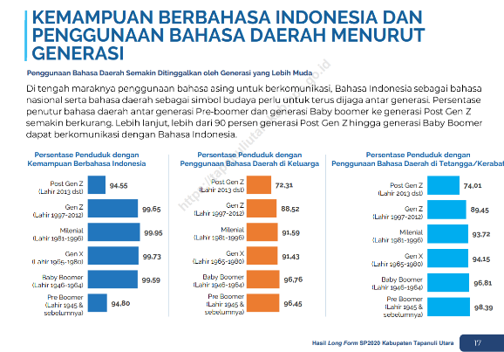
Figure 2. Indonesian language ability and use of regional languages ​​by generation.

The convenience and various benefits of the development of digital technology are one of the reasons why Generation Z is very active in cyberspace and the internet. Digital technology is not only able to provide answers to what Generation Z wants to find or needs, but also supports their need to remain visible in the digital space. This is one of the main reasons for the high use of social media by this generation.
Generation Z is known as the digital native generation, namely a generation that has been accustomed to technology since birth and grew up amidst the rapid development of the digital era. They do not only use technology as a tool, but make it an integral part of their daily lives. On the other hand, Generation Z is also faced with the demand to continue to be active and up to date with various things related to digitalization, both in social, educational, and lifestyle aspects.
Based on the demographic profile data of Meta's advertising audience in Indonesia published by DataReportal in January 2024, the 18–23 age group constitutes 27.1% of the total active social media users. Meanwhile, the 25–34 age group is the largest group, at 37.7%. The rest consists of users aged 35 and over to 65 and over. Referring to this data, it can be concluded that students of the Tourism Study Program, Class of 2023, who are mostly in the 18–23 age range, are included in the second-largest demographic group in social media usage. This shows that students currently have great potential in digital activities, especially in the context of tourism promotion through social media. Complete data on the demographic distribution of Meta's advertising audience can be seen in Figure 3 below:

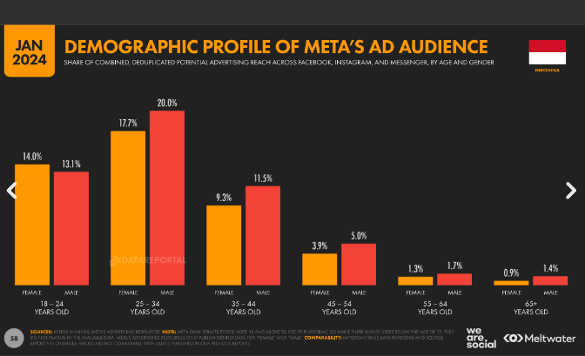
Figure 3. Demographic profile of meta ad audience

Classes in the Cultural and Religious Tourism Study Program for the 2023 Academic Year are multicultural classes. The concept of multiculturalism refers to an understanding that respects and acknowledges the existence of cultural relativism due to ethnic and cultural diversity, each of which has its own characteristics. According to Yudi Hartono (2003:420), multicultural education is in principle education that respects differences. The goal is that these differences do not become a source of conflict and division, but rather become the basis for building tolerance, mutual respect, and strengthening unity.
This attitude of tolerance is what encourages the creation of dynamic diversity and enriches the nation's cultural identity that should be preserved. In this class, the diversity of students' cultures and ethnicities includes Batak Toba, Batak Simalungun, Pakpak, Nias, Mentawai, and Alor. Existing cultural differences often become a challenge in the process of intercultural communication. Therefore, students' ability to adapt quickly to new cultures is needed, as well as utilize various easily accessible sources of information to support their understanding of different cultural contexts.
Social media platforms are one source or medium that can fulfill and answer the need for such information. Students' understanding of intercultural communication here does not mean a form of demand for students to master other cultures completely, but this understanding is related to how students understand differences, eliminating inhibiting factors such as ethnocentrism, stereotypes or stigmas that have often appeared in their daily communication patterns, whether consciously or not. Social media platforms as a medium for students to get fast, and relevant information should be one of the factors that can help overcome this.
From the results of the study conducted in two classes, namely Group A and Group B in the Cultural and Religious Tourism Study Program Class of 2023, totaling 33 students, data was obtained regarding the three most frequently used social media platforms, as well as the types of content most frequently accessed by students. This data was collected before students received learning on the Intercultural Communication course. This means that at the time of data collection, students did not yet have a deep conceptual understanding of intercultural communication, especially in the context of interactions with individuals from different cultural backgrounds. This information is important as initial data to see the extent to which students' perceptions, media preferences, and communication patterns have changed after gaining an understanding of intercultural communication through lectures. Thus, the impact of learning can be analyzed more comprehensively. Data regarding the social media platforms most frequently accessed by students before taking the Intercultural Communication Course can be seen in Table 1 below:

Table 1.
Social media frequently accessed by students.

No | Sosial Media | Average access time | Type of content viewed and accessed
1. | Tiktok | 4-6 Hours | Motivation, humor, culinary, tourism, sports, education, humor and various other content (various))
2. | Instagram | 1-2 Hours | Automotive, humor, travel, music, culinary, films, and various other content (various)
3. | youtube | 1 Hours | Games and sports

Based on the data in Table 1, it can be concluded that the platform most frequently accessed by students is TikTok, with an average usage time of around 5 hours per day or equivalent to 20.8% of the total time in a day. This shows that TikTok is the dominant platform in students' social media activities. Furthermore, Instagram is used for an average of 1.5 hours per day, or around 6.25% of the time in a day, making it the second platform that is quite frequently accessed by students for various types of content. Meanwhile, YouTube is accessed for around 1 hour per day, or equivalent to 4.2% of the time in a day. If added up, the total time spent by students accessing these three platforms reaches 7.5 hours per day. Of this amount, TikTok contributes around 66.7% of the total social media access time, confirming its position as the most dominant platform in students' daily use. The distribution diagram of social media access time in 24 hours can be seen in Figure 4 below: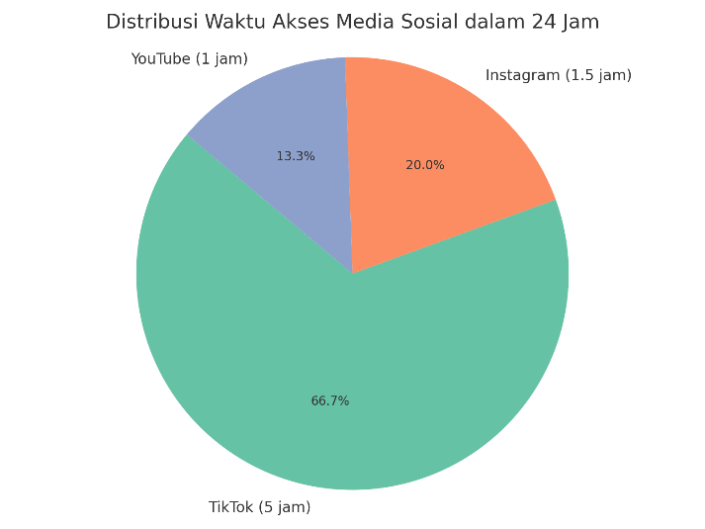
Figure 4. Distribution diagram of social media access time in 24 hours

The reasons why students choose the three main social media, TikTok, Instagram, and YouTube, are certainly inseparable from the various advantages, functions, and rich features offered by each platform. TikTok, for example, allows users to create and access short videos up to three minutes long, complete with music features, filters, and various other creative elements. This platform is considered interesting because it is able to present information quickly, concisely, and entertainingly. Meanwhile, Instagram provides space for students to express themselves through visual content in the form of photos and videos that are packaged aesthetically, and can be shared through various features such as feeds, stories, and reels. YouTube is the choice because it provides a variety of long-form video content that can be watched, uploaded, or shared easily. This platform is widely known as a means of sharing knowledge, entertainment, and learning. However, the data in the previous table also indicates that at the beginning of the semester, before students took the Intercultural Communication course, cultural-themed content was still very minimally accessed by them. This shows that not many students are actively searching for or consuming content related to cross-ethnic cultural issues or intercultural communication practices.

DISCUSSION

Socialization of Intercultural Communication Understanding in Multicultural Classes

In the Academic Year 2023/2024 Even Semester, Group A and Group B students from the Cultural and Religious Tourism Study Program take the Intercultural Communication course. Through this course, students gain a variety of knowledge and understanding of the concepts, principles, and practices of intercultural communication. This knowledge encourages the growth of motivation to learn further and try to understand the cultural differences that exist in their environment. The socialization carried out continuously through learning materials also makes it easier for students to open up, accept diversity, and form an inclusive attitude towards others. Thus, communication barriers that were previously caused by cultural differences can be gradually overcome. This shows that intercultural communication education has an important role in building understanding and creating a harmonious learning environment in multicultural classes.
Student activities on social media are an important medium to be utilized as a means of overcoming various communication problems, especially in the context of intercultural communication. However, this utilization must, of course, be supported by the ability to adapt and efforts to expand the types of content accessed by students, especially content that can help them learn new cultures. Relevant content can be an alternative source for finding solutions to the communication challenges they face. After gaining an understanding of intercultural communication for one semester through classroom learning, there was a significant change in the types of content accessed by students on social media. If previously students tended to consume general content such as motivation, humor, culinary, tourism, sports, and various other content that was random and less focused on educational value, now there has been a shift. Students are starting to be interested in accessing content related to cultural diversity, local values, and cross-cultural communication practices. In addition to the types of content accessed becoming more relevant, the frequency and duration of access to culturally themed content has also increased. This shows that the learning process in the classroom has succeeded in encouraging students to be more aware and active in equipping themselves with information that supports their understanding of other cultures, especially in the context of a multicultural classroom.
The types of content that are now increasingly accessed or watched by students include various aspects of cultural diversity, such as traditional ceremonies, traditional clothing, traditional houses, traditional musical instruments, regional dances, traditional weapons, regional songs, traditional foods, to cultural content in short video formats such as those found on TikTok. Although there has been an increase in the types of culturally themed content consumed by students, the overall duration of social media use is still relatively the same as before they took the Intercultural Communication course. The types of content related to cultural diversity accessed by students, as well as the social media used to access it, can be seen in Table 2 below:

Table 2.
Cultural diversity content

No | Cultural Diversity Content | Social media used | Estimated Content Access | Purpose of Accessing Content
1 | Traditional ceremonies | TikTok | 3-5 times/day | Adding education and understanding of students related to culture in a particular area, especially areas visited by students. From this content, students also understand a little about the regional language used in the content.
 |  | Youtube | 1 time/ day | Increasing students' education and understanding of the culture in a particular area, especially the areas visited by students.
2 | Traditional clothes | TikTok | 2-3 times/day | Providing an understanding of the use of traditional clothing and its functions.
 |  | Youtube | 1  time/day | Providing an understanding of the use of traditional clothing and its functions
3 | Traditional house | TikTok | 1  time/day | Providing an understanding of the use of traditional clothing and its functions
4 | Traditional musical instruments | Instagram | 1  time/day | Providing an understanding of the use of traditional musical instruments and their functions
 |  | TikTok | 1  time/day | Providing an understanding of the use of traditional musical instruments and their functions
 |  | Youtube | 3 times/ day | Providing an understanding of the use of traditional musical instruments and their functions
5 | Traditional dance | TikTok | 1-2 times/day | Providing an understanding of regional dances and their functions
 |  | Instagram | 1  time/day | Providing an understanding of regional dances and their functions with attractive visuals.
6 | Traditional weapons | TikTok | 1  time/day | Providing an understanding of regional weapons and their functions
7 | Folk songs | TikTok | 3-5 times/day | Providing an understanding of regional songs, from here students can understand the language much faster and gradually understand the meaning contained in the regional songs they listen to.
 |  | Youtube | 5 times/ day | Providing an understanding of regional songs, from here students can more quickly understand the language and gradually understand the meaning contained in the regional songs they listen to in audiovisual form.
8 | Typical food | TikTok | 5 times/ day | Providing an understanding of regional food, through this understanding students can overcome culture shock quickly when it comes to food. The variety of information they get on social media provides education about the characteristics of each region's food that is easier to understand.

Content such as regional songs, regional specialties, and activities related to traditional ceremonies are often accessed by students. The following diagram shows the distribution of students' daily access to various cultural diversity content on social media.

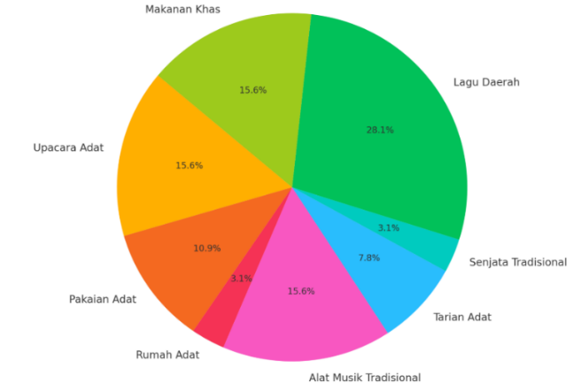

Figure 5. Diagram of daily access to cultural diversity content by students
The adaptation process that students undergo when they are in a new environment

According to Young Yun Kim (2001), intercultural adaptation is a process that requires individuals to change their way of life and communication patterns in order to adapt to a new culture. This process is also experienced by new students in the Cultural and Religious Tourism Study Program, IAKN Tarutung. In addition to gaining understanding through the Intercultural Communication course, students also get additional exposure through access to religious content on social media.
In the adaptation process, students will face various dynamics when they are in a cultural environment that is different from their original background. To be able to adapt effectively to a new culture, students need to go through the stages of adaptation that are commonly experienced in an intercultural context. Kim identified three main stages in the adaptation process, namely: the arrival stage (honeymoon), the stress or culture shock stage, and the adjustment stage. These three stages are important in shaping students' ability to interact and communicate effectively in a new cultural environment.
In the early stages of the arrival process (honeymoon), students experience feelings of joy, enthusiasm, and high curiosity about the new culture they encounter. At this stage, students still have feelings of happiness and optimism about new experiences and a desire to explore and understand new cultures, because at this stage students still tend to be aware of deeper cultural differences. Next, the stress stage (cultural shock), students face the reality of greater cultural differences, which causes feelings of stress, confusion, and even frustration. This happens because students realize the differences between their home culture and the new culture. Usually caused by confusion about social norms, habits and lifestyles. At the adjustment stage, students begin to adjust to their new culture and learn to navigate the differences that exist. At this stage, students begin to feel more comfortable and are able to communicate more effectively with people from new cultures. What students do is start learning to adapt to the way they speak, body language, and interact in accordance with the new culture. The stages of adaptation carried out by students when they are in a new culture, as well as the triggering factors and the length of time to adapt to the three processes can be seen in Table 3 below:

Table 3.
The process of student adaptation in a new environment

NO | Adaptation Process | understanding | Trigger factors | The impact | Long adaptation time
1 | Honeymoon | The phase where a person still has high enthusiasm and curiosity and is enthusiastic about the new atmosphere that they will experience. | Natural beauty  First time to the destination  Discovering the uniqueness of new culture  New environment and atmosphere  New friends | Having a feeling of happiness  Upload content/stories related to the destination  Share stories | 1-2 weeks
2 | Stress (cultural shock) | The phase where the burning enthusiasm and curiosity change into frustration, annoyance and inability to do anything because the actual reality does not match the expectations that were had at the beginning of the stage. | Differences in language, food, weather, habits | Daily activities become ineffective | 1 month
3 | Adjustment | The phase where a person will start to develop various ways to be able to adapt to the existing situation. A person begins to resolve the crisis experienced in the frustration phase. | Don't want to be in a stressful phase for too long and want to adapt quickly. | Grammar adjustments, understanding meaning, adjusting to food, weather and so on.. | 3 month

After going through these three adaptation processes, students can be more prepared and understand the adaptation process that they will experience. This is in line with Kim (2001), who stated that cultural adaptation is a dynamic process when individuals who enter a new environment will rebuild and maintain a stable and good relationship with their new environment.
From the discussion above, it can be concluded that understanding intercultural communication in the digital era plays an important role in creating effective communication, especially for students in multicultural classrooms. The use of social media platforms has significantly influenced the way students from various cultural backgrounds interact and communicate, as well as being a means to help them find strategies to improve the effectiveness of cross-cultural communication. Digital platforms provide various conveniences and innovative approaches that can be used wisely to overcome communication barriers. On the other hand, the socialization process through the Intercultural Communication course also plays an important role in raising students' awareness of the importance of accepting and appreciating diversity. Generation Z, who grew up and developed in a digital environment, greatly benefits from the presence of social media, which offer quick access to information and knowledge about new cultures.

The richness of features and flexibility of social media allow students to gain a more contextual and engaging learning experience, supporting the formal learning they receive in class. Every individual who enters a new cultural environment will certainly go through a process of adaptation; in this context, social media become an effective tool in helping students face communication challenges in that environment. With the increasing ability of students to solve communication problems, the creation of effective communication becomes more possible.

CONCLUSION

Understanding intercultural communication in the digital era makes it easier for individuals, especially students, to overcome various communication problems that often arise when they are in a new cultural environment. The development of digital technology has opened up wide access to cross-cultural information and knowledge, allowing students to adapt more quickly to the various communication dynamics they face. Social media are one of the effective tools that students can use to understand cultural differences in a more flexible and interesting way. The process of accepting and adapting to a new culture is a key factor in creating effective communication, especially in multicultural classes.
The results of this study indicate that the use of digital technology can act as a bridge to overcome communication barriers that arise due to differences in students' cultural backgrounds. Effective communication greatly influences the smoothness of the teaching and learning process and an inclusive academic atmosphere. Thus, communication barriers that often occur both in the classroom and in new environments can be minimized through the use of digital technology features, in addition to the importance of formal learning and socialization carried out in the classroom. The combination of conceptual understanding obtained through the Intercultural Communication course and independent exploration through social media has been proven to accelerate the process of student adaptation in a multicultural environment. The implications of these findings are expected to encourage the development of a curriculum that is more responsive to cultural diversity in the classroom, as well as encourage more integrative and technology-based intercultural communication teaching, considering that students are now increasingly digitally connected in their daily lives.

REFERENCES

Alo, L. (2004). Dasar-dasar komunikasi antarbudaya. Yogyakarta: Pustaka Pelajar.
Andriansyah, Irfan. Maharani, Anastasya. (2021). Optimalisasi Instagram Sebagai Media Marketing. Bandung: CV. Cendekia Press.
Cai, D. A., & Rodríguez, J. I. (1996). Adjusting to cultural differences: The intercultural adaptation model. Intercultural Communication Studies, 6(2), 31–42.
Datareportal.com. (2024, February 21). Digital 2024 Indonesia. Retrieved June 15, 2024, from https://datareportal.com/reports/digital-2024-indonesia
Dhifa Nabila., et al. (2020). Peradaban Media Sosial di Era Industri 4.0. Instrans Publishing Group
Hartono, Y., & Hasyim, D. (2003). Pendidikan multikultural di sekolah. UPT Penerbitan dan Percetakan UNS.
Kim, Y. Y. (2001). Becoming intercultural: An integrative communication theory and cross-cultural adaptation. Sage Publications.
Lutfhi, M. (2018). Upaya meningkatkan komunikasi antarbudaya dengan tujuan harmonisasi hegemoni warga. Jurnal Ilmu Komunikasi Network Media, 1(2). Retrieved from https://jurnal.dharmawangsa.ac.id/index.php/junetmedia/article/view/362
Mulyana, D. (2002). Ilmu komunikasi: Suatu pengantar. Bandung: Remaja Rosda Karya.
Mulyana, D., & Rakhmat, J. (2001). Komunikasi antarbudaya: Panduan berkomunikasi dengan orang-orang berbeda budaya. Bandung: Remaja Rosda Karya.
Mumtaz, A. T., & Karmilah, M. (2021). Digitalisasi wisata di desa wisata. Jurnal Kajian Ruang, 1(1). https://doi.org/10.30659/jkr.v1i1.19790
Nasrullah, R. (2015). Media sosial perspektif komunikasi, budaya, dan sosioteknologi. Bandung: Simbiosa Rekatama Media.
Samovar, L. A., McDaniel, R. E., & Porter, R. E. (2010). Communication between cultures (7th ed.). Wadsworth.
Shepherd, J. (2011). What is the digital era? In Social and economic transformation in the digital era (pp. 1–18). IGI Global. https://doi.org/10.4018/978-1-59140-158-2.ch001
Tapanuliutarakab.bps.go.id. (2023, February 10). Hasil long form sensus penduduk 2020 Kabupaten Tapanuli Utara. Retrieved July 17, 2024, from https://tapanuliutarakab.bps.go.id/id/publication/2023/02/10/e141c25e965dc0dd8ffd6e3d/hasil-long-form-sensus-penduduk-2020-kabupaten-tapanuli-utara.html

