Postmodernism Based on Communication Studies: Literature Review Through Mapping of NVivo 12 Pro

Geofakta Razali¹, Arsa Widitarsa Utoyo², Kurnia Setiawan³, Algooth Putranto⁴, Anita Rosana⁵
faktageo@gmail.com
- Sahid University
- Multimedia Nusantara University
- Tarumanegara Universitu
- Sahid University
- London School of Public Relation
Abstrak
Era modern tidak berpihak pada keunikan individu sebagai makhluk sosial, tetapi menganggap masalah sosial sebagai hal yang seragam. Hal ini memunculkan pemahaman baru yang disebut postmodernisme. Postmodernisme bersikap antipatetik terhadap penjelasan yang mengklaim berlaku untuk semua kelompok, budaya, tradisi, atau ras, serta tidak berfokus pada kebenaran relatif setiap orang. Perkembangan teknologi membuat komunikasi tidak lagi terikat oleh ruang dan waktu. Dengan demikian, kebebasan individu dalam berkomunikasi tidak lagi dapat diseragamkan. Di sisi lain, tuntutan untuk memberikan ruang bagi kebebasan individu semakin meningkat, seiring dengan kebebasan berekspresi yang disalurkan melalui berbagai media digital. Penelitian ini bertujuan untuk mengkaji dan memetakan studi komunikasi berdasarkan fungsi dan komponen pendukungnya, agar penelitian lebih lanjut dapat menganalisis bagaimana hal tersebut berhubungan dengan perkembangan postmodernisme yang memberikan kebebasan bagi setiap individu untuk berkomunikasi. Metode penelitian yang digunakan adalah tinjauan literatur yang diperoleh dari Google Scholar dengan bantuan PoP pada periode 2014-2023. Analisis literatur dilakukan dengan mengelompokkan studi komunikasi berdasarkan fungsi dan elemen pendukungnya yang dipetakan menggunakan metode Prisma dengan bantuan NVivo 12 Pro. Fungsi komunikasi terdiri atas fungsi sosial, ekspresi, dan instrumental. Elemen komunikasi meliputi sumber, pesan, media komunikasi, dan dampak komunikasi. Hasil penelitian menunjukkan bahwa studi ilmu komunikasi di era pasca-modernisasi saat ini didominasi oleh aktivitas komunikasi dalam bentuk ekspresi diri, terutama dengan dukungan media digital. Temuan ini juga sejalan dengan paradigma postmodernisme, yang menjadikan karakteristik individu dominan dalam proses komunikasi.
Kata kunci: Studi Komunikasi; NVivo 12 Pro; postmodernisme; prisma; publish or perish

Abstract
The modern era does not take the side of an individual’s uniqueness as a social being but considers social problems to be likened. This generates a new understanding called postmodernism. Postmodernism is antipathetic to explanations that claim to apply to all groups, cultures, traditions, or races. It does not focus on the relative truth of each person. Technological developments have made communication no longer bound by space and time. Thus, individual freedom in communication can no longer be likened. On the other hand, the demand to provide space for individual freedom is increasing, along with freedom of self-expression channeled through various digital media. This research aims to examine and map the study of communication based on its functions and supporting components, for further research to analyze how it relates to the development of postmodernism which gives freedom to each individual to communicate. The research method was a literature review obtained from Google Scholar with the help of PoP in the 2014-2023 period. Literature analysis was carried out by grouping communication studies based on their functions and supporting elements which were mapped using the Prisma method with the help of NVivo 12 Pro. Communication functions consist of social, expression, and instrumental. The elements of communication consist of sources, messages, communication media, and the impact of communication. The results of the research showed that the study of communication science in the current post-modernization era is dominated by communication activities in the form of self-expression, especially with the support of digital media. The findings are also in line with the postmodernism paradigm. It makes individual characteristics dominant in the communication process.
Keywords: Communication Studies; Vivo 12 Pro; postmodernism; prism; publish or perish

Introduction
The modern era has passed the classical period. The era has integrated into all aspects of life (Ziborov et al., 2021). The modern era has also been adopted in every study of science, which is marked by the development of classical scientific rationality with subject-object opposition, dominance of one truth, monologist, and an orientation especially towards truth (Kitchen & Proctor, 2015). The modern era is marked by the ongoing process of globalization in economic, political, and cultural life, which leads to the generalization of the feelings and values of the nation. This condition raises criticism from experts who consider the modern era to be the elimination of social aspects or individual freedom (Kuznetsova et al., 2020). These experts are considered the originators of postmodernism (Urmina et al., 2022).
Postmodern understanding is an understanding conveyed by postmodernism experts, namely the originators and adherents of postmodern theory who provide responses as well as criticism of the failure of modernism experts in completing and resolving various kinds of problems in social life (Aang Ridwan, 2013). The term postmodernism was first coined by a philosopher named J.F Lyotard (Ziborov et al., 2021). Postmodernists give harsh criticism to modernists in terms of the universality of the answers to the problems of social life. Postmodernism offers an understanding that any study of science that follows the modernization era must be able to adapt to the social conditions in which it is used to live and socialize (Murphy, 2007). In simple terms, the notion of postmodernism is the flexibility of every application of modernization, so that it is more in favor of one's character as a social being. Postmodernism has broadly begun to be applied to various studies of both social and scientific sciences. Postmodernists are highly skeptical of explanations that claim to apply to all groups, cultures, traditions, or races, and instead do not focus on the relative truth of each person.
In the current postmodern era, technology continues to develop very rapidly. Thus, it requires humans to be able to quickly adapt to the digital world, as a new space to present a virtual world and provide freedom for each individual to carry out any action that takes place continuously and has an impact on social life (Wahid et al., 2021). The development of digital technology has brought human dreams beyond boundaries, one of which is in communication activities. Technological developments make communication no longer have space and time boundaries. Hence, individual freedom in communication can no longer be likened. On the other hand, the demand to provide space for individual freedom is increasing, along with freedom of self-expression channeled through various digital media. This condition requires academics in the field of communication to be able to study how the form of criticism in the modernization era has become increasingly massive along with the development of communication media that favors individual freedom. (Nesya, 2021) Postmodernism, with its emphasis on pluralism and the deconstruction of meaning, drives transmedia branding to create diverse narratives across multiple platforms, allowing audiences to interact in multidirectional ways and interpret messages based on their unique contexts.
The study of communication science is closely related to its functions and elements. Especially, various means of supporting communication are increasingly diverse. It is not only through print media but also through digital media which has even created a new job space for digital content creators (Rahayu & Briandana, 2022). The growing development of communication media also has various impacts on social life. Sometimes, it even causes negative impacts. Based on the studies above, the researcher tries to examine various studies related to components in communication science from the point of view of postmodernism which is seen as a new space in communication that favors the freedom of each individual. A literature review is carried out by mapping research patterns based on aspects that support communication with the help of the NVivo 12 Pro program (Syaodih et al., 2021). The NVivo 12 Pro program was chosen because it can map in detail the relationship of each selected literature with the groupings that have been determined by the researcher. It includes how the characteristics of the articles are through the assigned code (Bandur, 2019; Mulyanti et al., 2022). It is expected that the findings of this research will show the pattern of communication activities over the past ten years and its relation to the current development of postmodernism.
Method
- Research Design
This research is a literature review. This adopted a qualitative descriptive design. The literature review was carried out by examining various studies over the past decade (2014 to 2023). Literature is obtained by searching on programs that are not paid, namely Publish or Perish or popularly known as the PoP abbreviation. Search for PoP programs is through several criteria. First is the source of literature by choosing Google Scholar. Both typings are in the year range (2014-2023). The third is the type of literature, namely articles sourced from journals (as publishers), and not in the form of books, papers, or final assignments. Fourth is keywords, including the words "postmodernism" and "communication". Search results with the PoP program obtained metadata of 200 articles (Figure 1).
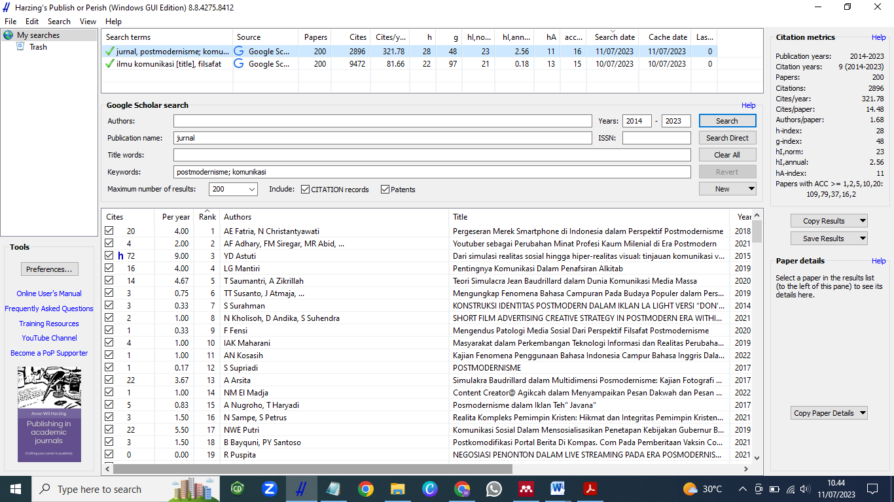
Figure 1. PoP view on reference literature search

- Research Data Analysis
Figure 2. Stages of literature reduction with the Prisma method

Thereafter, The metadata results from searching with the PoP program were stored in the "ris" format. Thus, they are easily read by the Mendeley program. Through the Mendeley program, a selection was made for each title obtained based on the needs of the researcher. The selection process was the metadata reduction stage of the PoP program. At this stage, the researcher used the Prisma method (Figure 1). The selected literature was then analyzed and codified through the NVivo Pro 12 program. The initial mapping of the NVivo 12 Pro program is shown in Figure 3. In NVivo, the nodes are the study of communication science, with the code "Communication", and the nodes have branches in the form of child nodes, including functions and elements of communication. In Figure 3, The grouping adopts the research of Razali (2020), which is the study of communication science associated with postmodernism, including the functions and elements of communication. The communication function is divided into three criteria, namely the function of expression, social function, and instrumental function. On the elements of communication, researchers grouped them into sources, media, messages, and the impact of communication. Each literature review was given a year code and serial number, as described in the reduction process through the Prisma method. (Pérez-Esteban et al., 2023).

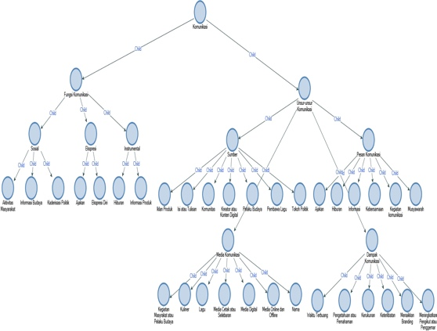
Figure 3. Mapping based on codification in NVivo 12 Pro Program

Result and Discussion
The classification of the literature review is based on communication functions, communication objectives, and elements of communication. Communication as a social function is a process of building communication in social activities with various accompanying aspects, such as culture. Communication as an expressive function is the process of conveying the expression of the communicator in conveying the meaning of what is communicated. Communication as a ritual function is closely related to cultural ritual activities, as a process of conveying messages from the rituals performed. Communication as an instrumental function, is a medium to inform or give impact to recipients of information in the form of entertainment, invitations, or beliefs. The further category is the elements of communication, including communication sources, communicators, messages in the communication process, communication media, and the impact of the communication process.
- Communication as Function
The process of communication cannot be separated from the functions conveyed in it. Communication becomes meaningful if it has a function or role. Based on Zumiarti (2020), Communication activities have several functions, namely the communication process which functions as a social activity, expression activity, ritual activity, and as an instrument. In this research, based on the literature obtained, three functions of communication were found. There were social, expressive, and instrumental functions (Figure 4). Communication as a social function is divided into community activities, cultural information, and political regeneration. Communication as an instrumental function is grouped into product information and entertainment. Finally, communication as expression is grouped into self-expression and solicitation. (Lestari, 2022) The relationship between interpersonal communication patterns and postmodernism lies in the shift toward fluid, individualized, and context-driven interactions, reflecting postmodernism’s embrace of subjective realities and diverse perspectives in meaning-making.
Communication as a social function means that communication is a process of activity that builds social communication. Social communication consists of various aspects, including activities related to culture (Razali, 2020). In Figure 4, communication activity as a social function is the least of the 20 studies that have been analyzed of 5 in the literature. In this group, the literature findings are regrouped into three namely community activities, cultural information, and political cadre formation. Community activities that are part of the local culture are the river transportation community in terms of communication regarding the determination of transportation fares on the Musi River in Palembang (Adli et al., 2021). Even though we are currently entering the era of postmodernism, local cultures in parts of Indonesia still adhere to the traditional way of communicating, namely through deliberation and consensus among community members. For communication as a social function, information is obtained that this study, even though it is small in number, remains a focus for the field of communication science. This can be seen from the distribution of years of article publication, and in the past two years, there have been no studies that have raised communication and social aspects, especially culture, as the focus of research that adopts postmodernism. (Suranto, 2024) Advocacy communication style aligns with postmodernism by encouraging diverse, decentralized voices to challenge dominant narratives, empowering individuals and communities to shape and redefine meaning within their unique cultural and social contexts.
The next grouping based on the communication function is the expressive function. The expressive function in communication studies is the process of conveying expressions from communication sources or communicators to convey the purpose of what is to be communicated or is being communicated (Razali, 2020). In this discussion, eight studies were obtained from the literature that was spread from 2014 to 2022. These findings indicated that the study of postmodernization in the science of communication-related to the function of expression is still in great demand today. One of the results of the study is the research of political communication, where during the postmodernization era, it has shifted to newer forms of media, namely through technological media (Simarmata, 2014). In addition, researchers found references to the study of communication science that leads to a culture of expression in the current digital age era, where social media is a means of self-expression, especially for children in their teens. The findings at this stage are valuable information for researchers. Thus, the current era of post modernization is an era dominated by communication activities in the form of self-expression, especially with the support of digital media. The findings are also in line with the postmodernism paradigm, which makes individual characteristics dominant in the communication process.
The last communication function discussed in this research is communication as an instrumental function. The function of communication as an instrument is the role of communication activity as a medium or intermediary to convey or inform the communicant, which can be in the form of entertainment, solicitation or persuasion, or impacting beliefs (Razali, 2020). In this discussion, seven studies were obtained and they always appear every year from the range of years that the researchers set, namely the last decade from 2014 to 2023. It can be concluded that the study of communication science that links postmodernism is still an attraction for academics, in particular on the role of communication as an instrumental. In this discussion, researchers grouped the instrumental functions into two, namely product information and entertainment. Product information in this section is dominated by the communication process in terms of product advertisements. One of the studies conducted was on the communication process of television advertisements for milk with the brand "Bear Brand".(Ayuswantana et al., 2022). The communication activity in this research is the communicator's effort to convey the figure of the Dragon as the main character, as a sign of strength as well as a representation of the benefits possessed by Bear Brand milk.
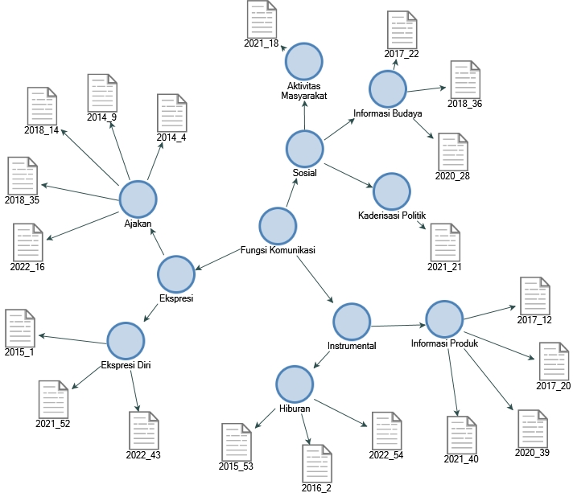
Figure 4. Mapping in the NVivo 12 Pro Program on communication functions

- Communication elements
Communication activity can be considered to occur if it includes elements of communication. The elements of communication will make communication effective because communication will occur if the communicator and the recipient have the same perception of what is being communicated (Ardiwinata & Ismuniar, 2021). In this research, the elements of communication are divided into four things, namely the source or communicator, the message or content of communication, communication media, and the impact of communication.
- Communicator or source of communication
In this discussion, the researcher classified the literature obtained based on the source of the occurrence of communication or communicators. Sources of communication can be actors or activities that cause communication. Sources of communication in the form of actors are sources of information or actors of communication. Based on the results of a review of 20 works of literature, communication sources are divided into six criteria, namely songwriters, political figures, cultural actors, communities, creators of digital content, product advertisements, and content or writing. It can be seen from Figure 5 that the literature obtained on communication elements in the form of sources is dominated by digital content or content creators. The literature in this group is eight and there are almost every search year span. This finding shows information that the study of communication science which includes elements of digital content is interested by communication science observers, especially in studies related to postmodernism, in which communicators create self-identities in the current post-modern era through various technological media.
One of the studies in this discussion is the literature code 2020_39 which discusses the Golden Tulip Legacy Hotel Surabaya's digital marketing communication strategy to overcome the challenges of the postmodern era (Teguh & Ciawati, 2020). The study of the literature shows that the post-modern era in communication science by utilizing media technology or content creators as communicators has received a lot of attention, compared to studies on communicators who utilize mass media or community activities. The findings at this stage also serve as information that the study of communication science in terms of its elements in the form of communicators is not the focus of arts workers. Studies that are also lacking in interest are research studies that use songwriters as communicators or sources of communication. On the other hand, these two things are elements of communication that were very popular before the digital age era, where a song or writing in the form of a book is an important part of the language and literature communication process.

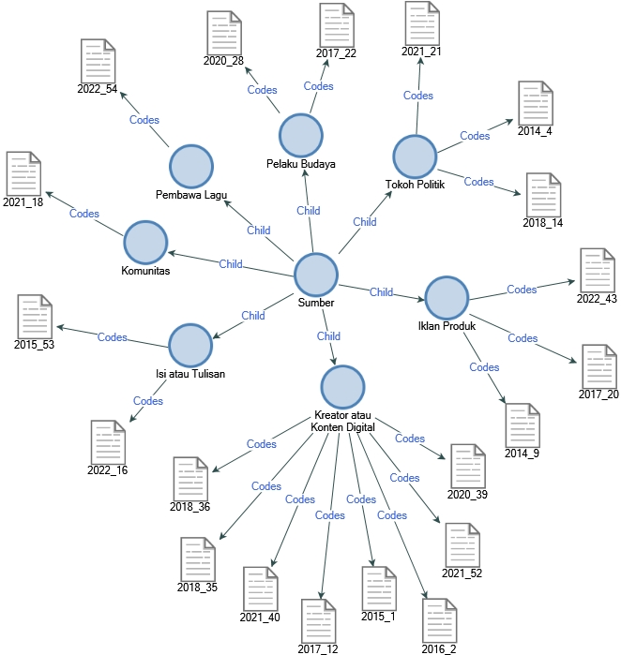
Figure 5. Source mapping in the NVivo 12 Pro program

- Message of Communication
The next element of communication in this study is the message or content of the communication process. Communication activity occurs when a message is conveyed during the communication process. The message from a communication activity is an integral part that must be studied in communication science. The elements of communication in the form of messages in this study are divided into six, including invitations, deliberations, entertainment, communication or discussion activities, togetherness, and information. Based on a study of 20 literature, the general results of a communication study were obtained which linked it to the postmodernization era in terms of message content in the form of information. (Dwipayana & Maeni, 2022). Information is the communication message that is most in demand by researchers in the field of communication science. A total of eight literature state that the message of communication is information and the literature is published in each search year (2014-2021). On the other hand, communication studies stated that the contents of messages in the form of togetherness between cultures were the least chosen as the focus of research. These results become a potential study opportunity for researchers in the field of communication science, moreover, cultural diversity in Indonesia is very rich. Thus, it requires more attention as a research study, especially in the current era of globalization which is heavily influenced by foreign cultures (Rabrusun & Lopulalan, 2023).
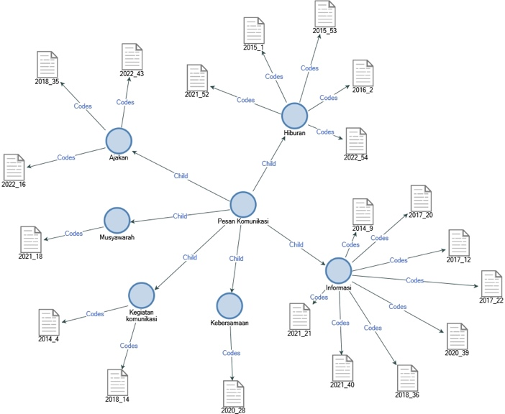
Figure 6. Communication message mapping in the NVivo 12 Pro program

- Communication media
Studies in communication science cannot be separated from the use of an intermediary or communication media. Communication media develops along with the advancement of science (Anwar et al., 2016). Previously, communication media was in the form of handwriting or through mass media, but now, this has been replaced with the help of technology and transformed into digital form. This is in line with the study of communication science which has changed since the post-modernization era, where technological media is used to adjust the characteristics or needs of communicators and communicants. The era of post-modernization which emphasizes individual characteristics in the modern era, is increasingly supported by the existence of technology. It is increasingly typical of giving rise to one's personality as a social being. In this discussion, the 20 literatures reviewed are grouped based on elements of communication in the form of media including print media, culinary or food, names, online and offline media, and community activities or cultural actors (Figure 7).
The findings in this research indicate that communication media in the form of print or cultural identity is the research with the lowest interest. As discussed previously, technological means are the most dominant, as well as in terms of communication media. The current postmodern era, where modernization has received criticism due to the lack of social aspects, is also shown through communication media. It is proven to be more on technology studies. Hence, communication is always synonymous with the term ICT or information and communication technology (Urmina et al., 2022). Therefore, it becomes inseparable between technology, information, and communication. The communication media that has been studied the most is digital media, such as social media, websites, or digital platforms which can be suggestions for disseminating information. Communication media in the form of cultural identity is still a promising research opportunity, one of which is cultural identity in culinary form. Culinary is a means of cultural communication in a region, and is one of the attractions for foreign tourists to visit Indonesia. This finding is a motivation for academics in the field of communication science, that culinary delights from various cultures in Indonesia have great potential for further study. In the end, the study of communication science research will adapt to the post-modernization era which campaigns for an era of modernization that is more pro-social.
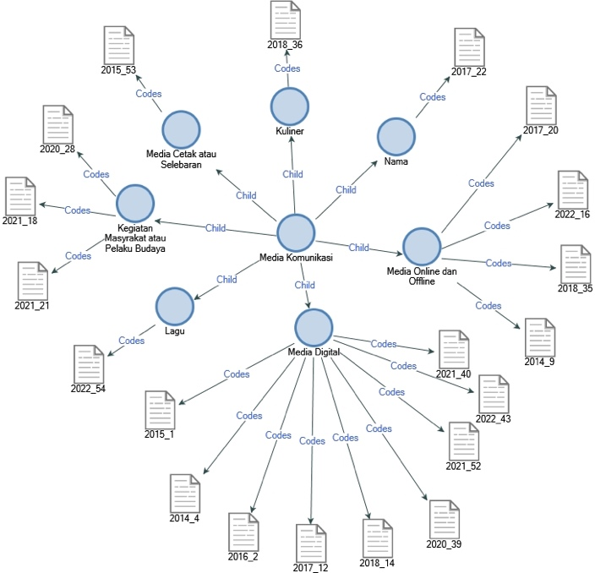
Figure 7. Communication media mapping in the NVivo 12 Pro Program

- Communication Impact
The last element of communication is the impact that occurs from communication activities. A communication process occurs if there is an effect formed after the communication activity. This is in line with the purpose of communication, namely the occurrence of a common perception between communicators and communicants. In this research, a review of 20 literature based on the impact is divided into six, such as involvement, increasing followers, knowledge, branding, wasting time, and harmony (Figure 8). Several findings indicated that negative impacts often occur with communication activities through digital devices such as the use of smartphones by school-age children (Istiyanto, 2016). Smartphones, which are purposely used as a means of communication between individuals, have been transformed into a means of communication or a source of information on various matters, including entertainment.
The misuse of technological media as a means of communication or interaction shows that the era of postmodernization gives individuals freedom to obtain information. Thus, it requires more intense supervision and education (Rorong, 2019). Figure 8 shows that the impact of communication in a balanced way shows positive and negative things. Positive things include increasing understanding or knowledge. On the contrary, the negative impact shows that time is wasted for students, who spend more time looking for entertainment through their gadgets.(Istiyanto, 2016). Assistance to children in using communication tools is important at this time, along with the increasingly massive flow of digital information. This should be an in-depth study for researchers in the field of communication. Thus, they can contribute to providing communication education for children who do not understand well how to use communication tools, and to be more careful in filtering information in today's digital world (Naamy, 2018).
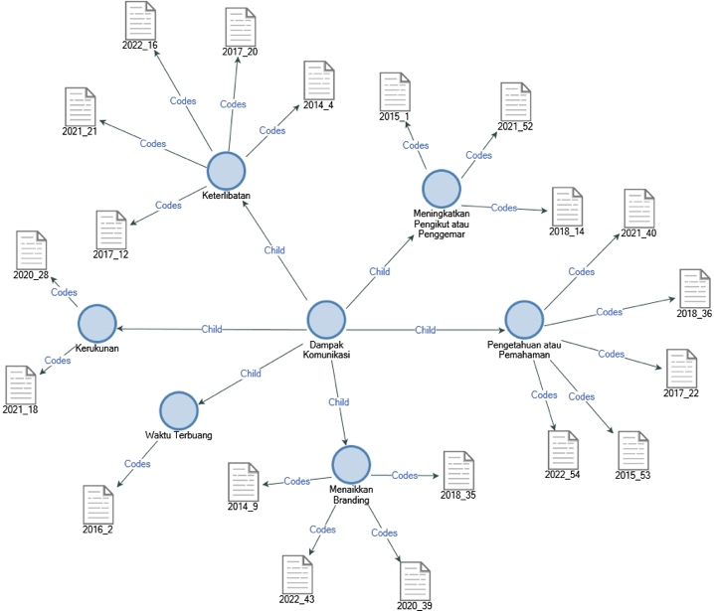
Figure 8. Communication impact
mapping in the NVivo 12 Pro Program

Conclusion
Communication as a social function remains the spirit and focus of communication science, especially those that promote culture as a research focus that adopts postmodernism. The era of postmodernization is dominated by communication activities in the form of self-expression, especially with the support of digital media. The findings are also in line with the postmodernism paradigm. It makes individual characteristics dominant in the communication process. Communication sources are divided into six criteria, such as songwriters, political figures, cultural actors, communities, creators of digital content, product advertisements, and content or writing. Communication elements in the form of media include print media, culinary or food, names, online and offline media, and community activities or cultural actors. The impact caused by communication is divided into six aspects, there is involvement, increasing followers, knowledge, branding, wasting time, and harmony.

Reference
Aang Ridwan. (2013). Filsafat Komunikasi. In Ilmu Komunikasi (Vol. 1). Bandung: Cv. Pustaka Setia.
Adli, Evanne, L., Karmila, L., & Dendi. (2021). Pola Komunikasi kelompok Komunitas Angkutan Air pada Bantaran Sungai Musi– Palembang. Jurnal Ilmu Komunikasi Balayudha, 1(2), 44–59. https://jurnal.uss.ac.id/index.php/jikoba/article/view/291
Anwar, R. K., Rizal, ,Edwin, Novianti, E., & Sugiana, D. (2016). Adaptasi Media Interaksi Sosial Tradisional. JAQFI: Jurnal Aqidah Dan Filsafat Islam, 1(1), 83–104.
Ardiwinata, E., & Ismuniar, C. (2021). Kemampuan Komunikasi Orangtua Dalam Mitigasi Learning Loss Pada Anak Di Kota Tarakan. Jurnal Mahasiswa BK An-Nur : Berbeda, Bermakna, Mulia, 7(3), 93. https://doi.org/10.31602/jmbkan.v7i3.5805
Ayuswantana, A. C., Darmawan, Y. S., & Nastiti, R. A. (2022). Kajian Sosok Naga Pada Iklan Susu Bear Brand 2015 & 2021 Dalam Sudut Pandang Postmodernism. Demandia, 7(1), 1–22. https://doi.org/10.25124/demandia.v7i1.3836
Bandur, A. (2019). Penelitian Kualitatif (Studi Multi-Disiplin Keilmuan dengan Nvivo 12 Plus). In Jakarta: Mitra Wacana Media. Mitra Wacana Media.
Dwipayana, A. A. P., & Maeni, R. (2022). New Media Dan Etika Komunikasi Digital (Upaya Meninjau Prinsip Tanggungjawab Hans Jonas). Maha Widya Duta : Jurnal Penerangan Agama, Pariwisata Budaya, Dan Ilmu Komunikasi, 6(1), 11. https://doi.org/10.55115/duta.v6i1.2082
Istiyanto, S. B. (2016). Telepon Genggam Dan Perubahan Sosial Studi Kasus Dampak Negatif Media Komunikasi dan Informasi Bagi Anak-Anak di Kelurahan Bobosan Purwokerto Kabupaten Banyumas. Jurnal Komunikasi Ikatan Sarjana Komunikasi Indonesia, 1(1), 58. https://doi.org/10.25008/jkiski.v1i1.36
Kitchen, P. J., & Proctor, T. (2015). Marketing communications in a post-modern world. Journal of Business Strategy, 36(5), 34–42. https://doi.org/10.1108/JBS-06-2014-0070
Kuznetsova, E. O., Shafazhinskaya, N. E., Kamenets, A. V., Meleshkina, E. A., & Orlova, N. G. (2020). Change of Postmodern Paradigm in Cultural studies and Socio-cultural Practice. Rupkatha Journal on Interdisciplinary Studies in Humanities, 12(1), 1–16. https://doi.org/10.21659/rupkatha.v12n1.17
Lestari, S. (2022). POLA KOMUNIKASI INTERPERSONAL ORANG TUA DAN ANAK DALAM MEMAHAMI BAHAYA GADGET DI TANGERANG. Jurnal Visi Komunikasi, 20(02), 169 - 186. doi:http://dx.doi.org/10.22441/visikom.v20i02.14350
Mulyanti, S., Mardhiya, J., & Solihah, M. (2022). Perspectives on Green Chemistry and the Application of Nvivo 12 Software: A Case Study of Pandemic Period in Chemistry Education. Scientiae Educatia: Jurnal Pendidikan Sains, 11(1), 49–55. https://www.syekhnurjati.ac.id/jurnal/index.php/sceducatia/article/view/10280
Murphy, D. J. (2007). The future of human and humanity. People, Plants and Genes, 27(1), 279–287. https://doi.org/10.1093/acprof:oso/9780199207145.003.0017
Naamy, N. (2018). Runtuhnya Dunia Sosial Di Era Komunikasi Media Simulakra. Komunike, 10(1), 77–88. https://doi.org/10.20414/jurkom.v10i1.559
Nesya, N., & Atmodjo, J. (2021). MODEL PEMASARAN DIGITAL ‘TRANSMEDIA BRANDING’ PADA CHANNEL NARASI.TV. Jurnal Visi Komunikasi, 19(02), 170-191. doi:http://dx.doi.org/10.22441/visikom.v19i02.11390
Pérez-Esteban, M. D., Carrión-Martínez, J. J., & Ortiz Jiménez, L. (2023). Systematic Review on New Challenges of University Education Today: Innovation in the Educational Response and Teaching Perspective on Students with Disabilities. Social Sciences, 12(245), 1–28. https://doi.org/10.3390/socsci12040245
Rabrusun, N., & Lopulalan, D. L. Y. (2023). Strategi Pemerintah Kota Tual Dalam Pelestarian Bahasa Daerah Sebagai Alat Komunikasi Publik. Jurnal Ilmu Komunikasi Pattimura, 2(1), 284–296. https://doi.org/10.30598/jikpvol2iss1pp284-296
Rahayu, E. K., & Briandana, R. (2022). Teknologi Komunikasi dan Pendidikan: Aplikasi E-Pasraman sebagai Bentuk Konstruksi Sosial Teknologi dalam Media Baru. Calathu: Jurnal Ilmu Komunikasi. https://journal.uc.ac.id/index.php/calathu/article/view/2440
Razali, G. (2020). Pengantar Ilmu Komunikasi, Hakikat Dan Unsur-Unsur Komunikasi. In Ilmu Komunikasi Dan Informasi & Transaksi Elektronik (pp. 1–20). CV. Media Sains Indonesia.
Rorong, M. J. (2019). Penempatan Teori Dalam Ilmu Komunikasi. Commed : Jurnal Komunikasi Dan Media, 4(1), 90–107. https://doi.org/10.33884/commed.v4i1.1417
Suranto, H., Bangun, C., Tjokrodinata, C., Feego, E., & Estherina, B. (2024). Corporate Social Advocacy Communication Style on #TBSFightForSisterhood on Instagram. Jurnal Visi Komunikasi, 23(01), 19 - 30. doi:http://dx.doi.org/10.22441/visikom.v23i01.23145
Simarmata, S. (2014). Media Baru, Ruang Publik Baru, Dan Transformasi Komunikasi Politik Di Indonesia. Jurnal Perkotaan, 3(2), 18–36.
Syaodih, E., Samsudin, A., Suhandi, A., Aminudin, A. H., Fratiwi, N. J., Adimayuda, R., & Rachmadtullah, R. (2021). Parent’s perspective on early childhood learning needs during covid-19 using nvivo 12 software: A case study in indonesia. Kasetsart Journal of Social Sciences, 42(4), 924–931. https://doi.org/10.34044/j.kjss.2021.42.4.28
Teguh, M., & Ciawati, S. T. (2020). Perancangan Strategi Digital Marketing Communication Bagi Industri Perhotelan Dalam Menjawab Tantangan Era Posmodern. Bricolage: Jurnal Magister Ilmu Komunikasi, 6(1), 51–134. https://doi.org/10.30813/bricolage.v6i01.2067
Urmina, I. A., Onuchina, K. K., Irza, N. D., Korsakova, I. A., & Chernikov, I. A. (2022). Intermedial Postmodernism in Art: Concepts and Cultural Practices. Rupkatha Journal on Interdisciplinary Studies in Humanities, 14(2), 0–14. https://doi.org/10.21659/rupkatha.v14n2.02
Wahid, U., Usino, W., Vera, N., Hardjianto, M., & Budiyanto, U. (2021). Komunikasi Budaya Kebudiluhuran melalui Kebijakan Inovasi Teknologi. Jurnal Ilmu Komunikasi, 19(1), 108–126. http://www.jurnal.upnyk.ac.id/index.php/komunikasi/article/view/3740
Ziborov, O., Medushevskaya, N., & Sigalov, K. (2021). The sociocultural context in law: modernism - postmodernism - metamodernism. Wisdom, 1(1), 232–245. https://doi.org/10.24234/wisdom.v1i1.682
Zumiarti. (2020). Teori, Fungsi, dan Manfaat Komunikasi. In Ilmu Komunikasi Dan Informasi & Transaksi Elektronik (pp. 57–79). CV. Media Sains Indonesia.

