PODCAST BOCOR ALUS POLITIK’S ROLE IN BUILDING
GEN Z'S POLITICAL AWARENESS
AHEAD THE 2024 ELECTION

Rachma Tri Widuri¹, Ariadne Khatarina Moniaga²
Politeknik Tempo, Jakarta¹²
Jl. Palmerah Barat No.8, RT.3/RW.5, Grogol Utara, Kec. Kby. Lama, Kota Jakarta Selatan, DKI Jakarta 12210
rachma.widuri@politekniktempo.ac.id

  - Abstract
This study explores how Tempo Media Group’s Bocor Alus Politik podcast enhances Generation Z’s political awareness as beginner voters in the 2024 Election. Available on Spotify and YouTube, this podcast was designed to meet the visual preferences of young people. Since it’s launch on May 20, 2023, it has launched several episodes which sparked public discussions and opinions towards the political figures. Using the uses and gratifications theory, this qualitative study with in-depth interviews and social media observations finds that Bocor Alus Politik significantly shapes Gen Z’s perception of the 2024 Election, demonstrating social media’s impact on fostering political awareness among young voters.

Keywords: Podcast, Bocor Alus Politik, Tempo Media, Gen Z, 2024 Election.

  - Abstrak
Penelitian ini mengeksplorasi bagaimana siniar Bocor Alus Politik milik Tempo Media Group meningkatkan kesadaran politik Generasi Z sebagai pemilih pemula pada Pemilu 2024. Tersedia di Spotify dan YouTube, siniar ini dirancang untuk memenuhi preferensi anak muda, yaitu media visual. Sejak diluncurkan pada 20 Mei 2023, beberapa episodenya telah memicu diskusi dan opini publik terhadap para tokoh politik. Dengan menggunakan teori uses and gratification, penelitian kualitatif dengan wawancara mendalam dan observasi media sosial ini menemukan bahwa siniar Bocor Alus Politik secara signifikan membentuk persepsi Generasi Z terhadap Pemilu 2024. Selain itu, media sosial berperan dalam menumbuhkan kesadaran politik di kalangan pemilih muda.

Kata kunci: Siniar, Bocor Alus Politik, Tempo Media, Gen Z, Pemilu 2024

In the digital era which makes the exchange of information so easy and abundant, society faces new challenges in sorting information. More ability and precision are needed to be able to recognize which news is valid and which information is wrong or even fake.
This condition is especially experienced by Generation Z, which was born with the very rapid development of information technology. The tsunami of information whose source is unclear means Generation Z is at great risk of being exposed to misleading information such as hoaxes.
Elections as a big goal of the Indonesian people as a democratic country are not free from the threat of hoaxes. The Election Commission (KPU) has set a voting schedule for the Presidential Election and Regional Head Election simultaneously on February 14, 2022. Similar to the two previous elections, this election still faces the challenge of hoaxes. The difference is, now Generation Z as first-time voters are also targets and perpetrators of spreading disinformation. (KPU, 2022)
This tsunami of information is ultimately counterproductive and makes people reluctant to dig up or access information about the election, including Gen Z. Voters determine their choice more from the candidate's physical image rather than news from the mass media.
This is a sign of the demographic transition of voters in Indonesia, which is now dominated by the millennial generation and Gen Z (Jati, 2024:3).
Main role of mass media is to inform any news in the world, including political news. This is one of four functions of mass media as stated by Walter Lipman, namely as a trusted information source, educator, agent of change, and policy advocate. (Fianto, et.al, 2023). For audiences who cannot access information directly from sources, the role of mass media as a bridge between the authorities/government and ordinary people is very crucial. Society depends on what is conveyed by the media it trusts. As a result, society becomes especially dependent on the media for information. The media doesn’t directly dictate what people think—audiences don’t passively accept media messages (Philo, 2008). Instead, it directs public attention toward certain topics, effectively narrowing the range of viewpoints and arguments that shape public discourse.
There is a reciprocal relationship of mutual need and even mutual influence between the mass media and the world of politics. Mass media, due to its persuasive power, has the ability to shape political awareness and sway public opinion on emerging political matters. According to Merrill and Lowenstein, as cited in Kustiawan et al. (2022), mass media (such as newspapers) operate under the press system, which is in turn influenced by the prevailing political system.
UNESCO stated that the reading interest of Indonesian is only 0.1%. This means that out of 1,000 Indonesians, only one person likes to read. (GoodStat in August 2023).
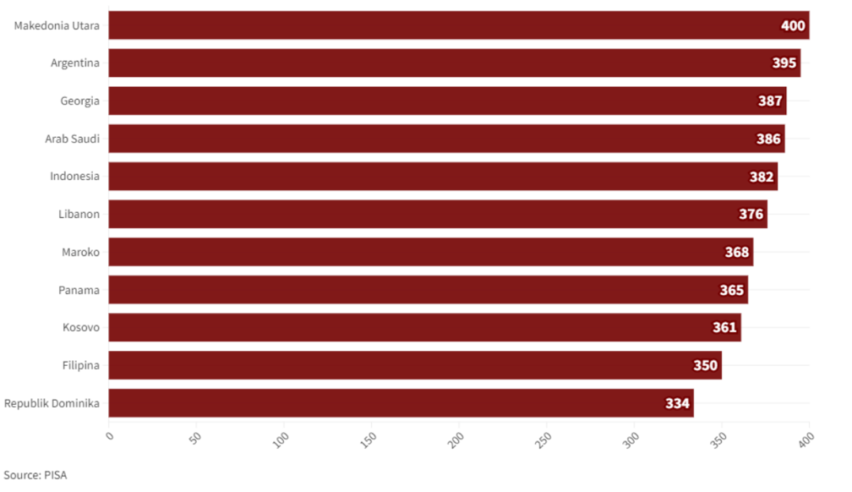
Figure 1. Countries with Lowest Literacy Index in the World (Source: PISA).
From media perspective, this is the root of the problem. The media is required to transform so that it plays a role as a channel for political communication. Political dynamics are part of the information that the media must contribute to the public. Basically, the media has a big influence on political developments in Indonesia. In an era of increasingly sophisticated technology, the use of media makes it very easy for political actors to disseminate political information and carry out political campaigns. The media has enormous power in a country's democracy because almost everyone gets their news from cable news and social media rather than original news sources. For this reason, this research was created to determine the significance of mass media in a delivering political communication messages.
Based on this tendency, Tempo Magazine produced a podcast entitled Bocor Alus Politik. This podcast was created to attract a generation that is no longer interested in reading, such as Gen Z. So, the contents of Tempo Magazine are translated into an audio-visual platform, so that people who don't read magazines can still capture the essence of the news even just by watching the podcast. From here, political awareness emerged which could guide Gen Z in voting in the 2024 elections.
In this study, Youtube and Instagram become the main arenas of analysis, where public opinion and debate develop. This study emerged from the awareness of the role of digital media, especially Youtube, in shaping public awareness of controversial cases, including politics. (Adi, 2024).
Based on the problems above, this study intented to explore:
1. What is Tempo's aim in producing the Bocor Alus Politik Podcast which is outside of its core print business?
2. Is it true that Bocor Alus Politik has contributed to raising Gen Z's political awareness?
3. What values, attitudes, and characters displayed by BAP can arouse Gen Z's interest in watching, and then encourage them to take a political stance?

Podcast Bocor Alus Politik
Bocor Alus Politik is a podcast that has been officially broadcast by the editors of Tempo Magazine since 2022. This podcast is fronted by five Tempo Magazine editorial crew. Stefanus Pramono, Egi Adyatama, Francisca Christy Rosana, Hussein Abri Donggoran, and Raymundus Rikang, are print media journalists recognized by the Pantau Foundation for their courage in explaining various legal and political maneuvers from the Istana Merdeka.
Bocor Alus Politik, a podcast owned by Tempo magazine and available on YouTube and Spotify every Saturday, has received recognition as the fastest-growing channel on YouTube and the most popular channel on Spotify Indonesia in 2023.
Bocor Alus Politik is an audio-visual format of Tempo Magazine's main news, which is broadcast ahead of the magazine's publication schedule. So the function of the Bocor Alus Politik Podcast is more or less as a teaser so that the audience is moved to read the full report in Tempo Magazine. Social media quickly became an outlet for many news media platform to airing their news. (Firmansyah, 2023).
Tempo magazine itself was founded in 1971. In 1982, Tempo was banned for the first time due to its sharp criticisms of the New Order regime and the Golkar Party amid the 1982 election.
A second ban came on June 21, 1994. The second ban occurred on June 21, 1994. Tempo magazine was banned by the government through the Minister of Information Harmoko. After Soeharto stepped down on May 21, 1998, it was agreed that Tempo magazine should be published again. So, since October 6, 1998, this magazine has returned under the auspices of PT Arsa Raya Perdana. (Setyarso, 2011: 36).
Gen Z
Generation Z, or Gen Z, refers to individuals born between 1995 and 2010. This term is rooted in Karl Mannheim's 1923 generational theory, which led sociologists to categorize people into various generational cohorts: the Depression Generation, World War II Generation, Post-WWII Generation, Baby Boomer Generations I and II, Generation X, Generation Y (Millennials), and, subsequently, Generation Z (Adica, 2022).
Alternatively, Codrington's generational theory outlines five distinct generational groups based on birth years: (1) Baby Boomers (1946–1964), (2) Generation X (1965–1980), (3) Generation Y (1981–1994), also known as Millennials, (4) Generation Z (1995–2010), sometimes referred to as the iGeneration, Net Generation, or Internet Generation, and (5) Generation Alpha (2011–2025) (Codrington in Hidayat, 2023).
A 2018 study by Tracy Francis and Fernanda Hoefel of McKinsey identifies four main behavioral traits associated with Gen Z, as illustrated in the figure below:

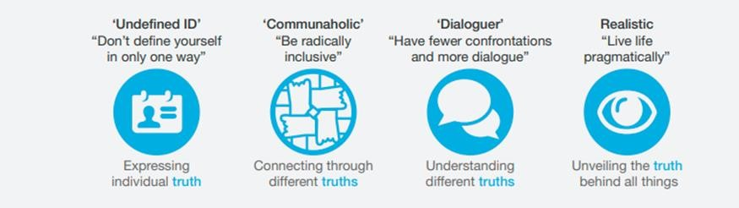
Figure 2: The search for the truth is at the root of all Generation Z’s behavior (Source: McKinsey, 2018).
Firstly, Gen Z is known as "the undefined ID," reflecting their appreciation for personal expression without attaching specific labels. Secondly, they are seen as "the communaholic" generation, highly inclusive and eager to participate in various communities, utilizing advanced technology to amplify their impact. Thirdly, Gen Z is called "the dialoguer," emphasizing their belief in the power of communication for conflict resolution and social change through dialogue. Lastly, they are labeled "the realistic," as they tend to be more practical and analytical in addressing issues of disconnection compared to previous generations (Francis, 2018).
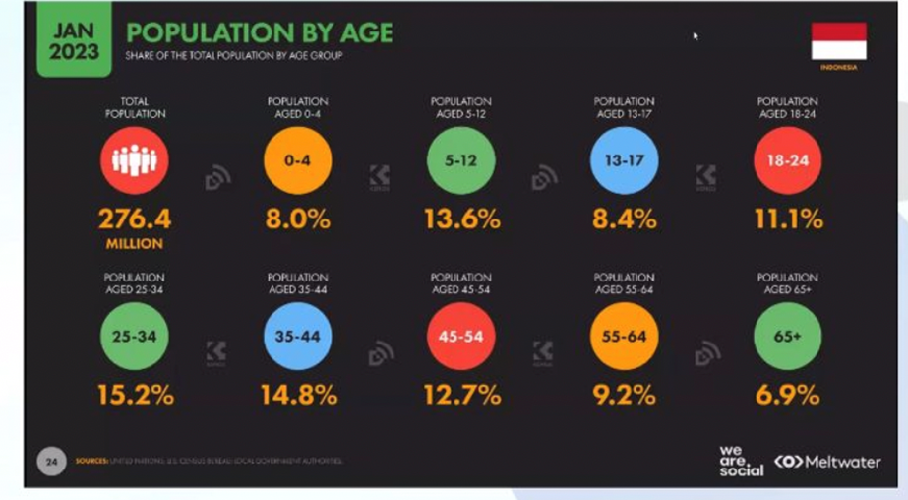
Figure 3. Population by Age, as January 2023. It shows that Gen Z is becoming the majority population (Source: We Are Social).
Presently, 70.72% of Indonesia’s population is of productive age (15-64 years), positioning the country to benefit from a demographic bonus projected to culminate in a "Golden Indonesia" by 2045. Generation Z, making up nearly 28% of the population—or around 75 million people—is the largest generational group. Their influence may surpass that of Millennials, who currently make up the second-largest group, totaling approximately 69.38 million people, or around 26% of the population.(IDN Research Institute).

Political Awareness
Zaller stated that political awareness is ‘‘the extent to which an individual pays attention to politics and understands what he or she has encountered’’ (Zaller 1992, in Solhaug, 2018). Political awareness involves an "intellectual or cognitive engagement with public affairs," evident through people’s grasp of governmental and political facts. This awareness forms through the exchange of political information between individuals and diverse sources in the public sphere. Widely recognized as a vital asset, political awareness shapes individuals’ political involvement, impacting both participation and active citizenship. Though there is some agreement on what constitutes political awareness, its conceptualization varies.
In democracies, political participation strengthens the government’s legitimacy, with legitimacy and citizen support playing key roles in democratic stability (Gil de Zúñiga et al., 2014 in Zelda, 2022).
Political knowledge and participation are central to democratic processes. The quality of citizenship and overall societal health are contingent on political knowledge, which correlates positively with voting behavior (Gallego & Oberski, 2012; Büchi & Vogler, 2017; Weinschenk et al., 2021). Empirical studies on voting behavior reveal that political knowledge significantly increases the likelihood of voting (Büchi & Vogler, 2017; N. Jung et al., 2011).
Besides that, several studies provide evidence for the simultaneous predictive value of political awareness and political knowledge on institutionalized and unconventional political activities (Gallego & Oberski, 2012; Johann, 2012). Hence, there is a need to understand better how political knowledge and awareness simultaneously impact political participation.
Political knowledge is essential for democracy, making it an important variable to consider, as it is a significant predictor of political engagement, such as voting turnout (de Vreese & Boomgaarden, 2006). In this study, political knowledge includes familiarity with electoral laws, processes, the purpose of elections, campaign issues, and actively following political news updates.
Political participation here is hypothesized through four indicators: active involvement in political discussions, expression of political aspirations, support for government initiatives, and promoting the policy-making process.
Relevant research explores political awareness and the formation of national identity, such as William A. Galston’s article “Political Knowledge, Political Engagement, and Civic Education,” which shows that political knowledge affects acceptance of democratic values, issue attitudes, and participation. Education is shown to be positively correlated with political participation (Fitri, 2023).
Print media reports expressed in sentences can only be interpreted by audiences who use an active mental system. Therefore, news, editorials, opinions, articles, and editorials must be arranged in such a way that they are easily digested by lay audiences. Meanwhile, radio listeners have a passive mental system and are very dependent on whether the words spoken by the announcer are clear or not. Meanwhile, television (audio-visual) media can fulfill the needs and desires of the audience.
The relationship between mass media and voters' political awareness in general elections has been widely studied by communication scientists, especially political communication. Sidney Kraus and Dennis David argue that media have an significant part in elections. Particular news from mass media can shift face-to-face as the most important channel for conveying political information. (Arriannie, 2022: 256-259).

2024 Election
Under the mandate of Law No. 7 of 2017 concerning General Elections Article 167 paragraph (8), the 2024 general election is a means of popular sovereignty to elect members of the DPR, DPRD, President and Vice President, and DPD. Elections are carried out directly, publicly, freely, secretly, honestly, and fairly based on Pancasila and the 1945 Constitution.
The Election Organizer consists of the KPU, Bawaslu, and the Honorary Council of General Election Organizers as one unit. The election participants are political parties, individuals, and pairs of candidates assigned by political parties or groups of it. Voters are Indonesian citizens who are 17 years of age or older, are married, or have previously been married.
The 2024 election stages begin with program and budget planning starting June 14, 2022. Then the preparation of KPU regulations, updating voter data, and compiling the voter list. Next is the registration and verification stage for participants in the 2024 Election on 29 July 2022 – 13 December 2022. The results will then be determined on 9 February 2023. At the time of determination, the three valid pairs of candidates for President-Vice President in the 2024 Election were Anies Rasyid Baswedan-Muhaimin Iskandar, Prabowo Subianto-Gibran Rakabuming Raka, and Ganjar Pranowo-Mahfud MD.
Nominations for President and Vice President will be held between 19 October 2023 – 25 November 2023. Next, during 28 November 2023 – 10 February 2024 is the campaign period. For three days, 11-13 February 2024 is the campaign's quiet period.
Voting in the 2024 Election will be held on February 14-15, and vote recapitulation will be until March 20, 2024. The peak or end of the 2024 Election will be when the President and Vice President-elect take the oath of office on October 20, 2024. (KPU Information Page)
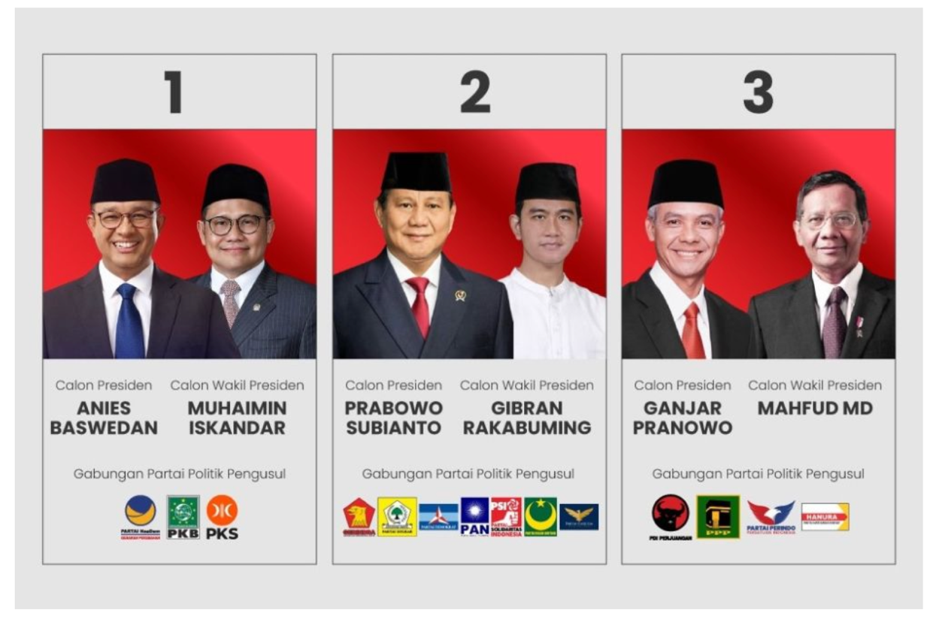
Figure 4. Candidate Pair for President – Vice President and Supporting Party in the 2024 Election.

  - METHOD
The research method used by researchers in this research is a descriptive qualitative method. Qualitative methods are approaches in social research aimed at gathering descriptive data through words and images. As Lexy J. Moleong explains, qualitative research collects data primarily in the form of words and visuals rather than numerical figures. (Wahyuni, 2023: 40). The method used to collect data is a literature study by collecting various supporting references regarding the role of mass media in forming political awareness.
Researchers also conducted in-depth interviews with the administrator of the podcast Bocor Alus Politik to explore the purpose of broadcasting this podcast. In-depth interviews were also conducted with viewers of Bocor Alus Politik who fall into the Gen Z category, who were selected using purposive random sampling.

  - FINDINGS
Mass media is one channel to fulfill human needs for information and entertainment. Mass media is a product of modern technology as a channel for mass communication. It is one of the important elements in the mass communication process. Channels called mass media are necessary for mass communication to take place. Based on its form, mass media is grouped into:
1. Print media, which includes formats like newspapers, magazines, books, brochures.
2. Electronic media, covers outlets such as radio, television, films, slides, and videos.
Cangara describes media as tools or channels for communicators to relay messages to audiences, with mass media specifically using mediums like newspapers, radio, films, and television to convey information from sources to the public (Habibie, 2018).
One of the mass media that is consistent with its reporting focus on politics and law is Tempo Magazine. Almost all the main news in every edition of Tempo Magazine is political news. Following the editorial claims on its official website, Tempo Magazine is known for its investigative coverage, special editions on Indonesian history and figures, as well as socio-cultural themes. This approach is hardly used by other media. (Haryanto, 2024).
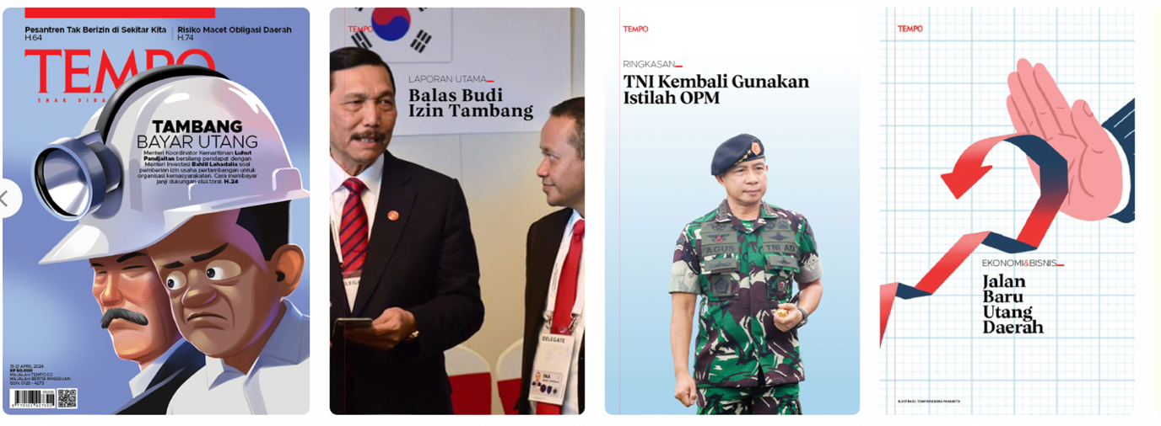
Figure 5. Cover series of various editions of Tempo Magazine, all with political themes.
There are five implications of the increasingly widespread use of tablet newspaper or paperless newspaper technology in the mass media industry in Indonesia. First, the direct implication is that there will be a massive technological shift from print media to a paperless newspaper business base which is very cheap in terms of procurement of production costs and distribution throughout the world. Second, another direct implication is that there is a change in people's orientation and lifestyle in accessing mass media. Third, the implications for media content will be more varied; because it reaches areas that are not separated by country/regional boundaries. Fourth, another main implication is that various mass media companies are increasingly integrating multimedia networks; so that multimedia convergence occurs. Fifth, another implication is that conventional print media companies will automatically go out of business. (Supadiyanto, 2013)
Research by IDN Times (2024) reveals that Gen Z’s reading habits emphasize the need to improve access to books and reading materials in Indonesia. Meanwhile, Indonesian traditional-print media is still at the adoption phase (Widuri, 2023)
One of the ways that Tempo Magazine has done to adapt and attract young readers is by visualizing the news that has been published in podcast form. In an in-depth interview, the Managing Editor for National News Tempo Magazines, Stefanus Pramono admitted that the Podcast Bocor Alus Politik is one of the efforts made by Tempo to attract the youth segment. "Back then, in 2022, when we initiated this conversation program, the aim was simple: to package complex political news into something easier to digest and have a wider reach," he said.
This is in line with the results of research by the IDN Research Institute in 2024. The research results indicate that as Indonesia heads into the 2024 elections, social and digital media will be crucial in influencing voters. Gen Z, in particular, depends heavily on social media and prefers short-form content over traditional news articles and detailed reports, making platforms like TikTok highly influential in shaping election outcomes. Aspiring political leaders will need to tailor their messages to address issues that matter to Gen Z, especially job creation, anti-corruption efforts, and welfare.
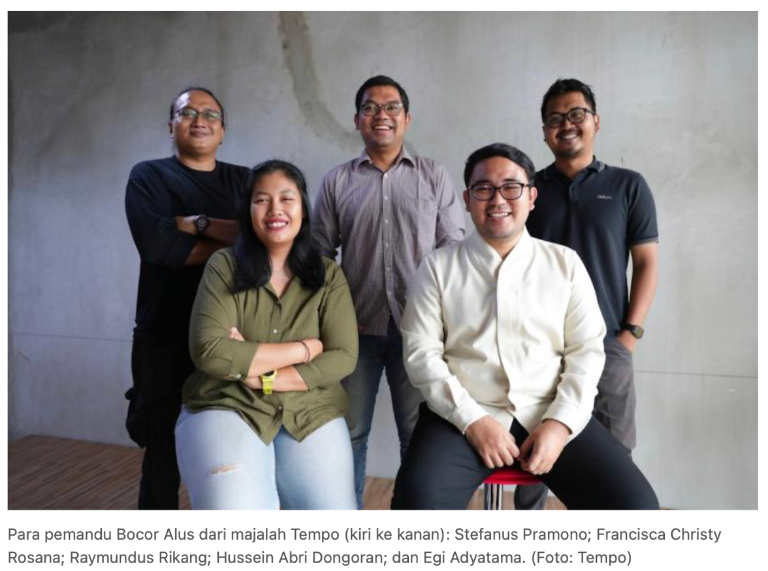
Figure 6. Host of Bocor Alus Politik Podcast won the Octovianus Pagau Award from Pantau Foundation.
According to Pram, the Bocor Alus program on YouTube is Tempo's effort to disseminate information as widely as possible. YouTube has become the most popular platform for Indonesian people to search for news. Reported on the official YouTube site, every month this social media platform is accessed by more than 2 billion users worldwide. The watch time reaches more than 1 billion hours. (Tumiwa dalam Septiana, 2024). A Populix survey last March showed that of the 79% of news consumer respondents, 94 percent accessed YouTube to search for information.
The concept of Bocor Alus is also simple: light conversation between journalists about the information they create for the print or digital version of the magazine. Tempo's digital edition is published every Sunday morning, while the print version is circulated on Mondays every week. So Bocor Alus, which airs every Saturday afternoon, becomes a kind of introduction for readers to find out what the political team writes on Sunday and the following Monday.
In the midst of the chaos of the 2024 elections, Tempo Magazine and Bocor Alus Politik have highlighted the serious challenges in exposing Jokowi's political maneuvers, which are often secretive. One of Jokowi's controversial steps ahead of the 2024 elections that was most highlighted by Bocor Alus was the appointment of Jokowi's eldest son, Gibran Rakabuming Raka, as a candidate for vice president. This sparked criticism of Jokowi's use of power and created a situation of doubt regarding the legitimacy of democratic institutions.
Bocor Alus Politik also discussed the role of Iriana, President Jokowi's wife, in Gibran's nomination as vice president. Tempo journalist Francisca Christy Rosanna (Cica) investigated directly in Solo, Central Java, Jokowi-Iriana's hometown to get data on Iriana's interference in Gibran's candidacy.
The large public response to Bocor Alus Politik resulted in an award from YouTube. Last October, YouTube awarded Tempo.co as a channel with fast viewership growth. That growth was supported by the podcast Bocor Alus Politik which is the most popular news program in 2023 on Spotify. "Awards are not the final goal of journalistic work, they are a marker of appreciation," said Pram.
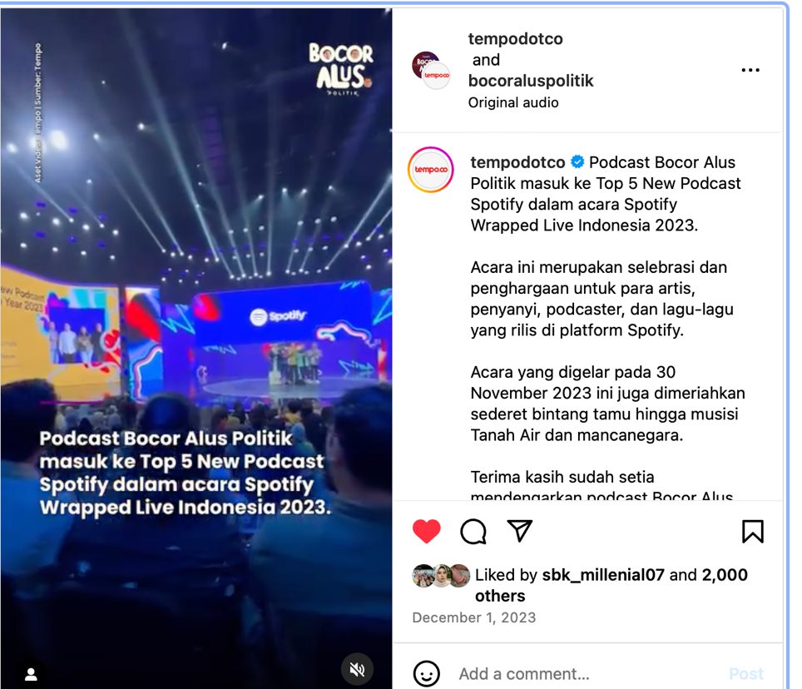
Figure 7. Bocor Alus Politik Received Appreciation from YouTube and Spotify in November 2023.
In fact, what the Bocor Alus Politik crew did was nothing more than carrying out the role of the press as a channel for political communication. The media wants to convey attitudes and at the same time open the public's eyes to political situations that are far from public reach and access. By conveying the reconstructed facts, they want to shape public opinion, and then raise public knowledge, awareness, and political attitudes.
This can be explained by the Agenda Setting theory which justifies that the media influences audiences in the presidential election through broadcasting news, issues, images, and the appearance of the candidates themselves. If an issue is considered important by the media, it will also be considered important by the public. So, if the media pays great attention to an issue, then the public will also pay great attention. On the other hand, if the media considers an issue to be less interesting so that it is not published or is only published in small portions, then naturally the issue will not attract public attention either. (Arriannie, 2022: 64).
This is what Tempo is trying to do with its BAP, ahead of the 2024 Election, where Gen Z, who are also first-time voters, tend to be apolitical, and apathetic about the country's political situation. Interestingly, recent IDN research indicates that issues like climate change, gender inequality, and political shifts hold relatively low priority among Gen Z respondents, with only 25%, 12%, and 11% showing concern for these topics, respectively. Politics was never a big concern for Gen Z. Only 8 percent of respondents from IDN admit that they read and pay full attention to political issues.
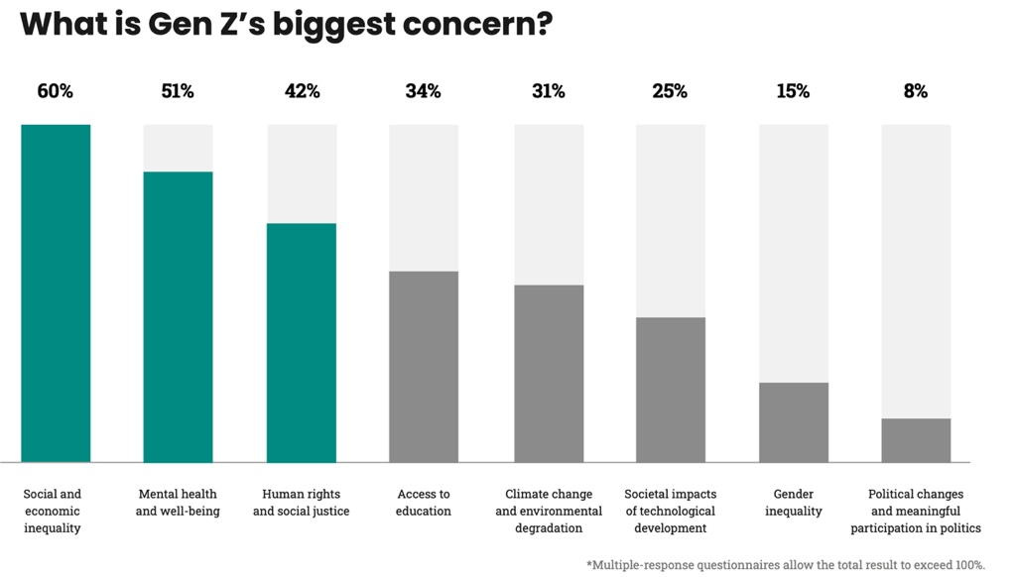
Figure 8. Gen Z Biggest Concern.
In accordance with Information Theory from Aubrey B. Fisher (in Arrhiane 2022: 66), what Tempo journalists and the BAP Podcast crew do is provide information which is a functional grouping of events and aims to eliminate uncertainty.
This was demonstrated, among other things, in the episode "The Queen Mother's Ambitions and Maneuvers" which aired on November 18, 2023, and was watched by around 3.4 million viewers. This episode was a favorite of some sources interviewed in depth by researchers. They are Generation Z, beginner voters, who have been apathetic about the Indonesian political situation.
After watching this episode, suddenly their view of Iriana, which they initially thought was plain, naive, never interfering in political affairs or Jokowi's government, changed. All these views disappeared after they watched the BAP, which revealed official information from trusted sources about Iriana's attitude in the 2024 elections.
"My favorite ep, in my opinion, is the first ep. I watched BAP, which was entitled "Iriana Jokowi's Ambition and Maneuver to Make Gibran Prabowo's Cawapres". "The reason is because in this ep, in my opinion, there is a bit of a plot twist, I never thought that, for example, there would be a figure, Mrs. Iriana, who was also involved in nominating Gibran as vice presidential candidate and this was also the ep that was the starting point for me to start watching BAP." (M, 19 years old)
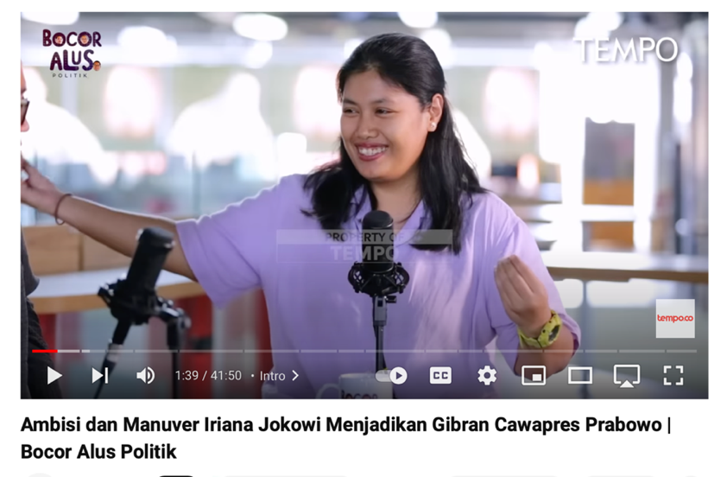
Figure 9. One of the BAP editions that is widely watched and attracts comments from netizens.
In this episode, Pram, Hussein, and Cica reveal the actions of the First Lady, Iriana Jokowi, to pave the way for her eldest son Gibran Rakabuming to become vice president alongside Prabowo Subianto. This certainly opens up new horizons and knowledge, as well as dispelling public doubts about Iriana's role in the Gibran-Prabowo candidacy. Iriana, who was initially portrayed as innocent, never interfering in government affairs, apparently played a big role in Gibran's candidacy.
“My favorite episode is the Queen Mother's Ambition and Maneuvers. I came to know the dark side, actually, almost all the episodes were revealed, but in this episode, Cica did a survey and interview directly at the location with Solo's family, which I immediately judged that the news presented is not as easy as "he said, he said" but requires extraordinary interview research..." (L, 20)
The efforts made by Tempo and the Bocor Alus Team to raise Gen Z's awareness of this political issue cannot be done in just 1-2 broadcasts. According to Mehrabian's Non-Verbal Theory, almost 93% of political communication arises from non-verbal messages. Mehrabian's findings are supported by Birdwhistell who states that 65-70% of the social meaning of interactions is carried out non-verbally, the rest is through spoken words.
Mark L Knapp conveys the concept of nonverbal theory in several categories, including:
1. Repetition, ideas are repeated after being conveyed verbally, coupled with gestures, for example, hand swings, and clenched hands.
2. Substitution, stopping speech with a verbal symbol, for example shaking the head.
3. Contradiction, diverting and conveying another meaning to the verbal message conveyed. For example, shaking hands, but looking in another direction.
4. Complement, expand, and perfect the verbal message with shouts or jumps or clapping hands.
5. Accentuation, verbal person affirmation with convincing gestures.
These variant of repetitions were carried out by the Bocor Alus Team in their podcast.
Agenda Setting Media in Communication
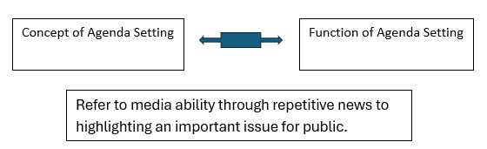
Figure 10. Bocor Alus Podcast Agenda Setting Model.
In each episode, the host of the Bocor Alus Politik podcast always succeeds in convincing the audience more with various gestures that show courage and confidence. There is no gesture of hesitation, fear, or worry in their podcast. It rather implies that they are brave because they are right, are not afraid of being sued because they have strong evidence, and never hesitate because they seek their data from highly trusted sources and always check them.
This was acknowledged by some Bocor Alus Politik viewers who were interviewed by researchers.
"(My favorite) Stefanus Pramono, because I think Mas Pram's demeanor makes the information conveyed look very convincing." (M, 20)
From the results of in-depth interviews with a number of Gen Z viewers of Bocor Alus Politik, it appears that they are satisfied with watching and using the information they got from this podcast as a reference. In the book The Uses of Mass Communication: Current Perspective on Gratification Research, Elihu Katz and Herber Blumer offer how to find information through the media, especially to meet their needs. This includes political needs. (Arrianie, 2022: 59). This is what the viewers of the Bocor Alus Politik podcast do and experience.
At this point, we can see that the role of the Bocor Alus Politik podcast has only reached the stage of opening eyes, increasing insight, and providing new knowledge to its audience. Political awareness has three dimensions as described below:

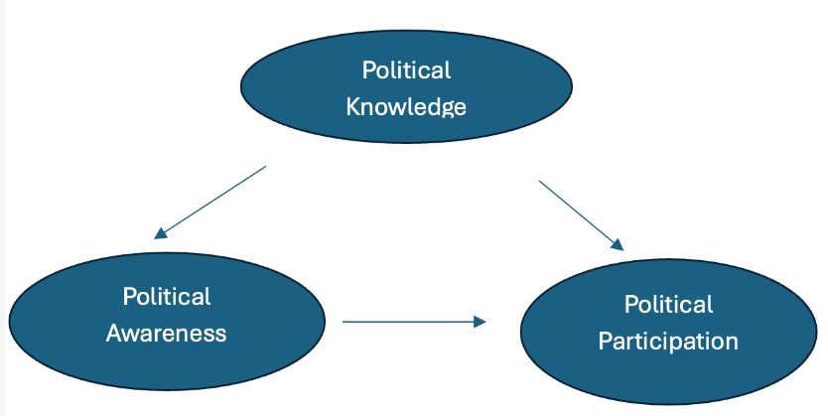
Figure 11. Model of Political Awareness.
Political awareness is knowledge regarding political events, elections, parties, campaigns, and other essential issues that indicate the propensity to participate politically. Effective civic participation is unlikely to occur (Abdo-Katsipis, 2017). In this study, political awareness is operationalized as being aware of political engagement, political participation as the right and obligation, being concerned with socio-political conditions, being aware of political issues, and being felt needed.
Political knowledge is also beneficial to democracy. Accordingly, there are good reasons to consider political knowledge an essential and relevant variable. Political knowledge is a crucial predictor of political engagement, like turnout. The indicators used for describing political knowledge in this study are knowing about electoral law, knowing about the electoral process, knowing the meaning of the election, knowing the issues in a political campaign, and being active in updating political news.
Meanwhile, political participation is hypothesized as measured by four indicators, i.e., being active in political dialogue, being active in expressing political aspirations, supporting the government's political activities, and promoting the political process in the policy process.
For viewers of Bocor Alus Politik podcast, after gaining new political knowledge from Podcast Bocor Alus Politik, the audience has a new awareness of the world of politics. Next, after he realized the importance of caring about politics, and not being apathetic, not apolitical, he also participated in the Election.
This was conveyed by a number of viewers who were randomly interviewed by researchers, as follows:
"When it comes to elections, yes, as a first-time voter, at that time I felt that my vote was not important enough, I even thought about abstaining, in fact, after I watched the BAP, my mind was immediately very open, my view changed that my vote was also an important part in election, yes, even though I didn't have any votes, because of the BAP I felt that I had to participate in fighting election fraud by not voting.
It's not apathetic, it's more like I'm aware of politics but just not interested in finding out more. The BAP influenced me in voting and shaped my views on politics in Indonesia Yes, BAP can create or shape my views regarding my mindset towards politics." (F, 19 years old)
From those answers which clearly show that there have been changes in the knowledge, attitudes, and actions taken by the audience since watching BAP regularly, this means that there is indeed a role for the BAP podcast in shaping Gen Z's political awareness ahead of the 2024 Election.
The role of mass media political communication has really been carried out by Tempo through the production team of the Podcast Bocor Alus Politik, namely:
1. Role of spreading political messages
In fact, political communication is not only limited to political activities such as elections. Political communication includes all forms of communication carried out to spread political messages from certain parties to gain mass support. Their aim is to shape others' opinions, pushing for changes or resisting shifts in perspective. Acting as brokers, they work to persuade others to support and agree with their proposed ideas (Syobah, 2012).
2. Role as a Political Influencer
From various literature on political communication, a common theme is its close association with mass media's role in the communication process. Many writings on political communication focus on campaigns aimed at swaying public opinion or consolidating political power, often emphasizing a power-oriented approach. Graber views political communication as a process involving the learning, acceptance, and internalization of rules, structures, and environmental factors that shape political life.
3. Role in Political Campaigns
Social media users (in this case is Youtube and Instagram viewer) who are well-informed and educated are not easily lied to, but are easily influenced and sympathetic to things that touch them. In the social media space, only factual information is valuable. To achieve confidence that the information must be factual, debate often arises.
Social media users are not people who can be led, but move with their own will and awareness. Social media only has a significant influence on politicians who work around the clock. Not an instant job once every five years. It is shown from the answer of one respondent as follows:
“BAP is 25% of my political reference, because I don't like only referring to certain media, I prefer to get information from various sources because I can more broadly determine my preferences in politics.” (C, 20 yo).
Indeed, respondent’s political action was refer to some information from Podcast Bocor Alus Politik, but it is only 25%.
An interesting feature of social media is its young demographic, coupled with its vast reach among billions of people. Social media goes beyond connecting people to include discussions on political issues, government policies, and public figures' actions. It has become an integral part of political life, serving as a platform for communication, self-promotion, and image-building for political parties, particularly during election campaigns (Ardha, 2014).

  - CONCLUSION
Political participation is essential for the consolidation of democracy. Building a stable democracy requires not only support for democratic values but also a commitment to engaging in democratic norms and procedures, such as active political involvement (Gan et al., 2017).
In recent decades, scientists have measured declines in political legitimacy in advanced industrial democracies (Arshad & Khurram, 2020). Public attention to political issues has also declined, especially among Gen Z. This is clearly illustrated in IDN research which places political issues as the thing that receives the least attention from Gen Z.
Aware of the function of the press as the fourth pillar of democracy, and that it must continue to speak the truth, Tempo Magazine does not want to allow the younger generation's apathy towards politics to continue. By making an effort to change printed news into an audio-visual format, Tempo is trying to "pick up the ball" by approaching Gen Z's media patterns and habits/behaviors.
This effort is considered successful, as evidenced by the increasing popularity of the Leaking Alus Politics Podcast among Gen Z ahead of the 2024 election. Millions of viewers, active comments, and the like button added to all Tempo and Bocor Alus account uploads are proof. This is reinforced by the results of the researcher's in-depth interviews with several randomly selected viewers of Bocor Alus, where they stated that they were inspired and became politically literate after watching episode after episode.
Researchers also saw the importance of repeated exposure to media messages, as did the Tempo team. Where they show one discussion repeatedly in the print version, podcast version, and short version via social media Instagram.
This research allowed us to examine the media’s role in shaping beliefs and behaviors by repeatedly delivering specific messages. In the interviews, we observed a link between individuals' prior exposure to information—often connected to the strength of their attitudes on the topic—and how much this information influenced their beliefs and opinions.

  - RECOMMENDATIONS
Based on the results of interviews with several parties in this research, we recommend the following:
1. Other mass media should imitate Tempo Media's steps in reproducing their news in podcast form. This method has proven effective in reaching a wider audience, especially Gen Z, who has a very different character from previous generations.
2. The media can involve figures from the younger generation to make it more relatable and attractive to Gen Z
3. Other issues besides politics can also start to be discussed, for example, health, environmental preservation, as well as economics and business.

  - REFERENCES
Adi, Kun Muhammad. (2024). Analisis Framing Konten Youtube Podcast Close the Door terkait Film Dokumenter Netflix “Ice Cold: Murder Coffee and Jessica Wongso”. Jurnal Visi Komunikasi, 23(1), 66-74.
Adica. (2022). Generation Z based on Generation Theory. <https://www.silabus.web.id/generasi-z-berdasarkan-teori-generasi/ >
Ardha, Berliani. (2014). Sosial Media Sebagai Media Penyampaian Politik. Jurnal Visi Komunikasi, 13(1), 113.
Arriannie, Lely. (2022). Teori, Model, Perspektif, dan Media Komunikasi Politik. Jakarta: Penerbit Buku Kompas.
Batam News. (2023). Podcast ‘Bocor Alus’ bersama Lima Wartawannya Terima Penghargaan dari Yayasan Pantau. <https://www.batamnews.co.id/berita-108853-podcast-bocor-alus-bersama-lima-wartawannya-terima-penghargaan-dari-yayasan-pantau.html>
Bocor Alus Politik. (2023). Profil. <https://majalah.tempo.co/read/surat-dari-redaksi/170284/bocor-alus-politik>
Boykoff, M. T. (2011). Who speaks for the climate? Making sense of media reporting on climate change. Cambridge, United Kingdom: Cambridge University Press.
Briant, E., Philo, G., & Watson, N. (2011). Bad news for disabled people: How the newspapers are reporting disability. Report. <http://www.inclusionlondon.co.uk/domains/inclusionlondon.co.uk/local/media/downloads/bad_news_for_disabled_people_pdf.pdf>
Bungin, Burhan. (2006). Sosiologi Komunikasi. Jakarta: Kencana Pranada Media Group.
Codrington, G. T. & Grant-Marshall, S. (2004). Mind the gap. Rosebank: Penguin Books.

Department of Work and Pensions (DWP). (2013). Fraud and error in the benefit system: Preliminary 2012/13 estimates (Great Britain). Report. <https://www.gov.uk/government/uploads/system/uploads/attachment_data/file/208563/FEM_1213P.pdf >
Elliot, L., & Atkinson, D. (2008). The Gods that failed; how blind faith in markets has cost us our future. <http://www.theguardian.com/business/2008/jun/02/globaleconomy.globalrecession>
Fairclough, N. (2003). Analyzing discourse. London, United Kingdom: Routledge.
Fianto Latif, et.al. (2023). Implementasi Sembilan Elemen Jurnalisme Bill Kovach dan Tom Rosenstiel Pada Berita Media Online. Jurnal Bincang Komunikasi, 1(2), 1-9.
Firmansyah, Dwi et al. (2023). Konvergensi Televisi dan Media Sosial dalam Distribusi Konten Berita. Jurnal Visi Komunikasi, 22(1), 16-27.
Fischer, D. (2011, January 3). 2010 in review: The year climate coverage 'fell off the map’. <http://wwwp.dailyclimate.org/tdc-newsroom/2011/01/climate-coverage>
Fischer, D. (2013, January 2). Climate coverage, dominated by weird weather, falls further in 2012. <http://wwwp.dailyclimate.org/tdc-newsroom/2013/01/2012-climate-change-reporting>
Fitri, Tin Amalia, et.al. (2023). How to Increase Political Awareness and Formation of National Political Identity through Citizenship Education?. Paper presented at the International Conference on Multidisciplinary Science, KnE Life Sciences, 89-110.
Francis, Tracy & Hoefel, Fernanda (2018, November 12), ‘True Gen’: Generation Z and its implications for companies. <https://www.mckinsey.com/industries/consumer-packaged-goods/our-insights/true-gen-generation-z-and-its-implications-for-companies>
Glasgow University Media Group. (1976). Bad news. London, United Kingdom: Routledge and Kegan Paul.
Glasgow University Media Group. (1980). More bad news. London, United Kingdom: Routledge and Kegan Paul.
Glasgow University Media Group. (1982). Really bad news. London, United Kingdom: Writers and Readers.
Goldenberg, S. (2013, February 15). Media campaign against windfarms funded by anonymous conservatives. <http://www.guardian.co.uk/environment/2013/feb/15/media-campaign-windfarms-conservatives>
Habibie, Dedi Kusuma. (2018). Dwi Fungsi Media Massa. Jurnal Ilmu Komunikasi, 7(2), 80.
Hall, J. (2011, November 24). Households face rising energy bills due to green taxes. <http://www.telegraph.co.uk/earth/energy/8911657/Households-face-rising-energy-bills-due-to-green-taxes.html>
Happer, C., Philo, G., & Froggatt, A. (2012). Climate change and energy security: Assessing the impact of information and its delivery on attitudes and behaviours. <http://www.chathamhouse.org/sites/default/files/public/Research/Energy,%20Environment%20and%20Development/1212ukerc_climatechange.pdf>
Haryanto, Ignatius. (2024). Digital Transformation in Tempo 1995-2022. Jurnal Komunikasi Indonesia, 13(1), 1-14.
Hidayat, Muhammad Nur, Rosdiana, dan Rachma Tri Widuri. Inspira TV's Strategy to Capture Gen Z through Digital TV. AL-I’LAM. Journal of Contemporary Islamic Communication & Media, 3(1), 21-35.
Herman, E., & Chomsky, N. (1994). Manufacturing consent: The political economy of the mass media. New York, NY: Vintage.
Hutton, W. (2008, October 5). This terrifying moment is our one chance for a new world. <http://www.guardian.co.uk/business/2008/oct/05/banks.marketturmoil>
Intyaswati, Drina. (2021). Peran Media Massa tehadap Partisipasi Politik Mahasiswa pada Pemilihan Umum 2019. Jurnal Penelitian Pers dan Komunikasi Pembangunan, 25(2), 140-149.
ICM/Sunday Telegraph. (2012, June). ICM/Sunday Telegraph Wisdom Index 2. <http://www.icmresearch.com/icmsunday-telegraph-wisdom-index-2-june-2012>
IDN Research Institute. (2024). Indonesia Gen Z Report. <https://cdn.idntimes.com/content-documents/indonesia-gen-z-report-2024.pdf>
Jati, Wasisto Raharjo Jati. (2024). Preferensi Politik Pemilih Muslim Indonesia Kontemporer. Jakarta: Penerbit Buku Kompas.
Kitzinger, J. (1993). Understanding AIDS: Media messages and what people know about Acquired Immune Deficiency Syndrome. In J. Eldridge (Ed.), Getting the message (pp. 271-304). London, United Kingdom: Routledge.
KPU. (2022) Informasi Pemilihan Umum. <https://infopemilu.kpu.go.id>
Kustiawan, Winda, Riris Silvia Br Tampubolon, et.al. (2022). Peran Media Massa dalam Komunikasi Politik. Jurnal Ilmu Komputer, Ekonomi, dan Manajemen, 2(1), 1795-1803.

Miller, D. (1998). Promotional strategies and media power. In A. Briggs & P. Cobley (Eds.), The media: An introduction (pp.65-80). London, United Kingdom: Longman.
Miller, D., & Dinan, W. (2000). The rise of the PR industry in Britain 1979-1998. European Journal of Communication, 15(1), 5-35.
Miller, D., & Dinan, W. (2009). Journalism, Public Relations and Spin. In K. Wahl-Jorgense & T. Hanitzsch (Eds.), Handbook of journalism studies (pp. 250-264). New York, NY: Routledge.
Monbiot, G. (2013, February 18). The educational charities that do PR for the rightwing ultra-rich. <http://www.guardian.co.uk/commentisfree/2013/feb/18/charities-pr-rightwing-ultra-rich>
Nimmo, Dan. (1989). Kominikasi Politik: Komunikator, Pesan dan Media. Bandung: PT Remaja Rosdakarya.
Philo, G. (1990). Seeing and believing: The influence of television. London, United Kingdom: Routledge.
Philo, G. (1995). Television politics the rise of the New Right. In G. Philo (Ed.), Glasgow Media Group Reader (Vol. 2; pp.198-224). London, United Kingdom: Routledge.
Philo, G. (Ed.). (1996). Media and mental distress. London, United Kingdom: Longman.
Philo, G. (2008). Active audiences and the construction of public knowledge. Journalism Studies, 9(4), 535-544. doi:10.1080/14616700802114217
Philo, G. (2010, August 15). Deficit crisis: Let’s really be in it together. The Guardian. Retrieved from http://www.guardian.co.uk/commentisfree/2010/aug/15/deficit-crisis-tax-the-rich
Philo, G., & Berry, M. (2004). Bad news from Israel. London, United Kingdom: Pluto.
Philo, G., & Berry, M. (2011). More bad news from Israel. London, United Kingdom: Pluto Press.
Philo, G., Briant, E., & Donald, P. (in press). Bad news for refugees. London, United Kingdom: Pluto.
Philo, G., Miller, D., & Happer, C. (in press). Circuits of communication and structures of power: The sociology of the mass media. In M. Holborn (Ed.), Contemporary sociology. London, United Kingdom: Polity.
Putri, Adel Andila. (2023). Krisis Literasi di Indonesia, Masih Perlu Ditingkatkan Lagi. <https://goodstats.id/article/krisis-literasi-di-indonesia-masih-perlu-ditingkatkan-lagi-j7MHB>
Septiana, Riyan & Rizki Briandana. (2023). Identitas Diri dan Isu Kesehatan Mental: Interpretasi Remaja terhadap Konten Podcast. Jurnal Visi Komunikasi, 23(1), 81-101.
Setyarso, Budi. (2011). Cerita di Balik Dapur Tempo (1971-2011). Jakarta: Kepustakaan Populer Gramedia.

Solhaug, Trond. (2018). Political Awareness, Conceptualization and Operationalization for Research. <https://ecpr.eu/Events/Event/PaperDetails/41662>
Sudibyo, Agus. (2022). Media Massa Nasional Menghadapi Disrupsi Digital. Jakarta: Kepustakaan Populer Gramedia.
Sukardi, Wina Armada. (2017, August 10). Nasib Media Cetak di Tangan Generasi Z. <https://www.lintasindonews.com/nasib-media-cetak-di-tangan-generasi-z/>
Supadiyanto. (2013). Implikasi Teknologi Digital dan Internet (Paperless Newspaper) Pada Industri Media Cetak di Indonesia. Prosiding dalam Seminar Nasional Menuju Masyarakat Madani dan Lestari, Direktorat Penelitian dan Pengabdian Masyarakat Universitas Islam Indonesia (DPPM UII) Yogyakarta. 687–696. <http://dppm.uii.ac.id/dokumen/seminar/2013/G.Supadiyanto.pdf>
Susanto, Tri Agus. (2023). Podcast ‘Bocor Alus Politik Tempo’: Podcast Tempo Versus Erick Thohir. Journal of Election and Leadership (JOELS), 4(2), 110-119. < https://doi.org/10.31849/joels.v4i2.15747 >
Syobah, Nurul. (2022). Peran Media Massa Dalam Komunikasi Politik. Jurnal Komunikasi dan Sosial Keagamaan, 15(1), 14.
Tempo Media Group. History. <https://www.tempo.id/corporate.php>
Van Dijk, T. A. (1998). Opinions and ideologies in the press. In A. Bell & P. Garrett (Eds.), Approaches to media discourse (p. 21-63). Oxford, United Kingdom: Blackwell.
Wahyuni, Sari. (2023). Riset Kualitatif. Strategi dan Contoh Praktis. Jakarta: Penerbit Buku Kompas.
We Are Social. Digital 2023 - Special Report. <https://wearesocial.com/id/blog/2023/01/digital-2023/>
Widuri, Rachma Tri & Muhammad Nur Hidayat. (2023). Koran Tempo’s Innovation to Engage Gen through Digitalization. KnE Social Sciences/ Annual Symposium on Applied Business Economics and Communication (ASABEC) 2023, 189-212.
Zetra, Aidinil, Kartini Aboo Talib, et al. (2022). Political Awareness, Knowledge, and Participation Relationship using Structural Equation Modeling Approach. Jurnal Wacana Politik, 7(1), 46-56.

